HOMEWORK1 REPORT
1.
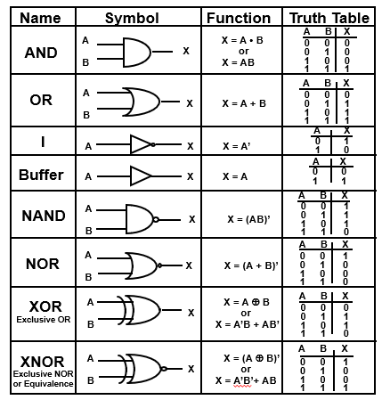
Figure 1. Each logic gates’ logic
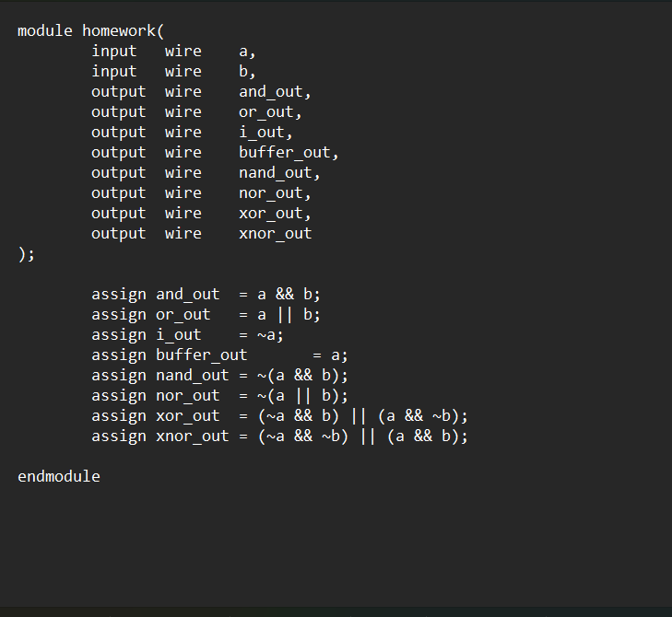
Figure 2. RTL code
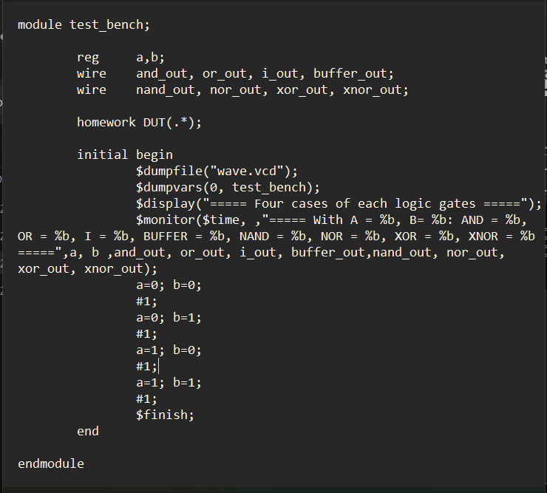
Figure 3. Test_bench code
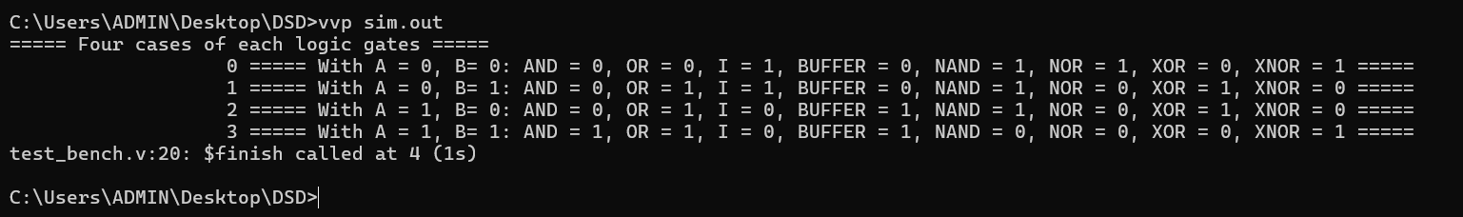
Figure 3. Test_bench result
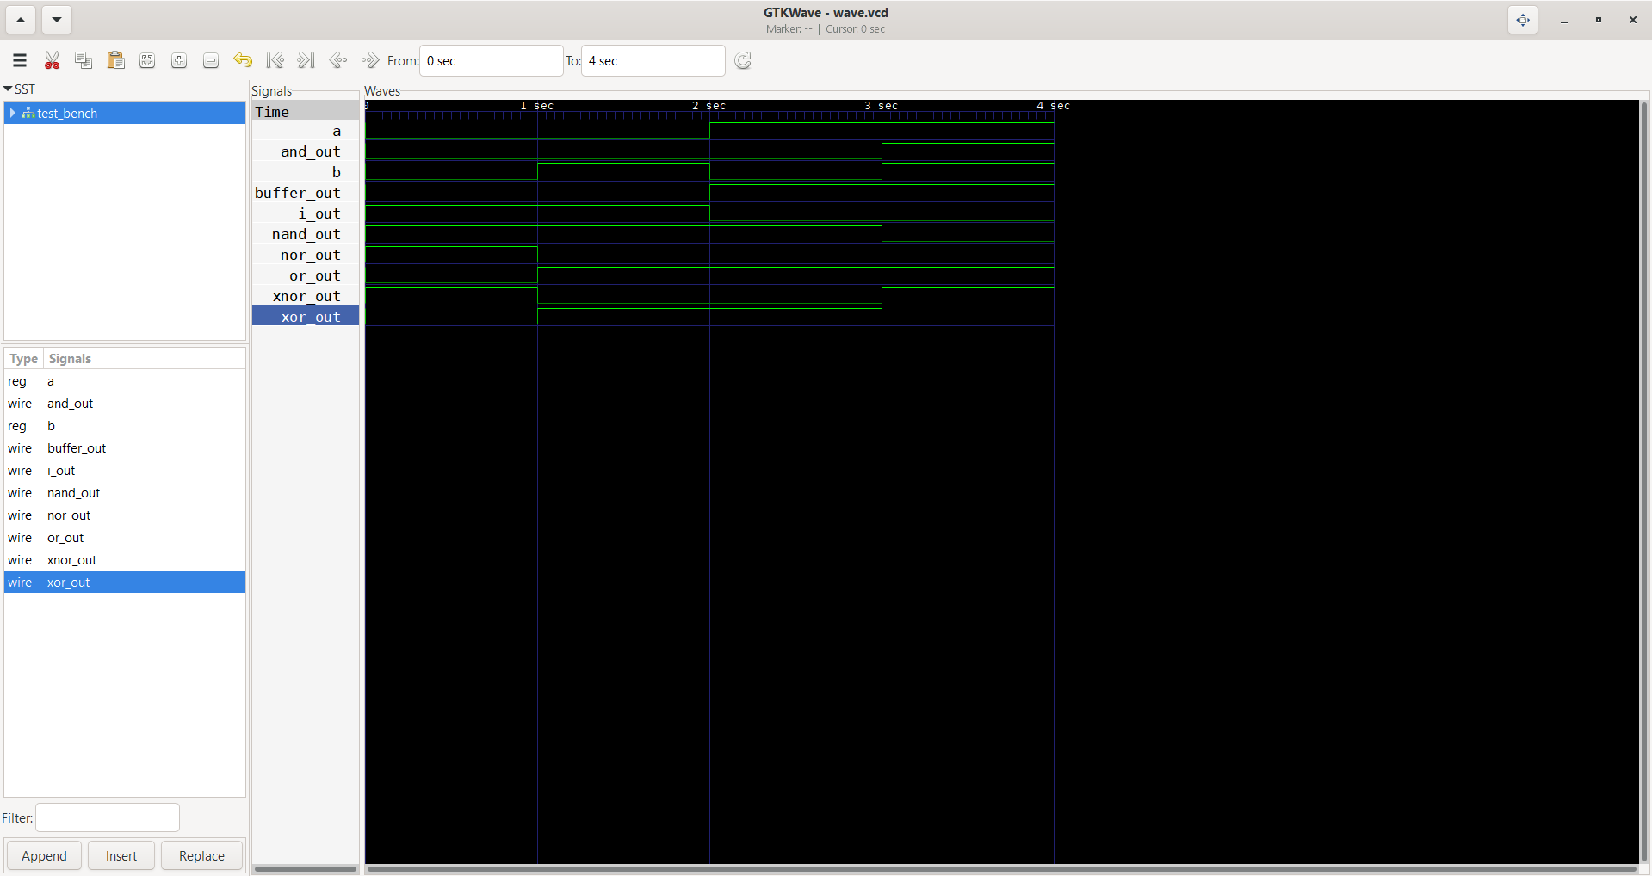
Figure 4. Waveform
2.
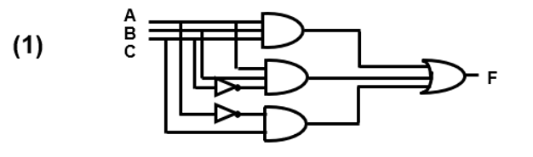
Figure 5. Module 1
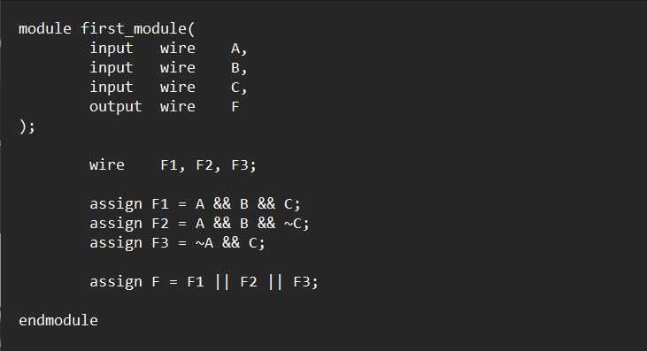
Figure 6. RTL code
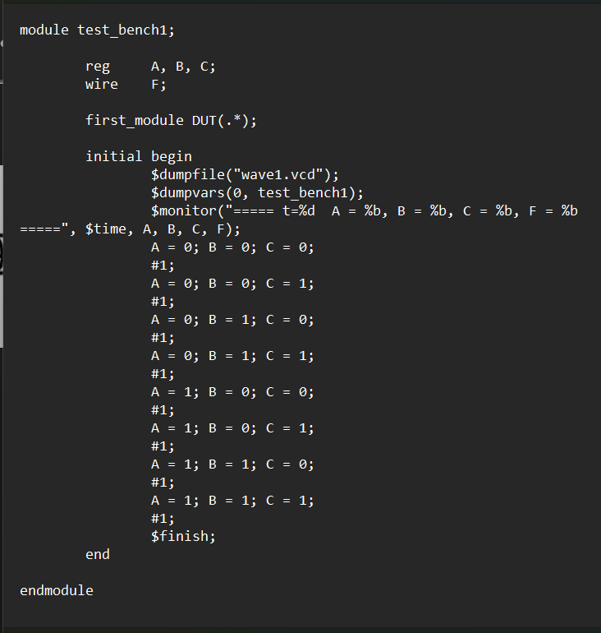
Figure 7. Test_bench of Module 1
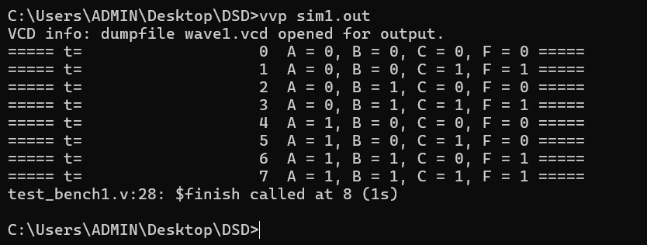
Figure 8. Module 1 Result
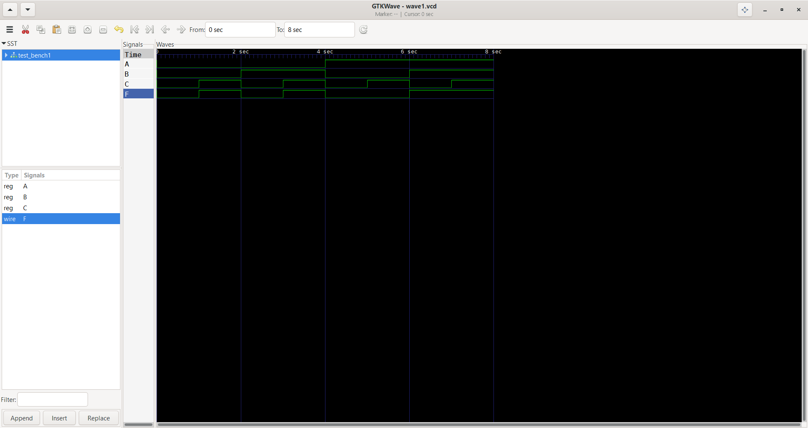
Figure 9. Module 1 Waveform
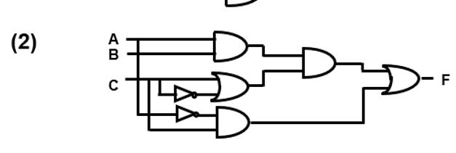
Figure 10. Module 2
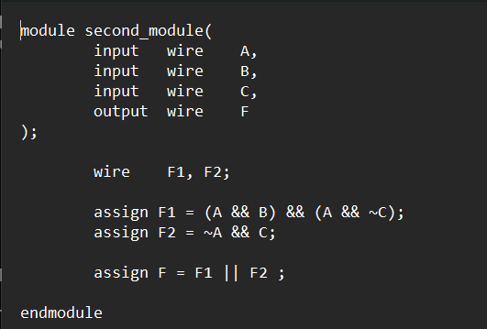
Figure 11. RTL code
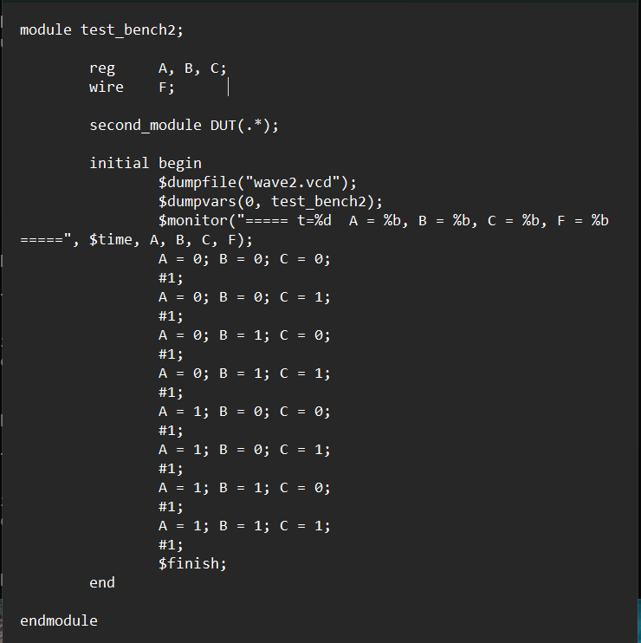
Figure 12. Test_bench of Module 2
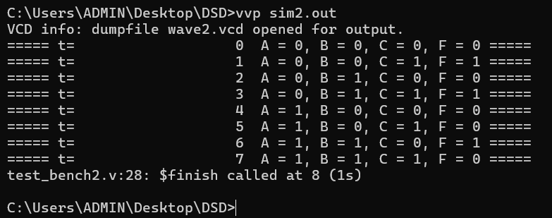
Figure 13. Module 2 Result
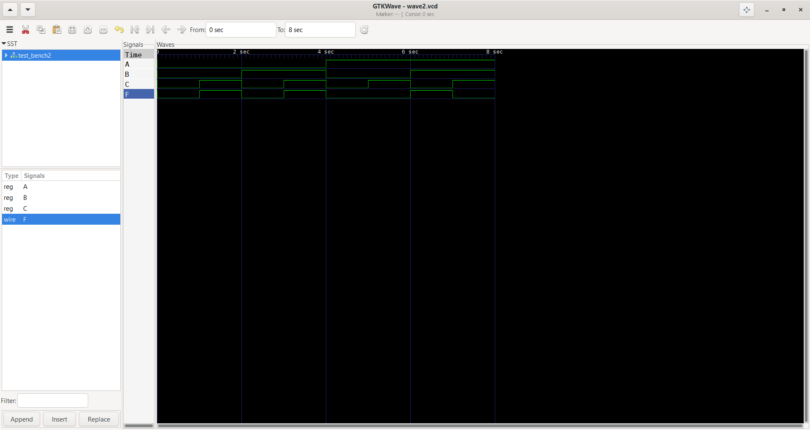
Figure 14. Module 2 Waveform
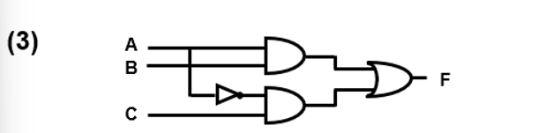
Figure 10. Module 3
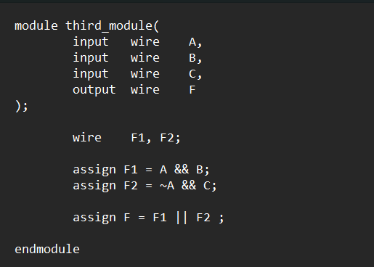
Figure 11. RTL code
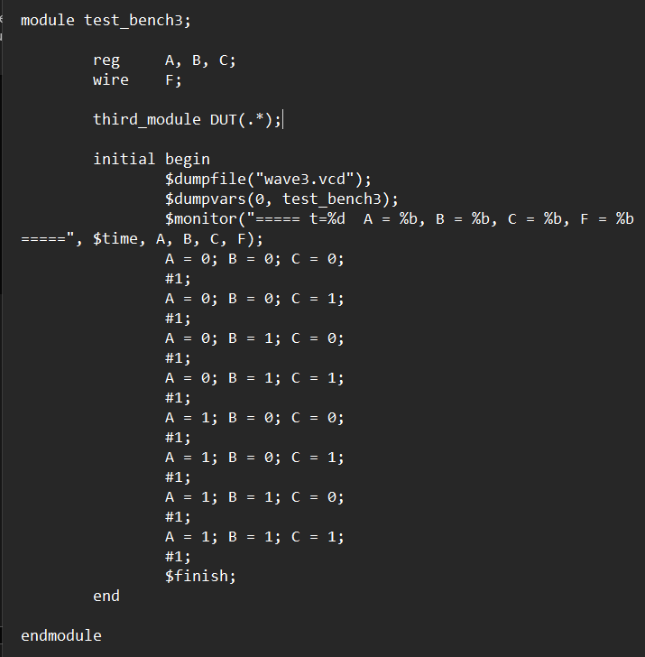
Figure 12. Test_bench of Module 3
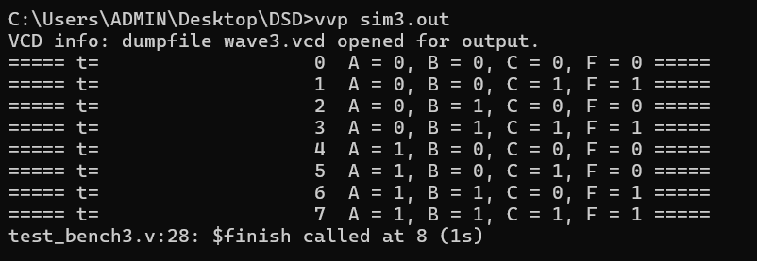
Figure 13. Module 3 Result
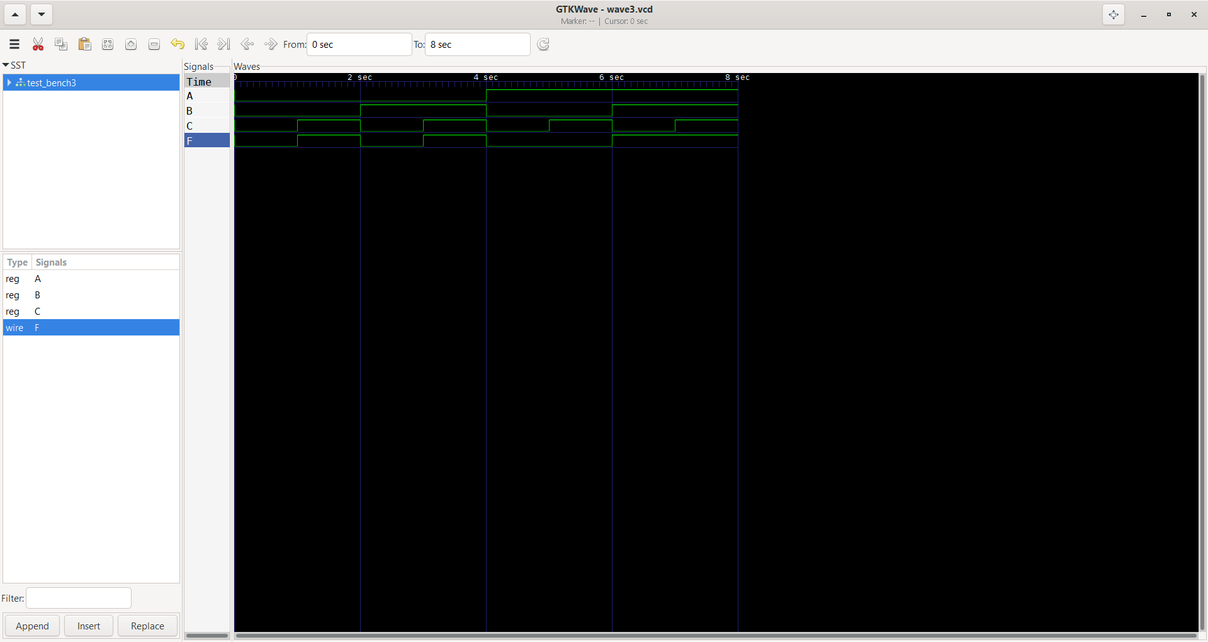
Figure 14. Module 3 Waveform

