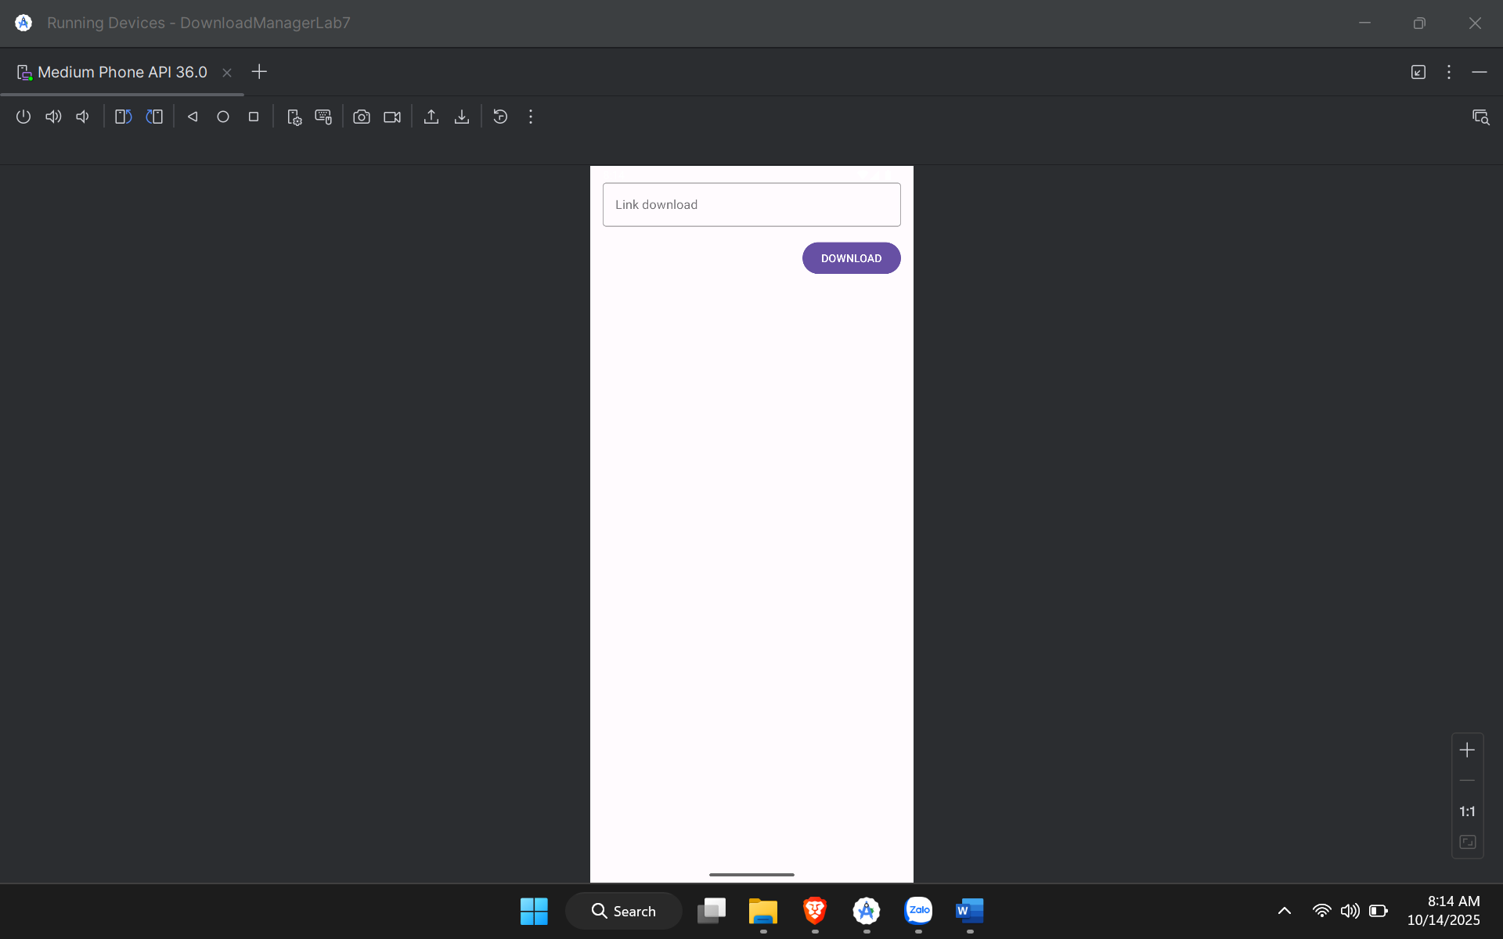

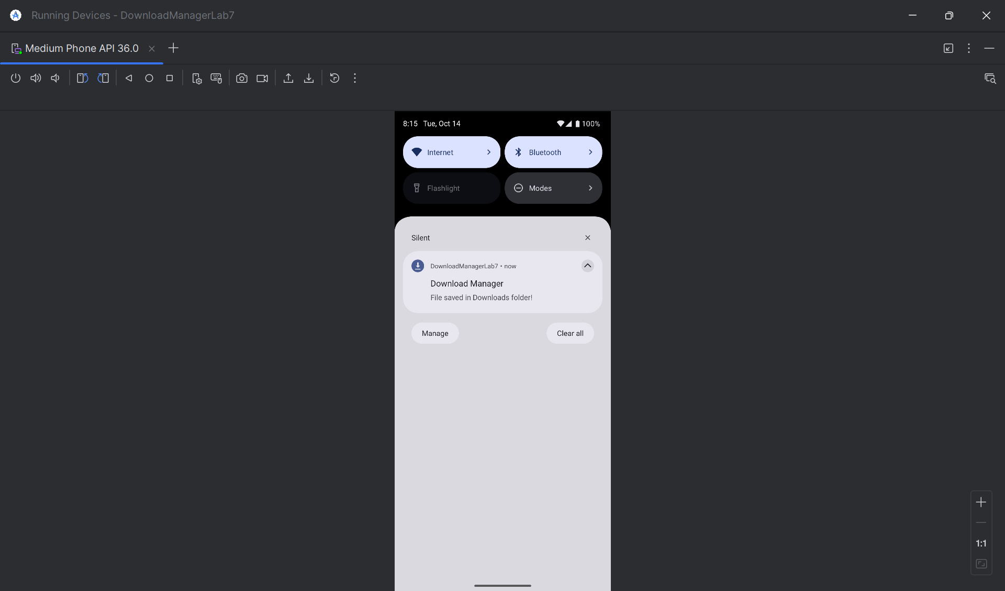

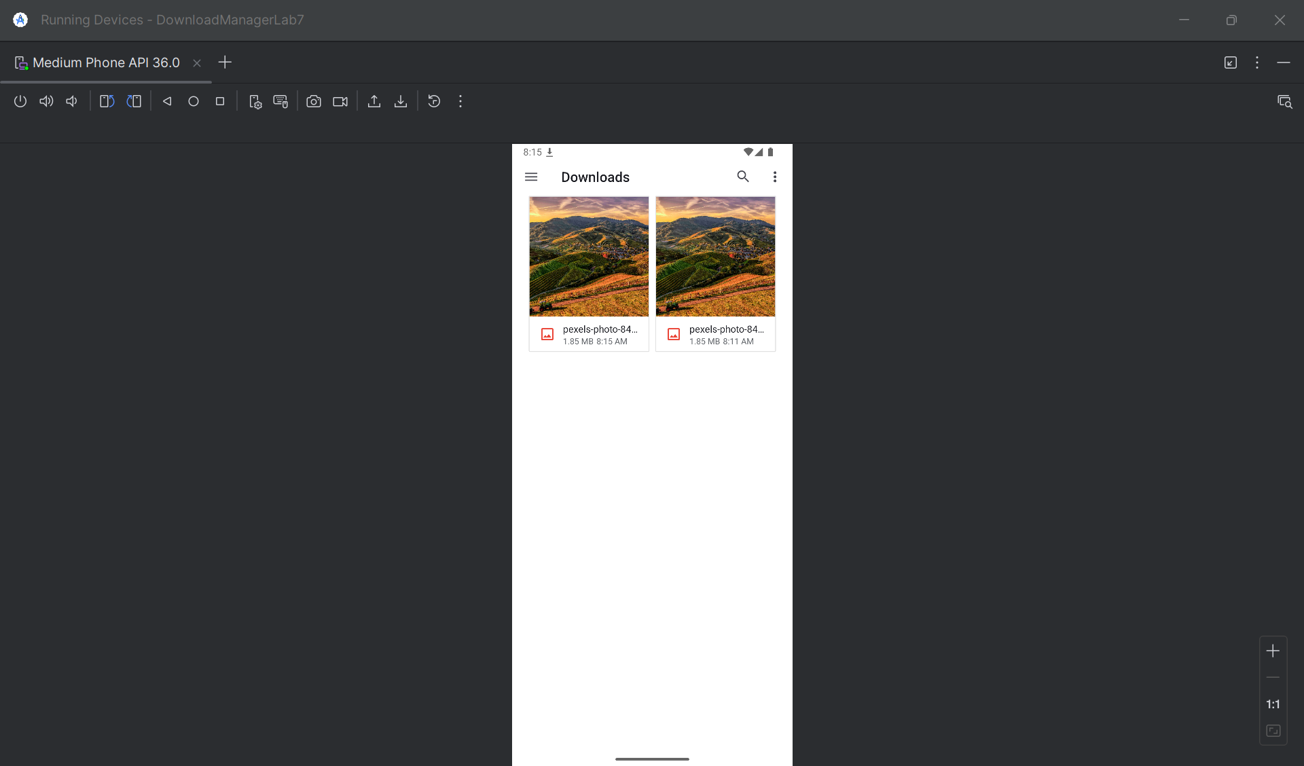

Link tải: <https://images.pexels.com/photos/842711/pexels-photo-842711.jpeg?cs=srgb&dl=pexels-christian-heitz-285904-842711.jpg&fm=jpg>

AndroidManifest.xml

<?xml version="1.0" encoding="utf-8"?>  
<manifest xmlns:android="http://schemas.android.com/apk/res/android"  
 xmlns:tools="http://schemas.android.com/tools">  
  
 <uses-permission android:name="android.permission.INTERNET" />  
 <uses-permission android:name="android.permission.FOREGROUND_SERVICE" />  
 <uses-permission android:name="android.permission.POST_NOTIFICATIONS" />  
 <uses-permission android:name="android.permission.FOREGROUND_SERVICE_DATA_SYNC" />  
  
  
 <uses-permission android:name="android.permission.WRITE_EXTERNAL_STORAGE"  
 android:maxSdkVersion="28" />  
  
  
 <application  
 android:allowBackup="true"  
 android:dataExtractionRules="@xml/data_extraction_rules"  
 android:fullBackupContent="@xml/backup_rules"  
 android:icon="@mipmap/ic_launcher"  
 android:label="@string/app_name"  
 android:roundIcon="@mipmap/ic_launcher_round"  
 android:supportsRtl="true"  
 android:theme="@style/Theme.DownloadManagerLab7"  
 tools:targetApi="31">  
  
 <activity  
 android:name=".MainActivity"  
 android:exported="true">  
 <intent-filter>  
 <action android:name="android.intent.action.MAIN" />  
 <category android:name="android.intent.category.LAUNCHER" />  
 </intent-filter>  
 </activity>  
  
 <service  
 android:name=".DownloadService"  
 android:foregroundServiceType="dataSync" />  
  
 <receiver  
 android:name=".NotificationActionReceiver"  
 android:enabled="true"  
 android:exported="false" />  
  
 </application>  
</manifest>

MainActivity.java

package com.example.downloadmanagerlab7;  
  
import android.Manifest;  
import android.content.Intent;  
import android.content.pm.PackageManager;  
import android.os.Build;  
import android.os.Bundle;  
import android.widget.Button;  
import android.widget.Toast;  
import androidx.activity.result.ActivityResultLauncher;  
import androidx.activity.result.contract.ActivityResultContracts;  
import androidx.appcompat.app.AppCompatActivity;  
import androidx.core.content.ContextCompat;  
  
import com.google.android.material.textfield.TextInputEditText;  
  
public class MainActivity extends AppCompatActivity {  
  
 private TextInputEditText etLink;  
 private Button btnDownload;  
 private String downloadUrl = "";  
  
 private final ActivityResultLauncher<String> requestPermissionLauncher =  
 registerForActivityResult(new ActivityResultContracts.RequestPermission(), isGranted -> {  
 if (isGranted) {  
 startDownloadService();  
 } else {  
 Toast.*makeText*(this, "Permission denied to post notifications", Toast.*LENGTH_SHORT*).show();  
 }  
 });  
  
 @Override  
 protected void onCreate(Bundle savedInstanceState) {  
 super.onCreate(savedInstanceState);  
 setContentView(R.layout.*activity_main*);  
  
 // Ánh xạ view bằng findViewById  
 etLink = findViewById(R.id.*etLink*);  
 btnDownload = findViewById(R.id.*btnDownload*);  
  
 btnDownload.setOnClickListener(v -> {  
 downloadUrl = etLink.getText().toString().trim();  
 if (downloadUrl.isEmpty()) {  
 Toast.*makeText*(this, "Please enter a download link", Toast.*LENGTH_SHORT*).show();  
 } else {  
 checkNotificationPermissionAndStart();  
 }  
 });  
 }  
  
 private void checkNotificationPermissionAndStart() {  
 if (Build.VERSION.*SDK_INT* >= Build.VERSION_CODES.*TIRAMISU*) {  
 if (ContextCompat.*checkSelfPermission*(this, Manifest.permission.*POST_NOTIFICATIONS*) ==  
 PackageManager.*PERMISSION_GRANTED*) {  
 startDownloadService();  
 } else {  
 requestPermissionLauncher.launch(Manifest.permission.*POST_NOTIFICATIONS*);  
 }  
 } else {  
 startDownloadService();  
 }  
 }  
  
 private void startDownloadService() {  
 Intent serviceIntent = new Intent(this, DownloadService.class);  
 serviceIntent.putExtra("url", downloadUrl);  
 startService(serviceIntent);  
 Toast.*makeText*(this, "Download started...", Toast.*LENGTH_SHORT*).show();  
 }  
}

NotificationActionReceiver.java

// File: NotificationActionReceiver.java  
package com.example.downloadmanagerlab7;  
  
import android.content.BroadcastReceiver;  
import android.content.Context;  
import android.content.Intent;  
import android.util.Log;  
  
public class NotificationActionReceiver extends BroadcastReceiver {  
 public static final String *ACTION_PAUSE* = "com.example.downloadmanager.ACTION_PAUSE";  
 public static final String *ACTION_RESUME* = "com.example.downloadmanager.ACTION_RESUME";  
 public static final String *ACTION_CANCEL* = "com.example.downloadmanager.ACTION_CANCEL";  
  
 @Override  
 public void onReceive(Context context, Intent intent) {  
 if (intent != null && intent.getAction() != null) {  
 Log.*d*("Receiver", "Action received: " + intent.getAction());  
 Intent serviceIntent = new Intent(context, DownloadService.class);  
 serviceIntent.setAction(intent.getAction());  
 context.startService(serviceIntent);  
 }  
 }  
}

activity_main.xml

<?xml version="1.0" encoding="utf-8"?>  
<LinearLayout xmlns:android="http://schemas.android.com/apk/res/android"  
 xmlns:tools="http://schemas.android.com/tools"  
 android:layout_width="match_parent"  
 android:layout_height="match_parent"  
 android:orientation="vertical"  
 android:padding="16dp"  
 tools:context=".MainActivity">  
  
 <com.google.android.material.textfield.TextInputLayout  
 style="@style/Widget.MaterialComponents.TextInputLayout.OutlinedBox"  
 android:layout_width="match_parent"  
 android:layout_height="wrap_content"  
 android:hint="Link download">  
  
 <com.google.android.material.textfield.TextInputEditText  
 android:id="@+id/etLink"  
 android:layout_width="match_parent"  
 android:layout_height="wrap_content"  
 android:inputType="textUri" />  
  
 </com.google.android.material.textfield.TextInputLayout>  
  
 <Button  
 android:id="@+id/btnDownload"  
 android:layout_width="wrap_content"  
 android:layout_height="wrap_content"  
 android:layout_gravity="end"  
 android:layout_marginTop="16dp"  
 android:text="DOWNLOAD" />  
  
</LinearLayout>

custom_notification.xml

<?xml version="1.0" encoding="utf-8"?>  
<LinearLayout xmlns:android="http://schemas.android.com/apk/res/android"  
 android:layout_width="match_parent"  
 android:layout_height="wrap_content"  
 android:orientation="vertical"  
 android:padding="8dp">  
  
 <TextView  
 android:id="@+id/tvLink"  
 style="@style/TextAppearance.Compat.Notification.Title"  
 android:layout_width="match_parent"  
 android:layout_height="wrap_content"  
 android:ellipsize="end"  
 android:maxLines="1"  
 android:text="Link: " />  
  
 <TextView  
 android:id="@+id/tvProgress"  
 style="@style/TextAppearance.Compat.Notification.Info"  
 android:layout_width="wrap_content"  
 android:layout_height="wrap_content"  
 android:layout_marginTop="4dp"  
 android:text="Complete: 0%" />  
  
 <ProgressBar  
 android:id="@+id/progressBar"  
 style="?android:attr/progressBarStyleHorizontal"  
 android:layout_width="match_parent"  
 android:layout_height="wrap_content"  
 android:layout_marginTop="4dp"  
 android:max="100"  
 android:progress="0" />  
  
 <LinearLayout  
 android:layout_width="match_parent"  
 android:layout_height="wrap_content"  
 android:layout_marginTop="8dp"  
 android:orientation="horizontal">  
  
 <Button  
 android:id="@+id/btnAction"  
 style="@style/Widget.AppCompat.Button.Borderless"  
 android:layout_width="0dp"  
 android:layout_height="40dp"  
 android:layout_weight="1"  
 android:text="Pause" />  
  
 <Button  
 android:id="@+id/btnCancel"  
 style="@style/Widget.AppCompat.Button.Borderless"  
 android:layout_width="0dp"  
 android:layout_height="40dp"  
 android:layout_weight="1"  
 android:text="Cancel" />  
 </LinearLayout>  
</LinearLayout>