Activity và inter

mainActivity.java

<?xml version="1.0" encoding="utf-8"?>  
<androidx.constraintlayout.widget.ConstraintLayout  
 xmlns:android="http://schemas.android.com/apk/res/android"  
 xmlns:app="http://schemas.android.com/apk/res-auto"  
 xmlns:tools="http://schemas.android.com/tools"  
 android:layout_width="match_parent"  
 android:layout_height="match_parent"  
 tools:context=".MainActivity">  
  
 <Button  
 android:id="@+id/btnHelloWorld"  
 android:layout_width="wrap_content"  
 android:layout_height="wrap_content"  
 android:layout_marginTop="228dp"  
 android:onClick="onBtnHelloClick"  
 android:text="HelloWorld"  
 app:layout_constraintEnd_toEndOf="parent"  
 app:layout_constraintStart_toStartOf="parent"  
 app:layout_constraintTop_toTopOf="parent"/>  
  
 <Button  
 android:id="@+id/btnRegister"  
 android:layout_width="wrap_content"  
 android:layout_height="wrap_content"  
 android:layout_marginTop="80dp"  
 android:onClick="onBtnRegisterClick"  
 android:text="Register"  
 app:layout_constraintEnd_toEndOf="parent"  
 app:layout_constraintStart_toStartOf="parent"  
 app:layout_constraintTop_toBottomOf="@id/btnHelloWorld"/>  
  
</androidx.constraintlayout.widget.ConstraintLayout>

package com.example.teoapp;  
  
import android.content.Intent;  
import android.os.Bundle;  
import android.view.View;  
import androidx.appcompat.app.AppCompatActivity;  
  
public class MainActivity extends AppCompatActivity {  
  
 @Override  
 protected void onCreate(Bundle savedInstanceState) {  
 super.onCreate(savedInstanceState);  
 setContentView(R.layout.*activity_main*);  
 }  
  
 // Xử lý nút HelloWorld  
 public void onBtnHelloClick(View view) {  
 Intent intent = new Intent(MainActivity.this, HelloActivity.class);  
 startActivity(intent);  
 }  
  
 // Xử lý nút Register  
 public void onBtnRegisterClick(View view) {  
 Intent intent = new Intent(MainActivity.this, RegisterActivity.class);  
 startActivity(intent);  
 }  
}

Tạo HelloActivity và RegisterActivity

* Chuột phải vào thư mục java → New → Activity → Empty Views Activity
* Tạo 2 activity: HelloActivity và RegisterActivity

Helloactivity.java

package com.example.teoapp;  
  
import android.os.Bundle;  
import androidx.appcompat.app.AppCompatActivity;  
  
public class HelloActivity extends AppCompatActivity {  
  
 @Override  
 protected void onCreate(Bundle savedInstanceState) {  
 super.onCreate(savedInstanceState);  
 setContentView(R.layout.*activity_hello*);  
 }  
}

RegisterActivity.java

package com.example.teoapp;  
  
import android.os.Bundle;  
import androidx.appcompat.app.AppCompatActivity;  
  
public class RegisterActivity extends AppCompatActivity {  
  
 @Override  
 protected void onCreate(Bundle savedInstanceState) {  
 super.onCreate(savedInstanceState);  
 setContentView(R.layout.*activity_register*);  
 }  
}

activity_main.xml

activity_hello.xml

<?xml version="1.0" encoding="utf-8"?>  
<androidx.constraintlayout.widget.ConstraintLayout  
 xmlns:android="http://schemas.android.com/apk/res/android"  
 xmlns:app="http://schemas.android.com/apk/res-auto"  
 xmlns:tools="http://schemas.android.com/tools"  
 android:layout_width="match_parent"  
 android:layout_height="match_parent"  
 tools:context=".HelloActivity">  
  
 <TextView  
 android:layout_width="wrap_content"  
 android:layout_height="wrap_content"  
 android:text="Hello World Activity!"  
 android:textSize="24sp"  
 app:layout_constraintBottom_toBottomOf="parent"  
 app:layout_constraintLeft_toLeftOf="parent"  
 app:layout_constraintRight_toRightOf="parent"  
 app:layout_constraintTop_toTopOf="parent" />  
  
</androidx.constraintlayout.widget.ConstraintLayout>

activity_register.xml

<?xml version="1.0" encoding="utf-8"?>  
<androidx.constraintlayout.widget.ConstraintLayout  
 xmlns:android="http://schemas.android.com/apk/res/android"  
 xmlns:app="http://schemas.android.com/apk/res-auto"  
 xmlns:tools="http://schemas.android.com/tools"  
 android:layout_width="match_parent"  
 android:layout_height="match_parent"  
 tools:context=".RegisterActivity">  
  
 <TextView  
 android:layout_width="wrap_content"  
 android:layout_height="wrap_content"  
 android:text="Register Activity!"  
 android:textSize="24sp"  
 app:layout_constraintBottom_toBottomOf="parent"  
 app:layout_constraintLeft_toLeftOf="parent"  
 app:layout_constraintRight_toRightOf="parent"  
 app:layout_constraintTop_toTopOf="parent" />  
  
</androidx.constraintlayout.widget.ConstraintLayout>

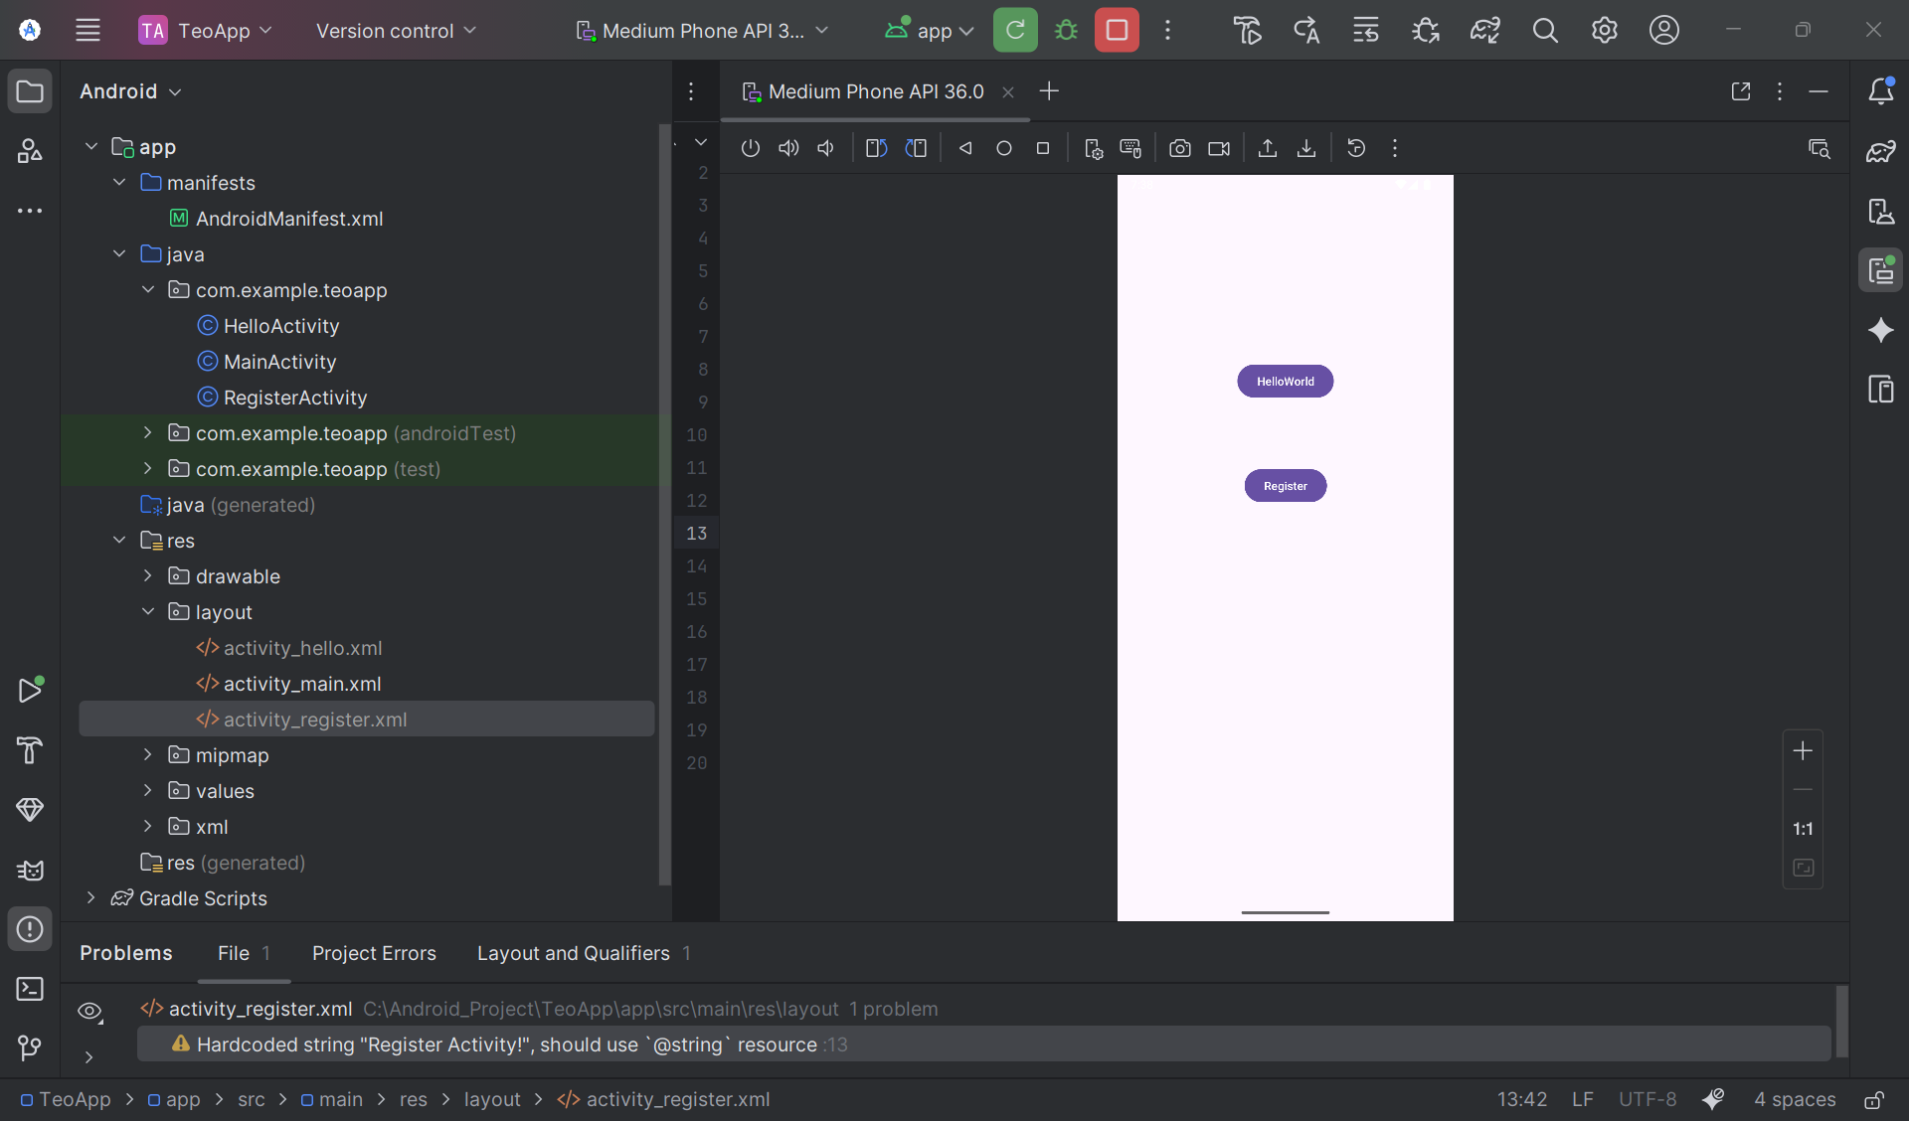

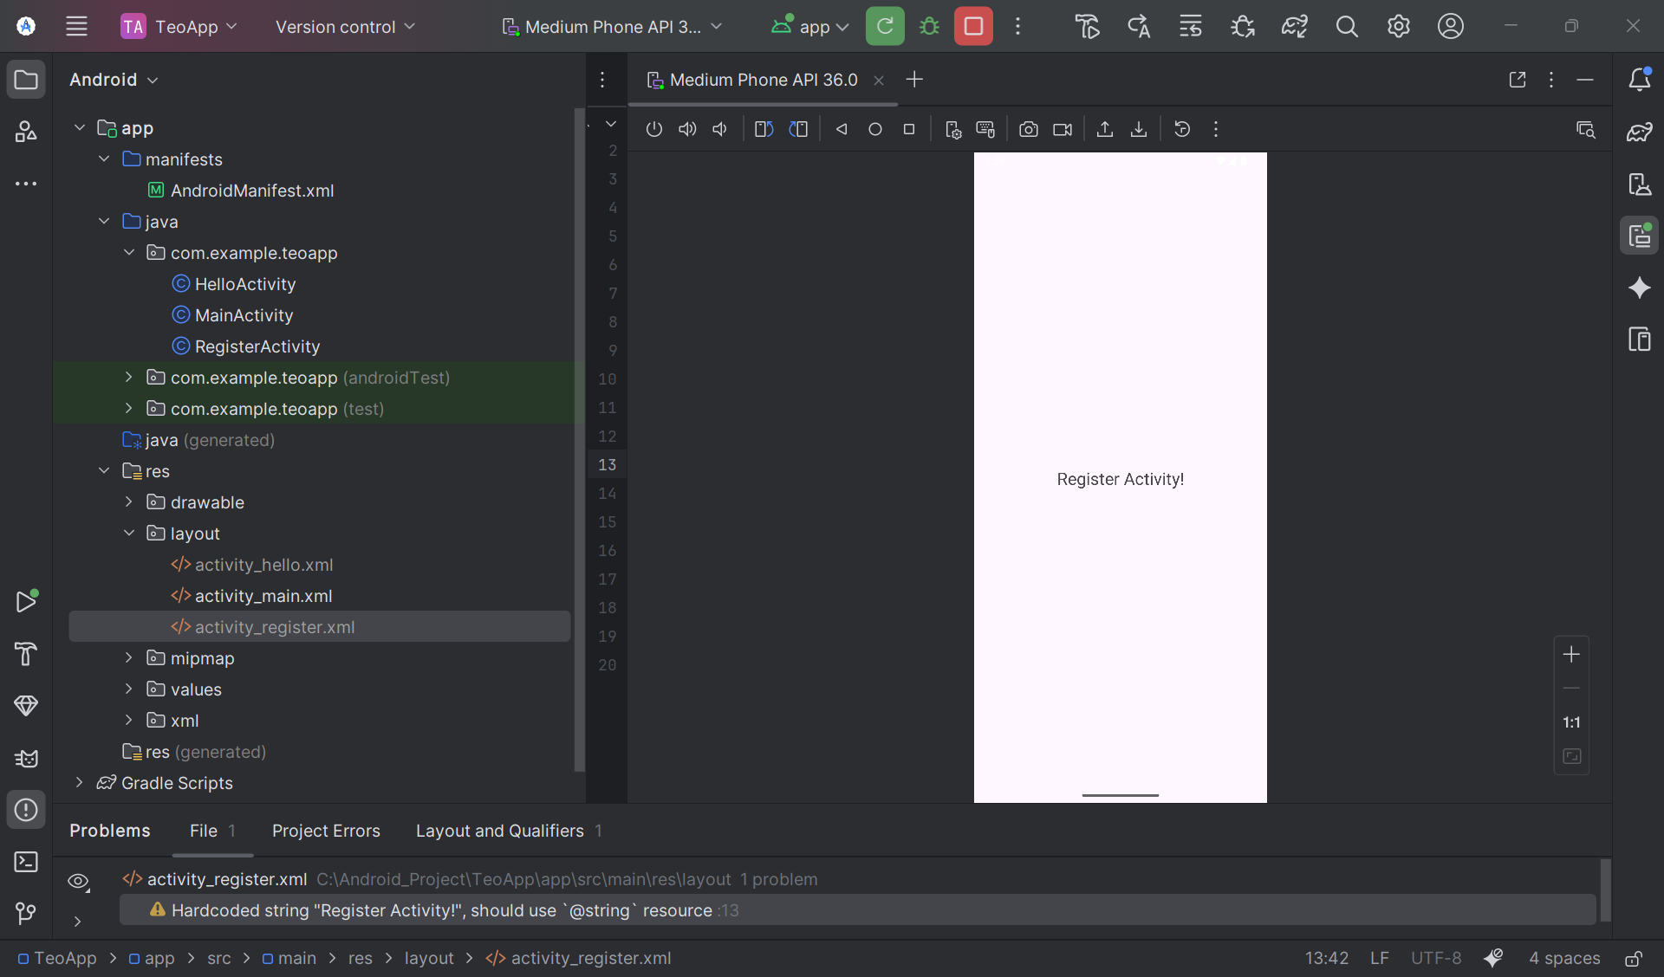

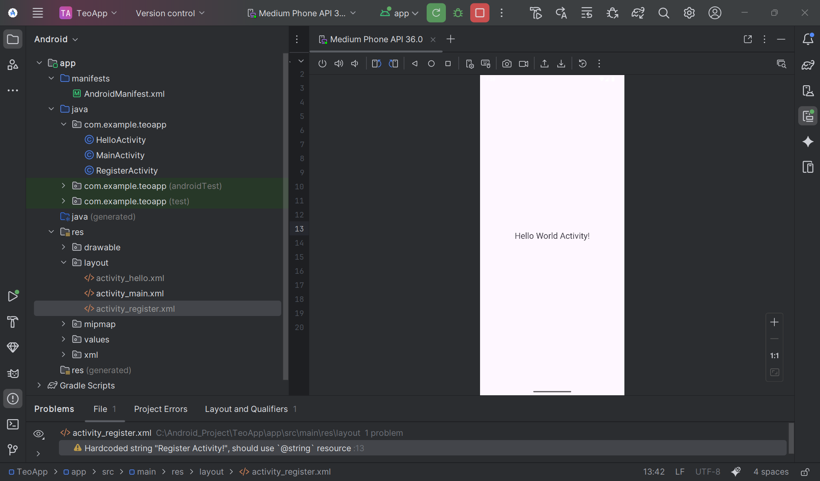

SMS

MainActivity.java package com.example.broadcastdemo;  
  
import android.content.*;  
import android.os.Bundle;  
import android.telephony.SmsManager;  
import android.view.View;  
import android.widget.*;  
import androidx.appcompat.app.AppCompatActivity;  
import java.util.ArrayList;  
  
public class MainActivity extends AppCompatActivity {  
  
 private TextView tvSmsContent, tvRequestList;  
 private ListView lvMessages;  
 private Button btnSafe, btnMayday;  
 private Switch swAutoResponse;  
 private BroadcastReceiver smsReceiver, powerReceiver;  
  
 private ArrayList<String> requesters = new ArrayList<>();  
 private ArrayAdapter<String> adapter;  
 public static boolean *isRunning* = false;  
  
 // Constants  
 public static final String *SMS_FORWARD_BROADCAST_RECEIVER* = "SMS_FORWARD_BROADCAST_RECEIVER";  
 public static final String *SMS_MESSAGE_ADDRESS_KEY* = "SMS_MESSAGE_ADDRESS_KEY";  
  
 @Override  
 protected void onCreate(Bundle savedInstanceState) {  
 super.onCreate(savedInstanceState);  
 setContentView(R.layout.*activity_main*);  
  
 initViews();  
 setupListView();  
 setupBroadcastReceivers();  
 setupClickListeners();  
  
 // Xử lý intent khi được start từ SmsReceiver  
 processIntent(getIntent());  
 }  
  
 private void initViews() {  
 tvSmsContent = findViewById(R.id.*tv_sms_content*);  
 tvRequestList = findViewById(R.id.*tv_request_list*);  
 lvMessages = findViewById(R.id.*lv_messages*);  
 btnSafe = findViewById(R.id.*btn_safe*);  
 btnMayday = findViewById(R.id.*btn_mayday*);  
 swAutoResponse = findViewById(R.id.*sw_auto_response*);  
 }  
  
 private void setupListView() {  
 adapter = new ArrayAdapter<>(this, android.R.layout.*simple_list_item_1*, requesters);  
 lvMessages.setAdapter(adapter);  
 }  
  
 private void setupBroadcastReceivers() {  
 // Receiver cho SMS  
 smsReceiver = new BroadcastReceiver() {  
 @Override  
 public void onReceive(Context context, Intent intent) {  
 if (intent.getAction() != null) {  
 if (intent.getAction().equals("android.provider.Telephony.SMS_RECEIVED")) {  
 processSmsIntent(intent);  
 } else if (intent.getAction().equals(*SMS_FORWARD_BROADCAST_RECEIVER*)) {  
 ArrayList<String> addresses = intent.getStringArrayListExtra(*SMS_MESSAGE_ADDRESS_KEY*);  
 if (addresses != null) {  
 processReceiveAddresses(addresses);  
 }  
 }  
 }  
 }  
 };  
  
 // Receiver cho trạng thái sạc pin  
 powerReceiver = new BroadcastReceiver() {  
 @Override  
 public void onReceive(Context context, Intent intent) {  
 String action = intent.getAction();  
 if (action != null) {  
 switch (action) {  
 case Intent.*ACTION_POWER_CONNECTED*:  
 showToast("🔌 " + getString(R.string.*power_connected*));  
 break;  
 case Intent.*ACTION_POWER_DISCONNECTED*:  
 showToast("🔋 " + getString(R.string.*power_disconnected*));  
 break;  
 }  
 }  
 }  
 };  
 }  
  
 private void processSmsIntent(Intent intent) {  
 Bundle bundle = intent.getExtras();  
 if (bundle != null) {  
 Object[] pdus = (Object[]) bundle.get("pdus");  
 if (pdus != null) {  
 for (Object pdu : pdus) {  
 android.telephony.SmsMessage sms =  
 android.telephony.SmsMessage.*createFromPdu*((byte[]) pdu);  
 String sender = sms.getDisplayOriginatingAddress();  
 String message = sms.getMessageBody();  
  
 // Hiển thị tin nhắn  
 String displayText = "SĐT: " + sender + "\nNội dung: " + message;  
 tvSmsContent.setText(displayText);  
  
 // Kiểm tra tin nhắn khẩn cấp  
 if (message.toLowerCase().contains("are you ok") ||  
 message.toLowerCase().contains("bạn có ổn không")) {  
 addRequester(sender);  
 }  
 }  
 }  
 }  
 }  
  
 private void setupClickListeners() {  
 btnSafe.setOnClickListener(v -> respond(true));  
 btnMayday.setOnClickListener(v -> respond(false));  
  
 swAutoResponse.setOnCheckedChangeListener((buttonView, isChecked) -> {  
 if (isChecked) {  
 btnSafe.setVisibility(View.*GONE*);  
 btnMayday.setVisibility(View.*GONE*);  
 // Tự động trả lời tất cả  
 if (!requesters.isEmpty()) {  
 respondToAll(true);  
 }  
 } else {  
 btnSafe.setVisibility(View.*VISIBLE*);  
 btnMayday.setVisibility(View.*VISIBLE*);  
 }  
 });  
 }  
  
 private void addRequester(String phoneNumber) {  
 if (!requesters.contains(phoneNumber)) {  
 requesters.add(phoneNumber);  
 adapter.notifyDataSetChanged();  
  
 // Tự động trả lời nếu bật chế độ auto  
 if (swAutoResponse.isChecked()) {  
 sendSMS(phoneNumber, getString(R.string.*i_am_safe_and_well_worry_not*));  
 requesters.remove(phoneNumber);  
 adapter.notifyDataSetChanged();  
 }  
 }  
 }  
  
 private void respond(boolean isSafe) {  
 if (!requesters.isEmpty()) {  
 String phoneNumber = requesters.get(0);  
 String message = isSafe ?  
 getString(R.string.*i_am_safe_and_well_worry_not*) :  
 getString(R.string.*tell_my_mother_i_love_her*);  
  
 sendSMS(phoneNumber, message);  
 requesters.remove(0);  
 adapter.notifyDataSetChanged();  
 }  
 }  
  
 private void respondToAll(boolean isSafe) {  
 String message = isSafe ?  
 getString(R.string.*i_am_safe_and_well_worry_not*) :  
 getString(R.string.*tell_my_mother_i_love_her*);  
  
 for (String phoneNumber : new ArrayList<>(requesters)) {  
 sendSMS(phoneNumber, message);  
 requesters.remove(phoneNumber);  
 }  
 adapter.notifyDataSetChanged();  
 }  
  
 private void sendSMS(String phoneNumber, String message) {  
 try {  
 SmsManager smsManager = SmsManager.*getDefault*();  
 smsManager.sendTextMessage(phoneNumber, null, message, null, null);  
 showToast("Đã gửi phản hồi tới: " + phoneNumber);  
 } catch (Exception e) {  
 showToast("Lỗi gửi tin nhắn: " + e.getMessage());  
 }  
 }  
  
 private void processReceiveAddresses(ArrayList<String> addresses) {  
 for (String address : addresses) {  
 addRequester(address);  
 }  
 }  
  
 private void processIntent(Intent intent) {  
 if (intent != null && intent.hasExtra(*SMS_MESSAGE_ADDRESS_KEY*)) {  
 ArrayList<String> addresses = intent.getStringArrayListExtra(*SMS_MESSAGE_ADDRESS_KEY*);  
 if (addresses != null) {  
 processReceiveAddresses(addresses);  
 }  
 }  
 }  
  
 private void showToast(String message) {  
 Toast.*makeText*(this, message, Toast.*LENGTH_SHORT*).show();  
 }  
  
 @Override  
 protected void onResume() {  
 super.onResume();  
 *isRunning* = true;  
  
 // Đăng ký receivers  
 IntentFilter smsFilter = new IntentFilter("android.provider.Telephony.SMS_RECEIVED");  
 smsFilter.setPriority(IntentFilter.*SYSTEM_HIGH_PRIORITY*);  
 smsFilter.addAction(*SMS_FORWARD_BROADCAST_RECEIVER*);  
 registerReceiver(smsReceiver, smsFilter);  
  
 IntentFilter powerFilter = new IntentFilter();  
 powerFilter.addAction(Intent.*ACTION_POWER_CONNECTED*);  
 powerFilter.addAction(Intent.*ACTION_POWER_DISCONNECTED*);  
 registerReceiver(powerReceiver, powerFilter);  
 }  
  
 @Override  
 protected void onPause() {  
 super.onPause();  
 *isRunning* = false;  
  
 // Hủy đăng ký receivers  
 try {  
 unregisterReceiver(smsReceiver);  
 unregisterReceiver(powerReceiver);  
 } catch (Exception e) {  
 e.printStackTrace();  
 }  
 }  
  
 @Override  
 protected void onNewIntent(Intent intent) {  
 super.onNewIntent(intent);  
 processIntent(intent);  
 }  
}

Power.java

package com.example.broadcastdemo;  
  
import android.content.BroadcastReceiver;  
import android.content.Context;  
import android.content.Intent;  
import android.widget.Toast;  
  
public class PowerStateChangeReceiver extends BroadcastReceiver {  
  
 @Override  
 public void onReceive(Context context, Intent intent) {  
 String action = intent.getAction();  
  
 if (action != null) {  
 switch (action) {  
 case Intent.*ACTION_POWER_CONNECTED*:  
 Toast.*makeText*(context, "🔌 " + context.getString(R.string.*power_connected*),  
 Toast.*LENGTH_LONG*).show();  
 break;  
  
 case Intent.*ACTION_POWER_DISCONNECTED*:  
 Toast.*makeText*(context, "🔋 " + context.getString(R.string.*power_disconnected*),  
 Toast.*LENGTH_LONG*).show();  
 break;  
 }  
 }  
 }  
}

SmsRecevirer.java

package com.example.broadcastdemo;  
  
import android.content.BroadcastReceiver;  
import android.content.Context;  
import android.content.Intent;  
import android.os.Bundle;  
import android.telephony.SmsMessage;  
import java.util.ArrayList;  
  
public class SmsReceiver extends BroadcastReceiver {  
  
 public static final String *SMS_FORWARD_BROADCAST_RECEIVER* = "SMS_FORWARD_BROADCAST_RECEIVER";  
 public static final String *SMS_MESSAGE_ADDRESS_KEY* = "SMS_MESSAGE_ADDRESS_KEY";  
  
 @Override  
 public void onReceive(Context context, Intent intent) {  
 if (intent.getAction() != null &&  
 intent.getAction().equals("android.provider.Telephony.SMS_RECEIVED")) {  
  
 Bundle bundle = intent.getExtras();  
 if (bundle != null) {  
 Object[] pdus = (Object[]) bundle.get("pdus");  
 ArrayList<String> emergencySenders = new ArrayList<>();  
  
 if (pdus != null) {  
 for (Object pdu : pdus) {  
 SmsMessage sms = SmsMessage.*createFromPdu*((byte[]) pdu);  
 String sender = sms.getDisplayOriginatingAddress();  
 String message = sms.getMessageBody().toLowerCase();  
  
 // Kiểm tra tin nhắn khẩn cấp  
 if (message.contains("are you ok") || message.contains("bạn có ổn không")) {  
 emergencySenders.add(sender);  
 }  
 }  
  
 if (!emergencySenders.isEmpty()) {  
 handleEmergencySenders(context, emergencySenders);  
 }  
 }  
 }  
 }  
 }  
  
 private void handleEmergencySenders(Context context, ArrayList<String> senders) {  
 if (!MainActivity.*isRunning*) {  
 // MainActivity đã bị tắt, start lại  
 Intent iMain = new Intent(context, MainActivity.class);  
 iMain.putStringArrayListExtra(*SMS_MESSAGE_ADDRESS_KEY*, senders);  
 iMain.setFlags(Intent.*FLAG_ACTIVITY_CLEAR_TOP* | Intent.*FLAG_ACTIVITY_NEW_TASK*);  
 context.startActivity(iMain);  
 } else {  
 // MainActivity đang chạy, gửi broadcast  
 Intent iForward = new Intent(*SMS_FORWARD_BROADCAST_RECEIVER*);  
 iForward.putStringArrayListExtra(*SMS_MESSAGE_ADDRESS_KEY*, senders);  
 context.sendBroadcast(iForward);  
 }  
 }  
}

activity_main.xml

<?xml version="1.0" encoding="utf-8"?>  
<LinearLayout xmlns:android="http://schemas.android.com/apk/res/android"  
 xmlns:app="http://schemas.android.com/apk/res-auto"  
 android:layout_width="match_parent"  
 android:layout_height="match_parent"  
 android:orientation="vertical"  
 android:padding="@dimen/margin_base">  
  
 <!-- Hiển thị tin nhắn SMS -->  
 <TextView  
 android:id="@+id/tv_sms_content"  
 android:layout_width="match_parent"  
 android:layout_height="wrap_content"  
 android:text="Chờ tin nhắn..."  
 android:textSize="@dimen/text_medium"  
 android:layout_marginBottom="20dp" />  
  
 <!-- Phần trả lời tin nhắn khẩn cấp -->  
 <TextView  
 android:id="@+id/tv_request_list"  
 android:layout_width="match_parent"  
 android:layout_height="wrap_content"  
 android:text="@string/these_people_want_to_know_if_u_are_ok"  
 android:textSize="@dimen/text_medium"  
 android:layout_marginBottom="10dp" />  
  
 <ListView  
 android:id="@+id/lv_messages"  
 android:layout_width="match_parent"  
 android:layout_height="0dp"  
 android:layout_weight="1"  
 android:layout_marginBottom="10dp" />  
  
 <!-- Nút trả lời -->  
 <LinearLayout  
 android:layout_width="match_parent"  
 android:layout_height="wrap_content"  
 android:orientation="vertical">  
  
 <Button  
 android:id="@+id/btn_safe"  
 android:layout_width="match_parent"  
 android:layout_height="wrap_content"  
 android:text="@string/i_am_safe_and_well"  
 android:layout_marginBottom="5dp" />  
  
 <Button  
 android:id="@+id/btn_mayday"  
 android:layout_width="match_parent"  
 android:layout_height="wrap_content"  
 android:text="@string/mayday"  
 android:layout_marginBottom="10dp" />  
  
 <!-- Tự động trả lời -->  
 <LinearLayout  
 android:layout_width="match_parent"  
 android:layout_height="wrap_content"  
 android:orientation="horizontal">  
  
 <TextView  
 android:layout_width="0dp"  
 android:layout_height="wrap_content"  
 android:layout_weight="1"  
 android:text="@string/auto_response"  
 android:textSize="@dimen/text_medium" />  
  
 <Switch  
 android:id="@+id/sw_auto_response"  
 android:layout_width="wrap_content"  
 android:layout_height="wrap_content" />  
 </LinearLayout>  
 </LinearLayout>  
  
</LinearLayout>

Dimen.xml <?xml version="1.0" encoding="utf-8"?>  
<resources>  
 <dimen name="margin_base">5dp</dimen>  
 <dimen name="margin_basex2">10dp</dimen>  
 <dimen name="text_medium">16sp</dimen>  
</resources>

Strings.xml

<resources>  
 <string name="app_name">Broadcast Demo</string>  
 <string name="you_have_a_new_message">Có tin nhắn mới!</string>  
 <string name="power_connected">Đã cắm sạc</string>  
 <string name="power_disconnected">Đã rút sạc</string>  
 <string name="these_people_want_to_know_if_u_are_ok">Những người này muốn biết bạn có ổn không?</string>  
 <string name="i_am_safe_and_well">Tôi an toàn</string>  
 <string name="mayday">Cứu tôi!</string>  
 <string name="auto_response">Tự động trả lời</string>  
 <string name="i_am_safe_and_well_worry_not">Tôi an toàn và khỏe mạnh. Đừng lo lắng!</string>  
 <string name="tell_my_mother_i_love_her">Hãy nói với mẹ tôi rằng tôi yêu bà</string>  
 <string name="are_you_ok">Bạn có ổn không?</string>  
</resources>