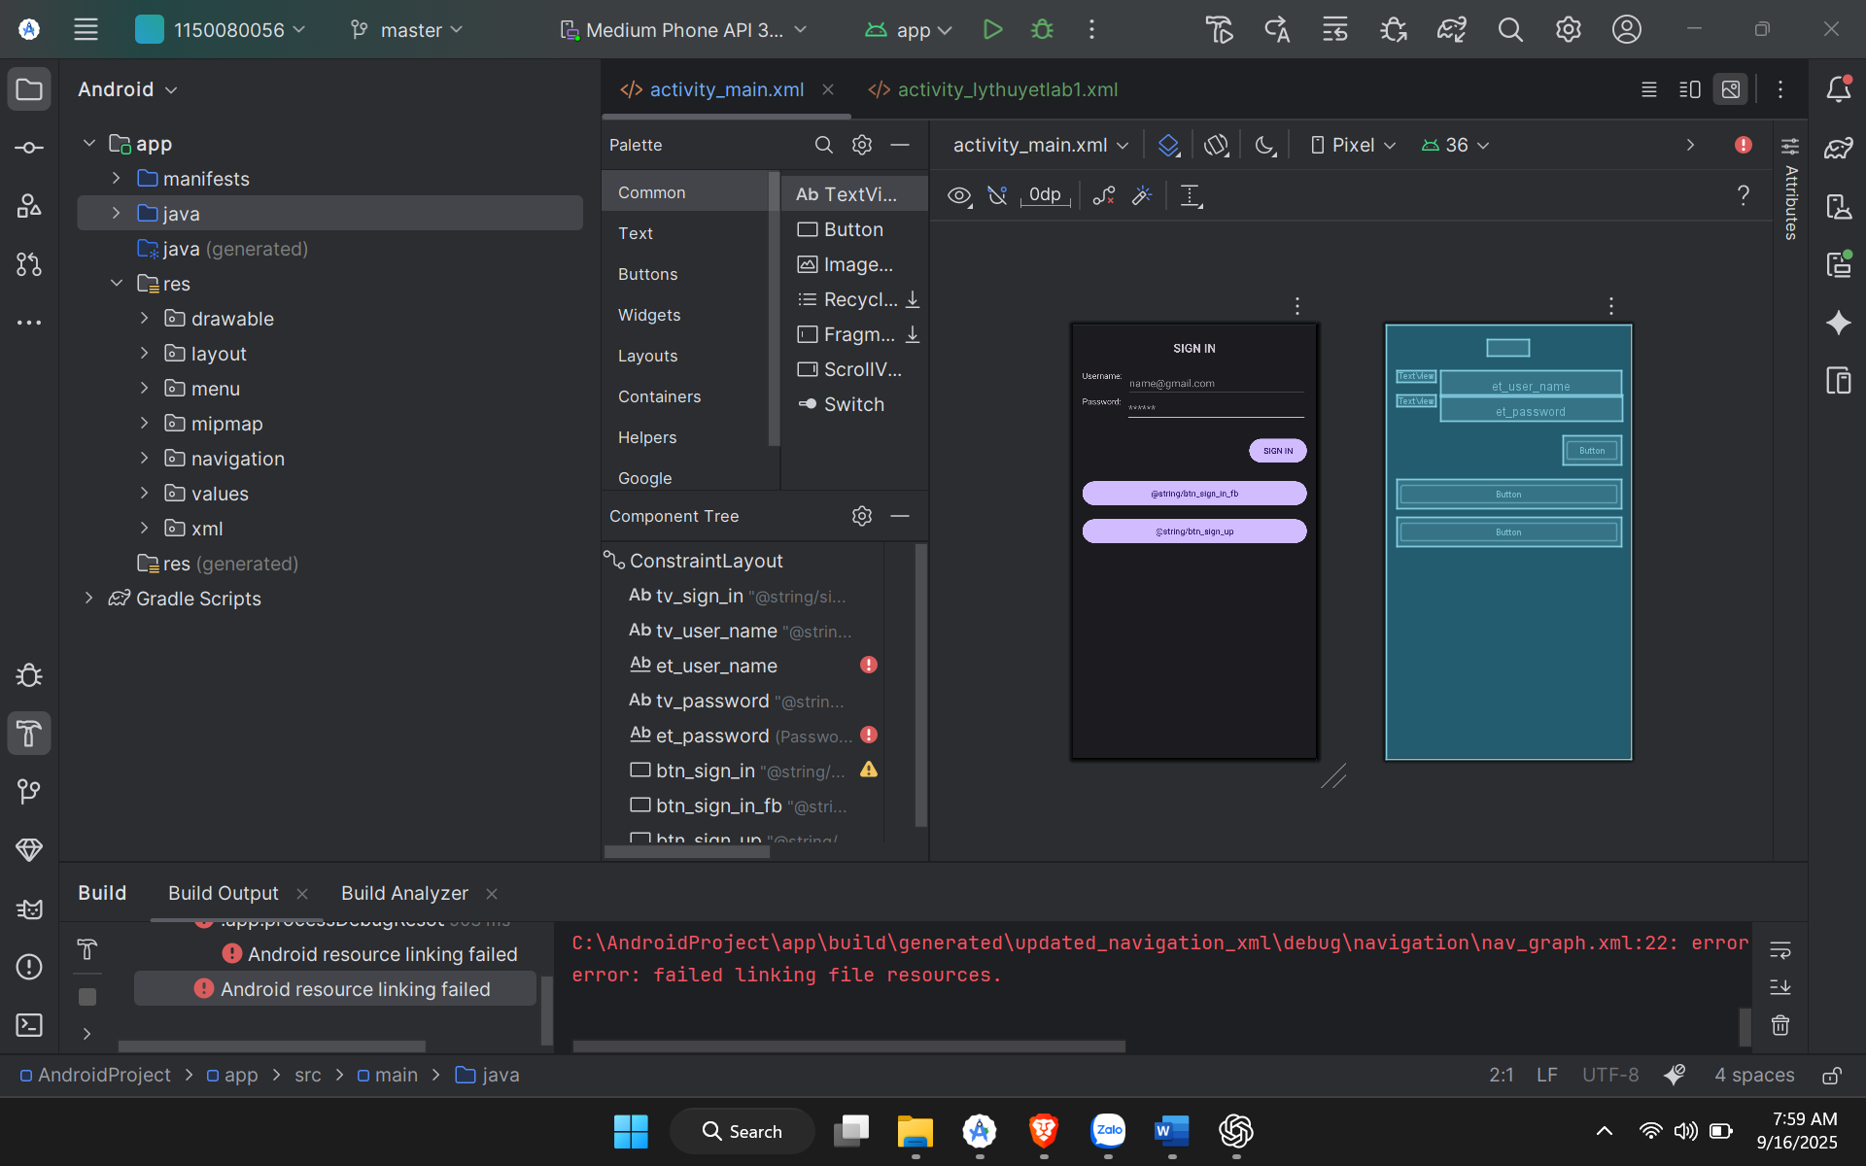

Code activity_main.xml

<?xml version="1.0" encoding="utf-8"?>

<androidx.constraintlayout.widget.ConstraintLayout xmlns:android="http://schemas.android.com/apk/res/android"

xmlns:app="http://schemas.android.com/apk/res-auto"

xmlns:tools="http://schemas.android.com/tools"

android:layout_width="match_parent"

android:layout_height="match_parent"

tools:context=".MainActivity">

<TextView

android:id="@+id/tv_sign_in"

android:layout_width="wrap_content"

android:layout_height="wrap_content"

android:text="@string/sign_in"

android:textSize="20sp"

android:textStyle="bold"

app:layout_constraintTop_toTopOf="parent"

app:layout_constraintStart_toStartOf="parent"

app:layout_constraintEnd_toEndOf="parent"

android:layout_marginTop="24dp"/>

<TextView

android:id="@+id/tv_user_name"

android:layout_width="wrap_content"

android:layout_height="wrap_content"

android:text="@string/username"

app:layout_constraintTop_toBottomOf="@id/tv_sign_in"

app:layout_constraintStart_toStartOf="parent"

android:layout_marginStart="16dp"

android:layout_marginTop="24dp"/>

<EditText

android:id="@+id/et_user_name"

android:layout_width="0dp"

android:layout_height="wrap_content"

android:hint="@string/hint_email"

app:layout_constraintTop_toTopOf="@id/tv_user_name"

app:layout_constraintStart_toEndOf="@id/tv_user_name"

app:layout_constraintEnd_toEndOf="parent"

android:layout_marginStart="8dp"

android:layout_marginEnd="16dp"/>

<TextView

android:id="@+id/tv_password"

android:layout_width="wrap_content"

android:layout_height="wrap_content"

android:text="@string/password"

app:layout_constraintTop_toBottomOf="@id/tv_user_name"

app:layout_constraintStart_toStartOf="parent"

android:layout_marginStart="16dp"

android:layout_marginTop="24dp"/>

<EditText

android:id="@+id/et_password"

android:layout_width="0dp"

android:layout_height="wrap_content"

android:hint="@string/hint_password"

android:inputType="textPassword"

app:layout_constraintTop_toTopOf="@id/tv_password"

app:layout_constraintStart_toEndOf="@id/tv_password"

app:layout_constraintEnd_toEndOf="parent"

android:layout_marginStart="8dp"

android:layout_marginEnd="16dp"/>

<Button

android:id="@+id/btn_sign_in"

android:layout_width="wrap_content"

android:layout_height="wrap_content"

android:text="@string/btn_sign_in"

app:layout_constraintTop_toBottomOf="@id/et_password"

app:layout_constraintEnd_toEndOf="parent"

android:layout_marginTop="24dp"

android:layout_marginEnd="16dp"/>

<Button

android:id="@+id/btn_sign_in_fb"

android:layout_width="0dp"

android:layout_height="wrap_content"

android:text="@string/btn_sign_in_fb"

app:layout_constraintTop_toBottomOf="@id/btn_sign_in"

app:layout_constraintStart_toStartOf="parent"

app:layout_constraintEnd_toEndOf="parent"

android:layout_marginTop="24dp"

android:layout_marginStart="16dp"

android:layout_marginEnd="16dp"/>

<Button

android:id="@+id/btn_sign_up"

android:layout_width="0dp"

android:layout_height="wrap_content"

android:text="@string/btn_sign_up"

app:layout_constraintTop_toBottomOf="@id/btn_sign_in_fb"

app:layout_constraintStart_toStartOf="parent"

app:layout_constraintEnd_toEndOf="parent"

android:layout_marginTop="16dp"

android:layout_marginStart="16dp"

android:layout_marginEnd="16dp"/>

</androidx.constraintlayout.widget.ConstraintLayout>

2. Làm Bằng ContraintLayout

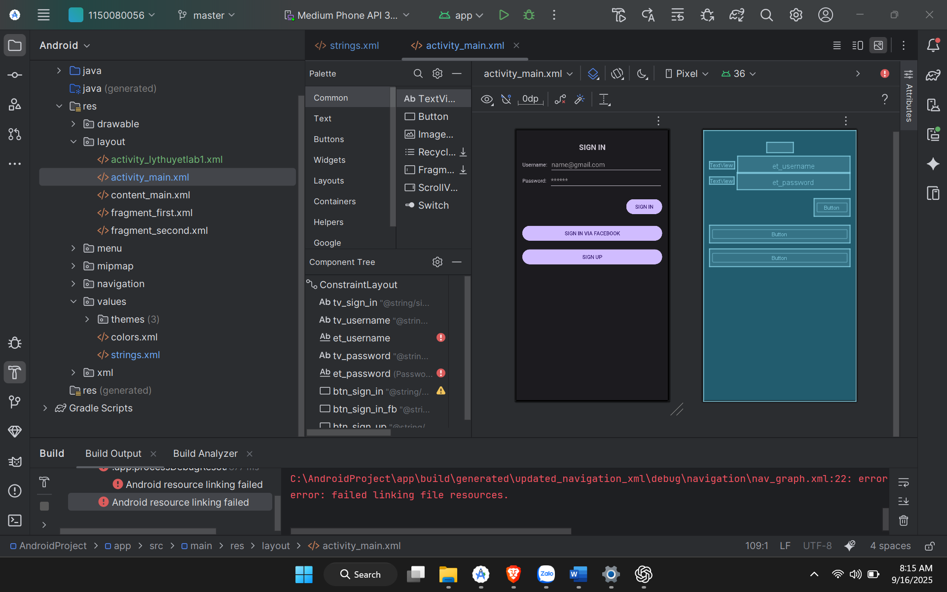

<?xml version="1.0" encoding="utf-8"?>

<androidx.constraintlayout.widget.ConstraintLayout xmlns:android="http://schemas.android.com/apk/res/android"

xmlns:app="http://schemas.android.com/apk/res-auto"

xmlns:tools="http://schemas.android.com/tools"

android:layout_width="match_parent"

android:layout_height="match_parent"

tools:context=".MainActivity">

<!-- Tiêu đề -->

<TextView

android:id="@+id/tv_sign_in"

android:layout_width="wrap_content"

android:layout_height="wrap_content"

android:text="@string/sign_in"

android:textSize="20sp"

android:textStyle="bold"

app:layout_constraintTop_toTopOf="parent"

app:layout_constraintStart_toStartOf="parent"

app:layout_constraintEnd_toEndOf="parent"

android:layout_marginTop="32dp"/>

<!-- Username label -->

<TextView

android:id="@+id/tv_username"

android:layout_width="wrap_content"

android:layout_height="wrap_content"

android:text="@string/username"

app:layout_constraintTop_toBottomOf="@id/tv_sign_in"

app:layout_constraintStart_toStartOf="parent"

android:layout_marginTop="24dp"

android:layout_marginStart="16dp"/>

<!-- Username input -->

<EditText

android:id="@+id/et_username"

android:layout_width="0dp"

android:layout_height="wrap_content"

android:hint="@string/hint_email"

app:layout_constraintTop_toTopOf="@id/tv_username"

app:layout_constraintBottom_toBottomOf="@id/tv_username"

app:layout_constraintStart_toEndOf="@id/tv_username"

app:layout_constraintEnd_toEndOf="parent"

android:layout_marginStart="8dp"

android:layout_marginEnd="16dp"/>

<!-- Password label -->

<TextView

android:id="@+id/tv_password"

android:layout_width="wrap_content"

android:layout_height="wrap_content"

android:text="@string/password"

app:layout_constraintTop_toBottomOf="@id/tv_username"

app:layout_constraintStart_toStartOf="parent"

android:layout_marginTop="24dp"

android:layout_marginStart="16dp"/>

<!-- Password input -->

<EditText

android:id="@+id/et_password"

android:layout_width="0dp"

android:layout_height="wrap_content"

android:hint="@string/hint_password"

android:inputType="textPassword"

app:layout_constraintTop_toTopOf="@id/tv_password"

app:layout_constraintBottom_toBottomOf="@id/tv_password"

app:layout_constraintStart_toEndOf="@id/tv_password"

app:layout_constraintEnd_toEndOf="parent"

android:layout_marginStart="8dp"

android:layout_marginEnd="16dp"/>

<!-- Sign In Button -->

<Button

android:id="@+id/btn_sign_in"

android:layout_width="wrap_content"

android:layout_height="wrap_content"

android:text="@string/btn_sign_in"

app:layout_constraintTop_toBottomOf="@id/et_password"

app:layout_constraintEnd_toEndOf="parent"

android:layout_marginTop="24dp"

android:layout_marginEnd="16dp"/>

<!-- Sign In via Facebook Button -->

<Button

android:id="@+id/btn_sign_in_fb"

android:layout_width="0dp"

android:layout_height="wrap_content"

android:text="@string/btn_sign_in_fb"

app:layout_constraintTop_toBottomOf="@id/btn_sign_in"

app:layout_constraintStart_toStartOf="parent"

app:layout_constraintEnd_toEndOf="parent"

android:layout_marginTop="24dp"

android:layout_marginStart="16dp"

android:layout_marginEnd="16dp"/>

<!-- Sign Up Button -->

<Button

android:id="@+id/btn_sign_up"

android:layout_width="0dp"

android:layout_height="wrap_content"

android:text="@string/btn_sign_up"

app:layout_constraintTop_toBottomOf="@id/btn_sign_in_fb"

app:layout_constraintStart_toStartOf="parent"

app:layout_constraintEnd_toEndOf="parent"

android:layout_marginTop="16dp"

android:layout_marginStart="16dp"

android:layout_marginEnd="16dp"/>

</androidx.constraintlayout.widget.ConstraintLayout>