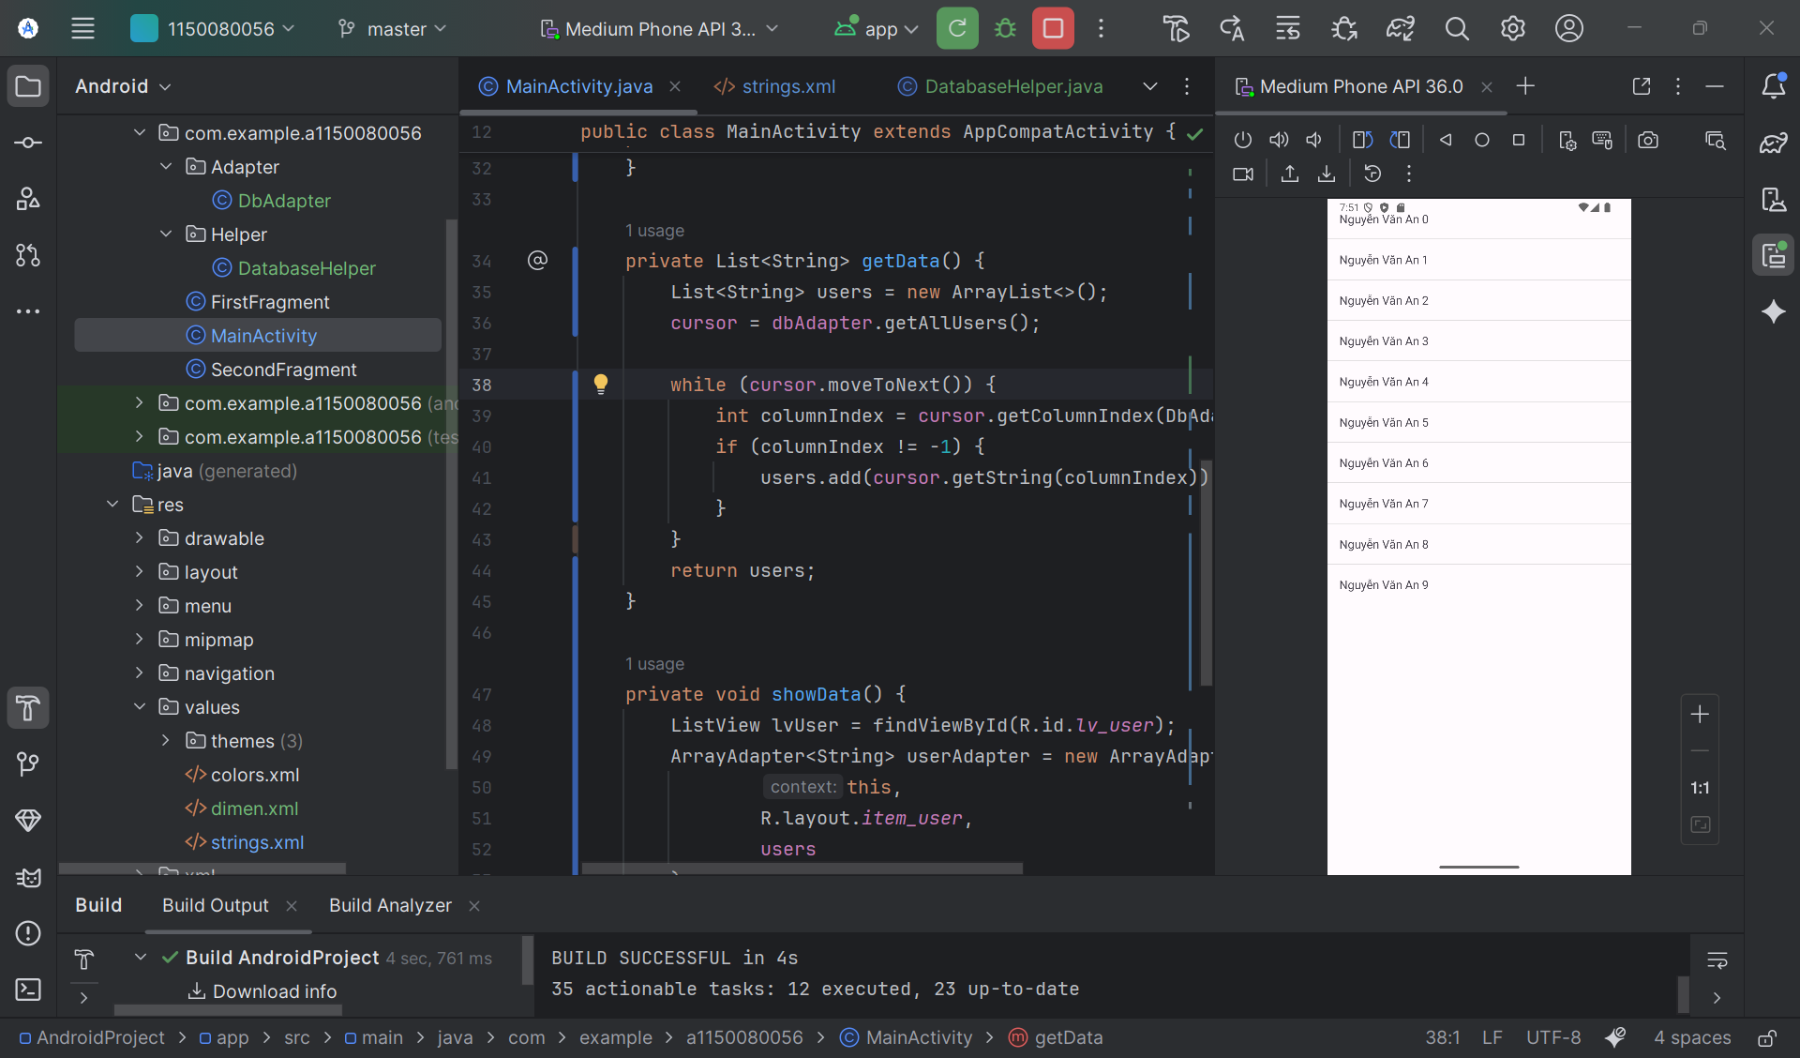

MainActivity.java

package com.example.a1150080056;  
  
import android.database.Cursor;  
import android.os.Bundle;  
import android.widget.ArrayAdapter;  
import android.widget.ListView;  
  
import androidx.appcompat.app.AppCompatActivity;  
  
import java.util.ArrayList;  
import java.util.List;  
import com.example.a1150080056.Adapter.DbAdapter;  
  
public class MainActivity extends AppCompatActivity {  
 private DbAdapter dbAdapter;  
 private Cursor cursor;  
 private List<String> users;  
  
 @Override  
 protected void onCreate(Bundle savedInstanceState) {  
 super.onCreate(savedInstanceState);  
 setContentView(R.layout.*activity_main*);  
  
 dbAdapter = new DbAdapter(this);  
 dbAdapter.open();  
 dbAdapter.deleteAllUsers();  
  
 for (int i = 0; i < 10; i++) {  
 dbAdapter.createUser("Nguyễn Văn An " + i);  
 }  
  
 users = getData();  
 showData();  
 }  
  
 private List<String> getData() {  
 List<String> users = new ArrayList<>();  
 cursor = dbAdapter.getAllUsers();  
  
 while (cursor.moveToNext()) {  
 int columnIndex = cursor.getColumnIndex(DbAdapter.*KEY_NAME*);  
 if (columnIndex != -1) {  
 users.add(cursor.getString(columnIndex));  
 }  
 }  
 return users;  
 }  
  
 private void showData() {  
 ListView lvUser = findViewById(R.id.lv_user);  
 ArrayAdapter<String> userAdapter = new ArrayAdapter<>(  
 this,  
 R.layout.*item_user*,  
 users  
 );  
 lvUser.setAdapter(userAdapter);  
 }  
  
 @Override  
 protected void onDestroy() {  
 super.onDestroy();  
 if (cursor != null) {  
 cursor.close();  
 }  
 if (dbAdapter != null) {  
 dbAdapter.close();  
 }  
 }  
}

Adapter/DBAdapter.js

package com.example.a1150080056.Adapter;  
import android.content.ContentValues;  
import android.content.Context;  
import android.database.Cursor;  
import android.database.sqlite.SQLiteDatabase;  
  
import com.example.a1150080056.Helper.DatabaseHelper;  
  
public class DbAdapter {  
 public static final String *KEY_ID* = "_id";  
 public static final String *KEY_NAME* = "name";  
 private DatabaseHelper dbHelper;  
 private SQLiteDatabase sqLiteDatabase;  
 private static final String *DATABASE_NAME* = "Database_Demo";  
 private static final String *DATABASE_TABLE* = "users";  
 private static final int *DATABASE_VERSION* = 2;  
 private final Context context;  
  
 public DbAdapter(Context ctx) {  
 this.context = ctx;  
 }  
  
 public DbAdapter open() {  
 dbHelper = new DatabaseHelper(context, *DATABASE_NAME*, null,  
 *DATABASE_VERSION*);  
 sqLiteDatabase = dbHelper.getWritableDatabase();  
 return this;  
 }  
  
 public void close() {  
 dbHelper.close();  
 }  
  
 public long createUser(String name) {  
 ContentValues inititalValues = new ContentValues();  
 inititalValues.put(*KEY_NAME*, name);  
 return sqLiteDatabase.insert(*DATABASE_TABLE*, null, inititalValues);  
 }  
  
 public boolean deleteUser(long rowId) {  
 return sqLiteDatabase.delete(*DATABASE_TABLE*, *KEY_ID* + "=" + rowId,  
 null) > 0;  
 }  
  
 public boolean deleteAllUsers() {  
 return sqLiteDatabase.delete(*DATABASE_TABLE*, null, null) > 0;  
 }  
  
 public Cursor getAllUsers() {  
 return sqLiteDatabase.query(*DATABASE_TABLE*, new String[]{*KEY_ID*,  
 *KEY_NAME*}, null, null, null, null, null);  
 }  
}

Helper/DatabaseHelper.js

package com.example.a1150080056.Helper;  
import android.content.Context;  
import android.database.sqlite.SQLiteDatabase;  
import android.database.sqlite.SQLiteOpenHelper;  
public class DatabaseHelper extends SQLiteOpenHelper {  
 private static final String *DATABASE_CREATE* = "create table users (_id integer primary key autoincrement, " + "name text not null);";  
 public DatabaseHelper(Context context, String name,  
 SQLiteDatabase.CursorFactory factory, int version) {  
 super(context, name, factory, version);  
// *TODO Auto-generated constructor stub* }  
 @Override  
 public void onCreate(SQLiteDatabase db) {  
// *TODO Auto-generated method stub* db.execSQL(*DATABASE_CREATE*);  
 }  
 @Override  
 public void onUpgrade(SQLiteDatabase db, int oldVersion, int newVersion)  
 {  
// *TODO Auto-generated method stub* db.execSQL("DROP TABLE IF EXISTS users");  
 onCreate(db);  
 }  
}

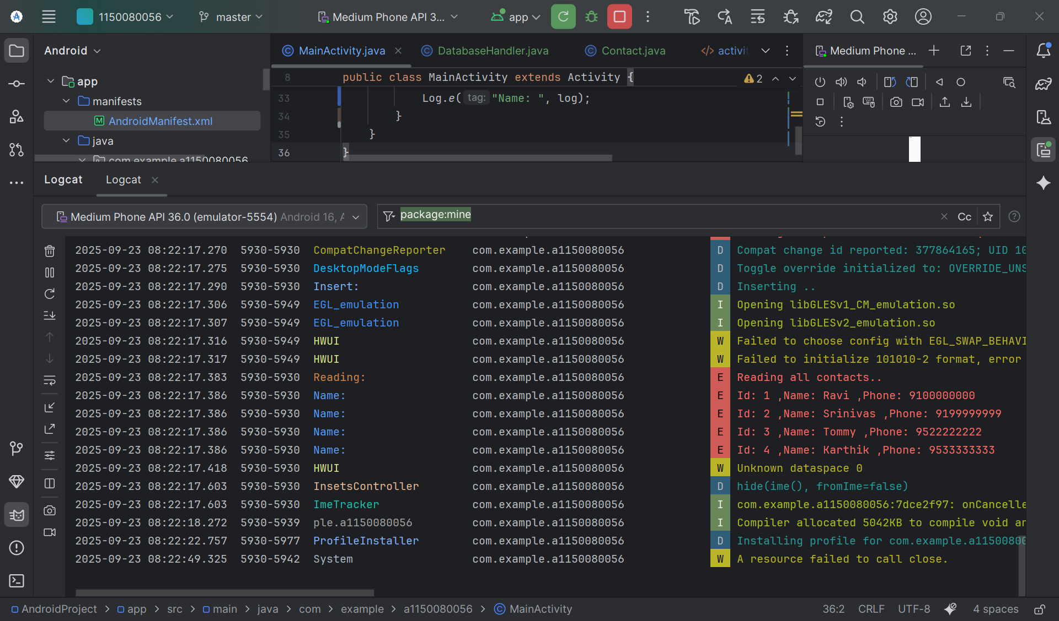

MainActivity

package com.example.a1150080056;

import android.app.Activity;

import android.os.Bundle;

import android.util.Log;

import java.util.List;

public class MainActivity extends Activity {

@Override

protected void onCreate(Bundle savedInstanceState) {

super.onCreate(savedInstanceState);

setContentView(R.layout.activity_main);

DatabaseHandler db = new DatabaseHandler(this);

/**

* CRUD Operations

* */

// Inserting Contacts

Log.d("Insert: ", "Inserting ..");

db.addContact(new Contact("Ravi", "9100000000"));

db.addContact(new Contact("Srinivas", "9199999999"));

db.addContact(new Contact("Tommy", "9522222222"));

db.addContact(new Contact("Karthik", "9533333333"));

// Reading all contacts

Log.e("Reading: ", "Reading all contacts..");

List<Contact> contacts = db.getAllContacts();

for (Contact cn : contacts) {

String log = "Id: " + cn.getID() + " ,Name: " + cn.getName() + " ,Phone: " + cn.getPhoneNumber();

// Writing Contacts to log

Log.e("Name: ", log);

}

}

}