Lab 1:
Bài 1:
Bước 1:
layout/activity_main.xml
<?xml version="1.0" encoding="utf-8"?>
<LinearLayout
xmlns:android="http://schemas.android.com/apk/res/android"
xmlns:app="http://schemas.android.com/apk/res-auto"
xmlns:tools="http://schemas.android.com/tools"
android:layout_width="match_parent"
android:layout_height="match_parent"
android:orientation="vertical"
android:padding="16dp"
tools:context=".MainActivity">

<EditText
android:id="@+id/edtA"
android:layout_width="match_parent"
android:layout_height="wrap_content"
android:hint="Nhập số A"
android:inputType="numberDecimal|numberSigned"
android:textSize="24sp" />

<EditText
android:id="@+id/edtB"
android:layout_width="match_parent"
android:layout_height="wrap_content"
android:layout_marginTop="8dp"
android:hint="Nhập số B"
android:inputType="numberDecimal|numberSigned"
android:textSize="24sp" />

<LinearLayout
android:layout_width="match_parent"
android:layout_height="wrap_content"
android:layout_marginTop="16dp"
android:orientation="horizontal"
android:weightSum="5">

<Button
android:id="@+id/btnPlus"
android:layout_width="0dp"
android:layout_height="wrap_content"
android:layout_weight="1"
android:text="+"
android:textSize="24sp" />

<Button
android:id="@+id/btnSub"
android:layout_width="0dp"
android:layout_height="wrap_content"
android:layout_weight="1"
android:text="-"
android:textSize="24sp" />

<Button
android:id="@+id/btnMul"
android:layout_width="0dp"
android:layout_height="wrap_content"
android:layout_weight="1"
android:text="*"
android:textSize="24sp" />

<Button
android:id="@+id/btnDiv"
android:layout_width="0dp"
android:layout_height="wrap_content"
android:layout_weight="1"
android:text="/"
android:textSize="24sp" />

<Button
android:id="@+id/btnMod"
android:layout_width="0dp"
android:layout_height="wrap_content"
android:layout_weight="1"
android:text="%"
android:textSize="24sp" />

</LinearLayout>

<TextView
android:id="@+id/tvResult"
android:layout_width="match_parent"
android:layout_height="wrap_content"
android:layout_marginTop="24dp"
android:gravity="center"
android:text="Kết quả"
android:textSize="30sp"
android:textStyle="bold" />

</LinearLayout>
Bước 2:
java/com/example/…../……
package com.example…..; // Thay đổi tên package cho phù hợp

import androidx.appcompat.app.AppCompatActivity;
import android.os.Bundle;
import android.view.View;
import android.widget.Button;
import android.widget.EditText;
import android.widget.TextView;
import android.widget.Toast;

public class MainActivity extends AppCompatActivity {

EditText edtA, edtB;
TextView tvResult;
Button btnPlus, btnSub, btnMul, btnDiv, btnMod;

@Override
protected void onCreate(Bundle savedInstanceState) {
super.onCreate(savedInstanceState);
setContentView(R.layout.activity_main);
initControl();
}

private void initControl() {
edtA = findViewById(R.id.edtA);
edtB = findViewById(R.id.edtB);
tvResult = findViewById(R.id.tvResult);
btnPlus = findViewById(R.id.btnPlus);
btnSub = findViewById(R.id.btnSub);
btnMul = findViewById(R.id.btnMul);
btnDiv = findViewById(R.id.btnDiv);
btnMod = findViewById(R.id.btnMod);

btnPlus.setOnClickListener(new View.OnClickListener() {
@Override
public void onClick(View v) {
calculate("+");
}
});

btnSub.setOnClickListener(new View.OnClickListener() {
@Override
public void onClick(View v) {
calculate("-");
}
});

btnMul.setOnClickListener(new View.OnClickListener() {
@Override
public void onClick(View v) {
calculate("*");
}
});

btnDiv.setOnClickListener(new View.OnClickListener() {
@Override
public void onClick(View v) {
calculate("/");
}
});

btnMod.setOnClickListener(new View.OnClickListener() {
@Override
public void onClick(View v) {
calculate("%");
}
});
}

private void calculate(String operator) {
try {
String strA = edtA.getText().toString();
String strB = edtB.getText().toString();

if (strA.isEmpty() || strB.isEmpty()) {
Toast.makeText(this, "Vui lòng nhập cả hai số", Toast.LENGTH_SHORT).show();
return;
}

double a = Double.parseDouble(strA);
double b = Double.parseDouble(strB);
double result = 0;

switch (operator) {
case "+":
result = a + b;
break;
case "-":
result = a - b;
break;
case "*":
result = a * b;
break;
case "/":
if (b == 0) {
Toast.makeText(this, "Không thể chia cho 0", Toast.LENGTH_SHORT).show();
return;
}
result = a / b;
break;
case "%":
if (b == 0) {
Toast.makeText(this, "Không thể chia cho 0", Toast.LENGTH_SHORT).show();
return;
}
result = a % b;
break;
}

// Hiển thị kết quả (làm tròn nếu là số nguyên)
if (result == (long) result) {
tvResult.setText(String.format("%d", (long) result));
} else {
tvResult.setText(String.format("%.2f", result));
}

} catch (NumberFormatException e) {
Toast.makeText(this, "Đầu vào không hợp lệ", Toast.LENGTH_SHORT).show();
}
}
}
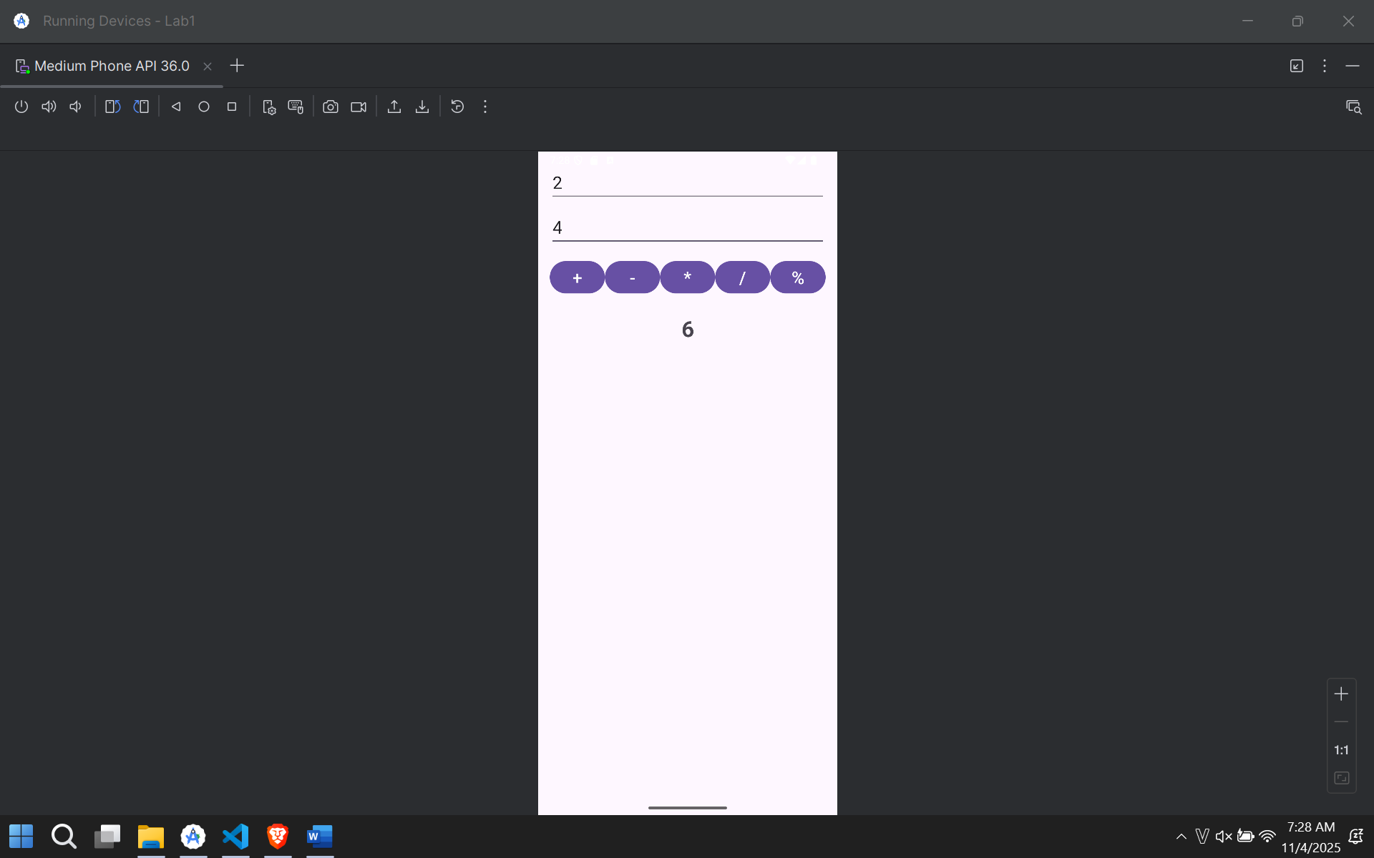
Bài 2:
Bước 1 :
Layout/activity_main.xml
<?xml version="1.0" encoding="utf-8"?>
<LinearLayout
xmlns:android="http://schemas.android.com/apk/res/android"
xmlns:app="http://schemas.android.com/apk/res-auto"
xmlns:tools="http://schemas.android.com/tools"
android:layout_width="match_parent"
android:layout_height="match_parent"
android:orientation="vertical"
android:gravity="center"
android:padding="16dp"
tools:context=".MainActivity">

<ImageView
android:id="@+id/ivDice"
android:layout_width="200dp"
android:layout_height="200dp"
android:src="@drawable/dice_1" />

<Button
android:id="@+id/btnRoll"
android:layout_width="wrap_content"
android:layout_height="wrap_content"
android:layout_marginTop="32dp"
android:text="Tung Xúc Xắc"
android:textSize="20sp" />

</LinearLayout>
Bước 2:
MainActivity.java
package com.example.lab1;
import androidx.appcompat.app.AppCompatActivity;
import android.os.Bundle;
import android.view.View;
import android.widget.Button;
import android.widget.ImageView;
import java.util.Random;
public class MainActivity extends AppCompatActivity {
ImageView ivDice;
Button btnRoll;
Random random = new Random();
@Override
protected void onCreate(Bundle savedInstanceState) {
super.onCreate(savedInstanceState);
setContentView(R.layout.activity_main);
ivDice = findViewById(R.id.ivDice);
btnRoll = findViewById(R.id.btnRoll);
btnRoll.setOnClickListener(new View.OnClickListener() {
@Override
public void onClick(View v) {
rollDice();
}
});
}
private void rollDice() {
int roll = random.nextInt(6) + 1; // Tạo số ngẫu nhiên từ 1 đến 6
switch (roll) {
case 1:
ivDice.setImageResource(R.drawable.dice_1);
break;
case 2:
ivDice.setImageResource(R.drawable.dice_2);
break;
case 3:
ivDice.setImageResource(R.drawable.dice_3);
break;
case 4:
ivDice.setImageResource(R.drawable.dice_4);
break;
case 5:
ivDice.setImageResource(R.drawable.dice_5);
break;
case 6:
ivDice.setImageResource(R.drawable.dice_6);
break;
}
}
}
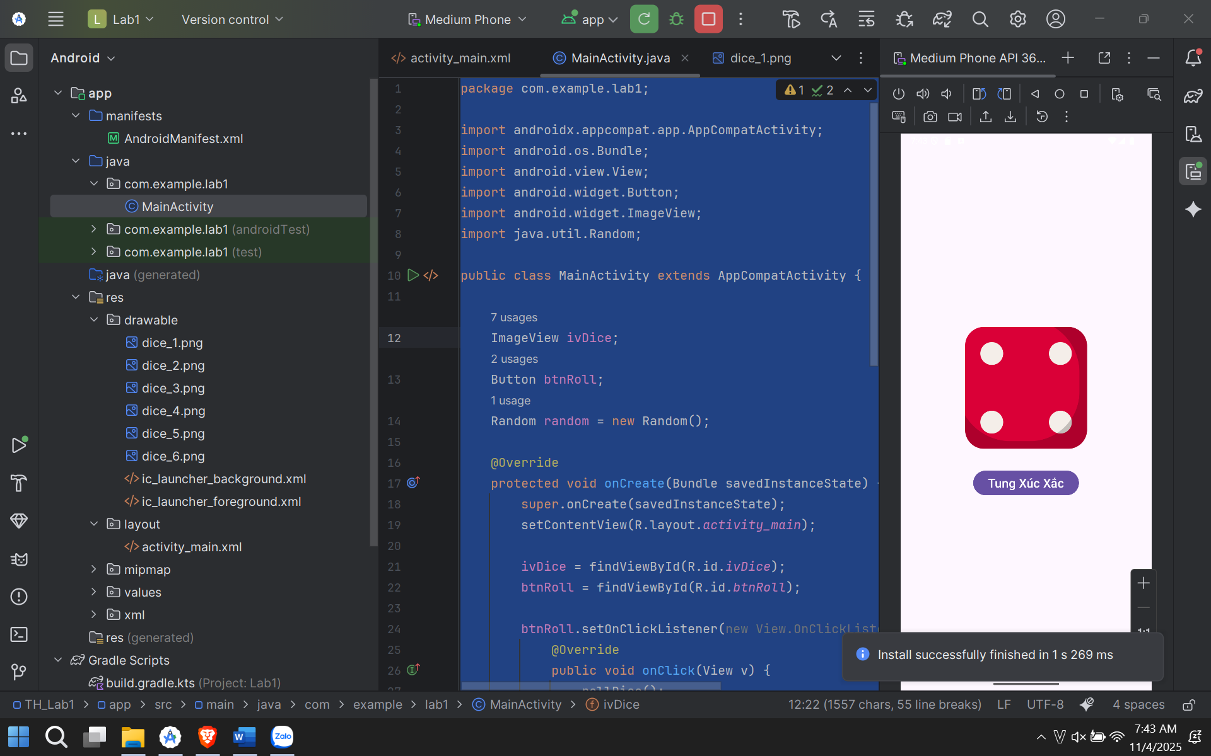
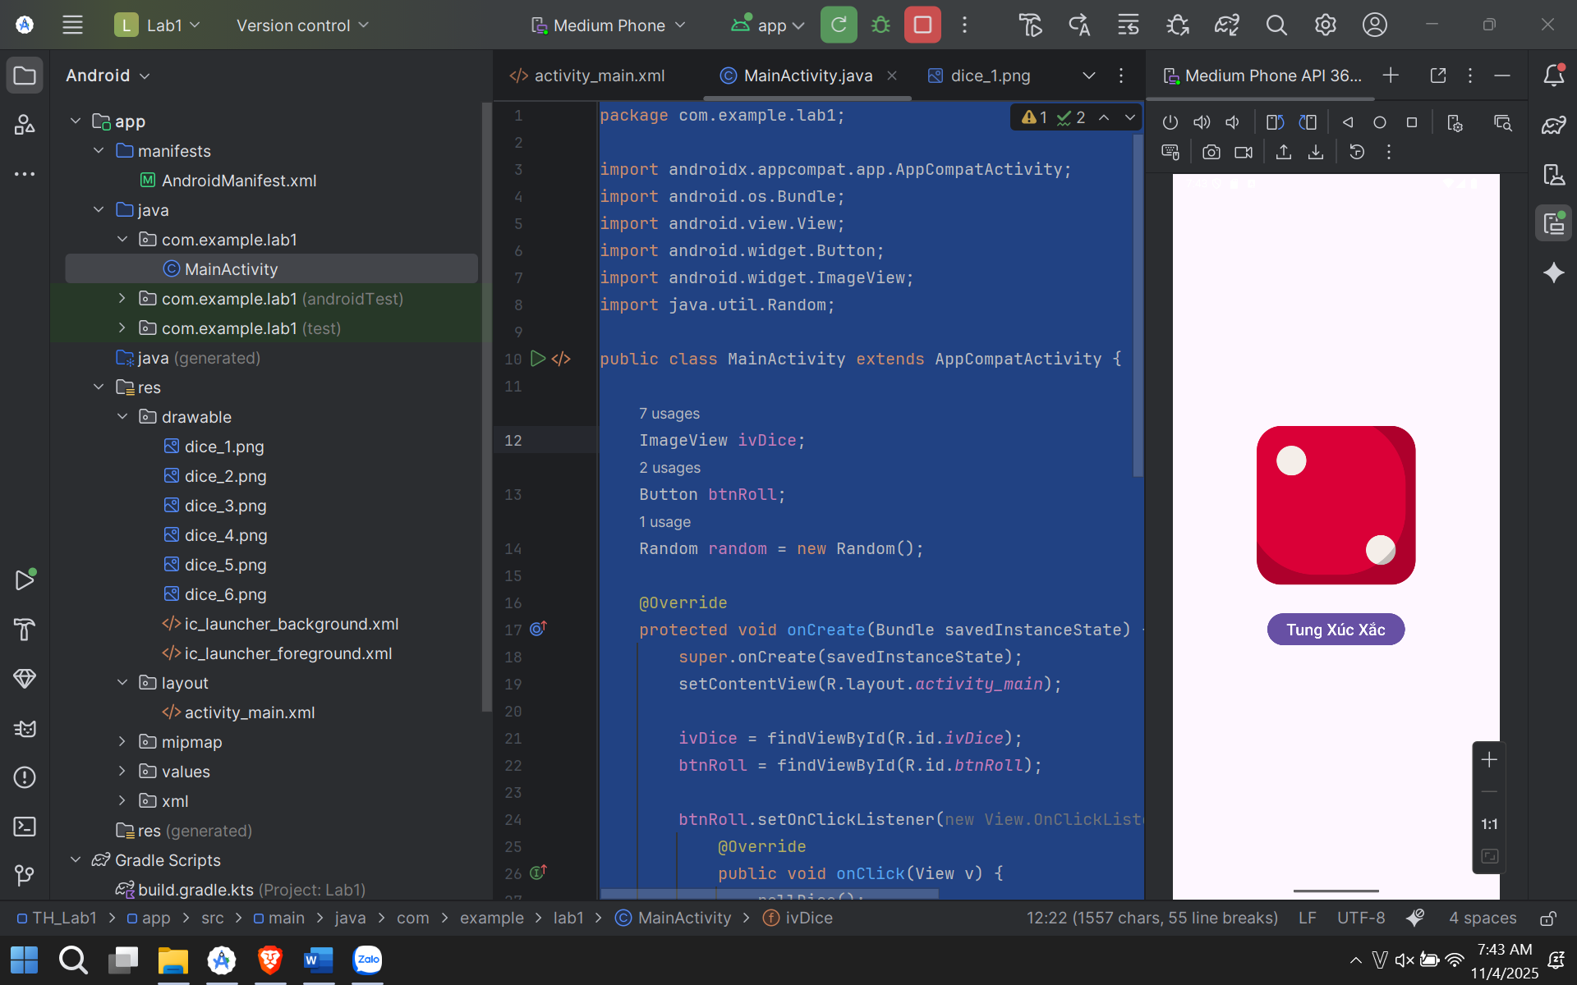
Bài 3:
Bước 1:
layout/activity_main.xml
<?xml version="1.0" encoding="utf-8"?>
<LinearLayout
xmlns:android="http://schemas.android.com/apk/res/android"
xmlns:app="http://schemas.android.com/apk/res-auto"
xmlns:tools="http://schemas.android.com/tools"
android:layout_width="match_parent"
android:layout_height="match_parent"
android:orientation="vertical"
android:padding="24dp"
tools:context=".MainActivity">
<com.google.android.material.textfield.TextInputLayout
android:id="@+id/tilPhoneNumber"
android:layout_width="match_parent"
android:layout_height="wrap_content"
style="@style/Widget.MaterialComponents.TextInputLayout.OutlinedBox">
<com.google.android.material.textfield.TextInputEditText
android:id="@+id/edtPhoneNumber"
android:layout_width="match_parent"
android:layout_height="wrap_content"
android:hint="@string/so_dien_thoai"
android:inputType="phone"
android:textSize="18sp" />
</com.google.android.material.textfield.TextInputLayout>
<com.google.android.material.button.MaterialButton
android:id="@+id/btnDial"
android:layout_width="match_parent"
android:layout_height="wrap_content"
android:layout_marginTop="16dp"
android:text="@string/mo_trinh_goi_dien"
android:paddingTop="12dp"
android:paddingBottom="12dp"
app:icon="@drawable/ic_call"
app:iconGravity="textStart" />
<com.google.android.material.textfield.TextInputLayout
android:id="@+id/tilMessage"
android:layout_width="match_parent"
android:layout_height="wrap_content"
android:layout_marginTop="32dp"
style="@style/Widget.MaterialComponents.TextInputLayout.OutlinedBox">
<com.google.android.material.textfield.TextInputEditText
android:id="@+id/edtMessage"
android:layout_width="match_parent"
android:layout_height="wrap_content"
android:hint="@string/noi_dung_tin_nhan"
android:inputType="textMultiLine"
android:minLines="3"
android:gravity="top"
android:textSize="18sp" />
</com.google.android.material.textfield.TextInputLayout>
<com.google.android.material.button.MaterialButton
android:id="@+id/btnSms"
android:layout_width="match_parent"
android:layout_height="wrap_content"
android:layout_marginTop="16dp"
android:text="@string/mo_trinh_nhan_tin"
android:paddingTop="12dp"
android:paddingBottom="12dp"
app:icon="@drawable/ic_sms"
app:iconGravity="textStart" />
</LinearLayout>
Bước 2:
MainActivity.java
package com.example.; // Thay đổi tên package cho phù hợp
import androidx.appcompat.app.AppCompatActivity;
import android.content.Intent;
import android.net.Uri;
import android.os.Bundle;
import android.view.View;
import android.widget.Button;
import android.widget.Toast;
import com.google.android.material.textfield.TextInputEditText;
public class MainActivity extends AppCompatActivity {
TextInputEditText edtPhoneNumber, edtMessage;
Button btnDial, btnSms;
@Override
protected void onCreate(Bundle savedInstanceState) {
super.onCreate(savedInstanceState);
setContentView(R.layout.activity_main);
edtPhoneNumber = findViewById(R.id.edtPhoneNumber);
edtMessage = findViewById(R.id.edtMessage);
btnDial = findViewById(R.id.btnDial);
btnSms = findViewById(R.id.btnSms);
btnDial.setOnClickListener(new View.OnClickListener() {
@Override
public void onClick(View v) {
openDialer();
}
});
btnSms.setOnClickListener(new View.OnClickListener() {
@Override
public void onClick(View v) {
openSmsApp();
}
});
}
private void openDialer() {
String phoneNumber = edtPhoneNumber.getText().toString();
if (phoneNumber.isEmpty()) {
Toast.makeText(this, R.string.vui_long_nhap_sdt, Toast.LENGTH_SHORT).show();
return;
}
Intent intent = new Intent(Intent.ACTION_DIAL);
intent.setData(Uri.parse("tel:" + phoneNumber));
startActivity(intent);
}
private void openSmsApp() {
String phoneNumber = edtPhoneNumber.getText().toString();
String message = edtMessage.getText().toString();
if (phoneNumber.isEmpty()) {
Toast.makeText(this, R.string.vui_long_nhap_sdt, Toast.LENGTH_SHORT).show();
return;
}
Uri uri = Uri.parse("smsto:" + phoneNumber);
Intent intent = new Intent(Intent.ACTION_SENDTO, uri);
intent.putExtra("sms_body", message);
startActivity(intent);
}
}
}
}
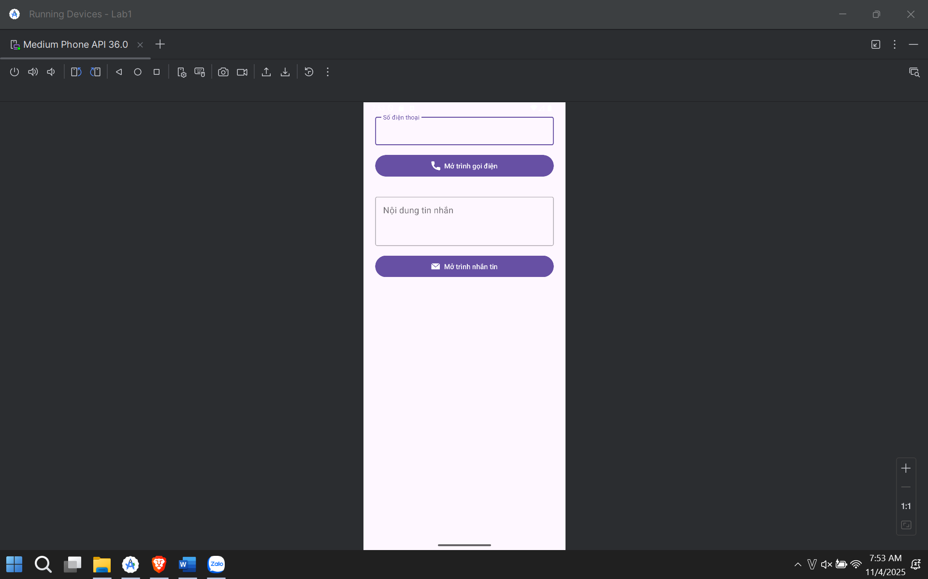
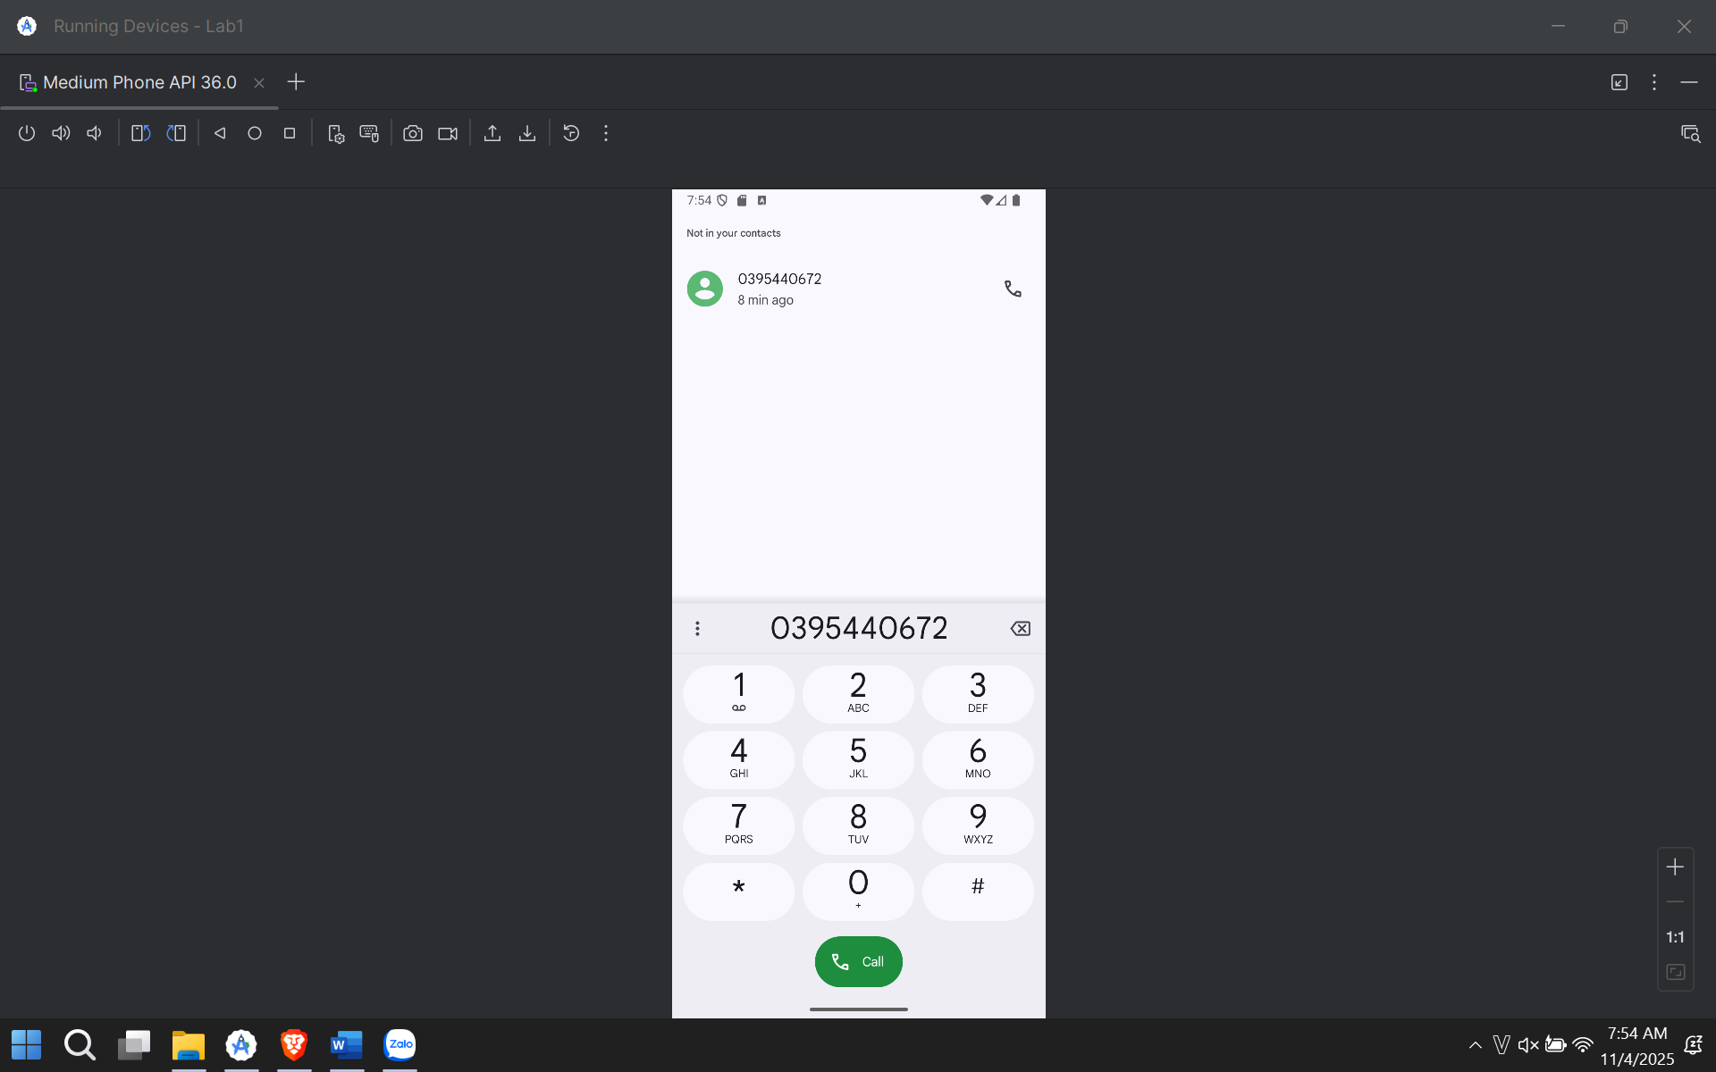

Lab 2:
Bước 1:
implementation ("com.google.android.material:material:1.10.0")
bước 2: app/src/main/AndroidManifest.xml
<?xml version="1.0" encoding="utf-8"?>
<manifest xmlns:android="http://schemas.android.com/apk/res/android"
xmlns:tools="http://schemas.android.com/tools">

<application
android:allowBackup="true"
android:dataExtractionRules="@xml/data_extraction_rules"
android:fullBackupContent="@xml/backup_rules"
android:icon="@mipmap/ic_launcher"
android:label="@string/app_name"
android:roundIcon="@mipmap/ic_launcher_round"
android:supportsRtl="true"
android:theme="@style/Theme.Lab2"
tools:targetApi="31">

<activity
android:name=".MainActivity"
android:exported="true">
<intent-filter>
<action android:name="android.intent.action.MAIN" />
<category android:name="android.intent.category.LAUNCHER" />
</intent-filter>
</activity>

<activity
android:name=".M000ActSplash"
android:exported="false"
android:noHistory="true"
android:theme="@style/Full_Screen" /> <activity
android:name=".M001ActProfile"
android:exported="false"
android:theme="@style/Theme.Material3.DayNight.NoActionBar"/>

</application>
</manifest>
Bước 3: app/src/main/res/values/themes.xml
<resources xmlns:tools="http://schemas.android.com/tools">
<style name="Base.Theme.Lab2" parent="Theme.Material3.DayNight.NoActionBar">
</style>

<style name="Theme.Lab2" parent="Base.Theme.Lab2" />

<style name="Full_Screen" parent="Theme.MaterialComponents.DayNight.NoActionBar"/>
</resources>
Bước 4: app/src/main/res/values/colors.xml
<?xml version="1.0" encoding="utf-8"?>
<resources>
<color name="purple_200">#FFBB86FC</color>
<color name="purple_500">#FF6200EE</color>
<color name="purple_700">#FF3700B3</color>
<color name="teal_200">#FF03DAC5</color>
<color name="teal_700">#FF018786</color>
<color name="black">#FF000000</color>
<color name="white">#FFFFFFFF</color>

<color name="gray_mid">#979797</color>
<color name="gray_dark">#535353</color>
<color name="indigo">#424FB7</color>
<color name="gray_light">#FAFAFA</color>

<color name="splash_color_1">#3D5AFE</color>
<color name="splash_color_2">#00C853</color>
<color name="splash_color_3">#FF6D00</color>
<color name="splash_color_4">#D500F9</color>
</resources>
Bước 5: app/src/main/res/values/strings.xml
<resources>
<string name="app_name">Lab 2</string>

<string name="animal_sound">Animal Sound</string>

<string name="txt_loading">Loading</string>

<string name="txt_name">Ali Connors</string>
<string name="txt_phone1">(650) 555-1234</string>
<string name="txt_title_mobile">Mobile</string>
<string name="txt_phone2">(323) 555-6789</string>
<string name="txt_email">aliconnors@example.com</string>

<string name="open_splash">Mở màn hình Chào (Lab 1+2)</string>
<string name="open_profile">Mở màn hình Profile (Lab 3)</string>
</resources>
Bước 6: app/src/main/res/drawable/bg_oval.xml
<?xml version="1.0" encoding="utf-8"?>
<shape xmlns:android="http://schemas.android.com/apk/res/android"
android:shape="oval">
<solid android:color="#FF4181" />
</shape>
Bước 7:
app/src/main/res/drawable/custom_progress_bar.xml
<?xml version="1.0" encoding="utf-8"?>
<rotate xmlns:android="http://schemas.android.com/apk/res/android"
android:fromDegrees="0"
android:pivotX="50%"
android:pivotY="50%"
android:toDegrees="360">

<shape
android:innerRadiusRatio="3"
android:shape="ring"
android:thicknessRatio="8"
android:useLevel="false">

<gradient
android:centerColor="@color/white"
android:endColor="@color/teal_200"
android:startColor="@color/white"
android:type="sweep"
android:useLevel="false" />
</shape>
</rotate>
Bước 8
app/src/main/res/layout/activity_main.xml
<?xml version="1.0" encoding="utf-8"?>
<LinearLayout
xmlns:android="http://schemas.android.com/apk/res/android"
xmlns:tools="http://schemas.android.com/tools"
android:layout_width="match_parent"
android:layout_height="match_parent"
android:orientation="vertical"
android:gravity="center"
android:padding="24dp"
tools:context=".MainActivity">

<Button
android:id="@+id/btnGoToSplash"
android:layout_width="match_parent"
android:layout_height="wrap_content"
android:text="@string/open_splash"
android:layout_marginBottom="16dp"/>

<Button
android:id="@+id/btnGoToProfile"
android:layout_width="match_parent"
android:layout_height="wrap_content"
android:text="@string/open_profile"/>

</LinearLayout>
Bước 9
app/src/main/res/layout/item_loading.xml
<?xml version="1.0" encoding="utf-8"?>
<LinearLayout xmlns:android="http://schemas.android.com/apk/res/android"
android:layout_width="match_parent"
android:layout_height="match_parent"
android:gravity="center"
android:background="#BF000000"
android:orientation="vertical">

<ProgressBar
android:layout_width="60dp"
android:layout_height="60dp"
android:indeterminateDrawable="@drawable/custom_progress_bar" />

<TextView
android:layout_width="wrap_content"
android:layout_height="wrap_content"
android:fontFamily="sans-serif-light"
android:text="@string/txt_loading"
android:textColor="@color/white"
android:textSize="24sp" />
</LinearLayout>
Bước 10
app/src/main/res/layout/m001_act_splash.xml
<?xml version="1.0" encoding="utf-8"?>
<FrameLayout xmlns:android="http://schemas.android.com/apk/res/android"
xmlns:tools="http://schemas.android.com/tools"
android:layout_width="match_parent"
android:layout_height="match_parent"
android:background="@color/purple_700">

<LinearLayout
android:id="@+id/splash_layout"
android:layout_width="match_parent"
android:layout_height="match_parent"
android:background="@color/purple_700"
android:gravity="center"
android:orientation="vertical">

<ImageView
android:id="@+id/splash_icon"
android:layout_width="128dp"
android:layout_height="128dp"
android:src="@drawable/ic_penguin"
tools:ignore="ContentDescription" />

<TextView
android:layout_width="wrap_content"
android:layout_height="wrap_content"
android:layout_marginTop="10dp"
android:fontFamily="sans-serif-light"
android:text="@string/animal_sound"
android:textColor="@color/white"
android:textSize="24sp" />
</LinearLayout>

<include layout="@layout/item_loading" />

</FrameLayout>
Bước 11
app/src/main/res/layout/m001_act_profile.xml
<?xml version="1.0" encoding="utf-8"?>
<LinearLayout xmlns:android="http://schemas.android.com/apk/res/android"
xmlns:app="http://schemas.android.com/apk/res-auto"
xmlns:tools="http://schemas.android.com/tools"
android:layout_width="match_parent"
android:layout_height="match_parent"
android:background="@color/gray_light"
android:orientation="vertical">

<FrameLayout
android:layout_width="match_parent"
android:layout_height="350dp">

<ImageView
android:layout_width="match_parent"
android:layout_height="300dp"
android:scaleType="centerCrop"
android:src="@drawable/bg_avatar"
tools:ignore="ContentDescription" />

<TextView
android:layout_width="wrap_content"
android:layout_height="wrap_content"
android:layout_gravity="bottom"
android:layout_marginStart="70dp"
android:layout_marginBottom="90dp"
android:fontFamily="sans-serif"
android:text="@string/txt_name"
android:textColor="@color/white"
android:textSize="40sp" />

<ImageView
android:layout_width="80dp"
android:layout_height="80dp"
android:layout_gravity="end|bottom"
android:layout_marginEnd="20dp"
android:layout_marginBottom="10dp"
android:background="@drawable/bg_oval"
android:padding="20dp"
android:src="@drawable/ic_star"
app:tint="@color/white"
tools:ignore="ContentDescription" />
</FrameLayout>

<TableRow
android:layout_width="match_parent"
android:layout_height="wrap_content"
android:padding="20dp">

<ImageView
android:id="@+id/icon_phone"
android:layout_width="60dp"
android:layout_height="60dp"
android:padding="10dp"
android:src="@drawable/ic_phone"
app:tint="@color/indigo"
tools:ignore="ContentDescription" />

<LinearLayout
android:layout_width="match_parent"
android:layout_height="wrap_content"
android:layout_marginStart="30dp"
android:orientation="vertical">

<TextView
android:layout_width="match_parent"
android:layout_height="wrap_content"
android:text="@string/txt_phone1"
android:textColor="@color/gray_dark"
android:textSize="20sp" />

<TextView
android:layout_width="match_parent"
android:layout_height="wrap_content"
android:layout_marginTop="5dp"
android:text="@string/txt_title_mobile"
android:textColor="@color/gray_mid"
android:textSize="18sp" />

<TextView
android:layout_width="match_parent"
android:layout_height="wrap_content"
android:layout_marginTop="30dp"
android:text="@string/txt_phone2"
android:textColor="@color/gray_dark"
android:textSize="20sp" />

<TextView
android:layout_width="match_parent"
android:layout_height="wrap_content"
android:layout_marginTop="5dp"
android:text="@string/txt_title_mobile"
android:textColor="@color/gray_mid"
android:textSize="18sp" />

<View
android:layout_width="match_parent"
android:layout_height="0.5dp"
android:layout_marginTop="30dp"
android:background="@color/gray_mid" />
</LinearLayout>
</TableRow>

<TableRow
android:layout_width="match_parent"
android:layout_height="wrap_content"
android:padding="20dp">

<ImageView
android:layout_width="60dp"
android:layout_height="60dp"
android:padding="10dp"
android:src="@drawable/ic_email"
app:tint="@color/indigo"
tools:ignore="ContentDescription" />

<LinearLayout
android:layout_width="match_parent"
android:layout_height="match_parent"
android:layout_marginStart="30dp"
android:orientation="vertical">

<TextView
android:layout_width="match_parent"
android:layout_height="wrap_content"
android:text="@string/txt_email"
android:textColor="@color/gray_dark"
android:textSize="20sp" />

<TextView
android:layout_width="match_parent"
android:layout_height="wrap_content"
android:layout_marginTop="5dp"
android:text="@string/txt_title_mobile"
android:textColor="@color/gray_mid"
android:textSize="18sp" />
</LinearLayout>
</TableRow>
</LinearLayout>
Bước 13
MainActivity.java
package com.example.; // THAY BẰNG PACKAGE CỦA BẠN

import androidx.appcompat.app.AppCompatActivity;
import android.content.Intent;
import android.os.Bundle;
import android.widget.Button;

public class MainActivity extends AppCompatActivity {

Button btnGoToSplash, btnGoToProfile;

@Override
protected void onCreate(Bundle savedInstanceState) {
super.onCreate(savedInstanceState);
setContentView(R.layout.activity_main);

btnGoToSplash = findViewById(R.id.btnGoToSplash);
btnGoToProfile = findViewById(R.id.btnGoToProfile);

btnGoToSplash.setOnClickListener(v -> {
Intent intent = new Intent(MainActivity.this, M000ActSplash.class);
startActivity(intent);
});

btnGoToProfile.setOnClickListener(v -> {
Intent intent = new Intent(MainActivity.this, M001ActProfile.class);
startActivity(intent);
});
}
}
Bước 14 M000ActSplash.java
package com.example.; // THAY BẰNG PACKAGE CỦA BẠN

import android.os.Bundle;
import android.widget.ImageView;
import android.widget.LinearLayout;
import androidx.appcompat.app.AppCompatActivity;
import androidx.core.content.ContextCompat;
import java.util.Random;

public class M000ActSplash extends AppCompatActivity {

private LinearLayout splashLayout;
private ImageView splashIcon;

// Mảng chứa các màu và icon
private final int[] colorList = {
R.color.splash_color_1,
R.color.splash_color_2,
R.color.splash_color_3,
R.color.splash_color_4
};

// Bạn phải tự thêm các icon này vào drawable
private final int[] iconList = {
R.drawable.ic_penguin,
R.drawable.ic_cat,
R.drawable.ic_dog
};

private final Random random = new Random();

@Override
protected void onCreate(Bundle savedInstanceState) {
super.onCreate(savedInstanceState);
setContentView(R.layout.m001_act_splash);

splashLayout = findViewById(R.id.splash_layout);
splashIcon = findViewById(R.id.splash_icon);

// Chọn ngẫu nhiên màu
int randomColorIndex = random.nextInt(colorList.length);
int randomColor = ContextCompat.getColor(this, colorList[randomColorIndex]);
splashLayout.setBackgroundColor(randomColor);

// Chọn ngẫu nhiên icon
int randomIconIndex = random.nextInt(iconList.length);
int randomIcon = iconList[randomIconIndex];
splashIcon.setImageResource(randomIcon);
}
}
Bước 15: M001ActProfile.java
package com.example.; // THAY BẰNG PACKAGE CỦA BẠN

import android.content.Intent;
import android.net.Uri;
import android.os.Bundle;
import android.widget.ImageView;
import androidx.appcompat.app.AppCompatActivity;

public class M001ActProfile extends AppCompatActivity {

private ImageView iconPhone;

@Override
protected void onCreate(Bundle savedInstanceState) {
super.onCreate(savedInstanceState);
setContentView(R.layout.m001_act_profile);

// Ẩn ActionBar theo yêu cầu của Lab
if (getSupportActionBar() != null) {
getSupportActionBar().hide();
}

// Ánh xạ View
iconPhone = findViewById(R.id.icon_phone);

// Gán sự kiện click (Bài tập 3)
iconPhone.setOnClickListener(v -> {
dialPhoneNumber();
});
}

private void dialPhoneNumber() {
// Lấy số điện thoại từ strings.xml
String phoneNumber = getString(R.string.txt_phone1);

// Tạo Intent để mở trình gọi điện
Intent intent = new Intent(Intent.ACTION_DIAL);
intent.setData(Uri.parse("tel:" + phoneNumber));
startActivity(intent);
}
}

