https://www.youtube.com/channel/UCJeY45jACFq5TNJD4fYmQ0w
https://www.youtube.com/@kimhana0406/streams

Tên: Nguyễn Trần Minh Khang
DC01
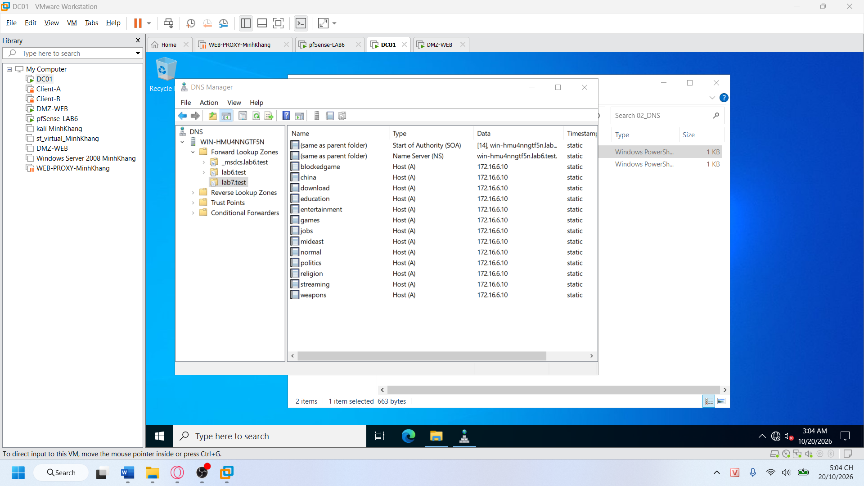
Dmz
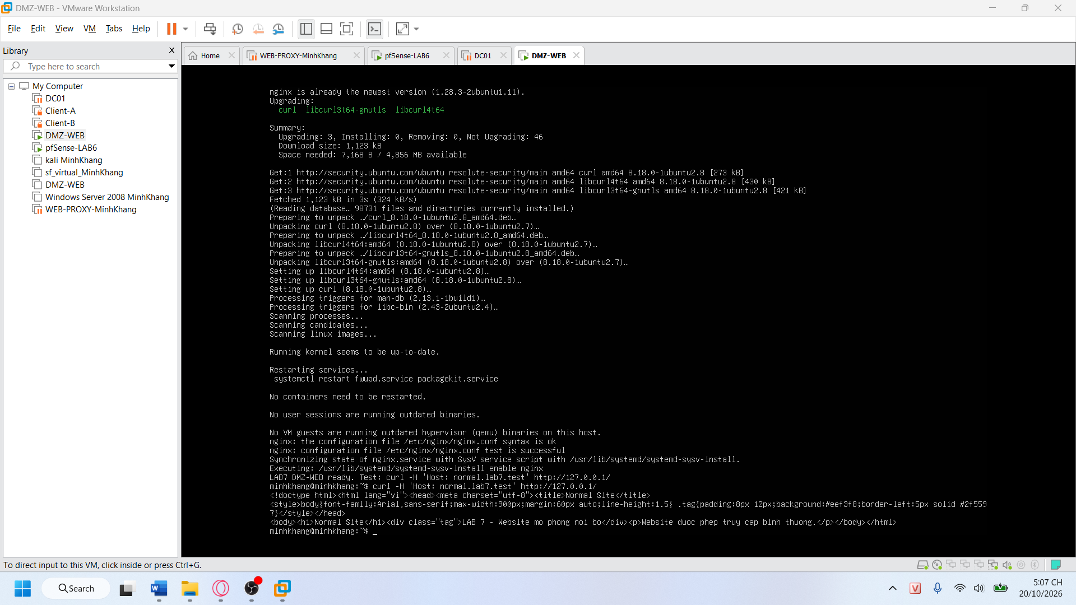
Proxy-web
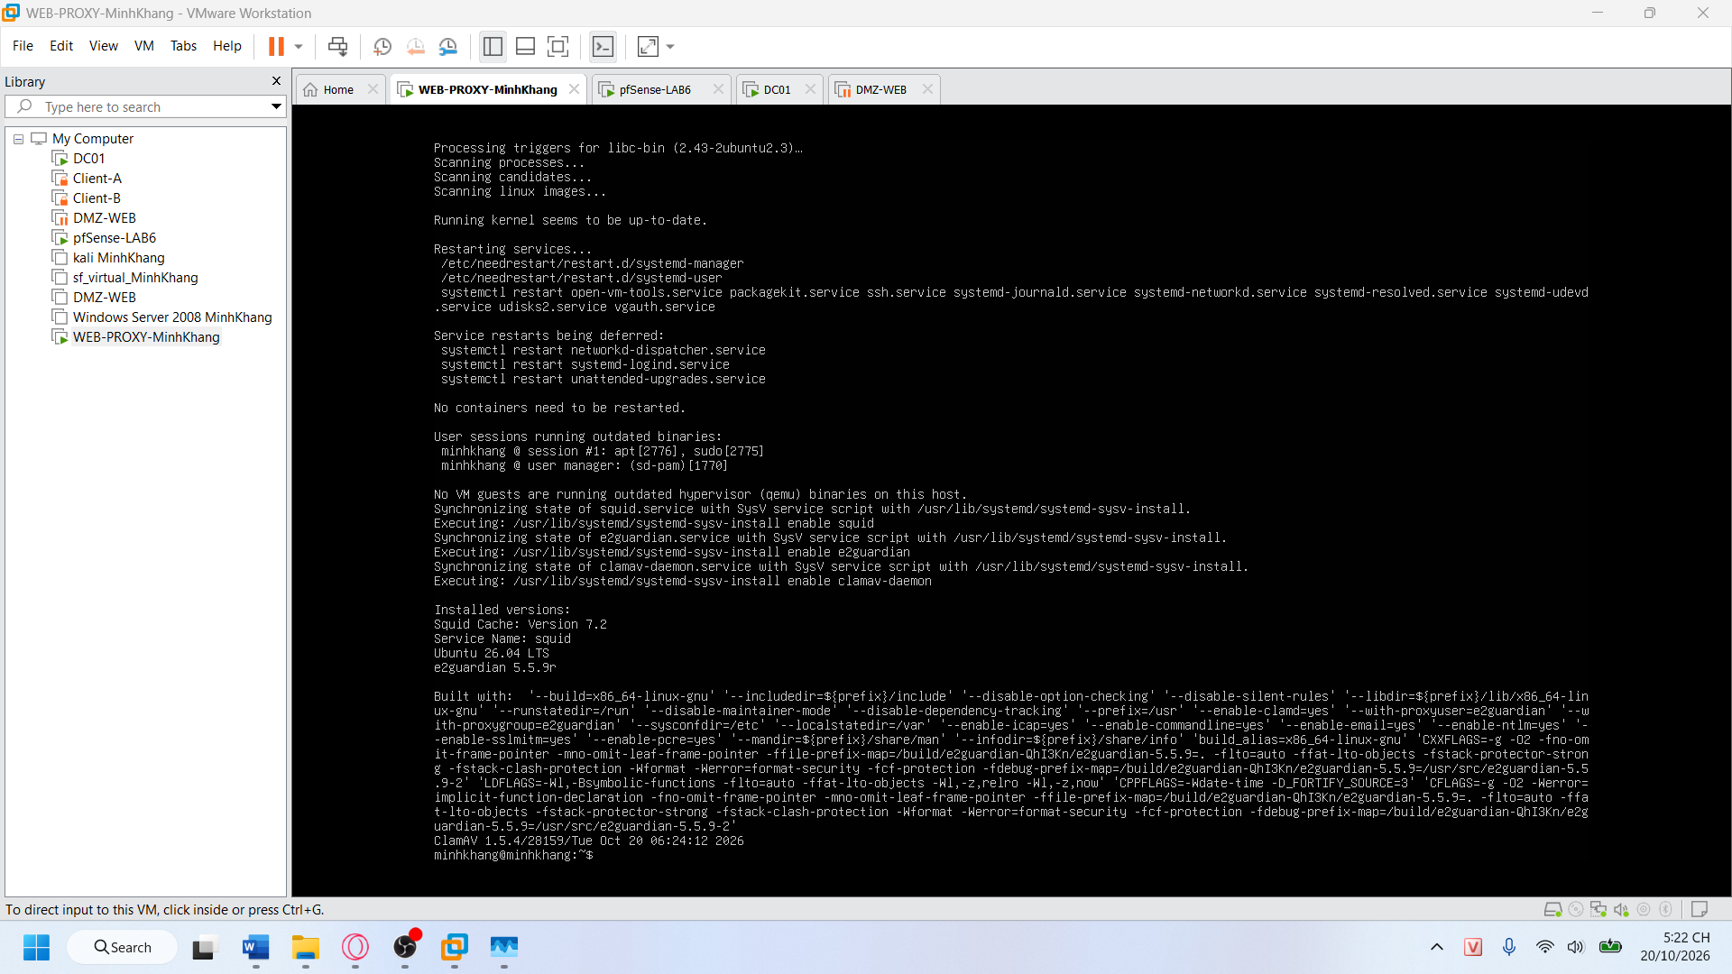
Dc01
