Bài 6:
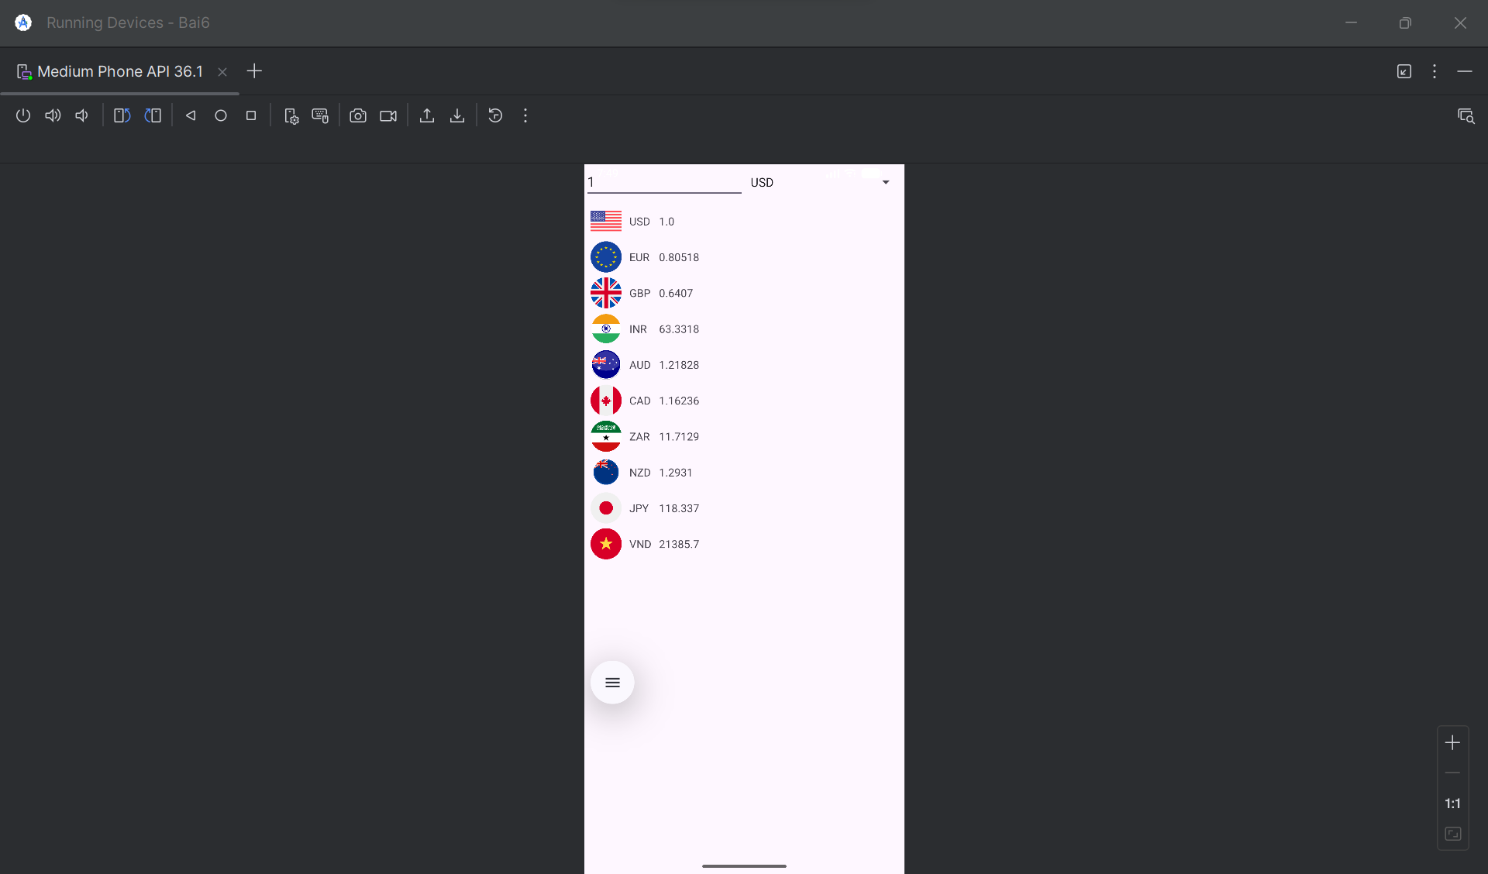
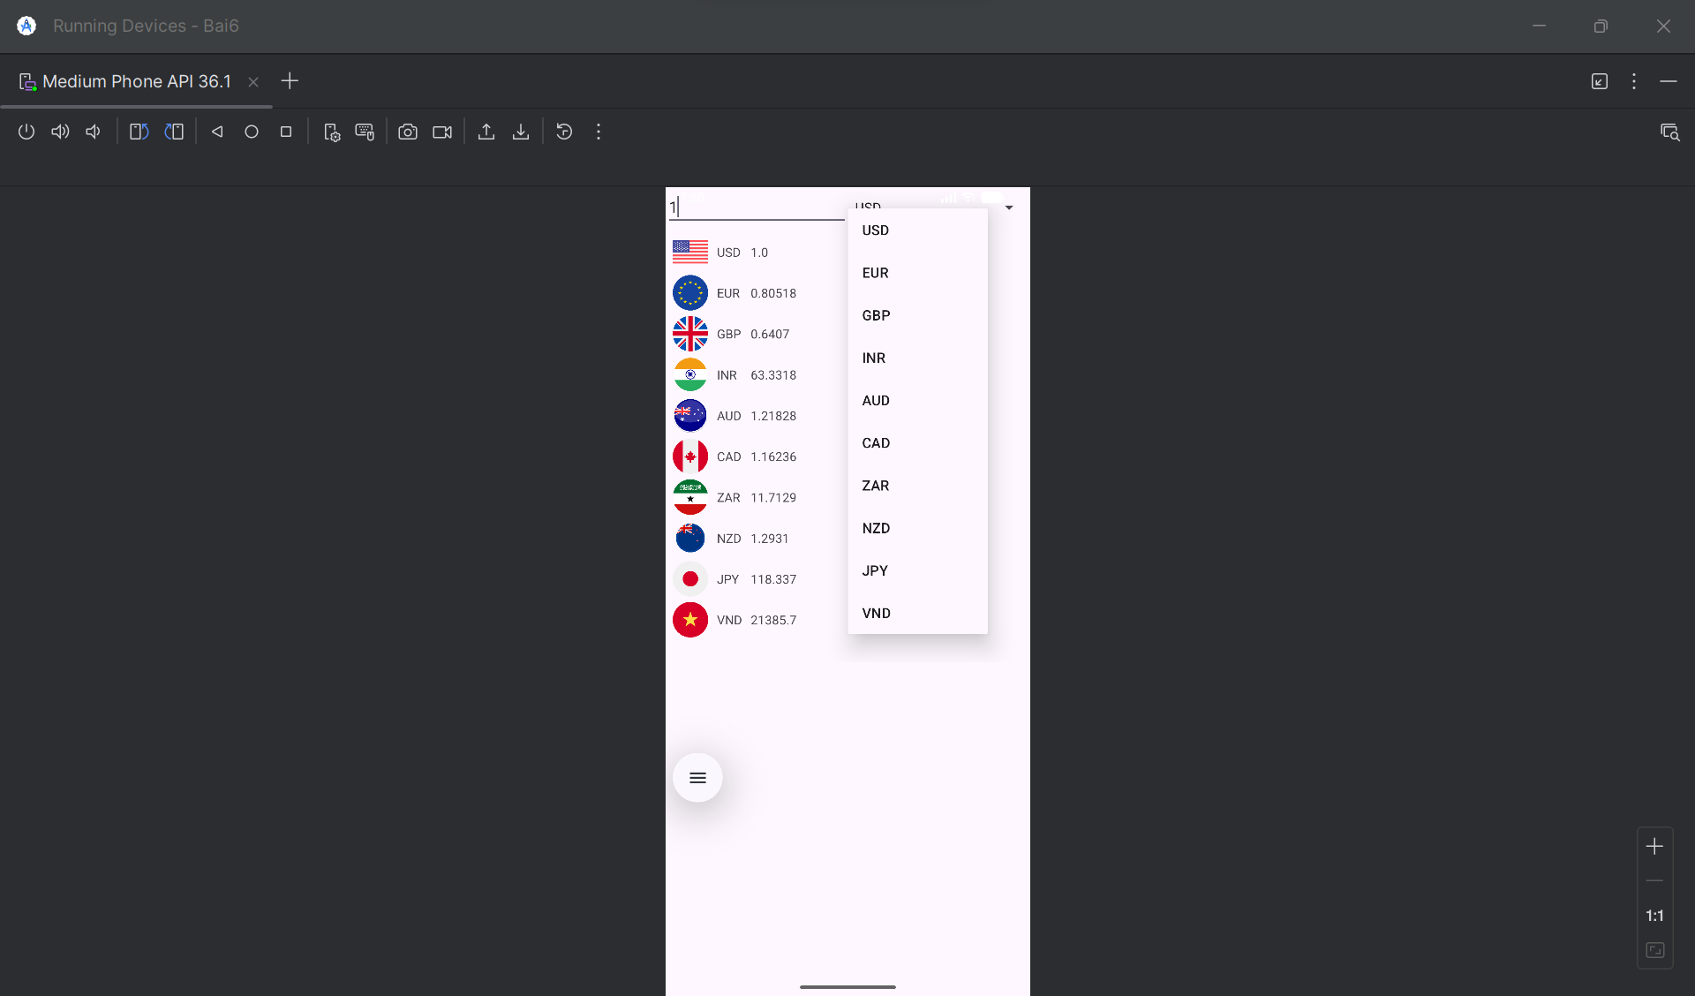
Bước 0: Chuẩn bị hình ảnh
Đây là bước quan trọng. Bạn cần sao chép 10 tệp hình ảnh lá cờ (ví dụ: usd.png, eur.png, gbp.png,...) vào thư mục res/drawable trong dự án Android Studio của bạn.

Bước 1: Tệp AndroidManifest.xml
Tệp này khai báo 3 màn hình (Activity) của bạn và đặt MainActivity làm màn hình khởi chạy.
Vị trí: app/src/main/AndroidManifest.xml
XML
<?xml version="1.0" encoding="utf-8"?>
<manifest xmlns:android="http://schemas.android.com/apk/res/android">
<application
android:allowBackup="true"
android:icon="@mipmap/ic_launcher"
android:label="@string/app_name"
android:roundIcon="@mipmap/ic_launcher_round"
android:supportsRtl="true"
android:theme="@style/Theme.Bai6"> <activity
android:name=".MainActivity"
android:exported="true">
<intent-filter>
<action android:name="android.intent.action.MAIN" />
<category android:name="android.intent.category.LAUNCHER" />
</intent-filter>
</activity>

<activity
android:name=".CurrencyActivity"
android:label="@string/title_activity_currency" />

<activity
android:name=".LengthActivity"
android:label="@string/title_activity_length" />

</application>
</manifest>

Bước 2: Tệp strings.xml
Tệp này chứa tất cả các chuỗi văn bản cho cả 3 màn hình.
Vị trí: app/res/values/strings.xml
XML
<resources>
<string name="app_name">Bộ công cụ đổi</string>
<string name="menu_button_currency">Chương trình đổi tiền</string>
<string name="menu_button_length">Đổi đơn vị đo chiều dài</string>

<string name="title_activity_currency">Chương trình đổi tiền</string>
<string name="currency_textbox_hint">Nhập số tiền</string>
<string name="usd_name">American Dollar</string>
<string name="eur_name">European Cash</string>
<string name="gbp_name">Greate Britain</string>
<string name="inr_name">Indian Rupe</string>
<string name="aud_name">Australia Dollar</string>
<string name="cad_name">Canadian Dollar</string>
<string name="zar_name">South Africa Rand</string>
<string name="nzd_name">New Zealand Dollar</string>
<string name="jpy_name">Yên Nhật</string>
<string name="vnd_name">Việt Nam Đồng</string>
<string name="usd_unit">USD</string>
<string name="eur_unit">EUR</string>
<string name="gbp_unit">GBP</string>
<string name="inr_unit">INR</string>
<string name="aud_unit">AUD</string>
<string name="cad_unit">CAD</string>
<string name="zar_unit">ZAR</string>
<string name="nzd_unit">NZD</string>
<string name="jpy_unit">JPY</string>
<string name="vnd_unit">VND</string>

<string name="title_activity_length">Đổi đơn vị đo chiều dài</string>
<string name="length_textbox_hint">Nhập độ dài</string>
<string name="header_result">Tương đương với</string>
<string name="unit_haily">Hải lý</string>
<string name="unit_dam">Dặm</string>
<string name="unit_km">Kilometer</string>
<string name="unit_ly">Lý</string>
<string name="unit_met">Met</string>
<string name="unit_yard">Yard</string>
<string name="unit_foot">Foot</string>
<string name="unit_inch">Inches</string>
</resources>

Bước 3: Màn hình Menu (MainActivity)
Tệp Layout: activity_main.xml
Vị trí: app/res/layout/activity_main.xml
XML
<?xml version="1.0" encoding="utf-8"?>
<LinearLayout
xmlns:android="http://schemas.android.com/apk/res/android"
xmlns:tools="http://schemas.android.com/tools"
android:layout_width="match_parent"
android:layout_height="match_parent"
android:orientation="vertical"
android:gravity="center"
android:padding="20dp"
tools:context=".MainActivity">

<Button
android:id="@+id/btnGoCurrency"
android:layout_width="match_parent"
android:layout_height="wrap_content"
android:textSize="18sp"
android:text="@string/menu_button_currency" />

<Button
android:id="@+id/btnGoLength"
android:layout_width="match_parent"
android:layout_height="wrap_content"
android:layout_marginTop="20dp"
android:textSize="18sp"
android:text="@string/menu_button_length" />

</LinearLayout>
Tệp Logic: MainActivity.java
Vị trí: app/src/main/java/com/example/bai6/MainActivity.java (Thay com.example.bai6 bằng tên package của bạn)
Java
package com.example.bai6; // <-- THAY BẰNG TÊN PACKAGE CỦA BẠN

import androidx.appcompat.app.AppCompatActivity;

import android.content.Intent;
import android.os.Bundle;
import android.view.View;
import android.widget.Button;

public class MainActivity extends AppCompatActivity {

private Button btnGoCurrency, btnGoLength;

@Override
protected void onCreate(Bundle savedInstanceState) {
super.onCreate(savedInstanceState);
setContentView(R.layout.activity_main);

// Ánh xạ các nút bấm
btnGoCurrency = (Button) findViewById(R.id.btnGoCurrency);
btnGoLength = (Button) findViewById(R.id.btnGoLength);

// Xử lý sự kiện bấm nút đổi tiền
btnGoCurrency.setOnClickListener(new View.OnClickListener() {
@Override
public void onClick(View v) {
// Tạo một "ý định" (Intent) để mở CurrencyActivity
Intent intent = new Intent(MainActivity.this, CurrencyActivity.class);
startActivity(intent); // Bắt đầu Activity mới
}
});

// Xử lý sự kiện bấm nút đổi độ dài
btnGoLength.setOnClickListener(new View.OnClickListener() {
@Override
public void onClick(View v) {
// Tạo một "ý định" (Intent) để mở LengthActivity
Intent intent = new Intent(MainActivity.this, LengthActivity.class);
startActivity(intent); // Bắt đầu Activity mới
}
});
}
}

Bước 4: Màn hình Đổi Tiền (CurrencyActivity)
Tệp Layout: activity_currency.xml
Vị trí: app/res/layout/activity_currency.xml (Đây là file đã sửa kích thước ImageView thành 40dp)
XML
<?xml version="1.0" encoding="utf-8"?>
<LinearLayout
xmlns:android="http://schemas.android.com/apk/res/android"
xmlns:tools="http://schemas.android.com/tools"
android:layout_width="match_parent"
android:layout_height="match_parent"
android:orientation="vertical"
tools:context=".CurrencyActivity">

<LinearLayout
android:layout_width="match_parent"
android:layout_height="wrap_content"
android:orientation="horizontal">

<EditText
android:id="@+id/txtNumber"
android:layout_width="0dip"
android:layout_height="wrap_content"
android:layout_weight="1"
android:ems="10"
android:hint="@string/currency_textbox_hint"
android:inputType="numberDecimal" />

<Spinner
android:id="@+id/spnUnit"
android:layout_width="0dip"
android:layout_height="wrap_content"
android:layout_weight="1" />
</LinearLayout>

<ScrollView
android:layout_width="match_parent"
android:layout_height="match_parent">

<TableLayout
android:layout_width="match_parent"
android:layout_height="wrap_content"
android:padding="5dp">

<TableRow
android:layout_width="match_parent"
android:layout_height="wrap_content"
android:gravity="center_vertical"
android:padding="3dp">

<ImageView
android:layout_width="40dp"
android:layout_height="40dp"
android:scaleType="centerInside"
android:contentDescription="@string/usd_name"
android:src="@drawable/usd" />

<TextView
android:layout_width="wrap_content"
android:layout_height="wrap_content"
android:paddingLeft="10dp"
android:text="@string/usd_unit" />

<TextView
android:id="@+id/lblUsd"
android:layout_width="wrap_content"
android:layout_height="wrap_content"
android:paddingLeft="10dp" />
</TableRow>

<TableRow
android:layout_width="match_parent"
android:layout_height="wrap_content"
android:gravity="center_vertical"
android:padding="3dp">

<ImageView
android:layout_width="40dp"
android:layout_height="40dp"
android:scaleType="centerInside"
android:contentDescription="@string/eur_name"
android:src="@drawable/eur" />

<TextView
android:layout_width="wrap_content"
android:layout_height="wrap_content"
android:paddingLeft="10dp"
android:text="@string/eur_unit" />

<TextView
android:id="@+id/lblEur"
android:layout_width="wrap_content"
android:layout_height="wrap_content"
android:paddingLeft="10dp" />
</TableRow>

<TableRow
android:layout_width="match_parent"
android:layout_height="wrap_content"
android:gravity="center_vertical"
android:padding="3dp">

<ImageView
android:layout_width="40dp"
android:layout_height="40dp"
android:scaleType="centerInside"
android:contentDescription="@string/gbp_name"
android:src="@drawable/gbp" />

<TextView
android:layout_width="wrap_content"
android:layout_height="wrap_content"
android:paddingLeft="10dp"
android:text="@string/gbp_unit" />

<TextView
android:id="@+id/lblGbp"
android:layout_width="wrap_content"
android:layout_height="wrap_content"
android:paddingLeft="10dp" />
</TableRow>

<TableRow
android:layout_width="match_parent"
android:layout_height="wrap_content"
android:gravity="center_vertical"
android:padding="3dp">

<ImageView
android:layout_width="40dp"
android:layout_height="40dp"
android:scaleType="centerInside"
android:contentDescription="@string/inr_name"
android:src="@drawable/inr" />

<TextView
android:layout_width="wrap_content"
android:layout_height="wrap_content"
android:paddingLeft="10dp"
android:text="@string/inr_unit" />

<TextView
android:id="@+id/lblInr"
android:layout_width="wrap_content"
android:layout_height="wrap_content"
android:paddingLeft="10dp" />
</TableRow>

<TableRow
android:layout_width="match_parent"
android:layout_height="wrap_content"
android:gravity="center_vertical"
android:padding="3dp">

<ImageView
android:layout_width="40dp"
android:layout_height="40dp"
android:scaleType="centerInside"
android:contentDescription="@string/aud_name"
android:src="@drawable/aud" />

<TextView
android:layout_width="wrap_content"
android:layout_height="wrap_content"
android:paddingLeft="10dp"
android:text="@string/aud_unit" />

<TextView
android:id="@+id/lblAud"
android:layout_width="wrap_content"
android:layout_height="wrap_content"
android:paddingLeft="10dp" />
</TableRow>

<TableRow
android:layout_width="match_parent"
android:layout_height="wrap_content"
android:gravity="center_vertical"
android:padding="3dp">

<ImageView
android:layout_width="40dp"
android:layout_height="40dp"
android:scaleType="centerInside"
android:contentDescription="@string/cad_name"
android:src="@drawable/cad" />

<TextView
android:layout_width="wrap_content"
android:layout_height="wrap_content"
android:paddingLeft="10dp"
android:text="@string/cad_unit" />

<TextView
android:id="@+id/lblCad"
android:layout_width="wrap_content"
android:layout_height="wrap_content"
android:paddingLeft="10dp" />
</TableRow>

<TableRow
android:layout_width="match_parent"
android:layout_height="wrap_content"
android:gravity="center_vertical"
android:padding="3dp">

<ImageView
android:layout_width="40dp"
android:layout_height="40dp"
android:scaleType="centerInside"
android:contentDescription="@string/zar_name"
android:src="@drawable/zar" />

<TextView
android:layout_width="wrap_content"
android:layout_height="wrap_content"
android:paddingLeft="10dp"
android:text="@string/zar_unit" />

<TextView
android:id="@+id/lblzar"
android:layout_width="wrap_content"
android:layout_height="wrap_content"
android:paddingLeft="10dp" />
</TableRow>

<TableRow
android:layout_width="match_parent"
android:layout_height="wrap_content"
android:gravity="center_vertical"
android:padding="3dp">

<ImageView
android:layout_width="40dp"
android:layout_height="40dp"
android:scaleType="centerInside"
android:contentDescription="@string/nzd_name"
android:src="@drawable/nzd" />

<TextView
android:layout_width="wrap_content"
android:layout_height="wrap_content"
android:paddingLeft="10dp"
android:text="@string/nzd_unit" />

<TextView
android:id="@+id/lblNzd"
android:layout_width="wrap_content"
android:layout_height="wrap_content"
android:paddingLeft="10dp" />
</TableRow>

<TableRow
android:layout_width="match_parent"
android:layout_height="wrap_content"
android:gravity="center_vertical"
android:padding="3dp">

<ImageView
android:layout_width="40dp"
android:layout_height="40dp"
android:scaleType="centerInside"
android:contentDescription="@string/jpy_name"
android:src="@drawable/jpy" />

<TextView
android:layout_width="wrap_content"
android:layout_height="wrap_content"
android:paddingLeft="10dp"
android:text="@string/jpy_unit" />

<TextView
android:id="@+id/lblJpy"
android:layout_width="wrap_content"
android:layout_height="wrap_content"
android:paddingLeft="10dp" />
</TableRow>

<TableRow
android:layout_width="match_parent"
android:layout_height="wrap_content"
android:gravity="center_vertical"
android:padding="3dp">

<ImageView
android:layout_width="40dp"
android:layout_height="40dp"
android:scaleType="centerInside"
android:contentDescription="@string/vnd_name"
android:src="@drawable/vnd" />

<TextView
android:layout_width="wrap_content"
android:layout_height="wrap_content"
android:paddingLeft="10dp"
android:text="@string/vnd_unit" />

<TextView
android:id="@+id/lblVnd"
android:layout_width="wrap_content"
android:layout_height="wrap_content"
android:paddingLeft="10dp" />
</TableRow>

</TableLayout>
</ScrollView>
</LinearLayout>
Tệp Logic: CurrencyActivity.java
Vị trí: app/src/main/java/com/example/bai6/CurrencyActivity.java (Thay com.example.bai6 bằng tên package của bạn)
Java
package com.example.bai6; // <-- THAY BẰNG TÊN PACKAGE CỦA BẠN

import androidx.appcompat.app.AppCompatActivity;

import android.os.Bundle;
import android.text.Editable;
import android.text.TextWatcher;
import android.view.View;
import android.widget.AdapterView;
import android.widget.ArrayAdapter;
import android.widget.EditText;
import android.widget.Spinner;
import android.widget.TextView;

public class CurrencyActivity extends AppCompatActivity {

// Khai báo biến lưu danh sách đơn vị đo
private String[] units = {
"USD", "EUR", "GBP", "INR", "AUD",
"CAD", "ZAR", "NZD", "JPY", "VND"
};

// Khai báo ma trận lưu tỉ giá
private double[][] ratio = {
{1.00000, 0.80518, 0.64070, 63.3318, 1.21828, 1.16236, 11.7129, 1.29310, 118.337, 21385.7},
{1.24172, 1.00000, 0.79575, 78.6084, 1.51266, 1.44314, 14.5371, 1.60576, 146.927, 26561.8},
{1.56044, 1.25667, 1.00000, 98.7848, 1.90091, 1.81355, 18.2683, 2.01791, 184.638, 33374.9},
{0.01580, 0.01272, 0.01012, 1.00000, 0.01924, 0.01836, 0.18493, 0.02043, 1.86910, 337.811},
{0.82114, 0.66119, 0.52620, 52.0860, 1.00000, 0.95416, 9.61148, 1.06158, 97.1120, 17567.9},
{0.86059, 0.69296, 0.55148, 54.5885, 1.04804, 1.00000, 10.0732, 1.11258, 101.777, 18401.7},
{0.08541, 0.06877, 0.05473, 5.40852, 0.10398, 0.09924, 1.00000, 0.11037, 10.0996, 1825.87},
{0.77402, 0.62319, 0.49597, 49.0031, 0.94215, 0.89951, 9.06754, 1.00000, 91.5139, 16552.1},
{0.00846, 0.00681, 0.00542, 0.53547, 0.01030, 0.00983, 0.09908, 0.01093, 1.00000, 180.837},
{0.00005, 0.00004, 0.00003, 0.00296, 0.00006, 0.00005, 0.00055, 0.00006, 0.00553, 1.00000}
};

// Khai báo các đối tượng View
private EditText txtNumber;
private Spinner spnUnits;
private TextView[] lblResults;

@Override
protected void onCreate(Bundle savedInstanceState) {
super.onCreate(savedInstanceState);
setContentView(R.layout.activity_currency); // Trỏ đúng layout

// Khởi tạo các biến thành viên
txtNumber = (EditText) findViewById(R.id.txtNumber);
spnUnits = (Spinner) findViewById(R.id.spnUnit);
lblResults = new TextView[]{
(TextView) findViewById(R.id.lblUsd),
(TextView) findViewById(R.id.lblEur),
(TextView) findViewById(R.id.lblGbp),
(TextView) findViewById(R.id.lblInr),
(TextView) findViewById(R.id.lblAud),
(TextView) findViewById(R.id.lblCad),
(TextView) findViewById(R.id.lblzar), // khớp với ID trong XML
(TextView) findViewById(R.id.lblNzd),
(TextView) findViewById(R.id.lblJpy),
(TextView) findViewById(R.id.lblVnd)
};

// Đưa dữ liệu vào Spinner
ArrayAdapter<String> adapter = new ArrayAdapter<String>(
this, android.R.layout.simple_spinner_item, units);
adapter.setDropDownViewResource(android.R.layout.simple_list_item_1);
spnUnits.setAdapter(adapter);

// Thiết lập các hàm xử lý sự kiện
// Xử lý sự kiện thay item được chọn trong Spinner
spnUnits.setOnItemSelectedListener(new AdapterView.OnItemSelectedListener() {
@Override
public void onItemSelected(AdapterView<?> arg0, View arg1, int arg2, long arg3) {
changeMoneyUnit(); // Gọi hàm đổi tiền
}
@Override
public void onNothingSelected(AdapterView<?> arg0) { }
});

// Xử lý sự kiện thay đổi nội dung ô nhập
txtNumber.addTextChangedListener(new TextWatcher() {
@Override
public void onTextChanged(CharSequence arg0, int arg1, int arg2, int arg3) {
changeMoneyUnit(); // Gọi hàm đổi tiền
}
@Override
public void beforeTextChanged(CharSequence arg0, int arg1, int arg2, int arg3) { }
@Override
public void afterTextChanged(Editable arg0) { }
});
}

// Cài đặt hàm đổi tiền
private void changeMoneyUnit() {
int rowIdx = spnUnits.getSelectedItemPosition();
String input = txtNumber.getText().toString();
if (input.isEmpty()) input = "0";
double number = Double.valueOf(input);

for (int i = 0; i < lblResults.length; i++) {
double temp = number * ratio[rowIdx][i];
lblResults[i].setText(String.valueOf(temp));
}
}
}

Bước 5: Màn hình Đổi Độ Dài (LengthActivity)
Tệp Layout: activity_length.xml
Vị trí: app/res/layout/activity_length.xml (Đây là file khớp với hình ảnh )
XML
<?xml version="1.0" encoding="utf-8"?>
<LinearLayout
xmlns:android="http://schemas.android.com/apk/res/android"
xmlns:tools="http://schemas.android.com/tools"
android:layout_width="match_parent"
android:layout_height="match_parent"
android:orientation="vertical"
tools:context=".LengthActivity">

<LinearLayout
android:layout_width="match_parent"
android:layout_height="wrap_content"
android:orientation="horizontal"
android:padding="5dp">

<EditText
android:id="@+id/txtNumber"
android:layout_width="0dip"
android:layout_height="wrap_content"
android:layout_weight="1"
android:ems="10"
android:hint="@string/length_textbox_hint"
android:inputType="numberDecimal" />

<Spinner
android:id="@+id/spnUnit"
android:layout_width="0dip"
android:layout_height="wrap_content"
android:layout_weight="1" />
</LinearLayout>

<TextView
android:layout_width="match_parent"
android:layout_height="wrap_content"
android:text="@string/header_result"
android:background="#009688"
android:textColor="@android:color/white"
android:padding="10dp"
android:textSize="16sp" />

<ScrollView
android:layout_width="match_parent"
android:layout_height="match_parent">

<TableLayout
android:layout_width="match_parent"
android:layout_height="wrap_content"
android:padding="10dp">

<TableRow
android:layout_width="match_parent"
android:layout_height="wrap_content"
android:paddingVertical="5dp">
<TextView
android:id="@+id/lblHaily"
android:layout_width="0dp"
android:layout_weight="1"
android:layout_height="wrap_content"
android:textSize="18sp"
android:text="0.0"/>
<TextView
android:layout_width="wrap_content"
android:layout_height="wrap_content"
android:textSize="18sp"
android:text="@string/unit_haily" />
</TableRow>

<TableRow
android:layout_width="match_parent"
android:layout_height="wrap_content"
android:paddingVertical="5dp">
<TextView
android:id="@+id/lblDam"
android:layout_width="0dp"
android:layout_weight="1"
android:layout_height="wrap_content"
android:textSize="18sp"
android:text="0.0"/>
<TextView
android:layout_width="wrap_content"
android:layout_height="wrap_content"
android:textSize="18sp"
android:text="@string/unit_dam" />
</TableRow>

<TableRow
android:layout_width="match_parent"
android:layout_height="wrap_content"
android:paddingVertical="5dp">
<TextView
android:id="@+id/lblKm"
android:layout_width="0dp"
android:layout_weight="1"
android:layout_height="wrap_content"
android:textSize="18sp"
android:text="0.0"/>
<TextView
android:layout_width="wrap_content"
android:layout_height="wrap_content"
android:textSize="18sp"
android:text="@string/unit_km" />
</TableRow>

<TableRow
android:layout_width="match_parent"
android:layout_height="wrap_content"
android:paddingVertical="5dp">
<TextView
android:id="@+id/lblLy"
android:layout_width="0dp"
android:layout_weight="1"
android:layout_height="wrap_content"
android:textSize="18sp"
android:text="0.0"/>
<TextView
android:layout_width="wrap_content"
android:layout_height="wrap_content"
android:textSize="18sp"
android:text="@string/unit_ly" />
</TableRow>

<TableRow
android:layout_width="match_parent"
android:layout_height="wrap_content"
android:paddingVertical="5dp">
<TextView
android:id="@+id/lblMet"
android:layout_width="0dp"
android:layout_weight="1"
android:layout_height="wrap_content"
android:textSize="18sp"
android:text="0.0"/>
<TextView
android:layout_width="wrap_content"
android:layout_height="wrap_content"
android:textSize="18sp"
android:text="@string/unit_met" />
</TableRow>

<TableRow
android:layout_width="match_parent"
android:layout_height="wrap_content"
android:paddingVertical="5dp">
<TextView
android:id="@+id/lblYard"
android:layout_width="0dp"
android:layout_weight="1"
android:layout_height="wrap_content"
android:textSize="18sp"
android:text="0.0"/>
<TextView
android:layout_width="wrap_content"
android:layout_height="wrap_content"
android:textSize="18sp"
android:text="@string/unit_yard" />
</TableRow>

<TableRow
android:layout_width="match_parent"
android:layout_height="wrap_content"
android:paddingVertical="5dp">
<TextView
android:id="@+id/lblFoot"
android:layout_width="0dp"
android:layout_weight="1"
android:layout_height="wrap_content"
android:textSize="18sp"
android:text="0.0"/>
<TextView
android:layout_width="wrap_content"
android:layout_height="wrap_content"
android:textSize="18sp"
android:text="@string/unit_foot" />
</TableRow>

<TableRow
android:layout_width="match_parent"
android:layout_height="wrap_content"
android:paddingVertical="5dp">
<TextView
android:id="@+id/lblInch"
android:layout_width="0dp"
android:layout_weight="1"
android:layout_height="wrap_content"
android:textSize="18sp"
android:text="0.0"/>
<TextView
android:layout_width="wrap_content"
android:layout_height="wrap_content"
android:textSize="18sp"
android:text="@string/unit_inch" />
</TableRow>

</TableLayout>
</ScrollView>
</LinearLayout>
Tệp Logic: LengthActivity.java
Vị trí: app/src/main/java/com/example/bai6/LengthActivity.java (Thay com.example.bai6 bằng tên package của bạn)
Java
package com.example.bai6; // <-- THAY BẰNG TÊN PACKAGE CỦA BẠN

import androidx.appcompat.app.AppCompatActivity;

import android.os.Bundle;
import android.text.Editable;
import android.text.TextWatcher;
import android.view.View;
import android.widget.AdapterView;
import android.widget.ArrayAdapter;
import android.widget.EditText;
import android.widget.Spinner;
import android.widget.TextView;

// Import thêm thư viện này để định dạng số thập phân
import java.text.DecimalFormat;

public class LengthActivity extends AppCompatActivity {

// Khai báo biến lưu danh sách đơn vị đo (8 đơn vị)
private String[] units = {
"Hải lý", "Dặm", "Km", "Lý", "Met", "Yard", "Foot", "Inch"
};

// Khai báo ma trận tỉ giá
private double[][] ratio = {
{1.00000000, 1.15077945, 1.8520000, 20.2537183, 1852.0000, 2025.37183, 6076.11549, 72913.38583},
{0.86897624, 1.00000000, 1.6093440, 17.6000000, 1609.3440, 1760.00000, 5280.00000, 63360.00000},
{0.53995680, 0.62137119, 1.0000000, 10.9361330, 1000.0000, 1093.61330, 3280.83990, 39370.07874},
{0.04937365, 0.05681818, 0.0914400, 1.0000000, 91.4400, 100.00000, 300.00000, 3600.00000},
{0.00053996, 0.00062137, 0.0010000, 0.0109361, 1.0000, 1.09361, 3.28084, 39.37008},
{0.00049374, 0.00056818, 0.0009144, 0.0100000, 0.9144, 1.00000, 3.00000, 36.00000},
{0.00016458, 0.00018939, 0.0003048, 0.0033333, 0.3048, 0.33333, 1.00000, 12.00000},
{0.00001371, 0.00001578, 0.0000254, 0.0002778, 0.0254, 0.02778, 0.08333, 1.00000}
};

// Khai báo các đối tượng View
private EditText txtNumber;
private Spinner spnUnits;
private TextView[] lblResults;
private DecimalFormat df = new DecimalFormat("#.####");

@Override
protected void onCreate(Bundle savedInstanceState) {
super.onCreate(savedInstanceState);
setContentView(R.layout.activity_length); // Trỏ đúng layout

// Kết nối các đối tượng View
txtNumber = (EditText) findViewById(R.id.txtNumber);
spnUnits = (Spinner) findViewById(R.id.spnUnit);
lblResults = new TextView[]{
(TextView) findViewById(R.id.lblHaily),
(TextView) findViewById(R.id.lblDam),
(TextView) findViewById(R.id.lblKm),
(TextView) findViewById(R.id.lblLy),
(TextView) findViewById(R.id.lblMet),
(TextView) findViewById(R.id.lblYard),
(TextView) findViewById(R.id.lblFoot),
(TextView) findViewById(R.id.lblInch)
};

// Đưa dữ liệu vào Spinner
ArrayAdapter<String> adapter = new ArrayAdapter<String>(
this, android.R.layout.simple_spinner_item, units);
adapter.setDropDownViewResource(android.R.layout.simple_list_item_1);
spnUnits.setAdapter(adapter);

// Thiết lập các hàm xử lý sự kiện
spnUnits.setOnItemSelectedListener(new AdapterView.OnItemSelectedListener() {
@Override
public void onItemSelected(AdapterView<?> arg0, View arg1, int arg2, long arg3) {
changeLengthUnit(); // Gọi hàm đổi độ dài
}
@Override
public void onNothingSelected(AdapterView<?> arg0) { }
});

txtNumber.addTextChangedListener(new TextWatcher() {
@Override
public void onTextChanged(CharSequence arg0, int arg1, int arg2, int arg3) {
changeLengthUnit(); // Gọi hàm đổi độ dài
}
@Override
public void beforeTextChanged(CharSequence arg0, int arg1, int arg2, int arg3) { }
@Override
public void afterTextChanged(Editable arg0) { }
});

changeLengthUnit(); // Tính toán lần đầu khi mở
}

// Hàm đổi đơn vị độ dài
private void changeLengthUnit() {
int rowIdx = spnUnits.getSelectedItemPosition();
String input = txtNumber.getText().toString();
if (input.isEmpty()) input = "0";
double number = Double.valueOf(input);

for (int i = 0; i < lblResults.length; i++) {
double temp = number * ratio[rowIdx][i];
lblResults[i].setText(df.format(temp));
}
}
}
Bài 7:
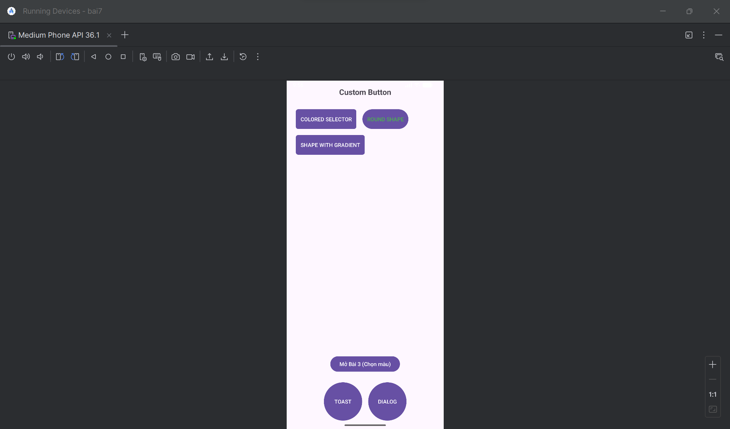
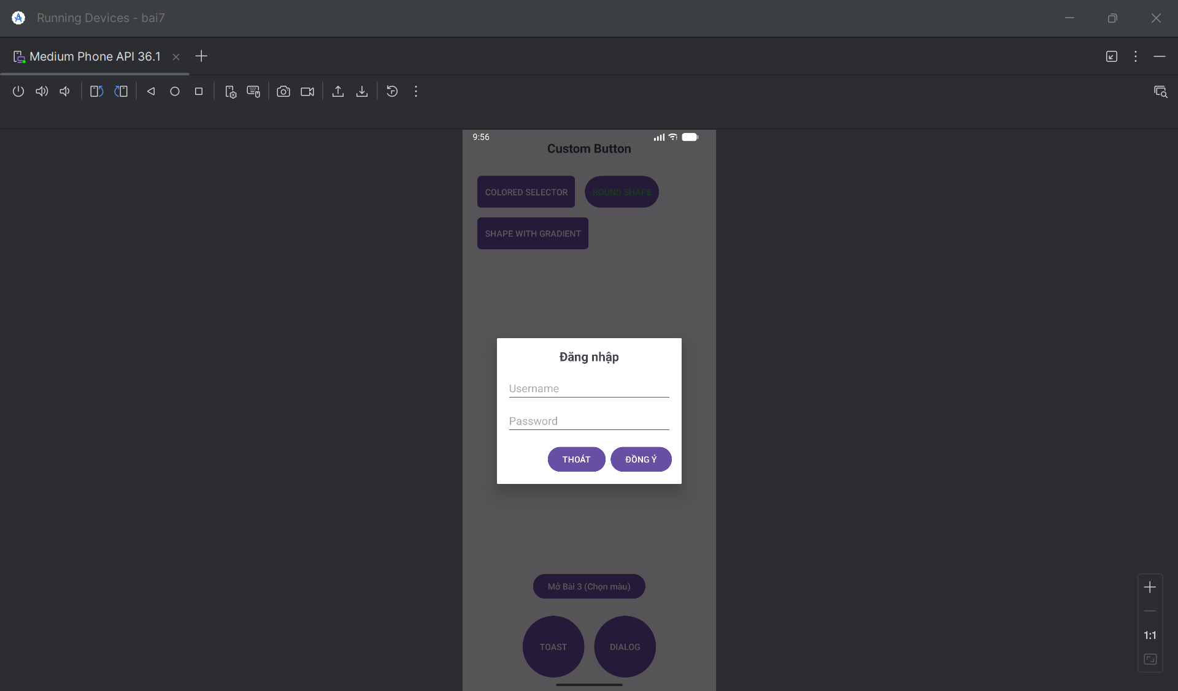
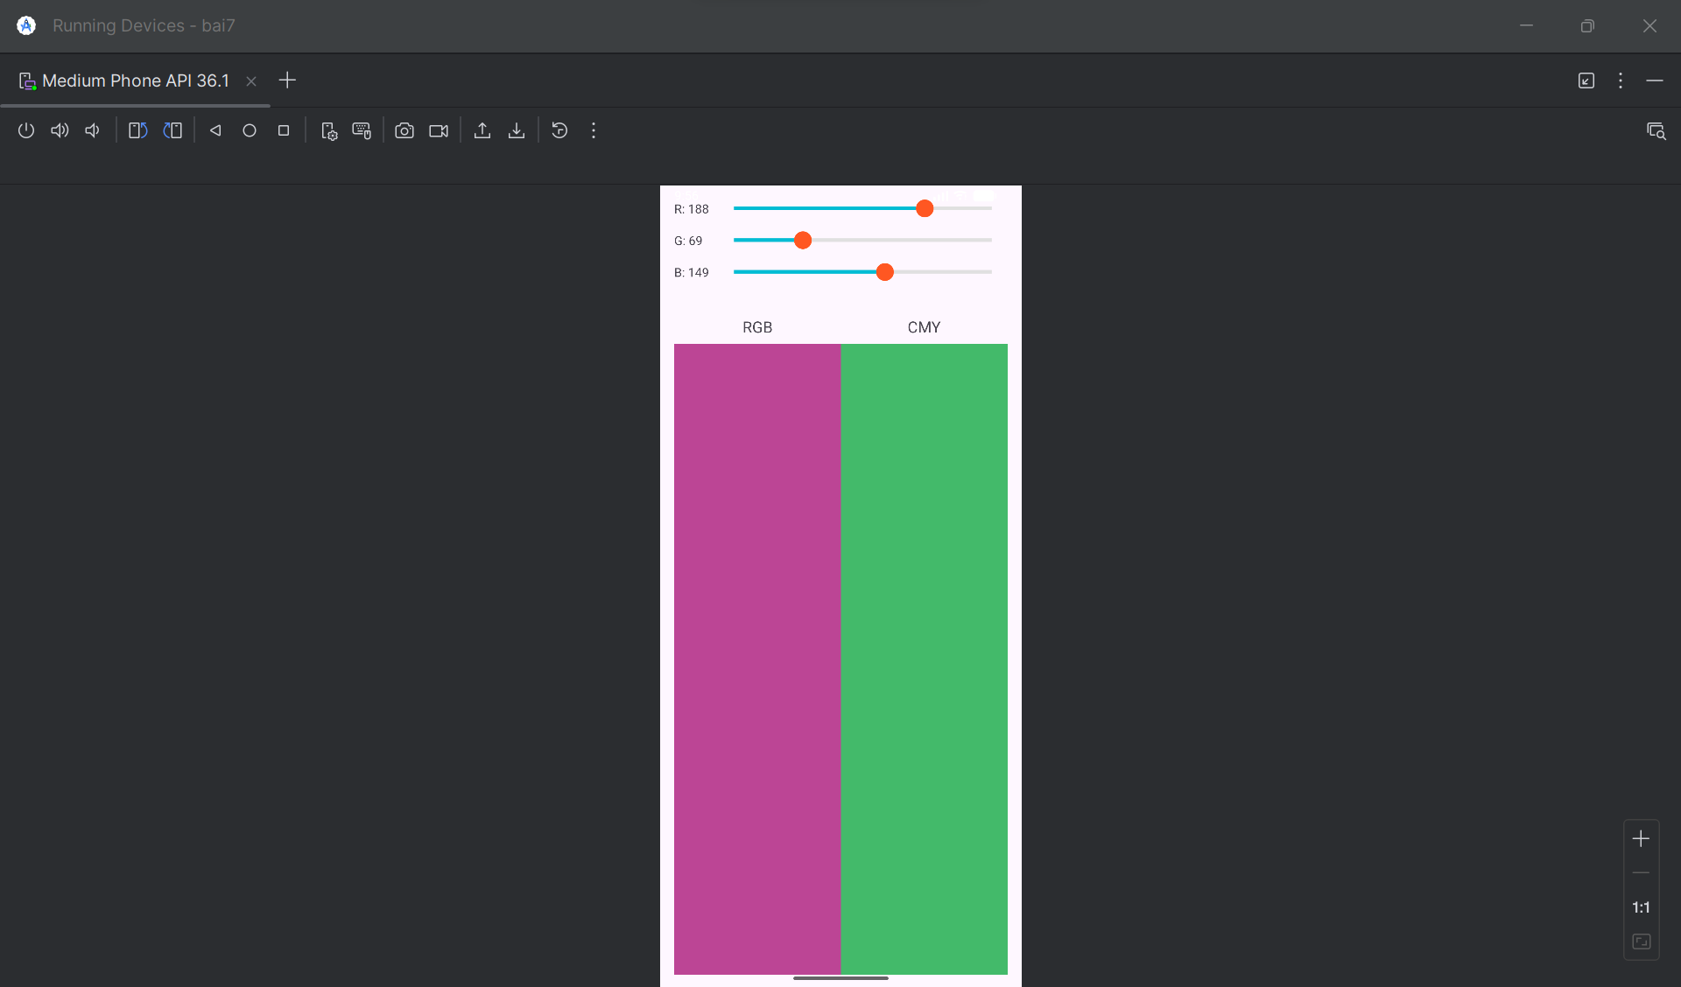
1. Các file Drawable
Tạo các file XML sau trong thư mục res/drawable/.
button_colored_selector.xml
XML
<?xml version="1.0" encoding="utf-8"?>
<selector xmlns:android="http://schemas.android.com/apk/res/android">
<item android:state_pressed="true">
<shape android:shape="rectangle">
<solid android:color="#00BCD4" />
<corners android:radius="6dp" />
</shape>
</item>
<item>
<shape android:shape="rectangle">
<solid android:color="#03A9F4" />
<corners android:radius="6dp" />
</shape>
</item>
</selector>
button_round_shape.xml
XML
<?xml version="1.0" encoding="utf-8"?>
<shape xmlns:android="http://schemas.android.com/apk/res/android"
android:shape="rectangle">
<solid android:color="#FFFFFF" />
<stroke
android:width="2dp"
android:color="#4CAF50" />
<corners android:radius="50dp" />
</shape>
button_gradient_shape.xml
XML
<?xml version="1.0" encoding="utf-8"?>
<shape xmlns:android="http://schemas.android.com/apk/res/android"
android:shape="rectangle">
<gradient
android:startColor="#FFC107"
android:endColor="#FF5722"
android:angle="0" />
<corners android:radius="6dp" />
</shape>
button_oval_blue.xml
XML
<?xml version="1.0" encoding="utf-8"?>
<selector xmlns:android="http://schemas.android.com/apk/res/android">
<item android:state_pressed="true">
<shape android:shape="oval">
<solid android:color="#0D47A1" />
</shape>
</item>
<item>
<shape android:shape="oval">
<solid android:color="#1976D2" />
</shape>
</item>
</selector>
custom_toast_background.xml
XML
<?xml version="1.0" encoding="utf-8"?>
<shape xmlns:android="http://schemas.android.com/apk/res/android"
android:shape="rectangle">
<solid android:color="#424242" />
<corners android:radius="12dp" />
<stroke
android:width="2dp"
android:color="#FFEB3B" />
</shape>
custom_seekbar_progress.xml
XML
<?xml version="1.0" encoding="utf-8"?>
<layer-list xmlns:android="http://schemas.android.com/apk/res/android">
<item android:id="@android:id/background">
<shape android:shape="line">
<stroke
android:width="4dp"
android:color="#E0E0E0" />
</shape>
</item>
<item android:id="@android:id/progress">
<clip>
<shape android:shape="line">
<stroke
android:width="4dp"
android:color="#00BCD4" />
</shape>
</clip>
</item>
</layer-list>
custom_seekbar_thumb.xml
XML
<?xml version="1.0" encoding="utf-8"?>
<shape xmlns:android="http://schemas.android.com/apk/res/android"
android:shape="oval">
<solid android:color="#FF5722" />
<size
android:width="20dp"
android:height="20dp" />
</shape>

2. Các file Layout
Tạo các file XML sau trong thư mục res/layout/.
custom_toast_layout.xml
XML
<?xml version="1.0" encoding="utf-8"?>
<LinearLayout
xmlns:android="http://schemas.android.com/apk/res/android"
android:id="@+id/custom_toast_container"
android:orientation="horizontal"
android:layout_width="wrap_content"
android:layout_height="wrap_content"
android:padding="12dp"
android:background="@drawable/custom_toast_background">

<ImageView
android:layout_width="wrap_content"
android:layout_height="wrap_content"
android:src="@android:drawable/ic_dialog_info"
android:layout_marginEnd="8dp"/>

<TextView
android:layout_width="wrap_content"
android:layout_height="wrap_content"
android:text="Custom Toast, made by..."
android:textColor="@android:color/white"
android:textSize="16sp"/>
</LinearLayout>
custom_dialog_layout.xml
XML
<?xml version="1.0" encoding="utf-8"?>
<LinearLayout
xmlns:android="http://schemas.android.com/apk/res/android"
android:orientation="vertical"
android:layout_width="300dp"
android:layout_height="wrap_content"
android:padding="16dp">

<TextView
android:layout_width="wrap_content"
android:layout_height="wrap_content"
android:text="Đăng nhập"
android:textSize="20sp"
android:textStyle="bold"
android:layout_gravity="center_horizontal"/>

<EditText
android:layout_width="match_parent"
android:layout_height="wrap_content"
android:hint="Username"
android:layout_marginTop="16dp"/>

<EditText
android:layout_width="match_parent"
android:layout_height="wrap_content"
android:hint="Password"
android:inputType="textPassword"
android:layout_marginTop="8dp"/>

<LinearLayout
android:layout_width="match_parent"
android:layout_height="wrap_content"
android:orientation="horizontal"
android:gravity="end"
android:layout_marginTop="16dp">

<Button
android:id="@+id/btnDialogThoat"
android:layout_width="wrap_content"
android:layout_height="wrap_content"
android:text="THOÁT"/>

<Button
android:id="@+id/btnDialogDongY"
android:layout_width="wrap_content"
android:layout_height="wrap_content"
android:text="ĐỒNG Ý"
android:layout_marginStart="8dp"/>
</LinearLayout>
</LinearLayout>
activity_main.xml
XML
<?xml version="1.0" encoding="utf-8"?>
<RelativeLayout
xmlns:android="http://schemas.android.com/apk/res/android"
xmlns:tools="http://schemas.android.com/tools"
android:layout_width="match_parent"
android:layout_height="match_parent"
android:padding="16dp"
tools:context=".MainActivity">

<TextView
android:id="@+id/title"
android:layout_width="wrap_content"
android:layout_height="wrap_content"
android:text="Custom Button"
android:textSize="20sp"
android:textStyle="bold"
android:layout_centerHorizontal="true"
android:layout_marginBottom="24dp" />

<Button
android:id="@+id/btnColoredSelector"
android:layout_width="wrap_content"
android:layout_height="wrap_content"
android:layout_below="@id/title"
android:text="COLORED SELECTOR"
android:textColor="@android:color/white"
android:background="@drawable/button_colored_selector"
android:layout_margin="8dp"
android:padding="12dp" />

<Button
android:id="@+id/btnRoundShape"
android:layout_width="wrap_content"
android:layout_height="wrap_content"
android:layout_below="@id/title"
android:layout_toEndOf="@id/btnColoredSelector"
android:text="ROUND SHAPE"
android:textColor="#4CAF50"
android:background="@drawable/button_round_shape"
android:layout_margin="8dp"
android:padding="12dp" />

<Button
android:id="@+id/btnGradientShape"
android:layout_width="wrap_content"
android:layout_height="wrap_content"
android:layout_below="@id/btnColoredSelector"
android:text="SHAPE WITH GRADIENT"
android:textColor="@android:color/white"
android:background="@drawable/button_gradient_shape"
android:layout_margin="8dp"
android:padding="12dp" />

<LinearLayout
android:id="@+id/bottom_buttons"
android:layout_width="match_parent"
android:layout_height="wrap_content"
android:orientation="horizontal"
android:layout_alignParentBottom="true"
android:gravity="center">

<Button
android:id="@+id/btnToast"
android:layout_width="100dp"
android:layout_height="100dp"
android:text="TOAST"
android:textColor="@android:color/white"
android:background="@drawable/button_oval_blue"
android:layout_margin="8dp"/>

<Button
android:id="@+id/btnDialog"
android:layout_width="100dp"
android:layout_height="100dp"
android:text="DIALOG"
android:textColor="@android:color/white"
android:background="@drawable/button_oval_blue"
android:layout_margin="8dp"/>
</LinearLayout>

<Button
android:id="@+id/btnOpenBai3"
android:layout_width="wrap_content"
android:layout_height="wrap_content"
android:layout_above="@id/bottom_buttons"
android:layout_centerHorizontal="true"
android:text="Mở Bài 3 (Chọn màu)"
android:layout_marginBottom="16dp"/>

</RelativeLayout>
activity_choose_color.xml
XML
<?xml version="1.0" encoding="utf-8"?>
<LinearLayout
xmlns:android="http://schemas.android.com/apk/res/android"
xmlns:tools="http://schemas.android.com/tools"
android:layout_width="match_parent"
android:layout_height="match_parent"
android:orientation="vertical"
android:padding="16dp"
tools:context=".ChooseColorActivity">

<LinearLayout
android:layout_width="match_parent"
android:layout_height="wrap_content"
android:orientation="horizontal"
android:gravity="center_vertical"
android:layout_marginBottom="16dp">

<TextView
android:id="@+id/tvRed"
android:layout_width="50dp"
android:layout_height="wrap_content"
android:text="R: 0"/>

<SeekBar
android:id="@+id/seekBarRed"
android:layout_width="0dp"
android:layout_height="wrap_content"
android:layout_weight="1"
android:max="255"
android:progress="0"
android:progressDrawable="@drawable/custom_seekbar_progress"
android:thumb="@drawable/custom_seekbar_thumb" />
</LinearLayout>

<LinearLayout
android:layout_width="match_parent"
android:layout_height="wrap_content"
android:orientation="horizontal"
android:gravity="center_vertical"
android:layout_marginBottom="16dp">

<TextView
android:id="@+id/tvGreen"
android:layout_width="50dp"
android:layout_height="wrap_content"
android:text="G: 0"/>

<SeekBar
android:id="@+id/seekBarGreen"
android:layout_width="0dp"
android:layout_height="wrap_content"
android:layout_weight="1"
android:max="255"
android:progress="0"
android:progressDrawable="@drawable/custom_seekbar_progress"
android:thumb="@drawable/custom_seekbar_thumb" />
</LinearLayout>

<LinearLayout
android:layout_width="match_parent"
android:layout_height="wrap_content"
android:orientation="horizontal"
android:gravity="center_vertical"
android:layout_marginBottom="16dp">

<TextView
android:id="@+id/tvBlue"
android:layout_width="50dp"
android:layout_height="wrap_content"
android:text="B: 0"/>

<SeekBar
android:id="@+id/seekBarBlue"
android:layout_width="0dp"
android:layout_height="wrap_content"
android:layout_weight="1"
android:max="255"
android:progress="0"
android:progressDrawable="@drawable/custom_seekbar_progress"
android:thumb="@drawable/custom_seekbar_thumb" />
</LinearLayout>

<LinearLayout
android:layout_width="match_parent"
android:layout_height="0dp"
android:layout_weight="1"
android:orientation="horizontal"
android:layout_marginTop="24dp">

<LinearLayout
android:layout_width="0dp"
android:layout_height="match_parent"
android:layout_weight="1"
android:orientation="vertical"
android:gravity="center_horizontal">
<TextView
android:layout_width="wrap_content"
android:layout_height="wrap_content"
android:text="RGB"
android:textSize="18sp"
android:layout_marginBottom="8dp"/>
<View
android:id="@+id/viewRGB"
android:layout_width="match_parent"
android:layout_height="match_parent"
android:background="#000000"/>
</LinearLayout>

<LinearLayout
android:layout_width="0dp"
android:layout_height="match_parent"
android:layout_weight="1"
android:orientation="vertical"
android:gravity="center_horizontal">
<TextView
android:layout_width="wrap_content"
android:layout_height="wrap_content"
android:text="CMY"
android:textSize="18sp"
android:layout_marginBottom="8dp"/>
<View
android:id="@+id/viewCMY"
android:layout_width="match_parent"
android:layout_height="match_parent"
android:background="#FFFFFF"/>
</LinearLayout>
</LinearLayout>
</LinearLayout>

3. Mã Java
Đây là các file .java cho các Activity.
MainActivity.java
Java
package com.example.ten_du_an_cua_ban;

import androidx.appcompat.app.AppCompatActivity;

import android.app.Dialog;
import android.content.Intent;
import android.os.Bundle;
import android.view.Gravity;
import android.view.LayoutInflater;
import android.view.View;
import android.view.ViewGroup;
import android.widget.Button;
import android.widget.Toast;

public class MainActivity extends AppCompatActivity {

Button btnToast, btnDialog, btnOpenBai3;

@Override
protected void onCreate(Bundle savedInstanceState) {
super.onCreate(savedInstanceState);
setContentView(R.layout.activity_main);

btnToast = findViewById(R.id.btnToast);
btnDialog = findViewById(R.id.btnDialog);
btnOpenBai3 = findViewById(R.id.btnOpenBai3);

btnToast.setOnClickListener(new View.OnClickListener() {
@Override
public void onClick(View v) {
showCustomToast();
}
});

btnDialog.setOnClickListener(new View.OnClickListener() {
@Override
public void onClick(View v) {
showCustomDialog();
}
});

btnOpenBai3.setOnClickListener(new View.OnClickListener() {
@Override
public void onClick(View v) {
Intent intent = new Intent(MainActivity.this, ChooseColorActivity.class);
startActivity(intent);
}
});
}

private void showCustomToast() {
LayoutInflater inflater = getLayoutInflater();
View layout = inflater.inflate(R.layout.custom_toast_layout,
(ViewGroup) findViewById(R.id.custom_toast_container));

Toast toast = new Toast(getApplicationContext());
toast.setGravity(Gravity.CENTER_VERTICAL, 0, 0);
toast.setDuration(Toast.LENGTH_LONG);
toast.setView(layout);
toast.show();
}

private void showCustomDialog() {
final Dialog dialog = new Dialog(this);
dialog.setContentView(R.layout.custom_dialog_layout);
dialog.setTitle("Đăng nhập");

Button btnDongY = dialog.findViewById(R.id.btnDialogDongY);
Button btnThoat = dialog.findViewById(R.id.btnDialogThoat);

btnDongY.setOnClickListener(new View.OnClickListener() {
@Override
public void onClick(View v) {
dialog.dismiss();
}
});

btnThoat.setOnClickListener(new View.OnClickListener() {
@Override
public void onClick(View v) {
dialog.dismiss();
}
});

dialog.show();
}
}
ChooseColorActivity.java
Java
package com.example.ten_du_an_cua_ban;

import androidx.appcompat.app.AppCompatActivity;

import android.graphics.Color;
import android.os.Bundle;
import android.view.View;
import android.widget.SeekBar;
import android.widget.TextView;

public class ChooseColorActivity extends AppCompatActivity {

SeekBar seekBarRed, seekBarGreen, seekBarBlue;
TextView tvRed, tvGreen, tvBlue;
View viewRGB, viewCMY;

@Override
protected void onCreate(Bundle savedInstanceState) {
super.onCreate(savedInstanceState);
setContentView(R.layout.activity_choose_color);

seekBarRed = findViewById(R.id.seekBarRed);
seekBarGreen = findViewById(R.id.seekBarGreen);
seekBarBlue = findViewById(R.id.seekBarBlue);
tvRed = findViewById(R.id.tvRed);
tvGreen = findViewById(R.id.tvGreen);
tvBlue = findViewById(R.id.tvBlue);
viewRGB = findViewById(R.id.viewRGB);
viewCMY = findViewById(R.id.viewCMY);

SeekBar.OnSeekBarChangeListener seekBarListener = new SeekBar.OnSeekBarChangeListener() {
@Override
public void onProgressChanged(SeekBar seekBar, int progress, boolean fromUser) {
updateColors();
}

@Override
public void onStartTrackingTouch(SeekBar seekBar) { }

@Override
public void onStopTrackingTouch(SeekBar seekBar) { }
};

seekBarRed.setOnSeekBarChangeListener(seekBarListener);
seekBarGreen.setOnSeekBarChangeListener(seekBarListener);
seekBarBlue.setOnSeekBarChangeListener(seekBarListener);

updateColors();
}

private void updateColors() {
int r = seekBarRed.getProgress();
int g = seekBarGreen.getProgress();
int b = seekBarBlue.getProgress();

tvRed.setText("R: " + r);
tvGreen.setText("G: " + g);
tvBlue.setText("B: " + b);

viewRGB.setBackgroundColor(Color.rgb(r, g, b));

int c = 255 - r;
int m = 255 - g;
int y = 255 - b;
viewCMY.setBackgroundColor(Color.rgb(c, m, y));
}
}

4. File AndroidManifest.xml
Bạn cần đảm bảo ChooseColorActivity được khai báo trong file manifest.
XML
<?xml version="1.0" encoding="utf-8"?>
<manifest xmlns:android="http://schemas.android.com/apk/res/android"
package="com.example.ten_du_an_cua_ban">

<application
android:allowBackup="true"
android:icon="@mipmap/ic_launcher"
android:label="@string/app_name"
android:roundIcon="@mipmap/ic_launcher_round"
android:supportsRtl="true"
android:theme="@style/Theme.TenDuAnCuaBan">

<activity
android:name=".MainActivity"
android:exported="true">
<intent-filter>
<action android:name="android.intent.action.MAIN" />
<category android:name="android.intent.category.LAUNCHER" />
</intent-filter>
</activity>

<activity
android:name=".ChooseColorActivity"
android:label="Choose Color" />

</application>

</manifest>

Bài 8:
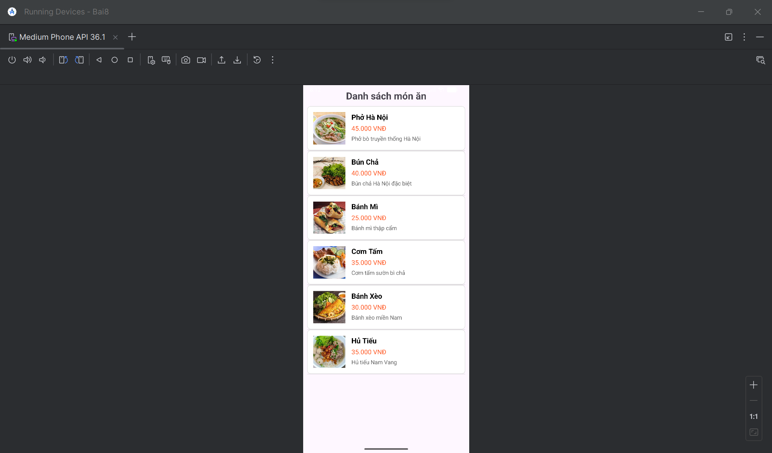
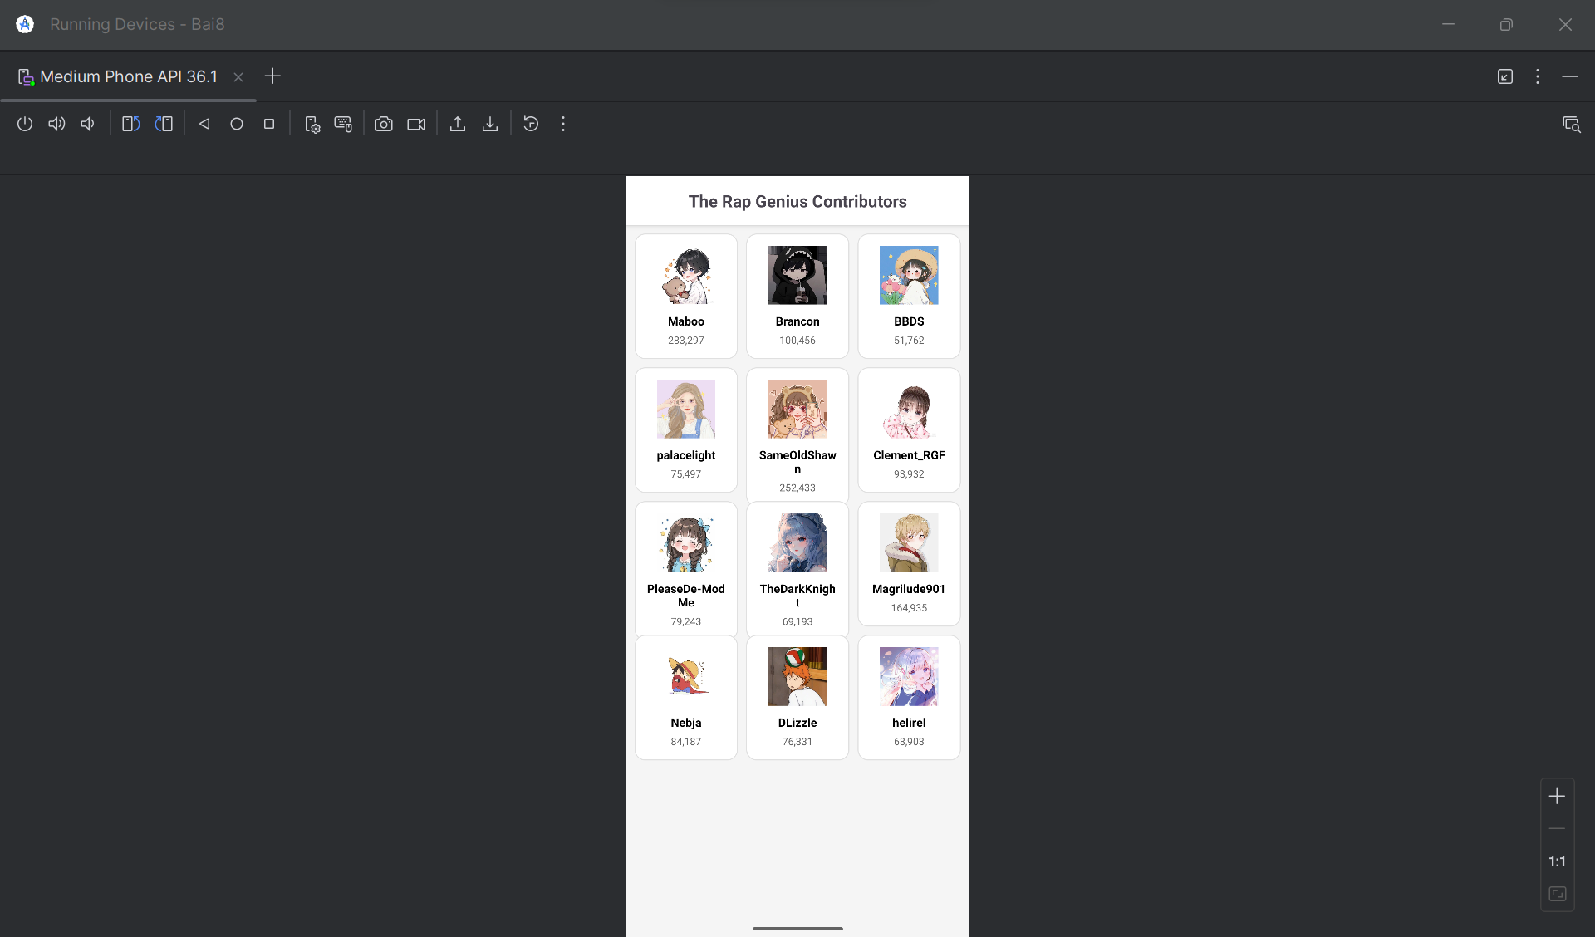
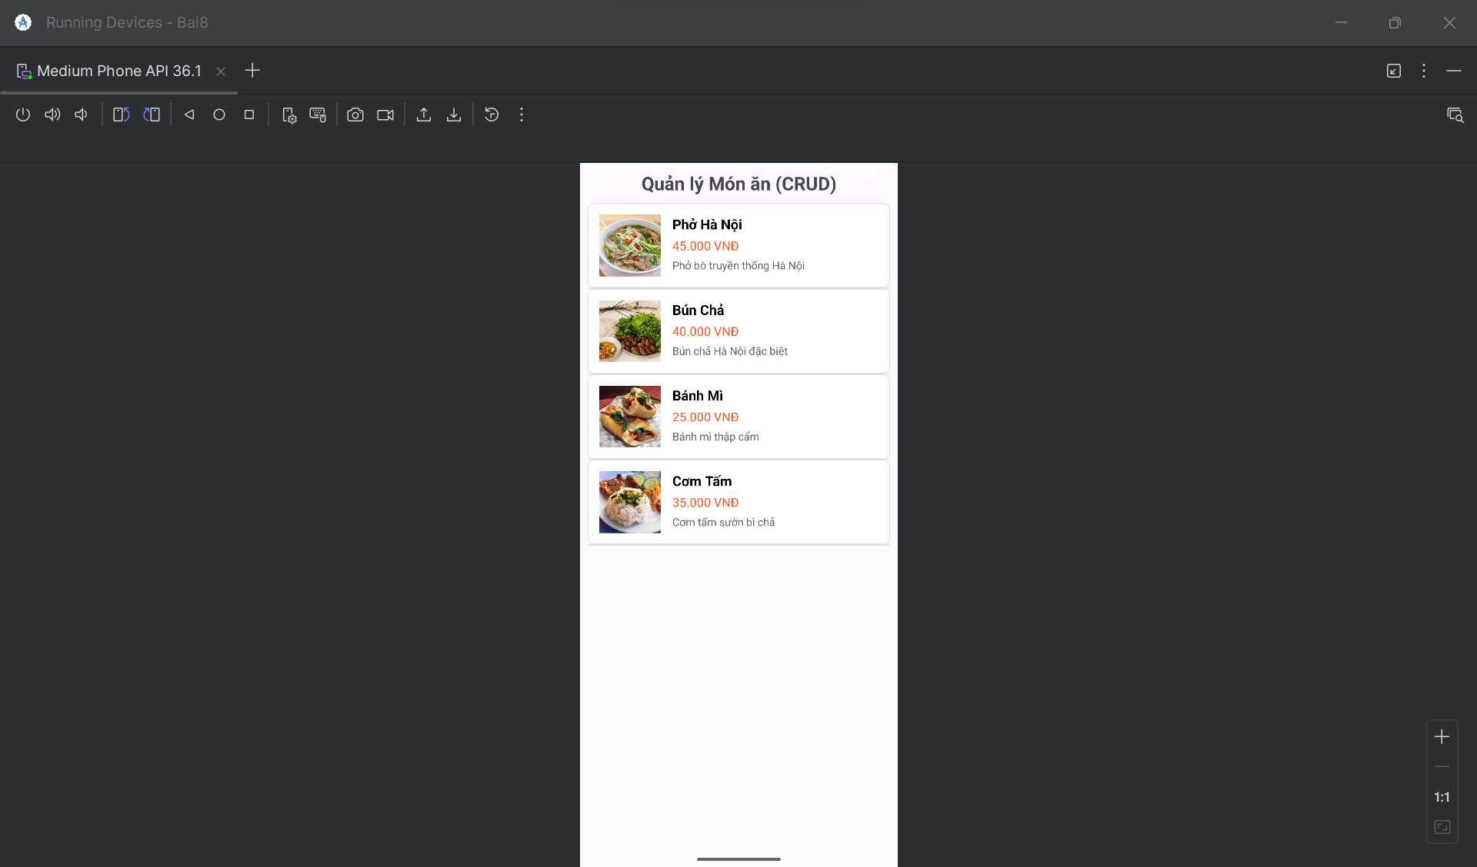
I. TẠO PROJECT MỚI
Bước 1: Mở Android Studio và tạo project mới
- File → New → New Project
- Chọn "Empty Views Activity"
- Đặt tên: Bai8
- Package name: com.example.bai8
- Language: Java
- Minimum SDK: API 21 (Android 5.0)
Bước 2: Chờ Android Studio tạo project xong
II. TẠO CÁC LỚP MODEL
1. Tạo lớp Food.java
Trong thư mục java/com.example.bai8, chuột phải → New → Java Class → Đặt tên Food
java
package com.example.bai8;

public class Food {
public int image;
public String name;
public String price;
public String description;

public Food(int image, String name, String price, String description) {
this.image = image;
this.name = name;
this.price = price;
this.description = description;
}
}
2. Tạo lớp Contributor.java
Chuột phải → New → Java Class → Đặt tên Contributor
java
package com.example.bai8;

public class Contributor {
public String name;
public String points;
public int avatar;

public Contributor(String name, String points, int avatar) {
this.name = name;
this.points = points;
this.avatar = avatar;
}
}
III. TẠO CÁC LAYOUT
1. Sửa file activity_main.xml
Mở res/layout/activity_main.xml và thay thế bằng:
xml
<?xml version="1.0" encoding="utf-8"?>
<FrameLayout xmlns:android="http://schemas.android.com/apk/res/android"
android:layout_width="match_parent"
android:layout_height="match_parent">

<!-- Main Menu -->
<LinearLayout
android:id="@+id/main_layout"
android:layout_width="match_parent"
android:layout_height="match_parent"
android:orientation="vertical"
android:padding="16dp"
android:background="#F5F5F5">

<TextView
android:layout_width="match_parent"
android:layout_height="wrap_content"
android:text="Ứng dụng Quản lý Món ăn"
android:textSize="24sp"
android:textStyle="bold"
android:gravity="center"
android:layout_marginBottom="30dp"
android:textColor="#333333" />

<Button
android:id="@+id/btnListView"
android:layout_width="match_parent"
android:layout_height="wrap_content"
android:text="Bài 1: ListView Món ăn"
android:textSize="16sp"
android:padding="15dp"
android:layout_marginBottom="15dp"
android:background="#4CAF50"
android:textColor="#FFFFFF" />

<Button
android:id="@+id/btnGridView"
android:layout_width="match_parent"
android:layout_height="wrap_content"
android:text="Bài 2: GridView Contributors"
android:textSize="16sp"
android:padding="15dp"
android:layout_marginBottom="15dp"
android:background="#2196F3"
android:textColor="#FFFFFF" />

<Button
android:id="@+id/btnCRUD"
android:layout_width="match_parent"
android:layout_height="wrap_content"
android:text="Bài 3: CRUD với Context Menu"
android:textSize="16sp"
android:padding="15dp"
android:background="#FF9800"
android:textColor="#FFFFFF" />

</LinearLayout>

<!-- List View -->
<LinearLayout
android:id="@+id/list_layout"
android:layout_width="match_parent"
android:layout_height="match_parent"
android:orientation="vertical"
android:padding="10dp"
android:visibility="gone">

<TextView
android:layout_width="match_parent"
android:layout_height="wrap_content"
android:text="Danh sách món ăn"
android:textSize="24sp"
android:textStyle="bold"
android:gravity="center"
android:layout_marginBottom="10dp" />

<ListView
android:id="@+id/listViewFood"
android:layout_width="match_parent"
android:layout_height="match_parent" />

</LinearLayout>

<!-- Grid View -->
<LinearLayout
android:id="@+id/grid_layout"
android:layout_width="match_parent"
android:layout_height="match_parent"
android:orientation="vertical"
android:background="#F5F5F5"
android:visibility="gone">

<TextView
android:layout_width="match_parent"
android:layout_height="wrap_content"
android:text="The Rap Genius Contributors"
android:textSize="20sp"
android:textStyle="bold"
android:gravity="center"
android:padding="16dp"
android:background="#FFFFFF"
android:elevation="4dp" />

<GridView
android:id="@+id/gridView"
android:layout_width="match_parent"
android:layout_height="match_parent"
android:numColumns="3"
android:verticalSpacing="10dp"
android:horizontalSpacing="10dp"
android:padding="10dp"
android:stretchMode="columnWidth" />

</LinearLayout>

<!-- CRUD View -->
<LinearLayout
android:id="@+id/crud_layout"
android:layout_width="match_parent"
android:layout_height="match_parent"
android:orientation="vertical"
android:padding="10dp"
android:visibility="gone">

<TextView
android:layout_width="match_parent"
android:layout_height="wrap_content"
android:text="Quản lý Món ăn (CRUD)"
android:textSize="24sp"
android:textStyle="bold"
android:gravity="center"
android:layout_marginBottom="10dp" />

<ListView
android:id="@+id/listViewFoodCRUD"
android:layout_width="match_parent"
android:layout_height="match_parent" />

</LinearLayout>

</FrameLayout>
2. Tạo layout item_food.xml
Chuột phải thư mục res/layout → New → Layout Resource File → Đặt tên item_food
xml
<?xml version="1.0" encoding="utf-8"?>
<LinearLayout xmlns:android="http://schemas.android.com/apk/res/android"
android:layout_width="match_parent"
android:layout_height="wrap_content"
android:orientation="horizontal"
android:padding="15dp"
android:background="@drawable/border_background"
android:layout_margin="5dp">

<ImageView
android:id="@+id/imgFood"
android:layout_width="80dp"
android:layout_height="80dp"
android:scaleType="centerCrop"
android:background="#E0E0E0" />

<LinearLayout
android:layout_width="0dp"
android:layout_height="wrap_content"
android:layout_weight="1"
android:orientation="vertical"
android:layout_marginLeft="15dp">

<TextView
android:id="@+id/txtFoodName"
android:layout_width="match_parent"
android:layout_height="wrap_content"
android:textSize="18sp"
android:textStyle="bold"
android:textColor="#000000" />

<TextView
android:id="@+id/txtFoodPrice"
android:layout_width="match_parent"
android:layout_height="wrap_content"
android:textSize="16sp"
android:textColor="#FF5722"
android:layout_marginTop="5dp" />

<TextView
android:id="@+id/txtFoodDescription"
android:layout_width="match_parent"
android:layout_height="wrap_content"
android:textSize="14sp"
android:textColor="#666666"
android:layout_marginTop="5dp" />
</LinearLayout>

</LinearLayout>
3. Tạo layout item_contributor.xml
Chuột phải thư mục res/layout → New → Layout Resource File → Đặt tên item_contributor
xml
<?xml version="1.0" encoding="utf-8"?>
<LinearLayout xmlns:android="http://schemas.android.com/apk/res/android"
android:layout_width="match_parent"
android:layout_height="wrap_content"
android:orientation="vertical"
android:gravity="center"
android:padding="15dp"
android:background="@drawable/grid_item_background">

<ImageView
android:id="@+id/imgAvatar"
android:layout_width="70dp"
android:layout_height="70dp"
android:scaleType="centerCrop"
android:background="#E0E0E0"
android:layout_marginBottom="10dp" />

<TextView
android:id="@+id/txtName"
android:layout_width="match_parent"
android:layout_height="wrap_content"
android:gravity="center"
android:textSize="14sp"
android:textStyle="bold"
android:textColor="#000000" />

<TextView
android:id="@+id/txtPoints"
android:layout_width="match_parent"
android:layout_height="wrap_content"
android:gravity="center"
android:textSize="12sp"
android:textColor="#666666"
android:layout_marginTop="5dp" />

</LinearLayout>
4. Tạo layout dialog_add_food.xml
Chuột phải thư mục res/layout → New → Layout Resource File → Đặt tên dialog_add_food
xml
<?xml version="1.0" encoding="utf-8"?>
<LinearLayout xmlns:android="http://schemas.android.com/apk/res/android"
android:layout_width="match_parent"
android:layout_height="wrap_content"
android:orientation="vertical"
android:padding="20dp">

<TextView
android:layout_width="match_parent"
android:layout_height="wrap_content"
android:text="Thêm món ăn mới"
android:textSize="18sp"
android:textStyle="bold"
android:gravity="center"
android:layout_marginBottom="20dp" />

<EditText
android:id="@+id/edtFoodName"
android:layout_width="match_parent"
android:layout_height="wrap_content"
android:hint="Tên món ăn"
android:layout_marginBottom="10dp" />

<EditText
android:id="@+id/edtFoodPrice"
android:layout_width="match_parent"
android:layout_height="wrap_content"
android:hint="Giá"
android:inputType="number"
android:layout_marginBottom="10dp" />

<EditText
android:id="@+id/edtFoodDescription"
android:layout_width="match_parent"
android:layout_height="wrap_content"
android:hint="Mô tả"
android:minLines="3"
android:layout_marginBottom="20dp" />

</LinearLayout>
IV. TẠO CÁC DRAWABLE
1. Tạo border_background.xml
Chuột phải thư mục res/drawable → New → Drawable Resource File → Đặt tên border_background
xml
<?xml version="1.0" encoding="utf-8"?>
<shape xmlns:android="http://schemas.android.com/apk/res/android">
<solid android:color="#FFFFFF"/>
<stroke android:width="1dp" android:color="#E0E0E0"/>
<corners android:radius="8dp"/>
<padding android:left="5dp" android:top="5dp" android:right="5dp" android:bottom="5dp"/>
</shape>
2. Tạo grid_item_background.xml
Chuột phải thư mục res/drawable → New → Drawable Resource File → Đặt tên grid_item_background
xml
<?xml version="1.0" encoding="utf-8"?>
<shape xmlns:android="http://schemas.android.com/apk/res/android">
<solid android:color="#FFFFFF"/>
<stroke android:width="1dp" android:color="#E0E0E0"/>
<corners android:radius="12dp"/>
<padding android:left="8dp" android:top="8dp" android:right="8dp" android:bottom="8dp"/>
</shape>
V. TẠO CÁC MENU
1. Tạo main_menu.xml
Chuột phải thư mục res → New → Android Resource Directory → Resource type: menu
Chuột phải thư mục res/menu → New → Menu Resource File → Đặt tên main_menu
xml
<?xml version="1.0" encoding="utf-8"?>
<menu xmlns:android="http://schemas.android.com/apk/res/android">
<item
android:id="@+id/menu_add"
android:title="Thêm món ăn"
android:icon="@android:drawable/ic_menu_add" />
</menu>
2. Tạo context_menu_food.xml
Chuột phải thư mục res/menu → New → Menu Resource File → Đặt tên context_menu_food
xml
<?xml version="1.0" encoding="utf-8"?>
<menu xmlns:android="http://schemas.android.com/apk/res/android">
<item
android:id="@+id/menu_edit"
android:title="Sửa" />
<item
android:id="@+id/menu_delete"
android:title="Xóa" />
</menu>
VI. TẠO CÁC ADAPTER
1. Tạo FoodAdapter.java
Chuột phải thư mục java/com.example.bai8 → New → Java Class → Đặt tên FoodAdapter
java
package com.example.bai8;

import android.content.Context;
import android.view.LayoutInflater;
import android.view.View;
import android.view.ViewGroup;
import android.widget.BaseAdapter;
import android.widget.ImageView;
import android.widget.TextView;
import java.util.ArrayList;

public class FoodAdapter extends BaseAdapter {
private ArrayList<Food> foodList;
private Context context;

public FoodAdapter(Context context, ArrayList<Food> foodList) {
this.context = context;
this.foodList = foodList;
}

@Override
public int getCount() {
return foodList.size();
}

@Override
public Object getItem(int position) {
return foodList.get(position);
}

@Override
public long getItemId(int position) {
return position;
}

@Override
public View getView(int position, View convertView, ViewGroup parent) {
if (convertView == null) {
convertView = LayoutInflater.from(context).inflate(R.layout.item_food, parent, false);
}

Food food = foodList.get(position);

ImageView imgFood = convertView.findViewById(R.id.imgFood);
TextView txtFoodName = convertView.findViewById(R.id.txtFoodName);
TextView txtFoodPrice = convertView.findViewById(R.id.txtFoodPrice);
TextView txtFoodDescription = convertView.findViewById(R.id.txtFoodDescription);

imgFood.setImageResource(food.image);
txtFoodName.setText(food.name);
txtFoodPrice.setText(food.price);
txtFoodDescription.setText(food.description);

return convertView;
}
}
2. Tạo ContributorAdapter.java
Chuột phải thư mục java/com.example.bai8 → New → Java Class → Đặt tên ContributorAdapter
java
package com.example.bai8;

import android.content.Context;
import android.view.LayoutInflater;
import android.view.View;
import android.view.ViewGroup;
import android.widget.BaseAdapter;
import android.widget.ImageView;
import android.widget.TextView;
import java.util.ArrayList;

public class ContributorAdapter extends BaseAdapter {
private ArrayList<Contributor> contributorList;
private Context context;

public ContributorAdapter(Context context, ArrayList<Contributor> contributorList) {
this.context = context;
this.contributorList = contributorList;
}

@Override
public int getCount() {
return contributorList.size();
}

@Override
public Object getItem(int position) {
return contributorList.get(position);
}

@Override
public long getItemId(int position) {
return position;
}

@Override
public View getView(int position, View convertView, ViewGroup parent) {
if (convertView == null) {
convertView = LayoutInflater.from(context).inflate(R.layout.item_contributor, parent, false);
}

Contributor contributor = contributorList.get(position);

ImageView imgAvatar = convertView.findViewById(R.id.imgAvatar);
TextView txtName = convertView.findViewById(R.id.txtName);
TextView txtPoints = convertView.findViewById(R.id.txtPoints);

imgAvatar.setImageResource(contributor.avatar);
txtName.setText(contributor.name);
txtPoints.setText(contributor.points);

return convertView;
}
}
VII. SỬA FILE MainActivity.java
Mở file MainActivity.java và thay thế toàn bộ nội dung bằng:
java
package com.example.bai8;

import android.app.AlertDialog;
import android.content.DialogInterface;
import android.os.Bundle;
import android.view.ContextMenu;
import android.view.LayoutInflater;
import android.view.Menu;
import android.view.MenuItem;
import android.view.View;
import android.widget.AdapterView;
import android.widget.Button;
import android.widget.EditText;
import android.widget.GridView;
import android.widget.ListView;
import android.widget.Toast;
import androidx.appcompat.app.AppCompatActivity;
import java.util.ArrayList;

public class MainActivity extends AppCompatActivity {

private Button btnListView, btnGridView, btnCRUD;
private ListView listViewFood, listViewFoodCRUD;
private GridView gridView;
private ArrayList<Food> foodList;
private ArrayList<Contributor> contributorList;
private FoodAdapter foodAdapter;
private ContributorAdapter contributorAdapter;

// Các layout view
private View mainView, listView, gridViewLayout, crudView;

@Override
protected void onCreate(Bundle savedInstanceState) {
super.onCreate(savedInstanceState);
setContentView(R.layout.activity_main);

initViews();
setupMainMenu();
initData();
}

private void initViews() {
mainView = findViewById(R.id.main_layout);
listView = findViewById(R.id.list_layout);
gridViewLayout = findViewById(R.id.grid_layout);
crudView = findViewById(R.id.crud_layout);

listViewFood = findViewById(R.id.listViewFood);
listViewFoodCRUD = findViewById(R.id.listViewFoodCRUD);
gridView = findViewById(R.id.gridView);

btnListView = findViewById(R.id.btnListView);
btnGridView = findViewById(R.id.btnGridView);
btnCRUD = findViewById(R.id.btnCRUD);
}

private void setupMainMenu() {
btnListView.setOnClickListener(new View.OnClickListener() {
@Override
public void onClick(View v) {
showListView();
}
});

btnGridView.setOnClickListener(new View.OnClickListener() {
@Override
public void onClick(View v) {
showGridView();
}
});

btnCRUD.setOnClickListener(new View.OnClickListener() {
@Override
public void onClick(View v) {
showCRUDView();
}
});
}

private void showMainView() {
mainView.setVisibility(View.VISIBLE);
listView.setVisibility(View.GONE);
gridViewLayout.setVisibility(View.GONE);
crudView.setVisibility(View.GONE);
}

private void showListView() {
mainView.setVisibility(View.GONE);
listView.setVisibility(View.VISIBLE);
gridViewLayout.setVisibility(View.GONE);
crudView.setVisibility(View.GONE);

foodAdapter = new FoodAdapter(this, foodList);
listViewFood.setAdapter(foodAdapter);
}

private void showGridView() {
mainView.setVisibility(View.GONE);
listView.setVisibility(View.GONE);
gridViewLayout.setVisibility(View.VISIBLE);
crudView.setVisibility(View.GONE);

contributorAdapter = new ContributorAdapter(this, contributorList);
gridView.setAdapter(contributorAdapter);
}

private void showCRUDView() {
mainView.setVisibility(View.GONE);
listView.setVisibility(View.GONE);
gridViewLayout.setVisibility(View.GONE);
crudView.setVisibility(View.VISIBLE);

foodAdapter = new FoodAdapter(this, foodList);
listViewFoodCRUD.setAdapter(foodAdapter);
registerForContextMenu(listViewFoodCRUD);
}

private void initData() {
// Data for ListView - Bài 1
foodList = new ArrayList<>();
foodList.add(new Food(android.R.drawable.ic_media_play, "Phở Hà Nội", "45.000 VNĐ", "Phở bò truyền thống Hà Nội"));
foodList.add(new Food(android.R.drawable.ic_media_play, "Bún Chả", "40.000 VNĐ", "Bún chả Hà Nội đặc biệt"));
foodList.add(new Food(android.R.drawable.ic_media_play, "Bánh Mì", "25.000 VNĐ", "Bánh mì thập cẩm"));
foodList.add(new Food(android.R.drawable.ic_media_play, "Cơm Tấm", "35.000 VNĐ", "Cơm tấm sườn bì chả"));
foodList.add(new Food(android.R.drawable.ic_media_play, "Bánh Xèo", "30.000 VNĐ", "Bánh xèo miền Nam"));
foodList.add(new Food(android.R.drawable.ic_media_play, "Hủ Tiếu", "35.000 VNĐ", "Hủ tiếu Nam Vang"));

// Data for GridView - Bài 2
contributorList = new ArrayList<>();
contributorList.add(new Contributor("Maboo", "283,297", android.R.drawable.sym_def_app_icon));
contributorList.add(new Contributor("Brancon", "100,456", android.R.drawable.sym_def_app_icon));
contributorList.add(new Contributor("BBDS", "51,762", android.R.drawable.sym_def_app_icon));
contributorList.add(new Contributor("palacelight", "75,497", android.R.drawable.sym_def_app_icon));
contributorList.add(new Contributor("SameOldShawn", "252,433", android.R.drawable.sym_def_app_icon));
contributorList.add(new Contributor("Clement_RGF", "93,932", android.R.drawable.sym_def_app_icon));
contributorList.add(new Contributor("PleaseDe-ModMe", "79,243", android.R.drawable.sym_def_app_icon));
contributorList.add(new Contributor("TheDarkKnight", "69,193", android.R.drawable.sym_def_app_icon));
contributorList.add(new Contributor("Magrilude901", "164,935", android.R.drawable.sym_def_app_icon));
}

// CRUD methods - Bài 3
@Override
public boolean onCreateOptionsMenu(Menu menu) {
getMenuInflater().inflate(R.menu.main_menu, menu);
return true;
}

@Override
public boolean onOptionsItemSelected(MenuItem item) {
if (item.getItemId() == R.id.menu_add) {
showAddDialog();
return true;
}
return super.onOptionsItemSelected(item);
}

@Override
public void onCreateContextMenu(ContextMenu menu, View v, ContextMenu.ContextMenuInfo menuInfo) {
super.onCreateContextMenu(menu, v, menuInfo);
getMenuInflater().inflate(R.menu.context_menu_food, menu);
}

@Override
public boolean onContextItemSelected(MenuItem item) {
AdapterView.AdapterContextMenuInfo info = (AdapterView.AdapterContextMenuInfo) item.getMenuInfo();
int position = info.position;

if (item.getItemId() == R.id.menu_edit) {
showEditDialog(position);
return true;
} else if (item.getItemId() == R.id.menu_delete) {
showDeleteDialog(position);
return true;
}
return super.onContextItemSelected(item);
}

private void showAddDialog() {
AlertDialog.Builder builder = new AlertDialog.Builder(this);
LayoutInflater inflater = getLayoutInflater();
View dialogView = inflater.inflate(R.layout.dialog_add_food, null);

final EditText edtFoodName = dialogView.findViewById(R.id.edtFoodName);
final EditText edtFoodPrice = dialogView.findViewById(R.id.edtFoodPrice);
final EditText edtFoodDescription = dialogView.findViewById(R.id.edtFoodDescription);

builder.setView(dialogView)
.setTitle("Thêm món ăn")
.setPositiveButton("Thêm", new DialogInterface.OnClickListener() {
@Override
public void onClick(DialogInterface dialog, int which) {
String name = edtFoodName.getText().toString();
String price = edtFoodPrice.getText().toString();
String description = edtFoodDescription.getText().toString();

if (!name.isEmpty() && !price.isEmpty()) {
foodList.add(new Food(android.R.drawable.ic_media_play, name, price + " VNĐ", description));
foodAdapter.notifyDataSetChanged();
Toast.makeText(MainActivity.this, "Đã thêm món ăn", Toast.LENGTH_SHORT).show();
} else {
Toast.makeText(MainActivity.this, "Vui lòng nhập đầy đủ thông tin", Toast.LENGTH_SHORT).show();
}
}
})
.setNegativeButton("Hủy", null)
.show();
}

private void showEditDialog(final int position) {
AlertDialog.Builder builder = new AlertDialog.Builder(this);
LayoutInflater inflater = getLayoutInflater();
View dialogView = inflater.inflate(R.layout.dialog_add_food, null);

final EditText edtFoodName = dialogView.findViewById(R.id.edtFoodName);
final EditText edtFoodPrice = dialogView.findViewById(R.id.edtFoodPrice);
final EditText edtFoodDescription = dialogView.findViewById(R.id.edtFoodDescription);

Food food = foodList.get(position);
edtFoodName.setText(food.name);
edtFoodPrice.setText(food.price.replace(" VNĐ", ""));
edtFoodDescription.setText(food.description);

builder.setView(dialogView)
.setTitle("Sửa món ăn")
.setPositiveButton("Lưu", new DialogInterface.OnClickListener() {
@Override
public void onClick(DialogInterface dialog, int which) {
String name = edtFoodName.getText().toString();
String price = edtFoodPrice.getText().toString();
String description = edtFoodDescription.getText().toString();

if (!name.isEmpty() && !price.isEmpty()) {
Food updatedFood = new Food(foodList.get(position).image, name, price + " VNĐ", description);
foodList.set(position, updatedFood);
foodAdapter.notifyDataSetChanged();
Toast.makeText(MainActivity.this, "Đã cập nhật món ăn", Toast.LENGTH_SHORT).show();
} else {
Toast.makeText(MainActivity.this, "Vui lòng nhập đầy đủ thông tin", Toast.LENGTH_SHORT).show();
}
}
})
.setNegativeButton("Hủy", null)
.show();
}

private void showDeleteDialog(final int position) {
new AlertDialog.Builder(this)
.setTitle("Xóa món ăn")
.setMessage("Bạn có chắc muốn xóa món ăn '" + foodList.get(position).name + "'?")
.setPositiveButton("Xóa", new DialogInterface.OnClickListener() {
@Override
public void onClick(DialogInterface dialog, int which) {
String deletedName = foodList.get(position).name;
foodList.remove(position);
foodAdapter.notifyDataSetChanged();
Toast.makeText(MainActivity.this, "Đã xóa món ăn: " + deletedName, Toast.LENGTH_SHORT).show();
}
})
.setNegativeButton("Hủy", null)
.show();
}

@Override
public void onBackPressed() {
if (listView.getVisibility() == View.VISIBLE ||
gridViewLayout.getVisibility() == View.VISIBLE ||
crudView.getVisibility() == View.VISIBLE) {
showMainView();
} else {
super.onBackPressed();
}
}
}

