Môn: Lập trình ứng dụng di động
Lớp K11_THMT
Tên: Nguyễn Trần Minh Khang
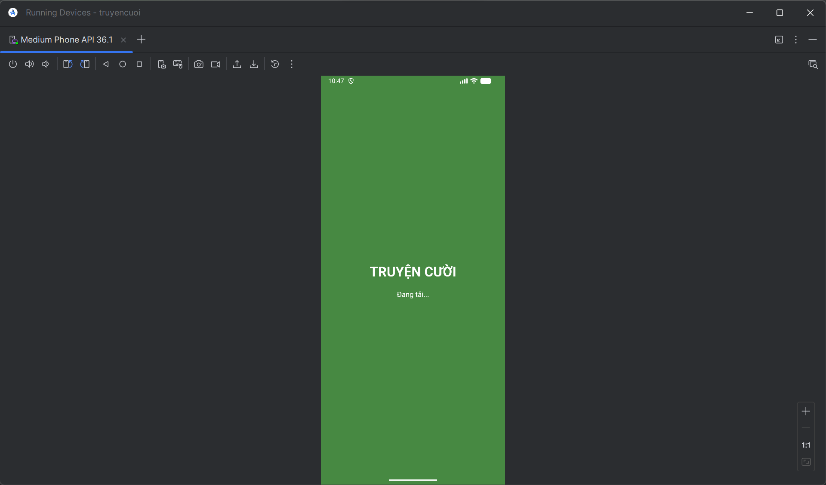
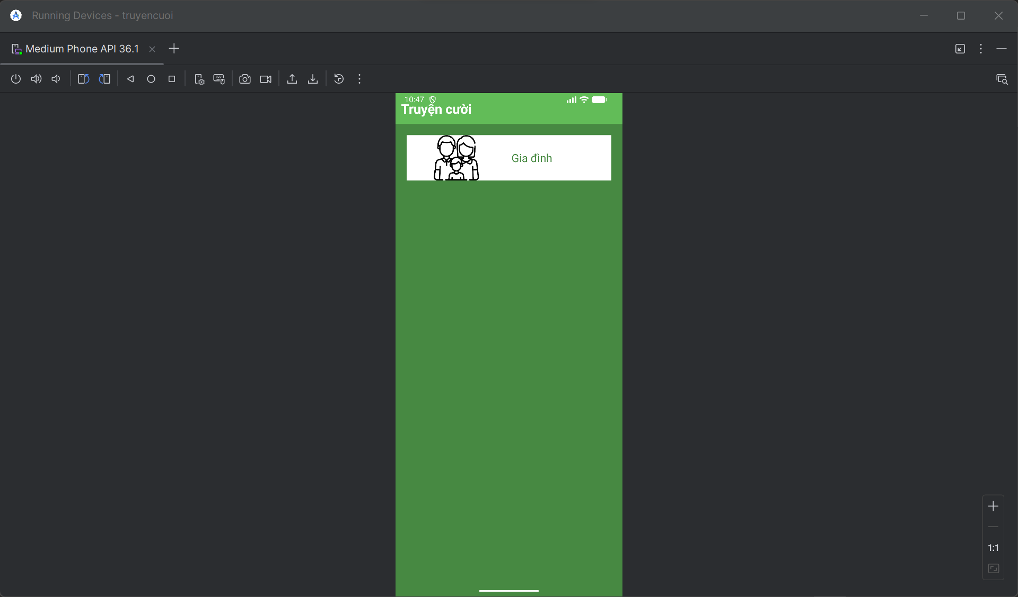
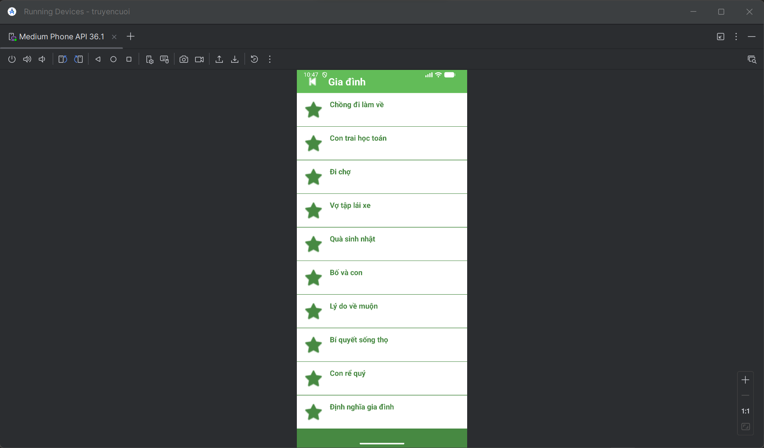
M000SplashFrg.java
package com.techja.truyencuoi;
import android.os.Bundle;
import android.os.Handler;
import android.util.Log;
import android.view.LayoutInflater;
import android.view.View;
import android.view.ViewGroup;
import androidx.fragment.app.Fragment;
public class M000SplashFrg extends Fragment {
private static final String TAG = "M000SplashFrg";
@Override
public View onCreateView(LayoutInflater inflater, ViewGroup container, Bundle savedInstanceState) {
Log.d(TAG, "onCreateView: Tạo view splash");
View view = inflater.inflate(R.layout.m000_frg_splash, container, false);
initViews();
return view;
}
private void initViews() {
Log.d(TAG, "initViews: Bắt đầu đếm ngược 2 giây");
new Handler().postDelayed(() -> {
Log.d(TAG, "initViews: Đã đợi 2 giây, chuyển màn hình");
gotoM001Screen();
}, 2000);
}
private void gotoM001Screen() {
try {
Log.d(TAG, "gotoM001Screen: Gọi MainActivity");
((MainActivity) getActivity()).gotoM001Screen();
} catch (Exception e) {
Log.e(TAG, "Lỗi gotoM001Screen: " + e.getMessage(), e);
}
}
}

M001TopicFrg.java
package com.techja.truyencuoi;
import android.content.Context;
import android.os.Bundle;
import android.util.Log;
import android.view.LayoutInflater;
import android.view.View;
import android.view.ViewGroup;
import android.widget.ImageView;
import android.widget.LinearLayout;
import android.widget.TextView;
import androidx.fragment.app.Fragment;
public class M001TopicFrg extends Fragment implements View.OnClickListener {
private Context mContext;
private static final String TAG = "M001TopicFrg";
@Override
public View onCreateView(LayoutInflater inflater, ViewGroup container, Bundle savedInstanceState) {
View rootView = inflater.inflate(R.layout.m001_frg_topic, container, false);
initViews(rootView);
return rootView;
}
@Override
public void onAttach(Context context) {
super.onAttach(context);
mContext = context;
}
private void initViews(View v) {
LinearLayout lnMain = v.findViewById(R.id.ln_topic);
lnMain.removeAllViews();
try {
// Tạo chủ đề "Gia đình"
View vTopic = LayoutInflater.from(mContext).inflate(R.layout.item_topic, null);
// --- SỬA Ở ĐÂY: KHÔNG can thiệp vào ImageView nữa để nó tự lấy ảnh từ XML ---
// ImageView ivTopic = vTopic.findViewById(R.id.iv_topic);
// ivTopic.setImageResource(android.R.drawable.ic_menu_gallery); // <--- DÒNG NÀY GÂY LỖI MẤT ẢNH
TextView tvTopic = vTopic.findViewById(R.id.tv_topic);
tvTopic.setText("Gia đình");
lnMain.addView(vTopic);
// Chỉnh khoảng cách (Margin)
LinearLayout.LayoutParams params = (LinearLayout.LayoutParams) vTopic.getLayoutParams();
params.bottomMargin = 40;
vTopic.setLayoutParams(params);
// Gắn tag để biết user chọn chủ đề nào
vTopic.setTag("gia_dinh");
vTopic.setOnClickListener(this);
} catch (Exception e) {
e.printStackTrace();
}
}
@Override
public void onClick(View v) {
String topicName = (String) v.getTag();
((MainActivity) getActivity()).gotoM002Screen(topicName);
}
}

M002StoryFrg.java
package com.techja.truyencuoi;
import android.content.Context;
import android.os.Bundle;
import android.view.LayoutInflater;
import android.view.View;
import android.view.ViewGroup;
import android.widget.TextView;
import androidx.fragment.app.Fragment;
import androidx.recyclerview.widget.LinearLayoutManager;
import androidx.recyclerview.widget.RecyclerView;
import java.io.BufferedReader;
import java.io.IOException;
import java.io.InputStreamReader;
import java.util.ArrayList;
public class M002StoryFrg extends Fragment {
private Context mContext;
private ArrayList<StoryEntity> listStory;
private String topicName;
@Override
public View onCreateView(LayoutInflater inflater, ViewGroup container, Bundle savedInstanceState) {
View rootView = inflater.inflate(R.layout.m002_frg_story, container, false);
initViews(rootView);
return rootView;
}
@Override
public void onAttach(Context context) {
super.onAttach(context);
mContext = context;
}
private void initViews(View v) {
v.findViewById(R.id.iv_back).setVisibility(View.VISIBLE);
v.findViewById(R.id.iv_back).setOnClickListener(v1 -> backToM001Screen());
TextView tvName = v.findViewById(R.id.tv_name);
// --- SỬA 1: Hiển thị tên chủ đề đẹp hơn ---
if (topicName.equals("gia_dinh")) {
tvName.setText("Gia đình");
} else {
tvName.setText(topicName);
}
RecyclerView rv = v.findViewById(R.id.rv_story);
listStory = readStory();
StoryAdapter adapter = new StoryAdapter(listStory, mContext);
rv.setAdapter(adapter);
rv.setLayoutManager(new LinearLayoutManager(mContext));
}
private ArrayList<StoryEntity> readStory() {
ArrayList<StoryEntity> listStory = new ArrayList<>();
BufferedReader reader = null;
try {
reader = new BufferedReader(
new InputStreamReader(mContext.getAssets().open("story/" + topicName + ".txt"), "UTF-8"));
String mLine;
// --- SỬA 2: Thuật toán đọc file mới (chống lỗi mất tên truyện) ---
while ((mLine = reader.readLine()) != null) {
// Nếu gặp dòng trống thì bỏ qua, đọc dòng tiếp theo
if (mLine.trim().isEmpty()) {
continue;
}
// Dòng có chữ đầu tiên sẽ là Tiêu đề (Title)
String title = mLine;
// Các dòng tiếp theo là nội dung, đọc cho đến khi gặp ký tự kết thúc ','0'),
StringBuilder contentBuilder = new StringBuilder();
while ((mLine = reader.readLine()) != null) {
if (mLine.contains("','0'),")) {
break; // Dừng lại khi gặp ký tự kết thúc truyện
}
contentBuilder.append(mLine).append("\n");
}
// Tạo đối tượng truyện và thêm vào danh sách
StoryEntity storyEntity = new StoryEntity(topicName, title, contentBuilder.toString());
listStory.add(storyEntity);
}
} catch (IOException e) {
e.printStackTrace();
}
return listStory;
}
public void setTopicName(String topicName) {
this.topicName = topicName;
}
private void backToM001Screen() {
((MainActivity) getActivity()).backToM001Screen();
}
}

MainActivity.java
package com.techja.truyencuoi;
import android.os.Bundle;
import android.widget.Toast;
import androidx.appcompat.app.AppCompatActivity;
import androidx.fragment.app.Fragment;
import java.util.ArrayList;
public class MainActivity extends AppCompatActivity {
private String topicName; // Lưu tên chủ đề đang chọn
@Override
protected void onCreate(Bundle savedInstanceState) {
super.onCreate(savedInstanceState);
setContentView(R.layout.activity_main);
// Bắt đầu vào màn hình Splash
showFrg(new M000SplashFrg());
}
private void showFrg(Fragment frg) {
try {
getSupportFragmentManager().beginTransaction()
.replace(R.id.ln_main, frg, null)
.commit();
} catch (Exception e) {
e.printStackTrace();
}
}
public void gotoM001Screen() {
showFrg(new M001TopicFrg());
}
public void gotoM002Screen(String topicName) {
this.topicName = topicName; // Lưu lại để dùng khi back
M002StoryFrg frg = new M002StoryFrg();
frg.setTopicName(topicName);
showFrg(frg);
}
public void backToM001Screen() {
gotoM001Screen();
}
public void gotoM003Screen(ArrayList<StoryEntity> listStory, StoryEntity story) {
M003DetailStoryFrg frg = new M003DetailStoryFrg();
frg.setData(topicName, listStory, story);
showFrg(frg);
}
// --- QUAN TRỌNG: XỬ LÝ NÚT BACK CỨNG TRÊN ĐIỆN THOẠI ---
@Override
public void onBackPressed() {
// Tìm xem fragment nào đang hiển thị
Fragment currentFrg = getSupportFragmentManager().findFragmentById(R.id.ln_main);
if (currentFrg instanceof M003DetailStoryFrg) {
// Đang đọc truyện -> Quay về danh sách
gotoM002Screen(topicName);
} else if (currentFrg instanceof M002StoryFrg) {
// Đang xem danh sách -> Quay về chọn chủ đề
gotoM001Screen();
} else if (currentFrg instanceof M001TopicFrg) {
// Đang ở màn hình chính -> Thoát App
super.onBackPressed();
} else {
super.onBackPressed();
}
}
}

StoryAdapter.java

package com.techja.truyencuoi;
import android.content.Context;
import android.view.LayoutInflater;
import android.view.View;
import android.view.ViewGroup;
import android.widget.TextView;
import androidx.recyclerview.widget.RecyclerView;
import java.util.ArrayList;
public class StoryAdapter extends RecyclerView.Adapter<StoryAdapter.StoryHolder> {
private final ArrayList<StoryEntity> listStory;
private final Context mContext;
public StoryAdapter(ArrayList<StoryEntity> listStory, Context mContext) {
this.listStory = listStory;
this.mContext = mContext;
}
@Override
public StoryHolder onCreateViewHolder(ViewGroup parent, int viewType) {
View view = LayoutInflater.from(mContext).inflate(R.layout.item_story, parent, false);
return new StoryHolder(view);
}
@Override
public void onBindViewHolder(StoryAdapter.StoryHolder holder, int position) {
StoryEntity item = listStory.get(position);
holder.tvName.setTag(item);
holder.tvName.setText(item.getName());
}
@Override
public int getItemCount() {
return listStory.size();
}
public class StoryHolder extends RecyclerView.ViewHolder {
TextView tvName;
public StoryHolder(View itemView) {
super(itemView);
// SỬA DÒNG NÀY - đổi từ tv_story sang tv_name
tvName = itemView.findViewById(R.id.tv_name);
itemView.setOnClickListener(v -> {
((MainActivity) mContext).gotoM003Screen(listStory, (StoryEntity) tvName.getTag());
});
}
}
}

StoryEntity.java
package com.techja.truyencuoi;
public class StoryEntity {
private final String topicName;
private final String name;
private final String content;
public StoryEntity(String topicName, String name, String content) {
this.topicName = topicName;
this.name = name;
this.content = content;
}
public String getTopicName() {
return topicName;
}
public String getName() {
return name;
}
public String getContent() {
return content;
}
}

DetailStoryAdapter.java
package com.techja.truyencuoi;
import android.content.Context;
import android.view.LayoutInflater;
import android.view.View;
import android.view.ViewGroup;
import android.widget.TextView;
import androidx.annotation.NonNull;
import androidx.viewpager.widget.PagerAdapter;
import java.util.List;
public class DetailStoryAdapter extends PagerAdapter {
private final List<StoryEntity> listStory;
private final Context mContext;
public DetailStoryAdapter(List<StoryEntity> listStory, Context mContext) {
this.listStory = listStory;
this.mContext = mContext;
}
@Override
public Object instantiateItem(ViewGroup container, int position) {
View view = LayoutInflater.from(mContext).inflate(R.layout.item_detail_story, container, false);
StoryEntity item = listStory.get(position);
TextView tvName = view.findViewById(R.id.tv_name);
TextView tvContent = view.findViewById(R.id.tv_content);
tvName.setTag(item);
tvName.setText(item.getName());
tvContent.setText(item.getContent());
container.addView(view);
return view;
}
@Override
public int getCount() {
return listStory.size();
}
@Override
public boolean isViewFromObject(View view, Object object) {
return view.equals(object);
}
@Override
public void destroyItem(ViewGroup container, int position, Object object) {
container.removeView((View) object);
}
}

AndroidManifest.xml
<?xml version="1.0" encoding="utf-8"?>
<manifest xmlns:android="http://schemas.android.com/apk/res/android"
package="com.techja.truyencuoi">

<application
android:allowBackup="true"
android:icon="@mipmap/ic_launcher"
android:label="@string/app_name"
android:theme="@style/Theme.Demo">

<activity
android:name=".MainActivity"
android:exported="true">
<intent-filter>
<action android:name="android.intent.action.MAIN" />
<category android:name="android.intent.category.LAUNCHER" />
</intent-filter>
</activity>
</application>
</manifest>

colors.xml
<?xml version="1.0" encoding="utf-8"?>
<resources>
<color name="purple_200">#FFBB86FC</color>
<color name="purple_500">#FF6200EE</color>
<color name="purple_700">#FF3700B3</color>
<color name="teal_200">#FF03DAC5</color>
<color name="teal_700">#FF018786</color>
<color name="black">#FF000000</color>
<color name="white">#FFFFFFFF</color>
<color name="greenMid">#478942</color>
<color name="greenLight">#62BC58</color>
<color name="greenSuperLight">#EFFFEE</color>
</resources>

Strings.xml
<resources>
<string name="app_name">TruyenCuoi</string>
<string name="txt_congai">Con gái</string>
<string name="txt_story">Vừa đúng vừa sai</string>
<string name="txt_gia_dinh">Gia đình</string>
</resources>

File: themes.xml
<resources xmlns:tools="http://schemas.android.com/tools">
<style name="Theme.Demo" parent="Theme.MaterialComponents.DayNight.NoActionBar">
<item name="colorPrimary">@color/purple_500</item>
<item name="colorPrimaryVariant">@color/purple_700</item>
<item name="colorOnPrimary">@color/white</item>
<item name="colorSecondary">@color/teal_200</item>
<item name="colorSecondaryVariant">@color/teal_700</item>
<item name="colorOnSecondary">@color/black</item>
<item name="android:statusBarColor" tools:targetApi="l">?attr/colorPrimaryVariant</item>
</style>
</resources>

File: activity_main.xml (Khung chứa chính của ứng dụng)
<?xml version="1.0" encoding="utf-8"?>
<LinearLayout xmlns:android="http://schemas.android.com/apk/res/android"
xmlns:tools="http://schemas.android.com/tools"
android:layout_width="match_parent"
android:layout_height="match_parent"
android:id="@+id/ln_main"
tools:context=".MainActivity"
android:orientation="vertical">
</LinearLayout>
File: actionbar_home.xml (Thanh tiêu đề màu xanh ở trên cùng có nút Back)
<?xml version="1.0" encoding="utf-8"?>
<LinearLayout xmlns:android="http://schemas.android.com/apk/res/android"
xmlns:app="http://schemas.android.com/apk/res-auto"
android:layout_width="match_parent"
android:layout_height="56dp"
android:background="@color/greenLight"
android:orientation="horizontal">

<ImageView
android:id="@+id/iv_back"
android:layout_width="56dp"
android:layout_height="56dp"
android:layout_marginStart="10dp"
android:padding="10dp"
android:src="@android:drawable/ic_media_previous"
android:visibility="gone"
app:tint="@color/white"/>

<TextView
android:id="@+id/tv_name"
android:layout_width="match_parent"
android:layout_height="match_parent"
android:layout_marginStart="10dp"
android:gravity="center_vertical"
android:text="Truyện cười"
android:textColor="@color/white"
android:textSize="24sp"
android:textStyle="bold"/>
</LinearLayout>
File: m000_frg_splash.xml (Màn hình chờ lúc mở app)
<?xml version="1.0" encoding="utf-8"?>
<LinearLayout xmlns:android="http://schemas.android.com/apk/res/android"
android:layout_width="match_parent"
android:layout_height="match_parent"
android:background="@color/greenMid"
android:gravity="center"
android:orientation="vertical">

<TextView
android:layout_width="wrap_content"
android:layout_height="wrap_content"
android:text="TRUYỆN CƯỜI"
android:textColor="@color/white"
android:textSize="30sp"
android:textStyle="bold"/>

<TextView
android:layout_width="wrap_content"
android:layout_height="wrap_content"
android:text="Đang tải..."
android:textColor="@color/white"
android:textSize="16sp"
android:layout_marginTop="20dp"/>
</LinearLayout>
File: m001_frg_topic.xml (Màn hình 1 - Chứa nút chọn chủ đề)
<?xml version="1.0" encoding="utf-8"?>
<LinearLayout xmlns:android="http://schemas.android.com/apk/res/android"
android:layout_width="match_parent"
android:layout_height="match_parent"
android:background="@color/greenMid"
android:orientation="vertical">

<!-- Nhúng thanh tiêu đề vào -->
<include layout="@layout/actionbar_home"/>

<ScrollView
android:layout_width="match_parent"
android:layout_height="match_parent">

<LinearLayout
android:id="@+id/ln_topic"
android:layout_width="match_parent"
android:layout_height="wrap_content"
android:orientation="vertical"
android:padding="20dp"/>
</ScrollView>
</LinearLayout>
File: item_topic.xml (Giao diện của cái nút "Gia đình")
<?xml version="1.0" encoding="utf-8"?>
<LinearLayout xmlns:android="http://schemas.android.com/apk/res/android"
xmlns:tools="http://schemas.android.com/tools"
android:layout_width="match_parent"
android:layout_height="wrap_content"
android:background="@color/white"
android:layout_marginBottom="10dp"
android:orientation="horizontal"
tools:ignore="UseCompoundDrawables">

<ImageView
android:id="@+id/iv_topic"
android:layout_width="180dp"
android:layout_height="82dp"
android:src="@drawable/gia_dinh"
tools:ignore="ContentDescription"/>

<TextView
android:id="@+id/tv_topic"
android:layout_width="match_parent"
android:layout_height="match_parent"
android:layout_marginStart="10dp"
android:fontFamily="sans-serif"
android:gravity="center_vertical"
android:text="@string/txt_gia_dinh"
android:textColor="@color/greenMid"
android:textSize="20sp"/>
</LinearLayout>
File: m002_frg_story.xml (Màn hình 2 - Danh sách các truyện)
<?xml version="1.0" encoding="utf-8"?>
<LinearLayout xmlns:android="http://schemas.android.com/apk/res/android"
xmlns:tools="http://schemas.android.com/tools"
android:layout_width="match_parent"
android:layout_height="match_parent"
android:background="@color/greenMid"
android:orientation="vertical">

<include layout="@layout/actionbar_home"/>

<androidx.recyclerview.widget.RecyclerView
android:id="@+id/rv_story"
android:layout_width="match_parent"
android:layout_height="match_parent"
tools:listitem="@layout/item_story"/>
</LinearLayout>
File: item_story.xml (Giao diện 1 dòng tên truyện trong danh sách)
<?xml version="1.0" encoding="utf-8"?>
<LinearLayout xmlns:android="http://schemas.android.com/apk/res/android"
xmlns:app="http://schemas.android.com/apk/res-auto"
android:layout_width="match_parent"
android:layout_height="80dp"
android:background="@color/white"
android:orientation="horizontal"
android:padding="15dp"
android:layout_marginBottom="1dp">

<ImageView
android:layout_width="50dp"
android:layout_height="50dp"
android:src="@android:drawable/btn_star_big_on"
app:tint="@color/greenMid"/>

<TextView
android:id="@+id/tv_name"
android:layout_width="match_parent"
android:layout_height="wrap_content"
android:layout_marginStart="15dp"
android:gravity="center_vertical"
android:text="Truyện cười"
android:textColor="@color/greenMid"
android:textSize="18sp"
android:textStyle="bold"/>
</LinearLayout>
File: item_detail_story.xml (Nội dung chi tiết của 1 truyện bên trong ViewPager)
<?xml version="1.0" encoding="utf-8"?>
<LinearLayout xmlns:android="http://schemas.android.com/apk/res/android"
android:layout_width="match_parent"
android:layout_height="match_parent"
android:orientation="vertical"
android:padding="10dp">

<TextView
android:id="@+id/tv_name"
android:layout_width="match_parent"
android:layout_height="wrap_content"
android:layout_marginTop="20dp"
android:gravity="center"
android:padding="10dp"
android:text="Vợ đúng vợ sai"
android:textColor="@color/greenMid"
android:textSize="24sp"
android:textStyle="bold"/>

<ScrollView
android:layout_width="match_parent"
android:layout_height="match_parent">

<LinearLayout
android:layout_width="match_parent"
android:layout_height="wrap_content"
android:orientation="vertical">

<TextView
android:id="@+id/tv_content"
android:layout_width="match_parent"
android:layout_height="wrap_content"
android:fontFamily="sans-serif-light"
android:gravity="center_vertical"
android:lineSpacingExtra="5dp"
android:padding="10dp"
android:text="Nội dung truyện"
android:textColor="@color/black"
android:textSize="18sp"/>
</LinearLayout>
</ScrollView>
</LinearLayout>

