AWS Serverless Granularity Research
Data Analysis Report for G1-G4 Lambda Decomposition Experiment
Generated from dataFinal.zip

1. Executive Summary
Scope. This report analyzes the final experimental dataset for four serverless granularity levels, G1 through G4, with three memory configurations per level: 128 MB, 512 MB, and 1024 MB. The workload target was 1000 requests per hour, and each Artillery scenario produced 1180 external HTTP requests over approximately 63 minutes.
Main result. The lowest mean end-to-end latency was observed at G3-512 MB with 359.9 ms. The lowest p95 latency was observed at G3-1024 MB with 376.2 ms, although that scenario also had the only non-perfect success rate in the dataset. The lowest estimated marginal cost was G1-128 MB at $0.001550 per 1,000 external requests.
Interpretation. The data does not support a simple claim that finer decomposition always improves performance. G2 and G3 improve end-to-end latency relative to G1 in most memory settings, but G4 introduces enough orchestration overhead to become slower and more expensive. The best practical trade-off is not the most granular design: G2-128 is attractive when cost is weighted heavily, while G3-512 is strongest when latency is prioritized.

2. Key Findings
Metric | Scenario | Value
Best mean latency | G3-512 MB | 359.9 ms
Best p95 latency | G3-1024 MB | 376.2 ms
Lowest estimated cost | G1-128 MB | $0.001550/1k requests
Best composite cost-latency score | G1-128 MB | 1.161
Only failed scenario | G3-1024 MB | 1179/1180 successful requests

3. Research Framing
Research question: How does Lambda function granularity affect end-to-end latency, tail latency, reliability, and marginal execution cost for an order-processing workflow implemented on AWS serverless infrastructure?
Hypothesis H1: Splitting the workflow from G1 to moderate granularity levels reduces end-to-end latency by separating responsibilities and reducing per-function execution time.
Hypothesis H2: Excessive decomposition increases coordination overhead and therefore increases latency and cost.
Hypothesis H3: Higher memory allocation can reduce latency, but not always enough to compensate for higher GB-second cost.
Hypothesis H4: Reliability remains stable across granularity levels when orchestration and child function invocations are correctly implemented.

4. Variables and Measurement Protocol
Category | Variable | Operationalization
Independent variable | Granularity level | G1, G2, G3, G4
Independent variable | Lambda memory | 128 MB, 512 MB, 1024 MB
Controlled variable | Workload | Target 1000 requests/hour; observed 1180 requests/scenario
Controlled variable | Region/runtime | AWS Lambda Node.js on Arm64, API Gateway HTTP API
Dependent variable | Client-side latency | Artillery http.response_time: mean, p95, p99, max
Dependent variable | Reliability | HTTP 2xx success count and success rate
Dependent variable | Lambda-side runtime | CloudWatch REPORT Duration and Billed Duration
Dependent variable | Cost | Estimated marginal Lambda compute + Lambda requests + HTTP API requests
Cost model. The report uses marginal cost rather than free-tier-adjusted monthly billing, because the purpose is experimental comparison. Lambda compute cost is calculated from modeled GB-seconds using Arm duration pricing. Lambda request cost is charged per Lambda invocation; API Gateway cost is charged per external HTTP request. Data transfer, CloudWatch Logs ingestion, X-Ray, and free-tier credits are excluded from the comparative estimate.
Pricing sources used: AWS Lambda Pricing (https://aws.amazon.com/lambda/pricing/) and Amazon API Gateway Pricing (https://aws.amazon.com/api-gateway/pricing/).

5. Scenario-Level Results
Scenario | Req. | Success | Mean ms | p95 ms | p99 ms | Comp. | Billed ms | Cost/1k
G1-128 | 1180 | 100.00% | 475.6 | 487.9 | 518.1 | 1 | 209.7 | $0.001550
G1-512 | 1180 | 100.00% | 476.5 | 487.9 | 550.1 | 1 | 208.7 | $0.002592
G1-1024 | 1180 | 100.00% | 485.7 | 497.8 | 550.1 | 1 | 208.8 | $0.003985
G2-128 | 1180 | 100.00% | 385.7 | 441.5 | 584.2 | 4 | 205.9 | $0.002143
G2-512 | 1180 | 100.00% | 371.5 | 383.8 | 415.8 | 4 | 191.0 | $0.003073
G2-1024 | 1180 | 100.00% | 374.8 | 391.6 | 424.2 | 4 | 191.2 | $0.004349
G3-128 | 1180 | 100.00% | 453.5 | 608.0 | 804.5 | 7 | 227.3 | $0.002779
G3-512 | 1180 | 100.00% | 359.9 | 383.8 | 450.4 | 7 | 115.4 | $0.003084
G3-1024 | 1180 | 99.92% | 363.0 | 376.2 | 432.7 | 7 | 125.6 | $0.003876
G4-128 | 1180 | 100.00% | 621.4 | 871.5 | 1107.9 | 13 | 399.2 | $0.004265
G4-512 | 1180 | 100.00% | 468.3 | 561.2 | 713.5 | 13 | 230.0 | $0.004947
G4-1024 | 1180 | 100.00% | 470.6 | 572.6 | 757.6 | 13 | 231.6 | $0.006252
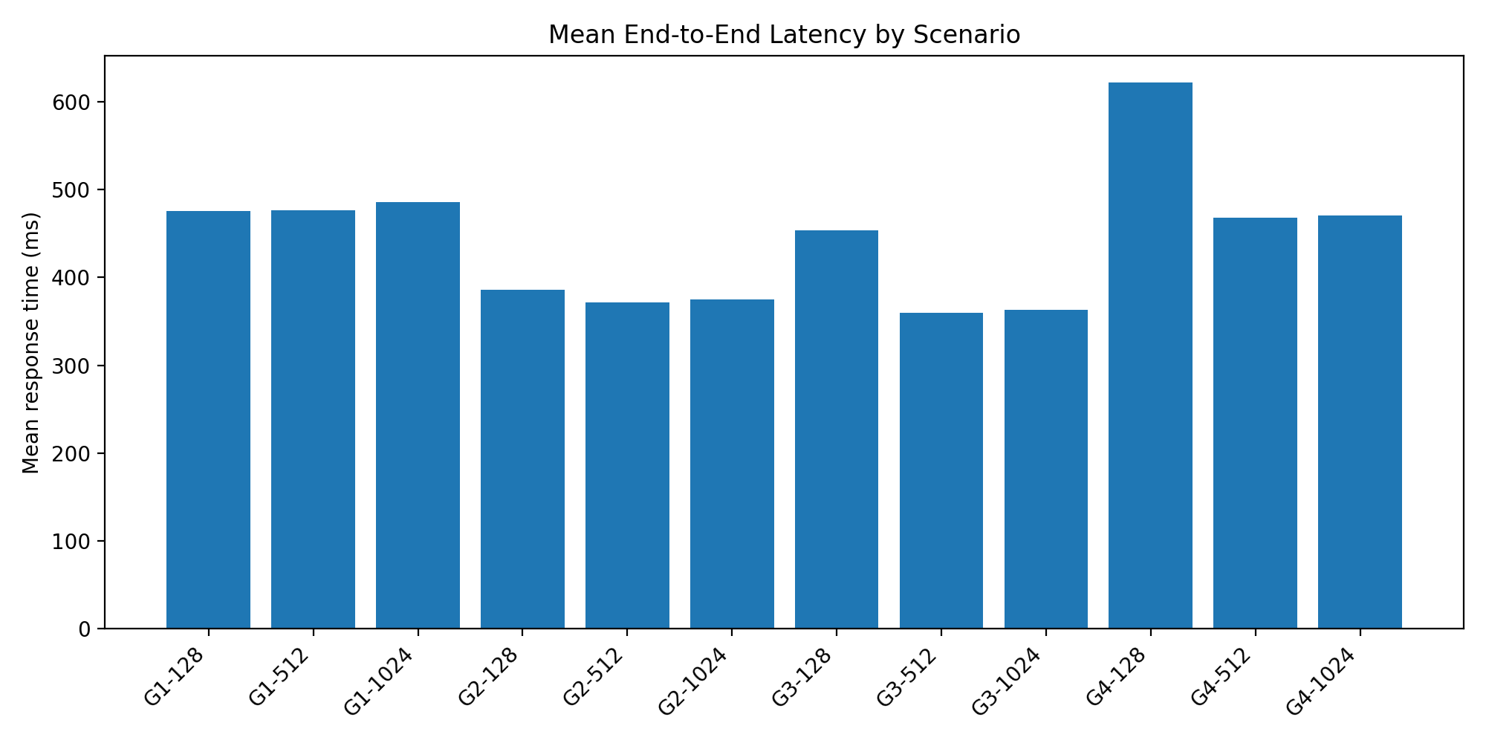
Figure 1. Mean end-to-end latency by scenario.
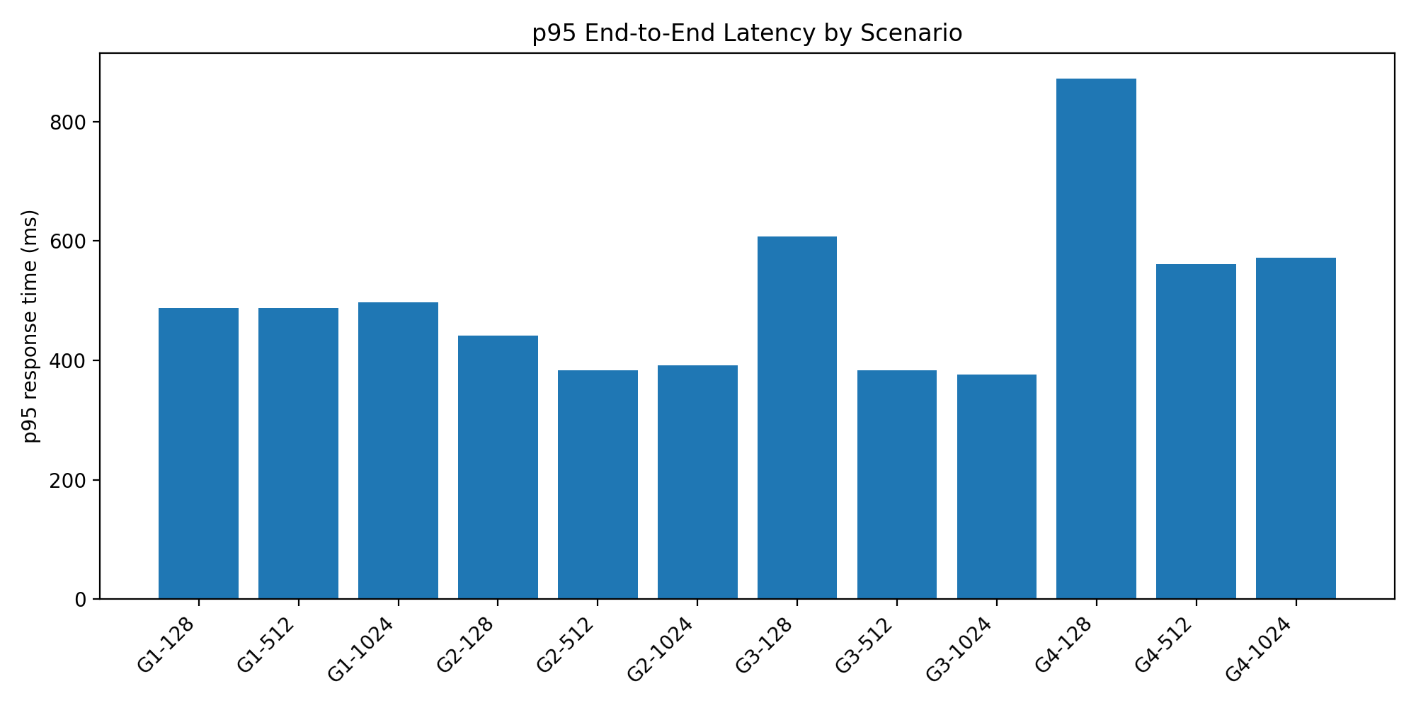
Figure 2. p95 end-to-end latency by scenario.
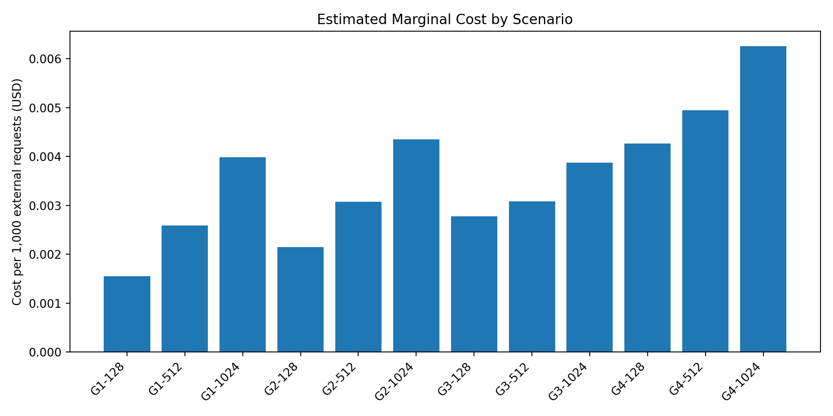
Figure 3. Estimated marginal cost per 1,000 external requests.

6. Granularity-Level Summary
Granularity | Avg mean ms | Avg p95 ms | Avg cost/1k | Best latency memory | Best cost memory | Min success
G1 | 479.3 | 491.2 | $0.002709 | 128 MB (475.6 ms) | 128 MB ($0.001550) | 100.00%
G2 | 377.3 | 405.6 | $0.003188 | 512 MB (371.5 ms) | 128 MB ($0.002143) | 100.00%
G3 | 392.1 | 456.0 | $0.003247 | 512 MB (359.9 ms) | 128 MB ($0.002779) | 99.92%
G4 | 520.1 | 668.4 | $0.005155 | 512 MB (468.3 ms) | 128 MB ($0.004265) | 100.00%

7. Interpretation of Results

7.1 Latency
Moderate decomposition improved latency. G3-512 reached 359.9 ms mean latency, which is 24.3% lower than the G1-128 baseline (475.6 ms). G2-512 also improved latency substantially at 371.5 ms mean latency.
Extreme decomposition harmed latency. G4-128 produced the worst mean latency at 621.4 ms and the worst p95 latency at 871.5 ms. This is consistent with orchestration overhead: G4 models 13 Lambda invocations per external workflow, compared with 1 in G1, 4 in G2, and 7 in G3.

7.2 Cost
The lowest marginal cost is the monolithic baseline. G1-128 costs approximately $0.001550 per 1,000 external requests. G2-128 increases the cost to $0.002143, while G4-1024 reaches $0.006252.
Memory scaling does not guarantee cost-performance dominance. Moving from 128 MB to 512 MB often reduces latency, especially for G2 and G3, but the cost rises because GB-second charge scales with configured memory. Moving from 512 MB to 1024 MB usually provides limited additional latency benefit while increasing cost further.

7.3 Reliability
Reliability was mostly stable. All scenarios except G3-1024 achieved 100% HTTP 2xx success in the Artillery results. G3-1024 had 1179 successful requests out of 1180, or 99.92%. Because this is a single failure in one run, it should be treated as a reliability signal requiring replication rather than a definitive architectural defect.

8. Hypothesis Evaluation
Hypothesis | Assessment | Evidence
H1 | Partially supported | G2 and G3 improved client-side mean latency relative to G1, especially at 512 MB. However, G4 did not improve latency.
H2 | Supported | G4 had the highest component count and showed substantially worse latency and cost, indicating orchestration overhead.
H3 | Supported with nuance | 512 MB was often the latency sweet spot, while 1024 MB gave limited additional benefit and higher cost.
H4 | Mostly supported | 11 of 12 scenarios achieved 100% success; one G3-1024 run had a single failed request.

9. Practical Recommendation
For a production-oriented implementation of this workflow, G2 or G3 is preferable to G4. G2-128 is the strongest low-cost decomposed option, giving materially lower mean latency than G1 while keeping cost relatively contained. G3-512 is the best latency-oriented option, but it costs almost twice the G1-128 baseline and has more operational complexity. G4 should be avoided unless the business requires very fine-grained ownership, independent deployment, or governance boundaries that justify the additional orchestration cost.

10. Threats to Validity
Internal validity: Some CloudWatch summary files contain aggregation differences across time windows. In particular, the G1 summary only includes G1-1024, so G1-128 and G1-512 were reconstructed from detailed CloudWatch CSV files. For G3/G4, child functions are not memory-suffixed, so the cost model treats them as shared 128 MB child functions.
Construct validity: Artillery response time measures client-side end-to-end latency, while CloudWatch Duration measures Lambda-side execution time. These are related but not identical constructs.
External validity: The workload is a synthetic order-processing workflow at approximately 1000 requests/hour. Results may differ for higher concurrency, heavier payloads, real databases, VPC networking, or external API dependencies.
Statistical conclusion validity: Each scenario appears to have one main run. More replications are needed to estimate variance, confidence intervals, and cold-start sensitivity.
Cost-model validity: The cost model excludes free tier, data transfer, logging, X-Ray tracing, deployment artifacts, and engineering/operations cost. It is therefore a marginal runtime estimate rather than a full AWS bill forecast.

11. Conclusion
The final dataset suggests that serverless function decomposition has a non-linear effect on performance and cost. Moderate decomposition can improve latency, but fine-grained decomposition beyond the workflow’s natural service boundaries can become counterproductive. In this experiment, G3-512 achieved the best mean latency, G1-128 achieved the lowest marginal cost, and G4 was consistently the least attractive design from a cost-performance perspective. Therefore, the study should conclude that optimal Lambda granularity is an engineering trade-off rather than a monotonic progression toward smaller functions.

Appendix A. Data Quality Notes
- G3-1024 success rate = 99.92% (1179/1180).
- CloudWatch/G1 summary file contains only research-order-g1-1024; G1-128 and G1-512 Lambda metrics were reconstructed from detailed per-request CloudWatch CSV files in RunTestFromClient.
- G3/G4 child Lambda functions are not memory-suffixed in CloudWatch; cost model treats them as 128 MB child functions shared across orchestrator memory variants, while orchestrator memory varies by scenario.
- Marginal cost estimates exclude AWS Free Tier and data transfer; they use Lambda Arm duration pricing, Lambda request pricing, and HTTP API request pricing.

Appendix B. Generated Files
- serverless_granularity_analysis.xlsx
- scenario_summary.csv
- granularity_summary.csv
- component_cloudwatch_detail.csv
- data_quality_notes.txt

