

Requirement & Design Specification
JOBTRANS - PLATFORM TO SUPPORT RECRUITMENT AND SEARCH FOR ONLINE JOBS
Version: 3.0

– Danang, November 2024–

Record of Changes
Version | Date | A*  M, D | In charge | Change Description
V1.0 | 1/10/2024 | A | All | Intial
V3.0 | 08/11/2024 | M | QuangNH | Modify all document
V3.0 | 05/11/2024 | A | DuyenVTM | Add function Create new shipment Order
*A - Added M - Modified D - Deleted

Contents
Record of Changes 2
Contents 3
I. Overview 6
1. User Requirements 6
1.1 Actors 6
1.2 Use Cases 6
2. Overall Functionalities 16
2.1 Screens Flow 16
2.2 Screen Descriptions 19
2.3 Screen Authorization 23
2.4 Non-UI Functions 28
3. System High Level Design 29
3.1 Database Design 29
3.2 Code Packages 33
1. Authentication 35
1.1 UC-01_Register 35
1.2 UC-02_Login 36
1.3 UC-03_Logout 37
1.4 UC-04_View profile 38
1.5 UC-05_Edit profile 38
1.6 UC-06_Change password 39
1.7 UC-07_Forgot password 40
2. Manage Admin's job posting 41
2.1 UC-36_Refund to employer 41
2.2 UC-37_Pay salary to seeker 41
2.3 UC-31_Report user 42
2.4 UC-34_View post list 43
2.4. UC-35_Verify job post 43
3.Online CV Management 44
3.1 UC-8.1_Create CV 44
3.2 UC-8.2_View CV 45
3.3 UC-8.3_Update CV 45
3.4 UC-8.4_Delete CV 46
4. Wallet and Transaction 47
4.1 UC-9_View Wallet and Transaction 47
5.Apply for a job 48
5.1 UC-06_Search job post 48
5.2 UC-12_View employer’s introduction page. 48
5.3 UC-11_View a job post 49
5.4 UC-13_Apply for a job 49
5.5 UC-14_View applied job list 50
6. Recruitment for job 51
6.1 UC-15.1_Create Job Post. 51
6.2 UC-15.2_View a Post 51
6.3 UC-15.3_Update a Post 52
6.4 UC-15.4_Delete a Post 53
6.5 UC-18_View applied seeker’s information. 53
6.6 UC-17_View applied seeker list. 54
6.7 UC-19_Confirm successful seeker. 55
7. Work online through JobTrans 56
7.1 UC-20_Prepaid for job 56
7.2. UC-21_Deposit money for job 56
7.3. UC-22_Chat 57
7.4.UC-23_View Progress 58
7.5. UC-24_Create new period of progress 59
7.6. UC-25_Accept period submission 60
7.7. UC-26_Reject period submission 61
7.8. UC-27_Submit period submission 61
7.9. UC-28_Submit final result offline 62
7.10 UC-29_Submit final result online 63
7.11 UC-30_Accept final result 64
8. Manage User - Admin 65
8.1 UC-38_View users list 65
8.2 UC-39_Ban/Unban user 65
8.3 UC-40_View user’s profile 66
III. Design Specifications 67
1.View list job - Admin: 67
1.1 View list job - Admin: 67
1.2. View job post 70
2.Authentication 72
2.1. Register 72
2.2. Login 73
2.3. Logout 75
2.4. Change password 76
2.5. Forgot password 77
2.6. View profile 82
2.7. Edit profile 84
3.Online CV Management 86
3.1.Create CV 86
3.2.View CV 89
3.3.Delete CV 91
3.4.Update CV 93
UI Design 93
4. Wallet and transaction management 95
4.1.View wallet 95
4.2. Add money into wallet 97
5. Apply for a job 99
5.1 Search job post 99
5.2 View employer’s information 101
5.3 View job post 103
5.4. Apply 104
5.5 View applied job list 106
6. Recruitment for job 108
6.1 Create Job Post 108
6.2 View a post 110
6.3 Update job post 112
6.4 Delete job post 114
6.5 View job post list 114
6.6 Update interview 116
6.7 View applied seeker list 117
7. Work online through JobTrans 119
7.1. Prepaid for job 119
7.2 Deposit for job 121
7.3 Chat 122
7.4 Create new period of progress - Employer 124
7.5 View Period Submission 125
7.6 Submit period submission 126
7.7 View confirmed job post - Employer 128
7.8 View job post - Seeker 130
7.9. Submit final result online 132
7.10. Submit final result offline 133
7.5.Give feedback 137
8. Manage User - Admin 138
8.1 View user list 138
8.2 Ban/Unban user 140
8.3 View user’s profile 141
IV. Appendix 142
1. Assumptions & Dependencies 142
2. Limitations & Exclusions 143
3. Business Rules 143
4. Application Messages List 146

I. Overview

1. User Requirements

1.1 Actors
# | Actor | Description
1 | Admin | The highest priority manager, has authority to view details, create new, search, update and delete the post, user, transaction  - Has authority to manage users, transaction, recruitment post  - Has authority to manage profile
2 | Employer | Employers are businesses or individuals who have recruitment needs, using the Platform to post recruitment ads and search for suitable Seekers.
3 | Seeker | A Seeker is a job seeker who uses the Platform to find jobs, apply, and track the hiring process.
4 | Guest | A guest is a user visit website without loging in

1.2 Use Cases

a. Diagram(s)
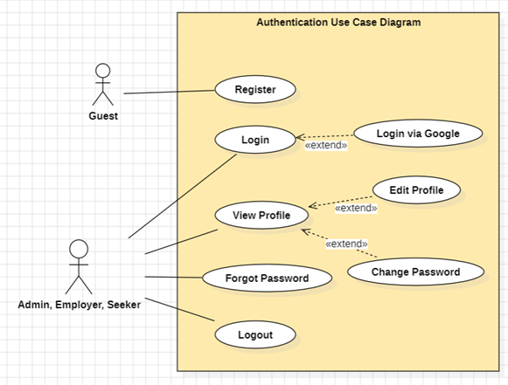
Figure 1. Authentication use case diagram
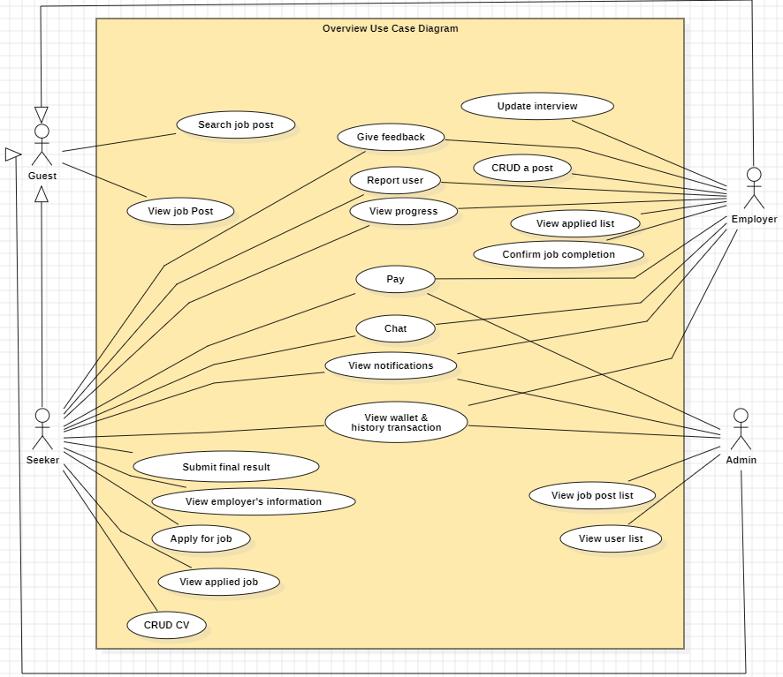
Figure 2. Overview use case diagram
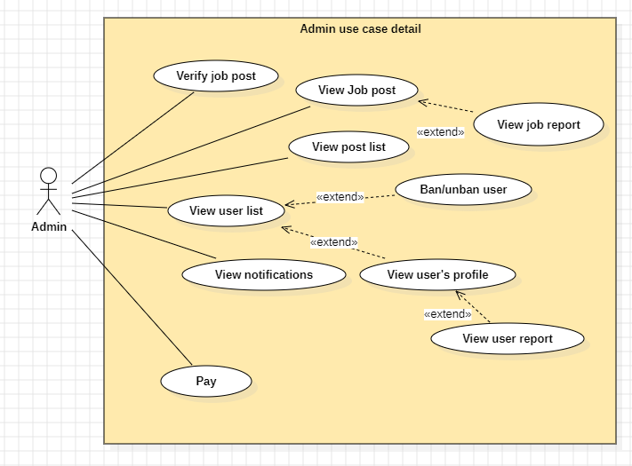
Figure 3. Admin use case diagram
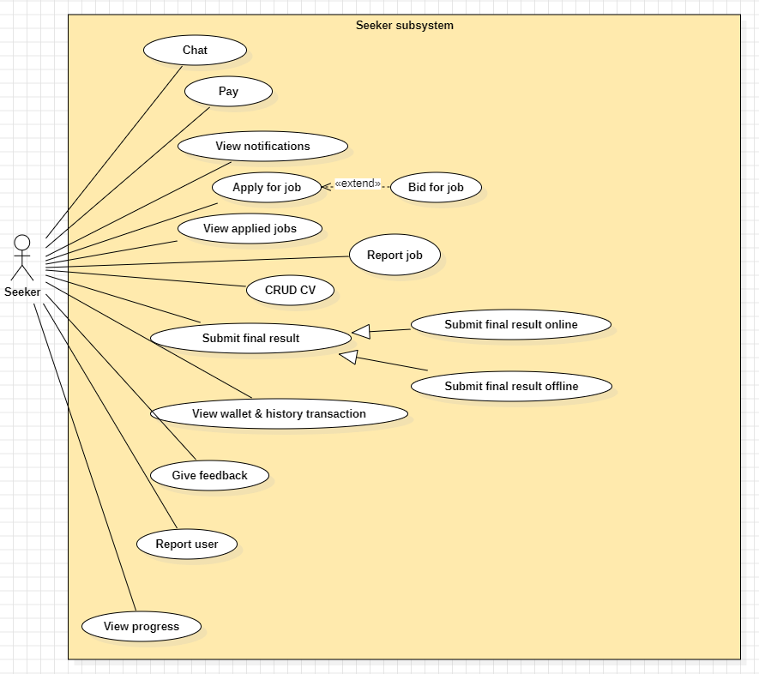
Figure 4. Seeker use case diagram
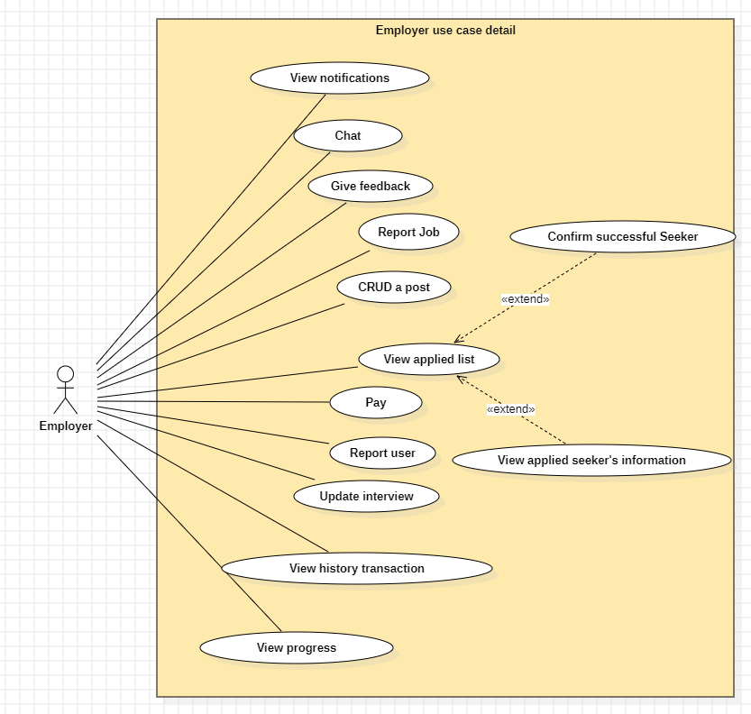
Figure 5. Employer use case diagram
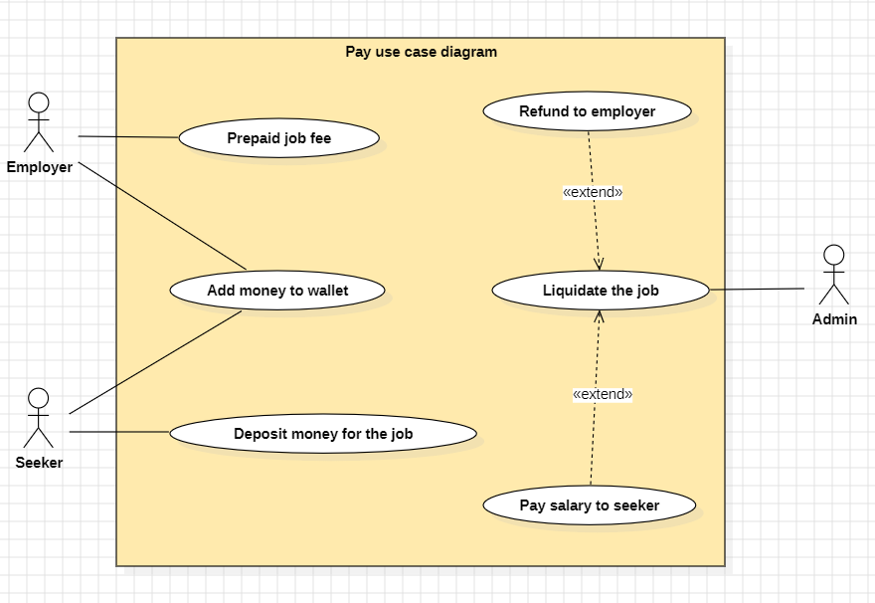
Figure 6. Pay use case diagram
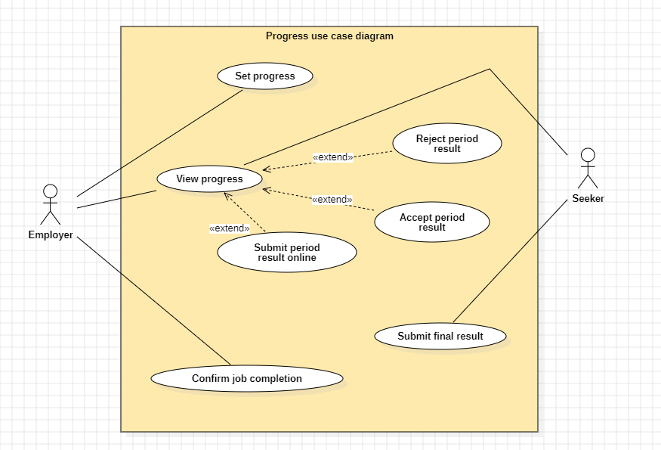
Figure 7. Progress use case diagram

b. Descriptions

ID | Feature | Use case | Description
UC-01 | Authentication | Register | Register new account to access features of the Platform
UC-02 | Authentication | Login | Any Users has account in the Platform, can access to the Platform by entering valid Username and password
UC-03 | Authentication | Logout | Log out the Platform
UC-04 | Authentication | View profile | Any Users after login successfully can view their profile on the platform.
UC-05 | Authentication | Edit profile | Users can edit their information like change name, change date of birth...
UC-06 | Authentication | Change Password | Users can change their password if they want as long as they enter a valid old password.
UC-07 | Authentication | Forgot password | When users log in if they forgot their password, they can request a verification mail to get an OTP then set a new password.
UC-08 | Online CV Management | CRUD CV | Seekers can create, view, update, delete their CV.
UC-09 | Wallet and Transaction Management | View transaction history (Wallet) | Users can view balance, history of transaction progress
UC-10 | Apply for job | Search job post | Users can search jobs by criteria such as location, specialization, and job type.
UC-11 | Apply for job | View job post | Users can view the information of job in detail.
UC-12 | Apply for job | View employer’s information | Seekers can view employer’s information
UC-13 | Apply for job | Apply for a job | Seekers apply by submitting an application form depending on Platform requirements and nature of work
UC-14 | Apply for job | View applied job list | Seekers can view list of job they applied
UC-15 | Recruitment for job | CRUD a post | Employers can create, view, update and delete a recruitment post.
UC-16 | Recruitment for job | Update interview | Employers can update interview for candidates including time and Google meet link
UC-17 | Recruitment for job | View applied seeker list | Employers can view complete Seeker’s information.
UC-18 | Recruitment for job | View applied seeker’s information | Employers can view candidates' information to see their information.
UC-19 | Recruitment for job | Confirm successful seeker | Employers confirm successful recruitment.
UC-20 | Work online through JobTrans | Prepaid for job | The employer will transfer the project funds into the system account in advance and the funds will be held until the project is liquidated.
UC-21 | Work online through JobTrans | Deposit money for job | Job seekers must deposit 10% of the project amount in advance to ensure that the work will be completed.
UC-22 | Work online through JobTrans | Chat | Users contact other users on platform chat channels.
UC-23 | Work online through JobTrans | View progress | Employer, Seeker can view the project’s progress including periods
UC-24 | Work online through JobTrans | Create period | Employers can set a progress for the seeker to follow each period of the project.
UC-25 | Work online through JobTrans | Accept period submission | Employers accept project period results after receiving results.
UC-26 | Work online through JobTrans | Reject period submission | The employer may reject the result if the result does not meet the requirements set forth by the employer in the post.
UC-27 | Work online through JobTrans | Submit period submission online | Seeker can send work results in the form of software projects, documents, images, mp4, mp3,... online on the system.
UC-28 | Work online through JobTrans | Submit final result offline | Seekers can submit physical results by filling out the shipping information form on the system.
UC-29 | Work online through JobTrans | Submit final result online | Seekers can submit final digital product on the platform
UC-30 | Work online through JobTrans | Accept final result | Employers confirm project results after receiving results.
UC-31 | Work online through JobTrans | Report user | can report violations of community standards on the platform.
UC-32 | Work online through JobTrans | Report job | Employers and job seekers can send job complaints with issues
UC-33 | Work online through JobTrans | Give feedback | Users can send a reputation assessment form after project completion.
UC-34 | Manage Job-Admin | View post list | Admins view job posts on the platform.
UC-35 | Manage Job-Admin | Verify job post | Admins can verify post content on the platform.
UC-36 | Manage Job-Admin | Refund to employer | Admin will transfer back the amount that the employer has previously sent and the seeker's deposit to the employer if the seeker cannot complete the job.
UC-37 | Manage Job-Admin | Pay salary to seeker | Admin will transfer the project completion money along with the amount that seeker transferred earlier if the project is confirmed completed.
UC-38 | Manage User - Admin | View Users list | Admins can view all Users on the platform
UC-39 | Manage User - Admin | Ban/Unban User | Admins can ban/unban user on the platform
UC-40 | Manage User - Admin | View User Profile | Admins can view user’s basic information on the platform

2. Overall Functionalities

2.1 Screens Flow
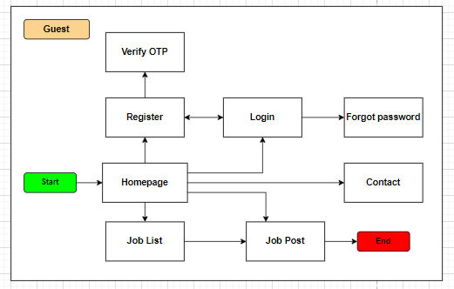
Figure 8. Screen flow Diagram – Guest
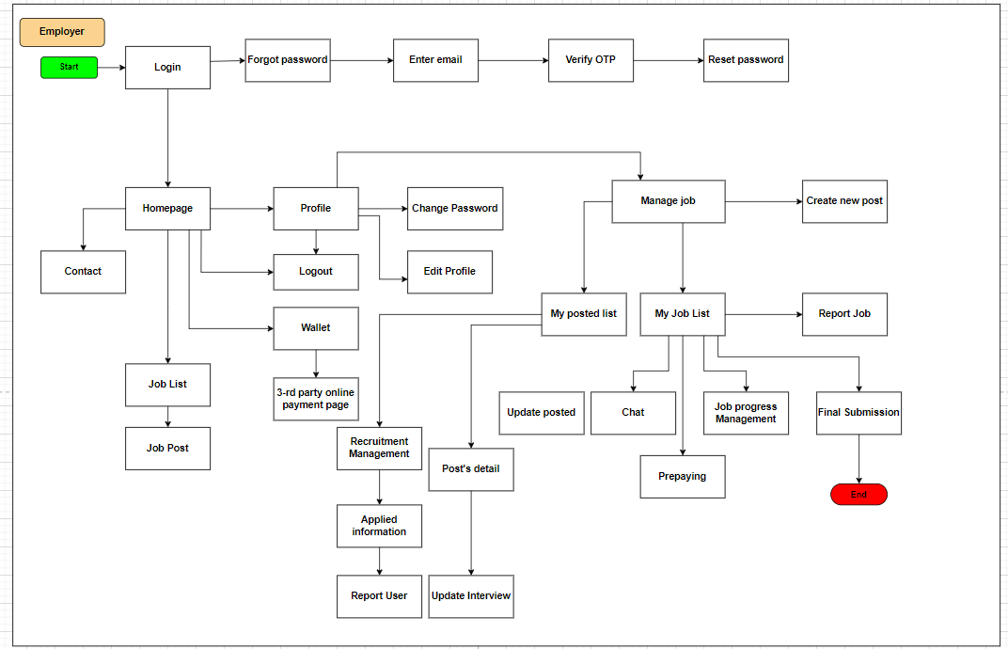
Figure 9. Screen flow Diagram – Employer
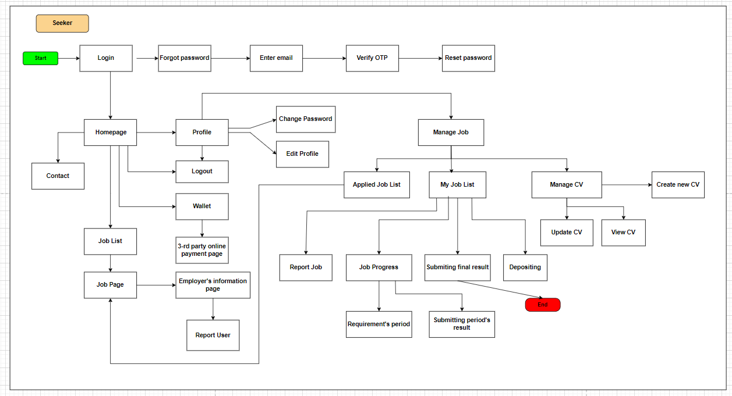
Figure 10. Screen flow Diagram – Seeker
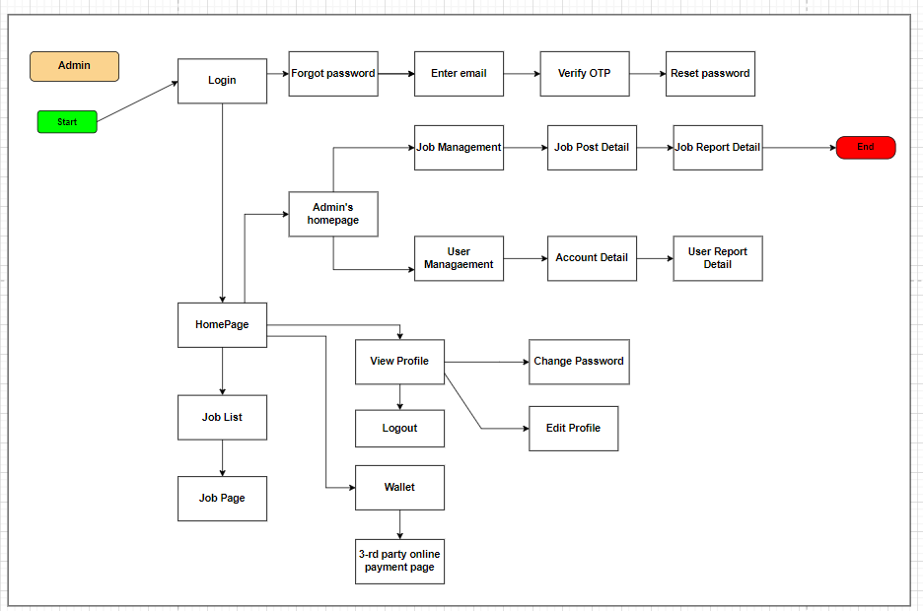
Figure 11. Screen flow Diagram – Admin

2.2 Screen Descriptions

ID | Feature | Screen | Description
1 | View list job post - Admin | Job management | Allows administrators to view a list of job postings and perform actions such as editing or deleting posts.
2 | View details job post - Admin | Job post details | Allows admins to view details about a specific job posting including job information and requirements.
3 | Refund money to employer - Admin | Job post details | Allows administrators to refund employers in cases where jobs are not completed or there are problems.
4 | Salary transfer to seeker - Admin | Job post details | Allows admin to transfer salary to candidate after job is completed.
5 | View list user | User management | Allows administrators to view a list of users and perform management actions such as locking accounts or editing information.
6 | View user information | Account details | Allows administrators to view detailed information about a specific user, including personal information and projects worked on.
7 | Register | Register | Allows users to register new accounts to use the system.
8 | Login | Login | Allows users to log into the system using their registered accounts or Google account.
9 | Logout | Logout | Allows users to log out of the system.
10 | View Profile | Profile | Allows users to view their personal profile information in the system.
11 | Edit profile | Edit profile | Allows users to edit their personal information.
12 | Change Password | Change password | Allows the user to change his current password.
13 | Forgot password | Forgot password | Allows users to recover their passwords through the "Forgot Password" function.
14 | Create CV | Create CV | Allows seekers to create online CVs for job search.
15 | View CV | View CV | Allows seekers to review the online CV they have created.
16 | Update CV | Update CV | Allows seekers to update information in their online CV.
17 | Delete CV | Manage CV | Allows seekers to delete the online CV they have created.
18 | View wallet | Wallet | Allows users to view their balance and information related to their e-wallet in the system (transaction history).
19 | View transaction history | Wallet | Allows users to view transaction history related to e-wallet.
20 | Add money into wallet | Wallet, 3-rd party online payment page | Allows users to deposit money into e-wallets to use for transactions within the system.
21 | Search job post | HomePage | Allows seekers to search for job postings based on keywords, location, or other criteria.
22 | View employer’s information | Employer’s information page | Allows seekers to view detailed information about the employer, including company name, address, and description.
23 | View job post | Job page | Allows seekers to view details of a job posting including job requirements and detailed description.
24 | Apply for job | Job page | Allows seekers to apply for a specific job through the system.
25 | View applied job list | Applied job list | Allows seekers to view a list of jobs they have applied for.
26 | CRUD job post | Manage job | Allows employers to create, view, update, and delete job postings.
27 | View posted list | View posted list | Allows employers to view a list of jobs they have posted on the system.
28 | View applied seeker list | Recruitment management | Allows employers to view a list of candidates who have applied to their jobs.
29 | View applied seeker’s information | Applied information | Allows employers to view detailed information about candidates who have applied for a job.
30 | Update interview | Post’s detail | Allows employers to update interview details and google meet links.
31 | Confirm successful seeker | Recruitment management | Allows employers to confirm that a candidate has been successfully selected for a job.
32 | Prepay for work | Prepaying | Allows employers to prepay a portion of the cost of a job through the system.
33 | Deposit to accept job | Depositing | Allows seekers to deposit money into the system to accept jobs.
34 | Chat | My Job List | Allows employers and seekers to exchange information and discuss jobs via online chat.
35 | Manage progress | Job progress management | Allows employers and candidates to track and manage the progress of assigned work.
36 | Submit period submission online | Submitting period’s result | Allow seekers to submit phased work progress reports online through the system.
37 | View list confirmed job- Employer | My job list | Allows employers to view a list of confirmed jobs on the JobTrans system.
38 | View list confirmed job - Seeker | My job list | Allows seekers to view a list of jobs they have been confirmed for on the JobTrans system.
39 | Submit final result online | Submitting final result | Allows seekers to submit final results of their work online through the system.
40 | Submit final result offline | Submitting final result | Allow seekers to submit final work results offline (in person) if the job requires it.
41 | Give feedback | Employer Information, Applied Information | Allows seekers and candidates to provide feedback on the collaboration after the job is completed.

2.3 Screen Authorization

Screen | Guest | Employer | Seeker | Admin
Home page | X | X | X | X
Register | X
Choose role | X
Fill in information | X
Login |  | X | X | X
Log in to the platform |  | X | X | X
Fill in information |  | X | X | X
Log in with google |  | X | X | X
Logout |  | X | X | X
Change password |  | X | X | X
Change password confirm |  | X | X | X
Fill in information |  | X | X | X
Back to personal page |  | X | X | X
Forgot password |  | X | X | X
Fill in information |  | X | X | X
Receive OTP code |  | X | X | X
Verify OTP |  | X | X | X
Fill in OTP |  | X | X | X
Back to home page |  | X | X | X
Profile |  | X | X | X
Query all information |  | X | X | X
Edit profile |  | X | X | X
Change password |  | X | X | X
Edit profile |  | X | X | X
Fill in information |  | X | X | X
Update profile |  | X | X | X
Create CV |  |  | X
Query basic profile information |  |  | X
Fill in information |  |  | X
Save CV |  |  | X
View CV |  | X | X
Query all CV information |  |  | X
Edit CV |  |  | X
Delete CV |  |  | X
Update CV |  |  | X
Query all CV information |  |  | X
Fill in information |  |  | X
Save CV |  |  | X
Wallet |  | X | X | X
Query wallet and transaction’s data |  | X | X | X
Add money into wallet |  | X | X | X
Filter transaction by date |  | X | X | X
Job list | X | X | X | X
Query data | X | X | X | X
Employer’s information |  | X | X | X
Query data |  | X | X | X
Job page | X | X | X | X
Query data | X | X | X | X
Apply job |  |  | X
Applied job list |  |  | X
Query data |  |  | X
View detail |  |  | X
Create new post |  | X
Fill in information |  | X
Upload file |  | X
Post recruitment |  | X
Post’s detail |  | X
Query data |  | X
Update post |  | X
Delete post |  | X
Update interview |  | X
Update post |  | X
Fill in information |  | X
Update confirm |  | X
Delete post |  | X
Employer’s posted list |  | X
Query data |  | X
Employer’s job list |  | X
Applied information |  | X
Query data |  | X
Update interview |  | X
Fill in information |  | X
Recruitment management |  | X
Accept request |  | X
Query data |  | X
Send message |  | X
My job list |  | X | X
Query data |  | X | X
View report |  | X | X
Report job |  | X | X
Job Progress |  | X | X
Requirements period |  | X | X
Submitting period result |  |  | X
Submit final result online |  |  | X
Fill in information |  |  | X
Upload file |  |  | X
Submit result |  |  | X
Submit final result offline |  |  | X
Fill in information |  |  | X
Submit result |  |  | X
Give feedback |  | X | X
Fill in information |  | X | X | X
Submit feedback |  | X | X | X
Job management |  |  |  | X
Verify post |  |  |  | X
Filter status |  |  |  | X
Query job data |  |  |  | X
Job-post-detail |  |  |  | X
Refund |  |  |  | X
Pay salary |  |  |  | X
View report |  |  |  | X
View applied list |  |  |  | X
View joined list |  |  |  | X
Verify post |  |  |  | X
Job report detail |  |  |  | X
User Management |  |  |  | X
Query employer list |  |  |  | X
Query seeker list |  |  |  | X
Query basic information of user |  |  |  | X
Ban/Unban user |  |  |  | X
Account detail |  |  |  | X
View report |  |  |  | X
Ban/Unban user |  |  |  | X
Query basic information of user |  |  |  | X
User report detail |  |  |  | X
Report User |  | X | X

2.4 Non-UI Functions

ID | Feature | System Function | Description
1 | <<Feature Name>> | <<Function Name1>> | <<Function Name1 Description>>
2 | …

3. System High Level Design

3.1 Database Design

a. Database Schema
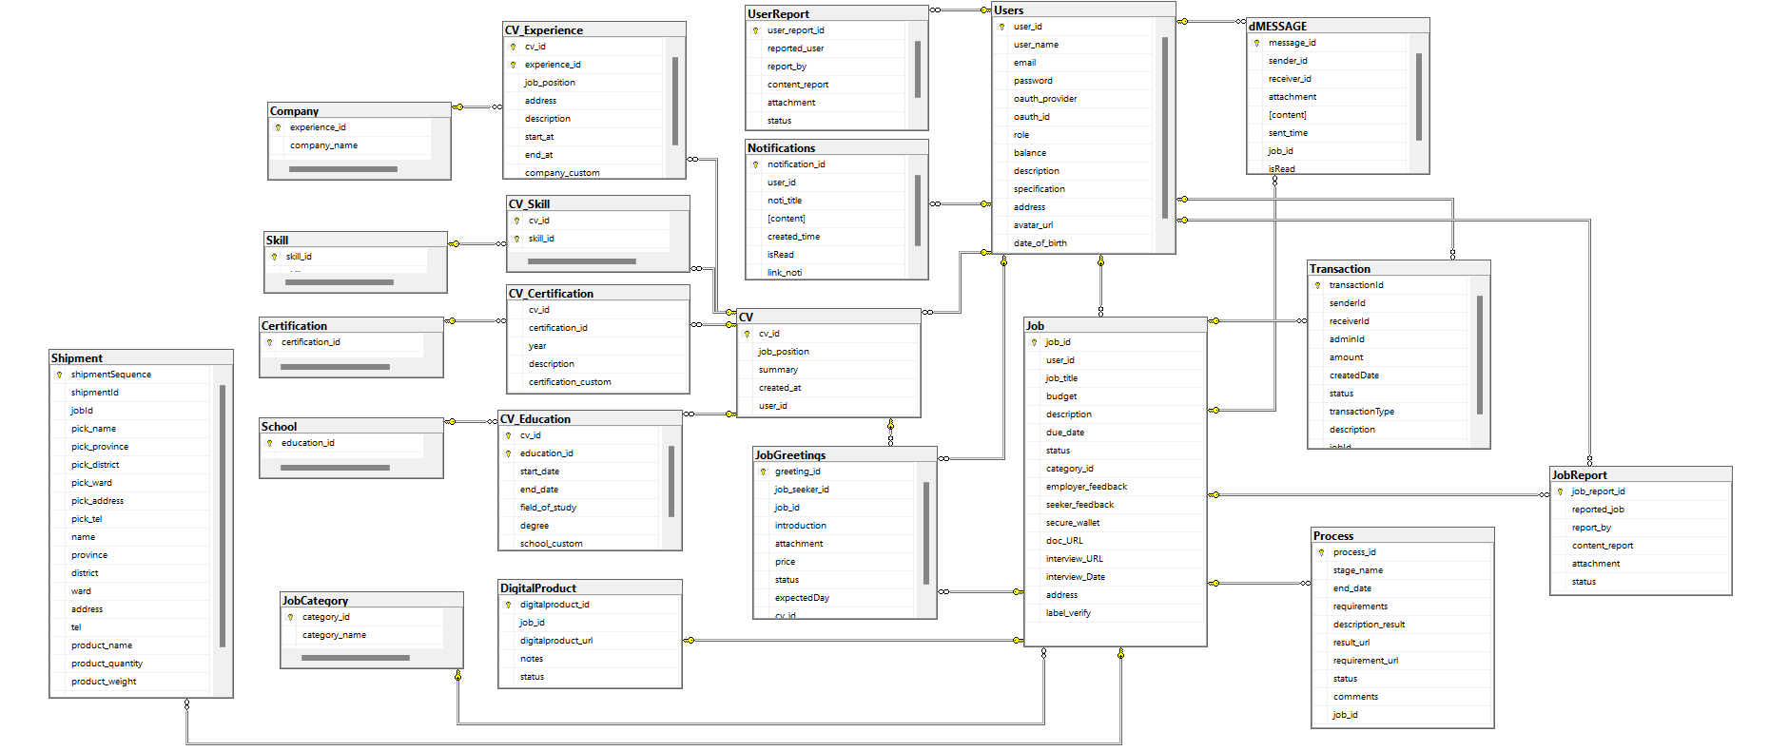

b. Table Descriptions
No | Table | Description
1 | Users | Stores information about users, including username, password, role, balance, description, date of birth, and authentication details.
2 | CV | Contains CV information for users, such as job position, summary, creation time, and associated user_id.
3 | CV_Experience | Stores details about work experience related to a CV, including job position, address, start and end dates, and custom company information.
4 | CV_Skill | Links skills to a CV by storing the cv_id and skill_id.
5 | CV_Certification | Stores information about certifications related to a CV, such as year, description, and custom certification name.
6 | CV_Education | Stores education details related to a CV, including start and end dates, field of study, degree, and custom school name.
7 | Company | Contains information about companies where the user gained experience, such as company name.
8 | Skill | Stores various skills that can be linked to a CV.
9 | Certification | Stores different certifications that can be linked to a CV.
10 | School | Stores information about schools that can be linked to a CV.
11 | Notifications | Stores notifications for users, including title, content, creation time, read status, and notification link.
12 | UserReport | Contains reports filed by or against users, including reported user, report content, and status.
13 | MESSAGE | Stores messages exchanged between users, including sender, receiver, message content, and attachment.
14 | Transaction | Records transaction details between users, such as sender, receiver, amount, date, status, and type.
15 | Job | Contains job listings, with details like job title, budget, description, due date, and associated user_id and category.
16 | JobCategory | Stores categories for job listings, including category name.
17 | JobGreetings | Stores greetings or introductions submitted by job seekers for job listings, including introduction, attachment, price, and status.
18 | JobReport | Contains reports on job listings, including the reported job, report content, and status.
19 | Shipment | Stores shipment details related to job listings, such as pickup and delivery addresses, contact details, and product info.
20 | Process | Contains information about the process stages for a job, such as stage name, requirements, results, and related job_id.
21 | DigitalProduct | Stores information on digital products related to jobs, including product URL, notes, and status.

3.2 Code Packages
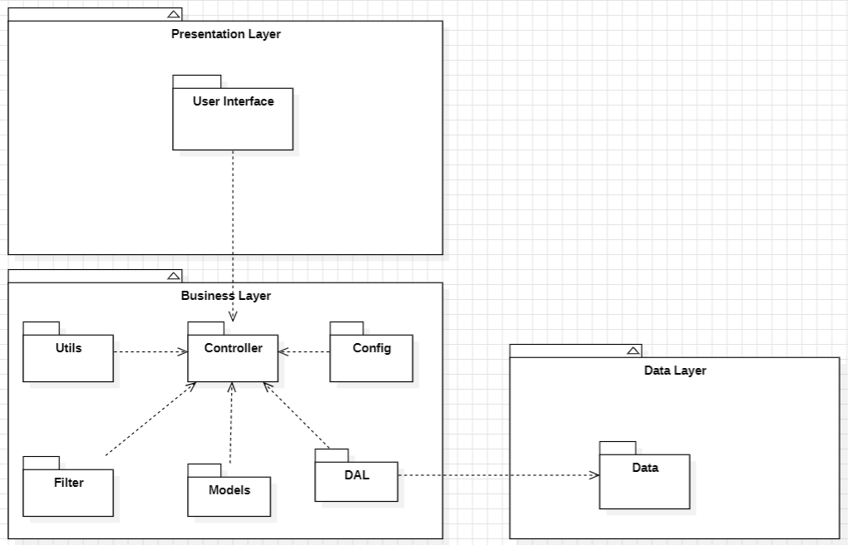
Package descriptions

No | Package | Description
1 | Presentation Layer | Contains the User Interface components, handling the user’s interaction with the system.
2 | Business Layer | Contains the core business logic and processing modules, managing data flow and rules.
3 | Data Layer | Manages the data access logic, handling storage and retrieval from the database.
4 | Controller | Acts as a bridge between the User Interface and other modules in the Business Layer.
5 | Utils | Provides utility functions and common services used across the application.
6 | Config | Manages configuration settings and application environment variables.
7 | Filter | Contains filters for data validation, authentication, and request processing.
8 | Models | Represents the data structure and entities used within the application’s domain.
9 | DAL (Data Access Layer) | Handles database operations specifically for retrieving and saving data.
10 | Data | Represents the underlying data and database schema definitions.

II. Requirement Specifications

1. Authentication

1.1 UC-01_Register

a. Functionalities
UC ID and Name: | UC-1_Register
Created By: | VuVN | Date Created: | 30/Sep/2024
Primary Actor: | Guest | Secondary Actors: | None
Trigger: | Guest clicks on the button “Đăng nhập/đăng ký” pop-up form.
Description: | As a guest I want to register successfully so that I can use the system’s authenticated features.
Preconditions: | Gmail must be unique when they register for the first time.
Postconditions: | Guests can register successfully.
Normal Flow: | 1.0 Register system  - A guest user navigates to the platform and clicks on the "Đăng nhập/Đăng ký" button located in the header.  - The platform opens a pop-up registration form that asks for details such as email, password, and role ( Employer, Seeker).  - The guest fills in the required information in the form fields (valid email, password, role selection).  - The guest clicks the "Đăng ký" button to submit the form for validation.  - System validates the register details .  - System tracks guest’s success register to the Activity Log.  - System accesses the Home Page.
Alternative Flows: | None
Exceptions: | 1.0.E1 Guest entered the wrong format of the fields  - The Error Message screen is shown to the user.  - Guests did not fill in required fields.  - Guests fills in invalid information.  1.0.E2 Guest’s email was available in system  - The Error Message screen is shown to the user.
Priority: | Must have
Frequency of Use:
Business Rules: | BR-01,BR-02,BR-03,BR-08
Other Information:
Assumptions:

b.Business Rule
ID | Business Rule | Business Rule Description
BR-01 | Wrong email rule | System will notify guest the message MSG01 if they dont fill invalid email address
BR-02 | Wrong password rule | System will notify User the MSG02 if they fill in invalid password ( < 8 regex)
BR-03 | Used email rule | System will notify guest the MSG03 if they had been used gmail for register
BR-08 | Wrong Re-entered Password rule | System will notify User the MSG11 if they fill in wrong re-entered password

1.2 UC-02_Login

a. Functionalities
UC ID and Name: | UC 2_Login
Created By: | VuVN | Date Created: | 30/Sep/2024
Primary Actor: | Admin, Seeker , Employer | Secondary Actors:
Trigger: | -·Users click on the button “đăng nhập/đăng ký” on header.  - Click on the ”đăng nhập”.
Description: | As a user, I want to be able to log into the system so that I can use the system’s authenticated features and access my personalized account.
Preconditions: | User has already has an account on the platform .
Postconditions: | Users can login successfully.
Normal Flow: | 2.0 Login system  - User accesses the User Login screen  - User types in the login details or choose other login options (see 2.1)  - User clicks the Login button  - System validates the login details  - System allows user to access  - System tracks user’s success login to the Activity Log  - System accesses the Home Page
Alternative Flows: | 2.1 Google Login  - User chooses to login system using Google account  - System redirects the user to the Google’s Login screen  - User types in the Google account details and chooses to login  - Google validates user’s login information successfully and redirect him/her back to the system  - Return to step 5 of normal flow.
Exceptions: | 2.0.E2 System can’t authenticate the user  - The Error Message screen is shown to the user  - User cancels the logging in => UC stops, change to Homepage  - User clicks “Forgot Password?” link => change to UC-5_Reset Password  - User clicks “Register” link => change to UC-2_Register User Account
Priority: | Must Have
Frequency of Use:
Business Rules: | BR-01,BR-02,BR-04,BR-36,BR-37
Other Information:
Assumptions:

b.Business Rule
ID | Business Rule | Business Rule Description
BR-01 | Wrong email rule | System will notify guest the message MSG01 if they dont fill invalid email address
BR-02 | Wrong password rule | System will notify User the MSG02 if they fill in invalid password ( < 8 regrex)
BR-04 | Notification about login information rule | -System will notify User the MSG04 and redirect to the guest homepage if they fill the wrong registered email and password.  -System will notify User the MSG05 and redirect to user homepage if they fill correct registered email and password
BR-36 | Role choosing Form Rule | -This form only appears for gmail when logging into the system for the first time (no role yet). The recommended role is Employer/Seeker.  -This form does not apply to Admin accounts.
BR-37 | Login-gmail Rule | In case gmail has been successfully registered with password on the system registration form, when logging in using gmail login method, it still accesses that account.

1.3 UC-03_Logout

a. Functionalities
UC ID and Name: | UC-3_Logout
Created By: | VuVN | Date Created: | 30/Sep/2024
Primary Actor: | Admin, Employer, Seeker | Secondary Actors:
Trigger: | Admin, Employer, Seeker click on “Đăng xuất”
Description: | As a user, I want to be able to log out of the system so that I can change other accounts.
Preconditions: | Users are logged in successfully as the actor above.
Postconditions: | - Users can log out successfully.  - End up the user's session.
Normal Flow: | 3.0 Logout  - User clicks on the avatar on the header.  - Users click on the button “Đăng xuất” on the header.
Alternative Flows: | None.
Exceptions: | None.
Priority: | Must have.
Frequency of Use:
Business Rules: | None.
Other Information:
Assumptions:

b.Business Rule
None

1.4 UC-04_View profile

a. Functionalities
UC ID and Name: | UC-4_View profile
Created By: | VuVN | Date Created: | 30/Sep/2024
Primary Actor: | Admin, Employer, Seeker | Secondary Actors:
Trigger: | Users click on the ”Thông tin”
Description: | As a user, I want to be able to view profile so that I can know exactly my specification
Preconditions: | Users logged in successfully as the actor above.
Postconditions: | Users can view detail information of their own accounts
Normal Flow: | 4.0 View profile system  - Users click on the avatar in the header.  - Users click on the ”Thông tin”
Alternative Flows: | None.
Exceptions: | None.
Priority: | High
Frequency of Use:
Business Rules: | None
Other Information:
Assumptions:

b.Business Rule
None

1.5 UC-05_Edit profile

a. Functionalities
UC ID and Name: | UC-4.1_Edit profile
Created By: | VuVN | Date Created: | 30/Sep/2024
Primary Actor: | Admin, Employer, Seeker | Secondary Actors:
Trigger: | Users has clicked on “Thông tin tài khoản” on the platform
Description: | As a user, I want to be able to change my account so that I can change my avatar.
Preconditions: | Users logged in successfully as actor above.
Postconditions: | Users can update information successfully.
Normal Flow: | 4.1.0 Edit profile system  - Users click on the avatar in the header.  - Users click on the ”Thông tin”  - Users click on the ”Chỉnh sửa thông tin”
Alternative Flows: | 4.1.1 Edit profile system  - Users click on the avatar in the header.  - Users click on the ”Sửa thông tin”
Exceptions:
Priority: | High
Frequency of Use:
Business Rules: | BR-38
Other Information:
Assumptions:

b.Business Rule
ID | Business Rule | Business Rule Description
BR-38 | Upload profile successfully rule | System will notify guest the MSG06 if they update new profile and database successfully

1.6 UC-06_Change password

a. Functionalities
UC ID and Name: | UC-4.2_Change password
Created By: | VuVN | Date Created: | 30/Sep/2024
Primary Actor: | Admin, Employer, Seeker | Secondary Actors:
Trigger: | Users click on “Đổi mật khẩu”
Description: | As a user, I want to be able to change my password so that I can update new password
Preconditions: | Users logged in successfully as the actor above.
Postconditions: | - Users can change passwords successfully.  - Users can use new password to login
Normal Flow: | 4.2.0 Change password system  - Users click on the avatar in the header.  - Users click on the ”Sửa thông tin”
Alternative Flows: | 4.2.1 Change password system  - Users click on the avatar in the header.  - Users click on the ”Sửa thông tin”
Exceptions:
Priority: | High
Frequency of Use:
Business Rules: | BR-02,BR-05
Other Information:
Assumptions:

b.Business Rule
ID | Business Rule | Business Rule Description
BR-02 | Wrong password rule | System will notify User the MSG02 if they fill in invalid password ( < 8 regex)
BR-05 | Wrong old password rule | System will notify users the message MSG06 if they don’t fill correct old password of account
BR-08 | Wrong re-enter password | System will notify users of the message MSG11 if the re-entered password is incorrect.
BR-40 | Wrong new password | System will notify users the message MSG22 if the re-entered password is the same as the old password.

1.7 UC-07_Forgot password

a. Functionalities
UC ID and Name: | UC-5_Forgot password
Created By: | VuVN | Date Created: | 30/Sep/2024
Primary Actor: | Admin, Employer, Seeker | Secondary Actors:
Trigger: | User click on “Quên mật khẩu” on form login
Description: | As a user, I want to be able to reset my password so that I can update new password
Preconditions: | User have already had account
Postconditions: | User is logged in successfully with new password
Normal Flow: | 5.0 Change password system  - Users click on”Đăng nhập/Đăng ký”in the header  - Users click on the ”Quên mật khẩu”
Alternative Flows: | None
Exceptions:
Priority: | High
Frequency of Use:
Business Rules: | BR-06,BR-07,BR-02,BR-08
Other Information:
Assumptions:

b.Business Rule
ID | Business Rule | Business Rule Description
BR-06 | Forgotten Account’s Gmail rule | If gmail has never registered before, the system will display message MSG07.
BR-07 | Wrong OTP rule | If OTP is wrong, the system will display message MSG09 and load the OTP form page again.  If OTP is correct, the system will display message MSG010 and redirect to the reset password page.
BR-02 | Wrong Password rule | System will notify User the MSG02 if they fill in invalid password ( < 8 regex)
BR-08 | Wrong Re-entered Password rule | System will notify User the MSG11 if they fill in wrong re-entered password

2. Manage Admin's job posting

2.1 UC-36_Refund to employer

a. Functionalities
UC ID and Name: | UC-25.4.1_Refund to employer
Created By: | QuangNH | Date Created: | 30/9/2024
Primary Actor: | Admin | Secondary Actors: | None
Trigger: | Admin clicks the "Hoàn Tiền" button.
Description: | Admin will transfer back the amount that the employer has previously sent and the seeker's deposit to the employer if the seeker cannot complete the job.
Preconditions: | - Employers and seekers do not prepay on time.  - The work was submitted for complaint (report job) for obvious reasons.
Postconditions: | - Job deposit deducted.  - Employer and Seeker's Wallet, Transaction History updated.
Normal Flow: | 25.4.1.0 Refund to employer  - Admin logs in the platform  - Admin clicks on “Quản lý công việc”  - Admin clicks on “Chi tiết công việc”  - Admin clicks on “Xác nhận chuyển số tiền hoàn trả” button
Alternative Flows: | N/A
Exceptions: | 25.4.1.0.E1 Login session has expired  - User logout the platform => UC stops, change to HomePage
Priority: | High
Frequency of Use:
Business Rules: | N/A
Other Information:
Assumptions:

b. Business Rules
None

2.2 UC-37_Pay salary to seeker

a. Functionalities
UC ID and Name: | UC-25.4.2_Pay salary to seeker
Created By: | QuangNH | Date Created: | 30/9/2024
Primary Actor: | Admin | Secondary Actors: | None
Trigger: | Admin clicks the "Trả Lương" button.
Description: | Admin will transfer the project completion money along with the amount that seeker transferred earlier if the project is confirmed completed.
Preconditions: | Status of job is “Đã hoàn thành”
Postconditions: | - Admin wallet increases 3% discount from deposit  - Seeker wallet increases deposit amount and salary of job
Normal Flow: | 25.4.2.0 Pay salary to seeker  - Admin logs in the platform  - Admin clicks on “Quản lý công việc”  - Admin clicks on “Chi tiết công việc”  - Admin clicks on “Xác nhận chuyển lương” button
Alternative Flows: | None
Exceptions: | 25.4.2.0.E1 Login session has expired  - User logout the platform => UC stops, change to HomePage
Priority: | High
Frequency of Use:
Business Rules: | BR-35
Other Information:
Assumptions:

b. Business Rules

ID | Business Rule | Business Rule Description
BR-35 | Deduction Rules | 3% of the total deposit is a fee paid to the intermediary system.

2.3 UC-31_Report user

a. Functionalities
UC ID and Name: | UC-9_Report user
Created By: | QuangNH | Date Created: | 30/9/2024
Primary Actor: | Employer, Seeker | Secondary Actors: | None
Trigger: | - The user or employer clicks "Báo Cáo" on the my jobs page for each accepted job.  - The user or employer clicks "Báo Cáo" on the employer page.
Description: | Seekers or employers can report violations of community standards on the platform.
Preconditions: | - The user or employer is logged into the system.  - Have the right to view the reported person's information page.
Postconditions: | The report is successfully submitted to the admin.
Normal Flow: | 9.0 Report user  - Seeker logs in the platform  - Seeker clicks on “Xem thông tin”  - Seeker clicks on “Công việc của tôi” on sidebar  - Seeker clicks on “Báo Cáo” button to report an user
Alternative Flows: | N/A
Exceptions: | 9.0.E1 Login session has expired  - User logout the platform => UC stops, change to HomePage
Priority: | High
Frequency of Use:
Business Rules: | N/A
Other Information:
Assumptions:

b. Business Rules
None

2.4 UC-34_View post list

a. Functionalities
UC ID and Name: | UC-22_View post list
Created By: | VuVN | Date Created: | 30/Sep/2024
Primary Actor: | Admin | Secondary Actors: | None
Trigger: | Admin clicks on “Quản lý bài đăng” on administrative admin
Description: | As an admin, I want to be able to view job posts so that I can view many jobs.
Preconditions: | Admin is logged in successfully as the actor above.
Postconditions: | Admin can view the job list successfully.
Normal Flow: | 22.0 View post list  - Admin logs in the platform  - Admin clicks on “Xem thông tin”  - Admin clicks on “Quản lý bài đăng” on sidebar
Alternative Flows: | None
Exceptions: | 22.0.E1 Login session has expired  - User logout the platform => UC stops, change to HomePage
Priority: | High
Frequency of Use:
Business Rules: | None
Other Information:
Assumptions:

b. Business Rules
None

2.4. UC-35_Verify job post

a. Functionalities
UC ID and Name: | UC-22.1_Verify job post
Created By: | VuVN | Date Created: | 30/Sep/2024
Primary Actor: | Admin | Secondary Actors: | None
Trigger: | Admin clicks on “Chưa duyệt” on the managed job list.
Description: | Admin can verify job posts so that it ensures the quality of the job listings on the platform.
Preconditions: | Admin is logged in successfully as the actor above.
Postconditions: | Admin can label “Đã duyệt” job posts successfully.
Normal Flow: | 22.1.0 Verify job post  - Admin logs in the platform  - Admin clicks on “Xem thông tin”  - Admin clicks on “Quản lý bài đăng” on sidebar
Alternative Flows: | None
Exceptions: | 22.1.0.E1 Login session has expired  - User logout the platform => UC stops, change to HomePage
Priority: | High
Frequency of Use:
Business Rules: | None
Other Information:
Assumptions:

b. Business Rules
None

3.Online CV Management

3.1 UC-8.1_Create CV

a. Functionalities
UC ID and Name: | UC-11.1_Create CV
Created By: | CongNV | Date Created: | 30/Sep/2024
Primary Actor: | Seeker | Secondary Actors: | None
Trigger: | User clicks the “ Tạo CV ” button in CV management.
Description: | As a Seeker, I want to be able to create my CV to apply for a job about experience, ability,....
Preconditions: | User is logged in successfully
Postconditions: | New CV is created.
Normal Flow | 11.1.0 Create CV  - Seeker logs in the platform  - Seeker clicks on “Xem thông tin”  - Seeker clicks on “Quản lí CV”  - Seeker click ‘’Tạo CV” in CV management  - Seeker fill in the CV creation form  - Seeker clicks “Lưu CV”.  - Create CV successfully
Alternative Flows: | None
Exceptions: | 11.1.0.E1 Login session has expired  - User logout the platform => UC stops, change to HomePage
Priority: | Could Have
Frequency of Use:
Business Rules: | BR-12, BR-13
Other Information:
Assumptions:

b. Business Rules
ID | Business Rule | Business Rule Description
BR-12 | Choosing field CV rule | - School, Company, skill selected from the system's available list  - These items seeker can choose more than 1
BR-13 | Fill information rule | If CV information is missing, click save CV and the system will send a notification MSG18.

3.2 UC-8.2_View CV

a. Functionalities
UC ID and Name: | UC-11.2_View CV
Created By: | CongNV | Date Created: | 30/Sep/2024
Primary Actor: | Seeker | Secondary Actors: | None
Trigger: | User clicks the “ Xem CV ” in CV management.
Description: | As a Seeker, I want to be able to see the details of my CV
Preconditions: | - User is logged in successfully  - CV of Seeker was created
Postconditions: | CV is displayed
Normal Flow | 11.2.0 View CV  - Seeker logs in the platform  - Seeker clicks on “Xem thông tin”  - Seeker clicks on “Quản lí CV”  - Seeker click ‘’Xem CV” in list CV page  - System display CV on view CV page
Alternative Flows: | None
Exceptions: | 11.2.0.E1 Login session has expired  - User logout the platform => UC stops, change to HomePage
Priority: | High
Frequency of Use:
Business Rules: | None
Other Information:
Assumptions:

b. Business Rules
None

3.3 UC-8.3_Update CV

a. Functionalities
UC ID and Name: | UC-11.3_Update CV
Created By: | CongNV | Date Created: | 30/Sep/2024
Primary Actor: | Seeker | Secondary Actors: | None
Trigger: | User select and clicks button “ Sửa CV ” in CV management.
Description: | As a Seeker, I want to be able to update my CV
Preconditions: | - User is logged in successfully  - Seeker has at least one CV page
Postconditions: | CV updated successfully
Normal Flow | 11.3 Update CV  - Seeker logs in the platform  - Seeker clicks on “Xem thông tin”  - Seeker clicks on “Quản lí CV”  - Seeker click ‘’Sửa CV” in list CV page  - Seeker fill in the form CV updation  - Seeker clicks “Lưu CV”.  - Update CV successfully
Alternative Flows: | None
Exceptions: | 11.3.0.E1 Login session has expired  - User logout the platform => UC stops, change to HomePage
Priority: | High
Frequency of Use:
Business Rules: | BR-12
Other Information:
Assumptions:

b. Business Rules
ID | Business Rule | Business Rule Description
BR-12 | Choosing field CV rule | School, Company, skill selected from the system's available list  These item seekers can choose more than 1.

3.4 UC-8.4_Delete CV

a. Functionalities
UC ID and Name: | UC-11.4_Delete CV
Created By: | CongNV | Date Created: | 30/Sep/2024
Primary Actor: | Seeker | Secondary Actors: | None
Trigger: | User clicks the “ Xoá CV ” button in CV management.
Description: | As a Seeker, I want to be able to delete my CV
Preconditions: | - User is logged in successfully  - Seeker has at least one CV page
Postconditions: | CV deleted successfully
Normal Flow | 11.4 Delete CV  - Seeker logs in the platform  - Seeker clicks on “Xem thông tin”  - Seeker clicks on “Quản lí CV”  - Seekerclick ‘’Xóa CV” in list CV page  - Cv deleted successfully
Alternative Flows: | None
Exceptions: | 11.4.0.E1 Login session has expired  - User logout the platform => UC stops, change to HomePage
Priority: | High
Frequency of Use:
Business Rules: | None
Other Information:
Assumptions:

b. Business Rules
None

4. Wallet and Transaction

4.1 UC-9_View Wallet and Transaction

a. Functionalities
UC ID and Name: | UC-15_View Wallet and Transaction
Created By: | QuangNH | Date Created: | 30/9/2024
Primary Actor: | Employer, Seeker, Admin | Secondary Actors: | Payment Gateway
Trigger: | The user clicks the "Xem ví" button.
Description: | Users can view balance, history of transaction progress
Preconditions: | The user has logged into the system.
Postconditions: | The system displays a list of transactions performed and the details of each transaction.
Normal Flow: | 15.1.0 View Wallet and Transaction  - Users logs in the platform  - Users clicks on “Xem ví”
Alternative Flows: | 15.1.0 View Wallet and Transaction  - Users logs in the platform  - Users clicks on “Xem thông tin”  - Users clicks on “Xem ví”
Exceptions: | 15.0.E1 Login session has expired  - User logout the platform => UC stops, change to HomePage
Priority: | High
Frequency of Use:
Business Rules: | BR-15
Other Information:
Assumptions:

b. Business Rules

ID | Business Rule | Business Rule Description
BR-15 | Transaction Display Rules | - Display transaction history including date, month, year, hour, minute, second, amount, transaction type and description  - Display from newest to oldest.  - Filter the display by the date the user wants to display(maximum 5 lines).  - There are 2 options: "Lọc" to filter by the date you want to view and "Xem thêm" to show all listings.

5.Apply for a job

5.1 UC-06_Search job post

a. Functionalities
UC ID and Name: | UC-06_Search job post
Created By: | CongNV | Date Created: | 30/Sep/2024
Primary Actor: | Guest, Admin, Seeker, Employer | Secondary Actors: | None
Trigger: | Users click “Tìm kiếm” on the search bar in home page
Description: | As a user , I want to be able to search jobs by keywords relevant to the title of the post.
Preconditions: | User visits homepage
Postconditions: | Display a list of jobs related to the searched keyword
Normal Flow | 6.0 Search job post  - User click “tìm kiếm” on search bar  - System display blank page or list result
Alternative Flows: | None
Exceptions: | 6.0.E1 Login session has expired  - User logout the platform => UC stops, change to HomePage
Priority: | High
Frequency of Use:
Business Rules: | BR-08
Other Information:
Assumptions:

b. Business Rules
ID | Business Rule | Business Rule Description
BR-09 | Search Results Rule | Display MSG17 if no search results are found.

5.2 UC-12_View employer’s introduction page.

a. Functionalities
UC ID and Name: | UC-12_View employer’s introduction page
Created By: | CongNV | Date Created: | 30/Sep/2024
Primary Actor: | Seeker, Admin | Secondary Actors: | None
Trigger: | User clicks avatar of employer of on job post page
Description: | As a seeker or admin , I want to be able to view employer’s introduction
Preconditions: | User is logged in successfully  The employer has posted at least 1 job posting.
Postconditions: | Employer's information is displayed
Normal Flow | 12.0 View employer’s introduction  1. User click avatar company on Job post page  2. Display employer’s introduction page
Alternative Flows: | None
Exceptions: | 12.0.E1 Login session has expired  - User logout the platform => UC stops, change to HomePage
Priority: | High
Frequency of Use:
Business Rules: | None
Other Information:
Assumptions:

b. Business Rules
None

5.3 UC-11_View a job post

a. Functionalities
UC ID and Name: | UC-07_View a job post
Created By: | CongNV | Date Created: | 30/Sep/2024
Primary Actor: | Admin, Guest, Seeker, Employer | Secondary Actors: | None
Trigger: | User clicks on each post in the job list page
Description: | As a user , I want to be able to view the information in detail.
Preconditions: | Job post is available
Postconditions: | Display information of job in detail.
Normal Flow | 7.0 View a job post  1. Select and click job summary on job list page  2. Display job detail page
Alternative Flows: | None
Exceptions: | 7.0.E1 Login session has expired  - User logout the platform => UC stops, change to HomePage
Priority: | High
Frequency of Use:
Business Rules: | None
Other Information:
Assumptions:

b. Business Rules
None

5.4 UC-13_Apply for a job

a. Functionalities
UC ID and Name: | UC-13_Apply for a job
Created By: | CongNV | Date Created: | 30/Sep/2024
Primary Actor: | Seeker | Secondary Actors: | None
Trigger: | User clicks on job they want to apply for on job page
Description: | As a seeker , I want to be able to apply for the job.
Preconditions: | - User is logged in successfully  - Seeker must have at least 1 CV  - The applied job has the status "Đang tuyển dụng"
Postconditions: | - Seeker applies and bids successfully  - Employer receives notification of new application
Normal Flow | 13.0 Apply for a job  - Seeker select job want to apply  - System display job detail page and application form  - Seeker fill form application  - Click "Ứng Tuyển"  - System apply successful
Alternative Flows: | None
Exceptions: | 13.0.E1 Login session has expired  - User logout the platform => UC stops, change to HomePage
Priority: | High
Frequency of Use:
Business Rules: | BR-14, BR-41
Other Information:
Assumptions:

b. Business Rules
ID | Business Rule | Business Rule Description
BR-14 | Job Apply Form Rule | Application form includes: Offer price, Estimated completion date, Proposal, attachment
BR-41 | Notification of new application to employer | Send notification of new job applications as MSG23 for employer and MSG24 for seeker about applying for a job.

5.5 UC-14_View applied job list

a. Functionalities
UC ID and Name: | UC-14_View applied job list
Created By: | CongNV | Date Created: | 30/Sep/2024
Primary Actor: | Seeker | Secondary Actors: | None
Trigger: | Click "công việc đã ứng tuyển" in the job management section in the sidebar on the profile page
Description: | As a seeker , I want to be able to view list of job i applied
Preconditions: | User is logged in successfully
Postconditions: | The list of jobs that the Seeker has applied for is displayed
Normal Flow: | 14.0 View applied job list  - Seeker click “quản lý công việc”  - Seeker click "công việc đã ứng tuyển”  - System display job list be applied
Alternative Flows: | None
Exceptions: | 14.0.E1 Login session has expired  - User logout the platform => UC stops, change to HomePage
Priority: | High
Frequency of Use:
Business Rules: | None
Other Information:
Assumptions:

b. Business Rules
None

6. Recruitment for job

6.1 UC-15.1_Create Job Post.

a. Functional Description
UC ID and Name: | UC-16.1_Create Job Post.
Created By: | QuangND | Date Created: | 30/Sep/2024
Primary Actor: | Employer | Secondary Actors: | None
Trigger: | User clicks “Đăng tin tuyển dụng” in sidebar.
Description: | As an employer, I want to be able to create a job post so that I can post my recruitment to find the human resources.
Preconditions: | User is logged in successfully with a role as an employer.
Postconditions: | User post a job successfully.
Normal Flow | 16.1.0 Create new job post  - User clicks on “Đăng tin tuyển dụng” button.  - System displays create a new job page.  - User fills in the content and uploads the document.  - System displays temporary content.  - User clicks “Đăng tin tuyển dụng” button.  - System posts a new job and saves the database.
Alternative Flows: | None
Exceptions: | 16.1.0.E1 Login session has expired  - User logout the platform => UC stops, change to HomePage
Priority: | Must Have
Frequency of Use:
Business Rules: | None
Other Information:
Assumptions:

b. Business Rules:
None

6.2 UC-15.2_View a Post

a. Functional Description
UC ID and Name: | UC-16.2_View a Post
Created By: | QuangND | Date Created: | 30/Sep/2024
Primary Actor: | Employer | Secondary Actors: | None
Trigger: | User clicks on the job title in the posted job list page.
Description: | As an employer, I want to be able to view my posted job so that I can review this post.
Preconditions: | - User is logged in successfully with a role as an employer.  - Job was posted successfully.
Postconditions: | Job post display successfully.
Normal Flow | 16.2.0 View posted job  1. User clicks on the Job title in the posted job list page .  2. System displays job’s information.
Alternative Flows: | None
Exceptions:
Priority: | Could Have
Frequency of Use:
Business Rules: | None
Other Information:
Assumptions:

b. Business Rules
None

6.3 UC-15.3_Update a Post

a. Functional Description
UC ID and Name: | UC-16.3_Update a Post
Created By: | QuangND | Date Created: | 30/Sep/2024
Primary Actor: | Employer | Secondary Actors: | None
Trigger: | User clicks “Cập nhật công việc” in job post.
Description: | As an employer, I want to be able to update a job post so that I can adjust the job post accordingly..
Preconditions: | - User is logged in successfully as an employer.  - User post a job successfully.
Postconditions: | User update job post successfully.
Normal Flow | 16.3.0 Update job post  - User clicks on “Xóa Nhiệm Vụ” button.  - System displays delete confirmation.  - User changes the content of the job post.  - System displays temporary content.  - User clicks “Cập nhật công việc” button.  - System updates job post.
Alternative Flows: | None
Exceptions:
Priority: | Could Have
Frequency of Use:
Business Rules: | BR-42
Other Information:
Assumptions:

b. Business Rules
ID | Business Rule | Business Rule Description
BR-42 | Update job post | The system will:  - Send MSG14 if the update is successful.  - Send MSG15 if there is an update error.

6.4 UC-15.4_Delete a Post

a. Functional Description
UC ID and Name: | UC-16.4_Delete a Post
Created By: | QuangND | Date Created: | 30/Sep/2024
Primary Actor: | Employer | Secondary Actors: | None
Trigger: | Employers click “Xóa” on the selected job in the posted job list or job page detail.
Description: | As an employer, I want to be able to create a job post so that I can delete inappropriate posts.
Preconditions: | - User is logged in successfully as an employer.  - User post a job successfully.
Postconditions: | Employers delete job posts successfully.
Normal Flow | 16.4.0 Delete job post  - User clicks on the “Thông tin” button.  - User clicks on the “Quản lý bài đăng” button.  - System display posted job list page.  - User clicks on the “Xóa” button.
Alternative Flows: | None
Exceptions:
Priority: | Could Have
Frequency of Use:
Business Rules: | None
Other Information:
Assumptions:

b. Business Rules
None

6.5 UC-18_View applied seeker’s information.

a. Functional Description
UC ID and Name: | UC-17_View applied seeker’s information.
Created By: | QuangND | Date Created: | 30/Sep/2024
Primary Actor: | Employer | Secondary Actors: | None
Trigger: | Employer clicks on the user name of the seeker on applied list.
Description: | As an employer, I want to be able to update a job's interview so that I can edit information about the job’s interview.
Preconditions: | - Employer is logged in successfully with a role as an employer.  - Job have at least 1 applied.
Postconditions: | System displays the seeker’s information successfully.
Normal Flow | 17.0 View applied seeker’s information.  - Employer clicks on the “Thông tin” button.  - Employer clicks on the “Quản lý bài đăng” button.  - System display posted job list page.  - Employer clicks on the “Quản lý tuyển dụng” button.  - Employer clicks on the user name of the seeker.
Alternative Flows: | None
Exceptions:
Priority: | Must Have
Frequency of Use:
Business Rules: | None
Other Information:
Assumptions:

b. Business Rules
None

6.6 UC-17_View applied seeker list.

a. Functional Description
UC ID and Name: | UC-18
Created By: | QuangND | Date Created: | 30/Sep/2024
Primary Actor: | Employer | Secondary Actors: | None
Trigger: | User click on "Quản lí tuyển dụng" of the selected post in posted job list page.
Description: | As an employer, I want to be able to view the applied seeker list so that I can know who is applying for my job.
Preconditions: | - User is logged in successfully as an employer.  - User post a job successfully.
Postconditions: | The Seeker list applied for a job is displayed.
Normal Flow | 18.1.0 View applied seeker list  - Employer clicks on the “Thông tin” button.  - Employer clicks on the “Quản lý bài đăng” button.  - System display posted job list page.  - Employer clicks on the “Quản lý tuyển dụng” button.
Alternative Flows: | None
Exceptions: | None
Priority: | Must Have
Frequency of Use:
Business Rules: | None
Other Information:
Assumptions:

b. Business Rules
None

6.7 UC-19_Confirm successful seeker.

a. Functional Description
UC ID and Name: | UC-18.2
Created By: | QuangND | Date Created: | 30/Sep/2024
Primary Actor: | Employer | Secondary Actors: | None
Trigger: | Employer clicks “Chấp nhận đề nghị” in manage bidder list.
Description: | As an employer, I want to be able to confirm the successful seeker so that I can recruit for my job.
Preconditions: | - User is logged in successfully as an employer.  - User post a job successfully.
Postconditions: | - Candidate information displays.
Normal Flow | 18.2.0 Confirm successful seeker  - Employer clicks on the “Thông tin” button.  - Employer clicks on the “Quản lý bài đăng” button.  - System display posted job list page.  - Employer clicks on the “Quản lý tuyển dụng” button.  - Employer clicks on the “Duyệt phỏng vấn” button.
Alternative Flows: | None
Exceptions: | If a Database connection error occurs, the system will display MSG10.
Priority: | Must Have
Frequency of Use:
Business Rules: | None
Other Information:
Assumptions:

b. Business Rules
None

7. Work online through JobTrans

7.1 UC-20_Prepaid for job

a. Functionalities
UC ID and Name: | UC-20. Prepaid for job
Created By: | DuyenVTM | Date Created: | 30/9/2024
Primary Actor: | Employer | Secondary Actors: | None
Trigger: | Employer clicks button “Trả trước” on selected job in My job list page
Description: | This use case allows employers to prepay job fee after accept successful seeker
Preconditions: | - User logged in successfully  - Employer chooses successful seeker
Postconditions: | - Job post with prepaid salary  - Update new transaction history and deduct employer’s wallet
Normal Flow: | 20. Prepaid for job  - Employer logs in the platform  - Employer clicks on “Công việc của tôi” on sidebar  - Employer clicks on “Trả trước” button  - Employer clicks on “Trả trước”
Alternative Flows: | N/A
Exceptions:
Priority: | High
Frequency of Use:
Business Rules: | BR- 31, BR-34
Other Information:
Assumptions:

b. Business Rules

ID | Business Rule | Business Rule Description
BR-31 | Status of Job Rules | Update status of job to “Nhà tuyển dụng đã đặt cọc”
BR-34 | Payment notification Rule | - If the account balance is less than the salary of the job, the system will display MSG19.  - If the account balance is more than the salary of the job, the system will deduct wallet balance and display MSG20.

7.2. UC-21_Deposit money for job

a. Functionalities
UC ID and Name: | UC-21._Deposit money for job
Created By: | DuyenVTM | Date Created: | 30/9/2024
Primary Actor: | Seeker | Secondary Actors: | None
Trigger: | User clicks “Đặt cọc” on selected job in My job list page
Description: | This use case allows job seekers to deposit 10% money of the project amount in advance to ensure that the work will be completed.
Preconditions: | - User is logged in successfully as a job seeker.  - Jobseeker is confirmed hiring.
Postconditions: | - Job post with full deposit  - Update new transaction history and deduct seeker’s wallet
Normal Flow: | 21.1.0 Deposit money for job  - Seeker logs in the platform  - Seeker click “Công việc của tôi” on the sidebar  - Seeker click on “Đặt cọc nhận việc” button  - Seeker click on “Đặt cọc”
Alternative Flows: | N/A
Exceptions:
Priority: | High
Frequency of Use:
Business Rules: | BR- 31, BR-34
Other Information:
Assumptions:

b. Business Rules

ID | Business Rule | Business Rule Description
BR-34 | Payment notification Rule | - If the account balance is less than the salary of the job, the system will display MSG19.  - If the account balance is more than the salary of the job, the system will deduct wallet balance and display MSG20.
BR-31 | Status of Job Rules | Update status of job to “Ứng viên đã đặt cọc”

7.3. UC-22_Chat

a. Functionalities
UC ID and Name: | UC-22. Chat
Created By: | DuyenVTM | Date Created: | 30/9/2024
Primary Actor: | Seeker | Secondary Actors: | None
Trigger: | - Case 1: User clicks icon message box on header  - Case 2: User clicks "Tin nhắn" on sidebar in profile page
Description: | This use case allows the employer, seeker, admin to send and receive the message from another user.
Preconditions: | Seeker and Employer can chat together after jobs are fully secured by Seeker and Employer.
Postconditions: | - The system updates message status (sent, read).  - Chat data is synchronised if multiple devices use the same account.  - User gets notification of new messages
Normal Flow: | 22. Chat  - User clicks on “Công việc của tôi” on the sidebar  - User clicks on “Chat” on specific job  - User enters message  - User sends message
Alternative Flows: | N/A
Exceptions:
Priority: | High
Frequency of Use:
Business Rules: | BR- 11, BR-39
Other Information:
Assumptions:

b. Business Rules

ID | Business Rule | Business Rule Description
BR-11 | Time to send message Rules | Message sending time under 3s
BR-39 | Notification of new messages | System notifies users about new messages as MSG21

7.4.UC-23_View Progress

a. Functionalities
UC ID and Name: | UC-23. View progress
Created By: | DuyenVTM | Date Created: | 30/9/2024
Primary Actor: | Seeker, Employer | Secondary Actors: | None
Trigger: | User clicks button “Tiến trình” on selected Job post in My job list manage
Description: | This use case allows employers, seekers to view job progress
Preconditions: | User logged in successfully  Job status is “Đang làm việc”
Postconditions: | System displays progress board
Normal Flow: | 22. View progress  - User logs in the system  - User clicks on “Công việc của tôi” on the sidebar  - User clicks on “Tiến trìnht” on specific job
Alternative Flows: | N/A
Exceptions:
Priority: | High
Frequency of Use:
Business Rules: | BR- 22
Other Information:
Assumptions:

b. Business Rules

ID | Business Rule | Business Rule Description
BR-22 | Periods Displaying Rules | ● The period of the job progress will be displayed in a table format  ● Each row is a period including the period name, end date, status, and action buttons  ● Sort order of end date closest to oldest  ❖ For employer: View results of each stage, Edit, Delete  For Seeker: View request, Submit results, View evaluation (if any)

7.5. UC-24_Create new period of progress

a. Functionalities
UC ID and Name: | UC-24. Create new period
Created By: | DuyenVTM | Date Created: | 30/9/2024
Primary Actor: | Employer | Secondary Actors: | None
Trigger: | Employer clicks button “Tạo mới giai đoạn” in Job progress management
Description: | This use case allows employers to set progress of the job for seekers to follow and submit in each period
Preconditions: | - Employer is logged in successfully  - Job status is “Đang làm việc”
Postconditions: | - New period is added  - Seeker got notification about new period
Normal Flow: | 24. Create new period of progress  - Employer logs in the system  - Employer clicks on “Công việc của tôi” on the sidebar  - Employer clicks on “Tạo mới giai đoạn” button  - Employer fills in the field  - Employer click “Tạo mới”
Alternative Flows: | N/A
Exceptions:
Priority: | Not often, depending on the user's needs.
Frequency of Use:
Business Rules: | BR- 31
Other Information:
Assumptions:

b. Business Rules

ID | Business Rule | Business Rule Description
BR-23 | Successful preiod Rules | The system will:  - Notify user MSG17 if create new period successfully  - Notify user MSG18 if create new period error  The table of period is added the new period as a row

7.6. UC-25_Accept period submission

a. Functionalities
UC ID and Name: | UC-25. Accept period submission
Created By: | DuyenVTM | Date Created: | 30/9/2024
Primary Actor: | Employer | Secondary Actors: | None
Trigger: | Employer clicks button “Chấp nhận” in result page of each period on Job progress board
Description: | This use case allows employers to confirm period submission that is submitted by seeker
Preconditions: | - User logged in successfully  - Period status is “Đã nộp kết quả”
Postconditions: | - Period is marked complete  - Seeker got completion notification
Normal Flow: | 25. Accept period submission  - Employer logs in the system  - Employer clicks on “Công việc của tôi” on the sidebar  - Employer clicks on “Xem kết quả” button  - Employer fills in the feedback field  - Employer click “Chấp nhận” button
Alternative Flows: | N/A
Exceptions:
Priority: | Not often, depending on the user's needs.
Frequency of Use:
Business Rules: | BR- 25
Other Information:
Assumptions:

b. Business Rules

ID | Business Rule | Business Rule Description
BR-25 | Status period Rule | System will:  - Update status of period in the progress “Hoàn thành”

7.7. UC-26_Reject period submission

a. Functionalities
UC ID and Name: | UC-26. Reject period submission
Created By: | DuyenVTM | Date Created: | 30/9/2024
Primary Actor: | Employer | Secondary Actors: | None
Trigger: | Employer clicks button “Từ chối” in result page of each period on Job progress board
Description: | This use case allows employers to reject period submission that is submitted by seeker
Preconditions: | - User logged in successfully  - Seeker submitted period submission on Job progress board
Postconditions: | - Period submission is rejected  - Seeker got rejection notification
Normal Flow: | 26. Reject period submission  - Employer logs in the system  - Employer clicks on “Công việc của tôi” on the sidebar  - Employer clicks on “Xem kết quả” button  - Employer fills in the feedback field  - Employer click “Từ chối” button
Alternative Flows: | N/A
Exceptions:
Priority: | Not often, depending on the user's needs.
Frequency of Use:
Business Rules: | BR- 25
Other Information:
Assumptions:

b. Business Rules

ID | Business Rule | Business Rule Description
BR-25 | Status period Rule | System will:  - Update status of period in the progress to “Bị từ chối”

7.8. UC-27_Submit period submission

a. Functionalities
UC ID and Name: | UC-27. Submit period submission
Created By: | DuyenVTM | Date Created: | 30/9/2024
Primary Actor: | Seeker | Secondary Actors: | None
Trigger: | Seeker clicks button “Nộp kết quả” in specific period on Job progress board for seeker
Description: | This use case allows seekers to submit period submission for each period in progress
Preconditions: | - User logged in successfully  - Job status is ‘Đang làm việc”
Postconditions: | - Submissions are submitted for specific period  - Employer got notification about new submissions
Normal Flow: | 27. Submit period submission  - Seeker logs in the system  - Seeker clicks on “Công việc của tôi”  - Seeker clicks on “Tiến trình”  - Seeker clicks on “Nộp kết quả”  - Seeker fills in required field  - Seeker clicks on “Nộp”
Alternative Flows: | N/A
Exceptions:
Priority: | Not often, depending on the user's needs.
Frequency of Use:
Business Rules: | BR- 25
Other Information:
Assumptions:

b. Business Rules

ID | Business Rule | Business Rule Description
BR-27 | Submission Page Rules | The system will display submission page included text box and file upload area
BR-25 | Status period Rule | System will:  Update new status of period to “Đã nộp kết quả”

7.9. UC-28_Submit final result offline

a. Functionalities
UC ID and Name: | UC-28. Submit final result offline
Created By: | DuyenVTM | Date Created: | 30/9/2024
Primary Actor: | Seeker | Secondary Actors: | None
Trigger: | The seeker clicks "Nộp sản phẩm" button.  The seeker clicks "Offline" button.
Description: | Seeker submits a physical result by filling out the shipping information form on the system.
Preconditions: | - The user or employer is logged into the system.  - Job status is “Đang làm việc”
Postconditions: | - The shipping information form is submitted and recorded.  - The system acknowledges receipt of the shipping information.
Normal Flow: | 28. Submit final result offline  - Seeker logs in the system  - Seeker clicks on “Công việc của tôi”  - Seeker clicks on “Nộp kết quả”  - Seeker clicks on “Offline”  - Seeker fills in required field  - Seeker clicks on “Nộp”
Alternative Flows: | N/A
Exceptions:
Priority: | High
Frequency of Use:
Business Rules: | BR- 25
Other Information:
Assumptions:

b. Business Rules

ID | Business Rule | Business Rule Description
BR-32 | Shipping form Rules | The shipping information must include all required fields.
BR-31 | Status of Job Rules | Update status of job to “Đã nộp kết quả”

7.10 UC-29_Submit final result online

a. Functionalities
UC ID and Name: | UC-20-2_Submit final result online
Created By: | QuangNH | Date Created: | 30/9/2024
Primary Actor: | Seeker | Secondary Actors: | None
Trigger: | The seeker clicks "Nộp sản phẩm" button.  The seeker clicks the "Online" button.
Description: | Seekers can submit online final digital product on the platform
Preconditions: | - The user or employer is logged into the system with a role as seeker.  - Job status is “Đang làm việc”  - Jobs are fully prepaid by Seeker and Employer.  - Job Greeting for a job was accepted.
Postconditions: | - The final digital product is uploaded and stored temporarily in the system.  - The job status is updated to "Đã nộp kết quả"  - Send notification to employer.
Normal Flow: | 20.2.0 Submit final result offline  1. Seeker logs in the platform  2. Seeker clicks on “Xem thông tin”  3. Seeker clicks on “Công việc của tôi” on sidebar  4. Seeker clicks on “Nộp sản phẩm” button  5. Seeker clicks on “Online” button
Alternative Flows: | N/A
Exceptions:
Priority: | High
Frequency of Use: | Not often, depending on the user's deposit needs.
Business Rules: | BR-30, BR-31
Other Information: | Users can receive email notifications after successful payment.
Assumptions:

b. Business Rules
ID | Business Rule | Business Rule Description
BR-30 | Check Format Results Rules | The seeker must upload the final product in a valid format (e.g., PDF, ZIP) and within the allowed file size limit.
BR-31 | Status of Job Rules | Update status of job to “Đã nộp kết quả”

7.11 UC-30_Accept final result

a. Functionalities
UC ID and Name: | UC-21.1_Accept final result
Created By: | QuangNH | Date Created: | 30/9/2024
Primary Actor: | Employer | Secondary Actors: | None
Trigger: | The employer clicks the button “Đã hoàn thành” on the final submission page
Description: | Employers confirm project results after receiving results.
Preconditions: | - The user or employer is logged into the system.  - Jobs are fully prepaid by Seeker and Employer.  - The employer has received the final result (either physically or digitally).
Postconditions: | - The job is marked as "Đã Hoàn Thành" in the system.  - Send completion notification to both employer and seeker
Normal Flow: | 21.1.0 Submit final result offline  - Employer logs in the platform  - Employer clicks on “Xem thông tin”  - Employer clicks on “Công việc của tôi” on sidebar  - Employer clicks on “Sản phẩm” button  - Employer clicks on “Nhận” button
Alternative Flows: | N/A
Exceptions:
Priority: | High
Frequency of Use:
Business Rules: | BR- 31
Other Information:
Assumptions:

b. Business Rules

ID | Business Rule | Business Rule Description
BR-31 | Status of Job Rules | Update status of job to “Đã Hoàn thành”

8. Manage User - Admin

8.1 UC-38_View users list

a. Functional Description
UC ID and Name: | UC-38_View Users List
Created By: | QuangND | Date Created: | 30/Sep/2024
Primary Actor: | Admin | Secondary Actors: | None
Trigger: | User clicks “Quản lý người dùng” in sidebar.
Description: | As an admin, I want to view the list of all users so that I can manage user accounts and maintain platform security.
Preconditions: | User is logged in successfully with a role as an admin.
Postconditions: | User view user list successfully.
Normal Flow | 38 View User List  - User clicks “Quản lý người dùng” in sidebar.  - System display User list.
Alternative Flows: | None
Exceptions: | 38.E1 Login session has expired  - User logout the platform => UC stops, change to HomePage
Priority: | Must Have
Frequency of Use:
Business Rules: | None
Other Information:
Assumptions:

b. Business Rules:
None

8.2 UC-39_Ban/Unban user

a. Functional Description
UC ID and Name: | UC-39_Ban/Unban user
Created By: | QuangND | Date Created: | 30/Sep/2024
Primary Actor: | Admin | Secondary Actors: | None
Trigger: | User clicks “Chặn/Bỏ Chặn” in view user list admin page.
Description: | As an admin, I want to ban or unban users based on their behavior to maintain a safe and professional environment.
Preconditions: | User is logged in successfully with a role as an admin.
Postconditions: | User ban/unban user successfully.
Normal Flow | 39 Ban/Unban User  - User click “chặn/bỏ chặn” in view user list admin page.  - System change status of user successfully.
Alternative Flows: | None
Exceptions: | 39.E1 Login session has expired  - User logout the platform => UC stops, change to HomePage
Priority: | Must Have
Frequency of Use:
Business Rules: | None
Other Information:
Assumptions:

b. Business Rules:
None

8.3 UC-40_View user’s profile

a. Functional Description
UC ID and Name: | UC-40 View user’s profile
Created By: | QuangND | Date Created: | 30/Sep/2024
Primary Actor: | Admin | Secondary Actors: | None
Trigger: | User clicks on the [Xem chi tiết] button on the user he/she wants to view in the user list admin page.
Description: | As an admin, I want to view user profiles so that I can verify their information and handle any issues.
Preconditions: | User is logged in successfully with a role as an admin.
Postconditions: | Platform displays selected user’s information successfully.
Normal Flow | 40 View User’s Profile  - User clicks on the [Xem chi tiết] button on the user he/she wants to view in the user list admin page.  - Platform displays selected user’s information successfully.
Alternative Flows: | None
Exceptions: | 40.E1 Login session has expired  - User logout the platform => UC stops, change to HomePage
Priority: | Must Have
Frequency of Use:
Business Rules: | None
Other Information:
Assumptions:

b. Business Rules:
None

III. Design Specifications

1.View list job - Admin:

1.1 View list job - Admin:
Allows administrators to view a list of job postings and perform actions such as editing or deleting posts.

UI Design

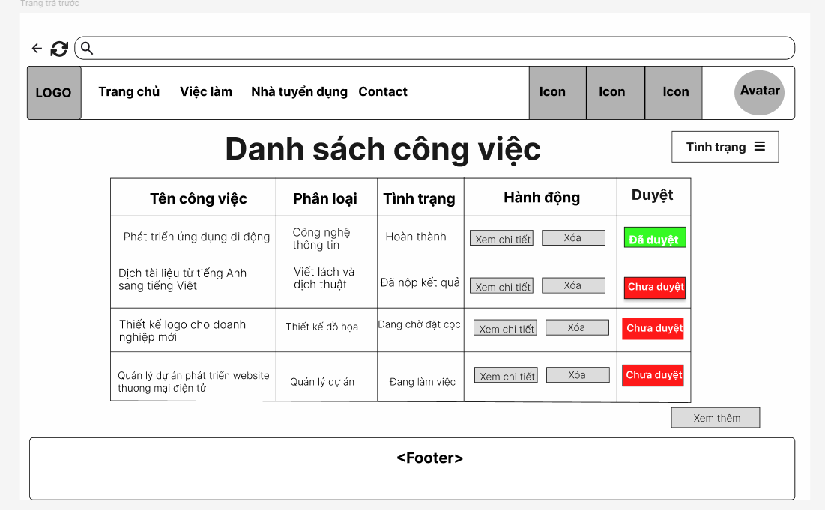
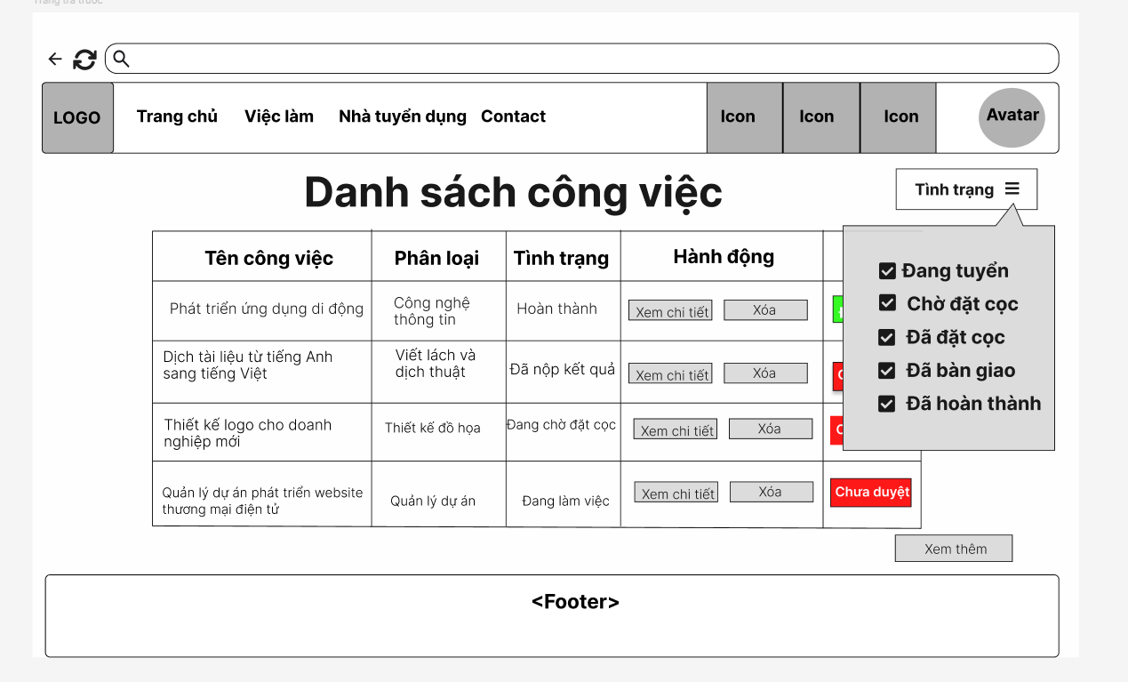

Field Name | Field Type | Description
Title | Heading | Display the title”Danh sách công việc” of the job posting
“Tình trạng” field | Combo box | Display status of job to choose to display
“Đang tuyển” field | Check mark | Add to the filter “Đang tuyển” field
“Chờ đặt cọc” field | Check mark | Add to the filter “Chờ đặt cọc” field
“Đã đặt cọc” field | Check mark | Add to the filter “Đã đặt cọc” field
“Đã bàn giao” field | Check mark | Add to the filter “Đã bàn giao” field
“Đã hoàn thành” field | Check mark | Add to the filter “Đã hoàn thành” field
Tên công việc | Text | Display name of job posting
Phân loại | Text | Display category of job posting
Tình trạng | Text | Display status of job posting
Hành động | Text | Display choices whether delete or view detail
Xem chi tiết | Button | Button to display the detailed information of job posting.
Xóa | Button | Button to delete the job posting
Duyệt | Text | Display the confirmation of job posting
Xem thêm | Button | Button to display more list of jobs
Error Message | Text | Displays error messages"Không thể kết nối đến máy chủ. Vui lòng kiểm tra lại kết nối Internet” when system can not connect to database

Database Access

Table | CRUD | Description
Job | R | Select all table job
1.Select all table job
SELECT * FROM [dbo].[Job]

1.2. View job post

UI Design
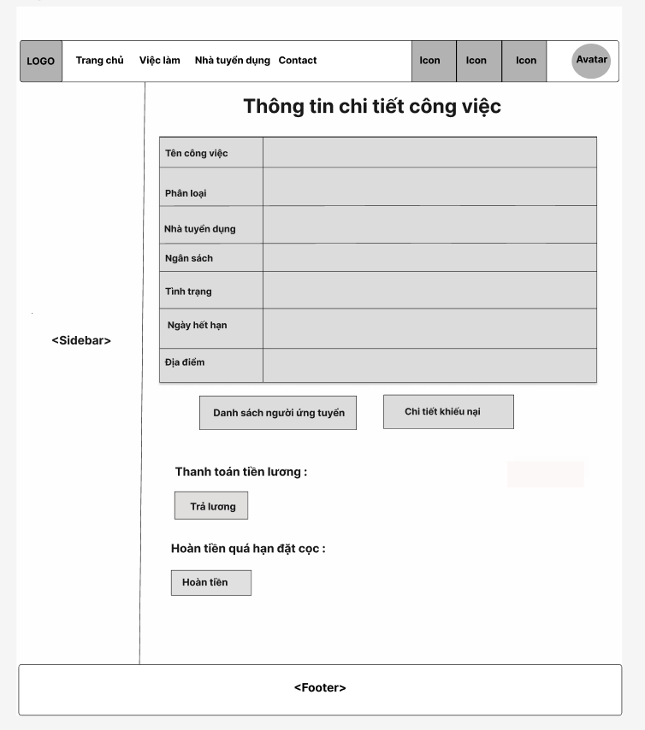

Field Name | Field Type | Description
Title | Heading | Display the title “Thông tin chi tiết công việc”
Job Title | Text | Display the title of job posting
Duedate | Date | Display the Duedate of the job posting
Category job | Text | Display the category of the job posting
Address | Text | Display the address of the job posting
Employer name | Text | Display the employer name
Budget | numerical | Display the budget of the job
Status | Text | Display the status of job
Danh sách ứng tuyển | Button | Button to display candidate these project
Chi tiết khiếu nại | Button | Button to display work complaint these project
Trả lương | Button | Button to confirm transfer salary to seeker.
Hoàn tiền | Button | Button to confirm refund the deposit to the employer

Database Access

Table | CRUD | Description
Job | R | Get job by jobId
1.Select all from job table
SELECT * FROM Job WHERE job_id = ?

2.Authentication

2.1. Register
Register new account to access features of the Platform

UI Design

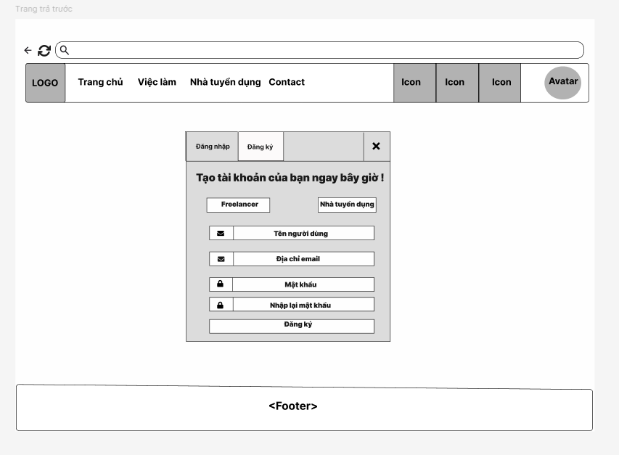

Field Name | Field Type | Description
Title | Heading | This field display “Tạo tài khoản của bạn ngay bây giờ!”
Freelancer | Choice | Field to choose role seeker for account
Nhà tuyển dụng | Choice | Field to choose role employer for account
Full Name | Input field | Field to input the guest's full name.
Email | Input field | Field to input a valid email address. Must follow email format.
Password | Input field | This field to input password
Confirm Password | Input field | This button allows user to prepay
Đăng ký | Button | Button to submit the registration form.
Error Message | Text | Displays error messages”Đăng ký thất bại” when registration is fail
Success Message | Text | Displays confirmation message “Đăng ký thành công”when registration is successful.

Database Access

Table | CRUD | Description
User | C | Inserting required fields into a table user in the database.
User | C | Inserting required fields into a table user in the database with registering by gmail
1. Inserting required fields into a table user in the database.
INSERT INTO Users(user_name,email,password,role,avatar_url, status) VALUES (?,?,?,?,?,?)

2.2. Login
Any Users has account in the Platform, can access to the Platform by entering valid Username and password

UI Design
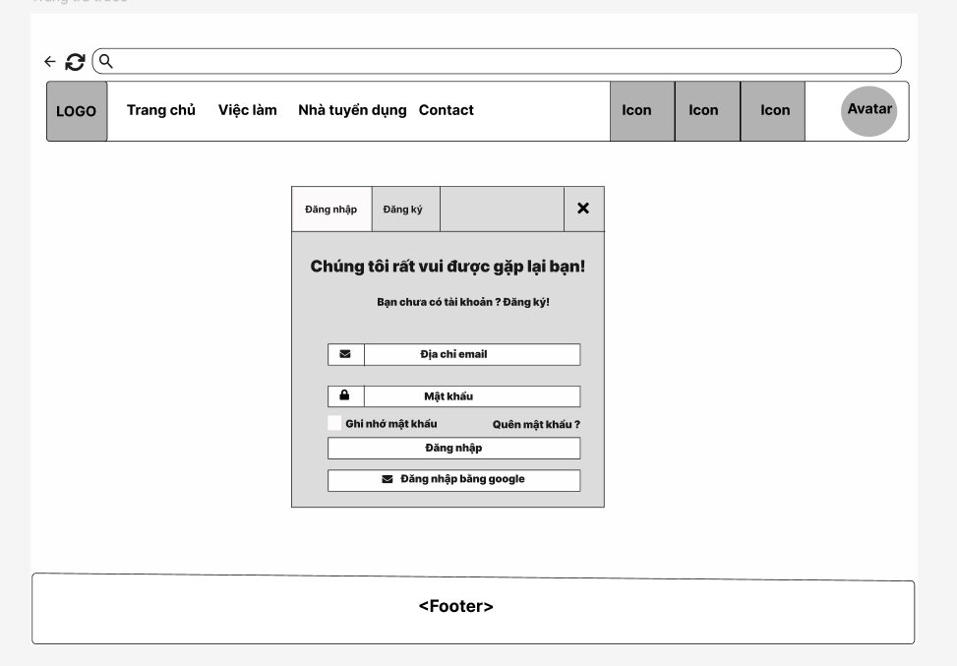

Field Name | Field Type | Description
Title | Heading | This field display “Chúng tôi rất vui được gặp lại bạn ”
Địa chỉ email | Input field | Field to input a valid email address. Must follow email format.
Mật khẩu | Input field | Field to input a valid password.Must be at least 8 regex.
Đăng nhập | Button | Button to submit the login form.
Error Message | Text | Displays an error message ”Đăng nhập thất bại” when invalid input is detected.
Success Message | Text | Display confirmation message”Đăng nhập thành công” when login is successful.
Ghi nhớ mật khẩu | Check mark | Allows users to stay logged until the session expires.
Quên mật khẩu | Hyperlink | Allows users to recover their password
Đăng nhập bằng Google | Hyperlink | Allows user to login with his/her Google account

Database Access

Table | CRUD | Description
Users | R | Verify UserName & Password information
Users | R | Check exist email
Users | R | Check login
Users | U | Add user by login google
1.Verify UserName & Password information
INSERT INTO Users(user_name, email, oauth_provider, oauth_id, avatar_url, status) VALUES (?,?,?,?,?,?);
2.Check exist email
SELECT * FROM Users WHERE email = ?
3.Add user by login google
INSERT INTO Users (user_name, email, oauth_provider, oauth_id, balance, avatar_url, status) VALUES (?, ?, ?, ?, ?, ?, ?)
4.Add user by login google
SELECT * FROM Users WHERE email = ? AND password = ?

2.3. Logout
Log out the Platform

UI Design
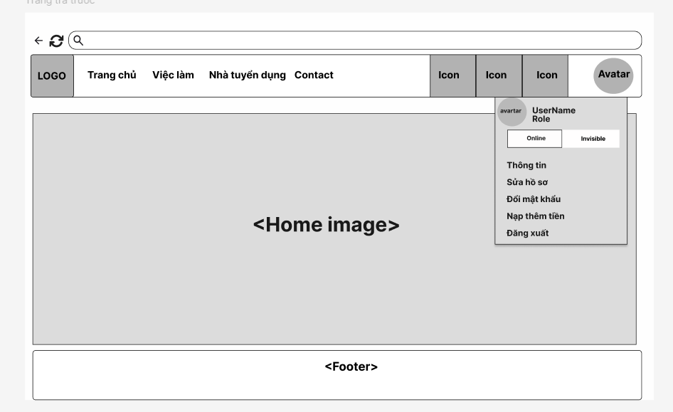

Field Name | Field Type | Description
Đăng xuất | Button | Button to submit the logout.

Database Access
None

2.4. Change password
Users can change their password if they want as long as they enter a valid old password.

UI Design
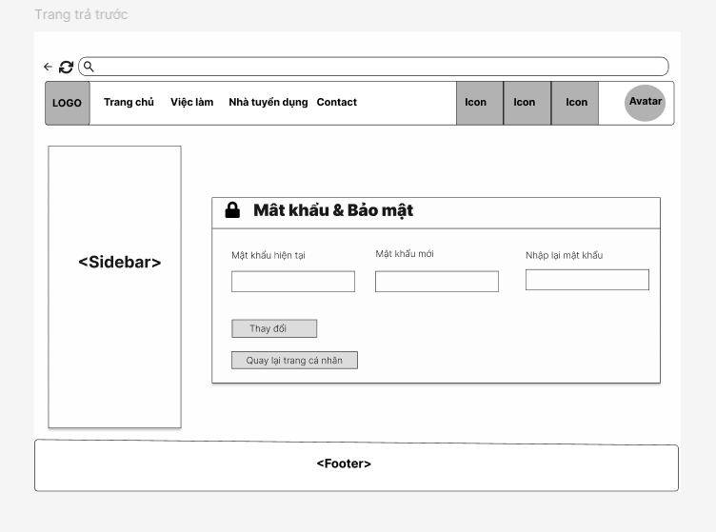

Field Name | Field Type | Description
Title | Heading | This field display “Mật khẩu & Bảo mật ”
Current Password | Input field | Field for the user to enter their current password.
New Password | Input field | Field for the user to enter their new password.
Repeat New Password | Input field | Field for the user to enter to repeat their new password.
Thay đổi | Button | Save changes new password
Error Message | Text | Displays error messages ”Đổi mật khẩu thất bại” when invalid input is detected.
Success Message | Text | Display confirmation message”Đổi mật khẩu thành công” when change password is successful.
Return to Profile page | Button | Field for the user to return to profile page

Database Access

Table | CRUD | Description
Users | R | Update new password with valid email
1.Update new password with valid email

UPDATE [dbo].[Users] SET password = ? WHERE email = ?

2.5. Forgot password
When users log in if they forgot their password, they can request a verification mail to get an OTP then set a new password.

UI Design
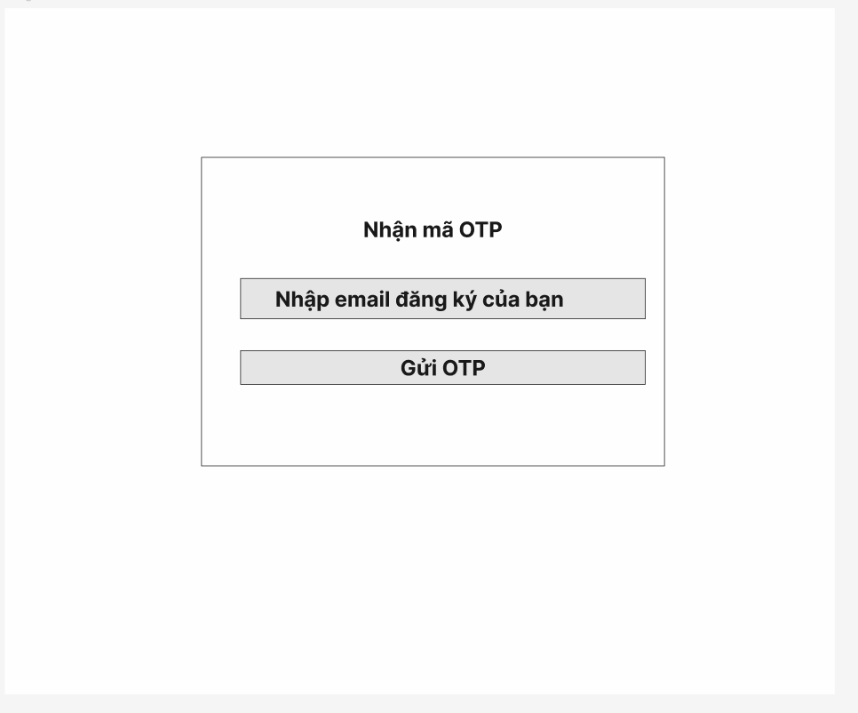
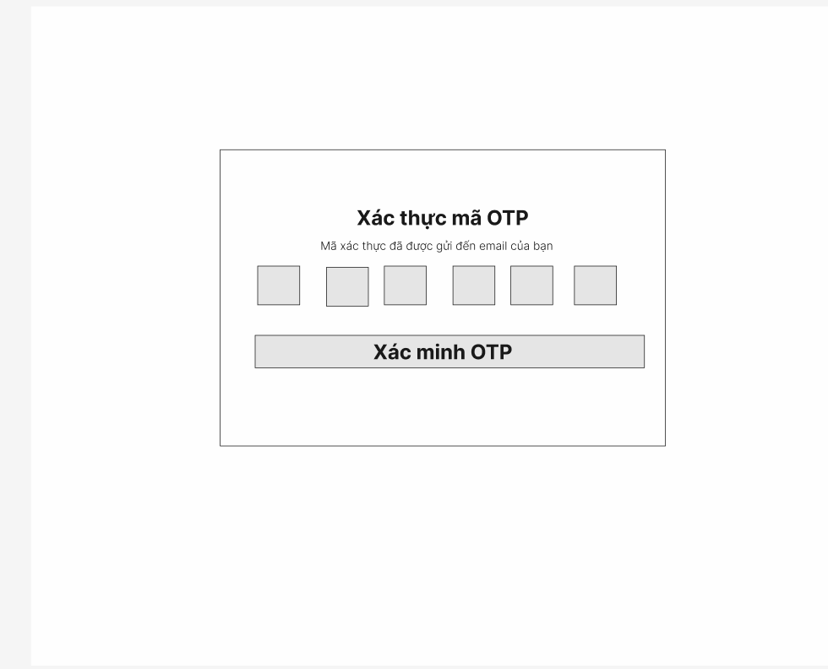
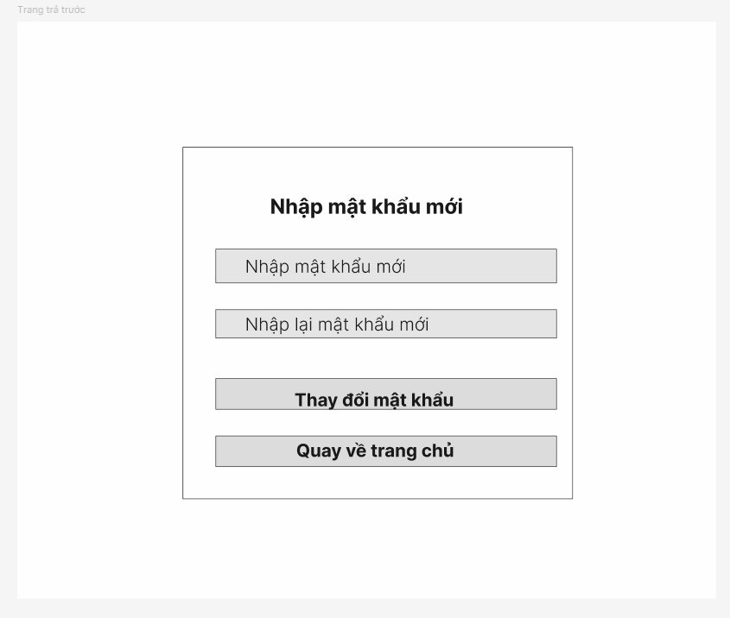

Field Name | Field Type | Description
Title | Heading | This field display “Nhập mã OTP”
Email | Input field | Field to input a valid email address. Must follow email format.
“Nhận OTP” button | Button | The system will send OTP to user via email
Error Message | Text | Displays error messages ”Email không đúng.Vui lòng thử lại” when invalid input is detected.

Field Name | Field Type | Description
Title | Heading | This field display “Xác thực mã OTP”
OTP input | Numerical | Enter OTP received via email
Error Message | Text | Displays error messages ”OTP không đúng.Vui lòng thử lại” when invalid is detected.
Verify OTP Button | Button | Verify an OTP to be sent to the email

Field Name | Field Type | Description
Title | Heading | This field display “Nhập mật khẩu mới”
New Password | Password Field | Field for the user to enter their new password.
Repeat New Password | Password Field | Field for the user to enter to repeat their new password.
Return home page | Button | Return to home page
Change Password Button | Button | Change to submit the new password
Error Message | Text | 1: Displays error messages when invalid ”Mật khẩu phải đủ 8 ký tự” input is detected.  2: Displays error messages when invalid ”Mật khẩu mới không trùng khớp” input is detected.
Success Message | Text | Display confirmation message”Đổi mật khẩu thành công” when changing password is successful.

Database Access

Table | CRUD | Description
Users | R | Select user with conditional email
User | U | Update password with email
1.Select user with condition email
SELECT * FROM [dbo].[Users] WHERE email = ?
2.Update password with email
UPDATE [dbo].[Users] SET password = ? WHERE email = ?

2.6. View profile
Any Users after login successfully can view their profile on the platform.
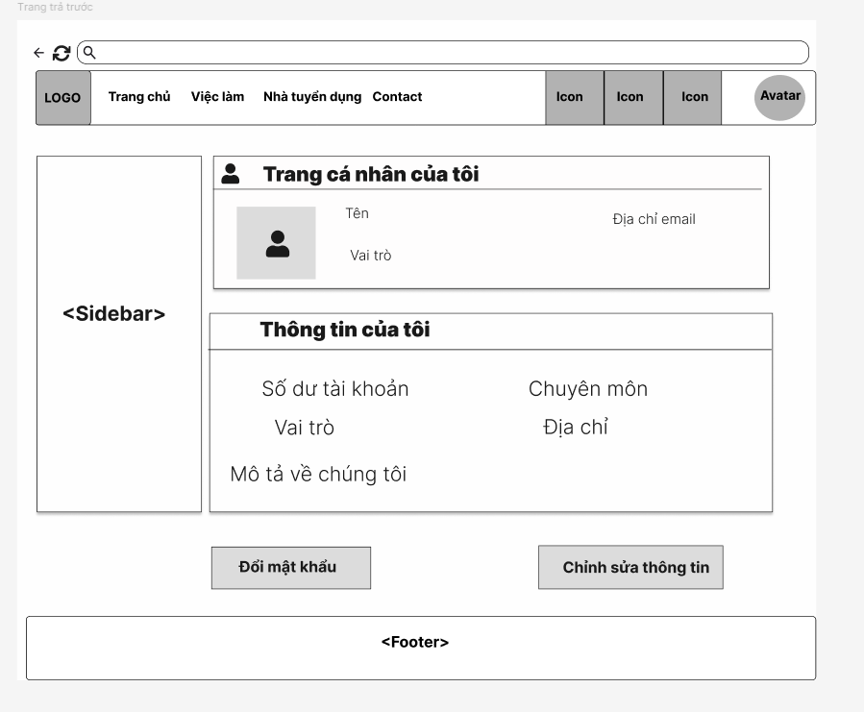

UI Design

Field Name | Field Type | Description
Title | Heading | This field display “Trang cá nhân của tôi”
Title | Heading | This field display “Thông tin của tôi”
Tên | Text | Display user name
Email | Text | Display Email address
Vai trò | Text | Display role
Số dư | Numerical | Display user’s balance
Chuyên môn | Text | Display user’s specification
Địa chỉ | Text | Display user’s address
“Chinh sửa Thông tin” button | Input field | Redirect to edit information.
“Đổi mật khẩu” button | Button | Redirect to change password.

Database Access

Table | CRUD | Description
Users | R | Select user with conditional user_id

1.Select user with conditional user_id
SELECT * FROM [dbo].[Users] WHERE user_id = ?

2.7. Edit profile
Users can edit their information like change name, change date of birth...

UI Design
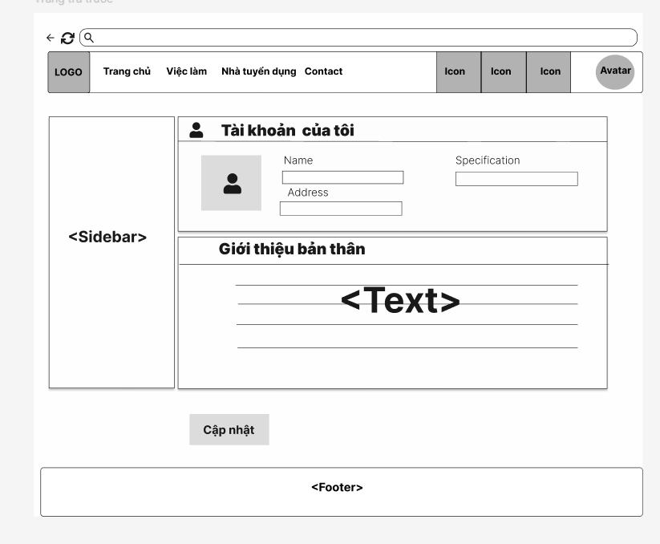

Field Name | Field Type | Description
Title | Heading | This field display “Tài khoản của tôi”
Name | Input | Field for the user to enter their address.
Address | Input | Field for the user to enter their address.
Specification | Input | Field for the user to enter their specification.
Title | Heading | This field display “Giới thiệu bản thân”
Cập nhật | Button | Button “Cập nhật” new information profile

Database Access

Table | CRUD | Description
Users | R | Select user with conditional user_id
Users | U | Update users with conditional gmail

1. Select user with conditional user_id

SELECT * FROM [dbo].[Users] WHERE user_id = ?

2. Update users with conditional gmail

UPDATE Users SET user_name = ?, role = ?, description = ?, specification = ?, address = ?, avatar_url=? WHERE email = ?

3.Online CV Management

3.1.Create CV
Seekers can create CVs to apply for the job.

UI Design
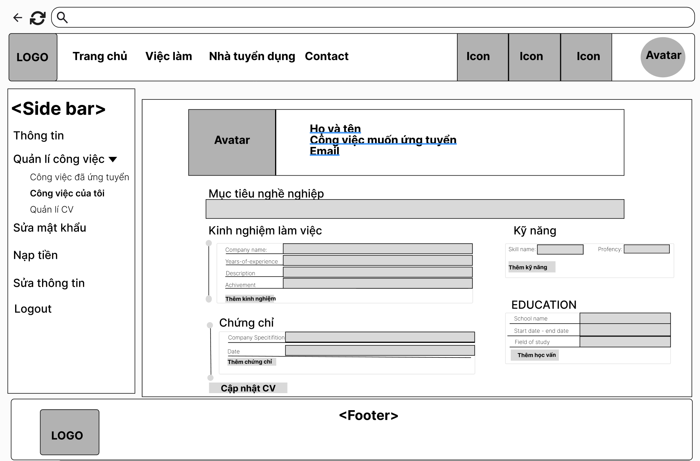

Field name | Filed type | Description
Avatar | Image | - Displays the user's profile picture.
Description Text | Text | - This field displays text: Họ và tên
Description Text | Text | - This field displays text: Công việc muốn ứng tuyển.
Description Text | Text | This field displays text: Email.
Description Text | Text | This field displays text: “Mục tiêu nghề nghiệp”
Description input | Input | This field allows the seeker to fill in the information.
Description Text | Text | This field displays text: “Kinh nghiệm làm việc”
Description Text | Text | - This field displays text: “Company name, years of experience, description, achievements”
Description input | Input | - This field input information of text: “Company name, years of experience, description, achievements”
Thêm kinh nghiệm | Button | Button for adding more forms to enter information.
Description Text | Text | This field displays text: “Chứng chỉ”
Description Text | Text | - This field displays text: “Company specification, date”
Description input | Input | - This field input information of text: “Company specification, date”
Thêm chứng chỉ | Button | Button for adding more forms to enter information.
Description Text | Text | - This field displays text: "Kĩ năng”
Description Text | Text | - This field displays text: "Skill name , proficiency Level”
Description input | Input | - This field input information of text: “Skill name , proficiency Level”
Thêm kĩ năng | Button | Button for adding more forms to enter information.
Description Text | Text | - This field displays text: "Education”
Description Text | Text | - This field displays text: "School Name,Time study,Field of Study”
Description input | Input | - This field input information of text: “School Name,Time study,Field of Study”
Thêm học vấn | Button | Button for adding more forms to enter information.
Cập Nhật CV | Button | Button for saving the entered information.
Database Access

Table | CRUD | Description
CV | C | insert CV
CV_skill | C | insert Skill CV
CV_education | C | insert Education CV
CV_experiencen | C | insert Experience CV
CV | R | get Last Inserted CVId
SQL Commands

Create CV:
INSERT INTO CV (title, summary, created_at, user_id) VALUES (?, ?, ?, ?)
Create Skill CV:
INSERT INTO CV_Skill (cv_id, skill_id, proficiency) VALUES (?, ?, ?)
Create Education CV
INSERT INTO CV_Education (cv_id, education_id, start_date, end_date,field_of_study, degree) VALUES (?, ?, ?, ?, ?,?)";
Create Experience CV
INSERT INTO CV_Experience (cv_id, experience_id, years_of_experience, achievement) VALUES (?, ?, ?, ?)";
get Last Inserted CVId
SELECT MAX(cv_id) AS last_cv_id FROM CV

3.2.View CV
Seekers can view CVs created to apply for the job.

UI Design
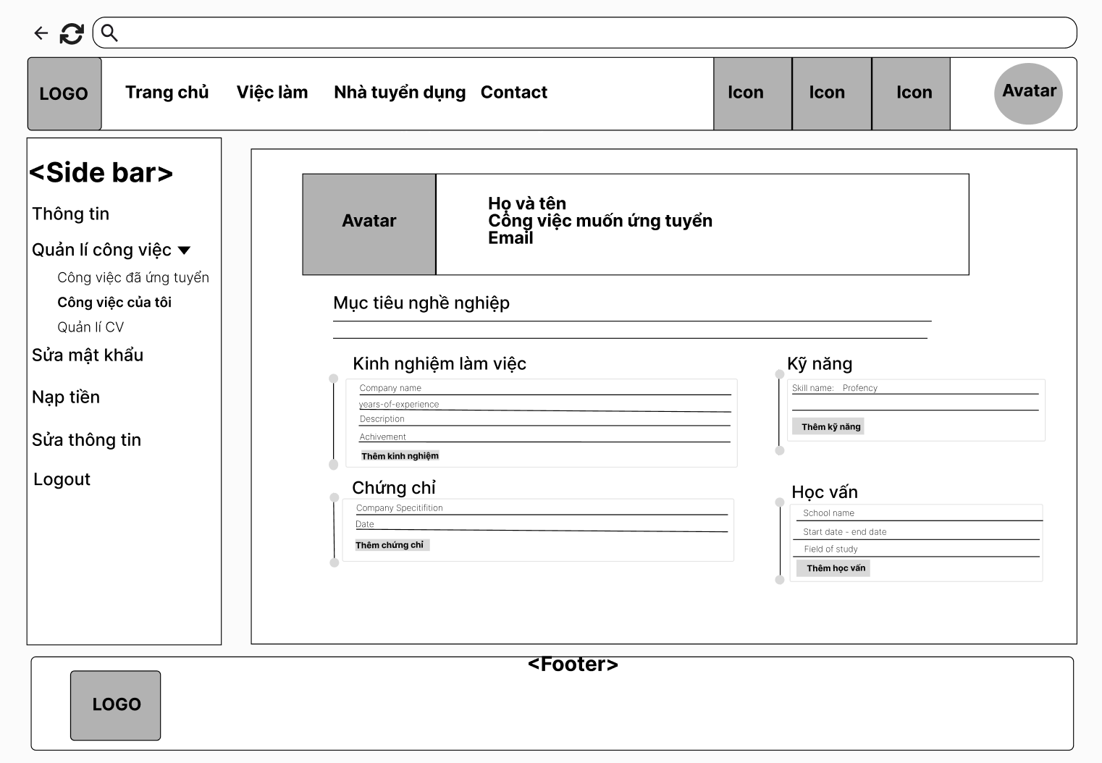

Field name | Field type | Description
Avatar | Image | - Displays the user's profile picture.
Description Text | Text | - This field displays username.
Description Text | Text | - This field displays the job title to apply.
Description Text | Text | This field displays email.
Description Text | Text | This field displays text: “Mục tiêu nghề nghiệp”
Description Text | Text | This field displays Career Summary of CV
Description Text | Text | This field displays text: “Kinh nghiệm làm việc”
Description Text | Text | This field displays Career Summary of CV
Description Text | Text | This field displays text: “Chứng chỉ”
Description Text | Text | - This field displays information of“Company specification, Date” of CV
Description Text | Text | - This field displays text: "Kĩ năng”
Description Text | Text | - This field displays information of: "Skill name , proficiency Level”
Description Text | Text | - This field displays text: "Học vấn”
Description Text | Text | - This field displays information of: "School Name,Time study,Field of Study”
Database Access
Table | CRUD | Description
CV | R | get CV by cv_id
CV_skill | R | get CV skill by cv_id
CV_education | R | get CV education by cv_id
CV_experiencen | R | get CV experience by cv_id

SQL Commands;
- Get CV by cv_id:
SELECT * FROM [dbo].[CV] WHERE user_id = ?
- Get CV skill by cv_id:
SELECT " +
"Skill.skill_id, " +
"Skill.skill_name, " +
"CV_Skill.proficiency " +
"FROM CV_Skill " +
"JOIN Skill ON CV_Skill.skill_id = Skill.skill_id " +
"WHERE CV_Skill.cv_id = ?
- Get CV education by cv_id:
SELECT CE.cv_id, CE.education_id, CE.start_date, CE.end_date, CE.degree, CE.field_of_study, S.school_name " +
"FROM CV_Education CE " +
"JOIN School S ON CE.education_id = S.education_id " +
"WHERE CE.cv_id = ?
- Get CV experience by cv_id
SELECT \n" +
" ce.cv_id,\n" +
" ce.experience_id,\n" +
" ce.years_of_experience,\n" +
" ce.achievement,\n" +
" c.company_name,\n" +
" c.description\n" +
"FROM \n" +
" CV_Experience ce\n" +
"JOIN \n" +
" Company c ON ce.experience_id = c.experience_id\n" +
"WHERE \n" +
" ce.cv_id = ?

3.3.Delete CV
Seekers can delete CVs created.

UI Design
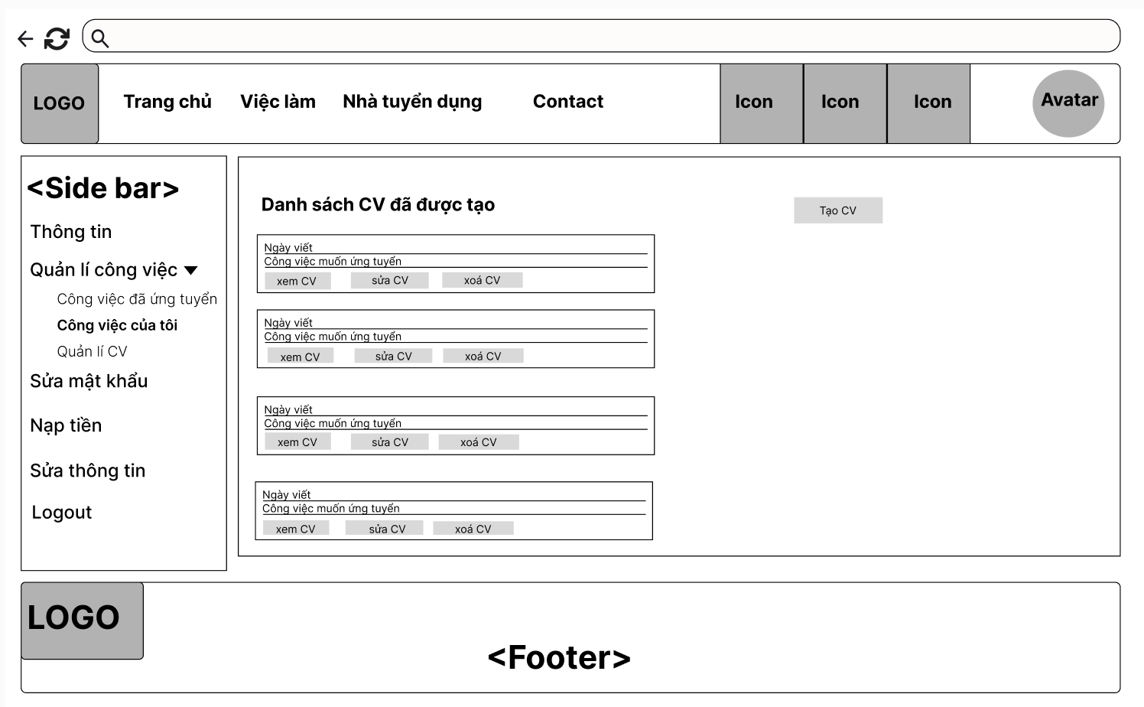

Field name | Field type | Description
Title | Heading | - This field displays text: Danh sách CV đã được tạo
Description Text | Text | - This field displays text: Ngày viết
Xem CV | Button | Button for view the CV.
Sửa CV | Button | Button for updating the CV.
Xoá CV | Button | Button to delete the CV.

Database Access
Table | CRUD | Description
CV | D | delete CV by cv_id
CV_skill | D | delete CV skill by cv_id
CV_education | D | delete CV education by cv_id
CV_experiencen | D | delete CV experience by cv_id

SQL Commands;

Delete CV by cv_id:
- DELETE FROM CV
WHERE cv_id = ?;
Delete CV skill by cv_id:
- DELETE FROM CV_Skill WHERE cv_id = ?;
Delete CV education by cv_id:
- DELETE FROM CV_Education WHERE cv_id = ?
Delete CV experience by cv_id:
- DELETE FROM CV_Experience WHERE cv_id = ?;

3.4.Update CV
Seekers can update their CV to apply for the job.

UI Design
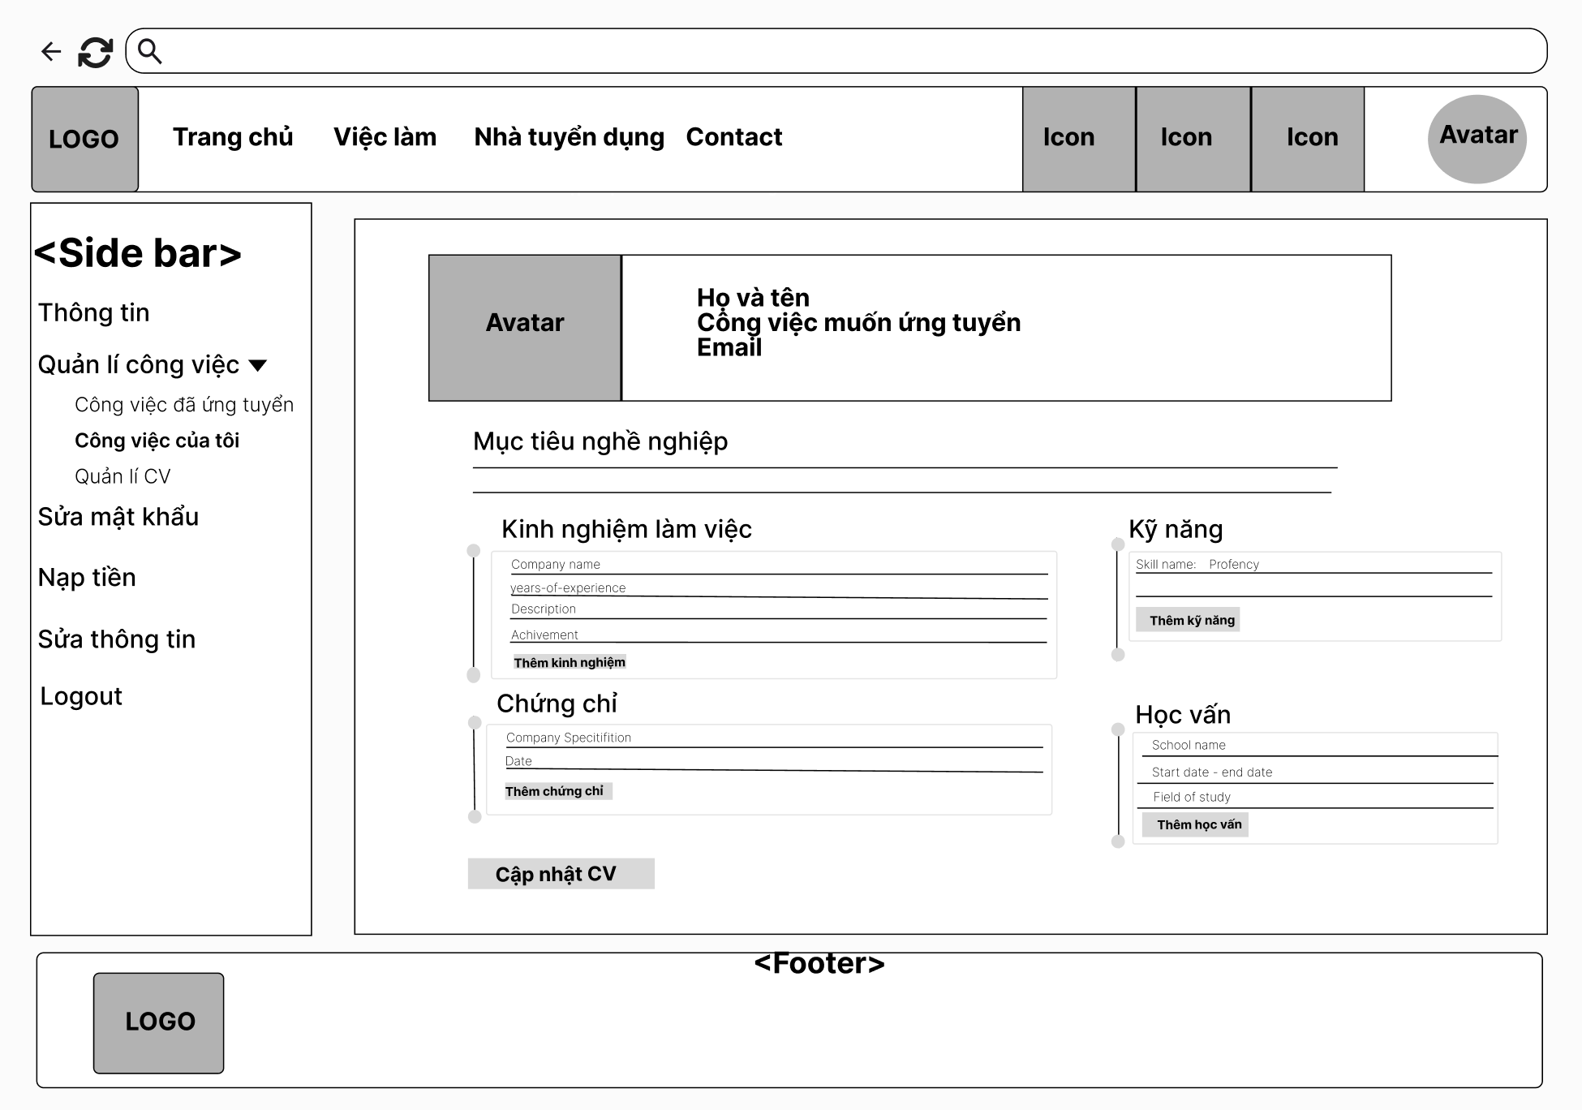

Field name | Field type | Description
Avatar | Image | - Displays the user's profile picture.
Description Text | Text | - This field displays text: Họ và tên
Description Text | Text | - This field displays text: Công việc muốn ứng tuyển.
Description Text | Text | This field displays text: Email.
Description Text | Text | - This field displays text: “Mục tiêu nghề nghiệp”
Description input | Input | This field allows the seeker to fill in the information.
Description Text | Text | This field displays text: “Kinh nghiệm làm việc”
Description Text | Text | - This field displays text: “Company name, years of experience, description, achievements”
Description input | Input | - This field input information of text: “Company name, years of experience, description, achievements”
Thêm kinh nghiệm | Button | Button for adding more forms to enter information.
Description Text | Text | This field displays text: “Chứng chỉ”
Description Text | Text | - This field displays text: “Company specification, date”
Description input | Input | - This field input information of text: “Company specification, date”
Thêm chứng chỉ | Button | Button for adding more forms to enter information.
Description Text | Text | - This field displays text: "Kĩ năng”
Description Text | Text | - This field displays text: "Skill name , proficiency Level”
Description input | Input | - This field input information of text: “Skill name , proficiency Level”
Thêm kĩ năng | Button | - Button for adding more forms to enter information.
Description Text | Text | - This field displays text: "Education”
Description Text | Text | - This field displays text: "School Name,Time study,Field of Study”
Description input | Input | - This field input information of text: “School Name,Time study,Field of Study”
Thêm học vấn | Button | - Button for adding more forms to enter information.
Cập Nhật CV | Button | Button for saving the entered information.

Table | CRUD | Description
CV | U | Update CV by cv_id
CV_skill | U | Update CV skill by cv_id
CV_education | U | Update CV education by cv_id
CV_experiencen | U | Update CV experience by cv_id

SQL Commands:
- Update CV by cv_id
UPDATE CV SET title = @title, summary = @summary, created_at = @created_at WHERE cv_id = ?
- Update CV skill by cv_id
UPDATE CV_Skill SET proficiency = @proficiency WHERE cv_id = ? AND skill_id = ?
-Update CV education by cv_id
UPDATE CV_Education SET start_date = @start_date, end_date = @end_date, field_of_study = @field_of_study, degree = @degree WHERE cv_id = ? AND education_id = ?;
- Update CV experience by cv_id
UPDATE CV_Experience SET years_of_experience = @years_of_experience, achievement = @achievement WHEREcv_id =? AND experience_id = ?

4. Wallet and transaction management

4.1.View wallet
Users can view balance, history of transaction progress

UI Design
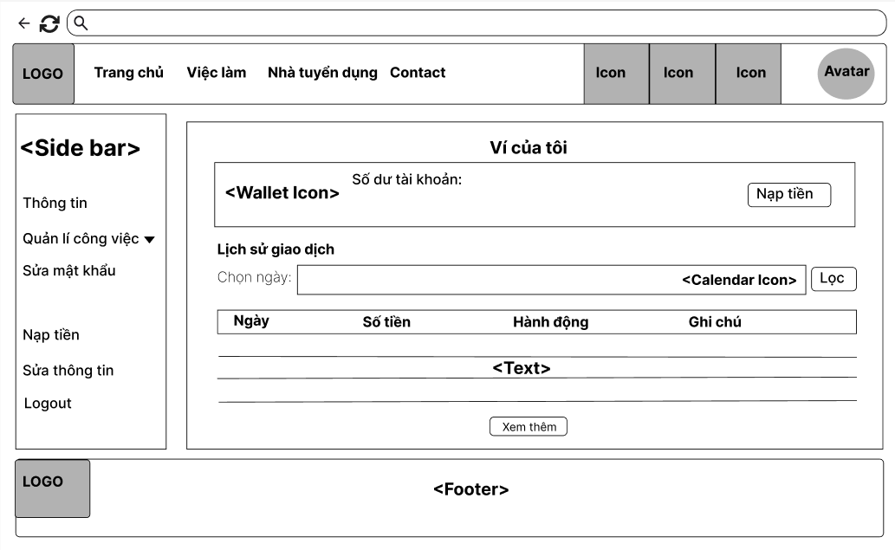
Field Name | Field Type | Description
Title | Heading | - This field displays text: “Ví của tôi”
Description | Text | - This field displays text: “Số dư tài khoản:”
Balance | Numeric | - This field displays the amount of money in their wallet.
Nạp tiền | Button | This button allows the user to add money to their wallet.
Description | Text | - This field displays text: “Lịch sử giao dịch:”
Description | Text | - This field displays text: “Chọn ngày:”
Calendar | Icon | This icon will help the user to choose time to view transactions.
Lọc | Button | This button allows the user to display transactions by time chosen.
Transaction table: Display information about Transaction .
Ngày | Text | - This field displays the transaction.
Số tiền | Text
Hành động | Text
Ghi chú | Text
Xem thêm | Button | This button allows the user to display more transactions.

Database Access
Table | CRUD | Description
Wallet | R | Get the user’s wallet balance
Transactions | R | Get transactions for the user, filtered by selected date.
SQL Commands
-Get the user’s wallet balance:
SELECT balance FROM Wallet WHERE user_id = ?;

-Get transactions for the user, filtered by selected date:
SELECT date, amount, action, note
FROM Transactions
WHERE user_id = ? AND transaction_date = ?;

-Get all transactions:
SELECT date, amount, action, note
FROM Transactions
WHERE user_id = ?
ORDER BY transaction_date DESC;

4. Wallet and transaction management

4.1.View wallet
Users can view balance, history of transaction progress

UI Design
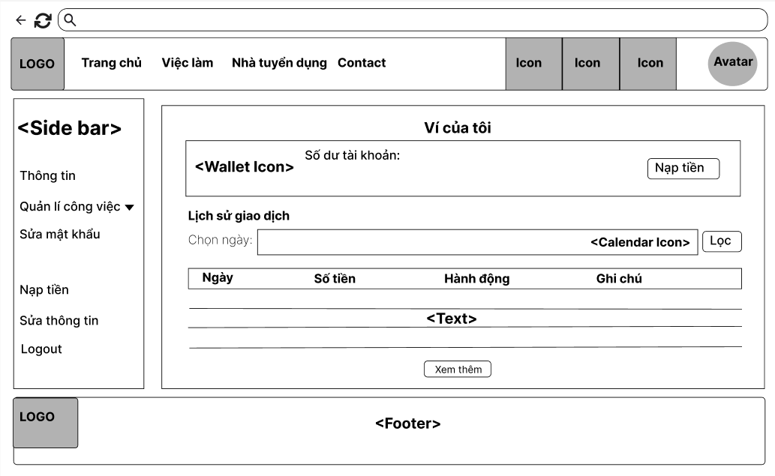
Field Name | Field Type | Description
Title | Heading | - This field displays text: “Ví của tôi”
Description | Text | - This field displays text: “Số dư tài khoản:”
Balance | Numeric | - This field displays the amount of money in their wallet.
Nạp tiền | Button | This button allows the user to add money to their wallet.
Description | Text | - This field displays text: “Lịch sử giao dịch:”
Description | Text | - This field displays text: “Chọn ngày:”
Calendar | Icon | This icon will help the user to choose time to view transactions.
Lọc | Button | This button allows the user to display transactions by time chosen.
Transaction table: Display information about Transaction .
Ngày | Text | - This field displays the transaction.
Số tiền | Text
Hành động | Text
Ghi chú | Text
Xem thêm | Button | This button allows the user to display more transactions.

Database Access
Table | CRUD | Description
Wallet | R | Get the user’s wallet balance
Transactions | R | Get transactions for the user, filtered by selected date.
SQL Commands
-Get the user’s wallet balance:
SELECT balance FROM Wallet WHERE user_id = ?;

-Get transactions for the user, filtered by selected date:
SELECT date, amount, action, note
FROM Transactions
WHERE user_id = ? AND transaction_date = ?;

-Get all transactions:
SELECT date, amount, action, note
FROM Transactions
WHERE user_id = ?
ORDER BY transaction_date DESC;

4.2. Add money into wallet
Users can add money to wallet

UI Design
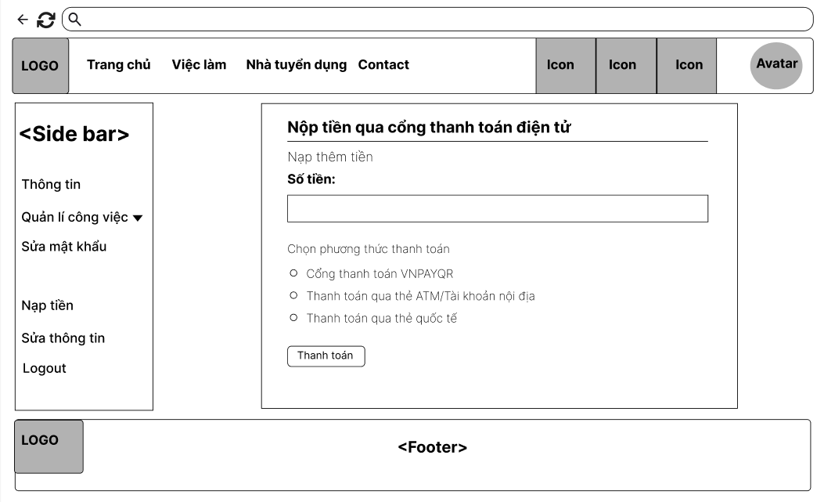
Field Name | Field Type | Description
Title | Heading | - This field displays text: “Nạp tiền qua cổng thanh toán điện tử”
Description | Text | - This field displays text: “Nạp thêm tiền”
Description | Text | - This field displays text: “Số tiền”
Description-text | Text-area | This field displays input money to add.
Description | Text | - This field displays text: “Chọn phương thức thanh toán”
Cổng thanh toán VNPAYQR | Choice | This choice allows the employer to deposit through VNPAY-QR.
Thanh toán qua thẻ ATM/Tài khoản nội địa | Choice | This choice allows the employer to deposit through ATM/Domestic Account.
Thanh toán qua thẻ quốc tế | Choice | This choice allows the employer to deposit through an international card.
Thanh toán | Button | This button allows the user to deposit money to their wallet.

Database Access

Table | CRUD | Description
Wallet | U | Update the user's wallet balance after successful payment.
Transactions | R | Create a new transaction record after the deposit is made.
SQL Commands
-Update the user's wallet balance after successful payment:
UPDATE Users
SET balance = balance + ?
WHERE user_id = ?;

-Create a new transaction record after the deposit is made:
INSERT INTO [Transaction] (senderId, receiverId, amount, createdDate, status, transactionType, jobId, description)
VALUES (?, NULL, ?, GETDATE(), 1, 'Deposit', NULL, 'Nạp tiền qua cổng thanh toán điện tử');

5. Apply for a job

5.1 Search job post
This use case allows users can search jobs by keywords relevant to the title of the post.

UI Design
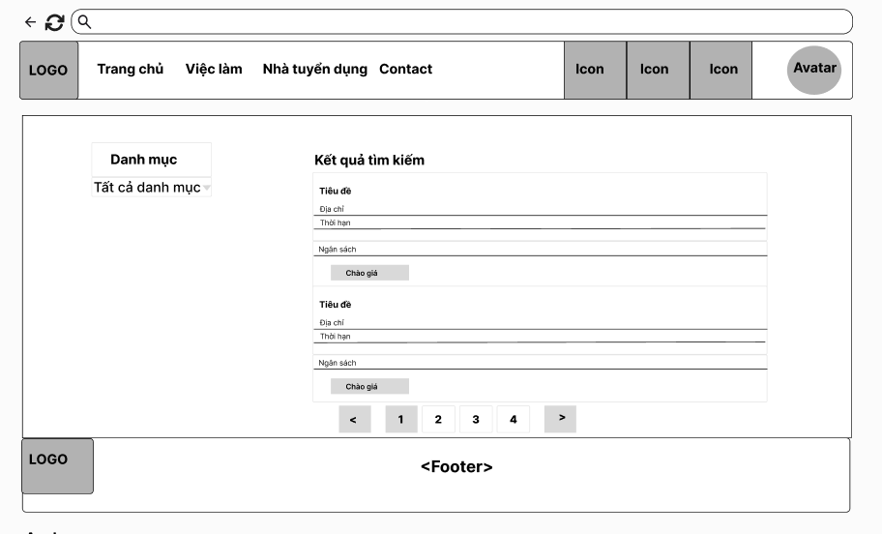

Filed name | Filed type | Description
Title | Heading | - This field displays text: “Danh mục”
Description Text | Dropdown | - Dropdown to filter search results by category. Displays "Tất cả danh mục" by default, allowing users to view all categories.
Title | Heading | - This field displays text:”Kết quả tìm kiếm”
Title (Tiêu đề) | Text | - Title of the search result item.
Address (Địa chỉ) | text | Displays the address for the item being searched.
Budget (Ngân sách) | text | Displays the budget associated with the listing
Bid Now Button (Đấu giá ngay) | button | - Button that allows the user to place a bid on the item immediately.

Database Access
Table | CRUD | Description
Job | R | get job by category_id
SQL Commands: -
Get job by category_id:
SELECT * FROM Job WHERE category_id = ?

5.2 View employer’s information
Allows seekers to view detailed information about the employer, including company name, address, and description.
UI Design
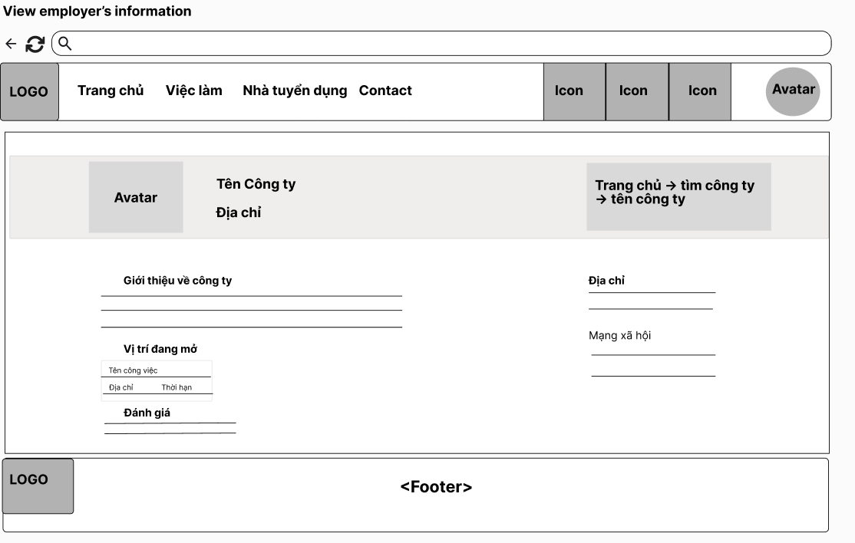

Filed name | Filed type | Description
Avatar | Image | - Displays the company's logo or image.
Tên công ty | Text | - Shows the name of the company.
Đánh Giá | Text | - Show review of company
Địa chỉ | Text | Show address of company
Title | Text | - This field displays text: “Trang chủ->hồ sơ công ty-> tên công ty”
Description Text | Text | This field displays text: “Giới thiệu về công ty”
Giới thiệu về công ty | Input | - This field input introduce about company
Description Text | Text | This field displays text: “Vị trí đang mở”
Địa chỉ (Address) | Text | - Displays the company’s address.
Mạng xã hội (Social Media) | Text | - Displays links to the company’s social media profiles.
Đánh giá (Reviews) | Text | - Section for displaying user reviews about the company.

Database Access

Table | CRUD | Description
Job | R | get job by user id
User | R | Get user by role = employer

SQL Commands:
- Get all user by role = employer:
SELECT * FROM Users WHERE role = 'employer’
- Get job by user id:
SELECT * From Job where user_id=?

5.3 View job post
This use case allows Admin, Guest, Seeker, Employer can view the information of job in detail.
UI Design
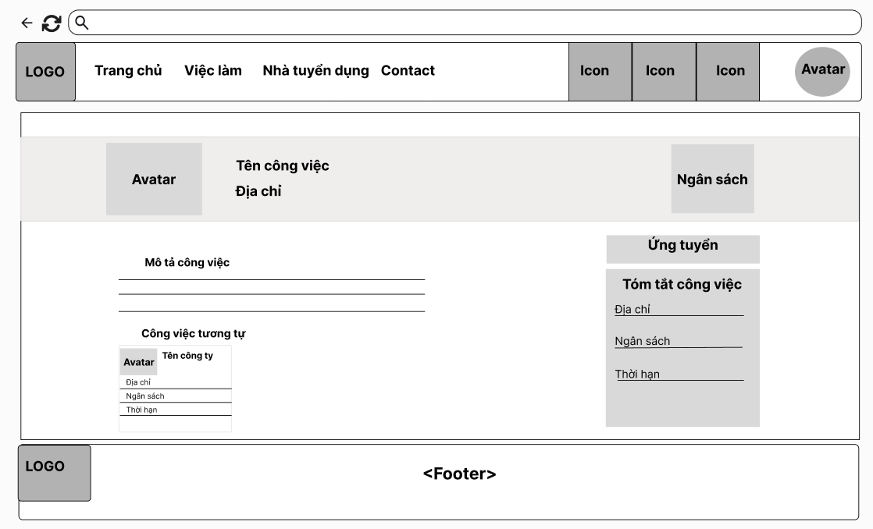

Filed name | Filed type | Description
Avatar | Image | - Displays the company's logo or image.
Tên công việc | Test | - Shows the title of the job.
Ngân sách | Number | - This field displays budget
Job description | Text | This field displays text: “Mô tả công việc”
Description Text | Text | - This field displays “Công việc tương tự”
Same job( Công việc tương tự) | Text | Displays same job positions, including:name company, location, and deadline,budget..
Tóm tắt công việc | Text | - Displays information of job , including:address,due time,budget..
Ứng tuyển | button | Display apply form

Database Access

Table | CRUD | Description
Job | R | get job by job_ id
Job | R | get jobs by categoryId excluding jobId
User | R | Get user by user_id

SQL Commands:
- Get job by job_ id:
SELECT * FROM Job WHERE job_id = ?
- Get user by user_id :
SELECT * FROM [dbo].[Users] WHERE user_id = ?
- get jobs by categoryId excluding jobId:
SELECT * FROM Job WHERE category_id = ? AND job_id != ?

5.4. Apply
Allows seekers to apply for a specific job through the system.

UI Design
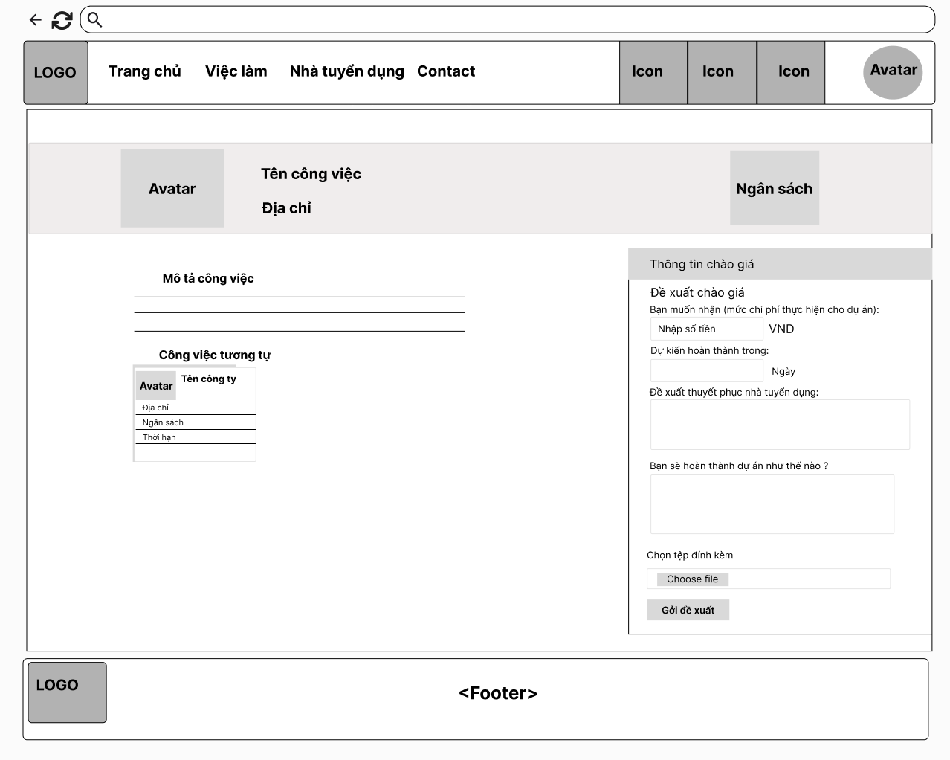

Filed name | Filed type | Description
Avatar | Image | - Displays the company's logo or image.
Tên công việc | Test | - Shows the title of the job.
Ngân sách | Number | - This field displays budget
Job description | Text | This field displays text: “Mô tả công việc”
Description Text | Text | - This field displays “Công việc tương tự”
Same job( Công việc tương tự) | Text | Displays same job positions, including:name company, location, and deadline,budget..
Tóm tắt công việc | Text | - Displays information of job , including:address,due time,budget..
Description Text | Text | - This field displays text: “Thông tin chào giá”
Description Text | Text | - This field displays text: “Đề xuất chào giá  - This field displays text: “Bạn muốn nhận mức giá nào cho dự á ”
Nhập số tiền | Input | Input field where the user enters the bid amount (in VND).
VND | Label | Displays the currency for the bid amount.
Description Text | Text | - This field displays text: “Dự kiến hoàn thành trong ”
Estimated time input | input | Input field where the user enters the time complete.
Description Text | Text | This field displays text: “Đề xuất thuyết phục nhà tuyển dụng ”
Convin input | input | Input the method of convincing the employer
Description Text | Text | This field displays text: “Bạn sẽ thực hiện dự án như thế nào?”
Enter how to do | input | Input how you will do the project
file | File | - This field displays text:Tệp đính kèm liên quan đến hệ thống.
Gửi đề xuất | button | Proposal sent to employer

5.5 View applied job list
Allows seekers to view a list of jobs they have applied for.

UI Design
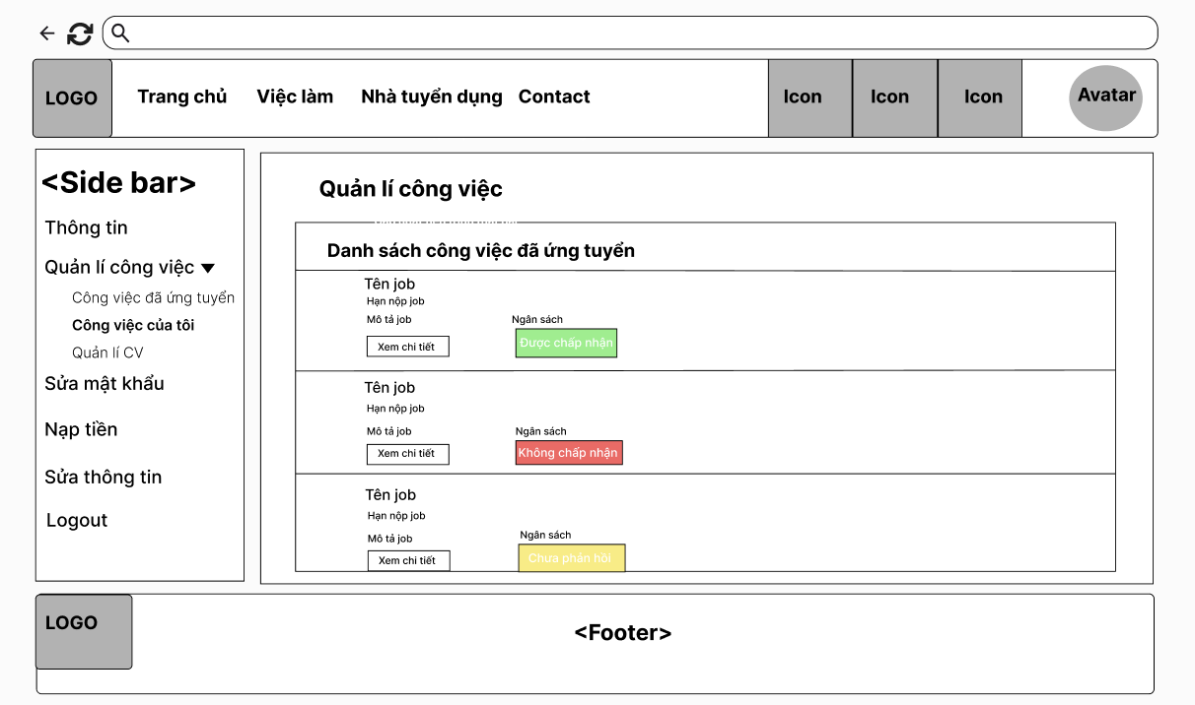

Filed name | Filed type | Description
Title | Heading | - This field displays text: “Quản lý công việc”
Title | Text | - This field displays text: “Danh sách công việc đã ứng tuyển”
Tên job | Text | - Displays the job title the user applied for.
Hạn nộp job | Text | Displays the due time for the job application.
Mô tả job | Text | - Description of the job applied for.
Xem chi tiết | button | A button to view detailed information of job.
Trạng thái | Status Label | Displays the current application:
Được chấp nhận | Status Label | - Green label indicating that the job application has been accepted.
Không chấp nhận | Status Label | - Red label indicating that the job application has been rejected.
Chờ trả lời | Status Label | Yellow label indicating that the job application is still awaiting a response.

Database Access

6. Recruitment for job

6.1 Create Job Post
Allows employers to create jobs for recruitment seekers.

UI Design
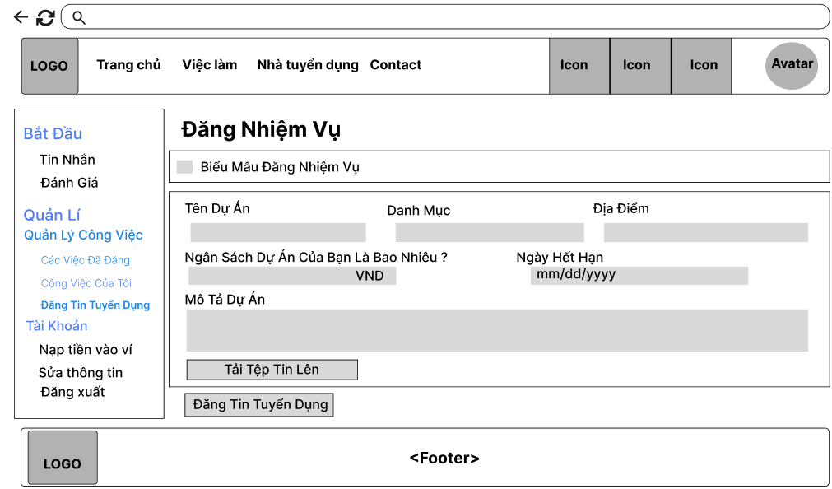

Field Name | Field Type | Description
Title | Heading | This field displays text: “Đăng Nhiệm Vụ”
Description | Text | This field displays text: “Tên Dự Án”
Description-Text | Text-area | This field displays the input title of job.
Description | Text | This field displays text: “Danh Mục”
Description-Text | Text-area | This field displays the input category of job.
Description | Text | This field displays text: “Địa Điểm”
Description-Text | Text-area | This field displays the input address of the job.
Description | Text | This field displays text: “Ngân Sách Dự Kiến Của Bạn Là Gì?”
Description-Text | Text-area | This field displays the input balance of the job.
Description | Text | This field displays text: “Ngày Hết Hạn”
Description-Text | Date | This field displays the input due date of job.
Description | Text | This field displays text: “Mô tả dự án của bạn”
Description-Text | Text-area | This field displays the input description of the job.
Tải tệp tin lên | Button | This button allows the employer to upload documents related to the job.
Đăng Tin Tuyển Dụng | Button | This button allows the employer to create a new job on the platform.

Database Access
Table | CRUD | Description
Job | C | Add new job
JobCategory | R | Get category list
User | R | Get user by email

SQL Commands:
1/ Add new job
INSERT INTO Job(user_id, job_title, budget, description, due_date, status, category_id, doc_URL, address) VALUES (?,?,?,?,?,?,?,?,?)

2/ Get category list
SELECT * FROM JobCategory

3/Get user by email
SELECT * FROM [dbo].[Users] WHERE email = ?

6.2 View a post
Allows user to view job detail.

UI Design
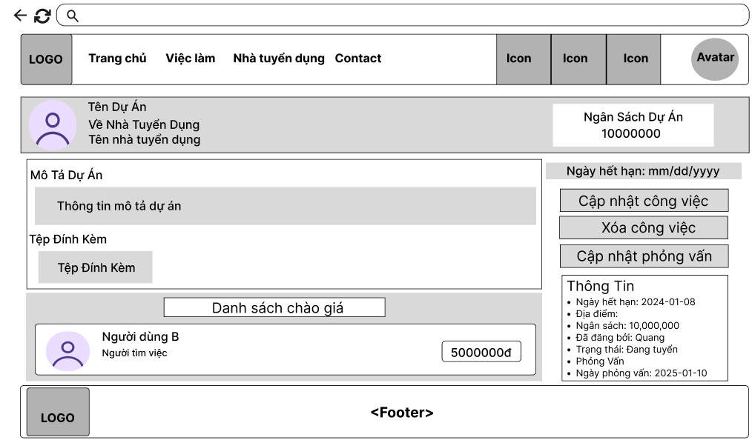

Field Name | Field Type | Description
User avatar | Image | This field displays the user's avatar.
Description Text | Text | - This field displays text: Name of Employer.
Description Text | Text | - This field displays text:”Về nhà tuyển dụng”.
Description Text | Text | - This field displays text:”Ngân sách dự án”.
Description Text | Text | - This field displays text:”Mô tả dự án”.
Description Text | Text | - This field displays text:Description of job.
Description Text | Text | - This field displays text:”Tệp đính kèm”.
Description File | File | - This field displays text:Tệp đính kèm liên quan đến hệ thống.
Title | Heading | - This field displays text: “Danh sách chào giá”.
User avatar | Image | This field displays the useeker's avatar.
Description Text | Text | This field displays text: Name of seeker.
Description Text | Text | This field displays text: Role of user.
Description Text | Text | This field displays text: Greeting price.
Description Text | Text | This field displays text: due date of this job.
Cập nhật công việc | Button | This button allows the employer to navigate to update the job post page.
Xóa công việc | Button | This button allows the employer to delete job post.
Cập nhật phỏng vấn | Button | This button allows the employer to navigate to update the interview page.
Description Text | Text | This field displays text: information about this job.

Database Access
Table | CRUD | Description
Job | R | Get job information by job ID
JobCategory | R | Get category name by ID
User | R | Get user by id

SQL Commands:
1/ Get job information by job ID
select * from Job where job_id = ?

2/ Get category name by ID
SELECT * FROM JobCategory WHERE category_id = ?

3/ Get user by user id
SELECT * FROM [dbo].[Users] WHERE user_id = ?

6.3 Update job post
Allows employers to update their job details posted.

UI Design
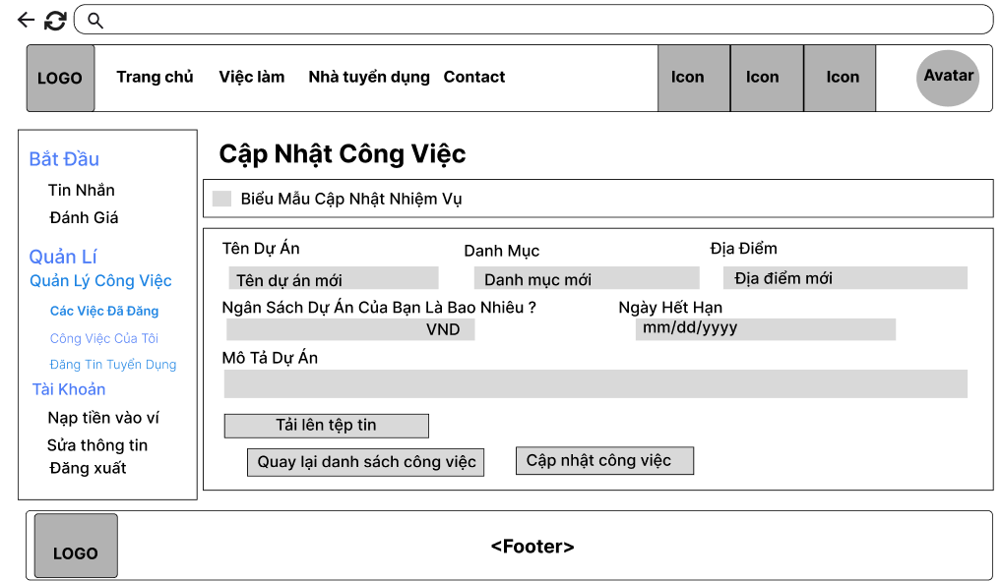

Field Name | Field Type | Description
Title | Heading | This field displays text: “Cập Nhật Nhiệm Vụ”
Description | Text | This field displays text: “Tên Dự Án”
Description-Text | Text-area | This field displays the input title of job.
Description | Text | This field displays text: “Danh Mục”
Description-Text | Text-area | This field displays the input category of job.
Description | Text | This field displays text: “Địa Điểm”
Description-Text | Text-area | This field displays the input address of the job.
Description | Text | This field displays text: “Ngân Sách Dự Kiến Của Bạn Là Gì?”
Description-Text | Text-area | This field displays the input balance of the job.
Description | Text | This field displays text: “Ngày Hết Hạn”
Description-Text | Date | This field displays the input due date of job.
Description | Text | This field displays text: “Mô tả dự án của bạn”
Description-Text | Text-area | This field displays the input description of the job.
Tải tệp tin lên | Button | This button allows the employer to upload documents related to the job.
Cập nhật công việc. | Button | This button allows the employer to update job posts on the platform.
Quay Lại Bài Đăng Của Tôi | Button | This button allows the employer to navigate back to the job post list page.

Database Access
Table | CRUD | Description
Job | U | Update a job
Job | R | Get job by job id
JobCategory | R | Get category list
User | R | Get user by email

SQL Commands:
1/ Update a job
UPDATE Job SET job_title = ?, description = ?, due_date = ?, budget = ?, address = ?, category_id = ?
WHERE job_id = ?

2/ Get job by job ID
select * from Job where job_id = ?

3/ Get category list
SELECT * FROM JobCategory

4/Get user by email
SELECT * FROM [dbo].[Users] WHERE email = ?

6.4 Delete job post
Allows employers to delete their job details posted.

UI Design
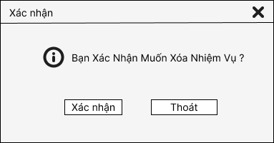

Database Access
Table | CRUD | Description
Job | D | Delete a job by job id

SQL Commands:
1/ Delete a job
DELETE FROM Job WHERE job_id = ?

6.5 View job post list
Allows employers to view their posted job list.

UI Design
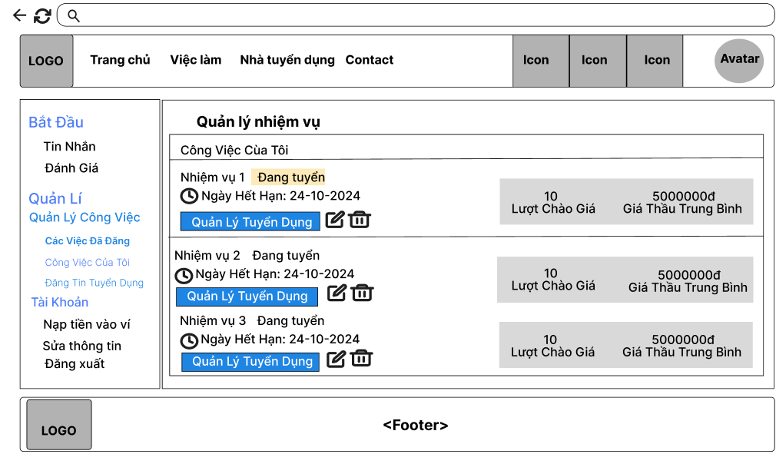

Field Name | Field Type | Description
Title name | Heading | This field displays text: “Quản lý nhiệm vụ”
Description Text | Text | This field displays text: “Công việc của tôi ”.
Description Text | Text | This field displays text: Tên công việc.
Description Text | Text | This field displays text: Trạng thái công việc.
Description Text | Text | This field displays text: Ngày hết hạn của công việc.
Description Text | Text | This field displays text: Lượt đấu thầu.
Description Text | Text | This field displays text: Giá Thầu Trung Bình.
Quản Lý Tuyển Dụng | Button | This button allows the employer to navigate to manage the bidder page.
Trash | Icon | This icon allows the employer to delete a job post.

Database Access
Table | CRUD | Description
Job | R | Get job post list by user id
JobGreeting | R | Get job greeting list by job id
User | R | Get user id by email

SQL Commands:
1/ Get job post list by user id
select * from Job where user_id = ?

2/ Get job greeting list by job id
SELECT * FROM JobGreetings WHERE job_id=?

3/ Get user by email
SELECT * FROM [dbo].[Users] WHERE email = ?

6.6 Update interview
Allows employers to update links to interviews of seekers.

UI Design
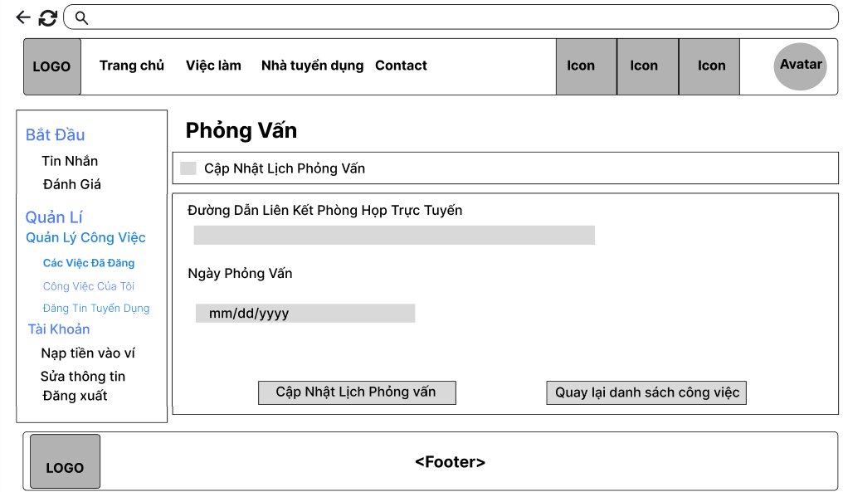

Field Name | Field Type | Description
Title | Heading | This field displays text: “Phỏng Vấn”
Description Text | Text | This field displays text: “Đường Dẫn Liên Kết Phòng Họp Trực Tuyến”
Description-Text | Text-area | This field allows employer to fill the link of the interview.
Description | Text | This field displays text: “Ngày Phỏng Vấn”
Description-Text | Date | This field displays the input due date of interview.
Cập nhật phỏng vấn. | Button | This button allows the employer to update job’s interview on the platform.
Quay Lại Danh Sách Công Việc | Button | This button allows the employer to navigate back to the job post list page.

Database Access
Table | CRUD | Description
Job | U | Update interview link and date
Job | R | Get job by job id

SQL Commands:
1/ Get job by id
select * from Job where job_id = ?

2/ Update interview link and date
UPDATE Job SET interview_URL = ?, interview_Date = ? WHERE job_id = ?

6.7 View applied seeker list
Allows employers to view applications for a job.

UI Design
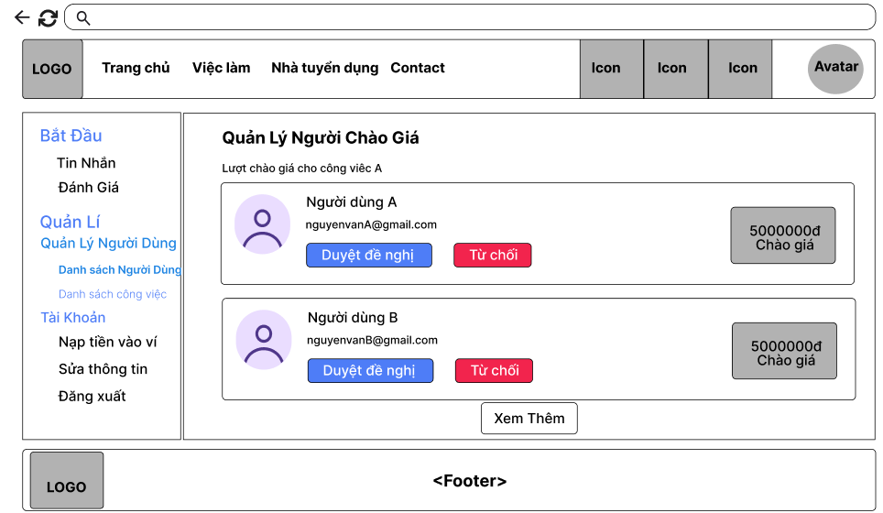

Field Name | Field Type | Description
Title | Heading | This field displays text: “Quản Lý Người Chào Giá”
Description Text | Text | This field displays text: “Lượt Chào Giá Cho Công Việc A”
Avatar | Image | This field displays avatar of seeker was applied
Description Text | Text | This field displays username of seeker was applied
Description Text | Text | This field displays email of seeker was applied
Description Text | Text | This field displays bidder price of seeker was applied
Chấp Nhận Đề Nghị | Button | This button allows the employer to confirm a seeker to do this job.
Gửi Tin Nhắn | Button | This button allows the employer to chat with this seeker.
Trash 2 | Icon | This icon allows the employer to remove a seeker from the applied seeker list.

Database Access
Table | CRUD | Description
Job | U | Update interview link and date
Job | R | Get job by job id

SQL Commands:
1/ Get job by id
select * from Job where job_id = ?

2/ Update interview link and date
UPDATE Job SET interview_URL = ?, interview_Date = ? WHERE job_id = ?

7. Work online through JobTrans

7.1. Prepaid for job
Allows employers to prepay job fee after accept successful seeker

UI Design:
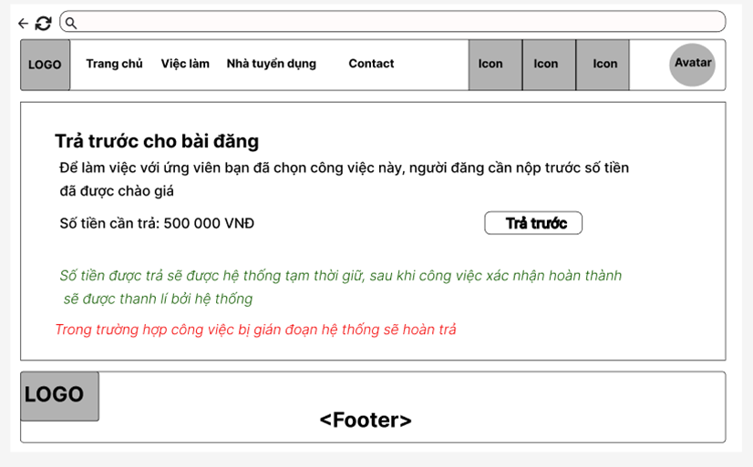

# | Component | Comp. Type | Description
1 | Title | Heading | This field displays text: “Trả trước cho bài đăng”
2 | Description Text | Text | This field displays text: “Để đăng tuyển …. ”
3 | Số tiền cần trả | Numeric | This field displays the amount to be prepaid
4 | Trả trước | Button | This button allows user to prepay
5 | System information | Text (Green/Red) | Information about the hold and refund process (if any).

Database Access

Table | CRUD | Description
Transaction | R, C | Get/Check Transaction exists, create new transaction (transaction type: prepay)
Job | R, U | Get Job that needs to prepay for job, update Job status
User | R, U | Get user who need to prepay for job, update new balance
JobGreeting | R | Get JobGreeting where valid status, jobId

SQL Commands

- Check Transaction Exists:
SELECT COUNT(1) FROM [dbo].[Transaction] WHERE description = "Trả trước" AND jobId = ?"

- Add new Transaction
INSERT INTO [dbo].[Transaction] (senderId, amount, createdDate, status, transactionType, description, jobId) VALUES (?, ?, ?, ?, ?, ?, ?)

- Update Job Status:
UPDATE Job SET status = ? WHERE job_id = ?

- Update Balance:
UPDATE Users SET balance = ? WHERE email = ?

7.2 Deposit for job
Allows job seekers to deposit 10% money of the project amount in advance to ensure that the work will be completed.

UI Design
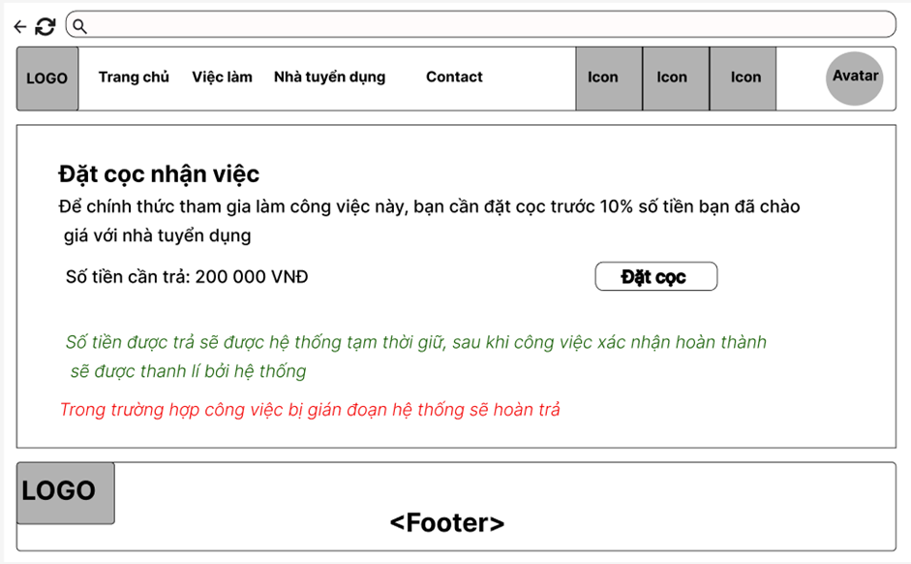
Field Name | Field Type | Description
Title | Heading | - This field displays text: “Trả trước cho bài đăng”
Description Text | Text | - This field displays text: “Để chính thức tham gia công việc …. ”
Số tiền cần trả | Numeric | - This field displays the amount to be prepaid
Đặt cọc | Button | - This button allows user to deposit
System information | Text (Green/Red) | - Information about the hold and refund process (if any).

Database Access

Table | CRUD | Description
Transaction | C, R | Get Transation exists, create new transaction (type: Deposit)
Job | R, U | Get Job that needs to deposit for money
User | R, U | Get User who needs to deposit, and Update new balance
JobGreeting | R | Get JobGreeting where valid status and jobId

SQL Commands

- Check Transaction Exists:
SELECT COUNT(1) FROM [dbo].[Transaction] WHERE description = "Đặt cọc" AND jobId = ?"

- Add new Transaction
INSERT INTO [dbo].[Transaction] (senderId, amount, createdDate, status, transactionType, description, jobId) VALUES (?, ?, ?, ?, ?, ?, ?)

- Update Job Status:
UPDATE Job SET status = ? WHERE job_id = ?

- Update Balance:
UPDATE Users SET balance = ? WHERE email = ?

7.3 Chat
Allows the employer, seeker, admin to send and receive the message from another user.

UI Design
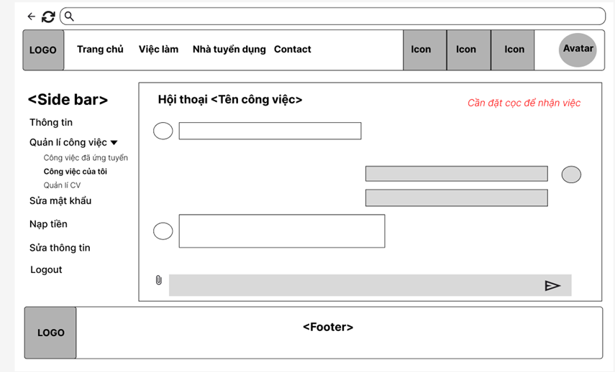
Field Name | Field Type | Description
Conversation name | Heading | - This field displays text: “Hội thoại + “Job name””
Sender | Image | - This field displays avatar of sender
Receiver | Image | This field displays avatar of receiver
Message | Text | - This field displays message content

Database Access

Table | CRUD | Description
Message | C, R | Get Message and add new message when sending new chat

- Get message by JobId:
SELECT * FROM dMESSAGE WHERE job_id = ? ORDER BY sent_time ASC
- Add new message:
INSERT INTO dMESSAGE (sender_id, receiver_id, attachment, content, sent_time, job_id, isRead) VALUES (?, ?, ?, ?, ?, ?, ?)

7.4 Create new period of progress - Employer
Allows employers to set progress of the job for seekers to follow and submit in each period

UI Design
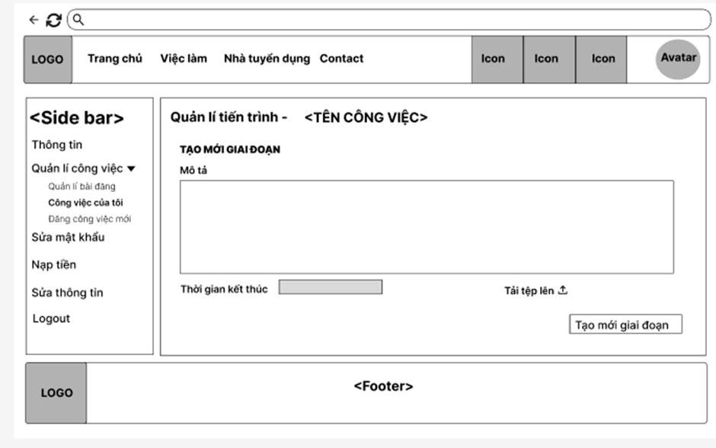
Field Name | Field Type | Description
Title | Heading | - This field displays text: “Tiến trình công việc + “Job name””
Description | Text-area | - This field displays input to record descriptive information about the period including requirements from the employer
Due date | Date | - This field displays date picker for due date
Attachment | Button | - This field displays upload button

Database Access

Table | CRUD | Description
JobProcess | C | Add new process when you want to create new period

- Create New Period:
INSERT INTO Process (job_id, stage_name, requirements, end_date, requirement_url, status)
VALUES (?, ?, ?, ?, ?, ?)

7.5 View Period Submission
Allowsemployers to confirm period submission that is submitted by seeker

UI Design
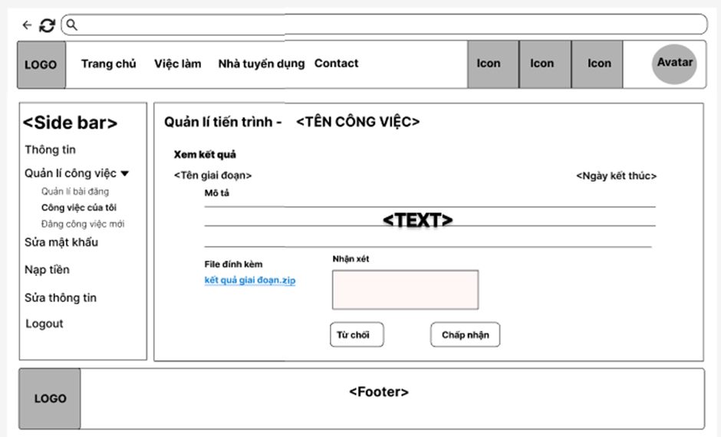
Field Name | Field Type | Description
Title | Heading | - This field displays text: “Xem kết quả””
Description | Text | - This field displays submission description/ content
Attachment | File | - This field displays attachment submitted
Feedback | Input | - This field displays input for employer enter feedback content about submission
Reject | Button | This field displays button for employer to reject if it doesn’t meet the requirement
Accept | Button | This field displays button for employer to accept if it meets the requirement

Database Access

Table | CRUD | Description
JobProcess | R | Get created period to show for employer and seeker

- Get process by Job Id:
SELECT * FROM process WHERE job_id = ?

7.6 Submit period submission
Allows seekers to submit period submission for each period in progress

UI Design
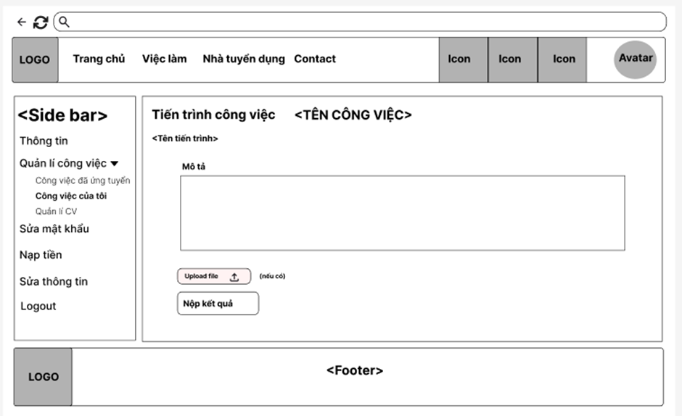
Field Name | Field Type | Description
Title | Heading | - This field displays text: “Tiến trình công việc + “Job name””
Description | Text-area | - This field displays input to record descriptive information about the period result
Attachment | Button | - This field displays upload button
Submit button | Button | - When this button is executed, the result is submitted.

Database Access

Table | CRUD | Description
JobProcess | R, U | Get process needs to submit and update period result for specific process

- Update Process:
UPDATE process SET description_result = ? WHERE process_id = ?
UPDATE process SET status = N'Đã nộp' WHERE process_id = ?

7.7 View confirmed job post - Employer
Allows employers to view a list of approved jobs for seekers.

UI Design
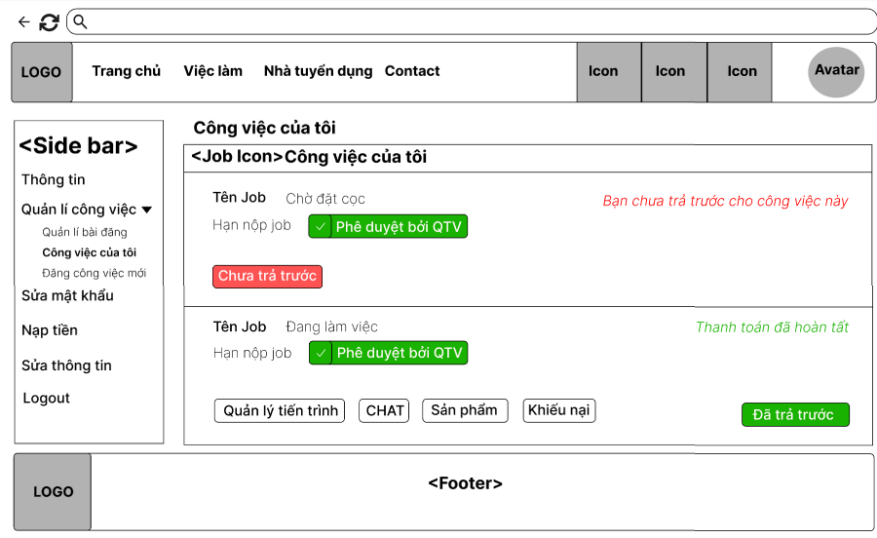
Field Name | Field Type | Description
Title | Heading | - This field displays text: “Công việc của tôi”
Title | Content | - This field displays text: “Công việc của tôi”
Deposit information | Text(Red/Green) | - Information about project payments of employers.
Products table: Display information about Products.
Tên Job | Text | - This field displays job title of job
Trạng thái | Text | - This field displays status of job
Hạn nộp | Date | - This field displays due date of job
Bạn chưa trả trước cho công việc này | Text(Red) | Display notification to the employer to pay for the project to start(if not already paid).
Thanh toán đã hoàn tất | Text(Green) | Display notification to the employer to paid for the project .
Quản lý tiến trình | Button | This button allows the employer to view the progress of the project.
Chat | Button | This button allows the employer to send a message to the seeker of the project.
Sản Phẩm | Button | This button allows the employer to view the result of the job.
Khiếu nại | Button | This button allows the employer to report the seeker.
Chưa trả trước | Button(Red) | This button allows the employer to pay for the project to start(if not already paid).
Đã trả trước | (Green) | This button notification to the employer to paid for the project .

Database Access

Table | CRUD | Description
Job | R,U | Get job details, check payment status, and update payment status.
Transactions | C,R | Create a new transaction when the employer pays for the project, read status.

SQL Commands
-Get job details:
SELECT job_title, status, due_date, budget, description, secure_wallet
FROM Job
WHERE user_id = ? AND job_id = ?;

-Insert New Payment Transaction:
INSERT INTO [Transaction] (senderId, receiverId, amount, createdDate, status, transactionType, jobId, description)
VALUES (?, NULL, ?, GETDATE(), 1, 'Project Payment', ?, 'Trả trước cho công việc');

-Check Payment Status:
SELECT *
FROM [Transaction]
WHERE jobId = ? AND senderId = ? AND transactionType = 'Project Payment';

-Update Job Payment Status:
UPDATE Job
SET secure_wallet = 1
WHERE job_id = ? AND user_id = ?;

7.8 View job post - Seeker
Allows seekers to view a list of confirmed jobs by employer.

UI Design
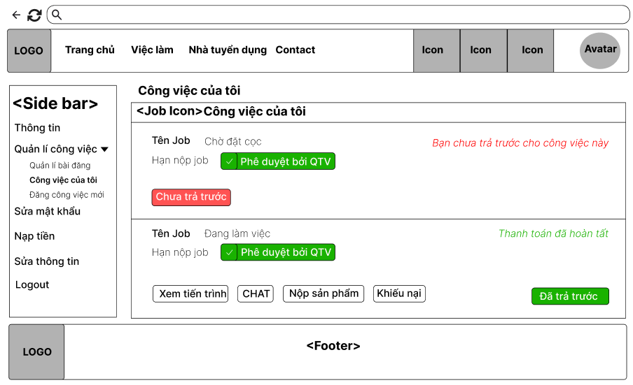

Field Name | Field Type | Description
Title | Heading | - This field displays text: “Công việc của tôi”
Title | Content | - This field displays text: “Công việc của tôi”
Deposit information | Text(Red/Green) | - Information about project payments of seekers.
Products table: Display information about Products.
Tên Job | Text | - This field displays job title of job
Trạng thái | Text | - This field displays status of job
Hạn nộp | Date | - This field displays due date of job
Bạn chưa trả trước cho công việc này | Text(Red) | Display notification to the seeker to deposit for the project to start(if not already paid).
Thanh toán đã hoàn tất | Text(Green) | Display notification to the seeker to deposited for the project .
Tiến trình | Button | This button allows the seeker to set the progress of the project.
Chat | Button | This button allows the seeker to send a message to the employer of the project.
Sản Phẩm | Button | This button allows the seeker to submit the result of the job to the employer.
Báo Cáo | Button | This button allows the seeker to report the employer.
Chưa trả trước | Button(Red) | This button allows the seeker to deposit for the project to start(if not already paid).
Đã trả trước | (Green) | This button notification to the seeker to deposited for the project .

Database Access

Table | CRUD | Description
Job | R,U | Get job details, check payment status, and update deposit status.
Transactions | C,R | Create a new transaction when the seeker makes the deposit, read deposit status.

SQL Commands

-Get Job Details:
SELECT job_title, status, due_date, budget, description, secure_wallet
FROM Job
WHERE job_id = ? AND user_id = ?;

-Insert New Deposit Transaction:
INSERT INTO [Transaction] (senderId, receiverId, amount, createdDate, status, transactionType, jobId, description)
VALUES (?, NULL, ?, GETDATE(), 1, 'Deposit', ?, 'Deposit for the job');

-Check Deposit Status:
SELECT *
FROM [Transaction]
WHERE jobId = ? AND senderId = ? AND transactionType = 'Deposit';

-Update Job Deposit Status:
UPDATE Job
SET secure_wallet = 1
WHERE job_id = ? AND user_id = ?;

7.9. Submit final result online
Allows seekers to submit online final results for the project.

UI Design
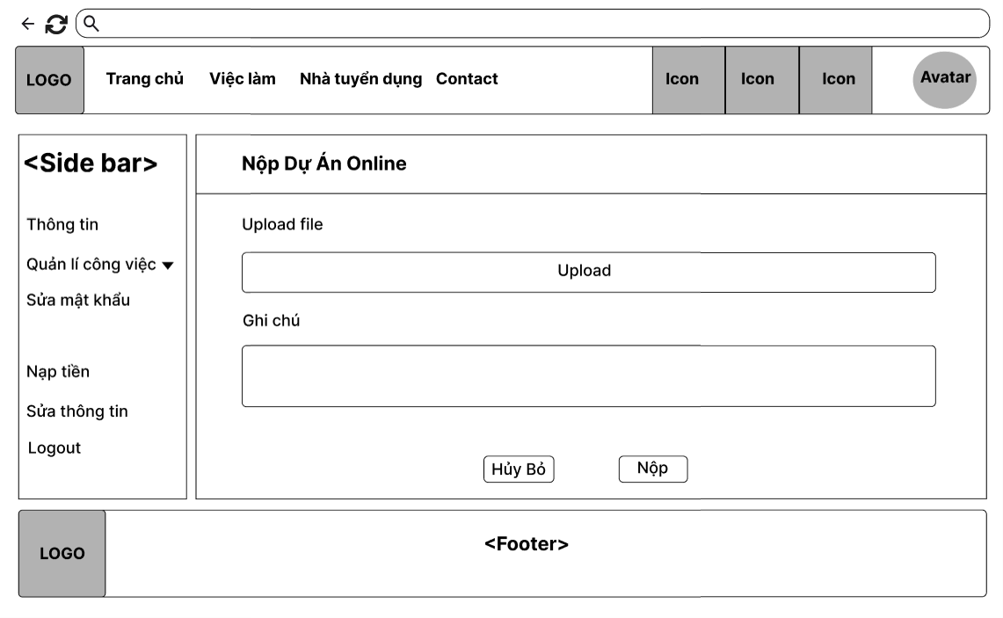
Field Name | Field Type | Description
Title | Text | - This field displays text: “Nộp Dự Án Online”
Description | Text | - This field displays text: “Upload file ”
Upload | Button | This button allows the seeker to upload files.
Description-Text | Text-area | - This field displays text: “Ghi chú”
Note | Text | - This field displays note contents
Hủy bỏ | Button | This button allows the seeker to exit the function.
Nộp | Button | This button allows the seeker to submit online results to the employer.

Database Access

Table | CRUD | Description
Job | R,U | Get job details and update submission status.
Submission | C,R | Create a new submission record when the seeker uploads a file, read submission status.

SQL Commands

-Retrieve Job Details
SELECT job_title, status
FROM Job
WHERE job_id = ? AND user_id = ?;

-Insert New Submission Record
INSERT INTO Submission (jobId, seekerId, note, filePath, submittedDate)
VALUES (?, ?, ?, ?, GETDATE());

-Check Submission Status
SELECT *
FROM Submission
WHERE jobId = ? AND seekerId = ?;

-Update Job Status
UPDATE Job
SET status = 'Submitted'
WHERE job_id = ? AND user_id = ?;

7.10. Submit final result offline
Allows seekers to submit offline final results for the project.

UI Design
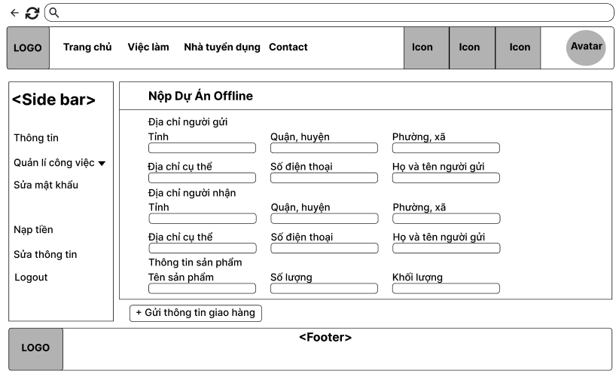
Field Name | Field Type | Description
Title | Heading | - This field displays text: “Nộp Dự Án Offline”
Shipment table: Enter information about Shipment.
Description-text | Text | - This field displays text: “Địa chỉ người gửi”
Description-text | Text | - This field displays text: “Tỉnh”
Description | Combo-box Single-choice | - This field is to select the sender's city.
Description-text | Text | - This field displays text: “Quận/Huyện”
Description | Combo-box Single-choice | - This field is to select the sender's district.
Description-text | Text | - This field displays text: “Phường xã”
Description | Combo-box Single-choice | - This field is to select the sender's ward.
Description-text | Text | - This field displays text: “Địa chỉ cụ thể”
Description | Text-area | - This field is to input the sender's specific address.
Description-text | Text | - This field displays text: “Số điện thoại”
Description | Text-area | - This field is to input the sender's phone number.
Description-text | Text | - This field displays text: “Họ và tên người gửi”
Description | Text-area | - This field is to input the sender's full name.
Description-text | Text | - This field displays text: “Địa chỉ người nhận”
Description-text | Text | - This field displays text: “Tỉnh”
Description | Combo-box Single-choice | - This field is to select the receiver’s city.
Description-text | Text | - This field displays text: “Quận/Huyện”
Description | Combo-box Single-choice | - This field is to select the sender's district.
Description-text | Text | - This field displays text: “Phường xã”
Description | Combo-box Single-choice | - This field is to select the receiver’s ward.
Description-text | Text-area | - This field displays text: “Địa chỉ cụ thể”
Description | Combo-box Single-choice | - This field is to input the receiver’s specific address.
Description-text | Text-area | - This field displays text: “Số điện thoại”
Description | Combo-box Single-choice | - This field is to input the receiver’s phone number.
Description-text | Text | - This field displays text: “Họ và tên người gửi”
Description | Text-area | - This field is to input the receiver’s full name.
Description-text | Text | - This field displays text: “Thông tin sản phẩm”
Description-text | Text | - This field displays text: “Tên sản phẩm”
Description | Text-area | - This field is to input the product’s name.
Description-text | Text | - This field displays text: “Số lượng”
Description | Text-area | - This field is to input the number of product.
Description-text | Text | - This field displays text: “Khối lượng”
Description | Text-area | - This field is to input the product’s weight.
Gửi thông tin giao hàng | Button | This button allows the seeker to submit offline results to the employer.

Database Access

Table | CRUD | Description
Shipment | C,R,U | Create a new shipment record, retrieve shipment details, and update shipment information.

SQL Commands

-Retrieve Shipment Information
SELECT sender_name, receiver_name, sender_phone, receiver_phone, sender_address, receiver_address, notes
FROM Shipment
WHERE shipmentId = ?;

-Insert New Shipment Record
INSERT INTO Shipment (jobId, senderId, receiverId, sender_name, receiver_name, sender_phone, receiver_phone, sender_address, receiver_address, notes, shipmentDate)
VALUES (?, ?, ?, ?, ?, ?, ?, ?, ?, ?, GETDATE());

-Check Shipment Status
SELECT *
FROM Shipment
WHERE jobId = ? AND senderId = ?;

-Update Shipment Information
UPDATE Shipment
SET sender_name = ?, receiver_name = ?, sender_phone = ?, receiver_phone = ?, sender_address = ?, receiver_address = ?, notes = ?
WHERE shipmentId = ?;

8. Manage User - Admin

8.1 View user list
Allows admin to view user list.

UI Design
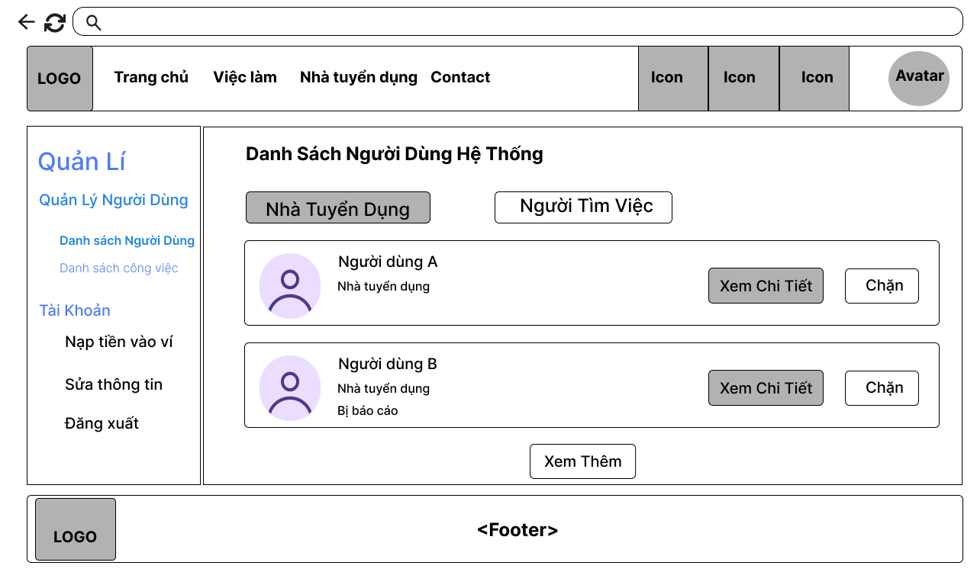

Field Name | Field Type | Description
Title name | Heading | This field displays text: “Danh sách người dùng hệ thống.”
Avatar | Image | This field displays the avatar of the user.
Description Text | Text | This field displays text: Tên người dùng.
Description Text | Text | This field displays text: “Vai trò của người dùng”.
[Xem chi tiết] | Button | This button allows the admin to navigate to the user information page of the selected user.
[Chặn/Bỏ chặn] | Button | This button allows the admin to ban/unban the selected user.
[Xem thêm] | Button | This button allows the admin to display more users.
[Nhà tuyển dụng] | Button | This button allows the admin to view users as role employer.
[Người tìm việc] | Button | This button allows the admin to view users as role seeker.

Database Access
Table | CRUD | Description
User | R | Get all user

SQL Commands:

/ Get all user
SELECT * FROM [dbo].[Users]

8.2 Ban/Unban user
Allows admin to ban/unban user.

UI Design


Field Name | Field Type | Description
Title name | Heading | This field displays text: “Danh sách người dùng hệ thống.”
Avatar | Image | This field displays the avatar of the user.
Description Text | Text | This field displays text: Tên người dùng.
Description Text | Text | This field displays text: “Vai trò của người dùng”.
[Xem chi tiết] | Button | This button allows the admin to navigate to the user information page of the selected user.
[Chặn/Bỏ chặn] | Button | This button allows the admin to ban/unban the selected user.
[Xem thêm] | Button | This button allows the admin to display more users.
[Nhà tuyển dụng] | Button | This button allows the admin to view users as role employer.
[Người tìm việc] | Button | This button allows the admin to view users as role seeker.

Database Access
Table | CRUD | Description
User | U | Update status of selected user

SQL Commands:

/ Update status of selected user
UPDATE Users SET status = ? WHERE user_id = ?

8.3 View user’s profile
Allows admin to view the user's profile.

UI Design
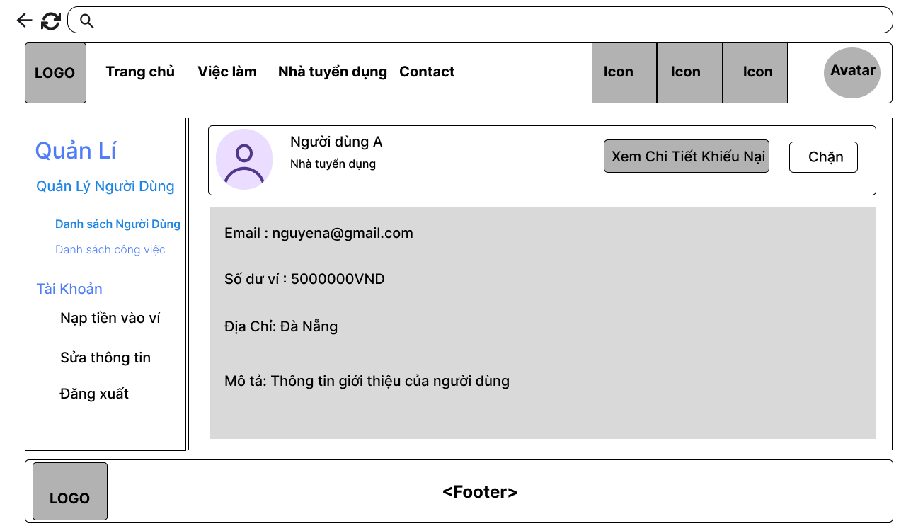

Field Name | Field Type | Description
Avatar | Image | This field displays the avatar of the user.
Description Text | Text | This field displays text: Tên người dùng.
[Xem chi tiết khiếu nại] | Button | This button allows the admin to navigate to the user report page of the selected user.
[Chặn/Bỏ chặn] | Button | This button allows the admin to ban/unban the selected user.
Description Text | Text | This field displays text: email người dùng.
Description Text | Text | This field displays text: số dư ví.
Description Text | Text | This field displays text: Địa chỉ.
Description Text | Text | This field displays text: Mô tả.

Database Access
Table | CRUD | Description
User | R | Get user by user id

SQL Commands:

/ Get user by user id
SELECT * FROM Users WHERE user_id = ?

IV. Appendix

1. Assumptions & Dependencies
Assumptions:
- AS-1: Users will have stable internet access to utilize the JobTrans platform.
- AS-2: Users possess basic technological knowledge to navigate and use the platform's features effectively.
- AS-3: Employers and job seekers will actively participate and cooperate in the recruitment and application processes.
- AS-4: The information and data provided by users will be accurate and valid.
- AS-5: The approval and verification processes by the admin will be carried out promptly to maintain the platform's performance.
Dependencies:
- DE-1: The project relies on modern web technologies (HTML, CSS, JavaScript, and another technology) for developing the user interface.
- DE-2: The platform will utilize a database management system (such as MySQL) to store user information and job data.
- DE-3: Support from online payment service providers is required to facilitate financial transactions between users and the platform.
- DE-4: Need to cooperate with third-party services (such as GHTK) to transport the products that need to be submitted directly to customers.
- DE-5: The project will depend on software development partners to ensure that technical requirements are implemented correctly and according to the expected timeline.

2. Limitations & Exclusions
LI-1: Mobile Application: The initial release will not include a dedicated mobile application; the platform will be accessible only via web browsers.
LI-2: Multi-Language Support: The platform will initially support only one language (Vietnamese), with plans for additional languages in future releases.
LI-3: Advanced Analytics and Reporting: Comprehensive analytics and reporting features for both employers and job seekers will not be included in the initial releases.
LI-4: Integration with External Job Boards: The product will not support integration with third-party job boards or recruitment systems during the initial rollout.
LI-5: Social Media Sharing Features: Users will not be able to share job postings or applications on social media platforms in the initial release.
LI-6: Performance Metrics and Benchmarking: The platform will not offer built-in performance metrics or benchmarking tools for evaluating job applications or recruitment efficiency in the initial release.

3. Business Rules

ID | Category | Rule Definition
BR-01 | Validation | Notify Guests with MSG01 if they don't provide a valid email address.
BR-02 | Validation | Notify Users with MSG02 if they provide an invalid password (less than 8 characters).
BR-03 | Integrity | Notify Guest with MSG03 if the provided email has already been used to register.
BR-04 | Authorization | Notify User with MSG04 if incorrect login credentials are provided, redirect to guest homepage; notify with MSG05 if correct credentials are provided, redirect to user homepage.
BR-05 | Validation | Notify Users with MSG06 if they provide an invalid old password.
BR-06 | Validation | Notify with MSG07 if the email is not registered, notify with MSG08 if it is registered.
BR-07 | Validation | Notify with MSG09 if OTP is incorrect, reload OTP form; if OTP is correct, notify with MSG010 and redirect to reset password.
BR-08 | Validation | Notify User with MSG11 if the re-entered password is incorrect.
BR-09 | Action-Enabler | Display MSG17 if no search results are found.
BR-10 | Structural | Display old sent/received messages in a conversation.
BR-11 | Performance | Ensure message sending time is under 3 seconds.
BR-12 | Integrity | School, company, and skill must be selected from available lists, and seekers can choose more than one.
BR-13 | Validation | Notify with MSG18 if CV information is incomplete when trying to save.
BR-14 | Integrity | Job application form must include offer price, estimated completion date, proposal, and attachment.
BR-15 | Action-Enabler | Display transaction history (including details like amount, date, etc.), filter by date, max 5 lines, with "Lọc" (Filter) and "Xem thêm" (View More) options.
BR-16 | Notification | Notify with MSG16 if a job update is successful.
BR-17 | Action-Enabler | Display delete confirmation pop-up for job deletion.
BR-18 | Action-Enabler | Display "Hiện tại chưa có ứng cử viên ứng tuyển." if no candidate has applied.
BR-19 | Integrity | Notify with MSG10 if there is a database connection error when displaying candidate information.
BR-20 | Action-Enabler | Display a confirmation pop-up for commitment.
BR-21 | Notification | Notify seeker with MSG15 if successfully added to the commitment list.
BR-22 | Structural | Display job progress periods in a table format, sorted by end date; employers can view, edit, delete, and seekers can view, submit, and view evaluations.
BR-23 | Notification | Notify users with MSG17 if creating a new period is successful, or with MSG18 if there is an error.
BR-24 | Action-Enabler | Display confirmation pop-up for accepting a period.
BR-25 | Structural | Update period status as "Đã nộp"/"Bị từ chối"/"Được chấp nhận".
BR-26 | Action-Enabler | Display confirmation pop-up for rejecting a period.
BR-27 | Structural | Display submission page including a text box and file upload area.
BR-28 | Action-Enabler | Update submission for each period of a job and change the period status to "Đã nộp kết quả".
BR-30 | Validation | Ensure the final product is uploaded in a valid format (PDF, ZIP) within file size limits.
BR-31 | Status | Update job status to “Đang tuyển”/”Đang chờ đặt cọc”/”Đang làm việc”/ "Đã nộp kết quả"/" Đã hoàn thành".
BR-32 | Validation | Ensure all required fields are filled in the shipping form.
BR-33 | Validation | Users can only enter amounts greater than 50,000 VND in the VNPAY form.
BR-34 | Integrity | Notify with MSG19 if account balance is less than job salary; deduct wallet balance and display MSG20 if sufficient.
BR-35 | Computation | Deduct 3% of the total deposit as a fee for the intermediary system.
BR-36 | Authorization | Role selection form appears for first-time login (Employer/Seeker); does not apply to Admin accounts.
BR-37 | Integrity | If a Gmail account is registered with a password, the same account is accessed when using Gmail login.
BR-38 | Notification | Notify guests with MSG06 if profile update and database save is successful.
BR-39 | Notification | Notify Users of new messages.
BR-40 | Validation | Notify the user with MSG22 if the re-entered password is the same as the old password.
BR-41 | Notification | Send notification of new job applications as MSG23 for employer and MSG24 for seeker about applying for a job.
BR-42 | Notification | Notify with MSG14 if updated successfully a job or with MSG15 if updated failed a job.

4. Application Messages List
# | Message Code | Message Type | Context | Content
1 | MSG01 | In line | Invalid email format when user fills out the email field | Sai định dạng email
2 | MSG02 | In line | Password does not meet the minimum length of 8 characters | Mật khẩu phải 8 kí tự trở lên
3 | MSG03 | Toast message | Email is already used when attempting to register | Email này đã được dùng để đăng kí
4 | MSG04 | Toast message | Login failed due to incorrect credentials | Đăng nhập thất bại
5 | MSG05 | Toast message | Login succeeded with correct credentials | Đăng nhập thành công
6 | MSG06 | Toast message | Password change failed | Đổi mật khẩu thất bại
7 | MSG07 | Toast message | Gmail has not been registered when attempting to retrieve account | Gmail chưa được đăng kí tài khoản
8 | MSG08 | Toast message | OTP sent successfully for account verification | Đã gửi mã OTP thành công
9 | MSG09 | Toast message | OTP verified successfully during account recovery | Xác thực OTP thành công
10 | MSG10 | Toast message | OTP verification failed during account recovery | Xác thực OTP thất bại
11 | MSG11 | In line | Re-entered password does not match the original password | Mật khẩu nhập lại không đúng
12 | MSG12 | Toast message | No search results found | 404 - Không tìm thấy kết quả nào
13 | MSG13 | In line | CV information is incomplete | Hãy điền đầy đủ thông tin
14 | MSG14 | Toast message | Job post updated successfully | Cập nhật bài đăng thành công
15 | MSG15 | Toast message | Job post update failed | Cập nhật bài đăng thất bại
16 | MSG16 | Toast message | Database connection error when performing an action | Lỗi kết nối cơ sở dữ liệu
17 | MSG17 | Toast message | New job period created successfully | Tạo mới giai đoạn thành công
18 | MSG18 | Toast message | Failed to create a new job period | Tạo mới giai đoạn thất bại
19 | MSG19 | Toast message | Insufficient account balance for payment | Số dư tài khoản không đủ
20 | MSG20 | Toast message | Payment completed successfully | Đã thanh toán thành công
21 | MSG21 | Pop up message | Notification of a new message related to a job post | <Tên job> - Bạn có tin nhắn mới
22 | MSG22 | In line | The re-entered password is the same as the old password. | Mật khẩu mới trùng với mật khẩu cũ.
23 | MSG23 | Pop up message | Send notification of new job applications for employer | Công việc bạn đăng có chào giá mới
24 | MSG24 | Pop up message | Send notification of new job applications for seeker. | Bạn có một chào giá mới cho công việc

