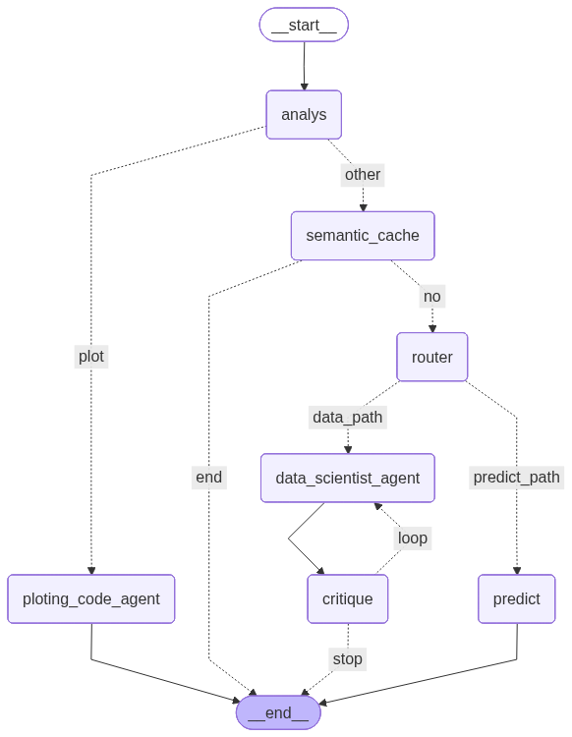

WORKFLOW
The process begins by analyzing the user’s query to determine their intent.
- If the intent is “plot”, the query is passed to the plotting_code_agent node.
- Otherwise, it proceeds to the semantic cache.
In the semantic cache, the system embeds the user’s query along with previously answered questions, then compares them using cosine similarity.
- If a new query is highly similar to a previous one, the system retrieves the stored answer directly without running further steps (cache hit).
- If no similar query is found (cache miss), and the user’s intent requires results from the data store, the LLM is used to generate code for data retrieval. The data is then fetched, and the LLM combines the retrieved information to produce a final answer.
After that, the system evaluates whether the generated answer sufficiently addresses the user’s question. If not, it retries up to three times to refine the response.
If the user’s intent is “predict”, the query is routed to the prediction node, which returns results generated by a linear regression model.
Linear regression was selected because it achieved the lowest MAE (Mean Absolute Error) compared to other models such as CatBoost and RBM.
Below are some illustrative examples: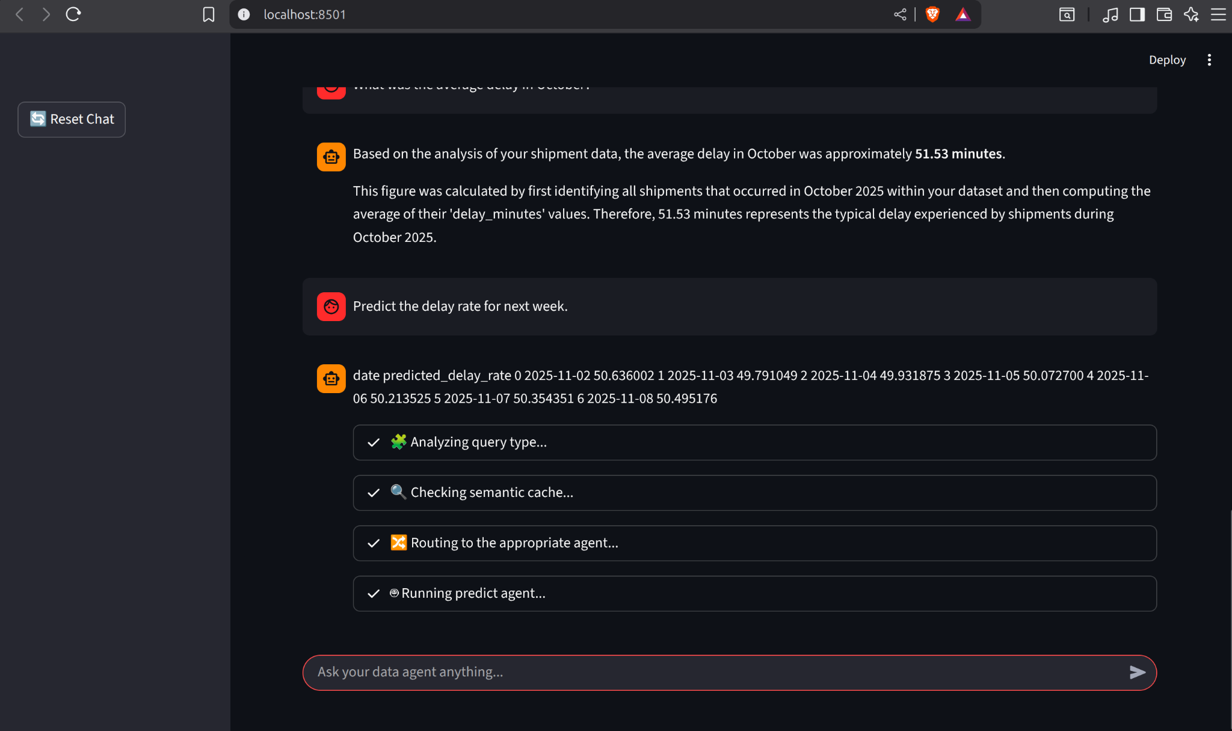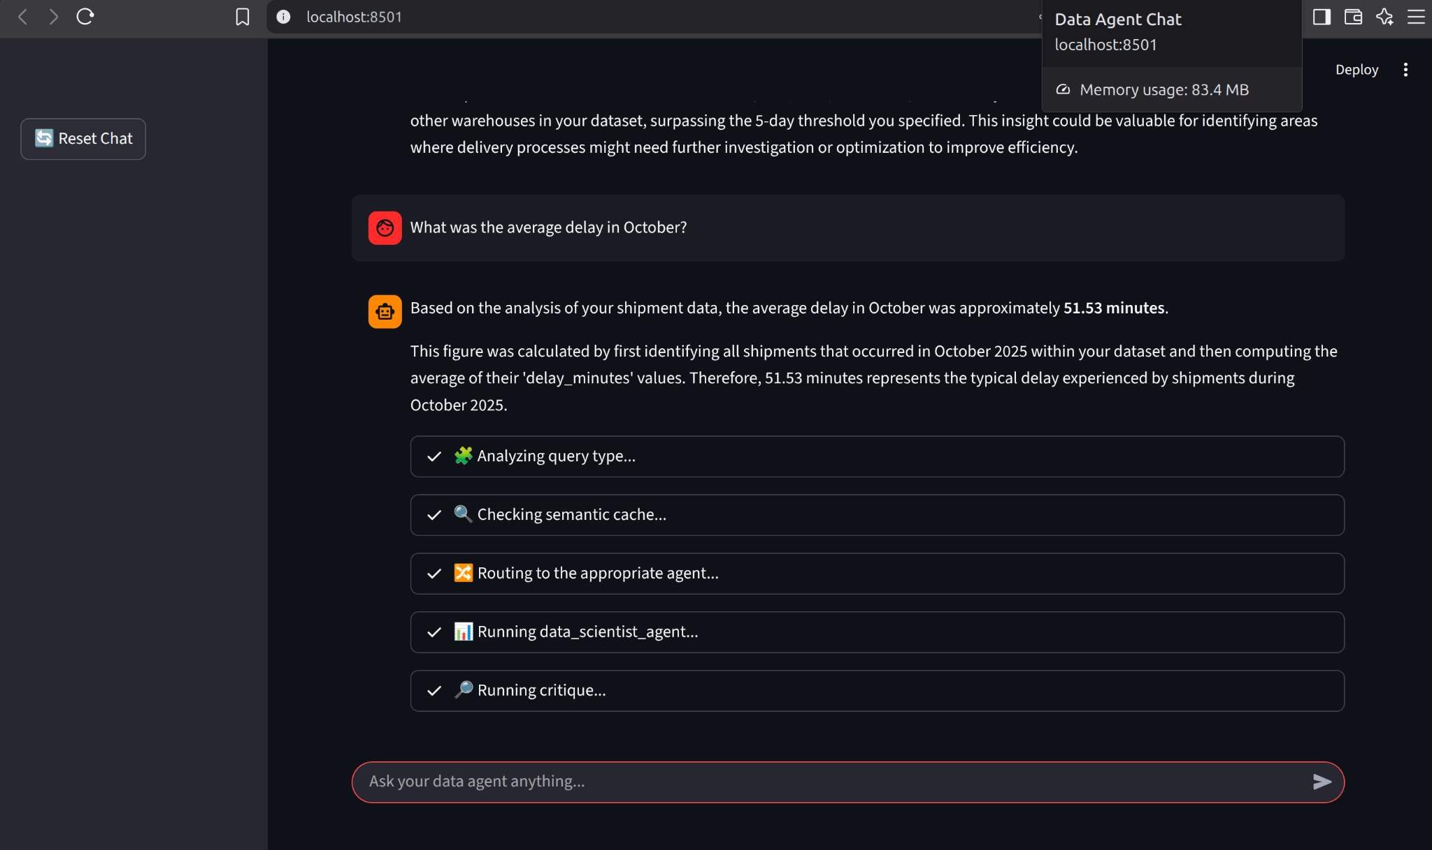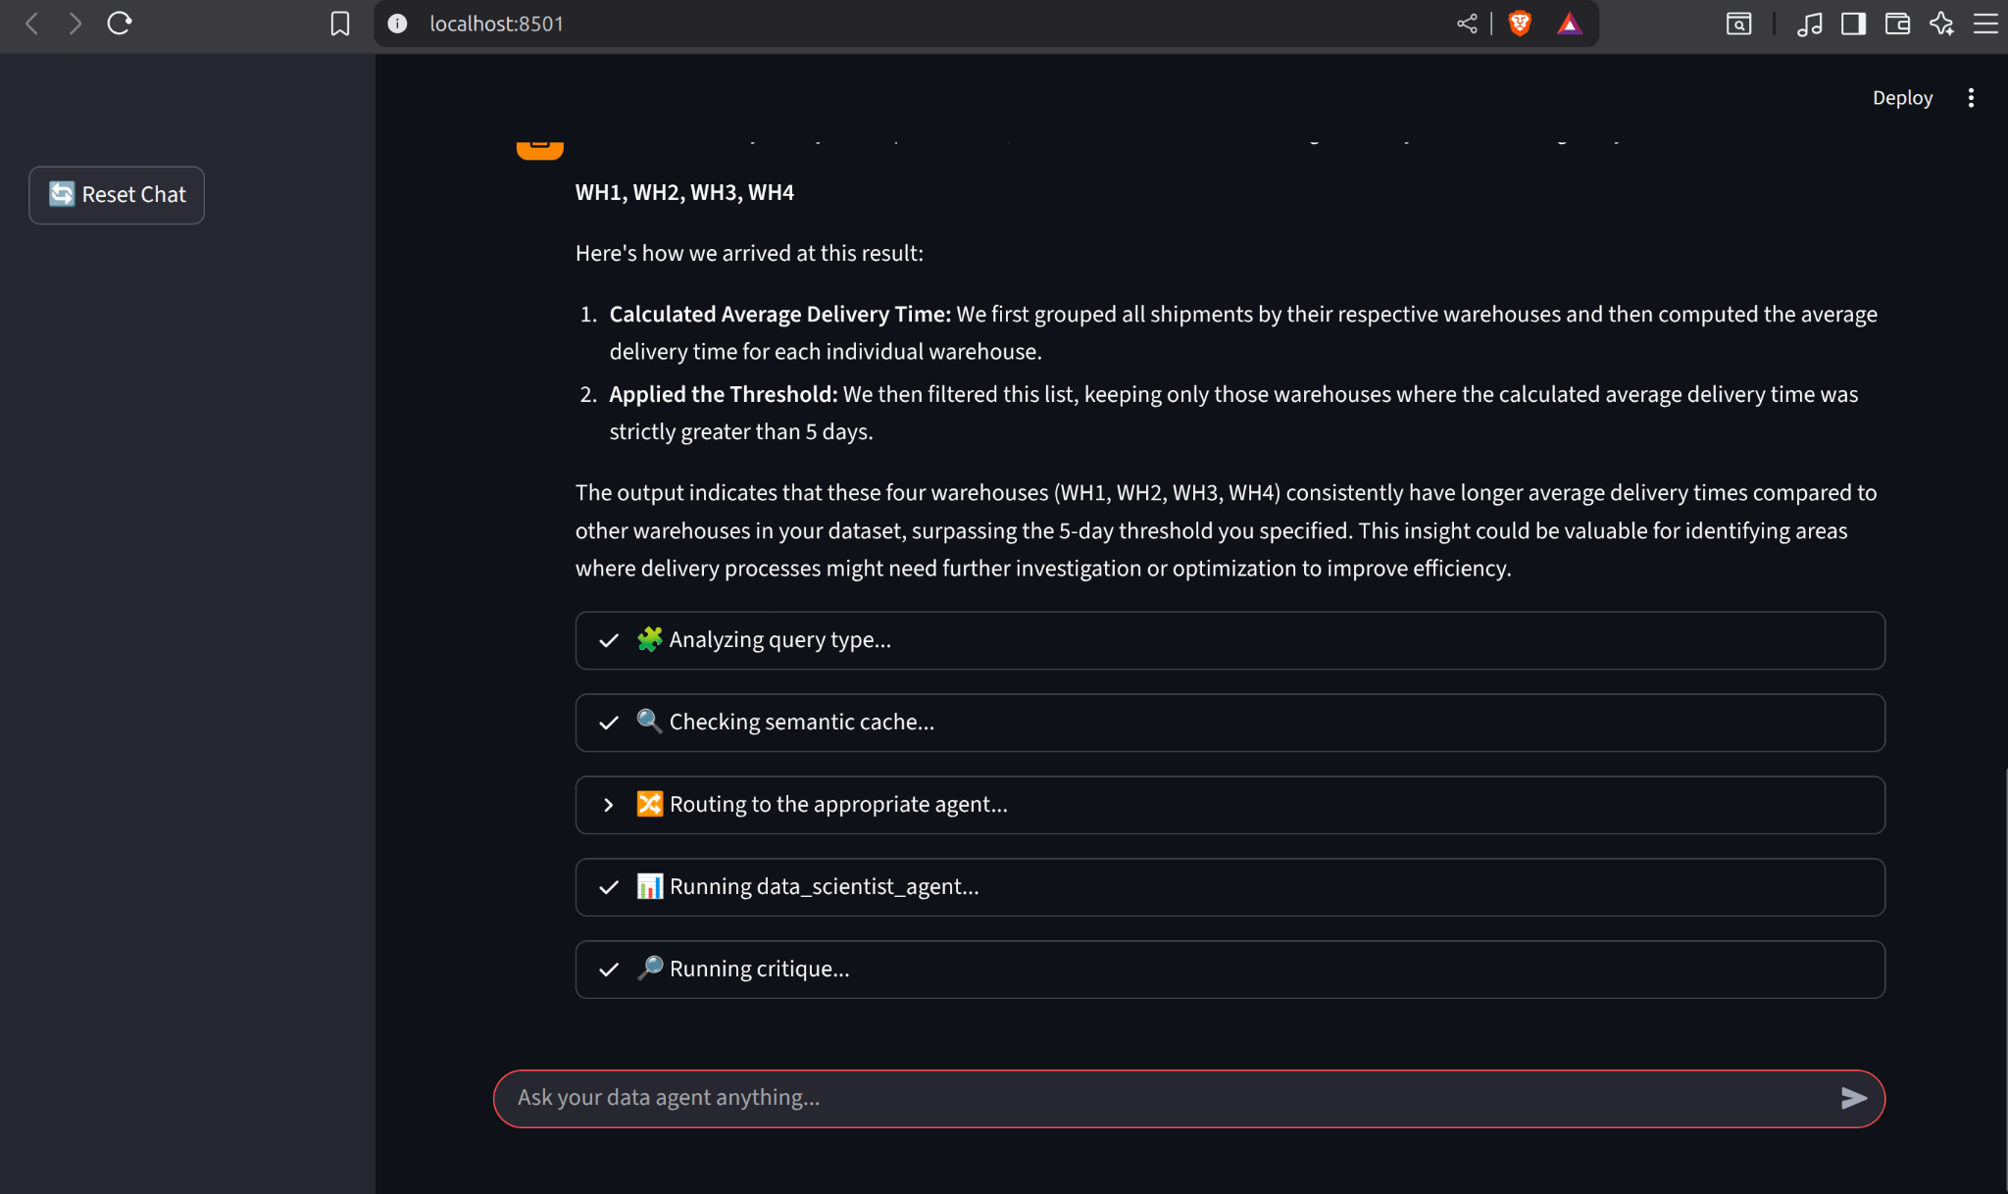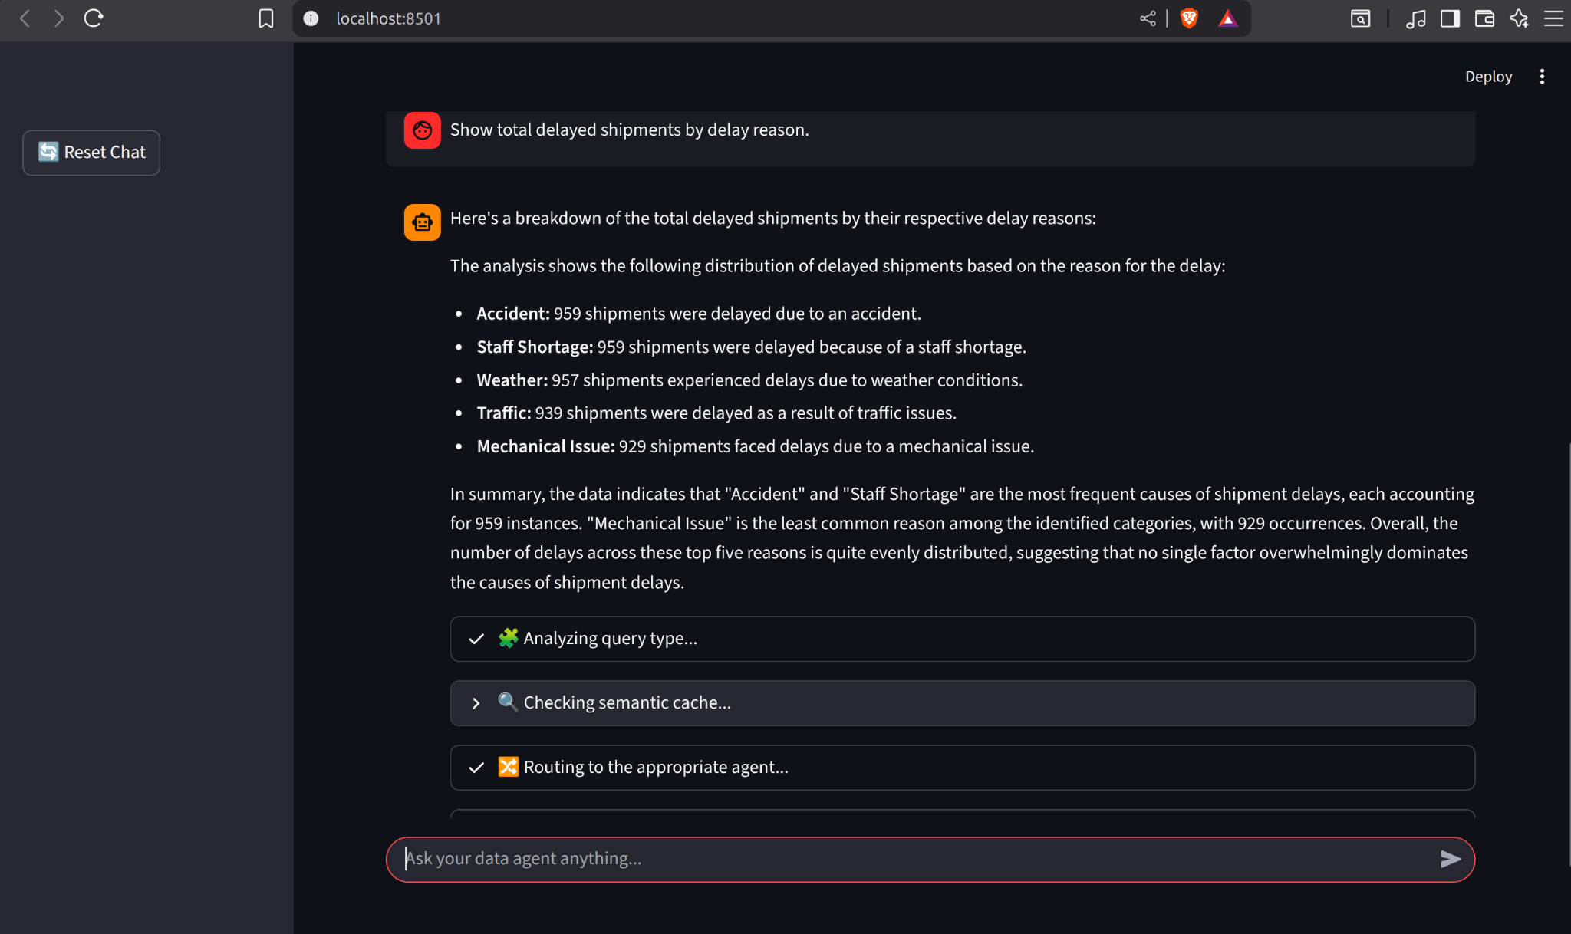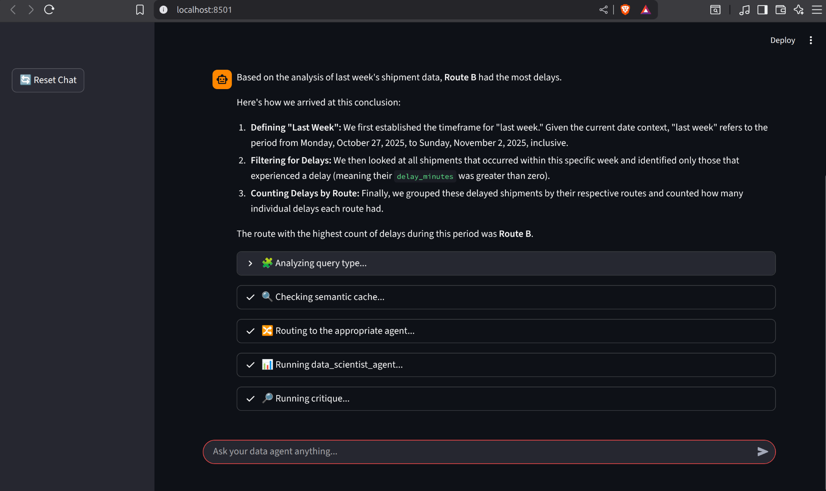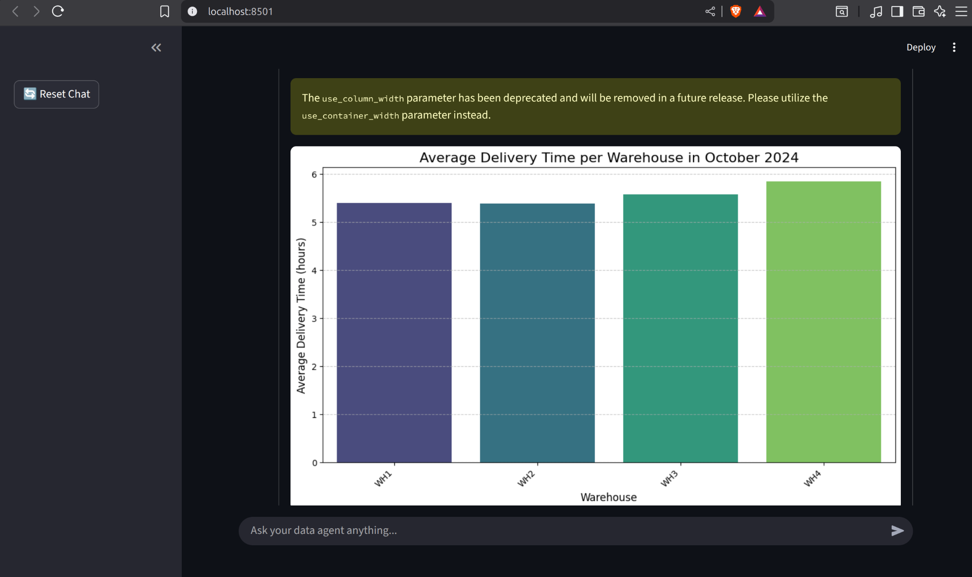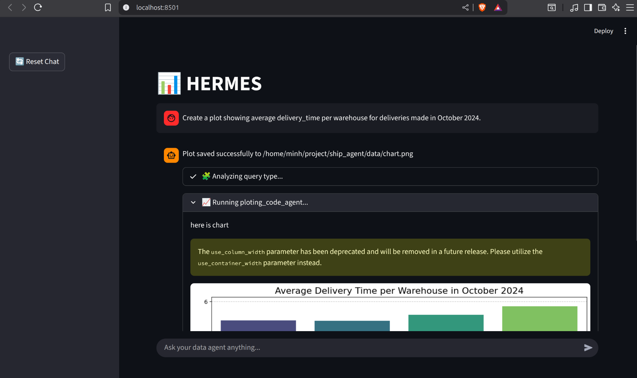

DATA
I used ChatGPT to generate synthetic data for the period 2023–2025, following the examples provided in the assignment.

ACCURACY
Since the system relies on LLMs, it is difficult to evaluate performance using traditional metrics. However, for the example queries given in the assignment—which are relatively simple—the system performs well and provides accurate responses with minimal errors. For more complex queries, further improvements will be made in the future.

RESPONSE TIME
Currently, the system takes over 10 seconds to respond to a single query. Most of the processing time is due to the heavy use of LLMs. In future iterations, I plan to integrate lighter and faster models to reduce latency and cost. For example, intent classification could be handled by a BERT-base model instead of an LLM to improve efficiency.

FUTURE WORK
- Optimize the cache mechanism for chart generation.
- Improve the ML model for predicting delay rates.
- Enhance the code generation capability of the data scientist node and integrate additional tools to increase accuracy.
- Further optimize the semantic cache for chart-related queries.
- Replace intent classification with a BERT-base model to reduce processing time and resource usage.

