Olist Report
Name: Minh Nguyen
Files: GoogleColab Notebook, PowerBI Dashboard, Powerpoint

Introduction
In this report, using PowerBI, I will provide an overview of Olist sales performance from the end of 2016 to the end of 2018. Then we will dive into a more thorough analysis of its Marketing performance with several important metrics. Marketing plays a crucial role in achieving several key business objectives and driving growth as it attracts new and retains customers, which is important for maximizing customer lifetime value and extracting the full potential from each customer. These analysis considers only completed orders, which is when the order has been delivered.

Data Description
Data Source: The Olist dataset is sourced from a Brazilian e-commerce company called Olist, which operates a marketplace that connects sellers and customers.

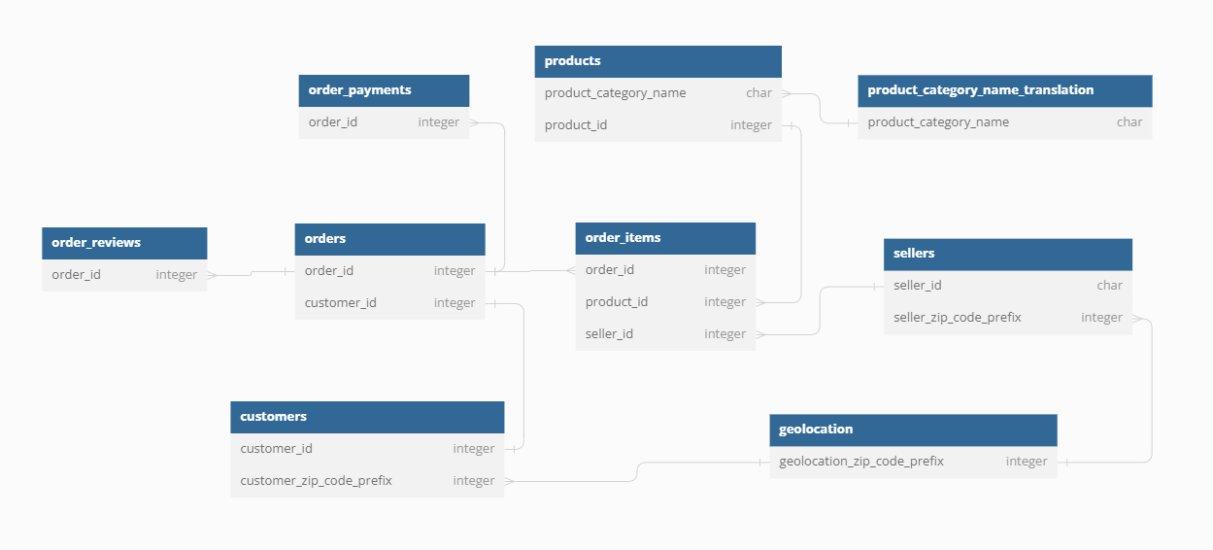
- Orders: This table contains information about individual customer orders, including order IDs, order creation dates, order status, and delivery information.
- Customers: The customers table provides details about customers who made purchases on the Olist platform. It includes customer IDs, names, email addresses, and geographic location.
- Sellers: The sellers table includes information about the sellers on the Olist platform. It contains seller IDs, seller names, and seller locations.
- Products: This table lists the products available for purchase on Olist. It includes product IDs, product descriptions, product categories, and pricing information.
- Payments: Payment information for each order is stored in this table. It includes payment IDs, payment types, payment installment details, and payment values.
- Reviews: The reviews table contains customer reviews and ratings for products purchased on Olist. It includes review IDs, review scores, and review comments.
- Geolocation: This table provides geolocation data for Brazilian postal codes, helping to map order delivery locations.
- Category Name Translation: This table provides the English name for product category names in the Products table.
- DIMDate: All Calendar Date information.
- DAX Measures: This table includes all DAX Measures I have created.
- Brazil State: Includes name, abbreviation, capital city, region and geographic data for Brazil.

Google Colab Notebook
Report Objectives: Overview of datasets, Data cleaning.
- Perform descriptive and exploratory analysis.
  - Check for null and duplicate values.
  - Check distribution.
- Clean and export data
  - Grouped geolocation data by zip_code_preix so that each code is one line.
  - State name is fixed with new data table (Brazil_state).
  - Rows with missing value contain information for other tables. Leaving them in will not affect the results while removing them may affect other tables.

PowerBI Dashboard

Overview Dashboard
Report Objectives: Track overall company performance.
Tables:
- DIMDate: Includes Calendar date and Datekey for entire datasets.
- dOverviewMetric: Allows switching between metrics.
DAX measures:
- Revenue = Total of payment values.
- Orders = Total rows of orders.
- Quantity = Total rows of order items.
- Average Order Value (AOV) = Revenue divided by Orders.
Findings:
- Revenue showed strong performance in 2017 but slowed in 2018.
Need to look at customer behavior, market trends and competitor strategies.
- Sellers from the São Paulo region contribute 64.37% of revenue, and customers from this region only account for 37.43%.
Sellers from São Paulo region could consider expansion into Rio de Janeiro and Minas Gerais regions.
- Health and beauty products are the highest-selling categories with strongest growth.
Targeted marketing campaigns and cross-selling strategies with perfumery.
- Despite the high average order value for computers, the lack of sales growth suggests potential market saturation or competition.
Investigate market.
* Gross Merchandize Value (GMV): Shows overall volume of business, which helps identify growth and revenue potential.
* AOV: Shows how much customers spend on average, which can help determine pricing and upselling strategies.
* Best seller: Highlights which products are most popular, helping you focus marketing efforts and inventory management.

Customers Dashboard
Report Objectives: Analyze customers’ growth and performance.
Tables:
- Brazil_State: Includes name, geographic and demographic information for Brazil.
Columns:
- CustomerMinDate: First date that customer placed an order.
- CustomerType: Whether that customer is New or Existing.
DAX Measures:
- OldCustomer/NewCustomer: Count of all old/new customers from CustomerType.
- Old/NewCustomer Sales: Revenue generated by each customer types.
- NewCustomer Ratio: Percentage of new customers over old customers.
- Retention Rate: Percentage of existing customers among all customers.
- CustomerLifetimeValue(CLV): Created variable to calculate Average Order Frequency, Average Customer Value and set Expected Customer Lifetime to 6 months to calculate CLV.
Findings:
- Sau Paulo alone contributes 70.97% of customers for Olist.
May need to diversify customer base and reduce dependency on top regions.
Considers customer acquisition campaign in Minas Gerais and Parana.
- Slowdown in new customer growth beginning of 2018. In line with Revenue growth.
Indicates that revenues are mostly from one-time customers.
Analyze customer acquisition strategies during that period.
- Overall customer retention rate is 2.22% and growing slowly.
Implement loyalty programs, personalized recommendations, or post-purchase engagement.
- A massive percentage of customers are New with New to Old ratio of ~4500%.
Customer segmentation, tailor marketing strategies to the two groups.
- Even at the expected customer lifetime of 6 months, CLV is at a concerning low of -42.28$.
Enhance the customer experience on website and while waiting.
- Overall, the sales contribution from existing customers is around 3%.
- Top customers with highest revenue are mostly single purchase of high value electronic products.
* New Customer Ratio: Indicates source of effectiveness of customer acquisition strategies for business growth and market expansion.
* Customer Lifetime Value: Helps prioritize customer retention efforts and customer relationship management.
* Retention Rate: Indicates customer loyalty and the effectiveness of retention strategies.
* Churn Rate: Alerts you to customer attrition, allowing you to take proactive measures to retain customers. Churn can simply be the reverse of retention rate.

Sellers Dashboard
Report Objectives: Analyze sellers’ growth and performance.
Columns:
- DeliveryResult: For each order, label it as either Early, On-time or Late.
- ReviewGroup: Label each review score as either Good (>= 3.8) or Bad
DAX Measures:
- LateOrder: Count of all orders that are late.
- Late Ratio: Percentage of late deliveries over all delivered orders.
- Product Mix: Calculates the number of unique categories sold.
Findings:
- More and more businesses want to sell on Olist.
Streamline the joining process for new sellers, provide resources and support for both new and existing sellers.
- Among top sellers, popular product categories are watches gifts and home décor furniture.
Promote these categories and consider offering incentives or support to sellers in these segments to further boost sales.
- Of the ~2000 bad reviewed orders, ~25% of them experienced late deliveries.
Improve logistics by implementing tracking, and communication with sellers and customers.
- Most top sellers have a product mix of around less than 10 categories.
- Other than watches, gifts and home décor, top rated sellers also sell a lot of health & beauty and stationary products.
- Trucker strikes in March 2018 caused a spike in late deliveries.
- The seller, with 23.14% late deliveries, operates in a very low population area.
Adjust delivery expectations for these regions.
* Product Mix: Helps acquire/retain customers, offers greater customer satisfaction, competitive advantage and cross/up-selling strategies.
* Order Fulfilment (Shipping time): Identify sellers’ operational efficiencies and affect customer experience.
* Reviews: Helps identify product quality or other issues in the process.

Powerpoint Presentation
Report Objectives: Deliver actionable insights.

Conclusion

Insights & Recommendation
Olist has been a powerhouse in growing its revenue in 2017 but has since hit a ceiling. Looking further, we instantly see that their customer base primarily consists of new timers. Even though their average reviews are great, their customers rarely make repurchases. Although we can try to fix Olist retention rate problem, we still need more data to identify the root cause.
- Targeted marketing campaigns
- Cross-selling strategies.
- Implement loyalty programs, personalized recommendations, or post-purchase engagement.
- Enhance customer experience for all stages of sale with emails or calls.
- Improve logistics by implementing tracking, and communication with sellers and customers.
- Diversify customer base or encourage sellers in Minas Gerais and Parana regions.

Additional Data

Customer Demographic
- Age
- Gender
- Occupation
- Family: Marital status, children
- Customized ads and targeted marketing

Marketing

Campaigns
- Campaign info/cost.
- Traffic source/click through rate.
- Conversion rate.
- Customer acquisition cost and Return-on-investment.

Website
- Total traffic.
- Time spent on site.
- Bounce rate.
- Click through rate.
- Website visibility, quality, and interest.

Product
- Cross/up-sell products click through.
- Cross/up-sell conversion rate.
- Identify customers’ interests and sales strategies.
- Sellers’ inventory.
- Warehouse location.
- Helps manage stock level with sales trend for location and time.
- Return rate.

Logistic
- Logistic provider info.
- Vehicle.
- GPS.
- Average items per route.
- Find inefficiency.

Operation
- Invoiced time stamp.
- Processed time stamp.
- Find inefficiency.
- At which stage was the order Canceled.
- May help identify problems.

Appendices
https://brazil-help.com/brazilian_states.htm
https://en.wikipedia.org/wiki/2018_Brazil_truck_drivers%27_strike

