**Assignment 03**

**Building a Web Application with ASP.NET Core Blazor**

# Introduction

Imagine you're an employee of a product retailer named **eStore**. Your manager has asked you to develop a Web application for member management, product management, and order management. The application has a default account whose email is “**admin@estore.com**” and password is “**admin@@**” that stored in the **appsettings.json**.

The application has to support adding, viewing, modifying, and removing products—a standardized usage action verbs better known as Create, Read, Update, Delete (CRUD) and Search. This assignment explores creating an application using ASP.NET Core Blazor, C#, and Entity Framework. An MS SQL Server database will be created to persist the data and it will be used for reading and managing data.

# Assignment Objectives

In this assignment, you will:

* Use the Visual Studio.NET to create a Web application and Class Library (.dll) project.
* Perform CRUD actions using Entity Framework Core
* Use LINQ to query and sort data
* Apply 3-layers architecture to develop the application
* Apply Repository pattern
* Implement CUD with SignalR to achieve real-time concerns
* Apply to validate data type for all fields
* Run the project and test the actions of the Web application.
* Evaluate the possibility of using windows service for this application
* Evaluate the possibility of using two-ways binding for this application

# Database Design

# 

# 

# Main Functions

* Member management, Product management, and Order management: Read, Create, Update and Delete actions.
* Search ProductName (keywork of ProductName) and UnitPrice
* Create a report statistics sales by the period from StartDate to EndDate, and sort sales in descending order
* Member authentication by Email and Password. If the user is “**Admin**” then allows to perform all actions, otherwise, the normal user is allowed to view/update the profile and view their orders history.

# Guidelines

# Activity 01: Build a solution [01 mark]

Create a Blank Solution named **Ass03Solution** that includes Class Library Project: **DataAccess, BusinessObject,** and an ASP.NET Core Blazor project named **eStore**

**Step 01**. Open the Visual Studio .NET application and create a Blank solution named **Asm03Solution**

**Step 02.** Create a Class Library project named **DataAccess**

From the File menu | Add | New Project, on the Add New Project dialog, select “Class Library” and performs steps as follows:

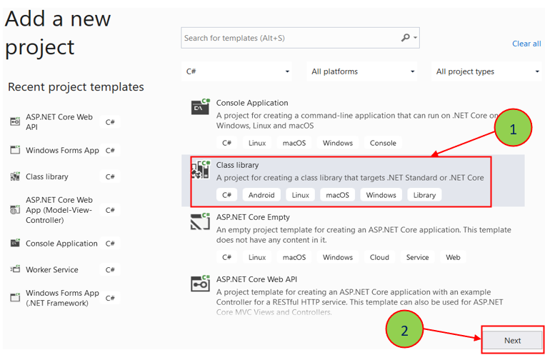

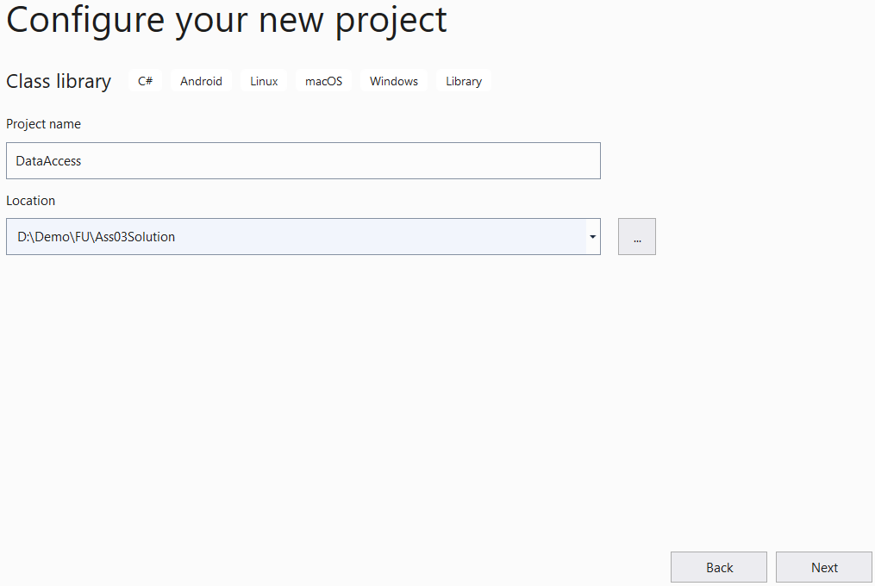

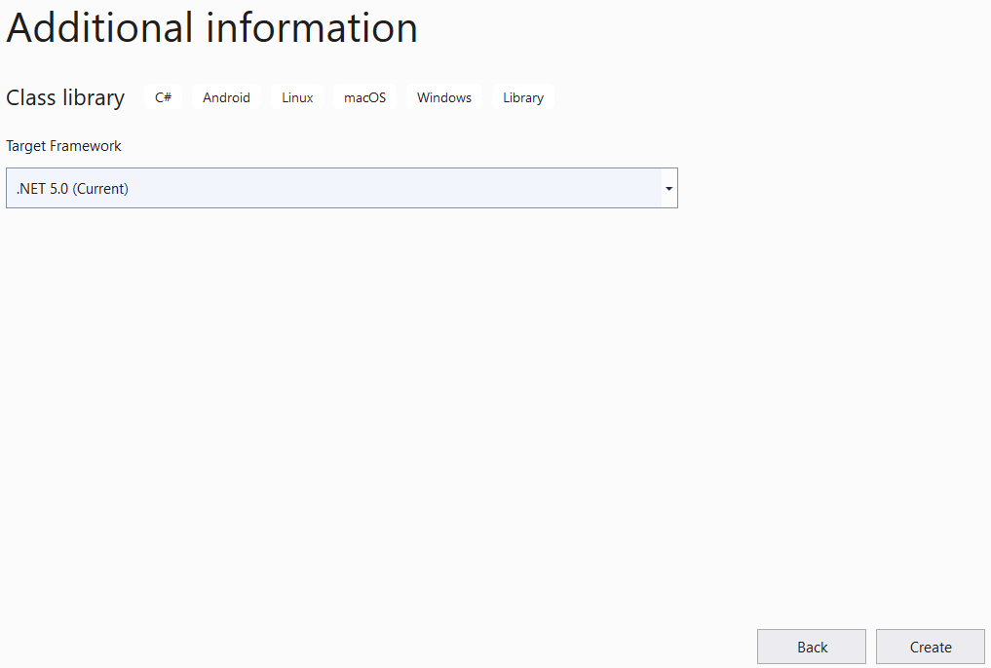

**Step 03.** Repeat **Step 02** to create a **BusinessObject** project.

**Step 04.** Create an ASP.NET Core Blazor project named **eStore**

* From the File menu | Add | New Project, on the Add New Project dialog, select “ASP.NET Core Blazor” and performs steps as follows:

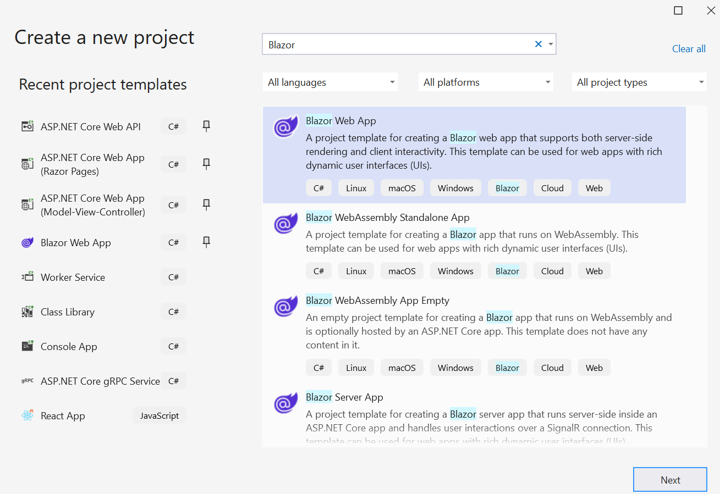

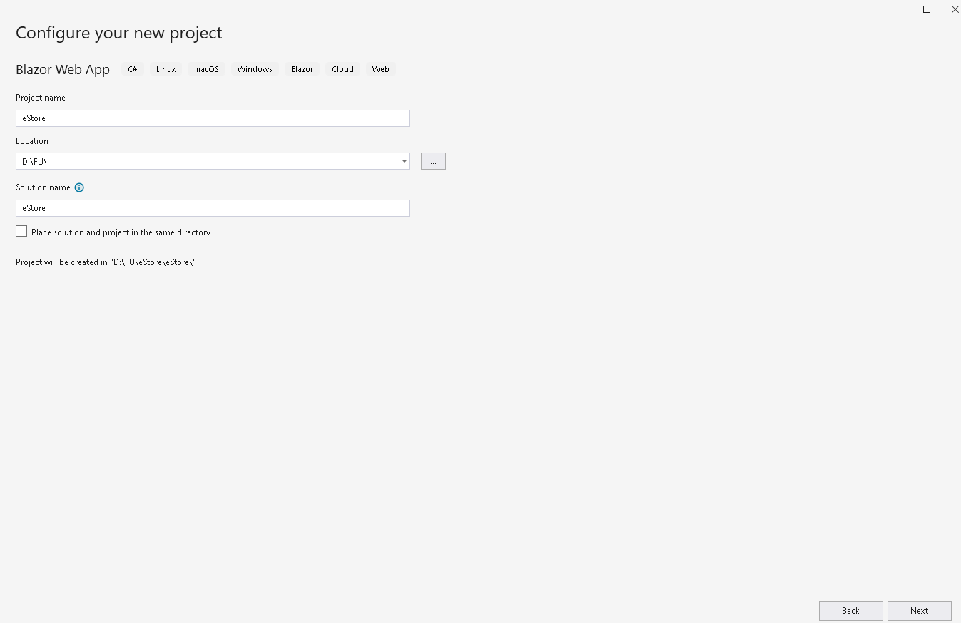

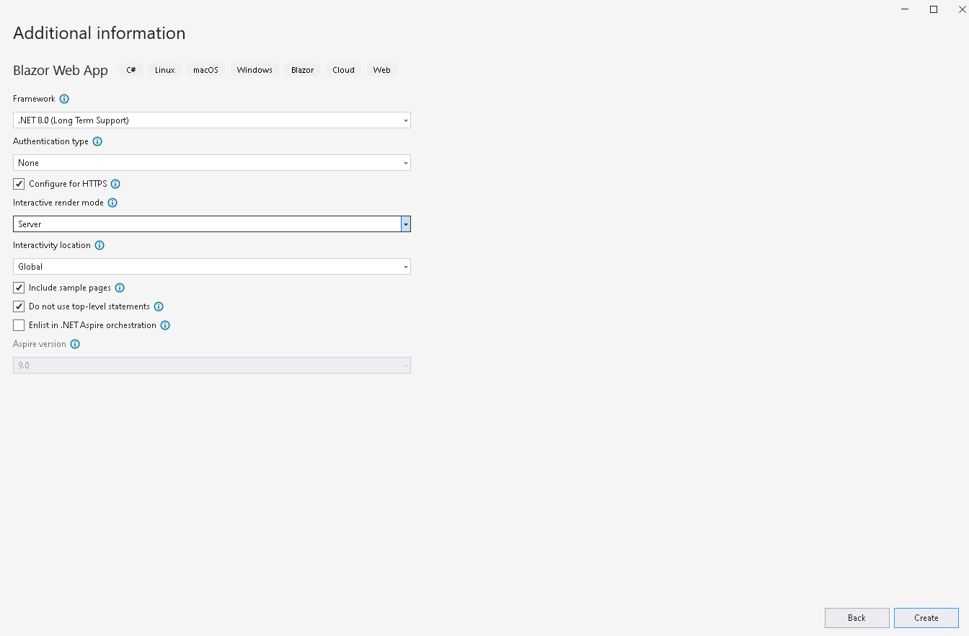

# Activity 02: Develop BusinessObject project [02 marks]

**Step 01**. Write codes to create classes and definition all data members

**Step 02**. Write codes to perform business rules for data members

# Activity 03: Develop DataAccess project [03 marks]

***Hints*:** If using Entity Framework, you can install the AutoMapper package from Nuget to map Entity with Busines Object.

**Step 01**. Add a project reference to the **BusinessObject** project

**Step 02**. Write codes for **Member.cs, IMemberRepository.cs** and **MemberRepository.cs**

**Step 03**. Write codes for **Product.cs, IProductRepository.cs** and **ProductRepository.cs**

**Step 04**. Write codes for **Order.cs, IOrderRepository.cs** and **OrderRepository.cs**

**Step 05**. Write codes for **OrderDetail.cs, IOrderDetailRepository.cs** and **OrderDetailRepository.cs**

# Activity 04: Develop MyStoreBlazorWebApp project [03 marks]

**Step 01**. Add a reference to **BusinessObject** and **DataAccess** project.

**Step 02**. Write codes for controllers to perform functions.

# Activity 05: Run the Web project and test all actions [01 mark]