S = 1

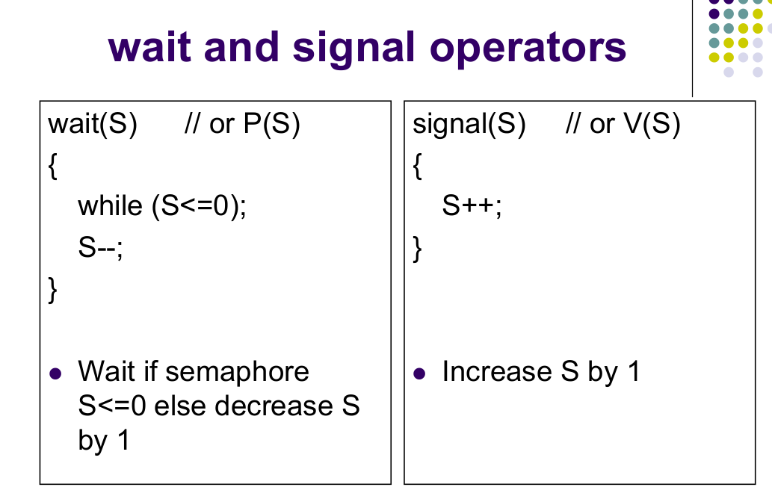

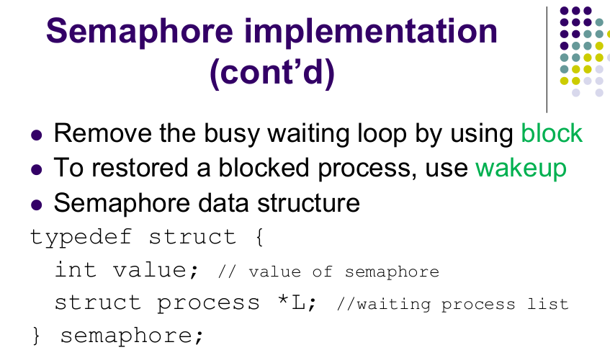

* **N** buffers, each can hold one item
* Semaphore **mutex** initialized to the value 1
* Semaphore **full** initialized to the value 0
* Semaphore **empty** initialized to the value N.

