Building a Simple Sequencer

Project Name: Simple Sequencer

Project Manager: Jarmo Verho

Prepared by: Minh Nguyen, Minh Do, Thong Nguyen, and Jarmo Verho

Issue Date: 6.5.2021

Version: 1.0

Distribution: Public

Synopsis: Building instructions for Simple Sequencer, including the electronic and mechanical parts.

Version history:

|  |  |  |  |  |  |
| --- | --- | --- | --- | --- | --- |
| **Version #** | **Implemented**  **By** | **Revision**  **Date** | **Approved**  **By** | **Approval**  **Date** | **Reason** |
| 0.1 | TN, JV | 26.4.2021 |  |  | Initial version |
| 0.2 | TN, JV, MN | 27.4.2021 |  |  | Mechanics updates |
| 0.3 | JV | 2.5.2021 |  |  | Minor fixes |
| 1.0 | MN, JV | 6.5.2021 | JV | 6.5.2021 | Added programming;  first release |

Populating the PCB

The silkscreen image of the sequencer PCB is shown in figure 1 and all the electronic components with their reference designators are listed in table 1. Representative photos of the components are collected in figure 2. Components missing designators are not soldered to the board: either they are installed on the front panel or they are pin header sockets. Of these header sockets, the 15 pin sockets are installed together with Arduino.

The board has both through-hole and surface mount components. In general, all the components with reference designators starting with “J” (connector, like J1) are through-hole components, while the rest are surface mount. The only exception to this is Arduino, U1. It is recommended to start from the surface mount components, as they have low profiles and won’t obstruct each other.

It is recommended to use additional flux when soldering the surface mount components, as it makes soldering much easier: it makes it easier to wet the components and their pads with solder and on the other hand, the solder won’t form bridges between pins so easily. Extra flux can be used with through hole components too, but the benefits aren’t as obvious with them. A pair of sharp tweezers are very handy when handling the surface mount components. If suitable tweezers aren’t available, a toothpick can be used press them to the board while soldering.

The design has 6 different kinds of resistors. Their values are clearly marked in the packaging, but if there’s a need to identify them afterwards, the three-number code indicates their value by stating the first two numbers + the number of zeroes. Thus, the value of the resistor in figure 2 (marking 102) is 1‑0‑00Ω = 1kΩ. Unfortunately, the same does not apply to the ceramic capacitors, as they have no markings. The third similar looking, albeit bigger, component is the fuse. All these components can be soldered either way – they’re not polarized. Another obvious case is presented by the MMBD914 diodes, as they can be installed only one way.

However, the remaining surface mount components are polarized. The tantalum capacitors have their positive ends marked with a stripe, while the PCB has “+” signs for the positive ends. The SOIC package ICs, namely TL082, ICL7662 and 74HC4051, have a general shape like presented in figure 2, but the exact way the first pin is marked can vary. Oftentimes the packages have a dimple like shown here. Other ways include a stripe or a notch in the end having pin 1. In some unfortunate cases there is no pin 1 marking at all, but even then, the text orientation is as shown in the figure. That is, the bottom left corner of the text points towards pin 1. The orientation of the 8 pin packages are marked with a dot signifying pin 1 on PCB, while the 16 pin packages have a dash next to pin 1. The remaining polarized SMD component is the transient voltage suppressor diode D2. Its cathode is marked with a stripe on the package and with a slightly longer line on the PCB.

After mounting the SMD components, the through-hole components can be populated. This can be started from Arduino and its 15-pin header sockets. The easiest way to do this is to insert Arduino’s headers to the sockets and then insert this combination to the PCB for soldering. The notch on the PCB layout marks the end where Arduino has its 3x2 pin connector. The second polarized through-hole component is the 10-pin Eurorack power connector. The notch in the connector itself points towards Arduino.

The remaining through-hole components are all pin headers and they are not polarized. They can be populated – or left out, depending on the builder’s preferences. If they are left out, the cables coming from the front panel components must be soldered directly to the PCB. This reduces the amount of work quite a lot, at least initially, but directly soldered wires tend to break easily. This can be prevented by protecting the joints with hot glue or something similar, but then rework becomes tedious. An alternative to direct soldering is to populate the pin headers on the PCB and then solder the wires coming from the UI components to pin header sockets and plugging these sockets to the PCB’s headers. Again, the solder joints to pin header sockets should be reinforced; this can be done with heat-shrink tubing or glue. This construction allows removing the PCB from the case, should it become necessary. Note that the 8-pin headers on board’s edge are for meant for modifications and extensions. They can be populated or left unpopulated, as per builder wishes.

Connecting the front-panel components

The front panel components can be divided into four larger groups: the gate switches, the control voltage potentiometers, the LEDs and the 3.5mm jacks. (See the mechanics section for details.) This leaves out the mode control switches, the pushbuttons, the portamento potentiometer and switch and the internal clock adjustment.

Due to the rather large number of wires going to the gate switches, it is best to start from them. The positions of the switches are shown in figures 5 and 10; the lower group of 16 holes is for the gate switches. It is suggested that the two leftmost switches are for step 1, but the most convenient order depends on how the instrument is usually held. Each of the switches connects with 3 wires to the main PCB, to the groups of pin headers starting from J51 and J53. Of these, J51 is the step 1 switch for gate output 1 and J53 the same for gate output 2. It is suggested that the switches belonging to gate output 1 are (J51, J48, J45, …) are installed in the lower row of 8 switches.

The middle pins of the switches connect to the middle pins of each connector. The remaining 2 wires can be connected either way; they determine which way the switches are on and off. The suggested way is that the lower pin of each PCB header connects to the corresponding switch’s leftmost pin, when the switches are mounted like in figure 10. It doesn’t matter much if some (or all) switches are accidentally connected the wrong way, as the pin header sockets can be swapped easily or the switches themselves can be rotated.

The potentiometers are connected in a similar manner. Their headers are on board’s right edge. Again, the middle pin connects to the middle pin of the corresponding header. This time, the uppermost two pin headers (J15, J23) are for the first step. Of these, J15 is for control voltage output 1. The other potentiometers for control voltage 1 follow downwards.

It is suggested that the uppermost pin of each header connects to the corresponding potentiometer’s left side contact. This way the control voltage increases when the potentiometer is turned clockwise – assuming the instrument is held in position shown in figures. The potentiometer positions in the front panel are shown in figure 6. It is suggested that the lower row is used for control voltage 1 potentiometers.

The LEDs are in two groups: J52-J34 on the PCB’s left edge indicating the active step and J6-J56 on the top right corner indicating the states of the gate outputs. On the first group, the top side contact on PCB is the negative wire and for the latter group, it’s the right-side contact. The LEDs usually have wires of differing lengths, in which case the shorter wire is negative, as shown in figure 3. They can also have a flat spot in the plastic, near the bottom part, marking the negative end. J52 is for step 1, the leftmost LED in the front panel. Again, this assumes that the instrument is kept in position shown in figures and that the steps progress from left to right in “normal” direction. The LED positions in the front panel are shown in figure 7. The group of 8 is for indicating the current step and the group of 4 is for the gate outputs. J6 is the LED for the first gate output. It is suggested that this is wired to the leftmost gate output indicator LED on the panel.

There are also eight 3.5mm jacks, like shown in figure 8. Four of these are for gate outputs, two are for control voltages and the remaining two are for clock and reset inputs. The four rightmost jacks are meant for the gate outputs, as they are positioned next to the corresponding gate output indicator LEDs.

The jack pin numbering is shown in figure 3. Of the shown pins, 1 is the ground pin and 3 is the signal. Pin 2 can be left unconnected or it can be connected to pin 3. The corresponding connectors on the PCB are connectors J5, J8, J3, J9 on the top right corner. J5 should be connected to the leftmost jack (assuming the LEDs were connected as suggested earlier) so that its leftmost pin connects to jack’s ground pin, 1. The other jacks are connected the same way.

It is suggested that the two jacks to the left from the gate output jacks would be used for control voltages. The corresponding connectors on the PCB are J65 and J66 on PCB’s bottom edge. This time, the rightmost PCB pin connects to the jack ground. J65 is the first control voltage output and, to maintain the same order than with the gate outputs, should go to the leftmost jack.

The remaining two jacks are for clock (J61) and reset (J7) inputs. The rightmost pins of each header on PCB connect to the corresponding jack grounds. It is suggested that the leftmost jack on the front panel would be the clock input jack.

The two push buttons on the panel (see figure 9) connect to J54 and J55 on the PCB. Of these, J54 is the clock input button and it is suggested that it is connected to the leftmost button on the front panel. The push buttons are not polarized, so it does not matter which way they are wired to the PCB.

The device has four mode selection switches: sequence direction, sequence length, clock source selection and portamento on/off. These are shown in figure 5 as the upper switch group. The last of these four is a DPDT switch. It is suggested that they are mounted in the indicated order to the front panel, starting from the left.

The sequence direction switch connects to PCB header J60 and the sequence length switch to J59. It is suggested that the switch left pin (see figure 10) is connected to the corresponding header’s left pin. This way the direction switch lever will point to sequence’s direction and when the sequence length switch points to the right, the sequence has 8 steps (otherwise 4).

The clock source switch connects to header J70. Again, it is suggested that the leftmost pin of the switch is connected to the leftmost header pin. This way, when the switch points to the right, external clock is selected.

The portamento switch connects to headers J63 and J64. The DPDT switch is like two stacked SPDT switches with a common lever and these switch halves connect to the headers independently. It does not matter which half goes to which header. It is suggested that the two leftmost pins of the switch connect to the rightmost pins of J63 and J64. This way the portamento is off when the switch points to the left. An alternative would be to connect one of them as suggested and flip the connections for the other: this way one of the control voltage outputs will always have portamento on and the switch then controls which output it is.

Two potentiometers are still unconnected. They are the two rightmost ones in figure 6. It is suggested that the top one is the internal clock speed adjustment and the bottom one the portamento. The portamento potentiometer is the only stereo potentiometer, which is to say that it has two electrically independent potentiometers ganged on the same shaft. It connects to headers J58 and J62. When it is mounted like shown in figure 10, the two leftmost pins of the potentiometer connect to rightmost pins of the headers. This way portamento increases when the potentiometer is turned clockwise.

The remaining potentiometer connects to J71. The potentiometer’s leftmost pin connects to the leftmost header pin. This makes the speed increase when turned clockwise.

It is recommended to bind the wires together with cable ties or something similar. It is also recommended to keep the related wires in their own bundles to make it easier to trace them afterwards. Using different colors to identify the wires is also helpful. Finally, it is suggested to use adhesive anchors to attach the wire bundles to the casing, so that vibration and impacts won’t damage them. Hot glue can also be used.

If the sequencer is used as an Eurorack instrument, there’s no need to install the external power jack. Instead, the Eurorack power cable is used to connect the instrument to the Eurorack. However, if stand-alone operation is desired, the power jack is needed. There’s a mounting hole in the case bottom (figure 12) for the power jack. The jack center pin connects to header J68’s upper pin and the jack side contact goes to the lower pin.

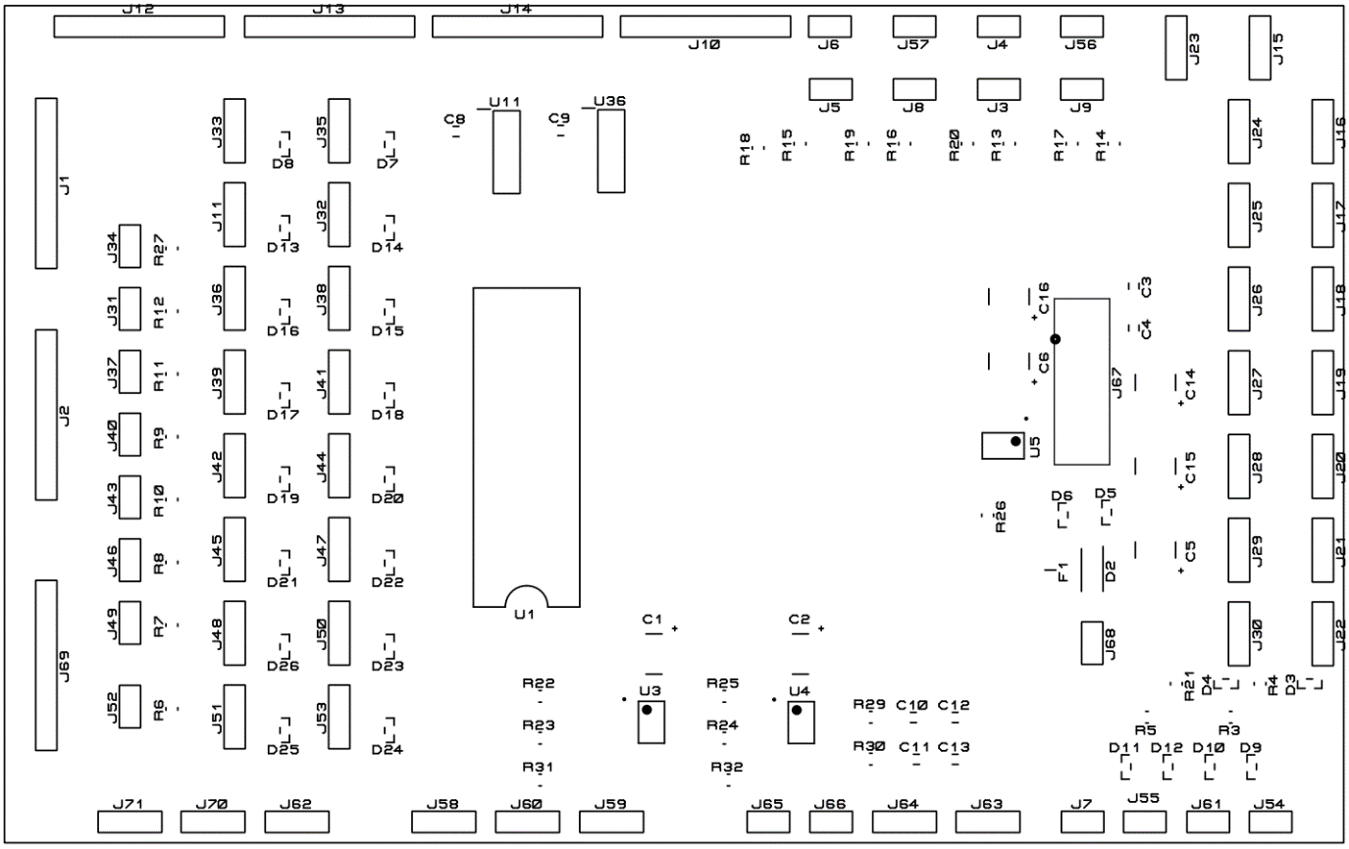

**Figure 1.** PCB layout

|  |  |  |  |
| --- | --- | --- | --- |
| ERA6AEB1210V | Panasonic SMD Resistor 125mW, 121Ohm, 0.1 %, 0805 |  Distrelec Export Shop |  | TSM 2314 SMD: N-channel 20 V 4.9 A 1.25 W 0.033 R SOT23 at reichelt  elektronik |  |
| Resistor | Ceramic capacitor | MMBD914 diode | Tantalum capacitor |
|  |  | 0466003.NR Littelfuse - Fuses - Distributors, Price Comparison, and  Datasheets | Octopart component search | Arduino Nano - Elektor |
| TVS diode | SOIC package IC | Fuse | Arduino Nano |
|  | P5375 - Oupiin 8 Pin Header Socket 8.5mm - Altronics | TruConnect 10 Way IDC Straight Boxed Header 2.54mm Pitch | Rapid Online | Miniature SPDT Toggle Switch |
| Pin header | Pin header socket | Eurorack connector | SPDT switch |
| 100DP1T1B1M1QEH E-Switch | Mouser |  | Rotary potentiometer |  |
| DPDT switch | Push button switch | Potentiometer | Stereo potentiometer |
| 4832.2211 Schurter Inc. | Connectors, Interconnects | DigiKey | MCM 27-4360 | 5219889F | የ Dialog Semiconductor 5219889F ክምችት ከ Ocean-Components.com |  ይገኛል 5219889F ከ Ocean-Components.com ጋር በጥሩ ዋጋ |  |
| 3.5mm jack | Power jack | LED |  |

**Figure 2.** Components

|  |  |
| --- | --- |
|  |  |
| LED polarity | 3.5mm jack pins |

**Figure 3.** LED and 3.5mm jack pins

|  |  |  |  |
| --- | --- | --- | --- |
| **Component** | **Designators** | **Amount** | **Notes** |
| Arduino Nano A000005 | U1 | 1 | Arduino.cc |
| TL082CP/NOPB | U3-U4 | 2 | Texas Instruments |
| 10kΩ linear potentiometer |  | 17 | Bourns P160KNP-0QC20B10K |
| 20kΩ stereo potentiometer |  | 1 | Bourns PDB182-K420K-203B |
| SPDT switch |  | 19 | E-switch 100SP1T1B1M2QEH |
| DPDT switch |  | 1 | E-switch 100DP1T1B1M1QEH |
| Push button |  | 2 | E-switch 800SP9B5M1QEH |
| 3.5mm jack |  | 8 | Schurter 4832.2211 |
| 10uF/25V | C1-C2,C5-C6,C14-C16 | 7 | Tantalum capacitor, size D |
| 100nF/50V | C3-C4,C8-C13 | 8 | Ceramic capacitor, 20%, 0805 |
| 10kΩ | R1, R3-R5,R21 | 5 | Resistor, 1%, 0805 |
| 1kΩ | R2, R6-R20,R27, R29-R30 | 19 | Resistor, 1%, 0805 |
| 10kΩ | R3-R5,R21 | 4 | Resistor, 1%, 0805 |
| 27kΩ | R22,R24 | 2 | Resistor, 1%, 0805 |
| 47kΩ | R23,R25 | 2 | Resistor, 1%, 0805 |
| 100Ω | R26,R31-R32 | 3 | Resistor, 1%, 0805 |
| ICL7662EBA+ | U5 | 1 | Maxim Integrated |
| 74HC4051D | U11,U36 | 2 | NXP |
| SMA6J15CA-TR | D2 | 1 | STMicroelectronics |
| MMBD914 | D3-D26 | 24 | Diodes, Inc. |
| 250mA 1206 fuse | F1 | 1 | Littelfuse 0466.250NR |
| IDC10 header, boxed | J67 | 1 | Amphenol 68712-001 |
| 2pin header | J3‑J9,J57,J57,J31,J34, J37,J40,J43,J46,J49, J52,J54,J55,J61,J65, J66,J68 | 23 | Harwin M20-9990246 |
| 3pin header | J11,J15-J30,J32,J33,  J35,J36,J38,J39,J41,  J42,J44,J45,J47,J48,  J50,J51,J53,J58‑J60,  J62‑J64,J70,J71 | 40 | Harwin M20-9990346 |
| 8pin header | J1,J2,J10,J12-J14,J69 | 7 | Harwin M20-9990845 |
| Header socket, 2pin |  | 23 | Sullins PPTC021LFBN-RC |
| Header socket, 3pin |  | 40 | Sullins PPPC031LFBN-RC |
| Header socket, 15pin |  | 2 | Sullins PPTC151LFBN-RC |
| Power jack |  | 1 | MCM 27-4360 |
| 3mm blue LED |  | 12 | Dialight 5219831F |
| PCB |  | 1 |  |

**Table 1.** Parts list.

Putting the case together

**Overview of the UI – front panel**

The panel, shown in figure 4, includes many holes which are prepared for each component. The components have their own specific positions. The task is to place them into correct spots and then fasten them with nuts.

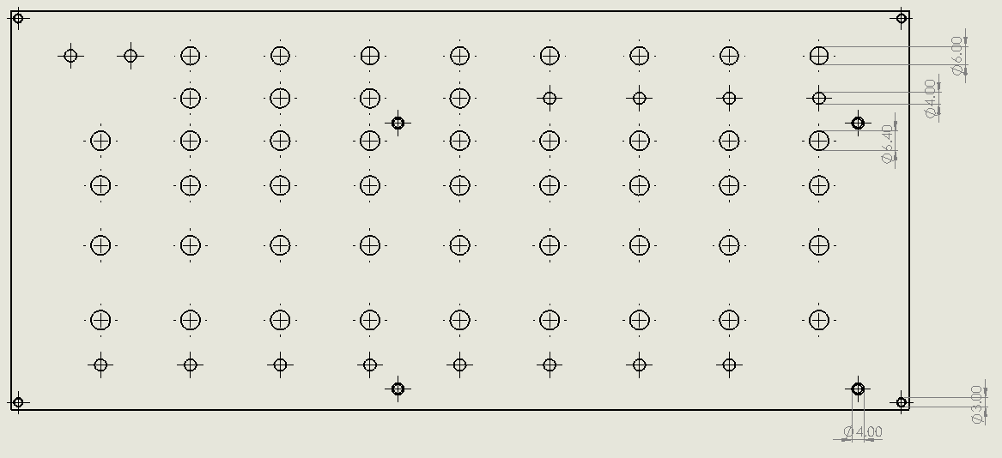

**Figure 4.** Front UI design.

**Switches**

All these components have similar threaded necks. They are mounted with the supplied two nuts.

Their locations are shown in figure 5. The larger group is for gate select switches and the smaller for other switches.

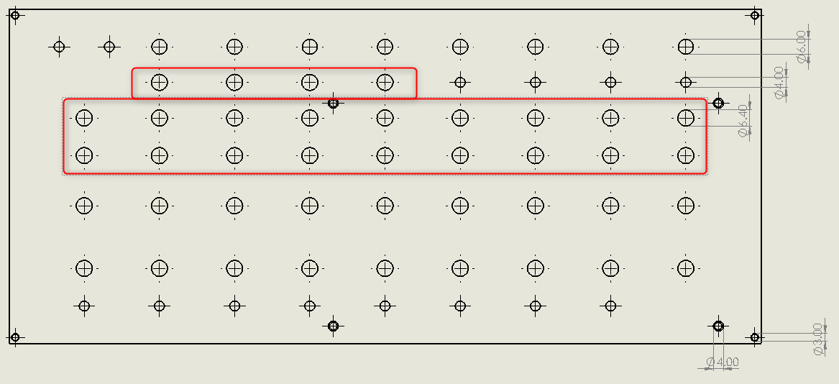

**Figure 5.** Switch locations on UI.

**Potentiometers**

Like with switches, the potentiometers have also threaded necks and they’re mounted with the supplied nuts. Also, after mounting these potentiometers, the knobs need to be mounted for better touch. The potentiometer locations are shown in figure 6.

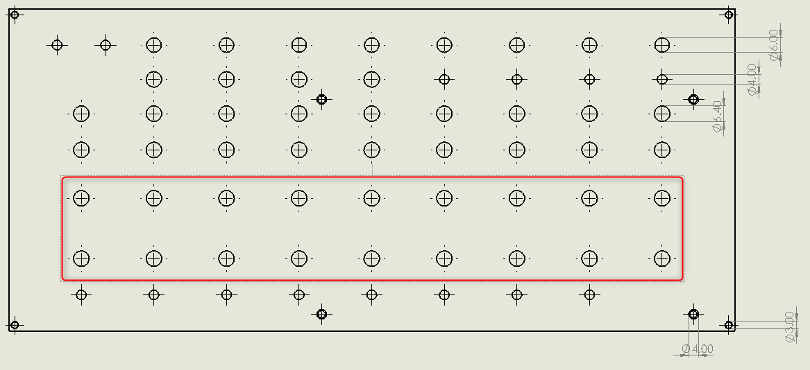

**Figure 6.** Potentiometers’ location on UI.

**LEDs**

LEDs are somewhat smaller when compared to the other components (3.8mm in diameter). To fix them into their places we need to add a little of super glue, epoxy or hot glue. The LED positions are shown in figure 7.

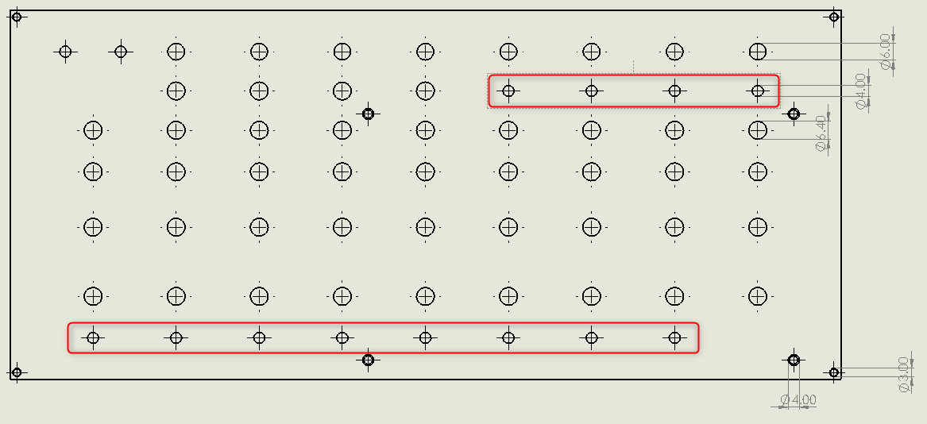

**Figure 7.** LED locations on UI.

**3.5mm jacks**

These jacks have threaded necks and are mounted with the supplied nuts.. Their locations are shown below, in figure 8.

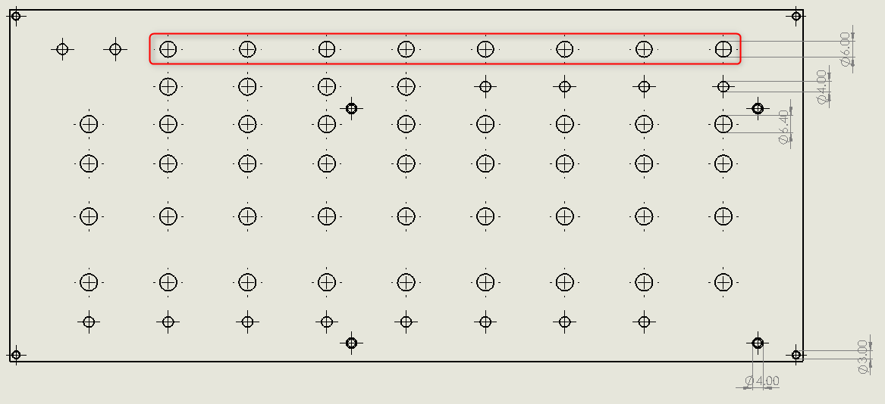

**Figure 8.** Jack locations on UI.

**Push buttons**

These buttons are slightly smaller than the jacks; they have same size as the LEDs. However, unlike LEDs, they are threaded and are fastened with nuts. Figure 9 shows their positions.

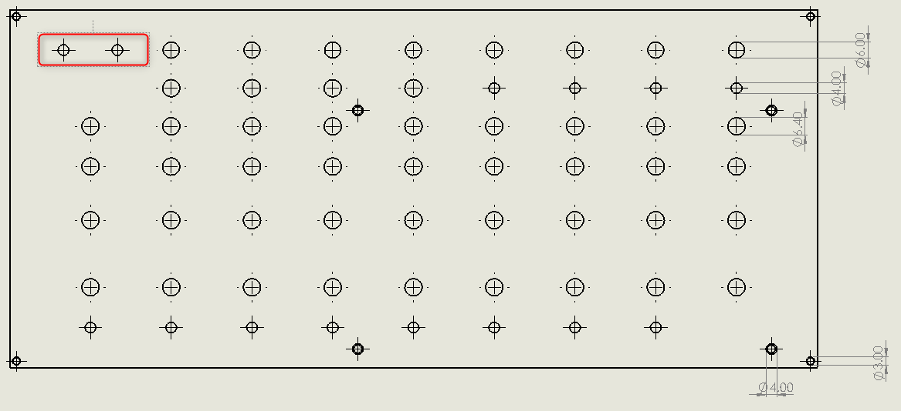

**Figure 9.** Push button locations on UI.

Note: for threaded components, it is necessary to first remove the nuts (from components where they aren’t supplied separately), then insert the component in question from the bottom side of the UI panel and then fix it into position with the nuts. Another point to pay attention is the component’s direction, so that there’s enough space for all components. Figure 10 shows an example.

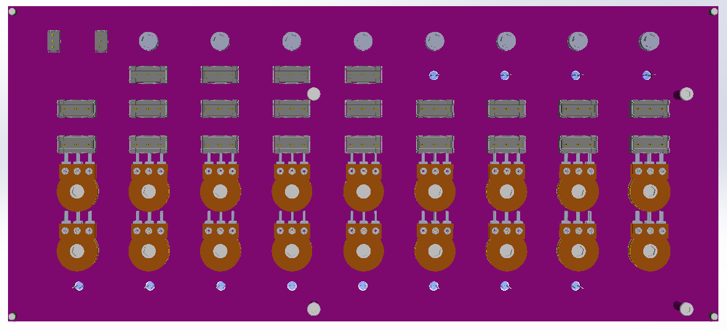

**Figure 10.** Component placement.

***Mounting the PCB***

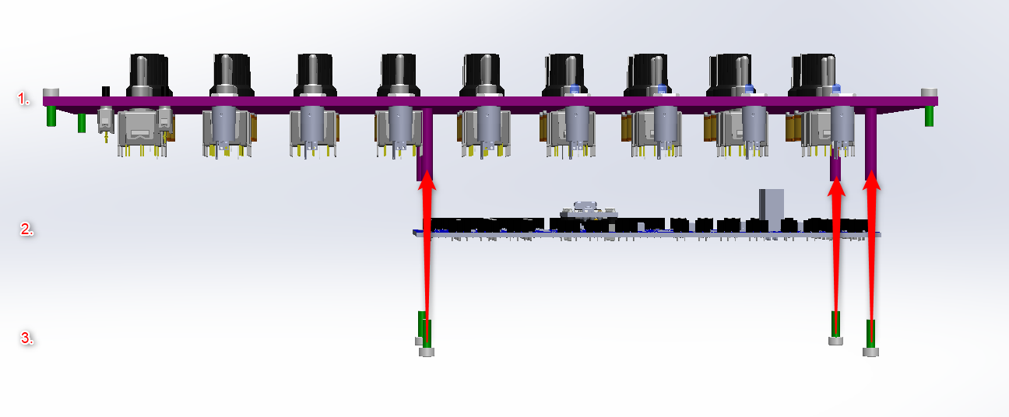

**Figure 11.** Assembly

The front panel has 4 threaded holes for mounting the printed circuit board, by using 4 screws on the corners of the board. This is demonstrated by figure 11. After this, the assembly of the front panel is finished. If the instrument is meant for Eurorack use, no further assembly is needed: the panel can now be mounted to the rack as usual.

***Stand-alone instrument, with bottom part***

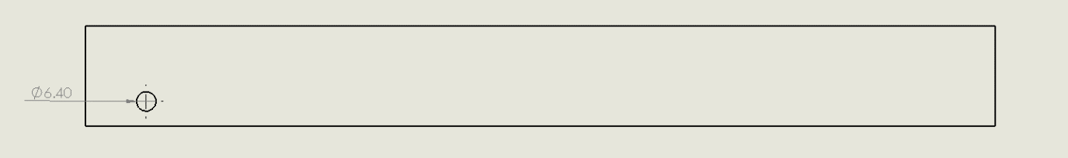

**Figure 12.** Power jack hole

The bottom part can be screwed to the front panel from its edges to convert the Eurorack instrument to a stand-alone instrument.

There is a hole in the back of the enclosure meant for the power jack, like shown in figure 12. To fix the component, we need to insert it from inside and fasten it by tightening its nut to the enclosure.

Programming

Arduino is supplied pre-programmed, so the instrument should work immediately after putting it together. However, the preprogrammed software is the default one, and possibly even an old version. Should builder want to change or update the program, the device needs to be programmed.

In the most minimal case you only need to upload a precompiled program, available as a .hex file. In this case there’s no need to install any actual programming environments. Instead, a hex file uploader can be used, like XLoader [1] or HextoArduino [2]. A mini-B USB cable is required for programming. These programs also require the serial port number used by Arduino. It can be found with Windows’ Device Manager: plug the cable in, and a category “Ports (COM & LPT)” should appear. Under this, the Arduino’s port and its COM port number should be visible. If there are several ports, the correct one can be found by unplugging Arduino and then connecting it again.

If the new software is in Arduino project format, you need to install the Arduino IDE [3]. The Arduino website has also extensive documentation on its use.

If the software is written in C, like the initial release of the Simple Sequencer software, the most convenient option is using the Microchip Studio [4] to compile it. This compiler produces .hex files, which can then be uploaded to Arduino. This can be done using the .hex file uploading tools mentioned above. An alternative is to configure Microchip Studio to use a suitable uploading tool. The most practical tool for this is AVRDUDE, which is actually used (and installed) by Arduino IDE. However, configuring Microchip Studio to use it is somewhat tedious. The link [5] to instructions is included in footnotes. These instructions require installing the Arduino IDE as well. An alternative would be to install AVRDUDE [6] separately and modifying the setup accordingly.

There’s also the option of getting an ISP AVR programmer, like USBasp or AVRISP. Microchip Studio can use AVRISP natively. Note that the ISP programmer’s use Arduino’s 2x3 pin connector instead of the USB connector and can be, depending on situation, more convenient or inconvenient.

It doesn’t work

**It doesn’t work at all!**

* Check the power supply and the power cable
* If you’re using an external power supply, check the wiring between the case jack and the PCB.
* Are you *sure* it doesn’t work? If all the LEDs are systematically installed the wrong way, the instrument does nothing visible.
* Can you reprogram the Arduino? If yes, try reprogramming the default program.
* Check all the polarized components (Arduino, ICs, tantalum capacitors, TVS diode, Eurorack power connector) on the PCB: are they connected the right way? If not, remove the problem parts with desoldering braid or otherwise and resolder them the correct way. Note: the first three components can be damaged permanently by wrong polarity. If they are damaged, they tend to run very hot.
* Check if fuse F1 is intact – particularly if you have found incorrectly populated components.
* Check all the solder joints related to power supplies. Try to see if there are cold joints or solder bridges.

**Some specific feature does not work**

Due to the nature of the instrument, it is far more likely that some singular thing, be it a switch, a potentiometer or a LED, does not work. In this case the problem is most likely close to the offending component or its wiring. However, this is complicated by the fact that the wiring extends to the PCB, possibly in not-so-obvious manner. The problems are most likely caused by bad solder joints and incorrect wiring (like swapped pins with LEDs). Figure 13 shows some examples of problematic solder joints. Even then, bad joints can sometimes be difficult to spot. In that case the joints can be probed with a toothpick (possibly revealing a bad contact) or joints can be simply re-heated with the soldering iron. When reworking the joints, it is recommended to use additional flux.

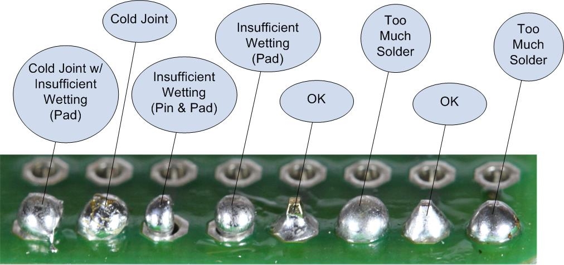

**Figure 13.** Solder joints, mostly bad.

1. XLoader: <https://www.hobbytronics.co.uk/arduino-xloader>
2. HEXtoArduino: <http://www.mediafire.com/file/tx2l85gsdkpf5d4/HEXtoArduino_V1.0.0.zip/file>
3. Arduino IDE: <https://www.arduino.cc/en/software>
4. Microchip Studio 7: <https://www.microchip.com/en-us/development-tools-tools-and-software/microchip-studio-for-avr-and-sam-devices#Downloads>
5. Microchip Studio instructions: <https://www.arnabkumardas.com/platforms/atmel/how-to-flash-or-program-arduino-from-atmel-studio/>
6. AVRDUDE: <https://www.nongnu.org/avrdude/>