**Iteration 1**

**Group 7**

**Group Members**

**Callum MacNeil**

**Date:**

**Mention your GitLab repo**

**Iteration Plan**

1. **User Stories & Acceptance Criteria**

**Provide your git project dashboard link.**

**2. Tasks Assignment: Acceptance test and Engineering task**

**[Necessary Field --> labels,task description, member assigned, start date, end date(expected), status [pending,completed,in progress] ]**

* **Could be downloaded from gitlab [refer tutorial]**

|  |  |  |  |  |  |  |
| --- | --- | --- | --- | --- | --- | --- |
| **Corresponding UserStory and Acceptance Criteria** | **Task(s)** | **Estimate** | **Member Assigned** | **Start** | **Expected** | **Status** |
| AT:1:1 |  |  |  |  |  |  |
| AT:1:1 |  |  |  |  |  |  |
| AT:1:1 |  |  |  |  |  |  |
| AT:1:2 |  |  |  |  |  |  |
| AT:1:3 |  |  |  |  |  |  |
| AT:1:3 |  |  |  |  |  |  |
| AT:3:1 |  |  |  |  |  |  |
| AT:3:1 |  |  |  |  |  |  |
| AT:3:1 |  |  |  |  |  |  |
| AT:3:1 |  |  |  |  |  |  |
| AT:3:1 |  |  |  |  |  |  |
| AT:3:1 |  |  |  |  |  |  |
| AT:5:1 |  |  |  |  |  |  |
| AT:5:1 |  |  |  |  |  |  |
| AT:5:1 |  |  |  |  |  |  |
| AT:5:1 |  | 1hr |  |  |  |  |
| AT:5:1 |  |  |  |  |  |  |
| AT:5:1 |  |  |  |  |  |  |
| AT:5:1 |  |  |  |  |  |  |
| AT:5:1 |  |  |  |  |  |  |
| AT:5:1 |  |  |  |  |  |  |
| AT:6:1 |  |  |  |  |  |  |
| AT:6:1 |  |  |  |  |  |  |
| AT:6:1 |  |  |  |  |  |  |
| AT:6:1 |  |  |  |  |  |  |
| AT:6:1 |  |  |  |  |  |  |
| AT:7:1 |  |  |  |  |  |  |
| AT:7:1 |  |  |  |  |  |  |
| AT:7:1 |  |  |  |  |  |  |
| AT:7:1 |  |  |  |  |  |  |

**3. Work Schedule (May 27th 2019 ~ June 18th 2019) [This is not mandatory, but it keeps track of the contribution of each group member]**

|  |  |  |  |  |  |  |
| --- | --- | --- | --- | --- | --- | --- |
| **Monday** | **Tuesday** | **Wednesday** | **Thursday** | **Friday** | **Saturday** | **Sunday** |
| **27** | **28** | **29** | **30** | **31** | **1** | **2** |
| Group Meeting: Brainstorming user stories |  | Lab 3: Agile game |  |  |  | Generated a list of user stories |
| Set up a board in Trello for user stories |  |  |  |  |  | Group review |
| **3** | **4** | **5** | **6** | **7** | **8** | **9** |
| Group Meeting:  Iteration 1 Planning and introduction to Jira |  | Client Meeting: discussed the user story with client if clarification is needed | Member 2 set up android components and architectures | Sarah set up firebase | Member 1 connected firebase with GitLab repo |  |
|  |  | Member 3 set up GitLab and Member 4set up Jira |  |  |  |  |
| **10** | **11** | **12** | **13** | **14** | **15** | **16** |
| Group Meeting |  | Client Meeting: Dropped user story 2 |  | Member 2 generated test report |  |  |
|  |  | Reassessed user story points |  |  |  |  |
|  |  |  |  |  |  |  |
| **17** | **18** |  |  |  |  |  |
|  | Meeting after the lecture to consult client about project report details |  |  |  |  |  |
|  | Peer review for user stories 6, 7, and 1; before pushing codes to GitLab repo. |  |  |  |  |  |
| Member 2: Progress charts | Submit project report for iteration 1 |  |  |  |  |  |
|  |  |  |  |  |  |  |

**4. Iteration Plan Change Log [Depends on Situation if you have made any changes in the iteration plan ]**

**Progress Charts**

1. **Testing Report**

**Following are situations to consider.**

* + If you have your CI running with Junit tests, provide screenshots of Espresso tests as shown above and discussed in the tutorial.
  + If you have not yet configured CI, show the proof of testing for both Junit and Espresso test as discussed in the tutorial.

**Note**: Take snapshots of the espresso and Junit tests if not configured by the CI when every 3-4 issues are completed.

**2. Burndown Chart**

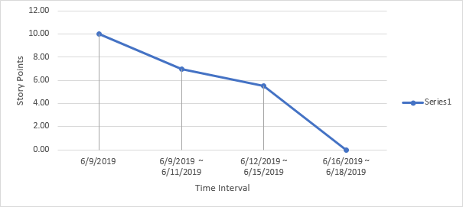

Check out the tutorial and learn how to make the burndown chart.

**3. Velocity Chart**

Check out the tutorial for more information. Sample snapshots are provided below.

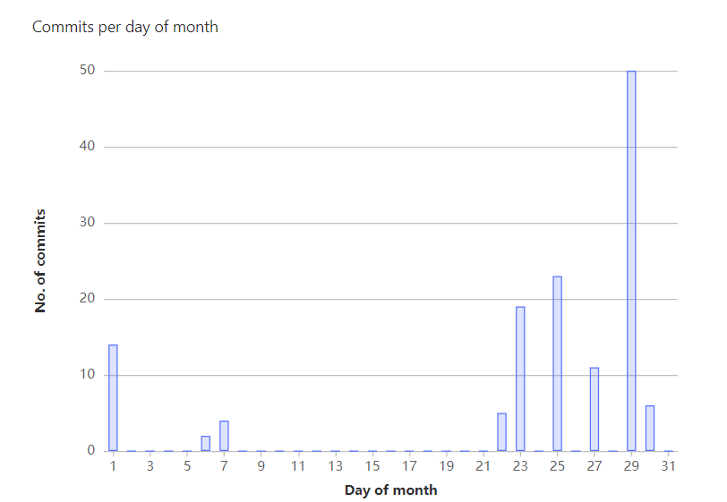

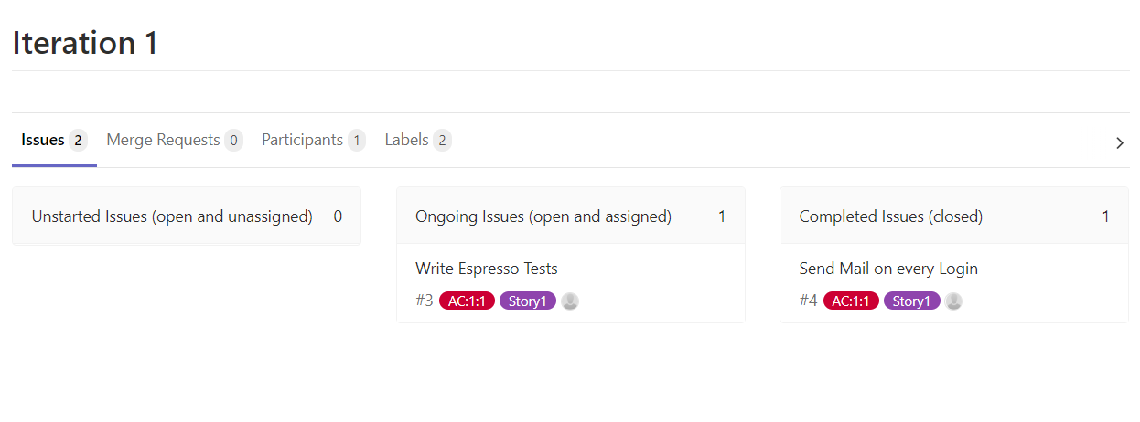

**Regular Standup Meetings [Can have your own format]**

1. **General Meeting Minutes: 2019-06-03**

Time and location: Collaborate Ultra/Teams/Discord

Attendance: Members who attended

Summary:

* Iteration Planning (2 hours)
* We brainstormed, listed user stories on a white board.
* Finished User Stories cards
* We examined user stories that we currently have by giving each user story a level of confidence and some points.
* Confidence 1-5 (least to most)
* Points: 1pt = 3 hours
* Better to overestimate than underestimate time
* US-2 Logout: Make sure data is saved -> saved on firebase
* Update every time we hit save
* Logout: We have to keep in mind to force log out the user of google (push notifications)
* Update database live for functionality
* We brainstormed how we would demonstrate that the user story has been implemented, and specified acceptance tests for each user story (with storyboards, and the help of Trello).
* For each task, we considered the relationships between tasks and defined the scope of implementation.
* We also introduced our background, figured out the pair-programming plan, and how to rotate pairs each Wednesday.

**2. Lab Meeting Minutes: 2019-06-05**

Time and location: Collaborate Ultra/Teams/Discord

Attendance: Members who attended

Summary:

* Met up with client and chose the critical, significant, and optional user stories.
* Considered relations between tasks, and which tasks are of high priority in terms of implementation.
* Selected the user stories to be worked on iteration 1: US-1, US-2, US-3, US-5, US-6, US-7, US-11, and US-13
* A total of 30 points for iteration 1
* We set up the GitLab repository
* Set up the Jira with the user stories and tasks for iteration 1
* Assigned pairs and user stories for each pair
* Build a schedule

**3. General Meeting Minutes: 2019-06-10**

Time and location: Collaborate Ultra/Teams/Discord

Attendance: Members who attended

Summary:

* Each pair started working on the allocated user stories.
* We discussed about the file naming conventions, version control methods, and how to do peer review for the work.
* We ran unit tests and espresso tests for the code, and followed the TDD development.
* We discussed about the engineering tests that we used for each acceptance test.

**4. General Meeting Minutes: 2019-06-11**

Time and location: Collaborate Ultra/Teams/Discord

Attendance: Members who attended

Summary:

* We started working on the allocated user stories.
* We discussed about the file naming conventions, version control methods, and how to do peer review for the work.
* We ran unit tests and espresso tests for the code, and followed the TDD development.
* We discussed about the engineering tests that we used for each acceptance test.

**5. General Meeting Minutes: 2019-06-12**

Time and location: Collaborate Ultra/Teams/Discord

Attendance: Members who attended

Summary:

* **What did each pair accomplish?**
* **Member 1 and Member2 (4 hours)**
* **Member 1 and Member2 (4.5 hours)**
* **Member 1 and Member2 (6 hours)**

**Iteration Post-mortem Review [4/100]**

*Issues With Development*

*Solutions*

*Goals for Upcoming Iteration*

**Links**