Part A – Embedded System Architecture
Lab 1: Embedded Computer Architecture and Software Build Flow (S32K144 EVB)

A.1 Microprocessor vs. Microcontroller
A microprocessor is a stand-alone processing unit (CPU only) that requires external memory and peripheral chips to build a working system. A microcontroller integrates the CPU together with memory and peripherals on a single chip, making it a complete, low-cost, low-power computer intended for dedicated control tasks. The table below compares the two across the criteria required by this lab.
Criterion | Microprocessor | Microcontroller
CPU | Present alone; only the processing core (ALU + control unit + registers) | Present, usually a smaller/simpler core integrated on the same chip
Internal Memory | None on-chip; needs external RAM/ROM | On-chip Flash (program) and RAM (data) included
Peripherals | None on-chip; timers, UART, ADC, etc. added externally | Built-in: GPIO, Timer, UART/SPI/I2C, ADC, Interrupt Controller
External Components | Many: memory chips, peripheral ICs, glue logic, buffers | Very few: mainly power supply, crystal (optional), decoupling caps
Power Consumption | Higher (multiple external chips, higher clock speeds) | Lower; often has sleep/low-power modes for battery operation
Cost | Higher (processor + external memory + peripherals) | Lower; single-chip solution reduces board and part cost
Typical Use | General-purpose computing: PCs, servers, laptops | Embedded/dedicated control: washing machines, automotive ECUs, IoT sensors

A.2 Generic Microcontroller Block Diagram
The diagram below shows the internal architecture common to virtually every microcontroller, including the S32K144: a central CPU connected to memory and peripheral blocks through a shared address bus and data bus, with the clock module driving all synchronous logic and the interrupt controller allowing peripherals to request the CPU's attention.
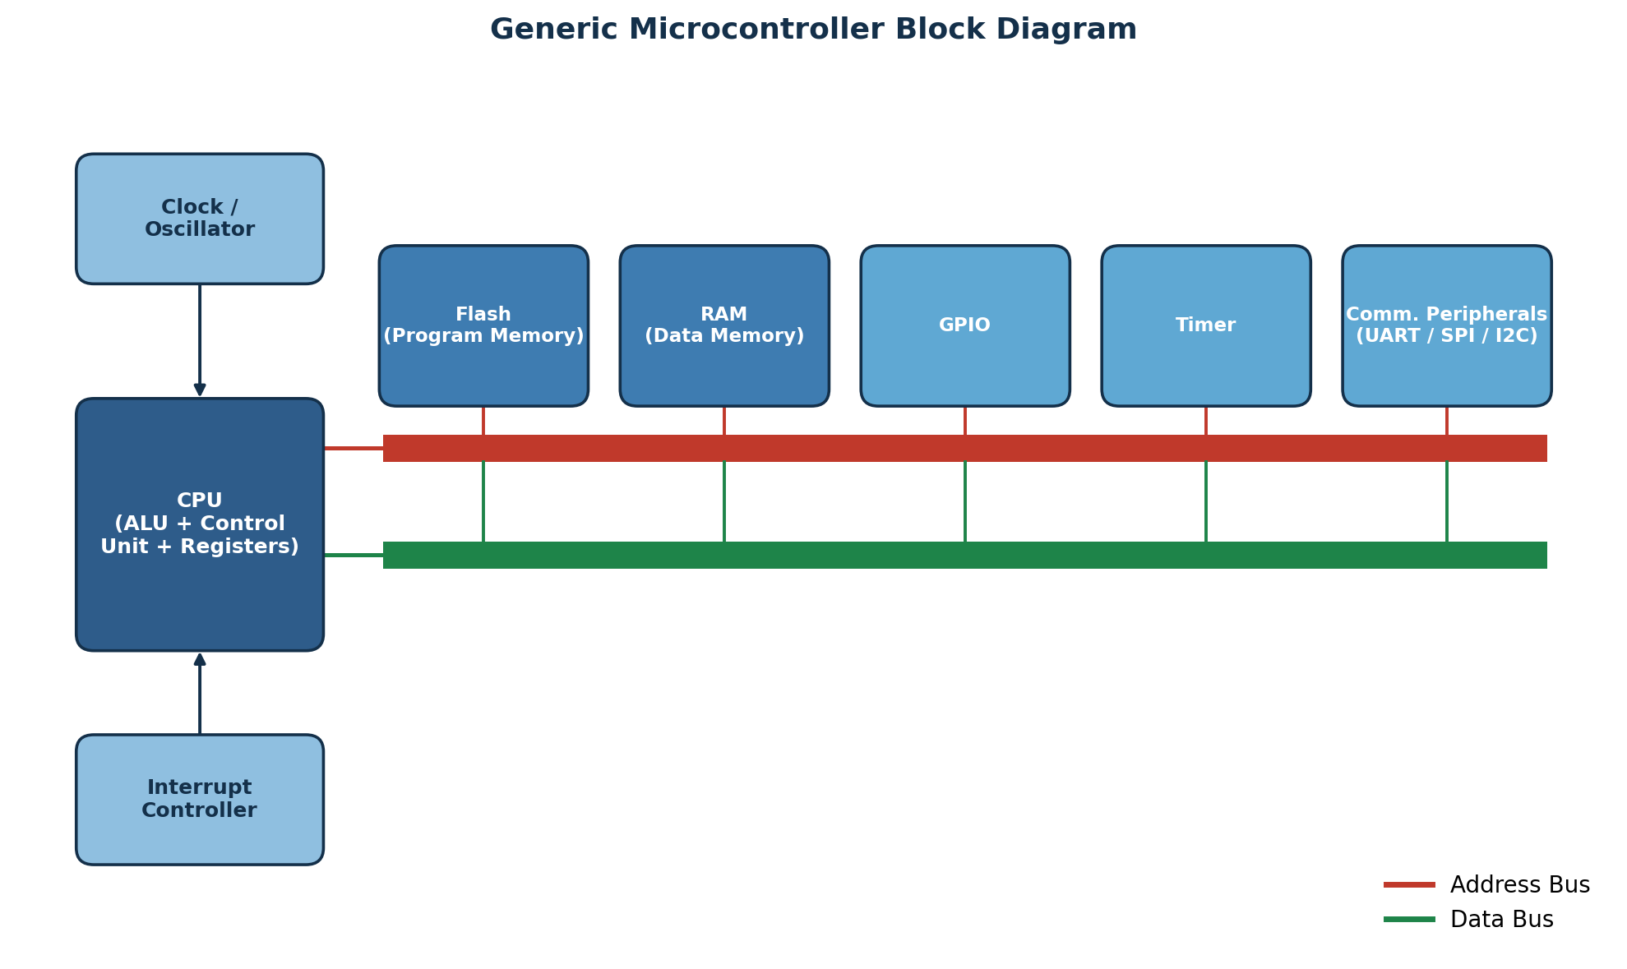
Figure 1. Generic microcontroller block diagram.
Role of each block:
- CPU (ALU + Control Unit + Registers) – fetches, decodes, and executes instructions; performs arithmetic/logic operations.
- Flash (Program Memory) – non-volatile memory that stores the compiled program code.
- RAM (Data Memory) – volatile memory used for variables, the stack, and the heap at run time.
- GPIO – general-purpose input/output pins used to read switches or drive LEDs/actuators.
- Timer – generates precise delays, PWM signals, or periodic interrupts.
- Communication Peripherals (UART/SPI/I2C) – exchange data with external devices or other chips.
- Clock/Oscillator – generates the timing signal that synchronizes every block on the bus.
- Interrupt Controller – prioritizes and routes interrupt requests from peripherals to the CPU.
- Address Bus / Data Bus – the shared pathways that let the CPU locate and exchange information with every block above (detailed in A.3).

A.3 Role of the Address Bus and Data Bus
The address bus and data bus work together every time the CPU accesses memory or a peripheral register. The address bus is unidirectional (CPU → memory) and selects which location is being accessed; the data bus is bidirectional and actually carries the information.

Memory Read (e.g., CPU fetches an instruction or loads a variable)
- The CPU places the address of the target memory location on the address bus.
- The CPU asserts the Read control signal (e.g., pulls the R/W line high).
- The memory decodes the address and places the stored data of that location onto the data bus.
- The CPU latches the value from the data bus into an internal register.

Memory Write (e.g., CPU stores a variable to RAM)
- The CPU places the destination address on the address bus.
- The CPU puts the value to be stored onto the data bus.
- The CPU asserts the Write control signal (e.g., pulls the R/W line low).
- The memory latches the value from the data bus into the addressed storage cell.
In short: the address bus says “where” and the data bus carries “what”, while a control signal says whether the operation is a read or a write.

A.4 Von Neumann vs. Harvard Architecture
Von Neumann and Harvard architectures differ mainly in how program (instruction) memory and data memory are organized and connected to the CPU.
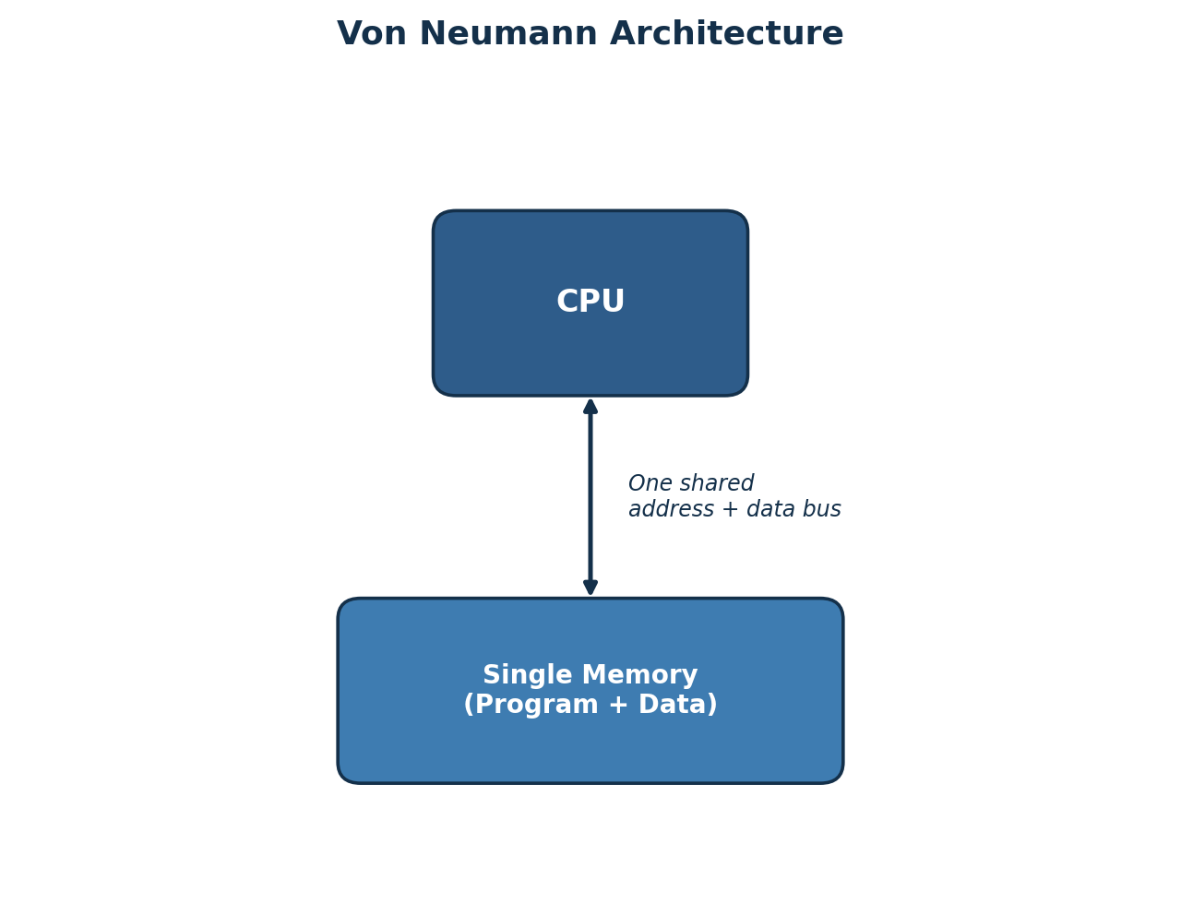  Figure 2. Von Neumann architecture. | 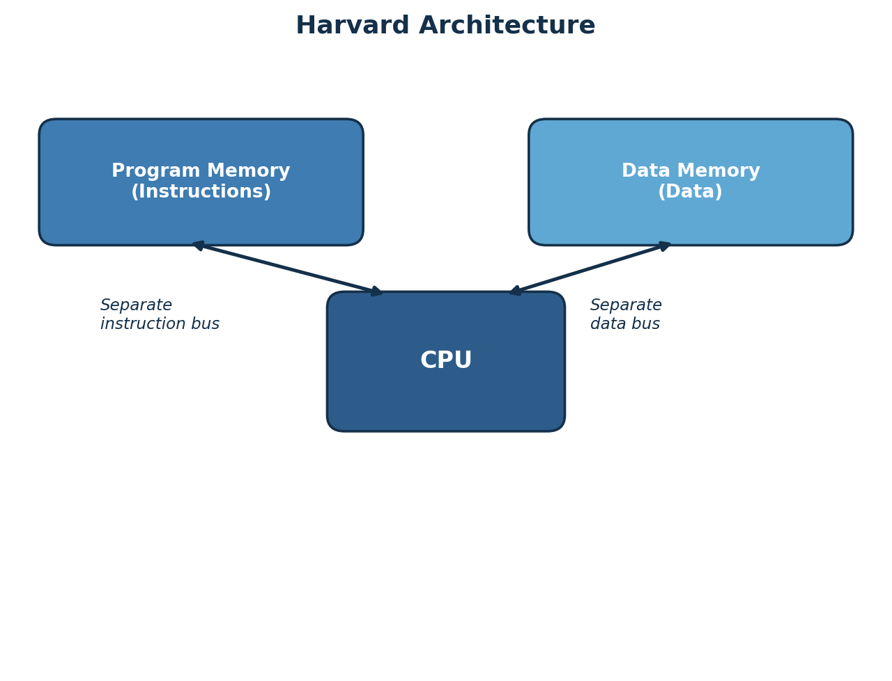  Figure 3. Harvard architecture.

Aspect | Von Neumann | Harvard
Memory | Single memory holds both program and data | Separate memories for program and data
Buses | One shared address bus and one shared data bus | Independent address/data buses for program and data
Access | CPU can access only instruction OR data in one bus cycle | CPU can fetch an instruction and access data simultaneously
Speed | Slower due to bus contention (“Von Neumann bottleneck”) | Faster; parallel instruction fetch and data access
Hardware Complexity | Simpler, cheaper to implement | More complex; needs duplicated bus/memory interfaces
Example | Classic x86 PCs, most general-purpose CPUs | Most microcontrollers: AVR, PIC, ARM Cortex-M (modified Harvard)

A.5 RISC vs. CISC
RISC (Reduced Instruction Set Computer) and CISC (Complex Instruction Set Computer) represent two philosophies for designing a processor's instruction set.
Characteristic | RISC | CISC
Instruction Set | Small, simple, fixed-length instructions | Large, complex, variable-length instructions
Execution Time | Mostly 1 clock cycle per instruction | Multiple clock cycles per instruction
Addressing Modes | Few addressing modes; load/store architecture | Many addressing modes; memory operands allowed in arithmetic ops
Hardware vs Software | More work done by the compiler/software | More functionality implemented directly in hardware/microcode
Chip Complexity / Power | Simpler decode logic; lower power | Complex decode logic; higher power
Representative Family | ARM (e.g., ARM Cortex-M4 in NXP S32K144) | Intel/AMD x86

References
- NXP Semiconductors, “S32K1xx Series Reference Manual,” NXP, 2021.
- NXP Semiconductors, “S32K144 Data Sheet,” NXP, 2021.
- ARM Limited, “Cortex-M4 Technical Reference Manual,” ARM DDI 0439.
- J. W. Valvano, Embedded Systems: Introduction to ARM Cortex-M Microcontrollers, 5th ed., 2018.
- D. A. Patterson and J. L. Hennessy, Computer Organization and Design: The Hardware/Software Interface, 5th ed., Morgan Kaufmann, 2013.
- M. Barr and A. Massa, Programming Embedded Systems: With C and GNU Development Tools, 2nd ed., O'Reilly Media, 2006.
- S. Furber, ARM System-on-Chip Architecture, 2nd ed., Addison-Wesley, 2000.

