HANOI UNIVERSITY OF SCIENCE AND TECHNOLOGY

School of Information and communications technology

Software Requirement Specification

Version 1.2

AN INTERNET MEDIA STORE

Subject: ITSS SOFTWARE DEVELOPMENT

Lê Minh Phúc - 20210687

*Hanoi,* *<March, 2024>*

Table of contents

Table of contents 1

1 Introduction 2

1.1 Objective 2

1.2 Scope 2

1.3 Glossary 2

1.4 References 3

2 Overall Description 4

2.1 Survey 4

2.2 Overall requirements 4

2.3 Business process 4

3 Detailed Requirements 5

3.1 Use case 1 6

3.2 Use case 2 7

4 Supplementary specification 8

4.1 Functionality 8

4.2 Usability 8

4.3 Reliability 8

4.4 Performance 8

4.5 Supportability 8

4.6 Other requirements 8

# Introduction

## The pursuit of knowledge, artistic expression, and entertainment has always been and will continue to be fundamental to human existence. However, life itself is not without its challenges, and there are occasions when creative endeavors struggle to connect with audiences, posing difficulties for artists and intellectuals in maintaining a satisfactory standard of living. Fortunately, in this era of a thriving Internet and the Fourth Industrial Revolution, new opportunities have emerged for everyone. One such opportunity is the AIMS Project, an E-commerce platform specifically tailored for the purchase of media products. This document seeks to offer a comprehensive overview of the subsystem, user groups, and their respective functions within the operational framework of the system. It delineates the system's objectives, features, as well as the interfaces and limitations it must adhere to when interfacing with external inputs. This documentation caters to both stakeholders and software developers alike.

## Objective

*The platform empowers customers to browse products, select items for purchase, proceed through checkout, make payments, and view their order history. The primary goal of this endeavor is to provide students with a hands-on chance to enhance their programming and software engineering skills, particularly in web development, database design, and software architecture. Furthermore, the project seeks to deepen students' understanding of the e-commerce industry, encompassing operational protocols and technical aspects such as payment processing, inventory management, and order fulfillment.*

## Scope

*The AIMS Software is an online platform built to simplify the process of ordering and paying for products for customers, while also providing administrative tools and inventory management features for administrators and product managers. Customers can enjoy functionalities such as browsing products, searching, adding items to their shopping cart, previewing invoices, and making payments using prepaid credit cards. They also have the capability to cancel orders and receive refunds. On the other hand, administrators and product managers can oversee and manage orders, including approving or rejecting pending orders, and updating inventory levels. They also have the authority to add, remove, or modify products in the inventory. The primary aim of the AIMS Software is to provide customers with a convenient and effective means of placing orders, while empowering administrators to efficiently manage orders and inventory. This includes advantages like streamlined order processing, enhanced inventory control, and improved customer satisfaction. The software aims to achieve these objectives by delivering a user-friendly and dependable system that caters to the needs of both customers and administrators. Regarding payment processing, customers have the choice to use a credit card, with transactions being handled by a third-party service named VNPAY*

## Glossary

* AIMS: An Internet Media Store - The project name for the desktop e-commerce software described in the document.
* E-commerce: A method of buying and selling goods and service online.
* Performance: The effectiveness and efficiency of the software in terms of speed, responsiveness, and reliability.
* Uptime: The duration for which the software remains operational and accessible to users without experiencing downtime or failure.
* Response time: The time taken by the software to respond to user interactions or requests.
* Product Manager: An administrative user responsible for managing the inventory of products available on the platform.
* VAT: an indirect tax on domestic consumption applied nationwide rather than at different levels, such as state, provincial, or local taxes
* Physical Media Products: Media products that exist in tangible form, such as books, CDs, LP records, and DVDs.
* Barcode: A unique code assigned to each physical product for inventory tracking and identification purposes.
* Pricing: The cost associated with purchasing a product, which may vary based on factors such as market demand and product value.
* Market Demand: The level of consumer interest and willingness to purchase a product at a given price.
* Product History: Records of operations (addition, editing, deletion) performed on products, stored for tracking and auditing purposes.
* Administrator: A privileged user responsible for managing user accounts, roles, and overall system settings.
* User Roles: Different levels of permissions and responsibilities assigned to users within the system, such as administrator or product manager.
* Customer: A user who interacts with the platform to browse, search for, and purchase products.
* Cart: A virtual container where customers can temporarily store selected products before proceeding to checkout.
* Order Placement: The process of selecting products, providing delivery and payment information, and confirming the purchase.
* Payment Method: The mode of payment chosen by the customer to complete the transaction, such as credit cards.
* Delivery Information: Details provided by the customer for shipping the purchased products, including recipient name, address, and contact information.
* Delivery Fee: The additional cost associated with delivering the purchased products to the customer's specified address.
* Rush Order Delivery: Expedited delivery option allowing customers to receive their items within a short timeframe for an extra fee.
* Shipping Fees: Charges applied for shipping the purchased products to the customer, calculated based on factors like weight and delivery location.
* VNPAY: A payment gateway service used for processing credit card payments and managing transactions.
* VNPAY Sandbox: A testing environment provided by VNPAY for developers to simulate payment and refund transactions without affecting real transactions.
* Payment Gateway: A service that facilitates online payments by securely transmitting payment information between the customer and the merchant's bank.
* Transaction DateTime: The date and time when a transaction occurs, recorded for reference and reconciliation purposes.
* Invoice: A document detailing the items purchased, their prices, taxes, fees, and the total amount due, provided to customers as a record of their transaction.
* Customer Support: Assistance provided to users by the platform's support team to address inquiries, resolve issues, or provide guidance on using the system.
* User Authentication: The process of verifying the identity of users before granting them access to the system, typically done through login credentials such as username and password.
* Session Management: The maintenance of user sessions to track their interactions with the system and ensure security and continuity during their browsing or purchasing journey.
* SSL Encryption: Secure Socket Layer encryption technology used to protect sensitive data transmitted between the user's browser and the platform's server, ensuring privacy and security during online transactions.

## References

# Overall Description

## Survey

There are three actors including customer, administrator and VNPAY.

## Overall requirements

2.2.1. Overview use case

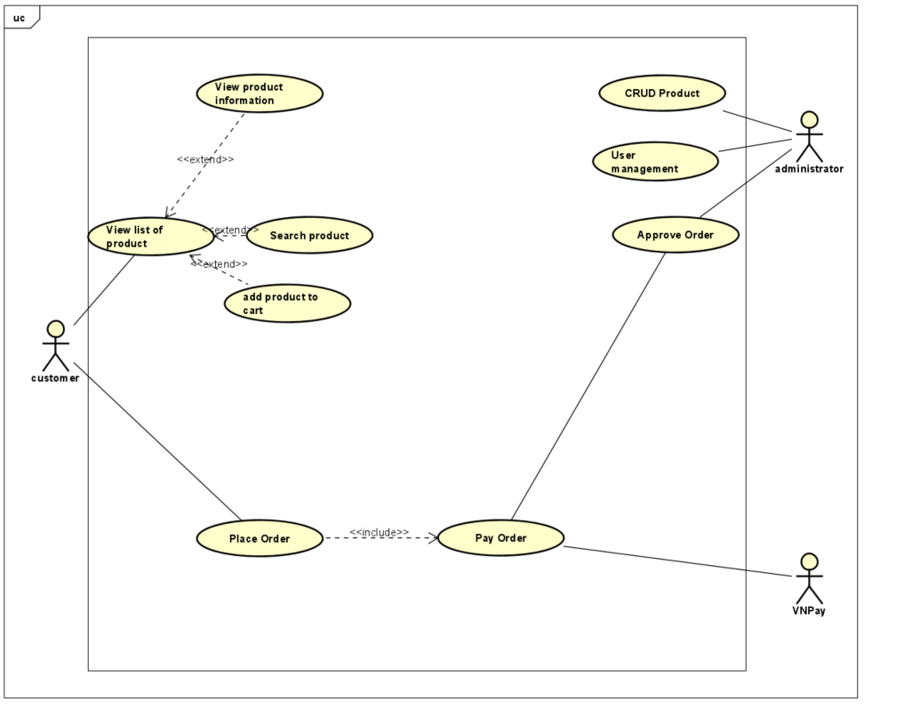

2.2.2. Place Order Use Case

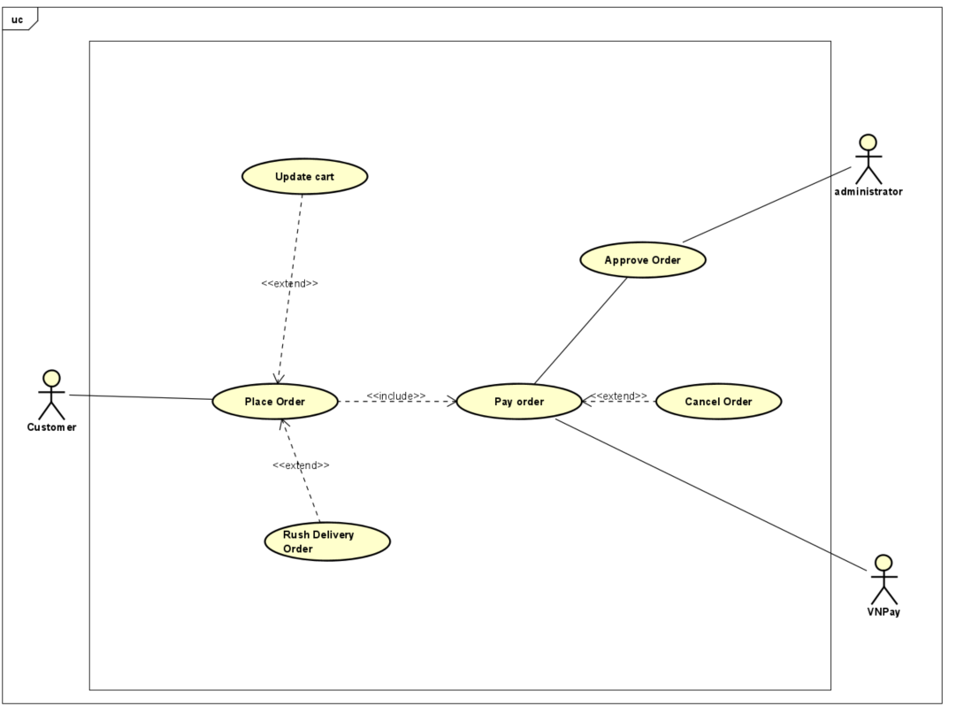

2.2.3. User Management Use Case

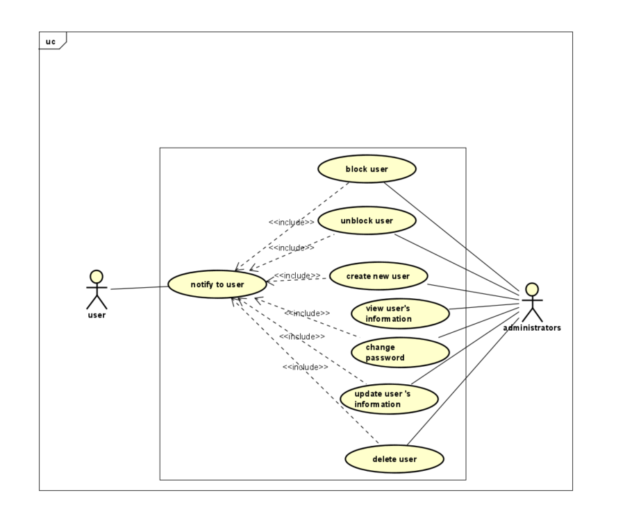

## Business process

First, use case “Place Order” starts. In the process, AIMs software will check whether the customer has placed rush order then use case “Place Rush Order” will be called. Otherwise, the “Place order” process still continues. At step 10, AIMs software will call use case “Pay Order”.

### 2.3.1. *Place order process*

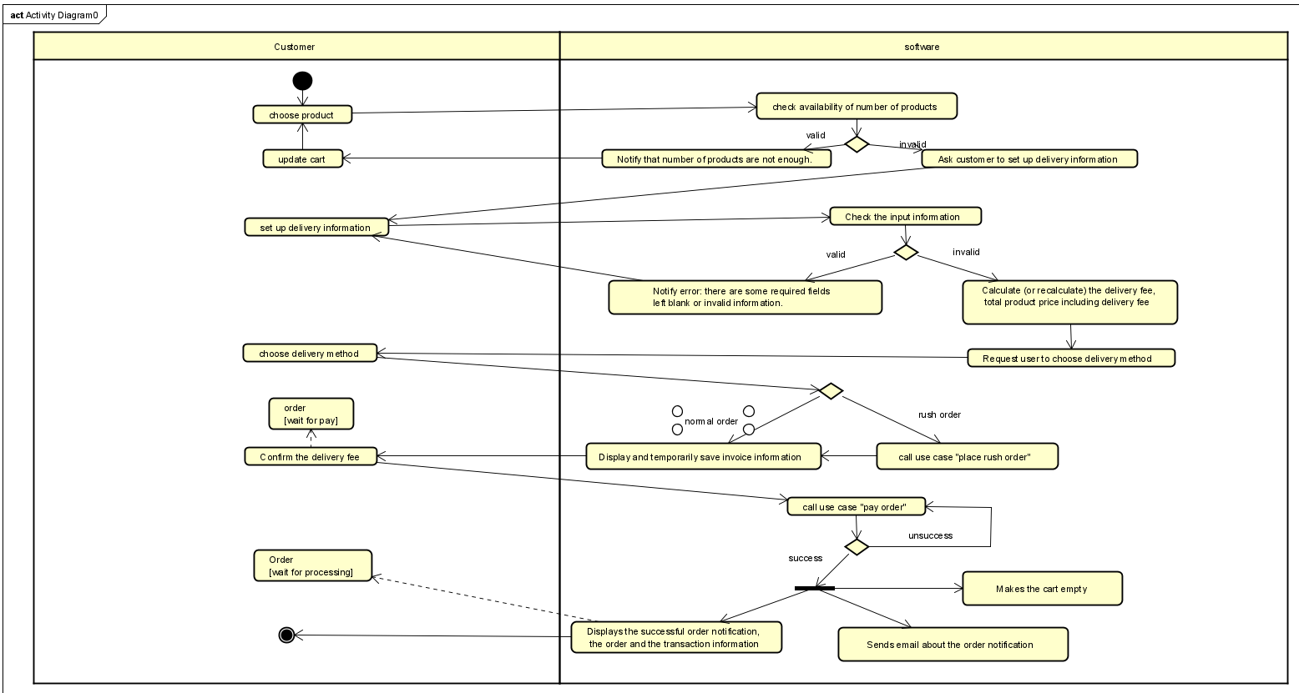

2.3.2. Pay order process

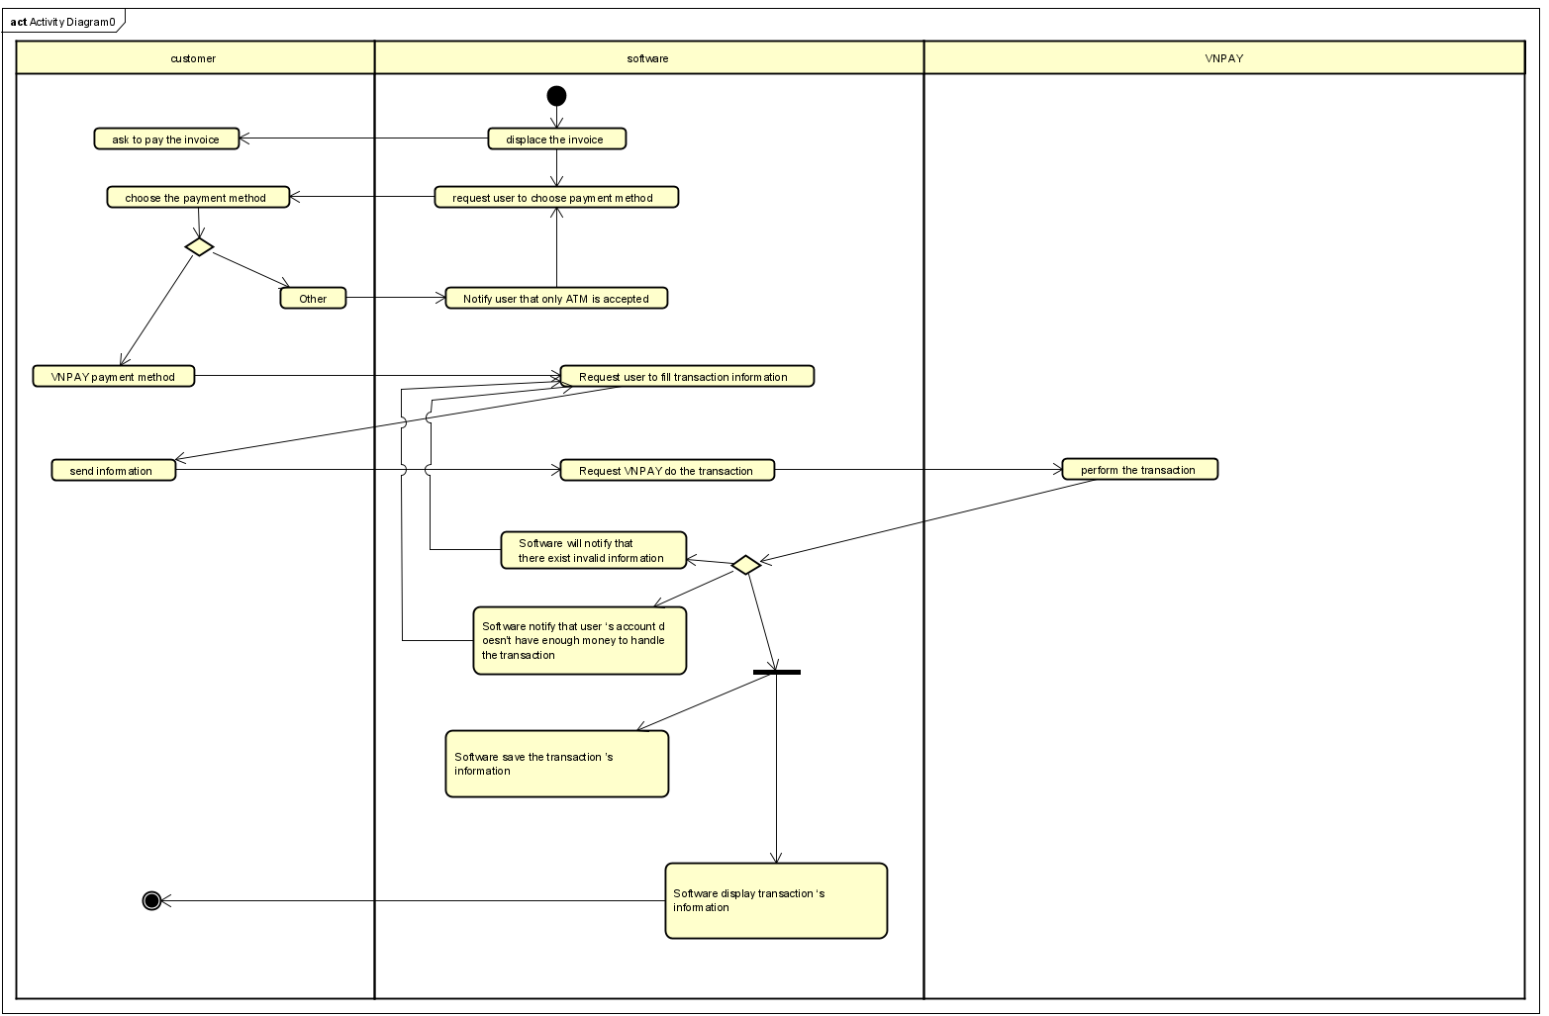

2.3.3. Place rush order process

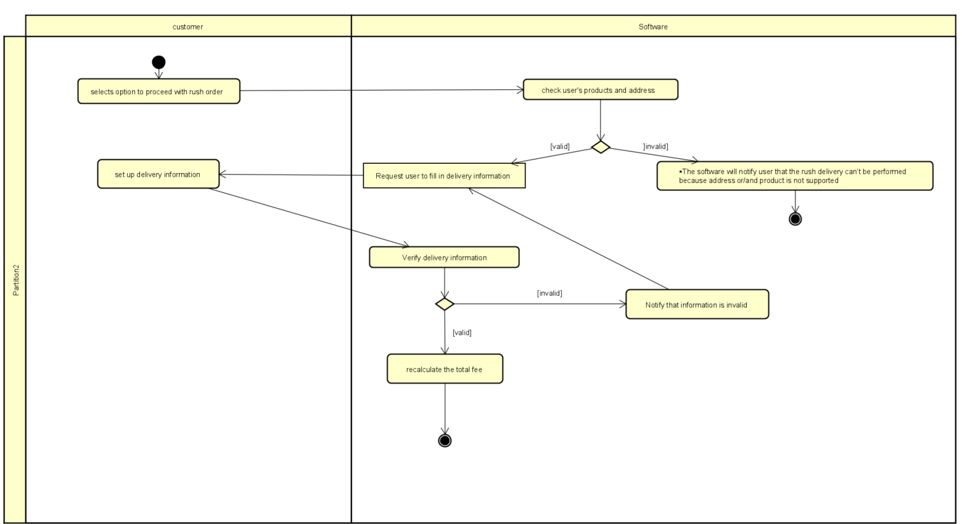

# Detailed Requirements

## USE CASE PLACE ORDER

|  |  |  |  |
| --- | --- | --- | --- |
| **Use case code** | UC003 | **Use case name** | Place order |
| **Actor** | Customer, software | | |
| **Description** | Customer is permitted to place order | | |
| **Precondition** | Need at least one item in the cart | | |
| **Flow of events**  **(Success)** | |  |  |  | | --- | --- | --- | | **No** | **Actor** | **Action** | | 1. | Customer | Choose product to place order in the cart view | | 2. | Software | Check the availability of products in cart | | 3. | Software | Ask customer to set up delivery information | | 4. | Customer | Set up delivery information | | 5. | Software | Check the input information | | 6. | Software | Calculate (or  recalculate) the delivery fee, total product price including delivery fee. | | 7. | Software | Display the delivery fee. | | 8. | Customer | Confirm the delivery fee | | 9. | Software | Display and temporarily save invoice information, | | 10. | Customer | Call the Use Case Pay Order | | 11. | Software | Creates a new order | | 12. | Software | Makes the cart empty | | 13. | Software | Sends email about the order notification | | 14. | Software | Displays the successful order notification, the order and the transaction information | | | |
| **Alternative flow** | |  |  |  |  |  | | --- | --- | --- | --- | --- | | **No** | **Location** | **Condition** | **Action** | **Resume location** | | 1. | 2 | The cart is empty | Notify error: The cart is empty. | 1 | | 2. | 3 | Number of products is insufficient | Notify that number of products are not enough. | 1 | | 3. | 5 | Information is invalid | Notify error: there are some required fields left blank or invalid information. | 3 | | 4. | 9 | Customer choose Pay Rush Order | Software call Pay Rush Order UC | 9 | | 5. | 10 | Customer pay the order unsuccessfully | Notify error: Can’t complete paying order | 9 | | | |
| **Post condition** | No | | |

II, Input data ( For delivery information)

|  |  |  |  |  |  |
| --- | --- | --- | --- | --- | --- |
| No | Data field | Description | Mandatory | Valid condition | Example |
| 1 | Name of receiver |  | Yes | Maximum number of character are 50 | Le Minh Phuc |
| 2 | Email |  | Yes |  | test@gmail.com |
| 3 | Phone number |  | Yes | 10 digits | 0123456789 |
| 4 | Address |  | Yes |  | Ngo 100 Tran Phu |
| 5 | Instruction for shipper |  | No |  |  |

III, Output data

|  |  |  |  |  |
| --- | --- | --- | --- | --- |
| No | Data field | Description | Display format | Example |
| 1 | Name of Product |  |  | DVD |
| 2 | Product price | Price of a product |  | 1000000 VND |
| 3 | Quantity |  |  | 3 |
| 4 | Total product prices |  |  | 2000000 VND |
| 5 | VAT | VAT fee |  | 50000 VND |
| 6 | Delivery fee |  |  | 30000 VND |
| 7 | Total price fee |  |  | 2080000 VND |
| 8 | Name of purchaser |  |  | Le Minh Phuc |
| 9 | Phone number of purchaser |  | 10 digits | 0192345678 |
| 10 | Address |  |  | Ngo 100 Tran Phu |

IV, Post Condition

No

## Use case Pay Order

UC – Pay Order

1, Use Case Code: UC04

2, Brief Description:

* User pay for their order

3, Actor

* User, Software, VNPAY

4, Precondition:

* The system has calculated user ‘s total fee ( which is The total amount that customers need to pay includes the total product price including VAT and the delivery fee)

5, Basic flows of event

1. AIMS software displays the invoice
2. Customer asks to pay the invoice
3. Software notify user to choose the method used to pay order
4. User choose to pay order via VNPAY
5. VNPAY request user to provide necessary information
6. User send all necessary information
7. VNPAY notifies the transaction result
8. Software save the transaction ’s information
9. Software display transaction ‘s information

6, Alternative flow

|  |  |  |  |  |
| --- | --- | --- | --- | --- |
| **No** | **Location** | **Condition** | **Action** | **Resume location** |
| 1 | 3 | If user doesn’t choose any payment method | Notify error: choose the payment method appeared above | 3 |
| 2 | 4 | User ‘s information is invalid | Software will notify that there exist invalid information | 3 |
| 3 | 6 | User ‘s account balance is insufficient to pay the order | Software notify that user ‘s account doesn’t have enough money to handle the transaction | 3 |
| 4 | 7 | If the user cancels the payment transaction |  | 1 |

7, Input data

|  |  |  |  |  |  |
| --- | --- | --- | --- | --- | --- |
| No | Data fields | Description | Mandatory | Valid condition | Example |
| 1 | Name of user |  | Yes | Less than 50 characters | Le Minh Phuc |
| 2 | Number of card |  | Yes | 16 digits | 0123 4567 8910 1112 |
| 3 | Expired date |  | Yes | MM/YYYY | 03/2024 |
| 4 | Transaction password |  | Yes | 4 digits | 1234 |

8, Output data

|  |  |  |  |  |
| --- | --- | --- | --- | --- |
| No | Data fields | Description | Display format | Example |
| 1 | Transaction ID |  |  | LMP298080324 |
| 2 | Cardholder's name |  |  | Le Minh Phuc |
| 3 | Deducted amount |  |  | 50000 VND |
| 4 | Total received fee |  |  | 1200000 VND |
| 5 | Transaction date and time |  | MM/DD/YYYY HH:MM:SS TT | 08/05/2024 03:05:15 PM |

9, Post Condition

No

## USE CASE “PLACE RUSH ORDER”

|  |  |  |  |  |  |  |  |  |  |  |  |  |  |  |  |  |  |  |  |  |  |  |  |  |  |  |  |  |  |  |  |  |  |  |  |  |  |  |  |  |  |  |  |  |
| --- | --- | --- | --- | --- | --- | --- | --- | --- | --- | --- | --- | --- | --- | --- | --- | --- | --- | --- | --- | --- | --- | --- | --- | --- | --- | --- | --- | --- | --- | --- | --- | --- | --- | --- | --- | --- | --- | --- | --- | --- | --- | --- | --- | --- |
| **Use Case “Place Rush Order”**   1. **Use case code**   UC005   1. **Brief Description**   This use case delivery allows customers to receive their items within a prearranged timeframe of 2 hours.   1. **Actors**    1. **User, Software** 2. **Preconditions**   User filled their address   1. **Basic Flow of Events** 2. User selects the option to proceed with rush order 3. The software check user ‘s products and address 4. The software request user to fill in delivery information 5. User set up delivery information 6. The software verifies the customer rush order information 7. The software recalculates the total fee 8. The software calls the UC “Pay Order” 9. **Alternative flows**   Table N-Alternative flows of events for UC Place order   |  |  |  |  |  | | --- | --- | --- | --- | --- | | **No** | **Location** | **Condition** | **Action** | **Resume location** | |  | At Step 2 | If no products are eligible | * The software will notify user that the rush delivery can’t be performed | Use case ends | |  | At Step 2 | If user’s address is not supported to perform rush delivery | * The software will notify user that the rush delivery can’t be performed | Use case ends | |  | At step 5 | Delivery information is invalid | * The software will notify user that information is invalid | At step 3 |  1. **Input data**   Table A-Input data of Place rush Order form   |  |  |  |  |  |  | | --- | --- | --- | --- | --- | --- | | **No** | **Data fields** | **Description** | **Mandatory** | **Valid condition** | **Example** | |  | Delivery information for rush order |  | Yes |  | Le Minh Phuc | |  | Delivery time |  | Yes | HH:MM -> HH:MM | 10:00 to 12:00 | |  | Delivery instruction |  | No |  | The house with blue  door |  1. **Output data**   No   1. **Postconditions**   **No** |

# Supplementary specification

## Functionality

Placing orders and paying orders, instead of features such as account authentication or user management.

## Usability

*The AIMS Project operates around the clock and is compatible with various platforms, enabling new users to quickly become acquainted with it.*

## Reliability

*In the event of a typical failure, the AIMS Software can be restored within one hour. Under normal conditions, the software has a response time of one second, which extends to two seconds during peak loads unless otherwise specified.*

## Performance

*The system is capable of accommodating up to 1000 concurrent customers without experiencing any significant performance degradation. Additionally, it can operate continuously for an average of 300 hours without encountering any failures.*

## Supportability

*The product manager has the capability to remove a maximum of 10 products simultaneously. Furthermore, there is a restriction in place where the product manager cannot delete or modify more than 30 products at a time, as a security precaution. However, there are no limitations on the number of products that can be added within a single day*

## Other requirements