Name: Phạm Hà Minh Quyên

20521824

Link: https://github.com/MinhQuyennn/lab51

Exercise 0

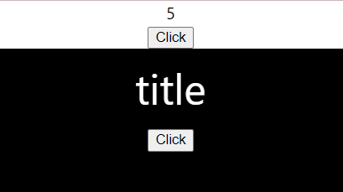

Exercise 1

Exercise 2

Index

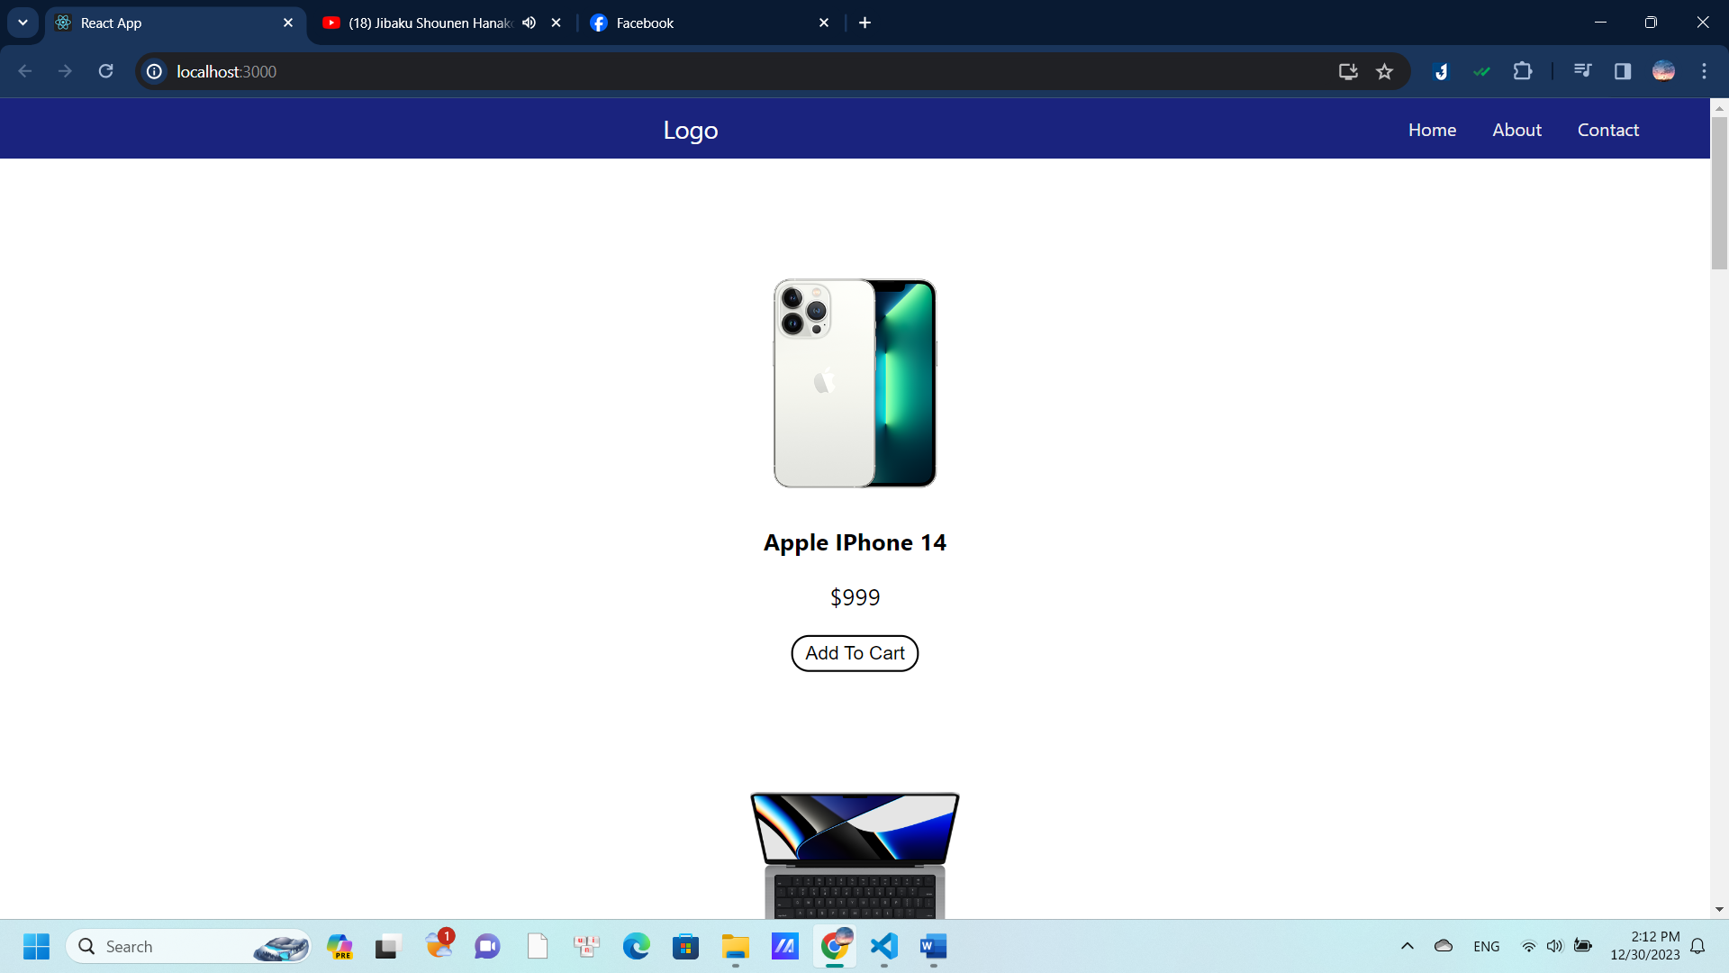

Grid

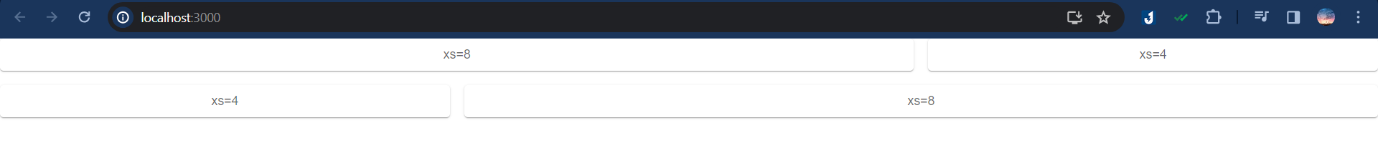

Pagination

Convertpage

Create message app

