Phạm Hà Minh Quyên – 20521824

Link: https://github.com/MinhQuyennn/mobileapplication_lab1

Exercise

Ex1

Ex2

Ex3

Ex4

Ex5

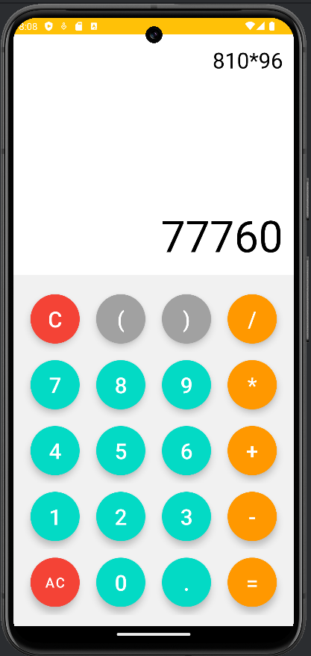

Homework

HW1

HW2

HW3

