Link: https://github.com/MinhQuyennn/mobileapplication_lab2

Ex1

Ex2

Ex3

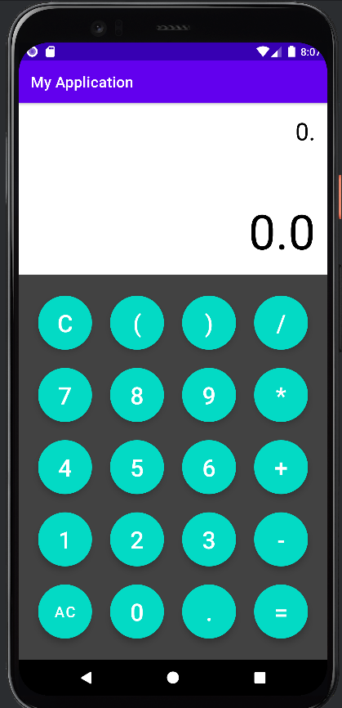

Ex4

Ex5

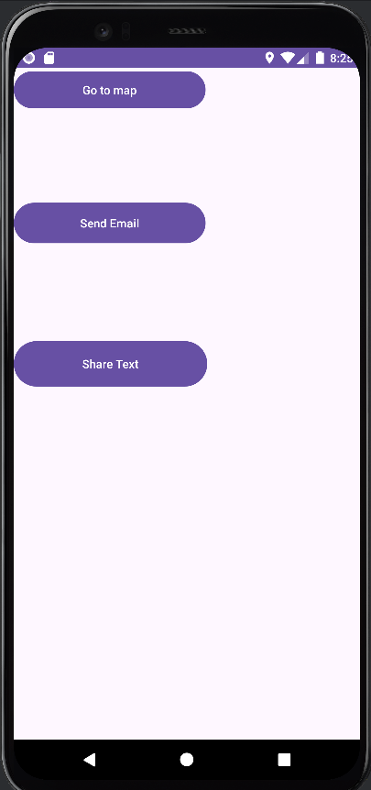

HW

