Development WebCode

Solution Design Document

|  |  |  |  |
| --- | --- | --- | --- |
| **Document filename:** | Development Webcode  Solution Design Document(SDD) | | |
| **Issue date:** | 26-November-2016 | | |
| **Version:** | 1 |  |  |
|  |  | | |

# Approval

|  |  |  |
| --- | --- | --- |
| **Approver** | **Approved** | **Approval Date** |
| **Project Manager:** |  |  |
| **Project Sponsor:** |  |  |
| **Lead BA:** |  |  |
| **Technical Lead:** |  |  |
| **Solutions Lead:** |  |  |
|  |  |  |

# Document History

|  |  |  |  |
| --- | --- | --- | --- |
| Version | Responsible | Date | Notes |
| Version 1.0 | Minh | 06-March-2016 | Initial Solution Design Database |
| *** End of Revision List *** | | | |

Table of Contents

Approval 2

Document History 3

1 Introduction 4

1.1 Background 4

1.2 Document Purpose 4

1.3 Scope 4

1.3.1 In scope 4

1.3.2 Not in scope 4

1.4 Definitions, acronyms and abbreviations 4

1.5 References 5

1.6 Issues and Assumptions 6

2 SSD WebSite Sourcecode Structure 7

2.1 Structure Solution Sourcecode Management Map 7

2.2 Technology Building Website 7

2.2.1 Overview 7

2.3 Structure Bsportproject Solution 7

3 . Development Process data in Project Solution 11

3.1. Overview 11

3.2. Process flow 11

4 Architecture 12

4.1 Overview 12

4.1.1 Metadata Architecture 12

Appendix A – Implementation Strategy 13

# Introduction

## Background

This document will initial concept and Structure SourceCode MVC Asp.Net for the requirements to design solution Web BSportTeam. The BSportProject is the central sourcecode for developing application web.

* BSportTeam for Booking Team football

The SSD will has the capability to analyse and clarify clearly requirements development Database adapt as solution design central database for application web.

In SSD, I only record solution design to be updated until present. For development in future, this document will be updated to the latest solution .

## Document Purpose

This document will identify the requirements specific to in scope follow version development BSportProject.

## Scope

### In scope

Account Management

Team’sport Management Activities

Website Operation

### Not in scope

Account Host Management

## Definitions, acronyms and abbreviations

|  |  |
| --- | --- |
| Term | Definition |
| BSportProject | BsportProject Solution Sourcecode |
| SDD | Solution Design Database |
|  |  |
|  |  |

## References

| Document | Location |
| --- | --- |
|  |  |

## Issues and Assumptions

|  |  |
| --- | --- |
| Item | Description |
|  |  |
|  |  |

# SSD WebSite Sourcecode Structure

## Structure Solution Sourcecode Management Map

## Technology Building Website

### Overview

The application will implement a claims based on Microsoft ASP.Net MVC 5 version Visual Studio 2013. Model Structure DB is Entity Model Database. AngularJS is used as one of technology development

## Structure Bsportproject Solution

**Diagram:**

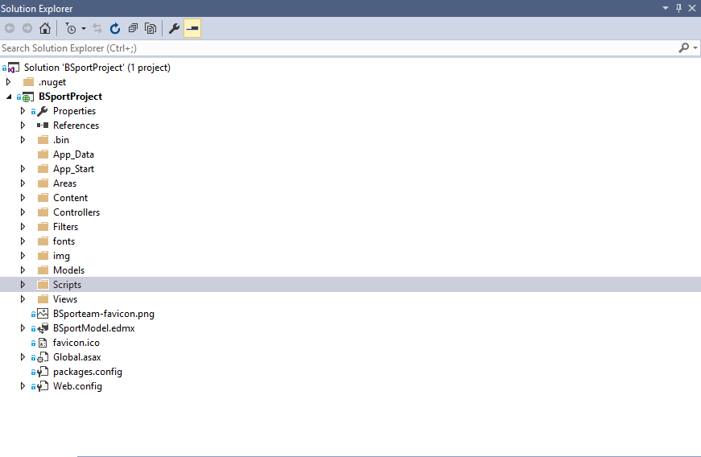

2.3.1. NutGet Folder

This Folder will be used to get package to be used development in this solution

2.3.2. App_Start

This Folder is stored Class Code configuration loading when App start on Browser Web

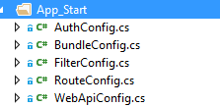

2.3.3. Areas Folder

This Folder is used to group Function will be built up in Websie

e.x. In website, Search Function will be a areas in Website

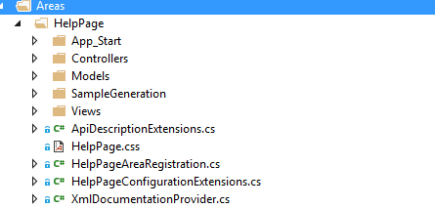

2.3.4. Content Folder

This Folder is used to store Css, Image ( Bootstrap, Style, Site…)

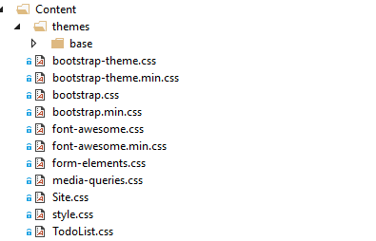

2.3.5. Controllers Folder

This Folder contains Controller Code will be processed function of object in Website ( Account, Home etc) at server

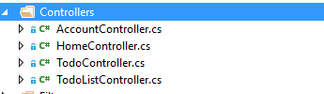

2.3.6. Filtter Folder

This Folder contains Codes to solve function about Filter to support Searching in Website



2.3.7.Model Folder

This folder contains context model Database or Model Layer protocol Data

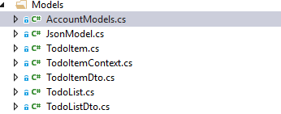

2.3.8.Scipts Folder

This Folders contains Script Angularjs or Javascript will be processed at Client

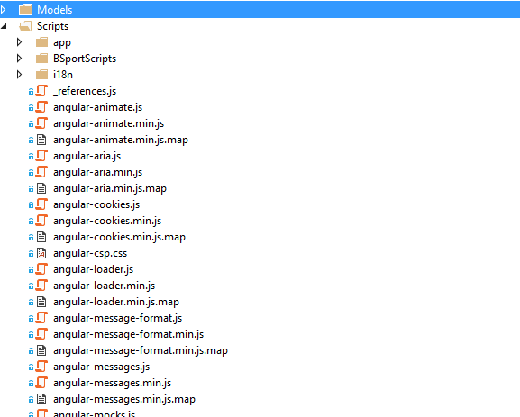

2.3.9. Views

This Folder contains UI development to Display result of app to user and directly interact with User . In this folder, will be held child group folder and each folder will represent Group UI, will be built for object in Website ( Account , Home etc). But especially, in this Views folder have Shared folder and in this shared folder contains Master UI , it will be used by all other views .

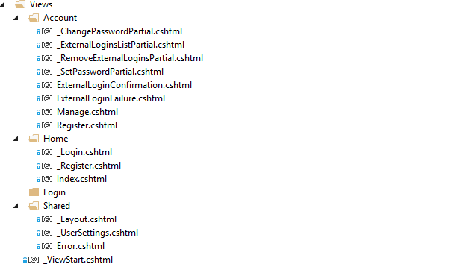

2.3.10. Webconfig

This file stores all config for this website



# . Development Process data in Project Solution

### 3.1. Overview

### 3.2. Process flow

# Architecture

## Overview

The development Structure Database will use the metadata tool to build structure object in DB .

### Metadata Architecture

# Appendix A – Implementation Strategy

**Deployment Servers**

**Local**

-TBC-

**Local.\PROD**

-TBC-

**TFS**

-TBC-

**Tuan environment**