BSPortTeam

**Use Case Description**

Version 0.1

18 February 2017

RECORD OF CHANGE

History of Amendments

|  |  |  |  |  |
| --- | --- | --- | --- | --- |
| **Date** | **Version** | **Modified Section** | **Summary of Change** | **Author** |
| 14/02/2017 | 0.1 | All | Initial version | Linh.H |
|  |  |  |  |  |
|  |  |  |  |  |
|  |  |  |  |  |
|  |  |  |  |  |
|  |  |  |  |  |
|  |  |  |  |  |
|  |  |  |  |  |
|  |  |  |  |  |

Table of Contents

1 Overview 4

1.1 Goal 4

1.2 Brief Description 4

2 Preconditions 4

3 Postconditions 4

4 Flow of Events 5

4.1 Basic Flow – Create new Team 5

4.2 Alternative Flow – Block/Unblock team 5

4.3 Alternative Flow – Update Team 5

4.4 Alternative Flow: View Team Daily Activities 6

4.5 Alternative Flow: Share your team activity 6

4.6 Alternative Flow: Create Team Booking 6

4.7 Alternative Flow – Invite/Release members to team 7

4.8 Alternative Flow – Duplicate Team 7

4.9 Alternative Flow – Accept Invitation 7

4.10 Alternative Flow – Reject Invitation 8

5 Screenshots 8

5.1 Screen: List of teams – Owner view 8

5.2 Screen: List of teams – Member view 10

5.3 Screen: Create new Team 11

5.4 Screen: Update Team 13

5.5 Screen: Team Daily Activities 15

5.6 Screen: Team Members 16

5.7 Screen: Team Booking 17

5.8 Pop up: Create Team Booking 18

6 Business Rules 19

6.1 Team Management 19

7 Assumptions 20

# Overview

## Goal

As the user in BSportTeam System, the user wants to create/ manage Team to BSportTeam system.

## Brief Description

This use case describes how a user can login to BSportTeam system on Web Application

|  |  |
| --- | --- |
| **Actor** | **Description** |
| User | To work on Account Team |

# Preconditions

* Actor has successfully accessed the BSportTeam system.

# Postconditions

* Actor has successfully logged into the system.

# Flow of Events

## Basic Flow – Create new booking

| Step | Event Description |
| --- | --- |
|  | Actor clicks on Booking tab on the menu |
|  | System shows **Screen: Account Booking** |
|  | Actor clicks on Schedule a game sport link |
|  | System shows **Pop up: Create Team Booking** |
|  | Actor input information into the form and clicks on Book button |
|  | System validates the input, if there’s no error, system shows notification “<Book Id> just created” |
|  | End Flow |

## Alternative Flow – Cancel booking

| Step | Event Description |
| --- | --- |
|  | Actor clicks on Booking tab on the menu |
|  | System shows **Screen: Account Booking** |
|  | Actor clicks on Cancel |
|  | System shows notification “Team <inputted team name> has been cancelled” |
|  | End Flow |

## Alternative Flow – Edit Booking

| Step | Event Description |
| --- | --- |
|  | Actor clicks on Booking tab on the menu |
|  | System shows **Screen: Account Booking** |
|  | Actor clicks on Edit |
|  | System shows **Pop up: Create Team Booking** |
|  | Actor inputs information into the form and click on Update button |
|  | System validates the input, if there’s no error, system shows notification “Team <inputted team name> has been updated” |
|  | End Flow |

# Screenshots

## Screen: Account Booking

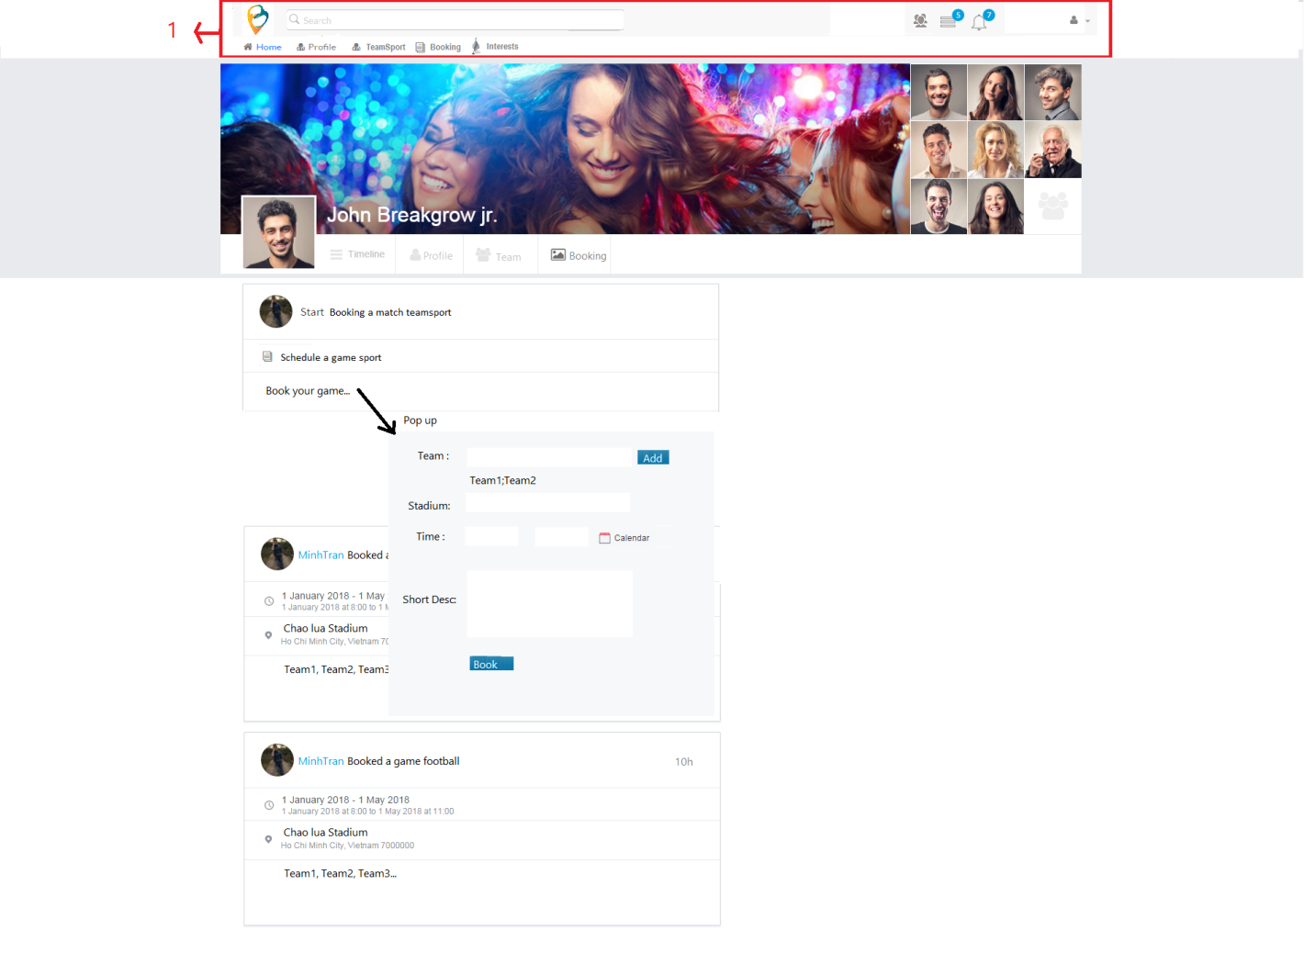

| Field Name | Required | Data Type | Description and Notes |
| --- | --- | --- | --- |
| Schedule a game sport |  | Hyperlink | To redirect to **Pop up: Create Team Booking** |
| Team booking information |  |  | To show booking of logged in user and status of booking. |

## Pop up: Create Team Booking



| Field Name | Required | Data Type | Description and Notes |
| --- | --- | --- | --- |
| Sport | Yes | Dropdown list | To select sport. Load all sport in system |
| Team | Yes | Auto complete | To select team name. Load all teams in system with same as selected sport  Validation   * No duplicate * Allow remove team |
| Stadium | Yes | Dropdown list | To select available stadium. Load stadium under selected sport.  Validation:   * Stadium have available time |
| Time | Yes | Datetime picker | To schedule time. Load by selected Stadium  Validation   * Start time < End time * Looping check in each of available period * Start time >= available start time of stadium * End time <= available end time of stadium * Allow booking for future time and past time if there’s available time in selected stadium |
| Short Desc |  | Text | To enter short description  Validation:   * Maximum is 500 chars |
| Book |  | Button | To proceed booking |

## Screen: Edit/Cancel Booking

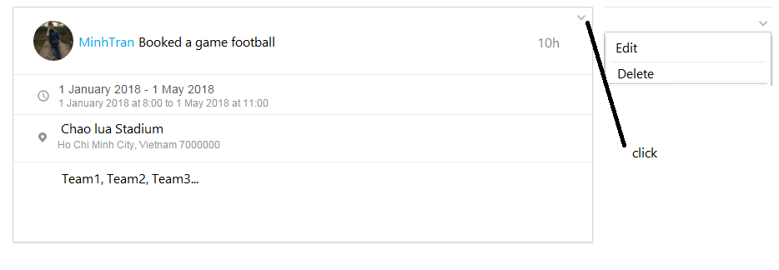

| Field Name | Required | Data Type | Description and Notes |
| --- | --- | --- | --- |
| Cancel |  | Button | To cancel selected booking.  Validation   * Booking is in **New/ Pending** state |
| Edit |  | Button | To redirect to **Pop up: Create Team Booking**  Validation   * Booking is not cancelled yet * Booking is in **New/Pending**  state |

# Business Rules

## Account Booking

| Business Rule ID | Description |
| --- | --- |
| 1 | Booking Status flow: New 🡪Pending🡪Confirmed 🡪 Done   * Event flow: Just created 🡪 Start Time < End Time and Start Time -1 hours <Current Time🡪 Start Time < End Time and Current Time <= Start Time -1 hours 🡪Current Time >= End Time |

## Cancel Booking

| Business Rule ID | Description |
| --- | --- |
| 1 | * When Booking is cancelled, scheduled time will be back to available time of Stadium and allow create new booking in that time |

# Assumptions

| Assumption ID | Description |
| --- | --- |
| 1 |  |