BSPortTeam

**Use Case Description**

Version 0.1

20 May 20177

RECORD OF CHANGE

History of Amendments

|  |  |  |  |  |
| --- | --- | --- | --- | --- |
| **Date** | **Version** | **Modified Section** | **Summary of Change** | **Author** |
| 11/01/2017 | 0.1 | All | Initial version | Linh.H |
|  |  |  |  |  |
|  |  |  |  |  |
|  |  |  |  |  |
|  |  |  |  |  |
|  |  |  |  |  |
|  |  |  |  |  |
|  |  |  |  |  |
|  |  |  |  |  |

Table of Contents

1 Overview 4

1.1 Goal 4

1.2 Brief Description 4

2 Preconditions 4

3 Postconditions 4

4 Flow of Events 5

4.1 Basic Flow – User Login 5

4.2 Alternative Flow – Change Language 5

4.3 Alternative Flow – Reset Password 5

4.4 Alternative Flow – Edit Profile 6

4.5 Alternative Flow – User Logout 6

4.6 Basic Flow – Register 6

4.7 Alternative Flow – Upload Cover Picture 6

5 Screenshots 7

5.1 Screen: Login 7

5.2 Screen: Profile >> Daily Activities 8

5.3 Screen: Reset Password 8

5.4 Screen: Edit Profile 10

5.5 Screen: Register 12

6 Business Rules 13

6.1 User Management 13

7 Assumptions 13

# Overview

## Goal

As the user in BSportTeam System, the user wants to update profile to BSportTeam system, so that user can use the BSportTeam system.

## Brief Description

This use case describes how a user can login to BSportTeam system on Web Application

|  |  |
| --- | --- |
| **Actor** | **Description** |
| User | To use functions in the system |

# Preconditions

* Actor has successfully accessed the BSportTeam system.

# Postconditions

* Actor has successfully logged into the system.

# Flow of Events

## Basic Flow – Edit Account Profile

| Step | Event Description |
| --- | --- |
|  | Actor clicks on Profile tab on the menu in **Screen: Account Main** |
|  | System show  **Profile** |
|  | Actor hover on personal information Area |
|  | System shows text “Edit your profile” link to **: Edit Profile** |
|  | Actors inputs information into the form and clicks on Save button |
|  | System validates the inputs. If there’s no error, system updates new information into db and shows in screen |
|  | System shows notification “Your profile has been updated” |
|  | End Flow |

## Alternative Flow – Add Profile Sport

| Step | Event Description |
| --- | --- |
|  | Actor clicks on Add button on the bottom screen |
|  | System shows **Screen: Add Profile Sport** |
|  | Actors inputs information into the form and clicks on Add button |
|  | System shows notification “New sport has been added” |
|  | End Flow |

## Alternative Flow – Update Profile Sport

| Step | Event Description |
| --- | --- |
|  | Actor clicks on Edit button in the same line of Sport name |
|  | System shows **Screen: Update Profile Sport** |
|  | Actors inputs information into the form and clicks on Save button |
|  | System validates the inputs. If there’s no error, system shows notification “Sport has been updated” |
|  | End Flow |

## Alternative Flow – Upload Cover

| Step | Event Description |
| --- | --- |
|  | Actor clicks on Change Cover button |
|  | System open window to select the image |
|  | Actors select image (.jpeg, .png, .jpg) in the form and clicks on Add button |
|  | System shows notification “Your account has been added” |
|  | End Flow |

## Alternative Flow – Upload Avatar

| Step | Event Description |
| --- | --- |
|  | Actor clicks on Change Avatar button |
|  | System open window to select the image |
|  | Actors select image (.jpeg, .png, .jpg) in the form and clicks on Add button |
|  | System shows notification “Your account has been added” |
|  | End Flow |

## Alternative Flow – Remove Profile Sport

| Step | Event Description |
| --- | --- |
|  | Actor clicks on Remove button in the same line of Sport name |
|  | System validates. If there’s no error, system shows notification “Sport has been removed” |
|  | End Flow |

## Alternative Flow: Setting Profile

| Step | Event Description |
| --- | --- |
|  | Actor clicks on Profile tab on the menu in **Screen: Account Main** |
|  | System show **Account Profile** |
|  | Actor clicks on Edit button |
|  | System shows **Screen: Setting Profile Account** |
|  | Actors inputs information into the form and clicks on Save changes button |
|  | System validates the inputs. If there’s no error, system updates new information into db and shows in screen |
|  | System shows notification “Your profile has been updated” |
|  | End Flow |

# Screenshots

## Screen: Profile

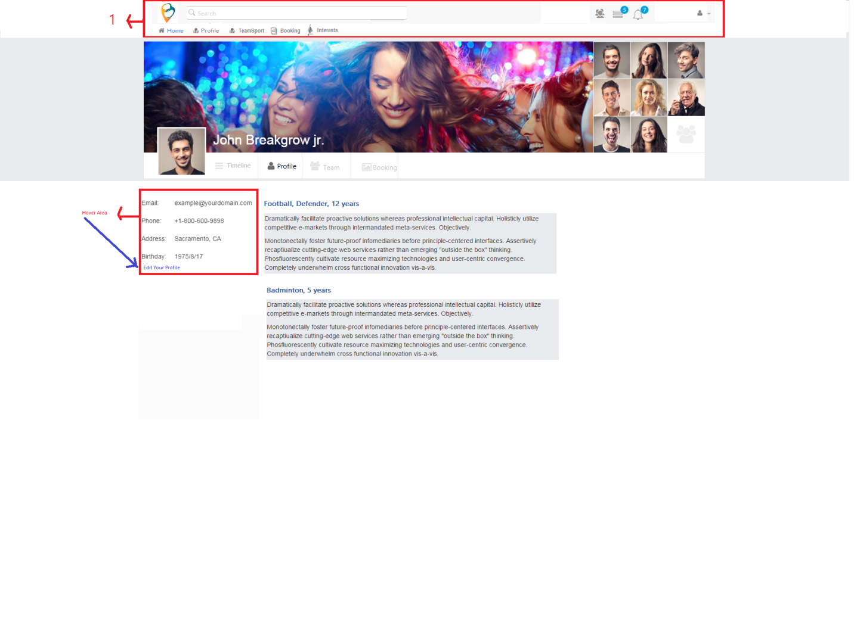

| Field Name | Required | Data Type | Description and Notes |
| --- | --- | --- | --- |
| Full Name | Yes | Text | To show full name. |
| Birthday | Yes | Text | To show birthday |
| Address | Yes | Text | To show address. |
| Email | Yes | Text | To show email address |
| Phone | Yes | Numeric | To show phone number |
| Experience Desc | Yes | Text | To show all experience on sport |

## Screen: Edit Profile

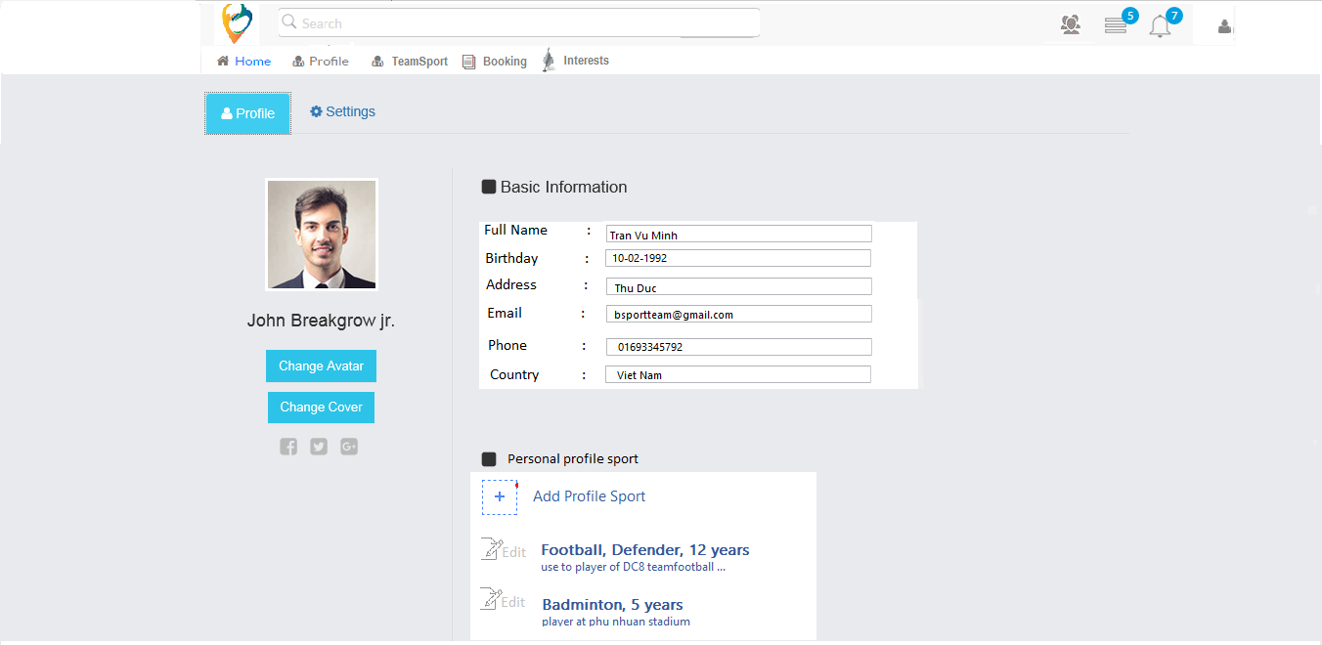

| Field Name | Required | Data Type | Description and Notes |
| --- | --- | --- | --- |
| Full Name | Yes | Text | To input full name.  Validation:   * Max length: 50 chars * Characters only |
| Birthday | Yes | Date time picker | To input birthday  Validation   * Actor must to over 16 years old |
| Address |  | Text | To input address.  Validation:   * Max length: 50 chars * Characters and numeric |
| Email | Yes | Text | To input email address  Validation   * Valid email format |
| Phone | Yes | Numeric | To input phone number  Validation   * Numeric * Max length: 20 |
| Country | Yes | Text | To input country  Validation:   * Max length: 50 * Characters and numeric |
| Save |  | Button | To proceed save data |
| Cancel |  | Button | To terminate close |

## Screen: Setting Profile Account

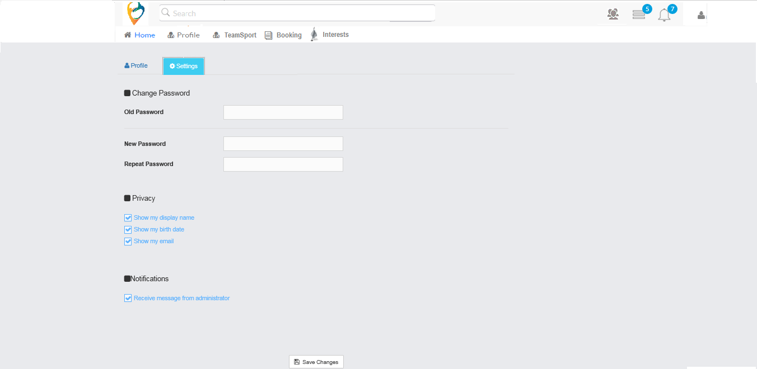

| Field Name | Required | Data Type | Description and Notes |
| --- | --- | --- | --- |
| Old Password | Yes | Text | To enter user’s password.  Validation:   * Same as current password. * If mismatch, show message “Your password is incorrect” |
| New Password | Yes | Text | To enter new password  Validation   * Min length: 8 digits * If not, show message “Incorrect password. Password must be at least 8 digits. Changes will not be saved !!!” |
| Repeat Password | Yes | Text | To confirm new password  Validation   * Min length: 8 digits * Must be the same as new password. Error message if not,“Should be input same as new password. Changes will not be committed !!!” |
| Show my display name |  | Checkbox | To proceed allow to enable user’s full name in his profile and others can see the information. |
| Show my birthday |  | Checkbox | To proceed allow to enable user’s birthday in his profile and others can see the information. |
| Show my email |  | Checkbox | To proceed allow to enable user’s email in his profile and others can see the email. |
| Receive message from administrator |  | Checkbox | To proceed allow to receive message in user’s side via notification |
| Save changes |  | Button | To proceed save all of changes |

## Screen: Add Profile Sport

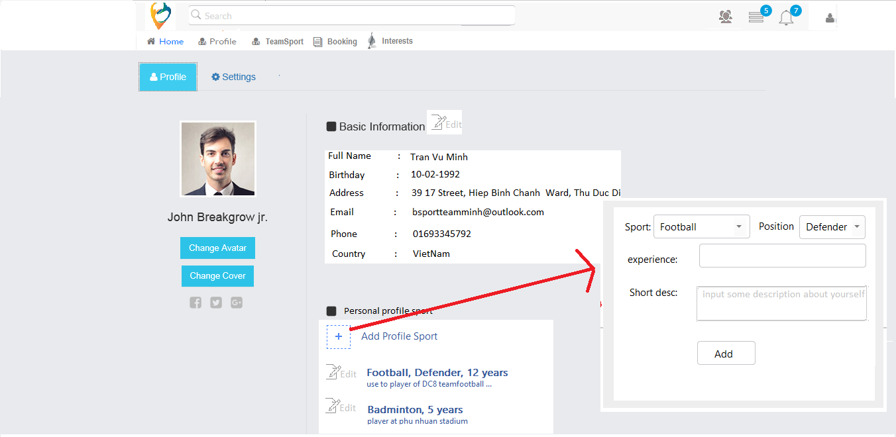

| Field Name | Required | Data Type | Description and Notes |
| --- | --- | --- | --- |
| Sport | Yes | Dropdown list | To select Sport Name  Validation   * Required |
| Position | Yes | Dropdown | To select Position  Validation   * Load depend to selected sport * Required |
| Experience |  | Textbox | To enter Experience  Validation   * Maximum is 500 characters |
| Short Desc |  | Textbox | To enter Short Desc  Validation   * Maximum is 500 characters |
| Add |  | Button | To proceed add new sport |

## Screen: Update Profile Sport

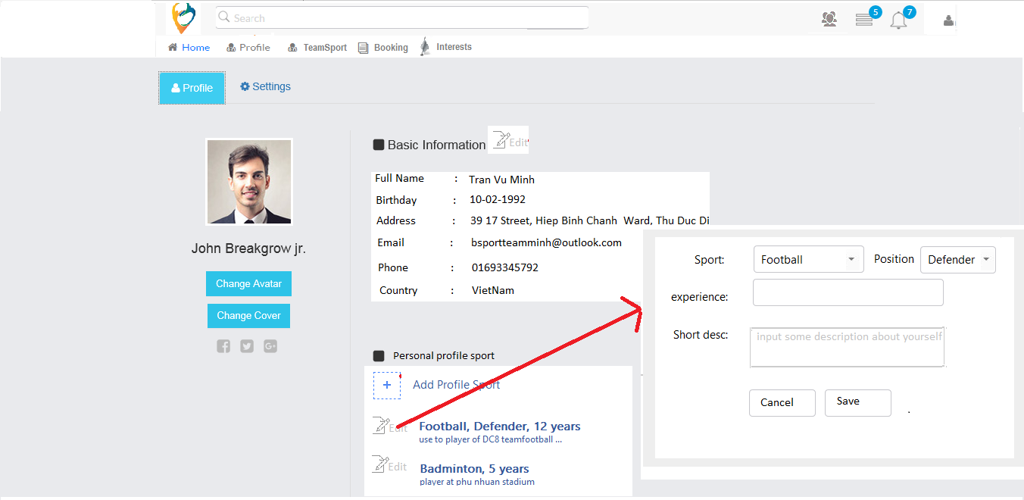

| Field Name | Required | Data Type | Description and Notes |
| --- | --- | --- | --- |
| Sport | Yes | Dropdown list | Disable. To show Sport Name  Validation   * Required |
| Position | Yes | Textbox | To select Position  Validation   * Load depend to selected sport * Required |
| Experience |  | Textbox | To enter Experience  Validation   * Maximum is 500 characters |
| Short Desc |  | Textbox | To enter Short Desc  Validation   * Maximum is 500 characters |
| Save |  | Button | To proceed update sport |
| Cancel |  | Button | To terminate close |

## Screen: Account Main

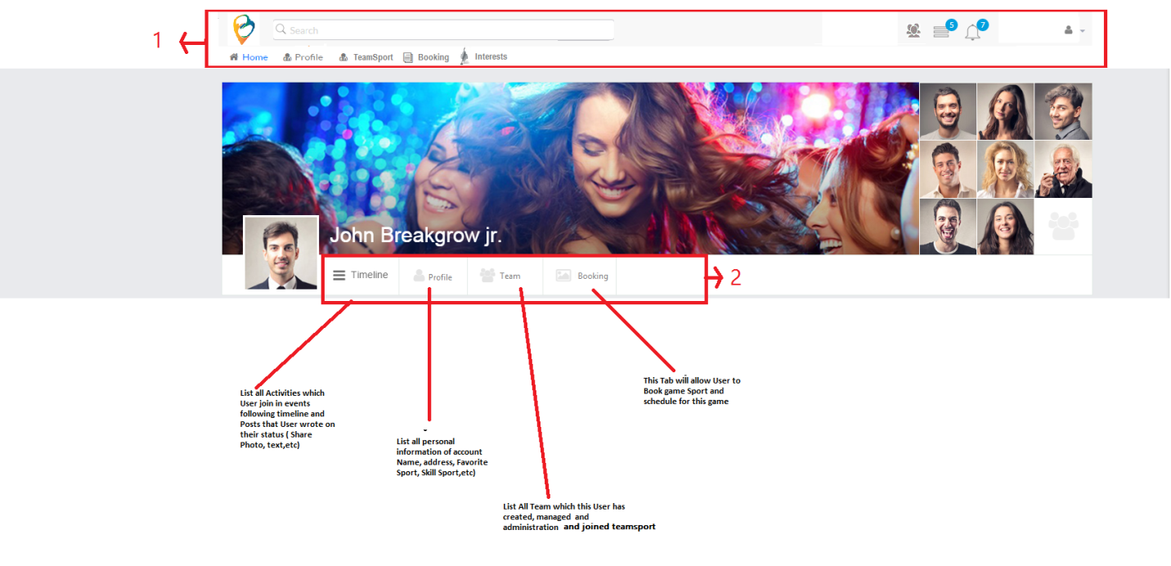

## Screen: Account Timelines

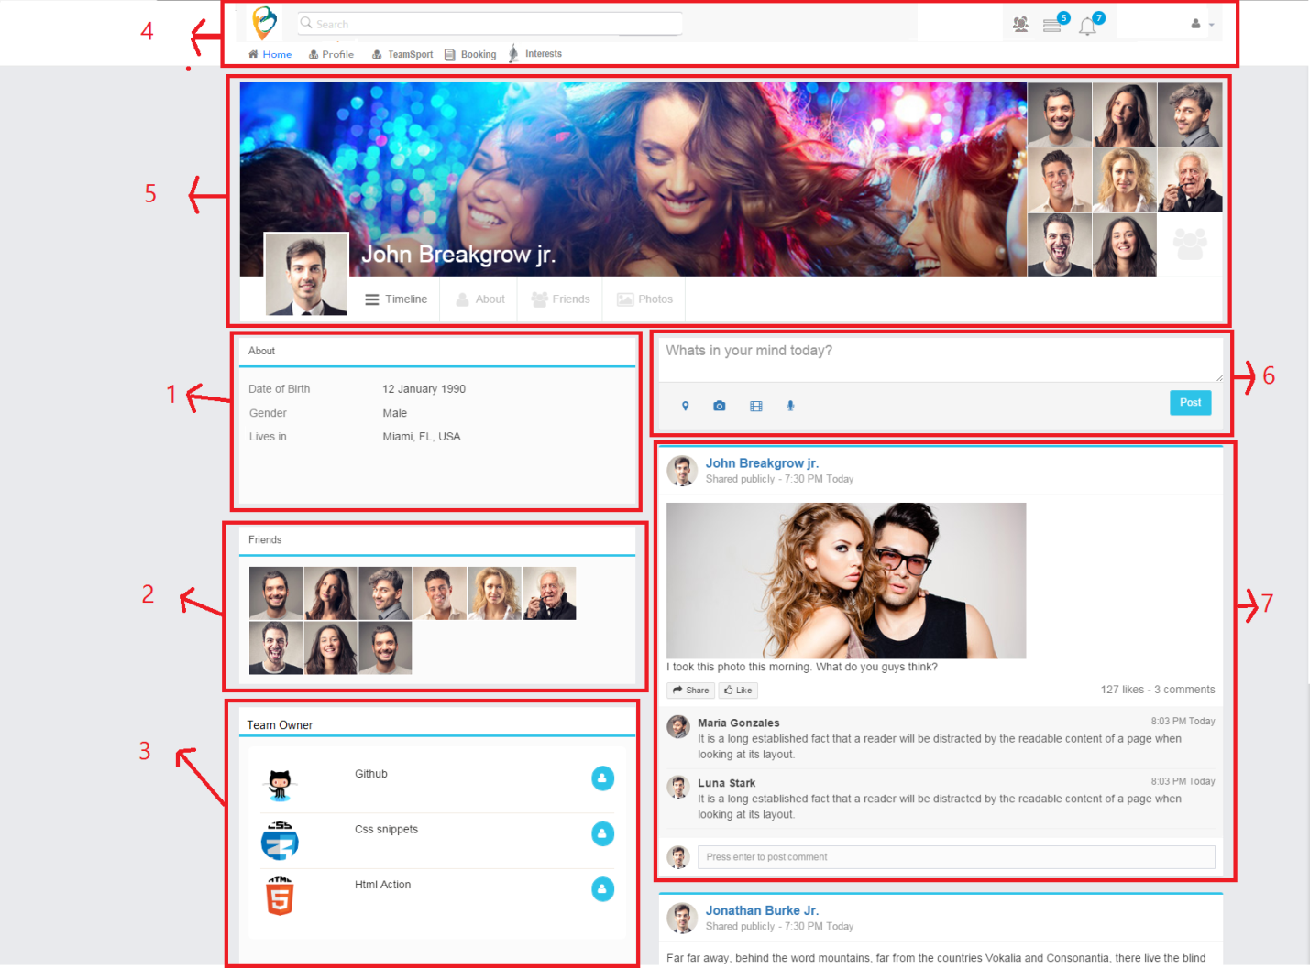

Index 1 : Show personal information as setting account profile

Index 2: show some member of teams

Business rule : not define just temporary random member ( maximum 10 members on this component)

Index 3: Show Teams which this user is owner

Index 4 : header

Index 5 :

* Cover
* Avatar
* Tab content ( Timeline, Profile, Team and Booking ) as describe above

Index 6: temporary not yet define waiting for new update

Index 7 : whole post share activities in any team page which user posted and booked schedule game

# Business Rules

## Team Management

| Business Rule ID | Description |
| --- | --- |
| 1 | * If User is new user, After Creating Account from Register page will be redirected to ~~Account~~ Edit Profile Page ~~and Profile Tab is activated firstly~~ |
| 2 | * If User log in to use account, after logging in from Log in Page will be redirected to Account Profile Page and ~~Daily Activities~~ Timelines Tab is activated firstly |

# Assumptions

| Assumption ID | Description |
| --- | --- |
| 1 |  |