BSPortTeam

**Use Case Description**

Version 0.1

20 May 2017

RECORD OF CHANGE

History of Amendments

|  |  |  |  |  |
| --- | --- | --- | --- | --- |
| **Date** | **Version** | **Modified Section** | **Summary of Change** | **Author** |
| 14/02/2017 | 0.1 | All | Initial version | Linh.H |
|  |  |  |  |  |
|  |  |  |  |  |
|  |  |  |  |  |
|  |  |  |  |  |
|  |  |  |  |  |
|  |  |  |  |  |
|  |  |  |  |  |
|  |  |  |  |  |

Table of Contents

1 Overview 4

1.1 Goal 4

1.2 Brief Description 4

2 Preconditions 4

3 Postconditions 4

4 Flow of Events 5

4.1 Basic Flow – Create new Team 5

4.2 Alternative Flow – Block/Unblock team 5

4.3 Alternative Flow – Update Team 5

4.4 Alternative Flow: View Team Daily Activities 6

4.5 Alternative Flow: Share your team activity 6

4.6 Alternative Flow: Create Team Booking 6

4.7 Alternative Flow – Invite/Release members to team 7

4.8 Alternative Flow – Duplicate Team 7

4.9 Alternative Flow – Accept Invitation 7

4.10 Alternative Flow – Reject Invitation 8

5 Screenshots 8

5.1 Screen: List of teams – Owner view 8

5.2 Screen: List of teams – Member view 10

5.3 Screen: Create new Team 11

5.4 Screen: Update Team 13

5.5 Screen: Team Daily Activities 15

5.6 Screen: Team Members 16

5.7 Screen: Team Booking 17

5.8 Pop up: Create Team Booking 18

6 Business Rules 19

6.1 Team Management 19

7 Assumptions 20

# Overview

## Goal

As the user in BSportTeam System, the user wants to create/ manage Team to BSportTeam system.

## Brief Description

This use case describes how a user can login to BSportTeam system on Web Application

|  |  |
| --- | --- |
| **Actor** | **Description** |
| User | To work on Account Team |

# Preconditions

* Actor has successfully accessed the BSportTeam system.

# Postconditions

* Actor has successfully logged into the system.

# Flow of Events

## Basic Flow – Create new Team

| Step | Event Description |
| --- | --- |
|  | Actor clicks on Team tab on the menu |
|  | System shows **Screen: List of teams** |
|  | Actor clicks on Create Team button |
|  | System shows **Screen: Create new Team** |
|  | Actors inputs information into the form and clicks on Create Team button |
|  | System validates the inputs. If there’s no error, System shows notification “Team <inputted team name> has been created” and redirect to **Screen: Team Timelines** |
|  | End Flow |

## Alternative Flow: View Team Timelines

| Step | Event Description |
| --- | --- |
|  | Actor clicks on Team tab on the menu |
|  | System shows **Screen: List of teams** |
|  | Actor selects team and clicks on hyperlink Team name |
|  | System shows **Screen: Team Timelines** |
|  | End Flow |

# Screenshots

## Screen: List of teams

When User click on Team Tab, this Tab will allow user to create Team and display all Teams which User created and managed. Concurrently , this tab also show up TeamSport which User joined

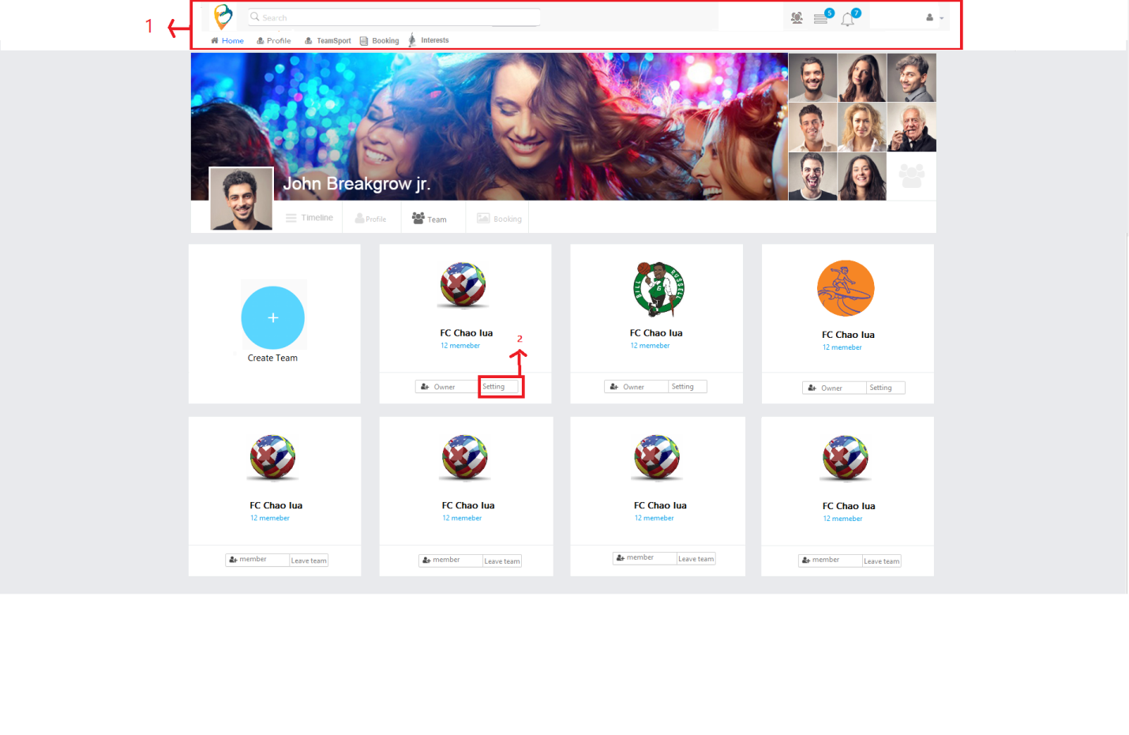

| Field Name | Required | Data Type | Description and Notes |
| --- | --- | --- | --- |
| Create Team |  | Button | To redirect to **Screen: Create new Team** |
| Team Name |  | Hyperlink | Show Team Name.  To redirect to **Screen: Update Team**  Validation   * Team is unblocked * Team owner is logged in user * Highlight when hover mouse on team name as Blue |
| Member numbers |  | Hyperlink | Show as Accepted members/Invited members.  To redirect to **Screen: Team Members**  Show all members (invited members) under selected team. |
| Your position in team |  | Text | Member of Owner |
| Leave team |  | Button | To proceed unjoin selected team, just show incase you are a member |
| Setting |  | Button | To proceed setting selected team, just show incase you are an owner |

## Screen: Create new Team

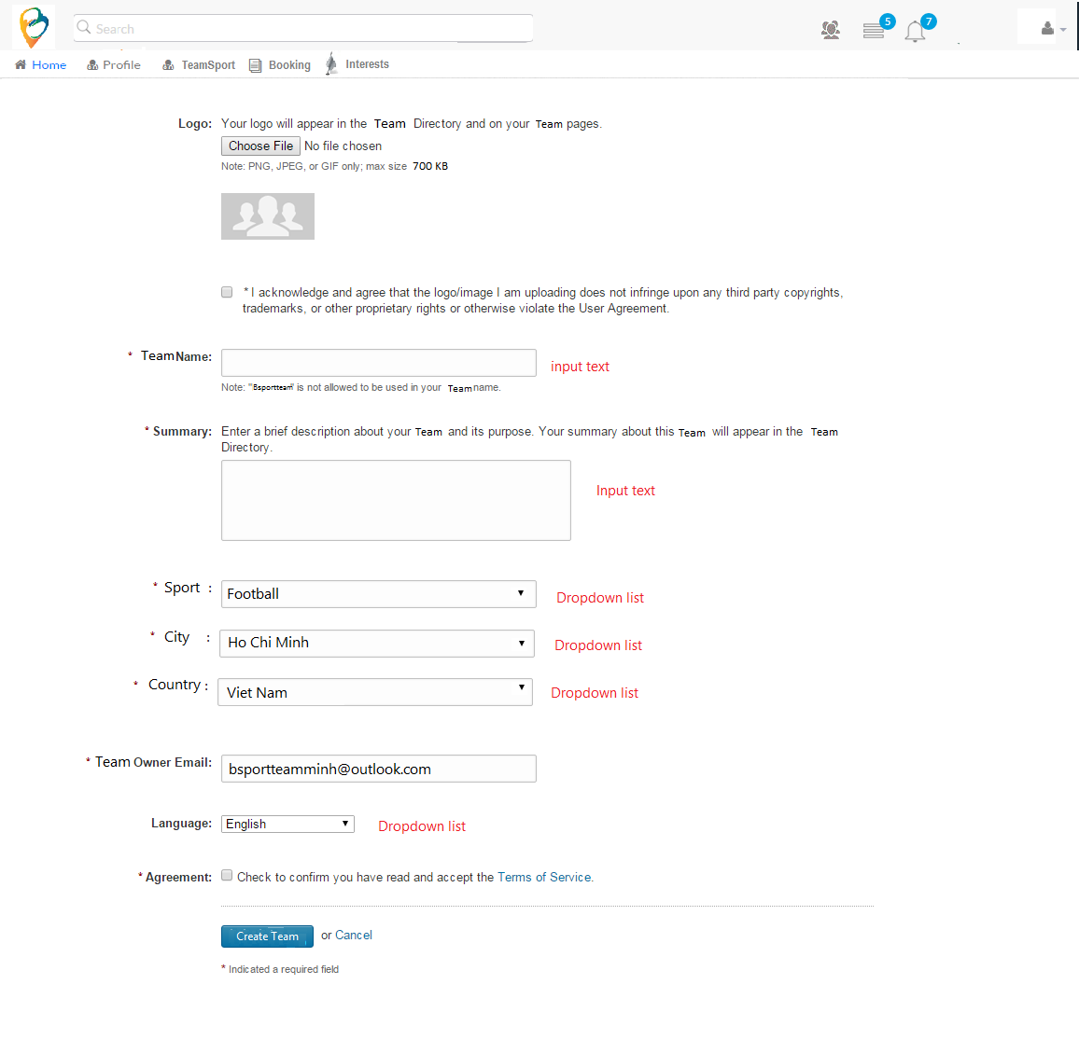

| Field Name | Required | Data Type | Description and Notes |
| --- | --- | --- | --- |
| Logo |  | Button | To upload Logo image  Validation   * PNG, JPEG, GIF * Max size 700GB |
| Team Name | Yes | Textbox | To enter Team Name  Validation   * Cannot duplicate team name under logged in user * Cannot input special characters * Maximum is 200 characters |
| Summary | Yes | Textbox | To enter Summary  Validation   * Maximum is 500 characters |
| Country | Yes | Dropdown list | To select country. Default is country of logged in user |
| Team Owner Email | Yes | Textbox | Auto filled email of logged in user. |
| Language |  | Dropdown list | To select language. Default is English |
| Agreement | Yes | Check box | To confirm before creating  Validation   * If user checks, enable Create Team button * If user unchecks, disable Create Team button |
| Create Team |  | Button | To redirect to **Screen: Team Members**  Validation   * All required fields is inputted |
| Cancel |  | Button | To cancel flow |

## Screen: Team Timelines

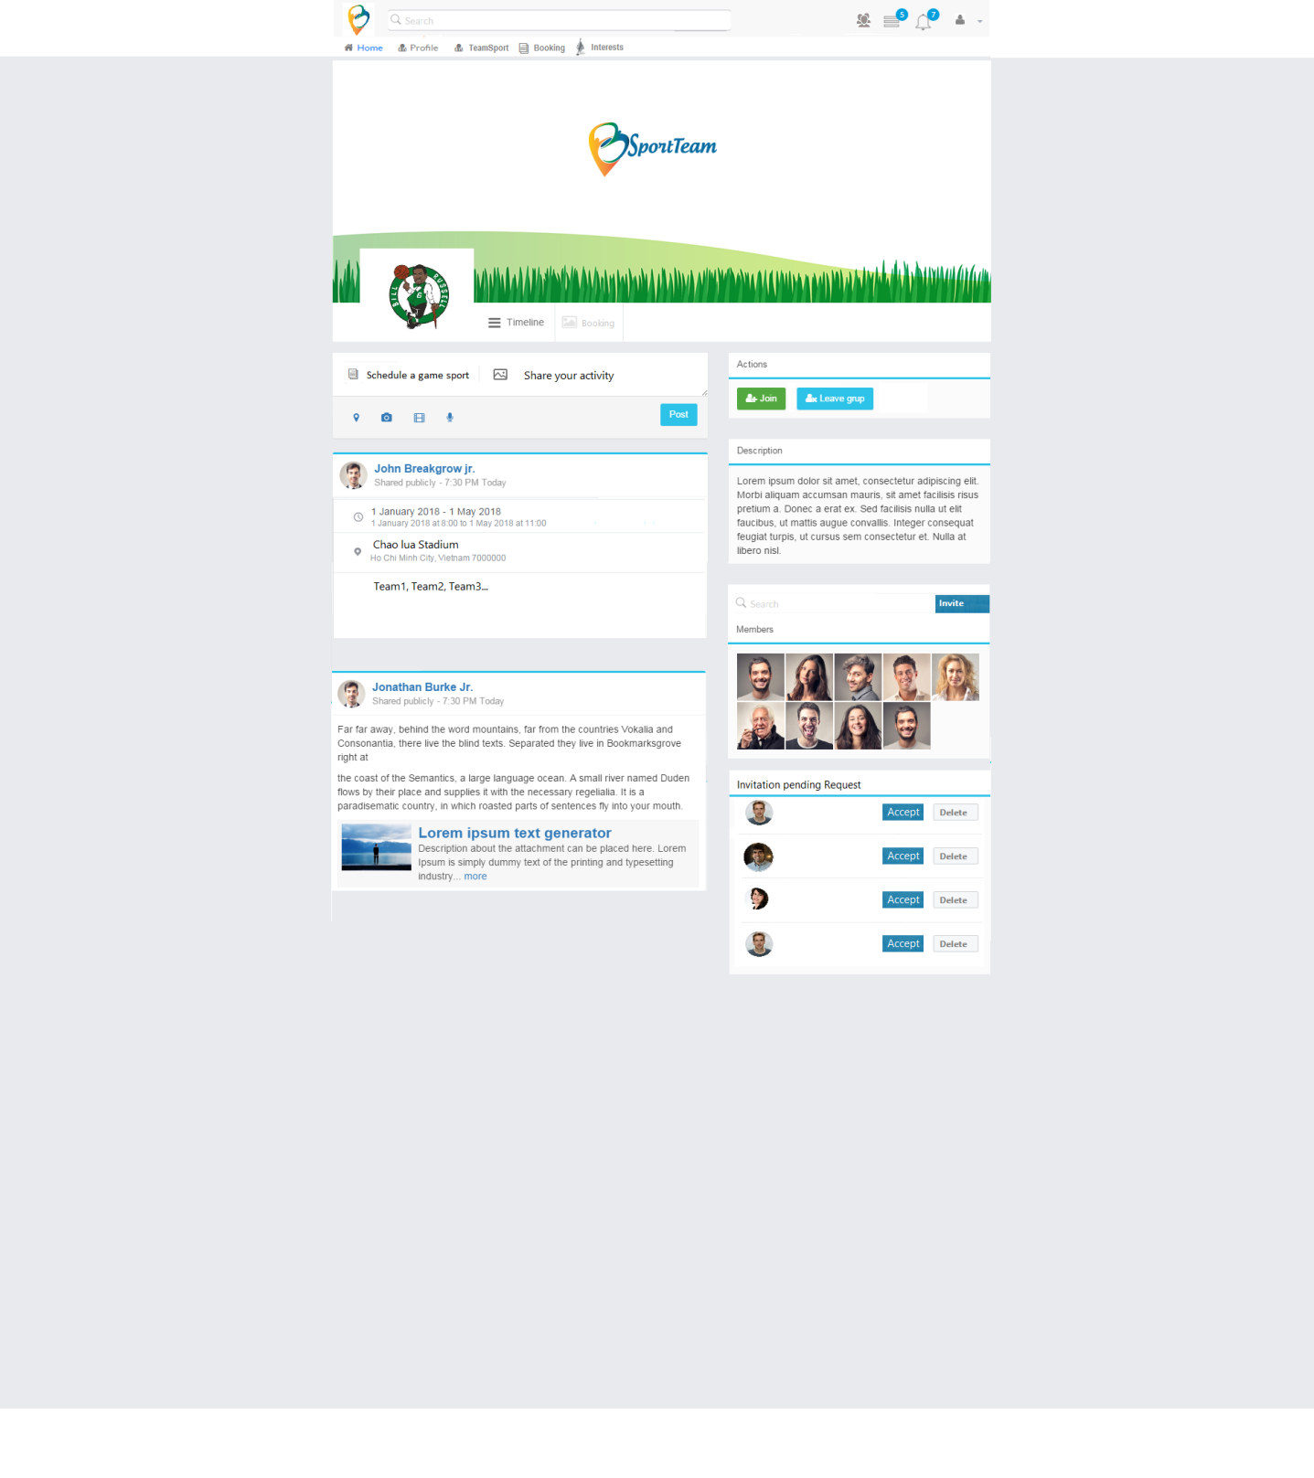

# Business Rules

## Account Team

| Business Rule ID | Description |
| --- | --- |
| 1 | Team Status flow: New 🡪 Forming 🡪 Ready to book   * Event flow: Just created (no one available) 🡪 Someone accepted invitation/Someone interrupt to release🡪 All invited members accepted and Team ready for booking |

## Team Booking

| Business Rule ID | Description |
| --- | --- |
| 1 | Booking Status flow: New 🡪Pending🡪Confirmed 🡪 Done   * Event flow: Just created 🡪 Start Time < End Time and Start Time -1 hours <Current Time🡪 Start Time < End Time and Current Time <= Start Time -1 hours 🡪Current Time >= End Time |

# Assumptions

| Assumption ID | Description |
| --- | --- |
| 1 |  |