BSPortTeam

**Use Case Description**

Version 0.1

13 January 2017

RECORD OF CHANGE

History of Amendments

|  |  |  |  |  |
| --- | --- | --- | --- | --- |
| **Date** | **Version** | **Modified Section** | **Summary of Change** | **Author** |
| 12/01/2017 | 0.1 | All | Initial version | Linh.H |
|  |  |  |  |  |
|  |  |  |  |  |
|  |  |  |  |  |
|  |  |  |  |  |
|  |  |  |  |  |
|  |  |  |  |  |
|  |  |  |  |  |
|  |  |  |  |  |

Table of Contents

1 Overview 4

1.1 Goal 4

1.2 Brief Description 4

2 Preconditions 4

3 Postconditions 4

4 Flow of Events 5

4.1 Basic Flow – User Login 5

4.2 Alternative Flow – Change Language 5

4.3 Alternative Flow – Reset Password 5

4.4 Alternative Flow – Edit Profile 6

4.5 Alternative Flow – User Logout 6

4.6 Basic Flow – Register 6

4.7 Alternative Flow – Upload Cover Picture 6

5 Screenshots 7

5.1 Screen: Login 7

5.2 Screen: Profile >> Daily Activities 8

5.3 Screen: Reset Password 8

5.4 Screen: Edit Profile 10

5.5 Screen: Register 12

6 Business Rules 13

6.1 User Management 13

7 Assumptions 13

# Overview

## Goal

As the user in BSportTeam System, the user wants to search Sport/Stadium in BSportTeam system.

## Brief Description

This use case describes how a user can work on BSportTeam system on Web Application

|  |  |
| --- | --- |
| **Actor** | **Description** |
| User | To use functions in the system |

# Preconditions

* Actor has successfully accessed the BSportTeam system.

# Postconditions

* Actor has successfully logged into the system.

# Flow of Events

## Basic Flow – FAQ

**Trigger**:

* Actor selects FAQ on the left side menu

| Step | Event Description |
| --- | --- |
|  | System shows **Screen: FAQ** with all of question in system |
|  | End Flow |

## Basic Flow – Search Sports

**Trigger**:

* Actor selects Sports on the left side menu

| Step | Event Description |
| --- | --- |
|  | System shows **Screen: Sports** |
|  | System shows all Sport in the system |
|  | End Flow |

## Basic Flow – Search Stadiums

**Trigger**:

* Actor selects Stadiums on the left side menu

| Step | Event Description |
| --- | --- |
| 1. | System shows **Screen: Stadiums** |
| 3. | System shows all Sport with User’s Country and City |
| 4. | End Flow |

# Screenshots

## Screen: Info Page

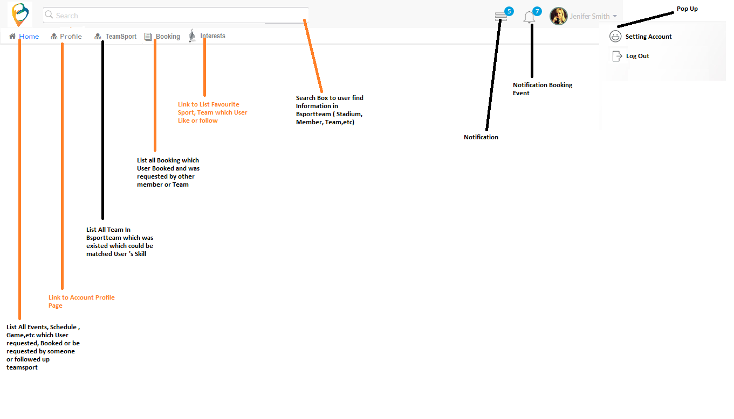

| Field Name | Required | Data Type | Description and Notes |
| --- | --- | --- | --- |
| Search |  | Textbox | To search all information in BSportTeam system such as Stadium, Member, Team…  Validate:   * Maximum: 100 characters * Accept text and numeric only * Press “Enter” to start finding |
| Notification |  |  | To receive notification from system when inviting/confirming join in team |
| Notification booking event |  |  | To receive notification from system when booking |
| Setting Account |  |  | Direct to Screen: Profile >> Profile |
| Log out |  |  | To log out. |
| Home |  |  | To list out all events, scheduled, game which user requested, booked |
| Profile |  |  | Direct to Screen: Profile |
| Team Sport |  |  | To list out /suggest all team in system which matched to user’s skill |
| Booking |  |  | To list out all Booking which booked by user or others members |
| Interests |  |  | To list out favorite sports, team which user follows |

## Screen: Left menu

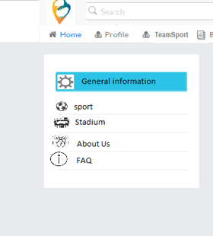

## Screen: Footer

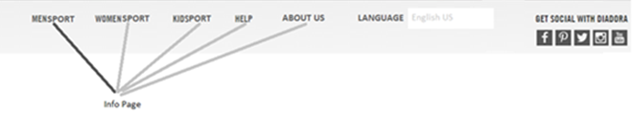

* Click on MENSPORT open new tab page and show up Info Page Portal with filtering sport for men
* Click on WOMENSPORT open new tab page and show up Info Page Portal with filtering sport for Women
* Click on KIDSPORT open new tab page and show up Info Page Portal with filtering sport for kids
* Click on HELP open new tab page and show up Info Page Portal
* Click on ABOUT US open new tab page and show up Info Page Portal with filtering sport for men

## Screen: Sports

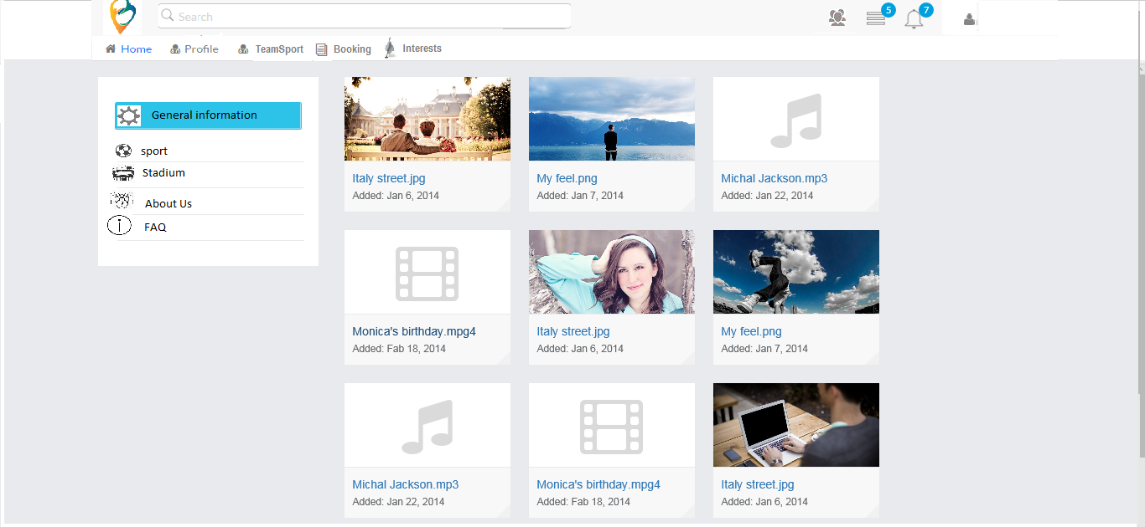

## Screen: Stadiums



| Field Name | Required | Data Type | Description and Notes |
| --- | --- | --- | --- |
| Result list |  | View | The result will be displayed, is all Stadium which Stadium joined in Bsportteam. It contains name of sport and Image for this stadium. When User click on stadium, Pop up will be displayed and show information detail about Stadium ( template not yet defined ) |

## Screen: FAQ

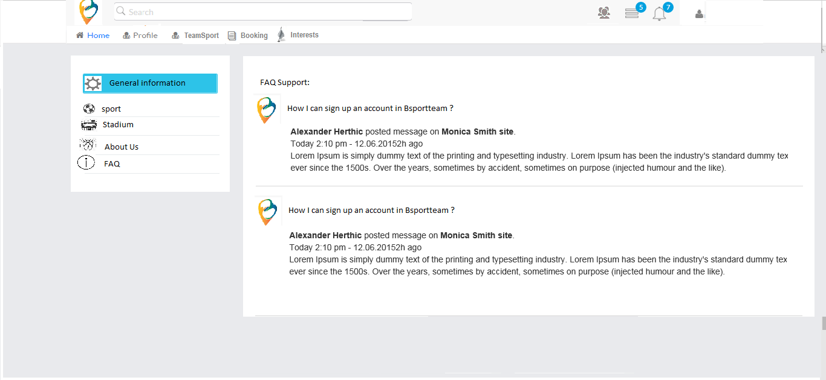

| Field Name | Required | Data Type | Description and Notes |
| --- | --- | --- | --- |
| Question view |  | Text | To show question list |
| Answer view |  | Text | To show answer list |

# Business Rules

| Business ID | Description |
| --- | --- |
| 1 | Header: We don’t show avatar of user on header. It just be icon and user click and then pop up be showed up Edit profile and sign out. When user click on Edit Profile 🡪 redirect to Screen: Edit Profile page and click on sign out 🡪 redirect to sign in and register page |

# Assumptions

| Assumption ID | Description |
| --- | --- |
| 1 |  |