BSPortTeam

**Use Case Description**

Version 0.1

20 May 20177

RECORD OF CHANGE

History of Amendments

|  |  |  |  |  |
| --- | --- | --- | --- | --- |
| **Date** | **Version** | **Modified Section** | **Summary of Change** | **Author** |
| 11/01/2017 | 0.1 | All | Initial version | Linh.H |
|  |  |  |  |  |
|  |  |  |  |  |
|  |  |  |  |  |
|  |  |  |  |  |
|  |  |  |  |  |
|  |  |  |  |  |
|  |  |  |  |  |
|  |  |  |  |  |

Table of Contents

1 Overview 4

1.1 Goal 4

1.2 Brief Description 4

2 Preconditions 4

3 Postconditions 4

4 Flow of Events 5

4.1 Basic Flow – User Login 5

4.2 Alternative Flow – Change Language 5

4.3 Alternative Flow – Reset Password 5

4.4 Alternative Flow – Edit Profile 6

4.5 Alternative Flow – User Logout 6

4.6 Basic Flow – Register 6

4.7 Alternative Flow – Upload Cover Picture 6

5 Screenshots 7

5.1 Screen: Login 7

5.2 Screen: Profile >> Daily Activities 8

5.3 Screen: Reset Password 8

5.4 Screen: Edit Profile 10

5.5 Screen: Register 12

6 Business Rules 13

6.1 User Management 13

7 Assumptions 13

# Overview

## Goal

As the user in BSportTeam System, the user wants to login/register to BSportTeam system, so that user can use the BSportTeam system.

## Brief Description

This use case describes how a user can login to BSportTeam system on Web Application

|  |  |
| --- | --- |
| **Actor** | **Description** |
| User | To use functions in the system |

# Preconditions

* Actor has successfully accessed the BSportTeam system.

# Postconditions

* Actor has successfully logged into the system.

# Flow of Events

## Basic Flow – Create new Team

| Step | Event Description |
| --- | --- |
|  | Actor clicks on Team tab on the menu in Account side |
|  | System shows **Screen: List of teams** |
|  | Actor clicks on Create Team button |
|  | System shows **Screen: Create new Team** |
|  | Actors inputs information into the form and clicks on Next button |
|  | System validates the inputs. If there’s no error, system shows **Screen: Team Timelines** |
|  | System shows notification “Team <inputted team name> has been created” |
|  | End Flow |

## Alternative Flow – Schedule a game sport

| Step | Event Description |
| --- | --- |
|  | Actor clicks on Schedule a game sport |
|  | System shows **Screen: Booking popup** |
|  | Actor input information into the form and clicks on Book button |
|  | System validates the input, if there’s no error, system shows notification “<Book Id> just created” |
|  | End Flow |

## Alternative Flow – View Team Booking

| Step | Event Description |
| --- | --- |
| 1. | Actor clicks on Booking tab on the Team menu |
| 2. | System shows **Screen: List of booking** |
| 3. | System shows all of booking in the team |
| 4. | End Flow |

## Alternative Flow: Share Activity Information

| Step | Event Description |
| --- | --- |
|  | The module should be available in Daily Activity and Booking screen as well. |
|  | System shows **Screen: Share Your Activity** |
|  | Actor input information and upload the image |
|  | System shows notification “You has been shared new activity” |
|  | End Flow |

## Alternative Flow – Invite members (owner) to team

| Step | Event Description |
| --- | --- |
|  | Actor input into Search tab and enter in **Screen: Search member** |
|  | System shows the users within condition |
|  | Actor clicks on members and clicks on Invite button |
|  | System shows notification to:   * Admin of team * User which be invited to team |
|  | End Flow |

## Alternative Flow – Invite member to team

| Step | Event Description |
| --- | --- |
|  | Actor input into Search tab and enter in **Screen: Search member** |
|  | System shows the users within condition |
|  | Actor clicks on members and clicks on Invite button |
|  | System shows notification to:   * Send to Admin of team |
|  | Admin “Accept”/”Reject” the request. If Admin accepts the request ,System will send notification to User which is invited, unless don’t send notification |
|  | End Flow |

## Alternative Flow – Release member

| Step | Event Description |
| --- | --- |
|  | Actor clicks on Member link |
|  | System direct to **Screen: List of members – Owner view** |
|  | Actor selects member and clicks on Release icon |
|  | End Flow |

## Alternative Flow – Set as an administrator

| Step | Event Description |
| --- | --- |
|  | Actor clicks on Member link |
|  | System direct to **Screen: List of members – Owner view** |
|  | Actor selects member and clicks on Set as an administrator icon |
|  | System shows notification to:   * User which be admin |
|  | End Flow |

## Alternative Flow – Accept request (Owner view)

| Step | Event Description |
| --- | --- |
|  | Actor clicks on Accept button in the right bottom |
|  | System shows notification to:   * User sent the request |
|  | End Flow |

## Alternative Flow – Reject request (Owner view)

| Step | Event Description |
| --- | --- |
|  | Actor clicks on Delete button in the right bottom |
|  | End Flow |

## Alternative Flow: Send request to Join/Leave Team (Member view)

| Step | Event Description |
| --- | --- |
|  | Actor clicks on Join/ Leave button in the top right |
|  | System shows notification to:   * Admin of team |
|  | End Flow |

# Screenshots

## Screen: List of teams

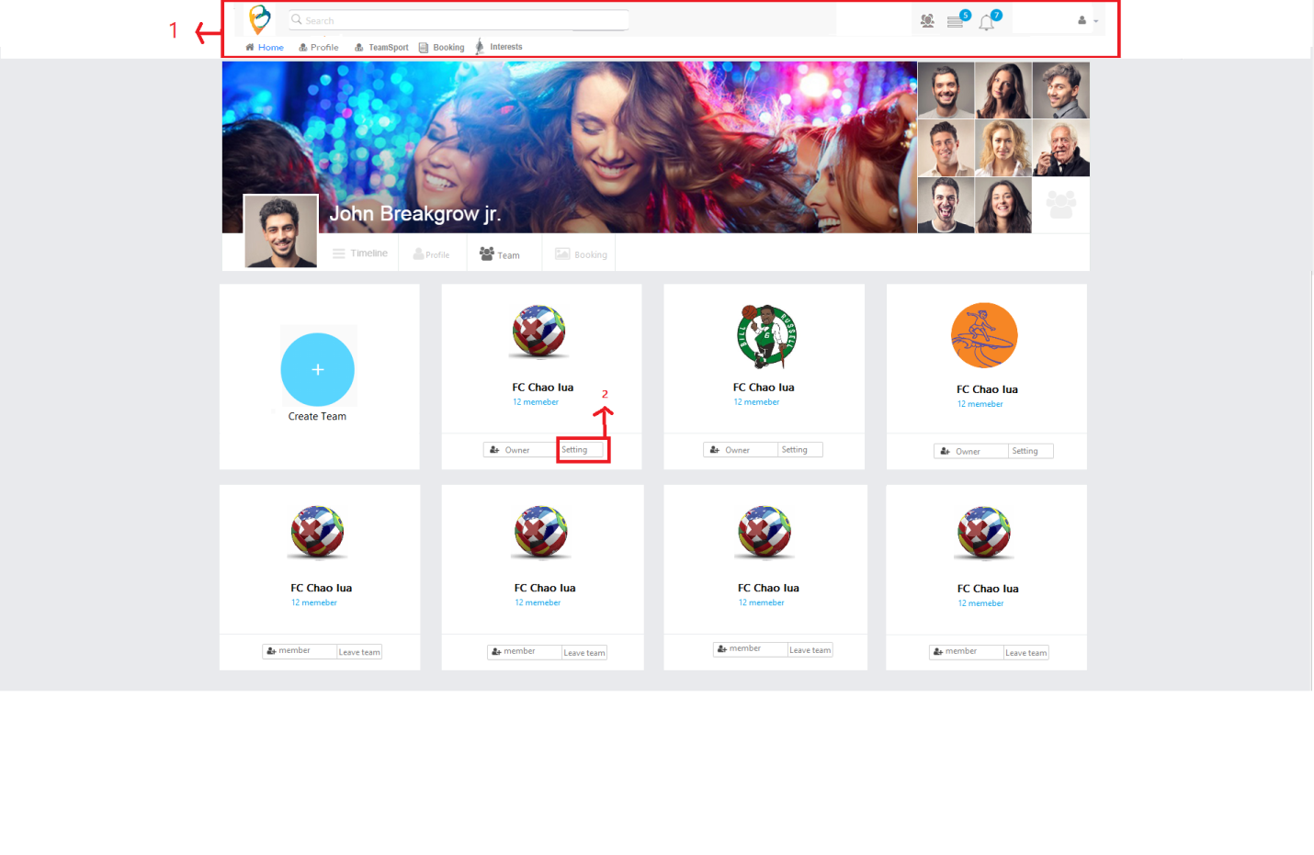

| Field Name | Required | Data Type | Description and Notes |
| --- | --- | --- | --- |
| Create Team |  | Button | To redirect to **Screen: Create new Team** |
| Team Name |  | Hyperlink | Show Team Name.  To redirect to **Screen: Update Team**  Validation   * Team is unblocked * Team owner is logged in user * Highlight when hover mouse on team name as Blue |
| Member numbers |  | Hyperlink | Show as Accepted members/Invited members.  To redirect to **Screen: List of members**  Show all members (invited members) under selected team. |
| Block/Unblock |  | Button | To block or unblock team  Validation   * All Booking under Team is done |
| Duplicate |  | Button | To duplicate selected team  Validation   * Unblocked team |

## Screen: Team Timelines

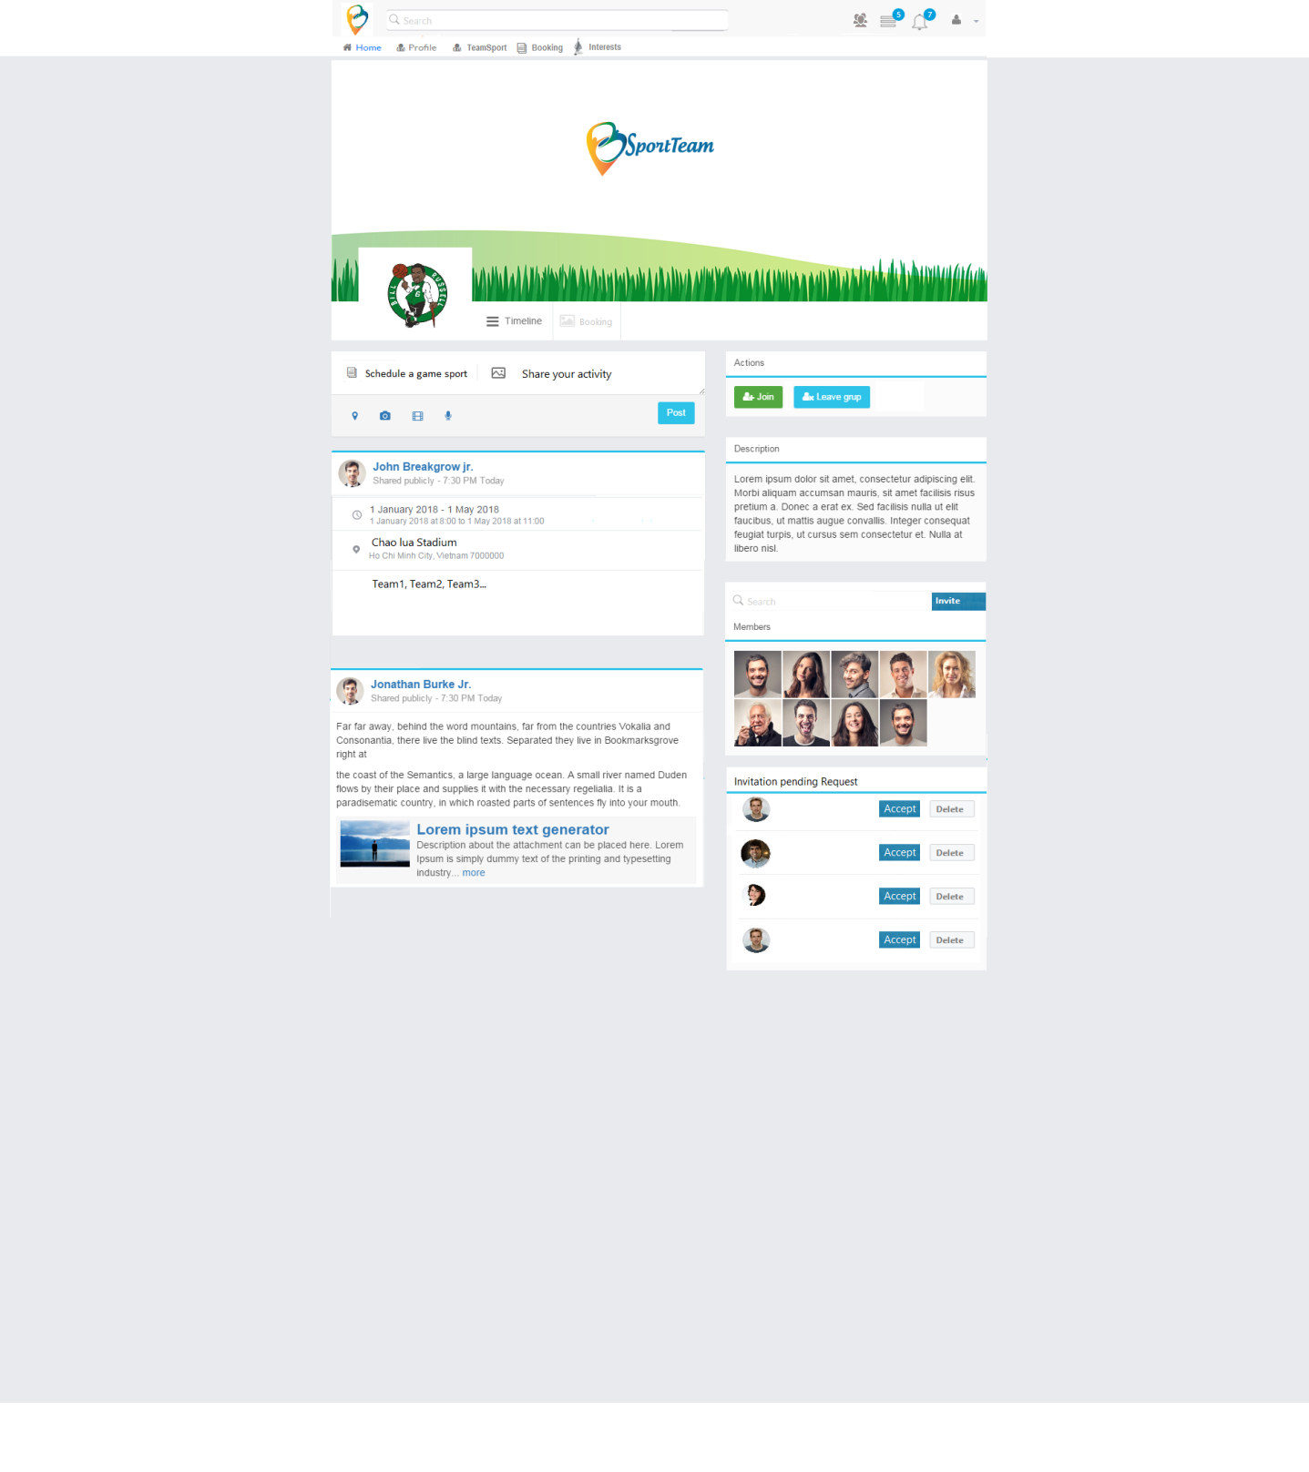

| Field Name | Required | Data Type | Description and Notes |
| --- | --- | --- | --- |
| Team Name |  | Hyperlink | Show Team Name.  To redirect to **Screen: Update Team**  Validation   * Team is unblocked * Team member is invited to join this team * Highlight when hover mouse on team name as Blue |
| Member numbers |  | Hyperlink | Show as Accepted members/Invited members.  To redirect to **Screen: List of members**  Show all members (invited members) under selected team. |
| Accept |  | Button | To Accept invitation |
| Reject |  | Button | To Reject invitation |

## Screen: List of booking

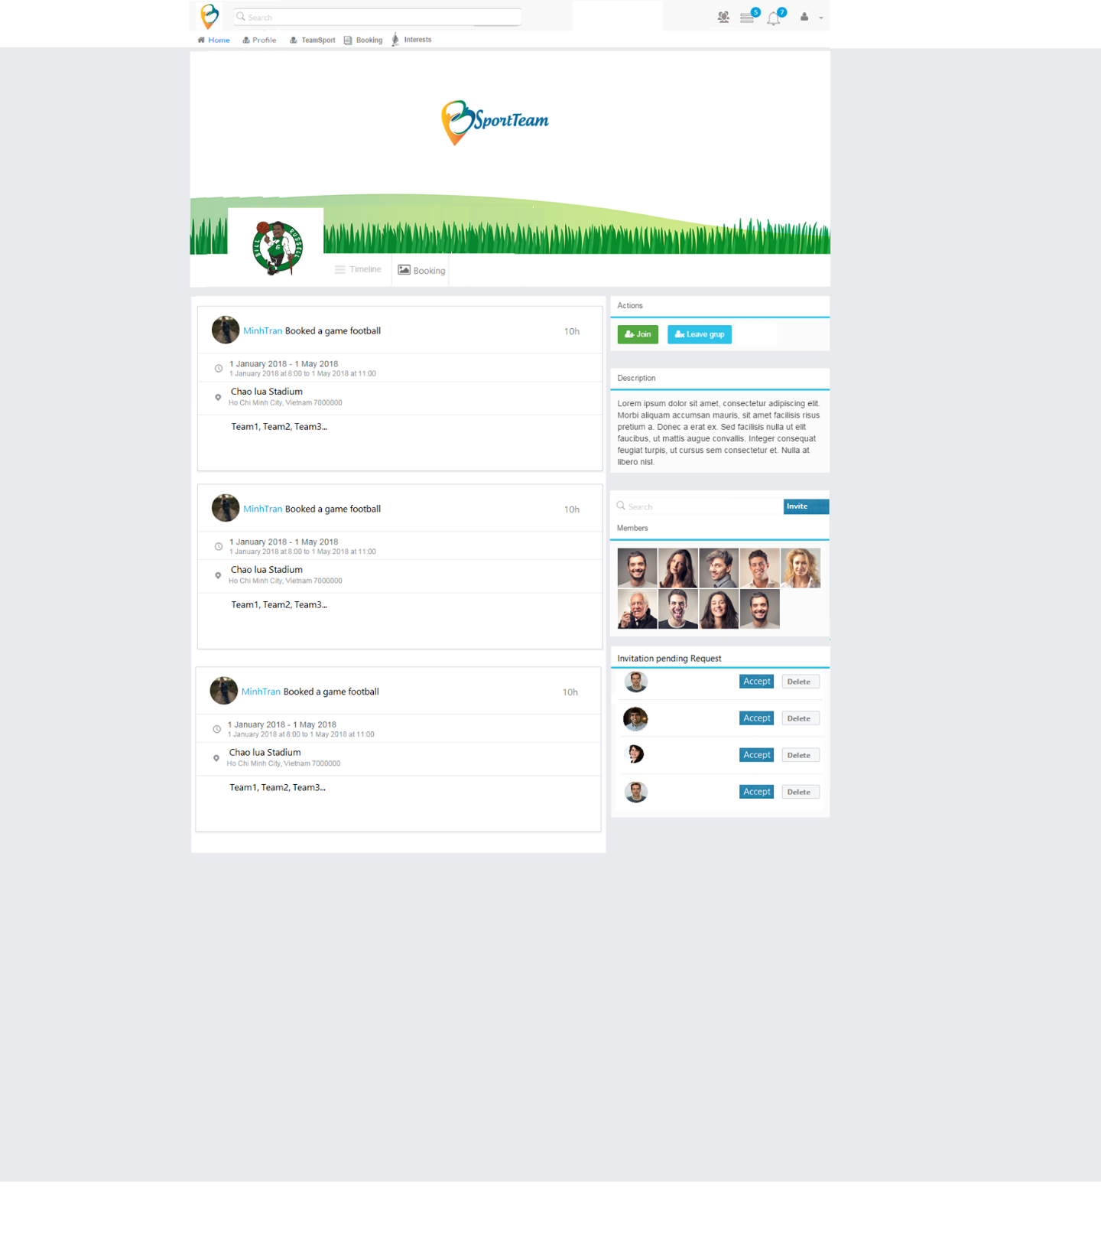

## Screen: Create new Team

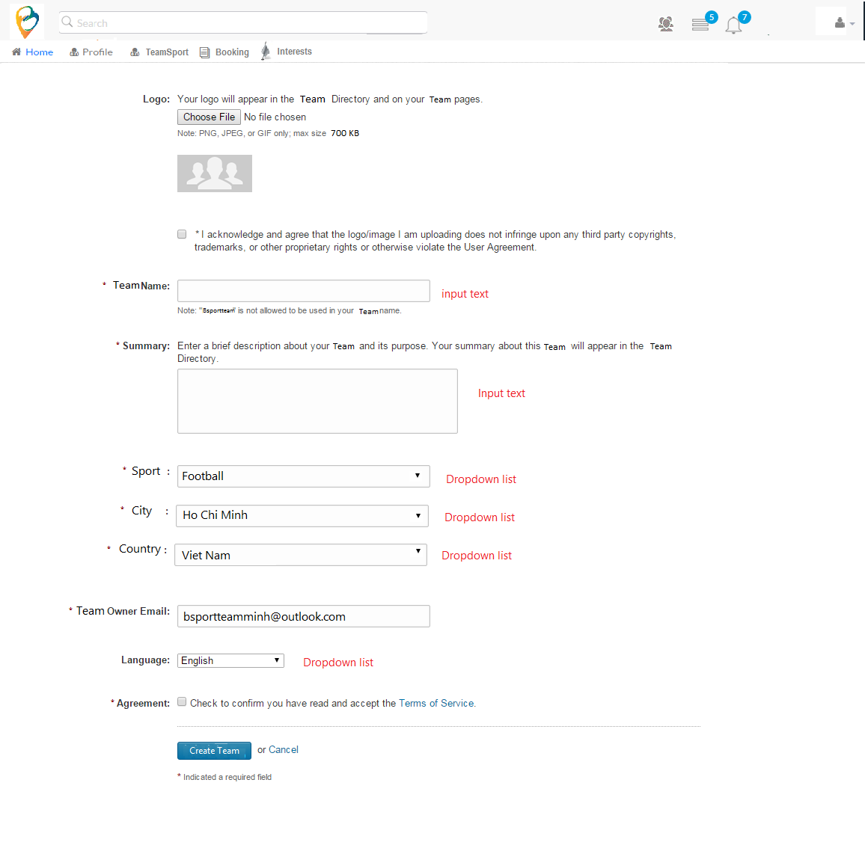

| Field Name | Required | Data Type | Description and Notes |
| --- | --- | --- | --- |
| Logo |  | Button | To upload Logo image  Validation   * PNG, JPEG, GIF * Max size 700GB |
| Team Name | Yes | Textbox | To enter Team Name  Validation   * Cannot duplicate team name under logged in user * Cannot input special characters * Maximum is 200 characters |
| Summary | Yes | Textbox | To enter Summary  Validation   * Maximum is 500 characters |
| Country | Yes | Dropdown list | To select country. Default is country of logged in user |
| Team Owner Email | Yes | Textbox | Auto filled email of logged in user. |
| Language |  | Dropdown list | To select language. Default is English |
| Agreement | Yes | Check box | To confirm before creating  Validation   * If user checks, enable Next button * If user unchecks, disable Next button |
| Next |  | Button | To redirect to **Screen: List of members**  Validation   * All required fields is inputted |
| Cancel |  | Button | To cancel flow |

## Screen: Booking popup

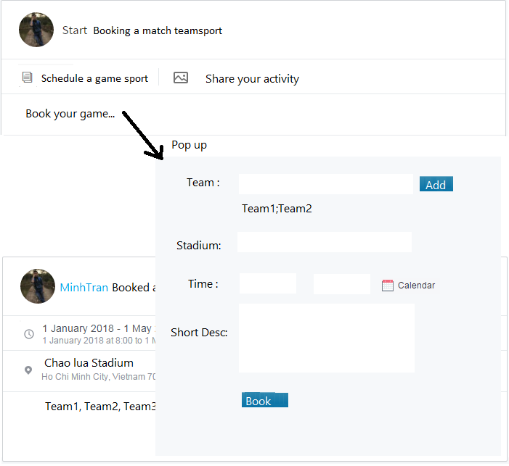

| Field Name | Required | Data Type | Description and Notes |
| --- | --- | --- | --- |
| Sport | Yes | Dropdown list | To select sport. Load all sport in system |
| Team | Yes | Auto complete | To select team name. Load all teams in system with same as selected sport  Validation   * No duplicate * Allow remove team |
| Stadium | Yes | Dropdown list | To select available stadium. Load stadium under selected sport.  Validation:   * Stadium have available time |
| Time | Yes | Datetime picker | To schedule time. Load by selected Stadium  Validation   * Start time < End time * Looping check in each of available period * Start time >= available start time of stadium * End time <= available end time of stadium * Allow booking for future time and past time if there’s available time in selected stadium |
| Short Desc |  | Text | To enter short description  Validation:   * Maximum is 500 chars |
| Book |  | Button | To proceed booking |

## Screen: Share Your Activity

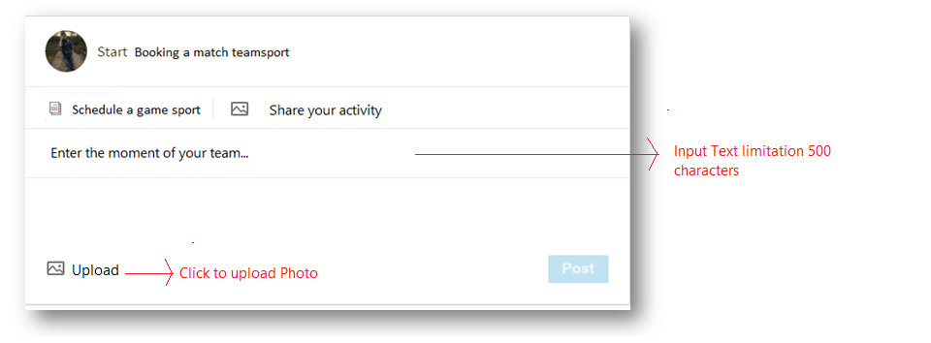

| Field Name | Required | Data Type | Description and Notes |
| --- | --- | --- | --- |
| Enter the moment of your team |  | Text | To input text  Validate:   * Maximum: 500 characters. Split character when over |
| Upload |  | Button | To input show window and allow select image.  File: JPEG, JPG, PNG, GIF |
| Post |  | Button | To proceed post activity and close this popup |

## Screen: Search member

Default in team page we show 9 members first of team

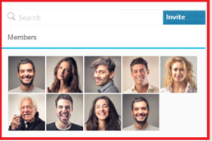

## Screen: List of members – member view

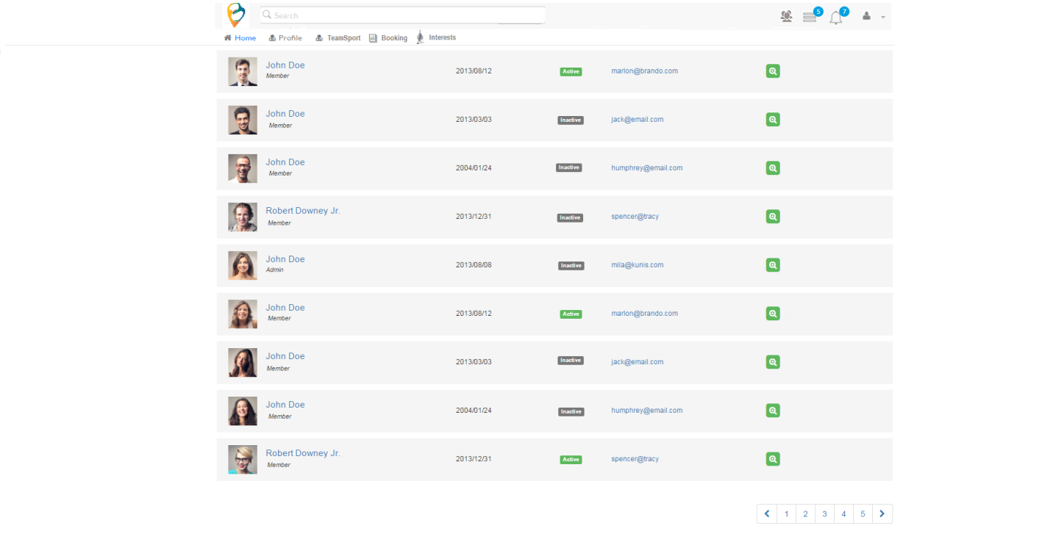

| Field Name | Required | Data Type | Description and Notes |
| --- | --- | --- | --- |
| Search |  | Text | To search by all information of profile.  If no search, show all user in system with paging |
| Member Name |  | Text | To show member name. |
| Status |  | Text | To follow status of invited members.  Values  Active: User is online at current time  Inactive: User is offline at current time |
| View |  | Button | To view information of user |

## Screen: List of members – Owner view

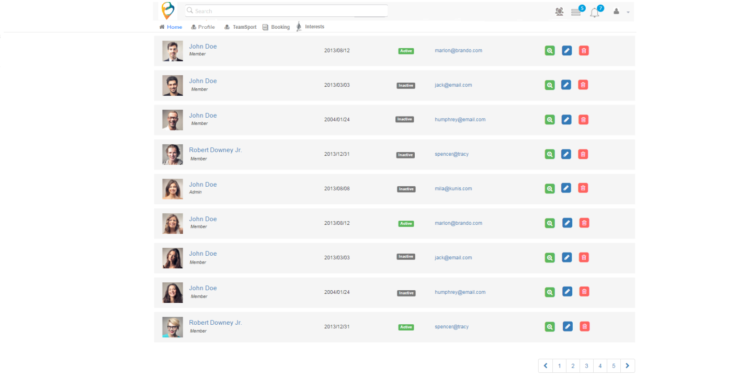

| Field Name | Required | Data Type | Description and Notes |
| --- | --- | --- | --- |
| Search |  | Text | To search by all information of profile.  If no search, show all user in system with paging |
| Member Name |  | Text | To show member name. |
| Status |  | Text | To follow status of invited members.  Values  Active: User is online at current time  Inactive: User is offline at current time |
| View |  | Button | To view information of user |
| Release |  | Button | To release member to team  Validation   * Shows on members of team |
| Set as an administrator |  | Button | To assign the user to administrator of team. |

## Screen: Notification after sending invitation request

The new user will receive a notification as below and can accept or reject.

Admin of team can reject the request to join/leave team form users

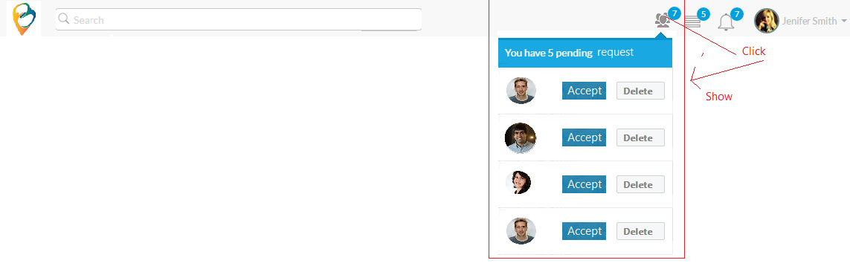

## Screen: Notification daily if there are something new

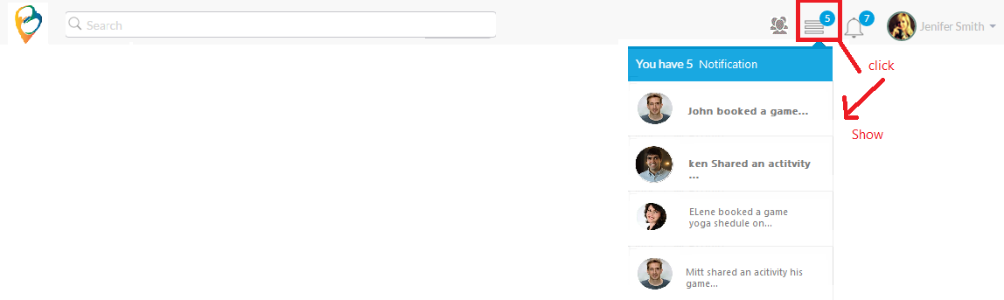

## Screen: Notification to remind the schedule

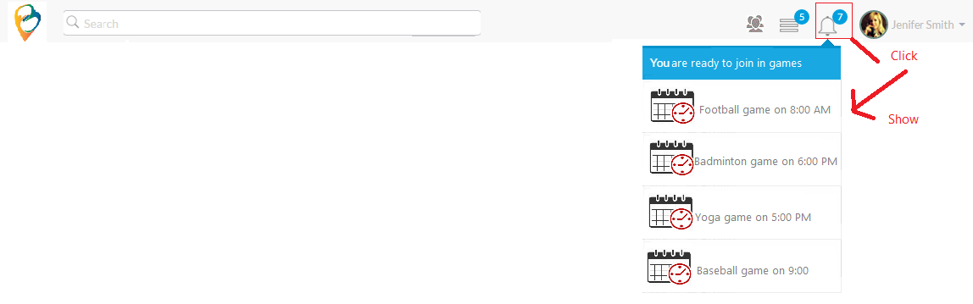

# Business Rules

## Team Management

| Business Rule ID | Description |
| --- | --- |
| 1 | * If User is new user, After Creating Account from Register page will be redirected to Account Profile Page and Profile Tab is activated firstly |
| 3 | * When any pop up shows in system, the background should be made blur and freeze to proceed |
| 4 | The popup will be closed once user clicks to other area. |
| 5 | **Share Your Activity:** The system should be handle to show message when user want to move tab “Booking new schedule” though incomplete sharing activity. MGS “Do you want to skip this post and make new schedule?” |
| 6 | **Invite member into team:** The both admin team and member can send invite request. |
| 7 | **Notification after sending the invitation request:** System will send notification for all member of team and new member. “<user name1> has been invited <username 2> to <team name>” |
| 8 | **Notification after accepting the invitation request:** System will send notification for all member of team. “<user name 2> has been accepted to <team name>” |
| 9 | **Permission of team member:**   * Reject request which has been received by team (booking) * Booking a game sport (delete, Edit) * Share activity of team (post, delete, edit in his content) * Send Request to user to add member to team |
| 10 | **Permission of admin team:**   * Reject member * Reject request * Add member * Booking a game sport * Share activity of team (post, delete, edit in al content) * Send Request to user to add member to team * Root person can delete any post and booking which member of team booked or posted before |
| 11 | **Booking transaction:**   * The limitation time for each booking is 2 minutes maximum. * Success of booking always is priority on the less session if in the case, having two booking happen in the same time on the same stadium as well as the same available time of game |

# Assumptions

| Assumption ID | Description |
| --- | --- |
| 1 | Status flow: New 🡪 Forming 🡪 Ready to book  Event flow: Just created (no one available) 🡪 Someone accepted invitation/Someone interrupt to release🡪 All invited members accepted and Team ready for booking |
| 2 | About Notification Category:   * If information related to change member in the team. It should be shown in Screen 5.9 * If information related to remind the schedule. It should be shown in Screen 5.11 * If information related to others (new booking, new sharing, ….) It should be shown in Screen 5.10 |