BSPortTeam

**Use Case Description**

Version 0.1

20 May 20177

RECORD OF CHANGE

History of Amendments

|  |  |  |  |  |
| --- | --- | --- | --- | --- |
| **Date** | **Version** | **Modified Section** | **Summary of Change** | **Author** |
| 11/01/2017 | 0.1 | All | Initial version | Linh.H |
|  |  |  |  |  |
|  |  |  |  |  |
|  |  |  |  |  |
|  |  |  |  |  |
|  |  |  |  |  |
|  |  |  |  |  |
|  |  |  |  |  |
|  |  |  |  |  |

Table of Contents

1 Overview 4

1.1 Goal 4

1.2 Brief Description 4

2 Preconditions 4

3 Postconditions 4

4 Flow of Events 5

4.1 Basic Flow – User Login 5

4.2 Alternative Flow – Change Language 5

4.3 Alternative Flow – Reset Password 5

4.4 Alternative Flow – Edit Profile 6

4.5 Alternative Flow – User Logout 6

4.6 Basic Flow – Register 6

4.7 Alternative Flow – Upload Cover Picture 6

5 Screenshots 7

5.1 Screen: Login 7

5.2 Screen: Profile >> Daily Activities 8

5.3 Screen: Reset Password 8

5.4 Screen: Edit Profile 10

5.5 Screen: Register 12

6 Business Rules 13

6.1 User Management 13

7 Assumptions 13

# Overview

## Goal

As the user in BSportTeam System, the user wants to login/register to BSportTeam system, so that user can use the BSportTeam system.

## Brief Description

This use case describes how a user can login to BSportTeam system on Web Application

|  |  |
| --- | --- |
| **Actor** | **Description** |
| User | To use functions in the system |

# Preconditions

* Actor has successfully accessed the BSportTeam system.

# Postconditions

* Actor has successfully logged into the system.

# Flow of Events

## Basic Flow – User Login

| Step | Event Description |
| --- | --- |
|  | Actor accesses BSportTeam system on Web Application |
|  | Actor clicks on Login button |
|  | System shows **Screen: Login** |
|  | Actor inputs login email and password, and clicks Sign in button |
|  | System validates the inputs. If there’s no error, system shows **Screen: Profile >> Timelines** |
|  | End Flow |

## Alternative Flow – Change Language

| Step | Event Description |
| --- | --- |
|  | Actor accesses BSportTeam system on Web Application |
|  | System shows **Screen: Register New Account** |
|  | Actor changes language |
|  | End Flow |

## Alternative Flow – Reset Password

| Step | Event Description |
| --- | --- |
| 1. | Actor accesses BSportTeam system on Web Application |
| 2. | Actor clicks on Login button |
| 3. | System shows **Screen: Login** |
| 4. | Actor clicks on Forgot Password button |
| 5. | System will send one email to this email. In this email will contain a link that link to **Screen: Request Reset Password** |
| 6. | Actor inputs email and clicks on Send button |
| 7. | System shows **Screen: Reset Password** |
| 8. | Actor inputs new password/confirm password and clicks on Reset button |
| 9. | System validates the inputs, saves the changes to database if there’s no error, and shows the informative popup. Refer to **MSG001** “<User Name> your password has been changed as of <Current Date Time>. It will be in effect from the next time you login” |
| 10. | End Flow |

## Alternative Flow – User Logout

| Step | Event Description |
| --- | --- |
|  | Actor selects User name -> Logout |
|  | System shows kills the user’s session and returns **Screen: Register New Account** |
|  | * End Flow |

## Basic Flow – Register

| Step | Event Description |
| --- | --- |
|  | Actor accesses BSportTeam system on Web Application |
|  | System shows **Screen: Register New Account** |
|  | Actor inputs login email, password and confirm, and clicks Create button |
|  | System validates the inputs. If there’s no error, system shows **Screen: Edit Profile** |
|  | End Flow |

# Screenshots

## Screen: Login

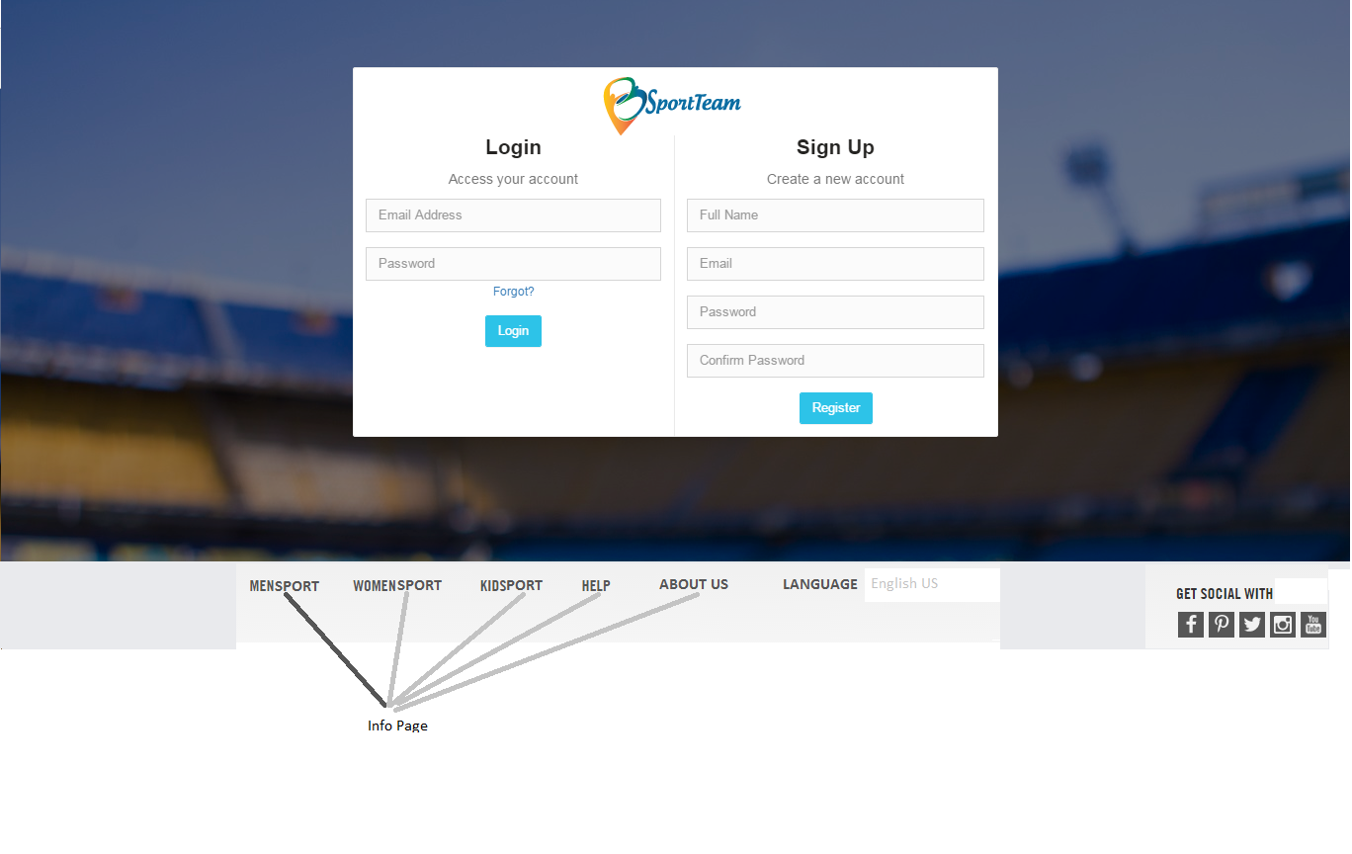

| Field Name | Required | Data Type | Description and Notes |
| --- | --- | --- | --- |
| Email | Yes | Text | To enter user email login  Validation   * Email format only: **MSG002** “Please enter valid values only” * Email empty or incorrect: **MSG003** “Please enter your login information correctly” |
| Password | Yes | Text | To enter user login password  Validation   * Password empty or incorrect: MSG003 “Please enter your login information correctly” |
| Sign in |  | Button | To proceed login  Rule: compare email and password. |
| Language |  | Dropdown list | To choose language.   * Default is English. * System support on :   English  Vietnamese |

## Screen: Profile >> Timelines

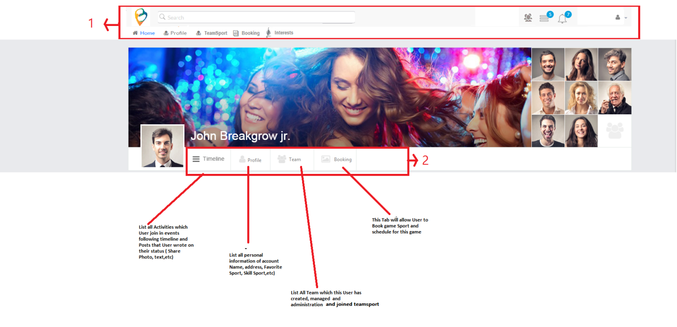

## Screen: Request Reset Password

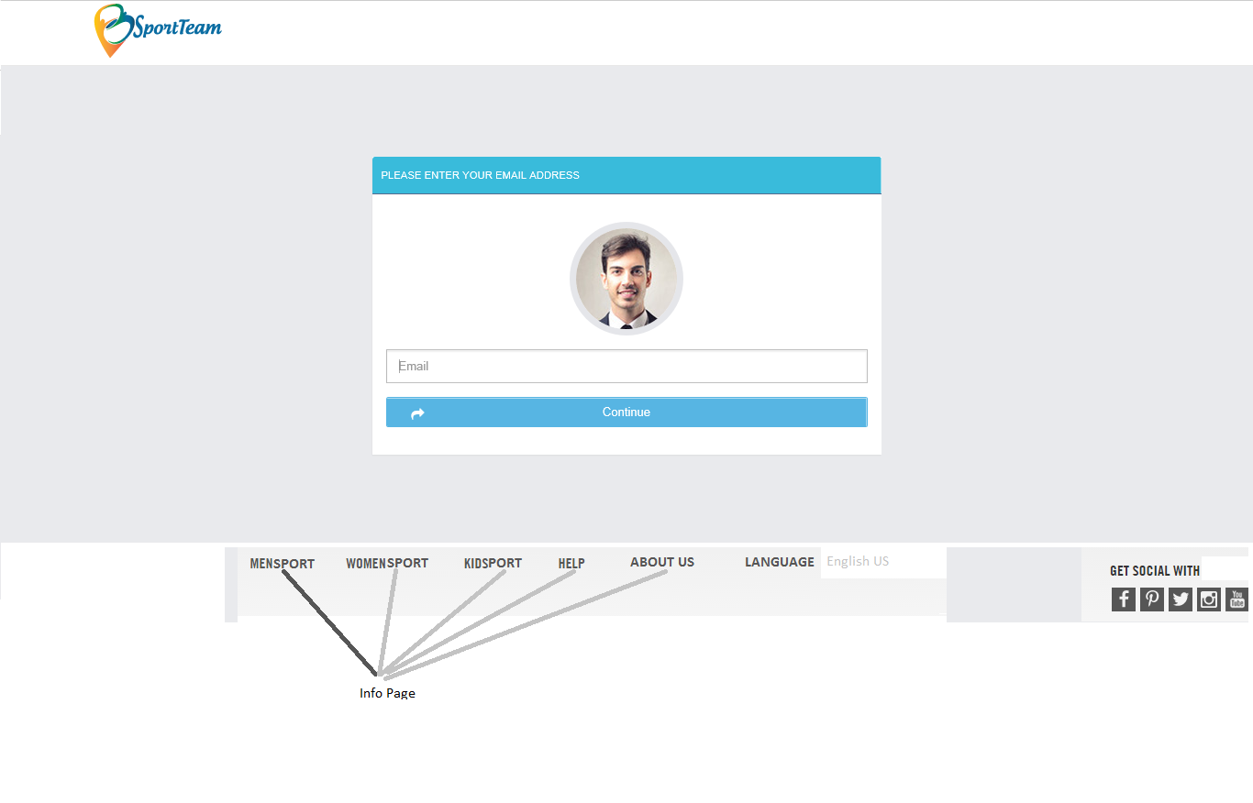

| Field Name | Required | Data Type | Description and Notes |
| --- | --- | --- | --- |
| Email | Yes | Text | To input user email  Validation   * Email format only: **MSG002** “Please enter valid values only” |
| Continue |  | Button | To proceed send email |

## Screen: Reset Password

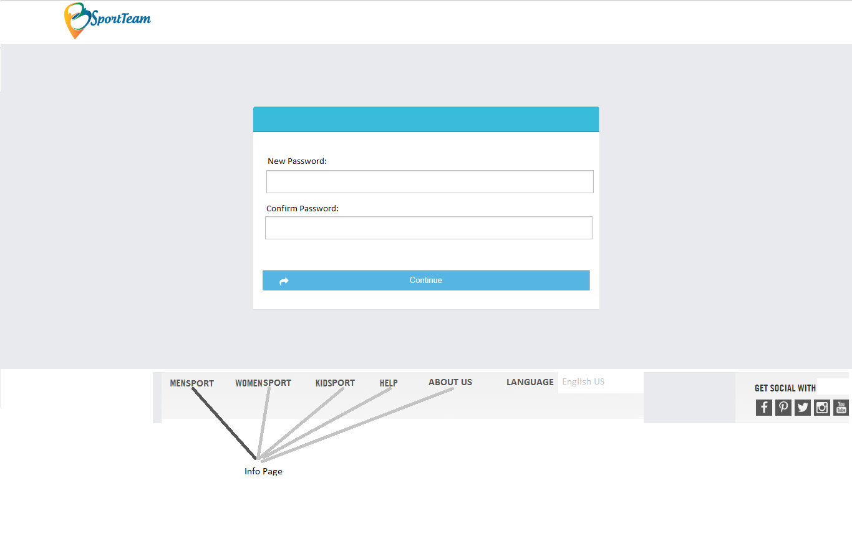

| Field Name | Required | Data Type | Description and Notes |
| --- | --- | --- | --- |
| New Password | Yes | Text | To input new password  Rule: minimum length of 8 characters  Validation:   * Less than 8 characters. Error message if not, **MSG004** “Incorrect password. Password must be at least 8 digits. Changes will not be saved !!!” |
| Confirm | Yes | Text | To confirm new password  Rule: minimum length of 8 characters  Validation:   * Must be the same as new password. Error message if not, **MSG005** “Should be input same as new password. Changes will not be committed !!!” |
| Reset |  | Button | To proceed change password |

## Screen: Edit Profile

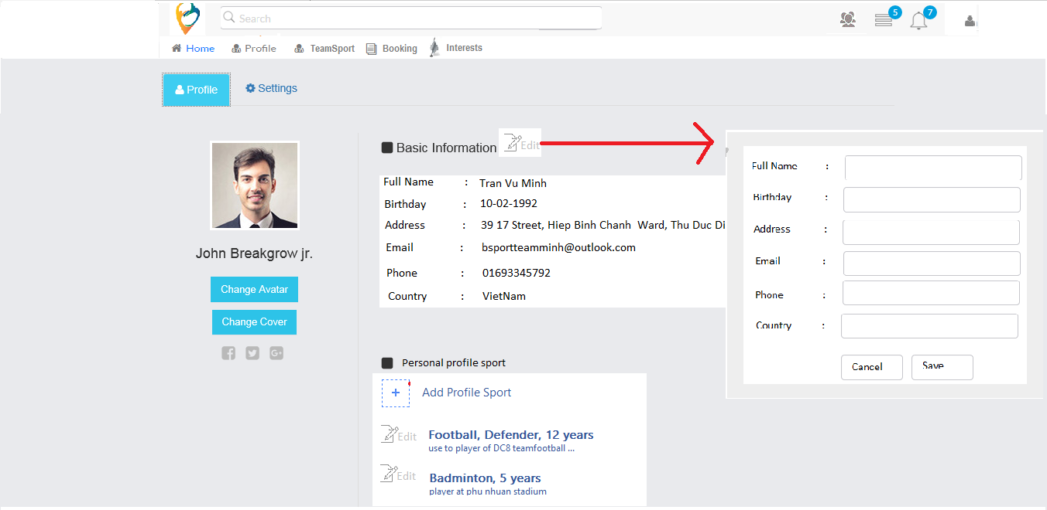

| Field Name | Required | Data Type | Description and Notes |
| --- | --- | --- | --- |
| Full Name |  | Text | To input Full name.  Validate :   * Maximum: 50 characters. Split character when over |
| Birthday |  | Date time picker | To input Birthday. |
| Address |  | Text | To input Address.  Validate:   * Maximum: 200 characters. Split character when over |
| Email |  | Text | To input email  Validate:   * Email format only: **MSG002** “Please enter valid values only” |
| Phone |  | Numeric | To input phone number  Validate:   * Numeric only. Don’t allow input others |
| Country |  | Dropdown list | To choose country |
| Sport |  | Dropdown list | To choose Sport type |
| Position |  | Dropdown list | To choose position |
| Experience |  | Dropdown list | To choose experience year |
| Overview skill |  | Text | To input skills  Validate:   * Maximum: 500 characters. Split character when over |
| Save |  | Button | To update profile |
| Cancel |  | Button | To terminate cancel |

## Screen: Register



| Field Name | Required | Data Type | Description and Notes |
| --- | --- | --- | --- |
| Email | Yes |  | To input user email  Validation   * Email format only: **MSG002** “Please enter valid values only” * Email empty or incorrect: **MSG003** “Please enter your login information correctly” |
| Full name | Yes | Text | To input full name of user |
| Password | Yes | Text | To input password  Rule: minimum length of 8 characters  Validation:   * Less than 8 characters. Error message if not, **MSG004** “Incorrect password. Password must be at least 8 digits. Changes will not be saved !!!” |
| Confirm | Yes | Text | To confirm password  Rule: minimum length of 8 characters  Validation:   * Must be the same as new password. Error message if not, **MSG005** “Should be input same as new password. Changes will not be committed !!!” |
| Create |  | Button | To proceed create user |

# Business Rules

## User Management

| Business Rule ID | Description |
| --- | --- |
| 1 | * If User is new user, After Creating Account from Register page will be redirected to ~~Account~~ Edit Profile Page ~~and Profile Tab is activated firstly~~ |
| 2 | * If User log in to use account, after logging in from Log in Page will be redirected to Account Profile Page and ~~Daily Activities~~ TimelinesTab is activated firstly |

# Assumptions

| Assumption ID | Description |
| --- | --- |
| 1 |  |