1. **Login/Register:**

**User** and **TeamSport** are entities in Web.

One User is signed up in web could create many TeamSport and each teamsport which User create , that User is Admininstrator on this TeamSport ( add new member, Remove members, Manage timeline operation of team , upload video,upload photos etc.)

Of course , every Account in Web can actively follow some teamsport that User want to join.

Each User can update their status time in time to let us know that User want to play Sport and need to follow event’sport of TeamSport

In Summary,

When User is created in this Web, User Can

Create Their TeamSport ( Yes , User is administrator on this Team)

Search TeamSport in Web to follow or join

Search Accounts in Web to Request or invite to join their team

Search information Stadium

Create Comment , like , share event

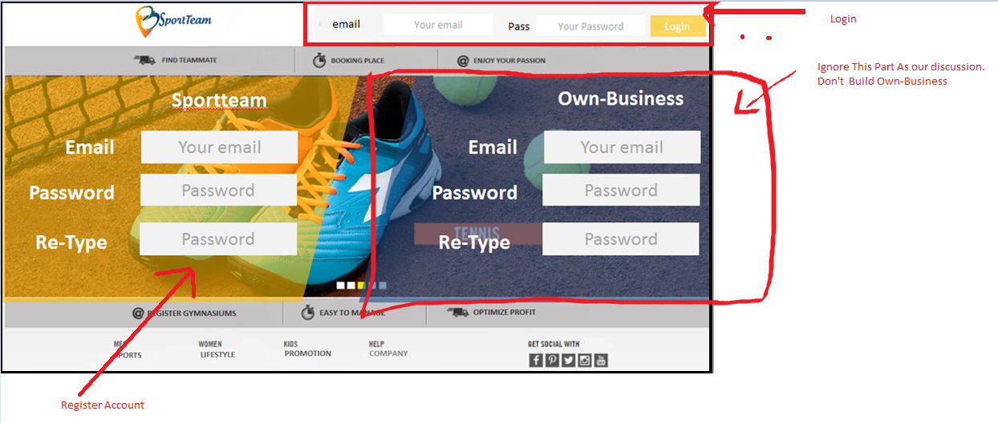

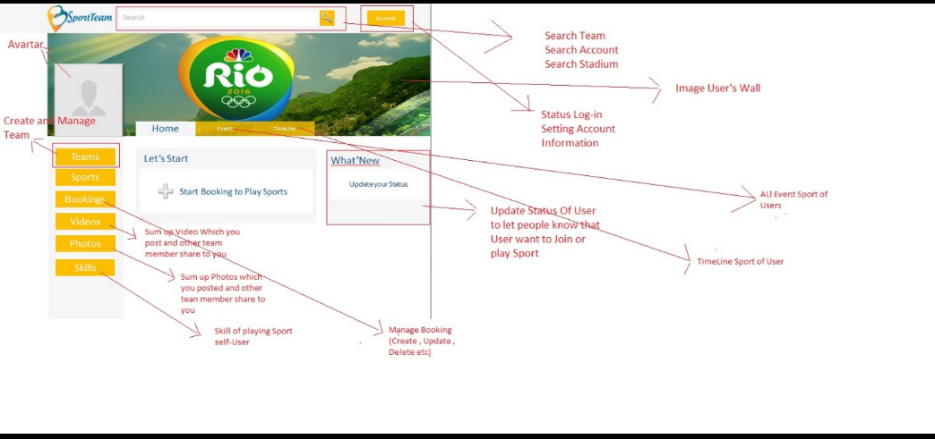

|  |  |  |
| --- | --- | --- |
|  | Description | Function |
| Register | -Register with basic information | - Register account for user.  - Register new team sport if User a leader  - register user is a member of a exist team if it has.  ,(No, everyAccount in This Web can create their teamsport and join or follow other TeamSport if they like ) |
| Login |  | * Login function * Forgotpassword function * Check role of user. |

1. **Manager:**

When User is Administrator of teamSport ( Mean that This User Created this TeamSport)

Find Accounts in Web

Invite Accounts in Web to join their team

Manage team’s members ( The quantity of team’s member)

Manage Timeline Activities of Team (Video,Photos)

Create Event or Set up game for Team

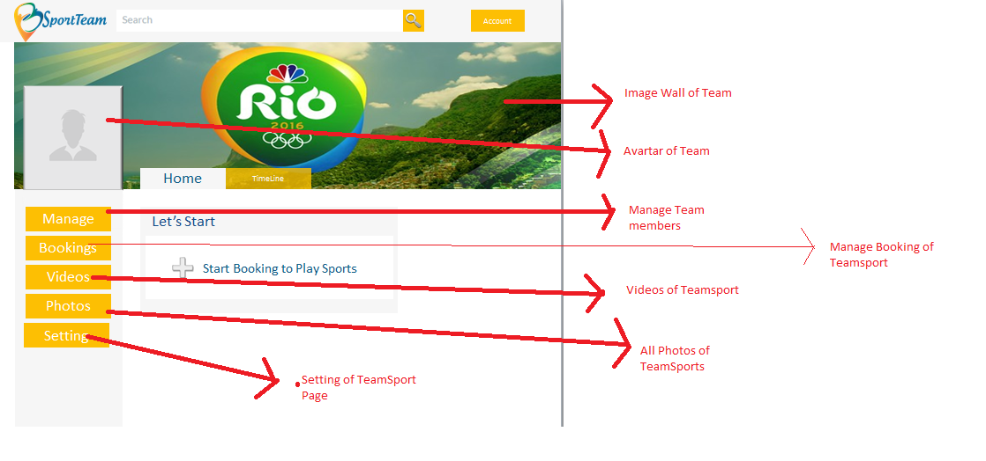

2.1. Admin Dardboard Site Manager:

|  |  |  |
| --- | --- | --- |
|  | Description | Function |
| Manager stadium  ->Manage Event Or Games |  | - Create, update , delete a stadium.  (Create, update , delete a Event)  - Get list a stadium.  Get list a Event  - Get detail of a stadium.(no need) |
| Manager all account of site   * No need   Because Account will manage Members for each Team which account create |  | * Get list all user. * Change status of user. (No , because accounts do this themselves |

2.2. User Dashboard:

2.2.1 Team Site :

|  |  |  |
| --- | --- | --- |
|  | Description | Function |
| Manager stadium |  | - Create, update , delete a stadium.  - Get list a stadium.  - Get detail of a stadium. |
| Manager all account of site |  | * Get list all user. * Change status of user. |

2.2.1 Search Site:

|  |  |  |
| --- | --- | --- |
|  | Description | Function |
| Manager all account of site |  | - Create, update , delete a match. |
| General Search |  | * Search team. * Search match. |