

Requirement Design Specification

HOSTEL MANAGEMENT AND SEARCH SYSTEM
(HMSS)

📍 Hanoi, April 2026 📍

Version 2.0 | PRN232
Table of content
I. Group Member 4
II. Introduction 5
2.1. Purpose of Document 5
2.2. Document Conventions 5
2.3. Intended Audience and Reading Suggestions 5
2.4. Product Scope 5
2.5. Definitions, Acronyms, and Abbreviations 5
III. System Overview 7
3.1. Technology Stack 7
3.1.1 Backend 7
3.1.2 Frontend 7
3.1.3 Database & Infrastructure 7
3.2. System Architecture 8
3.3. User Roles & Permission Matrix 8
3.3. Context Diagram 9
3.3.1. System Brief Description 9
2. External Entity Brief Description 10
IV. Database Design 11
4.1. Entity Relationship Overview 11
4.2. Entity: UserAccount 11
4.3. Entity: Property 12
4.4. Entity: RoomListing 12
4.5. Entity: RentalRequest 12
4.6. Entity: OwnerVerification 13
4.7. Entity: Conversation 14
4.8. Entity: ChatMessage 14
4.9. Entity: Payment 14
V. Functional Requirements 16
5.1. FR-01: User Authentication – Account Registration 16
5.2. FR-02: User Authentication – Login & JWT Issuance 17
5.3. FR-03: User Authentication – SystemAdmin 2FA Verification 18
5.4. FR-04: User Authentication – Google OAuth Single Sign-On 19
5.5. FR-05: Property Management – Create & Update Property 20
5.6. FR-06: Room Listing Management – Create, Edit & Publish 21
5.7. FR-07: Room Listing Management – Visibility Toggle 22
5.8. FR-08: Owner Identity Verification – Submit Verification Documents 23
5.9. FR-09: Room Search – Public Listing Discovery 24
5.10. FR-10: Rental Request – Tenant Submission 25
5.11. FR-11: Rental Request – Owner Review (Accept / Reject) 26
5.12. FR-12: Rental Request – Tenant Cancellation & Owner Revocation 27
5.13. FR-13: Real-Time Chat via SignalR 28
5.14. FR-14: Payment Processing via PayOS 29
5.15. FR-15: Admin – User Account Management 30
5.16. FR-16: Admin – Listing Control & Verification Review 31
VI. Non-Functional Requirements 33
6.1. NFR-01: Performance – API Response Time 33
6.2. NFR-02: Security – Password Hashing & Storage 34
6.3. NFR-03: Security – JWT Token Management 34
6.4. NFR-04: Security – Role-Based Access Control 35
6.5. NFR-05: Performance – Real-Time Chat Latency 35
6.6. NFR-06: Reliability – Database Auto-Migration 36
6.7. NFR-07: Security – CORS Policy Enforcement 36
6.8. NFR-08: Scalability – Storage Gateway Extensibility 37
VII. API Design & Mapping 38
7.1. Authentication API (/api/auth) 38
7.2. Registration API (/api/auth/register) 38
7.3. Google OAuth API (/api/auth/google) 38
7.4. Property Management API (/api/property) 38
7.5. Public Property View API (/api/property-view) 39
7.6. Room Listing Management API (/api/listing) 39
7.7. Room Search API (/api/room-search) 40
7.8. Public Room View API (/api/room) 41
7.9. Rental Request – Submission API (/api/rental-request) 41
7.10. Rental Request – Tenant Management API 41
7.11. Rental Request – Owner Review API 42
7.12. Owner Verification API (/api/verification) 42
7.13. Admin – Verification Review API (/api/admin/verification) 43
7.14. Admin – Listing Control API (/api/admin/listings) 43
7.15. Admin – User Account Management API (/api/admin/users) 43
7.16. Chat API (/api/chat) 44
7.17. Payment API (/api/payment) 44
7.18. SignalR WebSocket Hub (/hub/chat) 45
7.18.1 Client → Server Methods (Hub invocations) 45
7.18.2 Server → Client Events (broadcast) 45
7.18.3 SignalR Group Membership 45
VIII. System Design 46
8.1. Layered Architecture Design 46
8.2. Component & Module Design 47
8.2.1 Repository Interfaces 47
8.2.2 Gateway Interfaces 48
8.2.3 Services 48
8.3. State Machine Design 49
8.3.1 RoomListing Status State Machine 49
8.3.2 RentalRequest Status State Machine 50
8.3.3 OwnerVerification Status State Machine 51
8.3.4 Payment Status State Machine 52
8.3.5 UserAccount Status State Machine 53
8.4. Authentication & Authorization Design 54
8.4.1 JWT Token Structure 54
8.4.2 Authorization Policies 54
8.4.3 SystemAdmin Two-Factor Authentication Flow 54
8.4.4 Google OAuth 2.0 Flow 54
8.5. External Integration Design 55
8.5.1 PayOS Payment Gateway Integration 55
8.5.2 Mapbox Geocoding Integration 55
8.5.3 Email Notification Triggers 55
8.6. Database Configuration & Migration Design 56
8.6.1 EF Core Migration History 56
8.6.2 Auto-Migration on Startup 56
8.6.3 Seed Data (Development) 56
8.7. Dependency Injection Design (Program.cs) 57
8.8. Configuration Design 57
IX. Use Case Specifications 58
9.1. UC-01: Register Account 59
9.2. UC-02: Login with Email & Password (Tenant / Owner) 60
9.3. UC-03: Admin Login with Two-Factor Authentication 60
9.4. UC-04: Create and Publish Room Listing (Owner) 61
9.5. UC-05: Search & View Room Listings (Tenant) 62
9.6. UC-06: Submit Rental Request (Tenant) 63
9.7. UC-07: Accept or Reject Rental Request (Owner) 64
9.8. UC-08: Real-Time Chat Between Owner and Tenant 65
9.9. UC-09: Process Payment via PayOS (Tenant) 65
9.10. UC-10: Admin Reviews Owner Verification 66
X. Use Case Specifications 69
10.1. Visitor registers a new account 69
10.2. User logs in with email/password or Google OAuth 71
10.3. Visitor searches for rooms with filters and interactive map 72
10.4. Visitor views room detail with image gallery and embedded map 73
10.5. Tenant submits a rental request 74
10.6. Tenant views and manages rental requests 75
10.7. Tenant and Owner communicate via real-time chat (Request Detail) 76
10.8. Tenant views conversations on dedicated chat page 77
10.9. Owner manages properties 78
10.10. Owner creates and manages room listings 80
10.11. Owner submits identity verification 83
10.12. Owner reviews tenant rental requests 85
10.13. Owner views categorized chat inbox 86
10.14. Admin manages user accounts 88
10.15. Admin reviews owner verifications 89
10.16. Admin moderates room listings 90
10.17. Payment 91

I. Group Member
No | Full Name | Student ID | Position
2 | Ngô Minh Sơn | HE176848 | Member
3 | Tống Nguyên Tuấn | HE171132 | Member

II. Introduction

2.1. Purpose of Document
The purpose of this Requirement Design Specification (RDS) document is to provide a comprehensive and detailed description of the design and implementation blueprint for the Hostel Management and Search System (HMSS). This document covers the system's architecture, database design, REST API design, business logic, authentication model, and non-functional requirements. It serves as the authoritative technical reference for the development team and as a formal academic deliverable for the SWD392 – Software Design course evaluation.

2.2. Document Conventions
This document follows standard formatting conventions to ensure clarity:
- Bold text is used to emphasize key terms, field names, HTTP methods, and requirement labels.
- Italic text is used for sub-categories and supplementary descriptions.
- Code formatting (e.g., /api/auth/login) is used for API endpoints, field names, and enum values.
- Requirements are prioritized using MoSCoW methodology: Must Have (critical), Should Have (important but not critical), Could Have (nice to have).

2.3. Intended Audience and Reading Suggestions
This document is intended for multiple stakeholders involved in the project:
- Development Team (Backend, Frontend, Database): To understand the technical design, API contracts, and business rules required to build the system.
- Academic Instructors / Evaluators: To assess the completeness, coherence, and engineering quality of the system design for the SWD392 course.
- QA Engineers / Testers: To derive test cases from pre-conditions, post-conditions, and exception flows defined in each functional requirement.

2.4. Product Scope
HMSS is a full-stack web platform that connects property owners with tenants seeking hostel and rental room accommodations. The system provides a public search interface with map-based visualization, an owner portal for property and listing management, an identity verification workflow, a tenant request and communication system, real-time chat via SignalR, and payment processing through the PayOS Vietnamese payment gateway.
The backend is built with ASP.NET Core 8 and SQL Server (Entity Framework Core), exposing a RESTful API. The frontend is built with Next.js 16 and TypeScript. The system supports three user roles: Tenant, Owner, and SystemAdmin.

2.5. Definitions, Acronyms, and Abbreviations
- RDS: Requirement Design Specification – this document.
- REST: Representational State Transfer – architectural style for API design.
- JWT: JSON Web Token – compact, URL-safe token for authentication.
- ORM: Object-Relational Mapper – EF Core is used to map C# entities to SQL tables.
- DTO: Data Transfer Object – request/response payload class.
- SignalR: ASP.NET Core library for real-time WebSocket-based communication.
- PayOS: Vietnamese online payment gateway used for processing rental deposits.
- 2FA: Two-Factor Authentication – additional code-based login step for SystemAdmin.
- CORS: Cross-Origin Resource Sharing – controls which origins can call the API.
- EF Core: Entity Framework Core – .NET ORM used for database access and migrations.
- BCrypt: Password hashing algorithm (work factor 10) used to store user passwords.
- Mapbox: Third-party geocoding and map visualization service.
- MoSCoW: Prioritization framework: Must / Should / Could / Won't.
- HMSS: Hostel Management and Search System – the system described in this document.

III. System Overview

3.1. Technology Stack

3.1.1 Backend
Component | Technology | Version
Web Framework | ASP.NET Core | 8.0
ORM | Entity Framework Core | 8.0
Real-Time | SignalR (built-in) | 8.0
Authentication | JWT Bearer + Google OAuth 2.0 | 8.0
Password Hashing | BCrypt.Net-Next | 4.1.0
API Documentation | Swashbuckle (Swagger/OpenAPI) | 10.1.5
Database Driver | Microsoft.EntityFrameworkCore.SqlServer | 8.0.*

3.1.2 Frontend
Component | Technology | Version
Framework | Next.js | 16.2.0
UI Library | React | 19.2.4
Language | TypeScript | 5
Styling | Tailwind CSS | 4
Real-Time | @microsoft/signalr | 10.0.0
Maps | Mapbox GL + react-map-gl | 3.20.0 / 8.1.0

3.1.3 Database & Infrastructure
Component | Technology
Database Engine | SQL Server (SQLEXPRESS in development)
Schema Management | EF Core Code-First Migrations
File Storage | Local filesystem (extensible to cloud via ICloudStorageGateway)
Email | Gmail SMTP (smtp.gmail.com:587)
Payment Gateway | PayOS – Vietnamese payment service
Geocoding | Mapbox Geocoding API

3.2. System Architecture
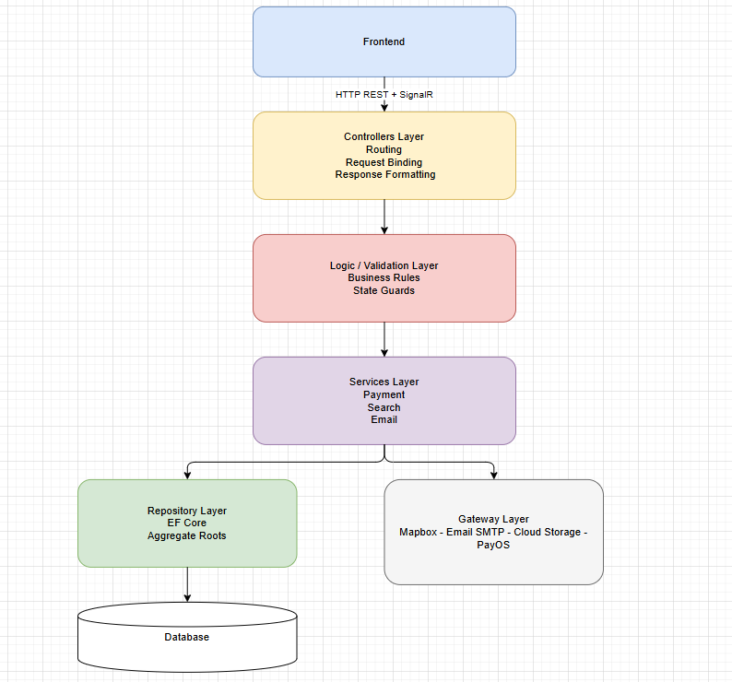
HMSS follows a layered N-tier architecture. The frontend communicates with the backend via HTTP REST calls and SignalR WebSocket connections. The backend is organized into five layers:
- Controllers Layer: Handles HTTP routing, request binding, and response formatting.
- Logic / Validation Layer: Enforces business rules and state transition guards.
- Services Layer: Orchestrates complex operations (payment, search, email notification).
- Repository Layer: Abstracts data access via EF Core (one repository per aggregate root).
- Gateway Layer: Wraps external integrations (Mapbox, Email SMTP, Cloud Storage, PayOS).

3.3. User Roles & Permission Matrix

Feature | Tenant | Owner | SystemAdmin
Search / View Listings | ✓ | ✓ | ✓
Submit Rental Request | ✓ | ✗ | ✗
Cancel Own Request | ✓ | ✗ | ✗
Create / Edit Property | ✗ | ✓ | ✗
Publish / Hide Listing | ✗ | ✓ (if verified) | ✗
Accept / Reject Request | ✗ | ✓ | ✗
Submit Verification | ✗ | ✓ | ✗
Review Verification | ✗ | ✗ | ✓
Manage User Accounts | ✗ | ✗ | ✓
Archive / Disable Listing | ✗ | ✗ | ✓
Chat (Owner ↔ Tenant) | ✓ | ✓ | ✗
Create Payment Link | ✓ | ✓ | ✗

3.3. Context Diagram
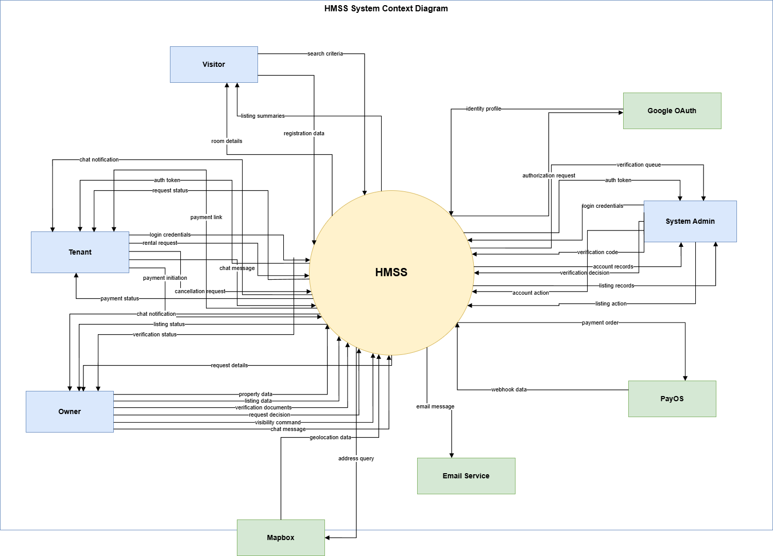

3.3.1. System Brief Description
Field | Description
System | HMSS
Type | Web platform
Purpose | Supports hostel and room rental management for the Vietnam market.
Core Scope | Room search, property and listing management, owner verification, rental requests, chat, payment, and administration.
Boundary | Connects visitors, tenants, owners, administrators, and external service providers in one system boundary.

2. External Entity Brief Description
External Entity | Description
Visitor | Public user who searches listings and views room details.
Tenant | Registered renter who submits requests, chats, and pays deposits.
Owner | Property manager who manages listings and reviews rental requests.
System Admin | Administrator who reviews verifications and controls accounts and listings.
Google OAuth | External identity provider for social login.
PayOS | Payment gateway for deposit checkout and payment callbacks.
Mapbox | Geocoding provider for address lookup and map coordinates.
Email Service | Outbound email provider for notifications and admin 2FA codes.
3. Key Data Flow Summary
Actor / Service | Data Flows
Visitor | search criteria; listing summaries; room details
Tenant | login credentials; rental request; cancellation request; chat message; payment initiation; auth token; request status; chat notification; payment link; payment status
Owner | property data; listing data; verification documents; request decision; visibility command; chat message; listing status; verification status; request details; chat notification
System Admin | login credentials; verification code; verification decision; account action; listing action; auth token; verification queue; account records; listing records
External Services | authorization request; identity profile; payment order; webhook data; address query; geolocation data; email message

IV. Database Design
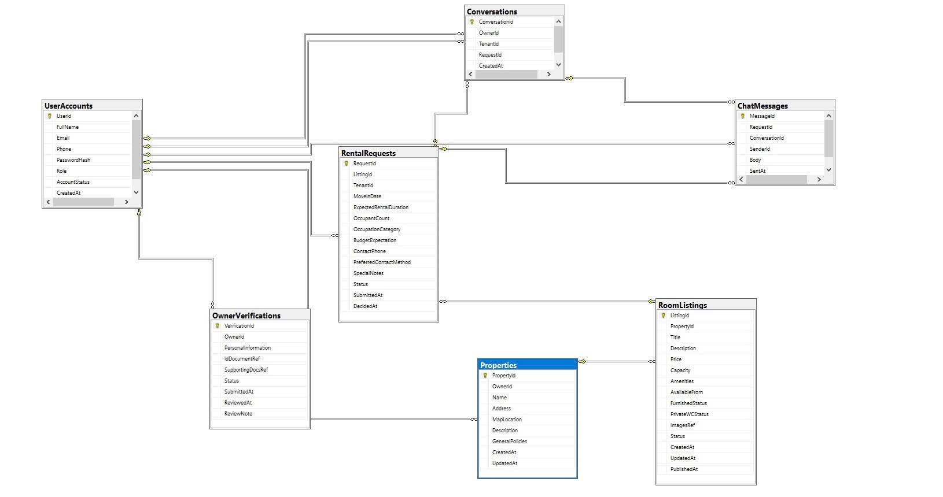

4.1. Entity Relationship Overview
The database consists of 8 primary entities:
- UserAccount – represents all registered users (Tenant, Owner, SystemAdmin).
- Property – a physical building owned by an Owner, containing multiple RoomListings.
- RoomListing – an individual rentable room published under a Property.
- RentalRequest – a formal rental application submitted by a Tenant for a RoomListing.
- OwnerVerification – identity verification submission required before an Owner can publish.
- Conversation – a persistent chat thread between an Owner and a Tenant.
- ChatMessage – individual message records stored under a Conversation or RentalRequest.
- Payment – PayOS payment record linked to an accepted RentalRequest.

4.2. Entity: UserAccount
Table: UserAccounts | File: Entities/UserAccount.cs
Column | Type | Constraint | Description
UserId | Guid | PK, NOT NULL | UUID primary key
FullName | nvarchar(256) | NOT NULL | User display name
Email | nvarchar(256) | NOT NULL, UNIQUE | Login email – indexed
Phone | nvarchar(50) | NOT NULL | Contact phone number
PasswordHash | nvarchar(512) | NOT NULL | BCrypt-hashed password
Role | nvarchar(20) | NOT NULL, CHECK | Tenant | Owner | SystemAdmin
AccountStatus | nvarchar(20) | NOT NULL, CHECK | Active | Suspended | Disabled
CreatedAt | datetime2 | NOT NULL | UTC creation timestamp

4.3. Entity: Property
Table: Properties | File: Entities/Property.cs
Column | Type | Constraint | Description
PropertyId | Guid | PK | UUID primary key
OwnerId | Guid | FK → UserAccount (NO ACTION) | Owner reference
Name | nvarchar(256) | NOT NULL | Property display name
Address | nvarchar(512) | NOT NULL | Full street address
MapLocation | nvarchar(512) | NULL | Mapbox query string for geocoding
Description | nvarchar(max) | NULL | Freetext description
GeneralPolicies | nvarchar(max) | NULL | House rules / policies
ImagesRef | nvarchar(max) | NULL | JSON array of image URLs
CreatedAt | datetime2 | NOT NULL | UTC creation timestamp
UpdatedAt | datetime2 | NOT NULL | Last modification timestamp

4.4. Entity: RoomListing
Table: RoomListings | File: Entities/RoomListing.cs
Column | Type | Constraint | Description
ListingId | Guid | PK | UUID primary key
PropertyId | Guid | FK → Property (CASCADE) | Parent property
Title | nvarchar(256) | NOT NULL | Room title
Description | nvarchar(max) | NULL | Room description
Price | decimal(18,2) | NOT NULL | Monthly rent in VND
Capacity | int | NOT NULL | Maximum number of occupants
Amenities | nvarchar(max) | NULL | JSON array of amenity strings
AvailableFrom | date | NOT NULL | Earliest move-in date
FurnishedStatus | nvarchar(30) | NOT NULL, CHECK | FullyFurnished | PartiallyFurnished | Unfurnished
PrivateWCStatus | nvarchar(20) | NOT NULL, CHECK | Private | Shared | None
ImagesRef | nvarchar(max) | NULL | JSON array of image URLs
Status | nvarchar(30) | NOT NULL, CHECK | Draft | PublishedAvailable | Locked | Hidden | Archived
CreatedAt | datetime2 | NOT NULL | UTC creation timestamp
UpdatedAt | datetime2 | NOT NULL | Last modification timestamp
PublishedAt | datetime2 | NULL | First publication timestamp

4.5. Entity: RentalRequest
Table: RentalRequests | File: Entities/RentalRequest.cs
Column | Type | Constraint | Description
RequestId | Guid | PK | UUID primary key
ListingId | Guid | FK → RoomListing (NO ACTION) | Target listing
TenantId | Guid | FK → UserAccount (NO ACTION) | Requesting tenant
MoveInDate | date | NOT NULL | Requested move-in date
ExpectedRentalDuration | int | NOT NULL | Duration in months
OccupantCount | int | NOT NULL | Number of occupants
OccupationCategory | nvarchar(max) | NULL | Student / Professional / Other
IsRoommateWanted | bit | NOT NULL | Roommate preference flag
BudgetExpectation | decimal(18,2) | NULL | Expected monthly budget VND
ContactPhone | nvarchar(50) | NOT NULL | Contact phone override
PreferredContactMethod | nvarchar(20) | NOT NULL, CHECK | Phone | Email | WhatsApp
SpecialNotes | nvarchar(max) | NULL | Additional notes for owner
Status | nvarchar(30) | NOT NULL, CHECK | Pending | Accepted | Rejected | CancelledByTenant | RevokedByOwner
PaymentStatus | nvarchar(20) | NOT NULL, CHECK | Unpaid | Paid | Failed
SubmittedAt | datetime2 | NOT NULL | UTC submission timestamp
DecidedAt | datetime2 | NULL | Owner decision timestamp

4.6. Entity: OwnerVerification
Table: OwnerVerifications | File: Entities/OwnerVerification.cs
Column | Type | Constraint | Description
VerificationId | Guid | PK | UUID primary key
OwnerId | Guid | FK → UserAccount (CASCADE) | Owner being verified
PersonalInformation | nvarchar(max) | NULL | Owner self-description
IdDocumentRef | nvarchar(1024) | NOT NULL | URL/path to national ID document
SupportingDocsRef | nvarchar(max) | NULL | JSON array of supporting document URLs
Status | nvarchar(20) | NOT NULL, CHECK | PendingReview | Verified | Rejected
SubmittedAt | datetime2 | NOT NULL | UTC submission timestamp
ReviewedAt | datetime2 | NULL | Admin review timestamp
ReviewNote | nvarchar(max) | NULL | Admin decision explanation

4.7. Entity: Conversation
Table: Conversations | File: Entities/Conversation.cs
Column | Type | Constraint | Description
ConversationId | Guid | PK | UUID primary key
OwnerId | Guid | FK → UserAccount (NO ACTION) | Owner participant
TenantId | Guid | FK → UserAccount (NO ACTION) | Tenant participant
RequestId | Guid? | FK → RentalRequest, NULL | Linked request (optional)
CreatedAt | datetime2 | NOT NULL | UTC creation timestamp

Unique Constraints: UNIQUE(OwnerId, TenantId, RequestId) WHERE RequestId IS NOT NULL | UNIQUE(OwnerId, TenantId) WHERE RequestId IS NULL

4.8. Entity: ChatMessage
Table: ChatMessages | File: Entities/ChatMessage.cs
Column | Type | Constraint | Description
MessageId | Guid | PK | UUID primary key
RequestId | Guid? | FK → RentalRequest, NULL | Legacy request-scoped message
ConversationId | Guid? | FK → Conversation, NULL | Conversation-scoped message
SenderId | Guid | FK → UserAccount (NO ACTION) | Message sender
Body | nvarchar(2000) | NOT NULL | Message text content
SentAt | datetime2 | NOT NULL | UTC send timestamp

Indexes: IX_ChatMessages(ConversationId, SentAt) | IX_ChatMessages(RequestId, SentAt)

4.9. Entity: Payment
Table: Payments | File: Entities/Payment.cs
Column | Type | Constraint | Description
PaymentId | Guid | PK | UUID primary key
RequestId | Guid | FK → RentalRequest (CASCADE) | Associated request
PayOSOrderCode | bigint | NOT NULL | PayOS order identifier
Amount | decimal(18,2) | NOT NULL | Payment amount (VND)
Status | nvarchar(20) | NOT NULL, CHECK | Pending | Paid | Cancelled | Failed
PaymentMethod | nvarchar(50) | NULL | Payment method (bank transfer, card)
TransactionId | nvarchar(100) | NULL | PayOS transaction reference
CreatedAt | datetime2 | NOT NULL | UTC creation timestamp
PaidAt | datetime2 | NULL | Payment success timestamp

V. Functional Requirements
This section defines the specific behaviors and API contracts that the backend development team must implement. Each functional requirement is specified with its HTTP endpoint, actor, description, pre-conditions, post-conditions, exception flows, and dependencies.
Functional requirements list:
- 5.1. FR-01: User Authentication – Account Registration
- 5.2. FR-02: User Authentication – Login & JWT Issuance
- 5.3. FR-03: User Authentication – SystemAdmin 2FA Verification
- 5.4. FR-04: User Authentication – Google OAuth Single Sign-On
- 5.5. FR-05: Property Management – Create & Update Property
- 5.6. FR-06: Room Listing Management – Create, Edit & Publish Listing
- 5.7. FR-07: Room Listing Management – Visibility Toggle (Hide / Show)
- 5.8. FR-08: Owner Identity Verification – Submit Verification Documents
- 5.9. FR-09: Room Search – Public Listing Discovery
- 5.10. FR-10: Rental Request – Tenant Submission
- 5.11. FR-11: Rental Request – Owner Review (Accept / Reject)
- 5.12. FR-12: Rental Request – Tenant Cancellation & Owner Revocation
- 5.13. FR-13: Real-Time Chat via SignalR
- 5.14. FR-14: Payment Processing via PayOS
- 5.15. FR-15: Admin – User Account Management
- 5.16. FR-16: Admin – Listing Control & Verification Review

5.1. FR-01: User Authentication – Account Registration
Attribute | Detailed Specification
Requirement ID | FR-01
Title | New User Account Registration
Actor | Unregistered Visitor (future Tenant or Owner)
HTTP Method & Endpoint | POST /api/auth/register
Request Body | { fullName: string, email: string, phone: string, password: string, role: "Tenant" | "Owner" }
Response Body | { userId: Guid, email: string, role: string, message: string }
Description | The system allows any unregistered visitor to create a new account by providing their full name, email address, phone number, password, and role. SystemAdmin accounts cannot be created via this endpoint. Passwords are hashed using BCrypt (work factor 10) before storage.
Priority / Type | Must
Source | Core platform requirement (user onboarding)
Pre-conditions | 1. The provided email address is not already registered in the system.  2. The request body passes all validation rules.
Post-conditions | 1. A new UserAccount record is created with AccountStatus = "Active".  2. The password is stored as a BCrypt hash, never in plain text.  3. HTTP 201 Created is returned with the new userId.
Exceptions / Alternate Flow | If email is already in use: HTTP 400 with { Errors: ["Email is already in use"] }.  If password does not meet complexity: HTTP 400 with validation error list.  If role is "SystemAdmin": HTTP 400 – forbidden role for self-registration.
Dependencies | IUserAccountRepository.FindByEmailAsync (duplicate check)  AuthenticationLogic.ValidateRegistrationAsync (validation)  BCrypt.Net-Next (password hashing)
Verification Method | Unit Test (duplicate email, password complexity) / Integration Test (full registration flow)

5.2. FR-02: User Authentication – Login & JWT Issuance
Attribute | Detailed Specification
Requirement ID | FR-02
Title | User Login with Email & Password
Actor | Registered User (Tenant or Owner)
HTTP Method & Endpoint | POST /api/auth/login
Request Body | { email: string, password: string }
Response Body | { token: string, userId: Guid, role: string, fullName: string, expiresAt: DateTime } OR { requiresVerification: true, userId: Guid } (for SystemAdmin)
Description | The system authenticates a registered user by verifying their email and BCrypt-hashed password. On success for Tenant and Owner roles, a signed JWT token is returned immediately. For SystemAdmin, a 6-digit 2FA code is emailed and requiresVerification: true is returned – the JWT is only issued after the code is verified via FR-03. JWT tokens expire after 30 minutes.
Priority / Type | Must
Source | Core platform requirement (secure access control)
Pre-conditions | 1. The user account exists and AccountStatus is "Active" (not Suspended or Disabled).  2. The provided password matches the stored BCrypt hash.
Post-conditions | 1. A JWT is issued containing claims: sub (UserId), email, role, jti.  2. Token expiry is set to 30 minutes from issuance.  3. For SystemAdmin: a 6-digit code is generated, cached in MemoryCache with 5-minute TTL, and emailed.
Exceptions / Alternate Flow | Invalid credentials: HTTP 401 Unauthorized.  Suspended account: HTTP 403 Forbidden with reason message.  Disabled account: HTTP 403 Forbidden – permanent block.
Dependencies | IUserAccountRepository.FindByEmailAsync  BCrypt.Net-Next (password verification)  JwtTokenService (token generation)  IEmailGateway (2FA code delivery for Admin)  IMemoryCache (2FA code storage)
Verification Method | Unit Test (BCrypt verification, JWT claims) / Integration Test (login flow + token decode)

5.3. FR-03: User Authentication – SystemAdmin 2FA Verification
Attribute | Detailed Specification
Requirement ID | FR-03
Title | Two-Factor Authentication Code Verification for SystemAdmin
Actor | SystemAdmin
HTTP Method & Endpoint | POST /api/auth/verify-code
Request Body | { userId: Guid, code: string }
Response Body | { token: string, userId: Guid, role: "SystemAdmin", fullName: string, expiresAt: DateTime }
Description | After a SystemAdmin completes the initial login (FR-02), they must submit the 6-digit verification code sent to their registered email. The system validates the code against the MemoryCache entry for the given userId. On success, a JWT token is issued.
Priority / Type | Must
Source | Security requirement (elevated admin privileges warrant additional authentication factor)
Pre-conditions | 1. A valid 6-digit code exists in MemoryCache for the given userId.  2. The code has not expired (5-minute TTL from issuance).  3. The userId corresponds to a SystemAdmin account.
Post-conditions | 1. The code is consumed and removed from MemoryCache.  2. A JWT with role=SystemAdmin is returned.
Exceptions / Alternate Flow | Code is incorrect: HTTP 400 – "Invalid verification code".  Code has expired (TTL elapsed): HTTP 400 – "Verification code has expired. Please log in again".  UserId not found in cache: HTTP 400 – "No pending verification for this user".
Dependencies | IMemoryCache (code retrieval and removal)  IUserAccountRepository.FindByIdAsync  JwtTokenService
Verification Method | Unit Test (expired code, wrong code, valid code) / Integration Test (full 2FA flow)

5.4. FR-04: User Authentication – Google OAuth Single Sign-On
Attribute | Detailed Specification
Requirement ID | FR-04
Title | Google OAuth 2.0 Single Sign-On
Actor | Unregistered Visitor or Existing User
HTTP Method & Endpoint | GET /api/auth/google → redirect to Google  GET /api/auth/google/callback → exchange code & issue JWT
Request Body | N/A (OAuth redirect flow; callback receives ?code=&state= query params)
Response Body | HTTP 302 redirect to frontend /login/google-callback?token=<jwt>
Description | The system integrates Google OAuth 2.0 to allow users to sign in or auto-register without a password. Step 1: the user is redirected to Google's consent screen with a CSRF state token stored in an HttpOnly cookie. Step 2: Google redirects back to /callback with an authorization code. The system exchanges the code for the user's email and name, then either logs in the existing account or auto-registers as a Tenant with a random unusable password hash.
Priority / Type | Should
Source | User experience requirement (simplified onboarding)
Pre-conditions | 1. Google OAuth application is configured (ClientId, ClientSecret, RedirectUri in appsettings.json).  2. The state cookie must match the callback state parameter (CSRF validation).
Post-conditions | 1. New users: a UserAccount with Role=Tenant and AccountStatus=Active is created.  2. Existing users: their account is retrieved by email.  3. A JWT token is issued and the user is redirected to the frontend callback URL with ?token=...
Exceptions / Alternate Flow | CSRF state mismatch: HTTP 400 – "Invalid OAuth state".  Google returns an error code: redirect to frontend with ?error=oauth_failed.  Auto-registered account is Disabled: HTTP 403.
Dependencies | GoogleAuthOptions (ClientId, ClientSecret, RedirectUri)  IHttpClientFactory (Google token exchange)  IUserAccountRepository  JwtTokenService
Verification Method | Integration Test (full OAuth redirect flow using test credentials) / Postman manual test

5.5. FR-05: Property Management – Create & Update Property
Attribute | Detailed Specification
Requirement ID | FR-05
Title | Owner Creates and Updates a Property
Actor | Owner (authenticated, Role = "Owner")
HTTP Method & Endpoint | POST /api/property/process (upload images)  POST /api/property (create property)  PUT /api/property/{propertyId} (update property)
Request Body | Create: { name: string, address: string, mapLocation?: string, description?: string, generalPolicies?: string, imageUrls?: string[] }  Update: same fields (all optional except name)
Response Body | Create: { propertyId: Guid, name: string, address: string, createdAt: DateTime }  Update: { propertyId: Guid, name: string, address: string, updatedAt: DateTime }
Description | An authenticated Owner can create a new Property by providing a name, address, and optional metadata. Images are uploaded separately via the /process endpoint which returns URLs, then passed in the create/update body. The system validates the required fields and persists the property with a generated UUID and the owner's UserId as OwnerId.
Priority / Type | Must
Source | Core platform requirement (owner content management)
Pre-conditions | 1. The caller is authenticated with Role = "Owner".  2. Name and Address are provided and non-empty.  3. For update: the propertyId must belong to the authenticated owner.
Post-conditions | 1. Create: a new Property record is saved; HTTP 201 returned.  2. Update: Property.UpdatedAt is refreshed; HTTP 200 returned.  3. Uploaded images are stored and accessible via /uploads/{filename}.
Exceptions / Alternate Flow | Missing name or address: HTTP 400 with validation errors.  Attempting to update another owner's property: HTTP 403 Forbidden.  Image upload exceeds allowed file size/type: HTTP 400.
Dependencies | IPropertyRepository (Save, Update, FindById)  ICloudStorageGateway.UploadImagesAsync  PropertyLogic.ValidateUpdate
Verification Method | Integration Test (create → retrieve → update → retrieve) / Postman manual test

5.6. FR-06: Room Listing Management – Create, Edit & Publish
Attribute | Detailed Specification
Requirement ID | FR-06
Title | Owner Creates, Edits and Publishes a Room Listing
Actor | Owner (authenticated, Role = "Owner", Verified)
HTTP Method & Endpoint | POST /api/listing (save as draft)  PUT /api/listing/{listingId} (update)  POST /api/listing/{listingId}/publish (publish)
Request Body | Create/Update: { propertyId: Guid, title: string, description?: string, price: decimal, capacity: int, amenities?: string[], availableFrom: date, furnishedStatus: string, privateWCStatus: string, imageUrls?: string[] }
Response Body | Create: { listingId: Guid, title: string, status: "Draft", message: string }  Publish: { listingId: Guid, newStatus: "PublishedAvailable", message: string }
Description | An Owner can create a room listing as a Draft under one of their properties. After uploading images and completing all fields, the owner can publish the listing. Publication is gated: the owner must be Verified (OwnerVerification.Status = "Verified"), the listing must have at least one image, and the listing must be in Draft status. On successful publication, Status changes to PublishedAvailable and PublishedAt is set.
Priority / Type | Must
Source | Core platform requirement (listing lifecycle management)
Pre-conditions | 1. Caller is authenticated with Role = "Owner".  2. propertyId belongs to the authenticated owner.  3. For publish: OwnerVerification.Status = "Verified", listing has images, Status = "Draft".
Post-conditions | 1. Draft created: RoomListing.Status = "Draft", HTTP 201.  2. Published: RoomListing.Status = "PublishedAvailable", PublishedAt = UTC now, HTTP 200.  3. Listing appears in public search results after publish.
Exceptions / Alternate Flow | Owner not verified: HTTP 400 – "Owner must be verified to publish listings".  No images uploaded: HTTP 400 – "Listing must have at least one image".  Listing not in Draft status: HTTP 400 – "Invalid state transition".
Dependencies | IRoomListingRepository (Save, Update, FindById)  IOwnerVerificationRepository.IsOwnerVerifiedAsync  PublishListingLogic.ValidateEligibility  ICloudStorageGateway.UploadImagesAsync
Verification Method | Unit Test (eligibility checks) / Integration Test (draft → publish flow)

5.7. FR-07: Room Listing Management – Visibility Toggle
Attribute | Detailed Specification
Requirement ID | FR-07
Title | Owner Hides or Shows a Published Listing
Actor | Owner (authenticated)
HTTP Method & Endpoint | POST /api/listing/{listingId}/visibility
Request Body | { action: "Hide" | "Show" }
Response Body | { listingId: Guid, newStatus: "Hidden" | "PublishedAvailable", message: string }
Description | An Owner can temporarily hide a published listing to prevent new tenant requests without archiving it. Hiding transitions Status from PublishedAvailable → Hidden. Showing transitions it back to PublishedAvailable. A hidden listing does not appear in public search results.
Priority / Type | Should
Source | Owner usability requirement (temporary vacancy management)
Pre-conditions | 1. Caller is authenticated with Role = "Owner" and is the listing owner.  2. Hide action: listing must be in PublishedAvailable status.  3. Show action: listing must be in Hidden status.
Post-conditions | 1. Hide: RoomListing.Status = "Hidden"; listing removed from public search.  2. Show: RoomListing.Status = "PublishedAvailable"; listing restored to public search.
Exceptions / Alternate Flow | Invalid state for action: HTTP 400 – "Cannot Hide a listing that is not PublishedAvailable".  Listing belongs to different owner: HTTP 403 Forbidden.
Dependencies | IRoomListingRepository (FindById, Update)  VisibilityLogic.ValidateVisibilityAction
Verification Method | Unit Test (state machine validation) / Integration Test

5.8. FR-08: Owner Identity Verification – Submit Verification Documents
Attribute | Detailed Specification
Requirement ID | FR-08
Title | Owner Submits Identity Verification Documents
Actor | Owner (authenticated, Role = "Owner")
HTTP Method & Endpoint | POST /api/verification/process (upload documents)  POST /api/verification (submit for review)
Request Body | Submit: { personalInformation?: string, idDocumentUrl: string, supportingDocUrls?: string[] }
Response Body | { verificationId: Guid, status: "PendingReview", message: string }
Description | Before an Owner can publish listings, they must submit an identity verification. The owner uploads their national ID document (required) and optional supporting documents via the /process endpoint, then submits the verification form. Status is set to PendingReview and the submission enters the admin review queue.
Priority / Type | Must
Source | Trust & safety requirement (prevent fraudulent listings)
Pre-conditions | 1. Caller is authenticated with Role = "Owner".  2. At least one ID document URL is provided in the request.
Post-conditions | 1. An OwnerVerification record is created with Status = "PendingReview".  2. The submission appears in the admin review queue.  3. HTTP 201 Created is returned.
Exceptions / Alternate Flow | Missing ID document: HTTP 400 – "ID document is required".  Owner already has a PendingReview submission: system may update the existing record.  File upload error: HTTP 400 with storage error message.
Dependencies | IOwnerVerificationRepository (Save)  ICloudStorageGateway.UploadDocumentsAsync  VerificationLogic.ValidateRequiredFields
Verification Method | Integration Test (upload → submit → verify admin queue entry)

5.9. FR-09: Room Search – Public Listing Discovery
Attribute | Detailed Specification
Requirement ID | FR-09
Title | Public Room Search with Filter Criteria
Actor | Any Visitor (unauthenticated or authenticated)
HTTP Method & Endpoint | GET /api/room-search/page (load all published listings)  POST /api/room-search/search (filter by criteria)
Request Body | Search: { minPrice?: decimal, maxPrice?: decimal, capacity?: int, furnishedStatus?: string, location?: string, amenities?: string[] }
Response Body | { summaries: ListingSummaryDto[], locationData: LocationDataDto[], properties: PropertySearchSummaryDto[], hasResults: bool }
Description | Any visitor can browse or search for available room listings. The system returns all listings with Status = "PublishedAvailable", enriched with Mapbox geocoordinates for map visualization. When search criteria are provided, the SearchMatchingService filters by price range, capacity, furnished status, location text, and amenities.
Priority / Type | Must
Source | Core platform requirement (primary user value)
Pre-conditions | 1. No authentication required.  2. At least one listing with Status = "PublishedAvailable" exists in the database.
Post-conditions | 1. Returns only PublishedAvailable listings.  2. Each listing is enriched with Mapbox geocoordinates.  3. hasResults = false if no listings match the criteria.
Exceptions / Alternate Flow | Mapbox API unavailable: listings returned without geocoordinates (graceful degradation).  No listings match criteria: HTTP 200 with hasResults = false and empty arrays.
Dependencies | IRoomListingRepository.FindPublishedListingsAsync  SearchMatchingService.FilterByCriteria  IMapGateway.GetLocationDataAsync (Mapbox)
Verification Method | Integration Test (filter combinations) / Manual test with Postman

5.10. FR-10: Rental Request – Tenant Submission
Attribute | Detailed Specification
Requirement ID | FR-10
Title | Tenant Submits a Rental Request for a Listing
Actor | Tenant (authenticated, Role = "Tenant")
HTTP Method & Endpoint | POST /api/rental-request
Request Body | { listingId: Guid, moveInDate: date, expectedRentalDuration: int, occupantCount: int, occupationCategory?: string, isRoommateWanted: bool, budgetExpectation?: decimal, contactPhone: string, preferredContactMethod: "Phone"|"Email"|"WhatsApp", specialNotes?: string }
Response Body | { requestId: Guid, status: "Pending", message: string }
Description | An authenticated Tenant can submit a rental request for any PublishedAvailable listing. The system validates that the listing is available, the tenant does not already have a Pending request for the same listing, and all required fields are provided. On success, a RentalRequest record with Status = "Pending" is created and email notifications are sent to both the Tenant and the property Owner.
Priority / Type | Must
Source | Core platform requirement (tenant-to-owner connection)
Pre-conditions | 1. Caller is authenticated with Role = "Tenant".  2. The target listing exists and has Status = "PublishedAvailable".  3. The tenant does not have an existing Pending request for this listing.  4. MoveInDate is a valid future date.
Post-conditions | 1. A new RentalRequest is created with Status = "Pending" and PaymentStatus = "Unpaid".  2. Email sent to tenant: "Your request has been submitted".  3. Email sent to property owner: "New rental request received".  4. HTTP 201 Created returned.
Exceptions / Alternate Flow | Listing not PublishedAvailable (Locked, Hidden, etc.): HTTP 400.  Duplicate pending request: HTTP 400 – "You already have a pending request for this listing".  OccupantCount exceeds listing capacity: HTTP 400.
Dependencies | IRentalRequestRepository (Save, FindByTenantId)  IRoomListingRepository.FindPublishedByIdAsync  RentalRequestLogic.ValidateRequestabilityWithDuplicateCheckAsync  IEmailGateway (notifications)
Verification Method | Unit Test (duplicate check, listing status guard) / Integration Test (full submission flow)

5.11. FR-11: Rental Request – Owner Review (Accept / Reject)
Attribute | Detailed Specification
Requirement ID | FR-11
Title | Owner Accepts or Rejects a Rental Request
Actor | Owner (authenticated, Role = "Owner")
HTTP Method & Endpoint | POST /api/rental-request/{requestId}/accept  POST /api/rental-request/{requestId}/reject
Request Body | N/A (no request body required)
Response Body | { requestId: Guid, newStatus: "Accepted" | "Rejected", message: string }
Description | An Owner can accept or reject a Pending rental request for their listing. Accepting a request atomically sets RentalRequest.Status = "Accepted" and RoomListing.Status = "Locked" (preventing further requests from being accepted). Rejecting sets Status = "Rejected". An email confirmation is sent to the tenant upon acceptance.
Priority / Type | Must
Source | Core platform requirement (owner decision workflow)
Pre-conditions | 1. Caller is authenticated with Role = "Owner" and owns the property of the target listing.  2. For accept: RentalRequest.Status = "Pending" AND RoomListing.Status = "PublishedAvailable".  3. For reject: RentalRequest.Status = "Pending".
Post-conditions | Accept:  1. RentalRequest.Status = "Accepted", DecidedAt = UTC now.  2. RoomListing.Status = "Locked".  3. Email sent to tenant: "Your rental request has been accepted".  Reject:  1. RentalRequest.Status = "Rejected", DecidedAt = UTC now.  2. RoomListing remains PublishedAvailable.
Exceptions / Alternate Flow | Request not in Pending status: HTTP 400 – "Request is not in a reviewable state".  Accept when listing is not PublishedAvailable: HTTP 400 – "Listing is not available".  Request belongs to another owner's listing: HTTP 403 Forbidden.
Dependencies | IRentalRequestRepository (FindById, Update)  IRoomListingRepository (FindById, Update)  ReviewRequestLogic.ValidateAcceptance  IEmailGateway (tenant notification)
Verification Method | Unit Test (state machine transitions) / Integration Test (accept → verify listing locked)

5.12. FR-12: Rental Request – Tenant Cancellation & Owner Revocation
Attribute | Detailed Specification
Requirement ID | FR-12
Title | Tenant Cancels Pending Request / Owner Revokes Accepted Request
Actor | Tenant (cancel) | Owner (revoke)
HTTP Method & Endpoint | POST /api/rental-request/{requestId}/cancel (Tenant)  POST /api/listing/{requestId}/reopen (Owner)
Request Body | N/A
Response Body | { requestId: Guid, newStatus: "CancelledByTenant" | "RevokedByOwner", message: string }
Description | Tenants can cancel a request that is still in Pending status. Owners can revoke a previously accepted request (e.g., the tenant is no longer interested). Revoking an accepted request reopens the listing by transitioning RoomListing.Status from "Locked" back to "PublishedAvailable".
Priority / Type | Must
Source | Flexibility requirement (accommodate changing plans)
Pre-conditions | Cancel: RentalRequest.Status = "Pending", caller is the tenant who submitted the request.  Revoke: RentalRequest.Status = "Accepted", caller is the owner of the listing.
Post-conditions | Cancel: RentalRequest.Status = "CancelledByTenant".  Revoke: RentalRequest.Status = "RevokedByOwner", RoomListing.Status = "PublishedAvailable".
Exceptions / Alternate Flow | Cancel Accepted/Rejected request: HTTP 400 – "Only Pending requests can be cancelled".  Revoke non-Accepted request: HTTP 400 – "Request is not in an accepted state".
Dependencies | IRentalRequestRepository (FindById, Update)  IRoomListingRepository (FindById, Update)  RentalRequestLogic.ValidateCancellationEligibility  ReopenLogic.ValidateConcurrencyStatus
Verification Method | Unit Test (state guards) / Integration Test (cancel → verify status, revoke → verify listing reopens)

5.13. FR-13: Real-Time Chat via SignalR
Attribute | Detailed Specification
Requirement ID | FR-13
Title | Real-Time Messaging Between Owner and Tenant
Actor | Owner or Tenant (authenticated)
HTTP Method & Endpoint | WebSocket: ws://localhost:5236/hub/chat?access_token=<jwt>  REST: GET /api/chat/conversations  REST: POST /api/chat/conversations/start  REST: POST /api/chat/conversations/from-request/{requestId}  REST: GET /api/chat/conversations/{conversationId}/history
Request Body | SignalR – JoinConversation(conversationId: string)  SignalR – SendConversationMessage(conversationId: string, body: string)  REST start: { otherPartyId: Guid }
Response Body | SignalR event ReceiveMessage: { messageId, senderId, senderName, body, sentAt }  History: [{ messageId, senderId, senderName, body, sentAt }]
Description | Owners and Tenants can communicate via a persistent, real-time chat system. Conversations are linked either to a RentalRequest (request-scoped) or created directly between two users (peer-to-peer). The SignalR hub groups clients by conversation ID (conv-{conversationId}). Messages are persisted to the ChatMessages table and last 50 messages are retrievable via REST. JWT is passed via query string for WebSocket authentication.
Priority / Type | Must
Source | User communication requirement (owner-tenant negotiation)
Pre-conditions | 1. Both participants are authenticated with valid JWTs.  2. A Conversation record exists (created via /start or /from-request).  3. The client has joined the SignalR group for the conversationId.
Post-conditions | 1. Message is persisted to ChatMessages table.  2. All clients in conv-{conversationId} group receive ReceiveMessage event.  3. All clients in user-{userId} personal groups receive NewChatMessage notification.
Exceptions / Alternate Flow | Invalid JWT in query string: SignalR connection rejected (401).  ConversationId not found: message send silently ignored or 404 returned.  Message body exceeds 2000 characters: HTTP 400 / SignalR error.
Dependencies | ChatHub (SignalR)  IConversationRepository (FindOrCreateAsync)  IChatMessageRepository (Save, FindByConversationId)
Verification Method | Integration Test (WebSocket connection + message send/receive) / Browser-based E2E test

5.14. FR-14: Payment Processing via PayOS
Attribute | Detailed Specification
Requirement ID | FR-14
Title | Create Payment Link and Process PayOS Webhook
Actor | Tenant or Owner (create link) | PayOS Server (webhook)
HTTP Method & Endpoint | POST /api/payment/create-link/{requestId} (authenticated)  POST /api/payment/webhook (public – PayOS callback)  GET /api/payment/by-request/{requestId} (authenticated)
Request Body | create-link: N/A (requestId in URL)  webhook: { orderCode: long, status: string, paymentMethod?: string, transactionId?: string }
Response Body | create-link: { paymentId: Guid, checkoutUrl: string, amount: decimal, status: "Pending" }  by-request: { paymentId, requestId, amount, status, paidAt?, paymentMethod? }
Description | Tenants (or owners) can create a PayOS payment link for an accepted rental request. The system generates a PayOS order with the rental deposit amount, stores a Payment record with Status = "Pending", and returns the checkout URL. PayOS calls the /webhook endpoint upon completion; the webhook handler updates Payment.Status and RentalRequest.PaymentStatus.
Priority / Type | Should
Source | Business requirement (deposit collection for confirmed bookings)
Pre-conditions | 1. RentalRequest.Status = "Accepted" (payment only valid for accepted requests).  2. No existing Paid payment for the same request.  3. PayOS credentials configured in appsettings.json.
Post-conditions | create-link: Payment record created with Status = "Pending", PayOSOrderCode stored.  webhook (Paid): Payment.Status = "Paid", PaidAt = UTC now, RentalRequest.PaymentStatus = "Paid".  webhook (Failed): Payment.Status = "Failed", RentalRequest.PaymentStatus = "Failed".
Exceptions / Alternate Flow | PayOS API unreachable: HTTP 502 with error message.  Duplicate webhook call: idempotent – already-Paid records are not updated again.  Invalid orderCode in webhook: HTTP 400 – "Payment record not found".
Dependencies | PaymentService (CreatePaymentLinkAsync, ProcessWebhookAsync)  IPaymentRepository (Save, FindByOrderCode, Update)  IRentalRequestRepository (Update PaymentStatus)
Verification Method | Integration Test (mock PayOS webhook call) / End-to-end test in PayOS sandbox environment

5.15. FR-15: Admin – User Account Management
Attribute | Detailed Specification
Requirement ID | FR-15
Title | SystemAdmin Manages User Account Status
Actor | SystemAdmin (authenticated, Role = "SystemAdmin")
HTTP Method & Endpoint | GET /api/admin/users (list accounts)  GET /api/admin/users/{userId} (get details)  POST /api/admin/users/{userId}/suspend  POST /api/admin/users/{userId}/enable  POST /api/admin/users/{userId}/disable
Request Body | N/A (userId in URL path)
Response Body | { userId: Guid, newStatus: "Active" | "Suspended" | "Disabled", message: string }
Description | The SystemAdmin can view all non-admin user accounts and change their status. Suspended accounts cannot log in but can be re-enabled. Disabled accounts are permanently blocked and cannot be re-enabled. The admin cannot disable their own account. An email notification is sent to the user when their account status changes.
Priority / Type | Must
Source | Platform governance requirement (abuse prevention)
Pre-conditions | 1. Caller is authenticated with Role = "SystemAdmin".  2. The target userId is not the calling admin's own account (for disable action).  3. Status transitions must be valid (e.g., cannot enable a Disabled account).
Post-conditions | 1. UserAccount.AccountStatus is updated in the database.  2. Email notification sent to the affected user.  3. Suspended users receive 403 on next login attempt.
Exceptions / Alternate Flow | Admin attempts to disable own account: HTTP 400 – "Cannot disable your own account".  Invalid status transition (e.g., enable a Disabled account): HTTP 400.  User not found: HTTP 404.
Dependencies | IUserAccountRepository (FindManageableUserAccounts, FindById, Update)  AccountStatusNotificationService.ComposeStatusChangedEmail  IEmailGateway
Verification Method | Unit Test (self-protection guard, transition rules) / Integration Test

5.16. FR-16: Admin – Listing Control & Verification Review
Attribute | Detailed Specification
Requirement ID | FR-16
Title | SystemAdmin Reviews Owner Verifications and Controls Listings
Actor | SystemAdmin (authenticated, Role = "SystemAdmin")
HTTP Method & Endpoint | GET /api/admin/verification  GET /api/admin/verification/{verificationId}  POST /api/admin/verification/{verificationId}/approve  POST /api/admin/verification/{verificationId}/reject  GET /api/admin/listings  POST /api/admin/listings/{listingId}/disable
Request Body | approve/reject: { reviewNote: string }  disable: N/A
Response Body | approve/reject: { id: Guid, newStatus: "Verified" | "Rejected", message: string }  disable: { listingId: Guid, newStatus: "Archived", message: string }
Description | SystemAdmin reviews pending owner verification submissions and approves or rejects them with an optional review note. On approval, OwnerVerification.Status = "Verified", enabling the owner to publish listings. On rejection, the reason is emailed to the owner. The admin can also view all public listings and archive any listing that violates platform policies.
Priority / Type | Must
Source | Platform governance requirement (quality control)
Pre-conditions | 1. Caller is authenticated with Role = "SystemAdmin".  2. For approve/reject: OwnerVerification.Status = "PendingReview".  3. For disable: listing must not already be Archived.
Post-conditions | Approve: OwnerVerification.Status = "Verified"; email sent to owner (approval notification).  Reject: OwnerVerification.Status = "Rejected"; email sent to owner with reviewNote.  Disable: RoomListing.Status = "Archived"; listing removed from all public views.
Exceptions / Alternate Flow | Verification not in PendingReview state: HTTP 400 – "Cannot review this submission".  Missing reviewNote for rejection: HTTP 400 – "Review note is required for rejection".  Listing already Archived: HTTP 400.
Dependencies | IOwnerVerificationRepository (FindPending, FindById, Update)  IRoomListingRepository (FindByStatus, Update)  VerificationLogic.ValidateDecision  ListingControlLogic.ValidateDisableAction  IEmailGateway
Verification Method | Integration Test (full approval/rejection flow) / Manual admin panel test

VI. Non-Functional Requirements
This section specifies the quality attributes, performance targets, security constraints, and reliability goals of the HMSS backend system.
Non-functional requirements list:
Requirement ID | Title | Category | Priority
NFR-01 | API Response Time | Performance & Optimization | Must
NFR-02 | Password Security | Security | Must
NFR-03 | JWT Token Management | Security | Must
NFR-04 | Role-Based Access Control | Security & Authorization | Must
NFR-05 | Real-Time Chat Latency | Performance / UX | Should
NFR-06 | Database Auto-Migration | Reliability | Must
NFR-07 | CORS Policy Enforcement | Security | Must
NFR-08 | Extensibility – Storage Gateway | Scalability | Could

6.1. NFR-01: Performance – API Response Time
Attribute | Detailed Specification
Requirement ID | NFR-01
Title | API Response Time Under Normal Load
Category | Performance & Optimization
Description | All REST API endpoints must respond within acceptable time limits to provide a smooth user experience on the frontend (Next.js, Tailwind CSS).
Priority / Type | Must
Source | User Experience standard (web application responsiveness)
Metrics (Measurable) | Read endpoints (GET): response time < 500ms for 95% of requests under normal load.  Write endpoints (POST, PUT): response time < 1,000ms for 95% of requests under normal load.  Search endpoint (POST /api/room-search/search): < 1,000ms including Mapbox API call.
Constraints / Hardware | Measured on development machine: Intel Core i5+, 8GB RAM, SQL Server SQLEXPRESS, no concurrent load simulation.
Verification Method | Performance profiling via Swagger UI + browser DevTools Network tab / Postman collection runner timing.

6.2. NFR-02: Security – Password Hashing & Storage
Attribute | Detailed Specification
Requirement ID | NFR-02
Title | Secure Password Storage Using BCrypt
Category | Security
Description | User passwords must never be stored in plain text. All passwords must be hashed using BCrypt before being written to the database.
Priority / Type | Must
Source | OWASP A02:2021 – Cryptographic Failures / Security best practices
Metrics (Measurable) | 100% of UserAccount.PasswordHash values must be BCrypt hashes (identifiable by $2a$ or $2b$ prefix).  BCrypt work factor: minimum 10.  Password hashing operation must complete within 500ms.
Constraints / Hardware | BCrypt.Net-Next 4.1.0 library. Google OAuth users receive a randomly generated, non-usable password hash.
Verification Method | Security Inspection: query the database directly and verify all PasswordHash columns begin with BCrypt prefix. Unit Test (password verify).

6.3. NFR-03: Security – JWT Token Management
Attribute | Detailed Specification
Requirement ID | NFR-03
Title | JWT Token Expiry and Signing
Category | Security
Description | All JWT tokens issued by the system must have a bounded expiry time and be signed with a sufficiently strong secret to prevent forgery.
Priority / Type | Must
Source | OWASP A07:2021 – Identification and Authentication Failures
Metrics (Measurable) | JWT expiry: 30 minutes from issuance (ExpiryMinutes = 30 in appsettings.json).  Signing algorithm: HS256 (HMAC SHA-256).  Secret length: minimum 32 characters (enforced by configuration).  100% of protected endpoints must reject requests with expired or tampered tokens.
Constraints / Hardware | Production JWT secret must be rotated from the development placeholder ("dev-secret-change-in-production-must-be-at-least-32-chars").
Verification Method | Unit Test (expired token returns 401, tampered token returns 401) / Postman collection with invalid/expired JWTs.

6.4. NFR-04: Security – Role-Based Access Control
Attribute | Detailed Specification
Requirement ID | NFR-04
Title | Role-Based Authorization on All Protected Endpoints
Category | Security & Authorization
Description | Every API endpoint that modifies data or accesses sensitive information must enforce role-based authorization. Callers with insufficient roles must receive HTTP 403.
Priority / Type | Must
Source | OWASP A01:2021 – Broken Access Control
Metrics (Measurable) | 0% unauthorized cross-role access: a Tenant cannot call Owner-only endpoints and vice versa.  Admin endpoints must be inaccessible to Tenant and Owner roles.  Ownership checks: an Owner can only modify their own properties/listings/requests.
Constraints / Hardware | Implemented via ASP.NET Core policy-based authorization: [Authorize(Policy="TenantOnly")], [Authorize(Policy="OwnerOnly")], [Authorize(Policy="SystemAdminOnly")].
Verification Method | Unit Test (wrong role returns 403) / Integration Test (cross-role access attempts) / Penetration test (manual).

6.5. NFR-05: Performance – Real-Time Chat Latency
Attribute | Detailed Specification
Requirement ID | NFR-05
Title | SignalR Message Delivery Latency
Category | Performance / User Experience
Description | Messages sent via SignalR (ChatHub) must be delivered to all recipients in the same conversation group with minimal perceptible delay.
Priority / Type | Should
Source | User experience requirement (real-time communication feel)
Metrics (Measurable) | Message delivery round-trip (send → ReceiveMessage event) < 200ms on localhost.  Last 50 messages loaded via GET /api/chat/conversations/{id}/history < 300ms.
Constraints / Hardware | Measured on localhost (no network latency). SignalR uses WebSocket transport with long-polling fallback. CORS AllowCredentials = true required.
Verification Method | Browser DevTools WebSocket frame timing / SignalR test client measuring event emission latency.

6.6. NFR-06: Reliability – Database Auto-Migration
Attribute | Detailed Specification
Requirement ID | NFR-06
Title | Zero-Downtime Schema Updates via EF Core Auto-Migration
Category | Reliability
Description | The system must automatically apply all pending database migrations on startup, ensuring the schema is always synchronized with the current codebase without manual intervention.
Priority / Type | Must
Source | DevOps requirement (frictionless deployment)
Metrics (Measurable) | 100% of EF Core migrations must apply successfully on a clean or existing database.  Migration execution on startup must complete in < 5 seconds for up to 10 pending migrations.  Seed data must be inserted on first run without error.
Constraints / Hardware | SQL Server SQLEXPRESS (development). Auto-migration runs in a scoped service at application startup via db.Database.Migrate().
Verification Method | Functional Test: delete the database, restart the API, verify all tables and seed data are created correctly.

6.7. NFR-07: Security – CORS Policy Enforcement
Attribute | Detailed Specification
Requirement ID | NFR-07
Title | Cross-Origin Request Restriction
Category | Security
Description | The API must only accept cross-origin requests from the official frontend origin. Requests from other origins must be rejected at the CORS preflight level.
Priority / Type | Must
Source | OWASP A05:2021 – Security Misconfiguration
Metrics (Measurable) | Only http://localhost:3000 is listed as an allowed origin in development.  100% of requests from unlisted origins receive HTTP 403 at CORS preflight (OPTIONS).  AllowCredentials = true is configured to support SignalR WebSocket cookie/token passing.
Constraints / Hardware | Production deployment must update CORS origin to the actual frontend domain. Wildcard (*) origins are forbidden when AllowCredentials = true.
Verification Method | Security Test: send a request from an origin other than localhost:3000 and verify HTTP 403 response.

6.8. NFR-08: Scalability – Storage Gateway Extensibility
Attribute | Detailed Specification
Requirement ID | NFR-08
Title | Cloud Storage Gateway Abstraction
Category | Scalability & Maintainability
Description | The file storage system must be abstracted behind an interface (ICloudStorageGateway) so that the local filesystem implementation can be replaced with a cloud provider (e.g., AWS S3, Azure Blob Storage) without changing any controller or service code.
Priority / Type | Could
Source | Scalability requirement (production readiness)
Metrics (Measurable) | Replacing LocalCloudStorageGateway with an S3Gateway should require changes only to:  1. The new gateway implementation class.  2. The DI registration line in Program.cs.  Zero changes required in any Controller, Logic, or Service class.
Constraints / Hardware | Current implementation: local ./uploads directory, served as static files via PhysicalFileProvider. BaseUrl and BasePath are configurable via appsettings.json.
Verification Method | Code Review: verify ICloudStorageGateway interface is the only dependency injected (never the concrete class).

VII. API Design & Mapping
This section documents the complete REST API surface of HMSS. All endpoints are served from the base URL http://localhost:5236/api. Requests to protected endpoints must include the header Authorization: Bearer <jwt_token>.
Public – No authentication required. Bearer – Any valid JWT (any role). Tenant – Role = Tenant only. Owner – Role = Owner only. Admin – Role = SystemAdmin only.

7.1. Authentication API (/api/auth)
Method | Endpoint | Auth | Request Body | Response Body | Controller
POST | /api/auth/login | Public | { email, password } | { token?, userId, role, fullName, expiresAt?, requiresVerification? } | AuthController
POST | /api/auth/verify-code | Public | { userId, code } | { token, userId, role, fullName, expiresAt } | AuthController
POST | /api/auth/logout | Bearer | (none) | { message } | AuthController
GET | /api/auth/me | Bearer | (none) | { userId, fullName, email, role, accountStatus } | AuthController

7.2. Registration API (/api/auth/register)
Method | Endpoint | Auth | Request Body | Response Body | Controller
GET | /api/auth/register | Public | (none) | { } (form metadata) | RegisterAccountController
POST | /api/auth/register | Public | { fullName, email, phone, password, role } | { userId, email, role, message } | RegisterAccountController

7.3. Google OAuth API (/api/auth/google)
Method | Endpoint | Auth | Request Body | Response Body | Controller
GET | /api/auth/google | Public | (none) | HTTP 302 → Google consent screen | GoogleAuthController
GET | /api/auth/google/callback | Public | ?code=&state= (query) | HTTP 302 → frontend ?token=<jwt> | GoogleAuthController

7.4. Property Management API (/api/property)
Method | Endpoint | Auth | Request Body | Response Body | Controller
GET | /api/property/form | Owner | (none) | { name?, address?, mapLocation?, description?, generalPolicies?, imageUrls? } | PropertyController
POST | /api/property/process | Owner | multipart/form-data (images[]) | { imageUrls[] } | PropertyController
POST | /api/property | Owner | { name, address, mapLocation?, description?, generalPolicies?, imageUrls? } | { propertyId, name, address, createdAt } | PropertyController
GET | /api/property/my | Owner | (none) | [{ propertyId, name, address, updatedAt }] | PropertyController
GET | /api/property/{propertyId}/edit | Owner | (none) | { propertyId, name, address, ... all fields } | PropertyController
POST | /api/property/{propertyId}/process | Owner | multipart/form-data (images[]) | { imageUrls[] } | PropertyController
PUT | /api/property/{propertyId} | Owner | { name, address?, mapLocation?, description?, generalPolicies?, imageUrls? } | { propertyId, name, address, updatedAt } | PropertyController

7.5. Public Property View API (/api/property-view)
Method | Endpoint | Auth | Request Body | Response Body | Controller
GET | /api/property-view/{propertyId} | Public | (none) | { propertyId, name, address, mapLocation, description, generalPolicies, images[], listings[] } | ViewPropertyController
GET | /api/property-view/{propertyId}/map | Public | (none) | { latitude, longitude, displayName, ... } | ViewPropertyController

7.6. Room Listing Management API (/api/listing)
Method | Endpoint | Auth | Request Body | Response Body | Controller
GET | /api/listing/my | Owner | (none) | [{ listingId, title, status, propertyId, propertyName }] | RoomListingController
GET | /api/listing/form/{propertyId} | Owner | (none) | { propertyId, propertyName, ... } | RoomListingController
POST | /api/listing/process | Owner | multipart/form-data (images[]) | { imageUrls[] } | RoomListingController
POST | /api/listing | Owner | { propertyId, title, description?, price, capacity, amenities?, availableFrom, furnishedStatus, privateWCStatus, imageUrls? } | { listingId, title, status: "Draft", message } | RoomListingController
GET | /api/listing/{listingId}/edit | Owner | (none) | { listingId, title, ... all fields } | RoomListingController
POST | /api/listing/{listingId}/process | Owner | multipart/form-data (images[]) | { imageUrls[] } | RoomListingController
PUT | /api/listing/{listingId} | Owner | { title, description?, price, capacity, amenities?, availableFrom, furnishedStatus, privateWCStatus, imageUrls? } | { listingId, title, status } | RoomListingController
GET | /api/listing/{listingId}/publish-form | Owner | (none) | { listingId, title, status, hasImages } | RoomListingController
GET | /api/listing/{listingId}/publish-check | Owner | (none) | { eligible: bool, blockers: string[] } | RoomListingController
POST | /api/listing/{listingId}/publish | Owner | (none) | { listingId, newStatus: "PublishedAvailable", message } | RoomListingController
GET | /api/listing/{listingId}/visibility | Owner | (none) | { listingId, status, availableActions[] } | RoomListingController
GET | /api/listing/{listingId}/visibility-check | Owner | ?action=Hide|Show | { eligible: bool, reason? } | RoomListingController
POST | /api/listing/{listingId}/visibility | Owner | { action: "Hide"|"Show" } | { listingId, newStatus, message } | RoomListingController
GET | /api/listing/accepted-arrangements | Owner | (none) | [{ requestId, listingId, listingTitle, tenantName, moveInDate, acceptedAt }] | RoomListingController
POST | /api/listing/reopen-by-listing/{listingId} | Owner | (none) | { listingId, newStatus: "PublishedAvailable", message } | RoomListingController
GET | /api/listing/{requestId}/reopen-check | Owner | (none) | { eligible: bool, reason? } | RoomListingController
POST | /api/listing/{requestId}/reopen | Owner | (none) | { requestId, newStatus: "RevokedByOwner", message } | RoomListingController

7.7. Room Search API (/api/room-search)
Method | Endpoint | Auth | Request Body | Response Body | Controller
GET | /api/room-search/page | Public | (none) | { summaries[], locationData[], properties[], propertyLocations[], hasResults } | RoomSearchController
POST | /api/room-search/search | Public | { minPrice?, maxPrice?, capacity?, furnishedStatus?, location?, amenities[]? } | { summaries[], locationData[], properties[], propertyLocations[], hasResults } | RoomSearchController
GET | /api/room-search/listing/{listingId} | Public | (none) | { listingId, detailUrl } | RoomSearchController

7.8. Public Room View API (/api/room)
Method | Endpoint | Auth | Request Body | Response Body | Controller
GET | /api/room/{listingId} | Public | (none) | { listingId, propertyId, ownerId, title, description, price, capacity, amenities[], availableFrom, furnishedStatus, privateWCStatus, images[], status, propertyName, propertyAddress, propertyPolicies } | ViewRoomController
GET | /api/room/{listingId}/map | Public | (none) | { latitude, longitude, displayName, ... } | ViewRoomController

7.9. Rental Request – Submission API (/api/rental-request)
Method | Endpoint | Auth | Request Body | Response Body | Controller
GET | /api/rental-request/form/{listingId} | Tenant | (none) | { listingId, listingTitle, price, address } | SubmitRentalRequestController
POST | /api/rental-request | Tenant | { listingId, moveInDate, expectedRentalDuration, occupantCount, occupationCategory?, isRoommateWanted, budgetExpectation?, contactPhone, preferredContactMethod, specialNotes? } | { requestId, status: "Pending", message } | SubmitRentalRequestController

7.10. Rental Request – Tenant Management API
Method | Endpoint | Auth | Request Body | Response Body | Controller
GET | /api/rental-request/my | Tenant | (none) | [{ requestId, listingTitle, moveInDate, status, submittedAt, availableActions[] }] | TenantRentalRequestController
GET | /api/rental-request/{requestId}/detail | Tenant | (none) | { requestId, listingId, listingTitle, moveInDate, ..., ownerName } | TenantRentalRequestController
GET | /api/rental-request/{requestId}/cancellation-check | Tenant | (none) | { eligible: bool, reason? } | TenantRentalRequestController
POST | /api/rental-request/{requestId}/cancel | Tenant | (none) | { requestId, newStatus: "CancelledByTenant", message } | TenantRentalRequestController

7.11. Rental Request – Owner Review API
Method | Endpoint | Auth | Request Body | Response Body | Controller
GET | /api/rental-request/room/{roomId} | Owner | (none) | [{ requestId, listingId, tenantName, moveInDate, status, submittedAt, contactPhone, specialNotes }] | ReviewRentalRequestController
GET | /api/rental-request/owner-all | Owner | (none) | [{ requestId, listingTitle, propertyName, tenantName, status, ... }] | ReviewRentalRequestController
GET | /api/rental-request/{requestId}/owner-detail | Owner | (none) | { requestId, tenantName, tenantEmail, tenantPhone, moveInDate, expectedRentalDuration, occupantCount, occupationCategory, isRoommateWanted, budgetExpectation, contactPhone, preferredContactMethod, specialNotes, status, submittedAt } | ReviewRentalRequestController
POST | /api/rental-request/{requestId}/accept | Owner | (none) | { requestId, newStatus: "Accepted", message } | ReviewRentalRequestController
POST | /api/rental-request/{requestId}/reject | Owner | (none) | { requestId, newStatus: "Rejected", message } | ReviewRentalRequestController

7.12. Owner Verification API (/api/verification)
Method | Endpoint | Auth | Request Body | Response Body | Controller
GET | /api/verification/form | Owner | (none) | { currentStatus: "Unverified"|"PendingReview"|"Verified" } | OwnerVerificationController
POST | /api/verification/process | Owner | multipart/form-data (docs[]) | { documentUrls[], previewInfo } | OwnerVerificationController
POST | /api/verification | Owner | { personalInformation?, idDocumentUrl, supportingDocUrls[]? } | { verificationId, status: "PendingReview", message } | OwnerVerificationController

7.13. Admin – Verification Review API (/api/admin/verification)
Method | Endpoint | Auth | Request Body | Response Body | Controller
GET | /api/admin/verification | Admin | (none) | [{ verificationId, ownerId, ownerName, submittedAt, status }] | ReviewVerificationController
GET | /api/admin/verification/{verificationId} | Admin | (none) | { verificationId, ownerId, ownerName, personalInformation, idDocumentRef, documentUrls[], status, submittedAt, reviewNote } | ReviewVerificationController
POST | /api/admin/verification/{verificationId}/approve | Admin | { reviewNote } | { id, newStatus: "Verified", message } | ReviewVerificationController
POST | /api/admin/verification/{verificationId}/reject | Admin | { reviewNote } | { id, newStatus: "Rejected", message } | ReviewVerificationController

7.14. Admin – Listing Control API (/api/admin/listings)
Method | Endpoint | Auth | Request Body | Response Body | Controller
GET | /api/admin/listings | Admin | (none) | [{ listingId, title, ownerName, price, status, address }] | ControlListingController
GET | /api/admin/listings/{listingId} | Admin | (none) | { listingId, title, description, ownerName, ownerEmail, price, status, address, images[] } | ControlListingController
POST | /api/admin/listings/{listingId}/disable | Admin | (none) | { listingId, newStatus: "Archived", message } | ControlListingController

7.15. Admin – User Account Management API (/api/admin/users)
Method | Endpoint | Auth | Request Body | Response Body | Controller
GET | /api/admin/users | Admin | (none) | [{ userId, fullName, email, role, accountStatus }] | UserAccountAdminController
GET | /api/admin/users/{userId} | Admin | (none) | { userId, fullName, email, phone, role, accountStatus, createdAt, availableActions[] } | UserAccountAdminController
POST | /api/admin/users/{userId}/suspend | Admin | (none) | { userId, newStatus: "Suspended", message } | UserAccountAdminController
POST | /api/admin/users/{userId}/enable | Admin | (none) | { userId, newStatus: "Active", message } | UserAccountAdminController
POST | /api/admin/users/{userId}/disable | Admin | (none) | { userId, newStatus: "Disabled", message } | UserAccountAdminController

7.16. Chat API (/api/chat)
Method | Endpoint | Auth | Request Body | Response Body | Controller
GET | /api/chat/{requestId}/history | Bearer | (none) | [{ messageId, senderId, senderName, body, sentAt }] (last 50, legacy) | ChatController
GET | /api/chat/conversations | Bearer | (none) | [{ conversationId, otherPartyId, otherPartyName, requestId?, listingTitle?, lastMessageBody?, lastMessageAt, category }] | ChatController
GET | /api/chat/conversations/{conversationId}/history | Bearer | (none) | [{ messageId, senderId, senderName, body, sentAt }] (last 50) | ChatController
POST | /api/chat/conversations/start | Bearer | { otherPartyId: Guid } | { conversationId } | ChatController
POST | /api/chat/conversations/from-request/{requestId} | Bearer | (none) | { conversationId } | ChatController

7.17. Payment API (/api/payment)
Method | Endpoint | Auth | Request Body | Response Body | Controller
POST | /api/payment/create-link/{requestId} | Bearer | (none) | { paymentId, checkoutUrl, amount, status: "Pending" } | PaymentController
GET | /api/payment/by-request/{requestId} | Bearer | (none) | { paymentId, requestId, amount, status, paidAt?, paymentMethod? } | PaymentController
POST | /api/payment/webhook | Public | { orderCode, status, paymentMethod?, transactionId? } | { success: bool } | PaymentController

7.18. SignalR WebSocket Hub (/hub/chat)
WebSocket endpoint: ws://localhost:5236/hub/chat?access_token=<jwt>
Authentication: JWT token passed via query string (WebSocket cannot use HTTP headers).

7.18.1 Client → Server Methods (Hub invocations)
Method Name | Parameters | Description
JoinChat | requestId: string | Join legacy request-scoped chat group (group name = requestId)
SendMessage | requestId: string, body: string | Send message in legacy request-scoped chat
JoinConversation | conversationId: string | Join conversation group (group name = conv-{conversationId})
SendConversationMessage | conversationId: string, body: string | Send message to conversation; persisted + broadcast

7.18.2 Server → Client Events (broadcast)
Event Name | Payload | Trigger
ReceiveMessage | { messageId, senderId, senderName, body, sentAt } | New message sent to a chat group the client has joined
ConversationListUpdated | (no payload) | Sent to user-{userId} group to trigger conversation list refresh
NewChatMessage | { conversationId, senderName, body } | Sent to user-{userId} group as a new-message notification badge

7.18.3 SignalR Group Membership
Group Name | Joined When | Purpose
user-{userId} | Automatically on WebSocket connect | Personal notifications (ConversationListUpdated, NewChatMessage)
{requestId} | After calling JoinChat(requestId) | Legacy request-scoped real-time messages
conv-{conversationId} | After calling JoinConversation(id) | Conversation-based real-time messages

VIII. System Design

8.1. Layered Architecture Design

The HMSS backend follows a strict layered architecture. Each layer has a single responsibility and communicates only with the layer directly below it. This separation enforces testability and allows components to be swapped independently.
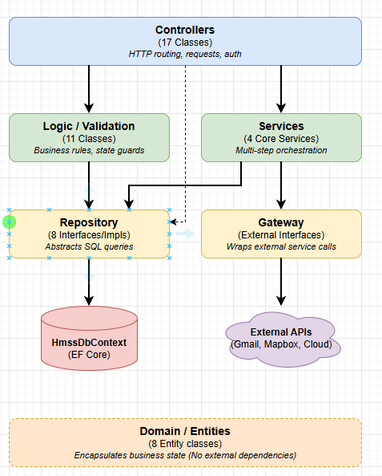

Layer | Components | Responsibility | Communicates With
Controllers | 17 Controller classes | HTTP routing, request binding, response formatting, authorization enforcement | Logic Layer, Services, Repositories (direct for simple queries)
Logic / Validation | 11 Logic classes (e.g. AuthenticationLogic, RentalRequestLogic) | Business rule validation, state transition guards, eligibility checks | Repository Layer
Services | PaymentService, SearchMatchingService, NotificationService, AccountStatusNotificationService | Orchestration of multi-step operations involving external gateways | Repository Layer, Gateway Layer
Repository | 8 Repository interfaces + implementations | All database read/write operations via EF Core; abstracts SQL queries | HmssDbContext (EF Core)
Gateway | IEmailGateway, ICloudStorageGateway, IMapGateway | Wraps all external service calls; allows mock substitution in tests | External APIs (Gmail SMTP, Mapbox, local filesystem / cloud)
Domain / Entities | 8 Entity classes with factory methods | Encapsulates business state and state transition rules (e.g. Publish(), Lock(), Revoke()) | (no external dependencies)

8.2. Component & Module Design

8.2.1 Repository Interfaces
All data access is performed through repository interfaces defined in Repositories/Interfaces/. Each repository corresponds to one aggregate root entity.
Interface | Entity | Key Methods
IUserAccountRepository | UserAccount | FindByEmailAsync, FindByIdAsync, FindManageableUserAccountsAsync, SaveAsync, UpdateAsync
IPropertyRepository | Property | FindByIdAsync, FindByOwnerIdAsync, SaveAsync, UpdateAsync
IRoomListingRepository | RoomListing | FindPublishedListingsAsync, FindPublishedByIdAsync, FindByOwnerIdAsync, FindByPropertyIdAsync, FindByStatusAsync, SaveAsync, UpdateAsync
IRentalRequestRepository | RentalRequest | FindByIdAsync, FindByIdWithPropertyAsync, FindByTenantIdAsync, FindByRoomIdAsync, FindAllByOwnerIdAsync, FindAcceptedByOwnerIdAsync, FindBestByOwnerAndTenantAsync, SaveAsync, UpdateAsync
IOwnerVerificationRepository | OwnerVerification | FindByIdAsync, FindPendingAsync, IsOwnerVerifiedAsync, SaveAsync, UpdateAsync
IConversationRepository | Conversation | FindByIdAsync, FindOrCreateAsync, FindByRequestIdAsync, FindByPairAsync, FindByParticipantAsync
IChatMessageRepository | ChatMessage | SaveAsync, FindByConversationIdAsync, FindByRequestIdAsync (last 50)
IPaymentRepository | Payment | FindByIdAsync, FindByRequestIdAsync, FindByOrderCodeAsync, SaveAsync, UpdateAsync

8.2.2 Gateway Interfaces
Interface | Current Implementation | Key Methods | External Service
IEmailGateway | EmailGateway (Gmail SMTP) | SendAsync(EmailMessage) | smtp.gmail.com:587
ICloudStorageGateway | CloudStorageGateway (Local FS) | UploadImagesAsync, UploadDocumentsAsync, RetrieveDocumentsAsync | Local ./uploads directory
IMapGateway | MapboxGateway | GetLocationDataAsync, GetPropertyLocationDataAsync, GetMapDataAsync | Mapbox Geocoding API

8.2.3 Services
Service | File | Key Methods | Used By
PaymentService | Services/PaymentService.cs | CreatePaymentLinkAsync, GetPaymentByRequestIdAsync, ProcessWebhookAsync | PaymentController
SearchMatchingService | Services/SearchMatchingService.cs | FilterByCriteria, BuildListingSummaries, BuildPropertySummaries | RoomSearchController
NotificationService | Services/NotificationService.cs | ComposeStatusChangedEmail | ReviewVerificationController
AccountStatusNotificationService | Services/AccountStatusNotificationService.cs | ComposeStatusChangedEmail (account events) | UserAccountAdminController
PropertyService | Services/PropertyService.cs | ValidatePropertyFields | PropertyController

8.3. State Machine Design

8.3.1 RoomListing Status State Machine
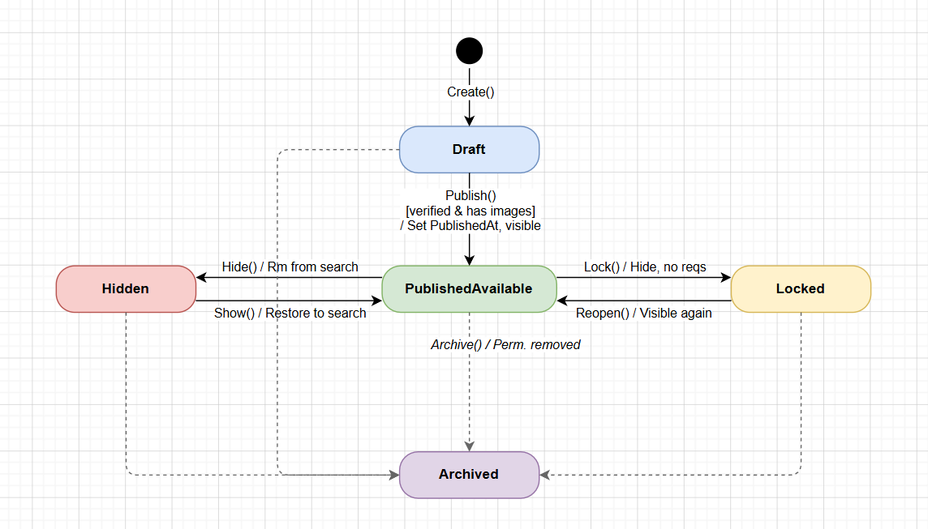
From State | To State | Trigger / Action | Side Effects
(new) | Draft | Create() factory method | None
Draft | PublishedAvailable | Publish() – owner verified + has images | PublishedAt = UTC now; listing visible in search
PublishedAvailable | Hidden | Hide() – owner action | Listing removed from public search
Hidden | PublishedAvailable | Show() – owner action | Listing restored to public search
PublishedAvailable | Locked | Lock() – on request Accept | New requests cannot be accepted; listing hidden from search
Locked | PublishedAvailable | Reopen() – on request Revoke | Listing visible again; new requests can be submitted
Any | Archived | Archive() – SystemAdmin action | Listing permanently removed from all views

8.3.2 RentalRequest Status State Machine
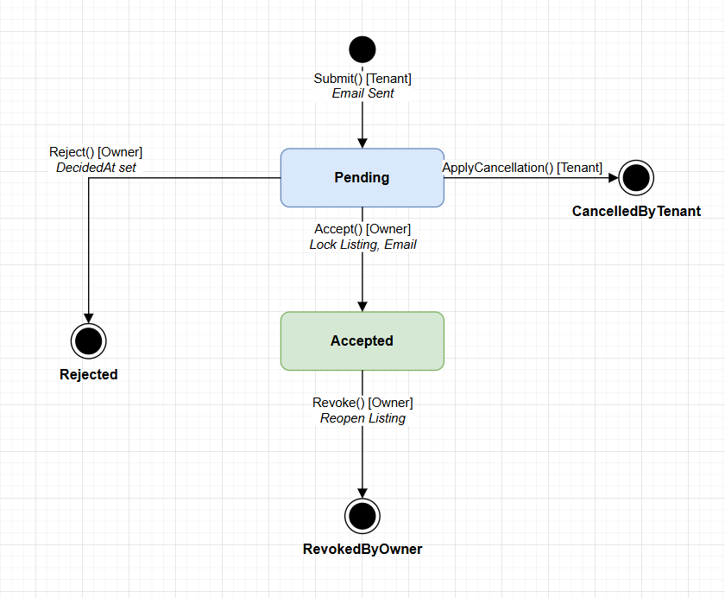
From State | To State | Trigger / Actor | Side Effects
(new) | Pending | Submit() – Tenant | Email to Tenant + Owner; RoomListing remains PublishedAvailable
Pending | Accepted | Accept() – Owner | RoomListing.Status → Locked; email to Tenant; DecidedAt set
Pending | Rejected | Reject() – Owner | DecidedAt set; RoomListing remains PublishedAvailable
Pending | CancelledByTenant | ApplyCancellation() – Tenant | None
Accepted | RevokedByOwner | Revoke() – Owner | RoomListing.Status → PublishedAvailable (reopened)

8.3.3 OwnerVerification Status State Machine
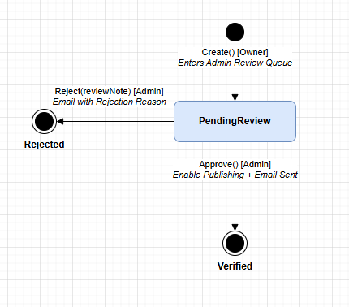
From State | To State | Trigger / Actor | Side Effects
(new) | PendingReview | Create() – Owner submits | Verification enters admin review queue
PendingReview | Verified | Approve() – SystemAdmin | Owner can now publish listings; email sent to owner
PendingReview | Rejected | Reject(reviewNote) – SystemAdmin | Email with rejection reason sent to owner

8.3.4 Payment Status State Machine
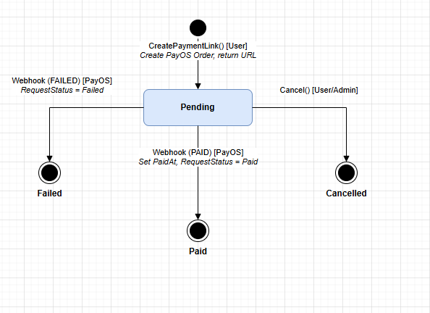
From State | To State | Trigger | Side Effects
(new) | Pending | CreatePaymentLink() – user action | PayOS order created; checkoutUrl returned
Pending | Paid | PayOS webhook (PAID event) | Payment.PaidAt set; RentalRequest.PaymentStatus = "Paid"
Pending | Failed | PayOS webhook (FAILED event) | RentalRequest.PaymentStatus = "Failed"
Pending | Cancelled | Cancel() – user/admin action | None

8.3.5 UserAccount Status State Machine
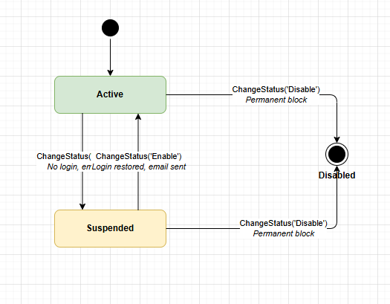
From Status | To Status | Trigger / Actor | Side Effects
Active | Suspended | ChangeStatus("Suspend") – Admin | User cannot log in; email notification sent
Suspended | Active | ChangeStatus("Enable") – Admin | User can log in again; email notification sent
Active | Disabled | ChangeStatus("Disable") – Admin | Permanent block; cannot be re-enabled
Suspended | Disabled | ChangeStatus("Disable") – Admin | Permanent block; cannot be re-enabled

8.4. Authentication & Authorization Design

8.4.1 JWT Token Structure
Claim | Value | Description
sub | UserId (Guid) | Subject identifier – uniquely identifies the user
email | User email address | Used for display and identification
jti | UUID (unique per token) | JWT ID – prevents token reuse in refresh scenarios
role | Tenant | Owner | SystemAdmin | Drives policy-based authorization decisions
exp | UTC + 30 minutes | Token expiry; requests with expired tokens receive HTTP 401

8.4.2 Authorization Policies
Policy Name | Required Role | Applied To
TenantOnly | Tenant | SubmitRentalRequestController, TenantRentalRequestController
OwnerOnly | Owner | PropertyController, RoomListingController, OwnerVerificationController, ReviewRentalRequestController
SystemAdminOnly | SystemAdmin | ReviewVerificationController, ControlListingController, UserAccountAdminController
(Bearer only) | Any role | AuthController (/me, /logout), ChatController, PaymentController

8.4.3 SystemAdmin Two-Factor Authentication Flow
Step 1: POST /api/auth/login with valid credentials → system returns { requiresVerification: true, userId }.
Step 2: System generates a 6-digit numeric code, stores it in IMemoryCache keyed by userId with TTL = 5 minutes, and sends it to the admin email via IEmailGateway.
Step 3: Admin submits POST /api/auth/verify-code { userId, code }.
Step 4: System retrieves the code from cache, compares it. On match: code removed from cache, JWT issued.
Step 5: On mismatch or expiry: HTTP 400 returned – admin must restart from Step 1.

8.4.4 Google OAuth 2.0 Flow
Step 1: GET /api/auth/google → system generates a CSRF state token, stores it in an HttpOnly cookie, redirects user to Google consent screen with scopes: openid email profile.
Step 2: User grants permission on Google.
Step 3: Google redirects to GET /api/auth/google/callback?code=&state=.
Step 4: System validates state cookie against query param (CSRF guard). Exchanges code for Google user profile (email, name).
Step 5: If email exists in UserAccounts → login. Otherwise → auto-register as Tenant.
Step 6: JWT issued, redirect to http://localhost:3000/login/google-callback?token=<jwt>.

8.5. External Integration Design

8.5.1 PayOS Payment Gateway Integration
Step | Actor | Action | Data
1 | User (Tenant) | POST /api/payment/create-link/{requestId} | requestId in URL
2 | PaymentService | Call PayOS API to create order | Amount derived from RentalRequest → Listing.Price
3 | System | Store Payment record (Status = Pending) | PayOSOrderCode, Amount, RequestId
4 | System → User | Return checkoutUrl to frontend | { paymentId, checkoutUrl, amount, status }
5 | User | Redirected to PayOS checkout page | (browser redirect)
6 | PayOS Server | POST /api/payment/webhook | { orderCode, status, paymentMethod?, transactionId? }
7 | PaymentService | Match orderCode → Payment record | Update Payment.Status + RentalRequest.PaymentStatus
8 | System | Return { success: true } to PayOS | (webhook acknowledgement)

8.5.2 Mapbox Geocoding Integration
Usage Point | Method Called | Input | Output
Search results page | GetLocationDataAsync(listings) | List of RoomListing objects | List<LocationDataDto> with lat/lng per listing
Search results page | GetPropertyLocationDataAsync(properties) | List of PropertySearchSummaryDto objects | List<PropertyLocationDataDto> with lat/lng per property
Property detail page | GetMapDataAsync(locationData) | MapLocation string from Property entity | MapDto with Mapbox tile data
Room detail page | GetMapDataAsync(locationData) | Address string from Property entity | MapDto with Mapbox tile data

8.5.3 Email Notification Triggers
Event | Recipient | Template / Subject
Rental request submitted | Tenant | "Your rental request has been submitted" – confirmation with listing details
Rental request submitted | Owner | "You have a new rental request" – tenant name, listing, move-in date
Request accepted | Tenant | "Your rental request has been accepted" – owner contact info
Owner verification approved | Owner | "Your identity verification has been approved" – can now publish listings
Owner verification rejected | Owner | "Your identity verification was rejected" – includes reviewNote
Account suspended | User | "Your account has been suspended" – reason and appeal instructions
Account disabled | User | "Your account has been permanently disabled"
SystemAdmin 2FA code | Admin | "Your HMSS login verification code: XXXXXX" – TTL: 5 minutes

8.6. Database Configuration & Migration Design

8.6.1 EF Core Migration History
Migration ID | Date | Description
20260321173603_Initial_create | 2026-03-21 | Base schema: all 8 tables, FK constraints, CHECK constraints on enums, seed data (6 owners, 1 admin, 1 tenant, 6 properties, 12 listings)
20260324142400_AddPropertyImagesRef | 2026-03-24 | Added ImagesRef column (nvarchar(max)) to Properties table
20260324221600_SeedPropertyImages | 2026-03-24 | Back-filled seed image URLs for all 6 seeded properties
20260417060119_AddIsRoommateWantedToRentalRequests | 2026-04-17 | Added IsRoommateWanted (bit, NOT NULL) column to RentalRequests table

8.6.2 Auto-Migration on Startup
The application calls db.Database.Migrate() inside a scoped service at startup (Program.cs). This ensures all pending migrations are applied automatically on deployment without manual DBA intervention. Seed data is inserted on first run via HasData() in OnModelCreating().

8.6.3 Seed Data (Development)
Email | Role | Password | Verified | Owns
admin@hmss.local | SystemAdmin | Admin@123! | N/A | N/A
owner@hmss.local | Owner | Owner@123! | Yes | Sunrise Hostel
owner2@hmss.local | Owner | Owner@123! | Yes | Central Park Residences
owner3@hmss.local | Owner | Owner@123! | Yes | Saigon Garden + Beachside Retreat
owner4@hmss.local | Owner | Owner@123! | Yes | Mountain View Lodge
owner5@hmss.local | Owner | Owner@123! | Yes | University Quarter House
tenant@hmss.local | Tenant | Tenant@123! | N/A | N/A

8.7. Dependency Injection Design (Program.cs)
All services, repositories, and gateways are registered in Program.cs using the ASP.NET Core DI container.
Registration | Lifetime | Interface → Implementation
HmssDbContext | Scoped | N/A (EF Core DbContext)
JwtTokenService | Singleton | N/A (token generation utility)
IUserAccountRepository | Scoped | → UserAccountRepository
IRoomListingRepository | Scoped | → RoomListingRepository
IRentalRequestRepository | Scoped | → RentalRequestRepository
IPropertyRepository | Scoped | → PropertyRepository
IOwnerVerificationRepository | Scoped | → OwnerVerificationRepository
IChatMessageRepository | Scoped | → ChatMessageRepository
IConversationRepository | Scoped | → ConversationRepository
IPaymentRepository | Scoped | → PaymentRepository
IEmailGateway | Scoped | → EmailGateway (Gmail SMTP)
ICloudStorageGateway | Scoped | → CloudStorageGateway (Local FS)
IMapGateway | Scoped | → MapboxGateway
AuthenticationLogic + 10 other Logic | Scoped | → concrete Logic classes
PaymentService + other Services | Scoped | → concrete Service classes
IMemoryCache | Singleton | → MemoryCache (2FA code storage)
SignalR | N/A | builder.Services.AddSignalR()

8.8. Configuration Design
All environment-specific values are managed through appsettings.json (development) and should be overridden via environment variables in production.
Configuration Key | Development Value | Production Notes
ConnectionStrings:DefaultConnection | Server=...\SQLEXPRESS;Database=HmssDb;TrustServerCertificate=True | Use managed cloud DB with SSL
Jwt:Secret | dev-secret-change-in-production-must-be-at-least-32-chars | MUST be replaced with a strong 64-char random secret
Jwt:ExpiryMinutes | 30 | Adjust based on security policy
Mapbox:AccessToken | pk.eyJ1Ijoi... (development token) | Use production Mapbox token with restricted scopes
GoogleOAuth:ClientId | 174358945930-... | Keep in environment variables, not in source code
GoogleOAuth:ClientSecret | GOCSPX-... | MUST be stored as a secret, never committed to source
Email:SmtpHost | smtp.gmail.com | Replace with SendGrid/SES for production volume
CloudStorage:Provider | Local | Change to "Azure" or "S3" for production deployment
CloudStorage:BasePath | ./uploads | Replace with cloud bucket path/URL

IX. Use Case Specifications
This section defines the behavioral requirements of the system from the user's perspective, using the UML Use Case Specification format. Each use case describes a single goal-driven interaction between an actor and the HMSS system.
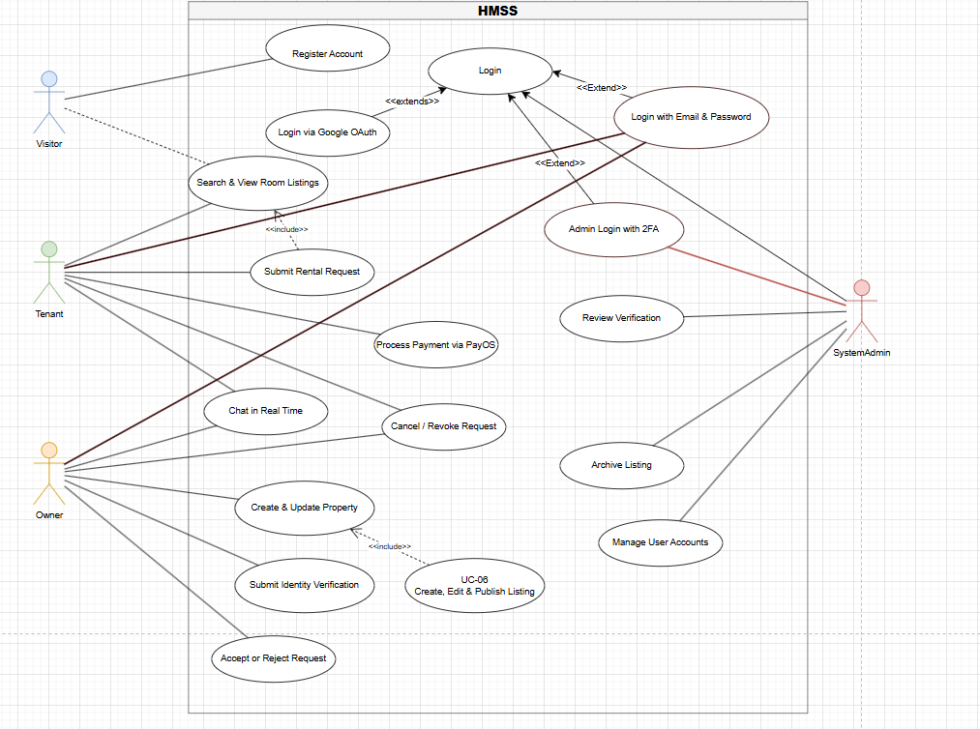
Use Case ID | Use Case Name | Primary Actor | Priority
UC-01 | Register Account | Visitor | Must
UC-02 | Login with Email & Password | Tenant / Owner | Must
UC-03 | Admin Login with 2FA | SystemAdmin | Must
UC-04 | Login via Google OAuth | Visitor | Should
UC-05 | Create & Update Property | Owner | Must
UC-06 | Create, Edit & Publish Room Listing | Owner | Must
UC-07 | Search & View Room Listings | Tenant | Must
UC-08 | Submit Rental Request | Tenant | Must
UC-09 | Accept or Reject Rental Request | Owner | Must
UC-10 | Cancel / Revoke Rental Request | Tenant / Owner | Must
UC-11 | Chat in Real Time | Tenant / Owner | Must
UC-12 | Process Payment via PayOS | Tenant | Should
UC-13 | Submit Owner Identity Verification | Owner | Must
UC-14 | Admin Review Owner Verification | SystemAdmin | Must
UC-15 | Admin Manage User Accounts | SystemAdmin | Must
UC-16 | Admin Archive Listing | SystemAdmin | Must

9.1. UC-01: Register Account
Attribute | Detailed Specification
Use Case ID | UC-01
Use Case Name | Register Account
Primary Actor | Visitor (unregistered user)
Goal | Create a new HMSS user account to access Tenant or Owner features.
Preconditions | 1. The visitor has not previously registered with the provided email.  2. The system registration endpoint is accessible.
Main Success Scenario | 1. Visitor opens the registration form (GET /api/auth/register).  2. Visitor enters: Full Name, Email, Phone, Password, Role (Tenant or Owner).  3. Visitor submits the form (POST /api/auth/register).  4. System validates: email uniqueness, password complexity, phone format, role validity.  5. System hashes the password using BCrypt.  6. System creates a UserAccount with AccountStatus = "Active".  7. System returns HTTP 201 with { userId, email, role, message }.
Alternative / Exception Flow | A1 – Email already registered: System returns HTTP 400 { Errors: ["Email is already in use"] }.  A2 – Password too weak: System returns HTTP 400 with complexity requirements.  A3 – Role = "SystemAdmin": System returns HTTP 400 – forbidden self-registration.  A4 – Missing required fields: System returns HTTP 400 with field-level validation errors.
Postconditions | 1. A new UserAccount record exists in the database with the provided details.  2. Password is stored as a BCrypt hash only.  3. User can now log in using the registered credentials.
Related Requirements | FR-01, NFR-02 (BCrypt hashing)

9.2. UC-02: Login with Email & Password (Tenant / Owner)
Attribute | Detailed Specification
Use Case ID | UC-02
Use Case Name | Login with Email & Password
Primary Actor | Registered Tenant or Owner
Goal | Authenticate and receive a JWT token to access protected features.
Preconditions | 1. The user has a registered account.  2. The account AccountStatus is "Active" (not Suspended or Disabled).
Main Success Scenario | 1. User submits POST /api/auth/login with { email, password }.  2. System retrieves UserAccount by email.  3. System verifies the submitted password against the BCrypt hash.  4. System generates a JWT with claims: sub, email, role, jti; expiry = 30 minutes.  5. System returns HTTP 200 with { token, userId, role, fullName, expiresAt }.
Alternative / Exception Flow | A1 – Email not found: HTTP 401 Unauthorized.  A2 – Wrong password: HTTP 401 Unauthorized.  A3 – Account Suspended: HTTP 403 Forbidden with suspension message.  A4 – Account Disabled: HTTP 403 Forbidden – permanent block.  A5 – Actor is SystemAdmin: System initiates 2FA flow instead (see UC-03).
Postconditions | 1. A valid JWT is returned to the client.  2. The frontend stores the JWT in memory/localStorage for subsequent requests.
Related Requirements | FR-02, NFR-03 (JWT expiry), NFR-02 (BCrypt)

9.3. UC-03: Admin Login with Two-Factor Authentication
Attribute | Detailed Specification
Use Case ID | UC-03
Use Case Name | Admin Login with 2FA
Primary Actor | SystemAdmin
Goal | Authenticate as SystemAdmin using 2FA to access admin management features.
Preconditions | 1. A SystemAdmin account exists and is Active.  2. Gmail SMTP is configured and reachable.
Main Success Scenario | 1. Admin submits POST /api/auth/login with { email, password }.  2. System verifies credentials (same as UC-02 Step 2-3).  3. System detects role = SystemAdmin; generates a 6-digit code.  4. System stores the code in MemoryCache with key = userId, TTL = 5 minutes.  5. System sends the code to the admin email via Gmail SMTP.  6. System returns HTTP 200 { requiresVerification: true, userId }.  7. Admin reads code from email.  8. Admin submits POST /api/auth/verify-code { userId, code }.  9. System retrieves code from cache; validates match.  10. System removes code from cache; issues JWT.  11. System returns { token, userId, role: "SystemAdmin", fullName, expiresAt }.
Alternative / Exception Flow | A1 – Wrong verification code: HTTP 400 "Invalid verification code".  A2 – Code expired (> 5 min): HTTP 400 "Code has expired"; admin restarts from Step 1.  A3 – Email delivery failure: admin must re-login to trigger code resend.  A4 – UserId not in cache: HTTP 400 "No pending verification".
Postconditions | 1. Admin holds a valid JWT with role=SystemAdmin.  2. The 2FA code is consumed and no longer valid.
Related Requirements | FR-03, NFR-03 (JWT)

9.4. UC-04: Create and Publish Room Listing (Owner)
Attribute | Detailed Specification
Use Case ID | UC-04
Use Case Name | Create, Edit and Publish Room Listing
Primary Actor | Owner (authenticated, Verified)
Goal | Make a room listing publicly visible so tenants can find and submit requests.
Preconditions | 1. Owner is authenticated (valid JWT, role = Owner).  2. Owner has created at least one Property.  3. Owner has been approved (OwnerVerification.Status = "Verified").
Main Success Scenario | 1. Owner retrieves property list (GET /api/property/my).  2. Owner requests listing creation form (GET /api/listing/form/{propertyId}).  3. Owner uploads room images (POST /api/listing/process) → receives imageUrls[].  4. Owner submits draft listing (POST /api/listing) with all fields including imageUrls.  5. System creates RoomListing with Status = "Draft". Returns { listingId }.  6. Owner checks publication eligibility (GET /api/listing/{listingId}/publish-check).  – System verifies: owner verified, listing has images, status = Draft.  7. Owner publishes listing (POST /api/listing/{listingId}/publish).  8. System sets Status = "PublishedAvailable", PublishedAt = UTC now.  9. Listing immediately appears in public search results.
Alternative / Exception Flow | A1 – Owner not verified: publish-check returns eligible=false with blocker message.  A2 – No images uploaded: publish-check blocks with "Listing must have at least one image".  A3 – Listing not in Draft: HTTP 400 "Invalid state transition".  A4 – Owner edits draft: PUT /api/listing/{listingId} updates fields, stays in Draft.
Postconditions | 1. RoomListing.Status = "PublishedAvailable".  2. PublishedAt timestamp is set.  3. Listing visible in GET /api/room-search/page results.
Related Requirements | FR-06, FR-07, NFR-04 (authorization)

9.5. UC-05: Search & View Room Listings (Tenant)
Attribute | Detailed Specification
Use Case ID | UC-05
Use Case Name | Search and View Room Listings
Primary Actor | Tenant (or any visitor – no auth required)
Goal | Discover available room listings that match personal requirements.
Preconditions | 1. At least one RoomListing with Status = "PublishedAvailable" exists.  2. Mapbox API is reachable (for map enrichment).
Main Success Scenario | 1. Visitor opens the search page (GET /api/room-search/page).  2. System returns all PublishedAvailable listings with Mapbox coordinates.  3. Visitor optionally applies filters (POST /api/room-search/search)  with criteria: minPrice, maxPrice, capacity, furnishedStatus, location, amenities.  4. System filters listings via SearchMatchingService; returns matching results.  5. Visitor selects a listing; frontend calls GET /api/room/{listingId}.  6. System returns full listing detail: price, capacity, amenities, property info, images, map data.
Alternative / Exception Flow | A1 – No listings match filters: hasResults = false, empty summaries array returned.  A2 – Mapbox API unavailable: listings returned without geocoordinates (graceful degradation).  A3 – Listing is Locked/Hidden/Archived: GET /api/room/{listingId} returns HTTP 404.
Postconditions | 1. Visitor sees a list of available rooms with location markers on map.  2. No side effects on database state.
Related Requirements | FR-09

9.6. UC-06: Submit Rental Request (Tenant)
Attribute | Detailed Specification
Use Case ID | UC-06
Use Case Name | Submit Rental Request
Primary Actor | Tenant (authenticated)
Goal | Formally apply to rent a specific published room listing.
Preconditions | 1. Tenant is authenticated (JWT, role = Tenant).  2. Target listing Status = "PublishedAvailable".  3. Tenant has no existing Pending request for this listing.
Main Success Scenario | 1. Tenant views listing detail and clicks "Request to Rent".  2. Tenant retrieves pre-filled form (GET /api/rental-request/form/{listingId}).  3. Tenant fills: moveInDate, expectedRentalDuration, occupantCount, occupationCategory,  isRoommateWanted, budgetExpectation, contactPhone, preferredContactMethod, specialNotes.  4. Tenant submits (POST /api/rental-request).  5. System validates: listing available, no duplicate, occupantCount ≤ capacity.  6. System creates RentalRequest with Status = "Pending", PaymentStatus = "Unpaid".  7. System sends email to Tenant: "Request submitted confirmation".  8. System sends email to Owner: "New rental request received".  9. System returns HTTP 201 { requestId, status: "Pending", message }.
Alternative / Exception Flow | A1 – Listing not PublishedAvailable: HTTP 400 with reason.  A2 – Duplicate pending request: HTTP 400 "You already have a pending request for this listing".  A3 – OccupantCount > capacity: HTTP 400 validation error.  A4 – Invalid moveInDate (past date): HTTP 400.
Postconditions | 1. RentalRequest created with Status = "Pending".  2. Both tenant and property owner receive email notifications.
Related Requirements | FR-10

9.7. UC-07: Accept or Reject Rental Request (Owner)
Attribute | Detailed Specification
Use Case ID | UC-07
Use Case Name | Accept or Reject Rental Request
Primary Actor | Owner (authenticated)
Goal | Review and make a binding decision on a tenant's rental request.
Preconditions | 1. Owner is authenticated (JWT, role = Owner).  2. RentalRequest.Status = "Pending" and belongs to owner's listing.  3. For Accept: RoomListing.Status = "PublishedAvailable".
Main Success Scenario – Accept | 1. Owner views pending requests (GET /api/rental-request/owner-all).  2. Owner reviews tenant details (GET /api/rental-request/{id}/owner-detail).  3. Owner accepts (POST /api/rental-request/{id}/accept).  4. System sets: RentalRequest.Status = "Accepted", DecidedAt = UTC now.  5. System atomically sets: RoomListing.Status = "Locked".  6. System sends email to tenant: "Your request has been accepted".  7. System returns { requestId, newStatus: "Accepted", message }.
Main Success Scenario – Reject | 3b. Owner rejects (POST /api/rental-request/{id}/reject).  4b. System sets: RentalRequest.Status = "Rejected", DecidedAt = UTC now.  5b. RoomListing remains PublishedAvailable.
Alternative / Exception Flow | A1 – Request not Pending: HTTP 400 "Request is not in a reviewable state".  A2 – Listing not PublishedAvailable (for Accept): HTTP 400 "Listing is no longer available".  A3 – Request belongs to different owner: HTTP 403 Forbidden.
Postconditions | Accept: Request = Accepted, Listing = Locked, email sent to Tenant.  Reject: Request = Rejected, Listing stays PublishedAvailable.
Related Requirements | FR-11

9.8. UC-08: Real-Time Chat Between Owner and Tenant
Attribute | Detailed Specification
Use Case ID | UC-08
Use Case Name | Real-Time Chat
Primary Actor | Tenant or Owner (both authenticated)
Goal | Exchange messages in real time to negotiate rental terms or discuss details.
Preconditions | 1. Both participants are authenticated with valid JWTs.  2. A Conversation exists or can be created (via /from-request or /start).
Main Success Scenario | 1. User opens conversation list (GET /api/chat/conversations).  2. User selects or creates conversation.  – For request-linked: POST /api/chat/conversations/from-request/{requestId}.  – For direct: POST /api/chat/conversations/start { otherPartyId }.  3. User loads chat history (GET /api/chat/conversations/{conversationId}/history).  4. Frontend establishes WebSocket: ws://.../hub/chat?access_token=<jwt>.  5. Frontend calls hub method: JoinConversation(conversationId).  6. User sends message: SendConversationMessage(conversationId, body).  7. Server persists message to ChatMessages table.  8. Server broadcasts ReceiveMessage event to all group members.  9. Server sends NewChatMessage notification to recipient's user-{userId} group.
Alternative / Exception Flow | A1 – Invalid JWT in WebSocket query: connection rejected (401).  A2 – Message body > 2000 chars: validation error.  A3 – Conversation not found: 404 returned from REST; hub send silently ignored.
Postconditions | 1. Message persisted in ChatMessages table.  2. All connected participants in the conversation receive the message in real time.
Related Requirements | FR-13, NFR-05 (latency)

9.9. UC-09: Process Payment via PayOS (Tenant)
Attribute | Detailed Specification
Use Case ID | UC-09
Use Case Name | Process Rental Deposit Payment via PayOS
Primary Actor | Tenant (authenticated); Secondary: PayOS (external system)
Goal | Pay the rental deposit for an accepted rental request using PayOS.
Preconditions | 1. RentalRequest.Status = "Accepted".  2. No existing Paid payment for the same request.  3. PayOS credentials configured in appsettings.json.
Main Success Scenario | 1. Tenant requests payment link (POST /api/payment/create-link/{requestId}).  2. System calls PayOS API to create payment order with rental amount.  3. System stores Payment record (Status = "Pending", PayOSOrderCode assigned).  4. System returns { checkoutUrl, paymentId, amount, status }.  5. Frontend redirects tenant to PayOS checkout page (checkoutUrl).  6. Tenant completes payment on PayOS platform.  7. PayOS calls POST /api/payment/webhook { orderCode, status: "PAID", transactionId }.  8. System matches orderCode → Payment record.  9. System sets Payment.Status = "Paid", PaidAt = UTC now.  10. System sets RentalRequest.PaymentStatus = "Paid".  11. System returns { success: true } to PayOS.
Alternative / Exception Flow | A1 – PayOS API unreachable: HTTP 502 returned to tenant.  A2 – Payment fails on PayOS: webhook status = "FAILED"; Payment.Status = "Failed".  A3 – Duplicate webhook: system is idempotent (already-Paid records not re-updated).  A4 – Tenant checks status: GET /api/payment/by-request/{requestId}.
Postconditions | 1. Payment.Status = "Paid", RentalRequest.PaymentStatus = "Paid".  2. PaidAt timestamp recorded for audit.
Related Requirements | FR-14

9.10. UC-10: Admin Reviews Owner Verification
Attribute | Detailed Specification
Use Case ID | UC-10
Use Case Name | Admin Review Owner Identity Verification
Primary Actor | SystemAdmin (authenticated)
Goal | Verify owner identity so they are authorized to publish listings on the platform.
Preconditions | 1. Admin is authenticated (JWT, role = SystemAdmin).  2. At least one OwnerVerification with Status = "PendingReview" exists.
Main Success Scenario | 1. Admin views pending submissions (GET /api/admin/verification).  2. Admin opens a submission (GET /api/admin/verification/{verificationId}).  3. Admin reviews: personalInformation, ID document URL, supporting documents.  4. Admin approves (POST /api/admin/verification/{id}/approve { reviewNote }).  5. System sets OwnerVerification.Status = "Verified", ReviewedAt = UTC now.  6. System sends approval email to the owner.  7. Owner can now publish listings (publish-check will pass).
Alternative / Exception Flow | A1 – Admin rejects: POST /api/admin/verification/{id}/reject { reviewNote }.  System sets Status = "Rejected"; email with rejection reason sent to owner.  Owner must re-submit a new verification.  A2 – Verification not in PendingReview: HTTP 400.  A3 – Missing reviewNote on rejection: HTTP 400.
Postconditions | Approve: OwnerVerification.Status = "Verified"; owner unblocked for publishing.  Reject: OwnerVerification.Status = "Rejected"; owner notified by email.
Related Requirements | FR-16, FR-08

2.1. Visitor browses the Home Page
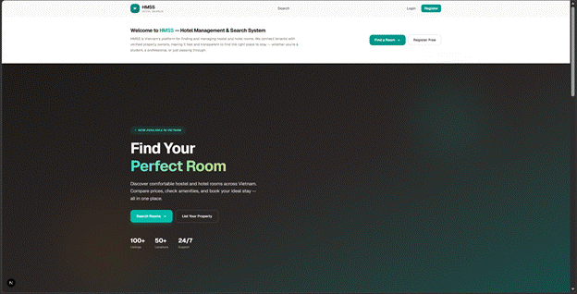
The visitor accesses the application at the root URL. The Home Page displays a hero section with a welcoming message, an overview of the platform’s features (search rooms, submit requests, manage properties), a “How It Works” step-by-step guide, information for property owners, and a call-to-action to register. The navigation bar provides links to Search, Login, and Register.

X. Use Case Specifications

10.1. Visitor registers a new account
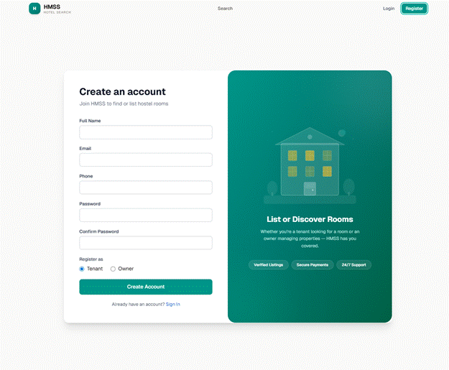
The visitor clicks “Register” and fills in the registration form: full name, email, phone number, password, and selects a role (Tenant or Owner). Upon successful registration, the user is redirected to the Login page.

10.2. User logs in with email/password or Google OAuth
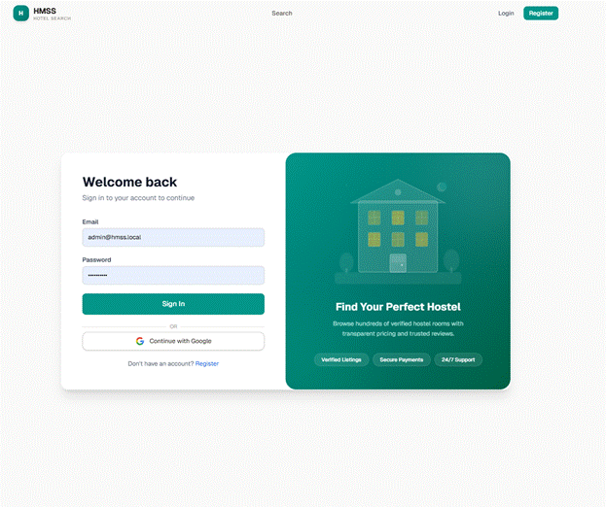
The user enters their email and password to authenticate. Alternatively, they can click “Continue with Google” to log in via Google OAuth 2.0. After successful authentication, the system issues a JWT token and redirects the user to their role-appropriate dashboard (Owner → Properties page, Tenant → My Requests page, Admin → User Management).

10.3. Visitor searches for rooms with filters and interactive map
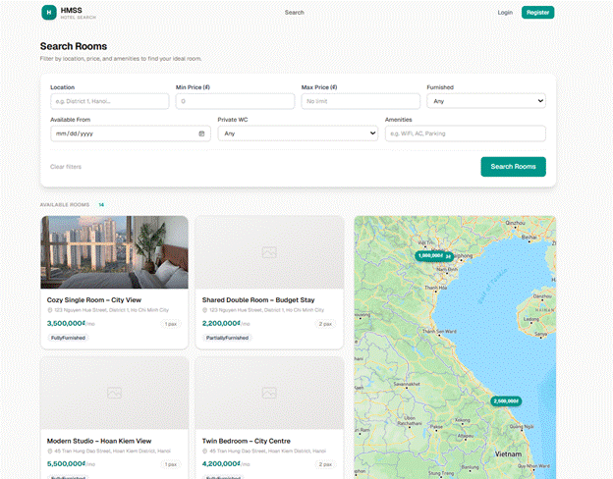
The search page displays a filter form at the top (location, min/max price, furnished status). Results appear as listing cards on the left panel and interactive Google Map with price pins on the right panel (desktop). Hovering over a listing card highlights the corresponding map pin and vice versa. Clicking a map pin scrolls to the listing card. On mobile, users toggle between List and Map views.

10.4. Visitor views room detail with image gallery and embedded map
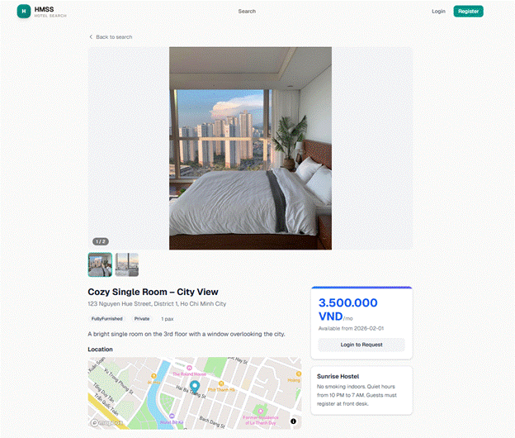
The room detail page shows a full image gallery with responsive display and fullscreen lightbox (click “View Full” to enlarge), room title, monthly price in VND, capacity, amenities list, furnished status, private WC status, availability date, detailed description, property general policies, and an embedded Google Map showing the property location. Tenants see a “Submit Rental Request” button and a “Contact Owner” button to start a direct conversation.

10.5. Tenant submits a rental request
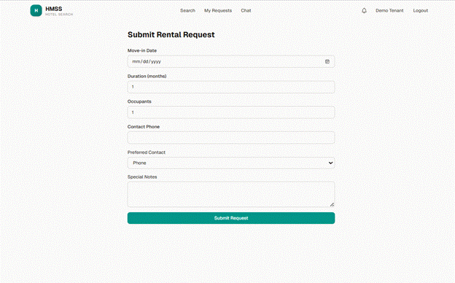
The tenant fills in the rental request form: move-in date, expected duration (months), occupant count, occupation category, budget expectation (VND), contact phone, preferred contact method (Phone/Email/WhatsApp), and optional special notes. A summary card shows the listing being requested.

10.6. Tenant views and manages rental requests
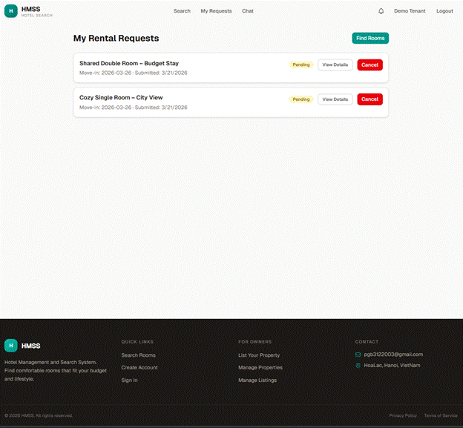
The tenant’s requests page lists all submitted rental requests with status badges (Pending, Accepted, Rejected, Cancelled, Revoked). Users can filter by status. Pending requests can be cancelled via a confirmation modal.

10.7. Tenant and Owner communicate via real-time chat (Request Detail)
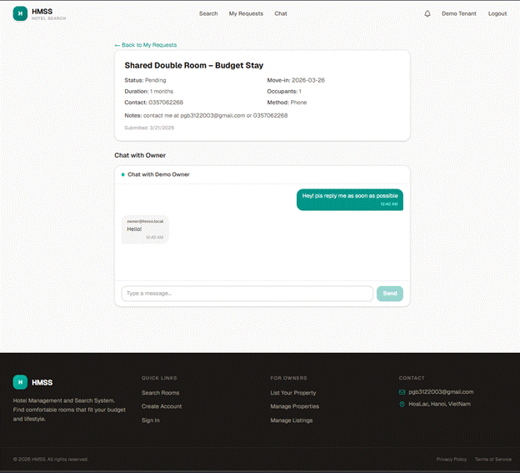
The request detail page includes an integrated chat box powered by SignalR WebSocket. The chat auto-resolves the request to a conversation — if no conversation exists for the owner-tenant pair, one is created and any legacy request-scoped messages are backfilled. Both participants see the same conversation whether they access it from the request detail page or the dedicated chat page.

10.8. Tenant views conversations on dedicated chat page
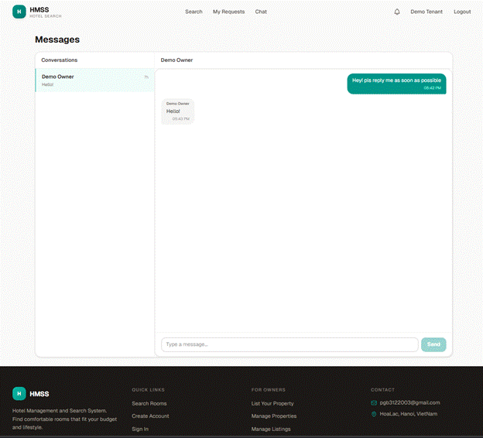
The tenant chat page displays all conversations in a split-view layout. The left panel lists all conversations with the other party’s name, listing title (if linked to a request), last message preview, and time-ago timestamp. The right panel shows the active conversation with full message history. On mobile, users toggle between list and chat views.

10.9. Owner manages properties
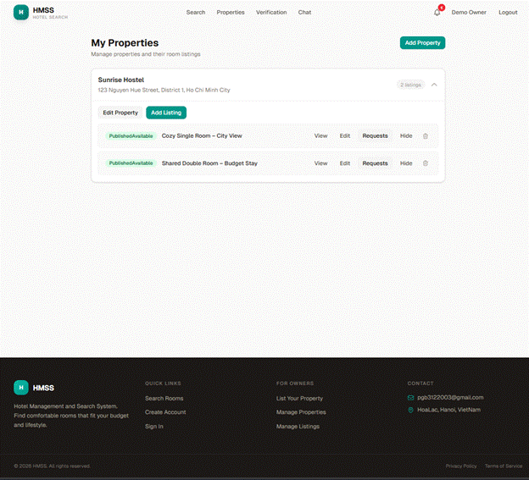
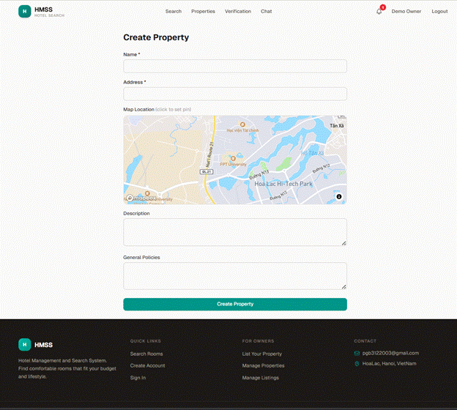
The owner’s properties page displays all properties as expandable accordion cards. Each property shows its details and nested room listings with status badges. The owner can create new properties, edit existing ones, and navigate to listing management.

10.10. Owner creates and manages room listings
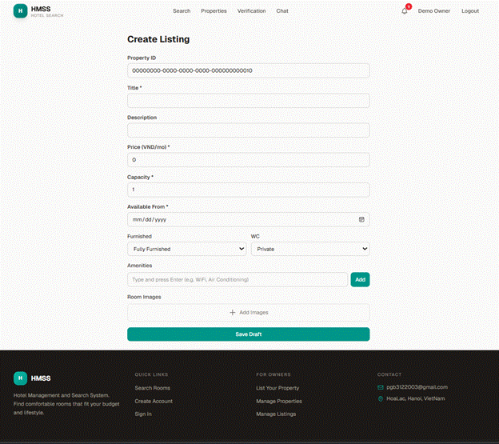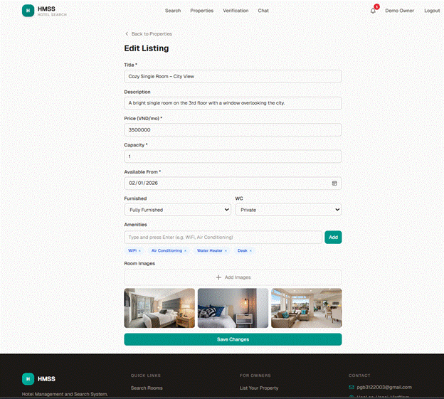
The owner creates a new listing by selecting a property and filling in: title, description, monthly price, capacity, amenities, available from date, furnished status, private WC status, and uploading room images. After saving as Draft, the owner can publish the listing (if verified), hide/show, or archive it.

10.11. Owner submits identity verification
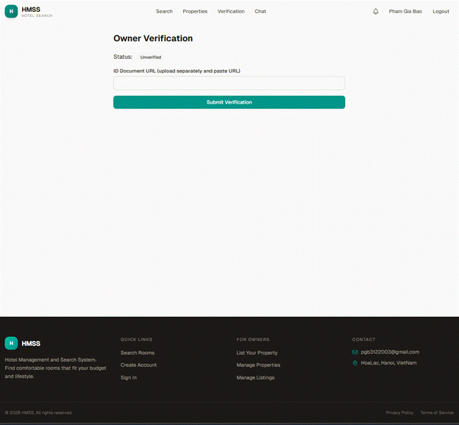
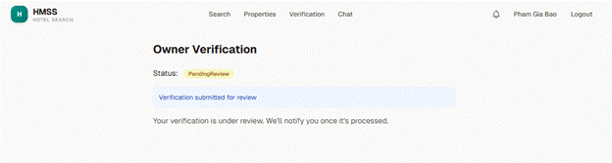
The verification page allows owners to submit their identity documents for admin review. The form includes personal information, ID document upload, and optional supporting documents. The current verification status is displayed.

10.12. Owner reviews tenant rental requests
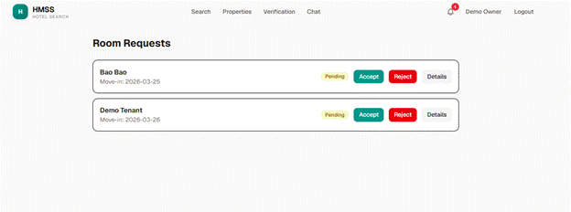
The owner views all rental requests for a specific room listing. For pending requests, the owner can Accept (locks the listing) or Reject the request. For accepted requests, the owner can Revoke (unlocks the listing).

10.13. Owner views categorized chat inbox
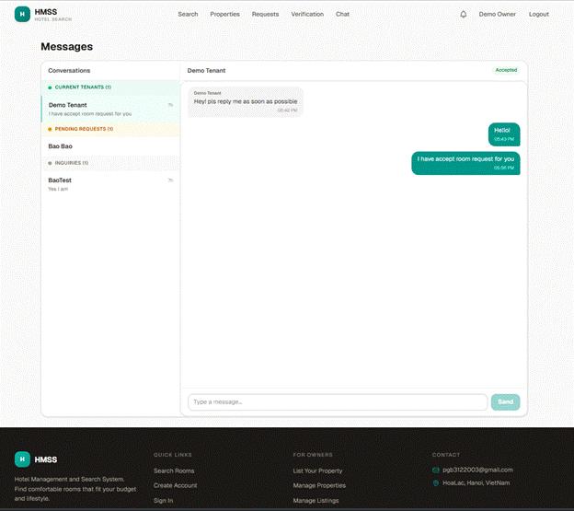
The owner’s chat page displays a categorized conversation inbox with three visually distinct sections:
● Current Tenants (green indicator) — conversations with tenants whose rental requests have been accepted
● Pending Requests (amber indicator) — conversations with tenants who have pending rental requests
● Inquiries (gray indicator) — conversations with tenants who have no active request or whose requests were rejected/cancelled
Each conversation shows the tenant’s name, linked listing title (if any), request status badge, last message preview, and time-ago timestamp. Category headers are sticky and show conversation counts. The conversation list updates in real-time via SignalR — when a new tenant sends a message, it appears immediately without requiring a page refresh. The right panel shows the active conversation with full message history.

10.14. Admin manages user accounts
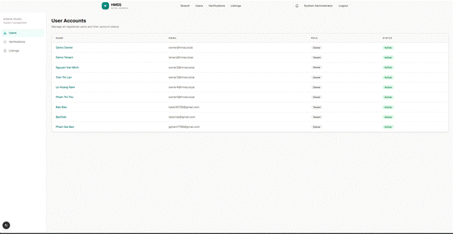
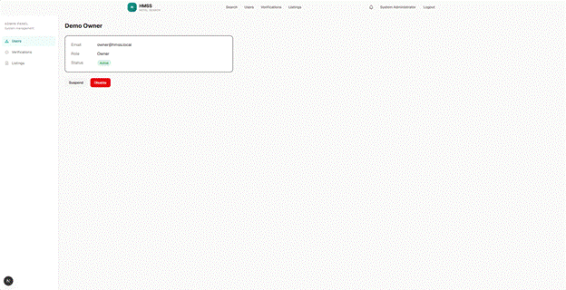
The admin user management page lists all user accounts with full name, email, role, and account status. Clicking a user opens the detail page where the admin can Suspend, Enable, or Disable the account following the state machine rules. Admins cannot disable their own account (self-protection).

10.15. Admin reviews owner verifications
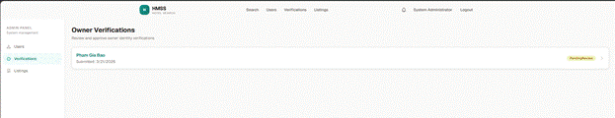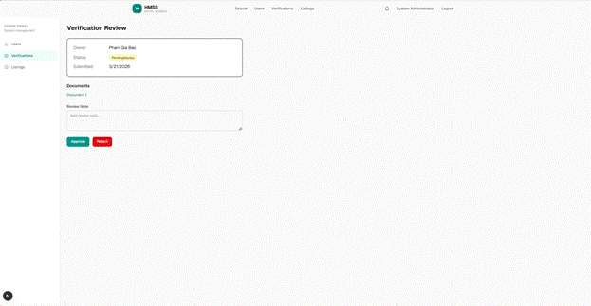
The admin verifications page lists pending owner verification submissions. The admin clicks a verification to review the submitted documents (ID document, supporting docs) and can Approve or Reject with review notes.

10.16. Admin moderates room listings
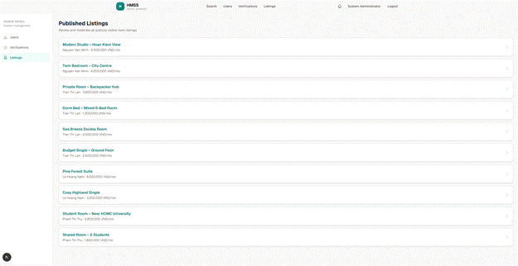
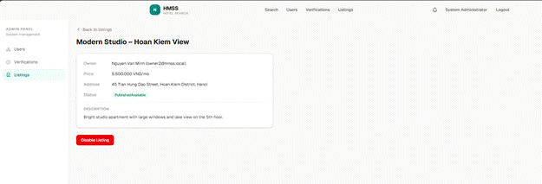

The admin listings moderation page shows all visible room listings. The admin can view listing details and disable inappropriate listings.

10.17. Payment
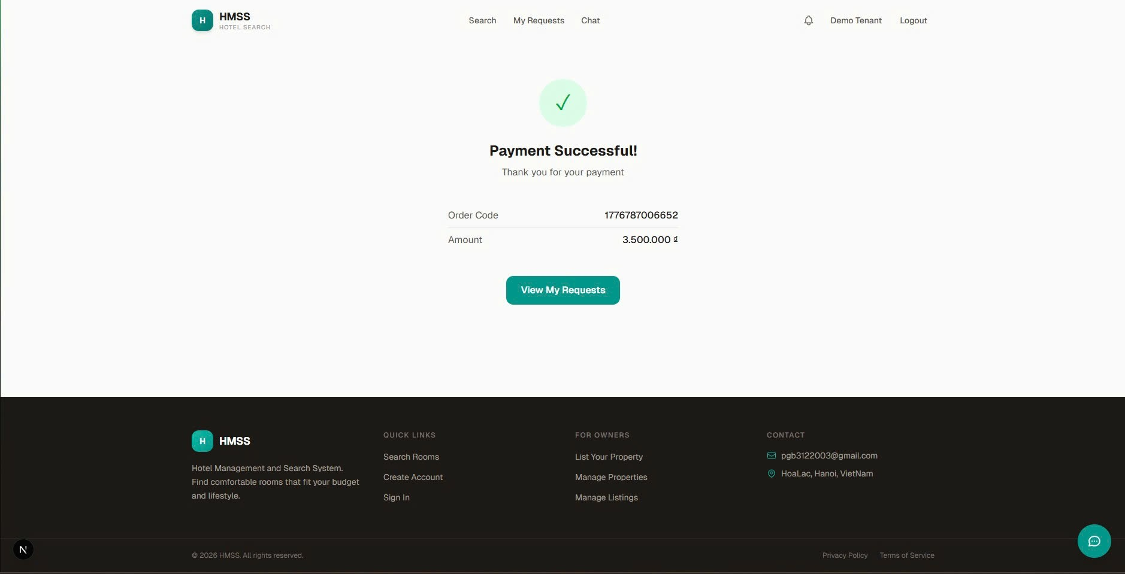

After completing the transaction, the user arrives at this confirmation page to verify their payment details, such as the Order Code and the total amount paid. Once they confirm the success of the transaction, the user typically clicks the "View My Requests" button to navigate back to their dashboard, where they can monitor the booking status or initiate a conversation with the property owner via the chat feature.

