**National University of Ho Chi Minh City**

**UNIVERSITY OF INFORMATION TECHNOLOGY**

**DEPARTMENT OF INFORMATION SYSTEMS**



**PROJECT REPORT**

**SYSTEM ANALYSIS AND DESIGN**

**TOPIC**

**BUILDING SYSTEM TO MANAGE SHOE STORE**

**Instructors:** Dr. Cao Thi Nhan

MSc. Duong Phi Long

**Class:** MSIS3303.N22.CTTT

**Students:**

Nguyễn Minh Thành 20521920

Quách Vinh Quang 20521811

Nguyễn Văn Tân 20521880

Tống Trường Thịn 20521958

**Ho Chi Minh City, June 20, 2023**

# ACKNOWLEDGMENT

*Dear* ***Dr.Cao Thi Nhan and MSc. Duong Phi Long,*** *who are teaching**at the University of Information Technology!*

First and foremost, I would like to express my deepest gratitude to ***Dr.Cao Thi Nhan*** who always cared for our team during this course. I appreciate your assistance and the sharing of your valuable experience, which will help us accomplish our project. I would sincerely like to thank Mr. Long, who teaches and supports our team throughout our course.

I would like to take this opportunity to thank ***MSc.Duong Phi Long*** for permitting us to carry out our project. Finally, I would like to express how honored when our team was able to learn from and attend your class.

Many thanks to ***Dr.Cao Thi Nhan*** and ***MSc.Duong Phi Long*** for your tireless efforts in guiding the team to success and encouraging our team to keep moving forward. My heartfelt gratitude goes to all of my classmates, especially my friends, for devoting their time to assisting and supporting our team in the fabrication of our project.

Ho Chi Minh City, 20 June 2023

Yours Sincerely,

Team 3

# COMMENTS

……………………………………………………………………………………

……………………………………………………………………………………

……………………………………………………………………………………

……………………………………………………………………………………

……………………………………………………………………………………

……………………………………………………………………………………

……………………………………………………………………………………

……………………………………………………………………………………

……………………………………………………………………………………

……………………………………………………………………………………

……………………………………………………………………………………

……………………………………………………………………………………

……………………………………………………………………………………

……………………………………………………………………………………

……………………………………………………………………………………

……………………………………………………………………………………

……………………………………………………………………………………

……………………………………………………………………………………

……………………………………………………………………………………

……………………………………………………………………………………

……………………………………………………………………………………

……………………………………………………………………………………

……………………………………………………………………………………

……………………………………………………………………………………

……………………………………………………………………………………

……………………………………………………………………………………

……………………………………………………………………………………

……………………………………………………………………………………

……………………………………………………………………………………

……………………………………………………………………………………

**SHOES SALES MANAGEMENT APPLICATION**

**Table of Contents**

ACKNOWLEDGMENT 2

COMMENTS 3

Chapter 1: INTRODUCTION 1

1.1. Introduction 1

1.3. Research Objectives / Objectives of the project 2

1.4. Scope of project / Limitations of the study 2

1.5 Developer tools & Technology 3

Chapter 2: REQUIREMENT SPECIFICATION 3

2.1. Situation survey/ Survey of the current situation 3

2.1.1 Interview 3

2.1.2. Survey of the organization/ Current organizational situation 11

2.1.3. Survey of business processes, major activities 12

2.2. Software requirements 16

2.2.1. Functional requirements 16

2.2.2. Non-functional requirements 17

Chapter 3: ANALYSIS AND DESIGN 17

3.1. Business Function Diagram (BFD) 18

3.2. Data Flow Diagram (DFD) 18

3.3. Entity Relational Data model (ERD) 28

3.4. Relational Data model (RDM) 30

Chapter 4: IMPLEMENTATION AND TESTING 30

4.1. Introduction to the implementation environment 31

4.2. User Interface 32

Chapter 5: CONCLUSION 39

References 39

# Chapter 1: INTRODUCTION

## 1.1. Introduction

In the age of technology, having a website has played a crucial part in managing business. Not only it helps to establish an online presence throughout the week, but also creates an opportunity for the enterprise to showcase their products internationally. When it comes to industries whose external appearance or movement are essential, footwear is the product that needs consideration the most. Following the rise of e-commerce, building a website for shoes management has contributed to the success of the shoes business. In this topic, we are going to discuss a lot of key aspects of building a shoes management website like gathering user requirements, designing an inventory management system ... and ensure that the website is visually attractive, functional and profitable.

**1.2. Research problems / Problems of the project**

Due to the geographical issue between the store and the customer, the proposed solution is an application (web-based, mobile-based, desktop-based) that aims to deliver information to customers as soonest. Customers are not only convenient in retrieving information about the products they intend to buy, but also easily perform operations such as booking or selecting size, color, etc. In addition, users can access the cinema-group containing lots of cinemas with variant choices (showtimes, places, seats, etc.). Customers can manage their point, membership status; the store is able to take advantage of customers’ information to make promotions for marketing. Nowadays, almost all stores have been applying technology to management and information delivery systems, but there are still problems.

Inventory Management: one of the key challenges for shoe stores is managing their inventory effectively. Research could explore how to optimize inventory levels based on customer demand, seasonal trends, and supplier lead times.

Online Sales: With the rise of e-commerce, shoe stores need to have a strong online presence to remain competitive. Research could explore how to optimize online sales channels, including website design, search engine optimization, and social media marketing. This could involve developing user-friendly interfaces, using data analytics to track customer behavior, and implementing targeted online advertising.

## 1.3. Research Objectives / Objectives of the project

The objectives of this project are to develop a website for shoe sales management that provides efficient and streamlined management of the following:

* Manage shoe inventory levels and product information to ensure the availability of stock and accurate product details.
* Manage user accounts and login information to ensure secure and personalized access to the website.
* Manage transaction information to ensure accurate and efficient processing of customer orders.
* Manage the latest information updates to keep customers informed about new arrivals and trends.
* Manage a backup system to ensure the safety and security of all data, including inventory, user information, and transactions.

## 1.4. Scope of project / Limitations of the study

Because of limitations about time, human, our teams focus to some main features such as:

* + Login to Admin/Customer Page
  + Customer management.
  + Product management.
  + Retrieval information
  + Make simple statistical charts

## 1.5 Developer tools & Technology

* Git / GitHub for version control.
* Visual Studio Code as a text editor.
* Draw.io as a diagram designing tool.
* Figma as a UI designing tool.

# Chapter 2: REQUIREMENT SPECIFICATION

## 2.1. Situation survey/ Survey of the current situation

Survey is one of the important parts in the software engineering process. Through conducting a situation survey, not only it gains our team a better understanding of the organization needs and expectations about the system, but also it helps in ensuring that the software system is designed and developed to meet the specific requirements of the organization and align with its goals. The situation survey of the Shoe Sales Management System is splitted into four smaller parts: Interview, survey of the organization, survey of business processes, survey of the existing system.

### 2.1.1 Interview

Establish an interview plan from preliminary to detailed, content and results with some notes about the interview with the partner of the project Building a shoe sales management application:

|  |  |  |  |  |
| --- | --- | --- | --- | --- |
| **Preliminary Interview Plan**  Project Name: Shoe store management application  Planned by: Quách Vinh Quang  Date: March 21, 2022 | | | | |
| No. | Topic | Achieved Goals | Start date | End date |
| 1 | Import Product Management | Understand the store's import process. | March 23, 2022 | March 23, 2022 |
| 2 | Product Management | Understand how to manage product inventory. | March 23, 2022 | March 23, 2022 |
| 3 | Customer Management | Understand how to manage customer. | March 23, 2022 | March 23, 2022 |
| 4 | Requirements about information technology: interface, hardware, software support | Learn more about the store's existing machinery resources to make the design plan, understand the customer's requirements for the system, and suggest to the customer the resource systems that need to be prepared. | March 23, 2022 | March 23, 2022 |

*Table 1 Preliminary interview plan*

|  |  |
| --- | --- |
| **Detailed Interview Plan**  Project Name: Shoe store management application  Planned by: Quách Vinh Quang  Date: March 23, 2022 | |
| **Start date & End date** | * Start: 9h00, March 23, 2022 * End: 11h15, March 23, 2022 |
| **Interview Location** | Directly at Dormitory A of the National University |
| **Interviewer team** | Consist of 2 members:   * Nguyễn Minh Thành: Lead Interviewer * Quách Vinh Quang |
| **Interviewee team** | Consist of 2 members:   * Nguyễn Văn Tân: Lead Project Partner * Tống Trường Thịnh |
| **Goals** | Capture and collect enough information about the items outlined in the preliminary interview plan made on March 21, 2022. |
| **Detailed Interview** | The interview took place with the following schedule of sections:   * Project Introduction and Validation. * Overview of the system to be built for the store. * In-depth system analysis: * Topic 1: Import Product Management. * Topic 2: Product Management. * Topic 3: Customer Management. * Topic 4: Requirements about information technology: interface, hardware, software support. |
| **Expected Time** | Expected time for each section of the interview:   * Project Introduction and Validation: **15 minutes** * Overview of the system to be built for the store: **30 minutes** * In-depth system analysis: **2 hours** |
| **General result** | * At the end of the interview, the interviewer team collected the necessary information to analyze the design of a project of building an application to manage shoe sales. * The partners are very open to contributing to the project and accepting the team's suggestions on how to build the application. |
| **Unexpected occurrence** | * No unexpected occurrences happened. |
| **Conclusion & Notes** | * If there are any additional requirements in the execution process, you can contact us, we are free to discuss improving the software in the best way possible. * Contact information: * Phone number: 0902 659 897 * Contact email: 20521920@gm.uit.edu.vn * Thank you for the information you have provided today, see you in the nearest day. |

*Table 2 Detailed interview plan*

|  |  |  |  |
| --- | --- | --- | --- |
| **Detailed Interview Content Table**  Project Name: Shoe store management application  Planned by: Quách Vinh Quang  Date: March 23, 2022 | | | |
| **Question** | | **Record** | **Answer attitude** |
| ***Topic 1***: Import Product Management. | *Question 1*: How are the regulations on controlling the amount of inventory to know when to import new goods? | Planning to organize personnel and assigning import operations, making reports of goods in the warehouse monthly and quarterly. Rely on annual reports to know when to add new stock and dispose of inventory. | Open-minded, enthusiastic |
| *Question 2:* What is the time to conduct periodic inspection and review of inventory product quality? | Staff will check and review a minimum of 2 times per quarter, and may have an unannounced inspection. | Open-minded, enthusiastic |
| *Question 3:* How will the commodity number be classified to facilitate the export of goods? | According to the manufacturer's batch number, classified according to the grade of the goods. | Open-minded, enthusiastic |
| ***Topic 2:*** Product Management | *Question 1*: How are the regulations on storing goods in the warehouse? | Goods will be stored in the physical warehouse, the physical warehouse location can be at the store if the quantity of goods is small, in addition, only warehouse staff can go to the warehouse. | Open-minded, enthusiastic |
| *Question 2:* How is the price of product determined? Does the product price affect the product quantity? | Product prices are set at a fixed market price, which will change depending on the sales of that product. The product quantity may vary depending on the price of the product. | Open-minded, enthusiastic |
| *Question 3:* How is product information stored? | Store on specialized software: product name, quantity and price of product. | Open-minded, enthusiastic |
| ***Topic 3:*** Customer management | *Question 1:* What outstanding features of the product to attract customers? | * Difference in design: different design compared to other stores but still has unique features, variety of colors and designs… * Material: The product is cool, absorbs sweat well, washes without stretching. * Price: moderate, not too expensive, suitable for all budgets. | Open-minded, enthusiastic |
| *Question 3:* How is customer information stored? | Store on specialized software: full name, contact information and address. | Open-minded, enthusiastic |
| ***Topic 4:*** Requirements about information technology: interface, hardware, software support | *Question 1*: How is your computer system configured? | We currently have 2 facilities and all of them are equipped with electrical equipment that are considered high today. | Open-minded, enthusiastic |
| *Question 2*: What are your wishes about the software interface eg colors, images, layout? | We want green as the main color and black white can be customized via light/dark mode. Lists and reports must be displayed in tabular format. The store logo should appear in the top left corner of every page. | Open-minded, enthusiastic |

*Table 3 Detailed Interview Content Table*

### 2.1.2. Survey of the organization/ Current organizational situation

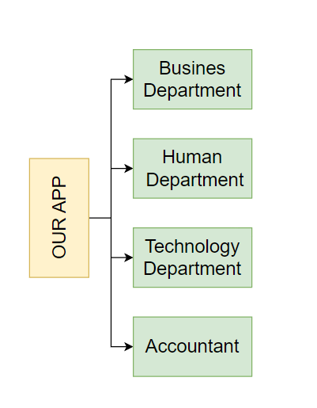

*Figure 1. Current organizational situation OurApp*

### 2.1.3. Survey of business processes, major activities

After looking through the given documents, we splitted the business process into smaller parts, which can be described as: Customer management, Shoe management, Inventory management, Product import process, Shoes booking process and Invoice management. Additionally, we thoroughly analyzed processes and wrote down each of them in a detailed way. Below are a comprehensive business process that have been broken down into sub processes:

**2.1.3.1 Business Department**

**Shoe management business:** connect with shoe suppliers and partner systems to input information about shoe inventory, pricing and  product details . This integration allows for seamless data exchange and collaboration with suppliers. The process involves: inputting information and pricing.

Importing information process:

* Establish integration with shoe suppliers to receive shoe data.
* Preprocess the received data and store it in our shoe management database for future transactions.
* The imported information includes shoe details such as title, brand, description, size options, and other relevant attributes.

Pricing process:

* Determine shoe pricing based on various factors, including the original     price from suppliers or customized pricing.
* Use specific pricing formulas or algorithms to calculate the final price.
* Store in our shoe management database

**Shoe marketing business**: propose new methods to improve product visibility, attract customers and optimize search engine rankings.

Promotion process:

* Develop creative promotional strategies to attract customers and drive sales.
* Identify target customer segments and tailor promotions to their preferences.
* Coordinate with the technical department to deploy effective promotional campaigns.

Customer services process:

* Set up a customer relationship management system to manage customer information and interactions.
* Ensure prompt response to customer inquiries and timely support.
* Implement customer service strategies in line with other departments to deliver a seamless customer experience.

Search engine optimization process:

* Implement strategies to optimize the visibility of shoe products on popular search engines like Google, Bing, etc.
* Enhance site content, meta tags and keywords to improve organic search rankings.

**2.1.3.2 Human Resource Department**

**Human resource management:** Supervising the activities of all employees in the shoe shop, including the employee information management process, employee activity management process and other related processes.

Employee information management process:

* Recruitment: Handle the recruitment process, including job posting, candidate selection and referral process.
* Add employee information: Collect and enter new employee information such as personal information, contact details, employment history and related documents.
* Update employee information: Regularly update employee records to reflect changes in personal information, job positions or any other relevant updates.
* Delete employee information: Delete employee information who have not been working with the company or have their contract expired and not renewed.

Employee management process:

* Employee working hours and activity tracking
* Employee activity history
* Periodic reports on employee performance:

**2.1.3.3 Technology Department**

**System management & development business**: Monitor the performance of the shoe management system and be prepared to address any anomalies while reviewing customer needs for system improvement, new features, and release documentation.

System management processess

* Tracking system information: Monitor and track traffic, requests, and database performance to ensure optimal system functionality.
* Interface readiness: Be prepared to interface with the system when an anomalous event or issue, minimize promptly addressing and resolving it to disruptions.
* Quality control: Conduct rigorous quality control measures before updating the system to ensure stability, functionality, and reliability.
* Database scaling and caching: Implement strategies for scaling the database and implementing caching techniques to improve system performance and responsiveness.

System development process:

* Collect customer needs: Collaborate with the marketing department to gather customer needs and feedback, understand their needs and expectations.
* Upgrading the shoe management system to fulfill customer needs by incorporating new features and functionalities
* Source code management to ensure version control
* Development and operations integration: Foster a seamless integration between development and operations teams to streamline system development, deployment, and maintenance.
* Continuous development and continuous delivery

**2.1.3.4 Accountant**

**Analysis business:** Implement data-driven reports to assist in monitoring the performance of the shoe management system. This includes processes related to financial calculations, employee compensation, and generating reports.

Salaries process:

* + Collect data from the Human Resources department, regarding employee working hours and other relevant factors.
  + Calculate salaries and bonuses for each employee at the end of the designated period.
  + Store the compensation data securely in the database for record-keeping and future reference.
  + Reporting process:
  + Retrieve necessary data from the shoe management system's database.
  + Generate comprehensive reports, focusing on key metrics such as total shoe sales, revenue, customer traffic, and promotional activities.
  + Evaluate the reports to gain insights into the overall performance of the shoe management system.
  + Present the reports to the management team for analysis and decision-making purposes.

**2.1.4. Survey of the existing system**

Based on the result of survey, the existing system requires:

* Operating System: Windows 7 or above.
* Processor: Intel core i3.
* Memory: 4Gb.
* Storage: 4Gb available space.

## 2.2. Software requirements

### 2.2.1. Functional requirements

**Storage:** The storage feature is one of the most important features of the system, which is the basis for implementing the system's features. To ensure effective management, the system needs to store the following information:

* User information: ID, username, full name, gender, date of birth, address, phone number, email registration time, accumulated points, password, user type.
* Shoe information : ID, price, color, size, brand, style, quantity, description, type.
* Transaction information : ID, username, details, quantity, price, order time, payment status and shipping details.

**Query**

* Product search: Users can search for shoes based on various criteria such as brand, style, color, size, and price.
* User search: Users can search for other users based on their username or other identifying information.
* Transaction search: Users can search for previous transactions based on various criteria such as order number, customer name, or order date.
* Inventory search: Users can search for inventory levels and replenishment schedules based on various criteria such as product name or supplier details.

**Statistic report**

* Statistical, analysis, reporting functions: help management staff monitor the general situation of the store.

### 2.2.2. Non-functional requirements

* GUI requirements: Friendly interface, easy-to-use, minimal.
* Security: Only faculty and anyone with legal permission can access and manage the information in the system.
* Constraints transaction/processing time.
* Stability and reliably: Frequently backup the data.

**2.2.3. Report Forms**

# Chapter 3: ANALYSIS AND DESIGN

## 3.1. Business Function Diagram (BFD)

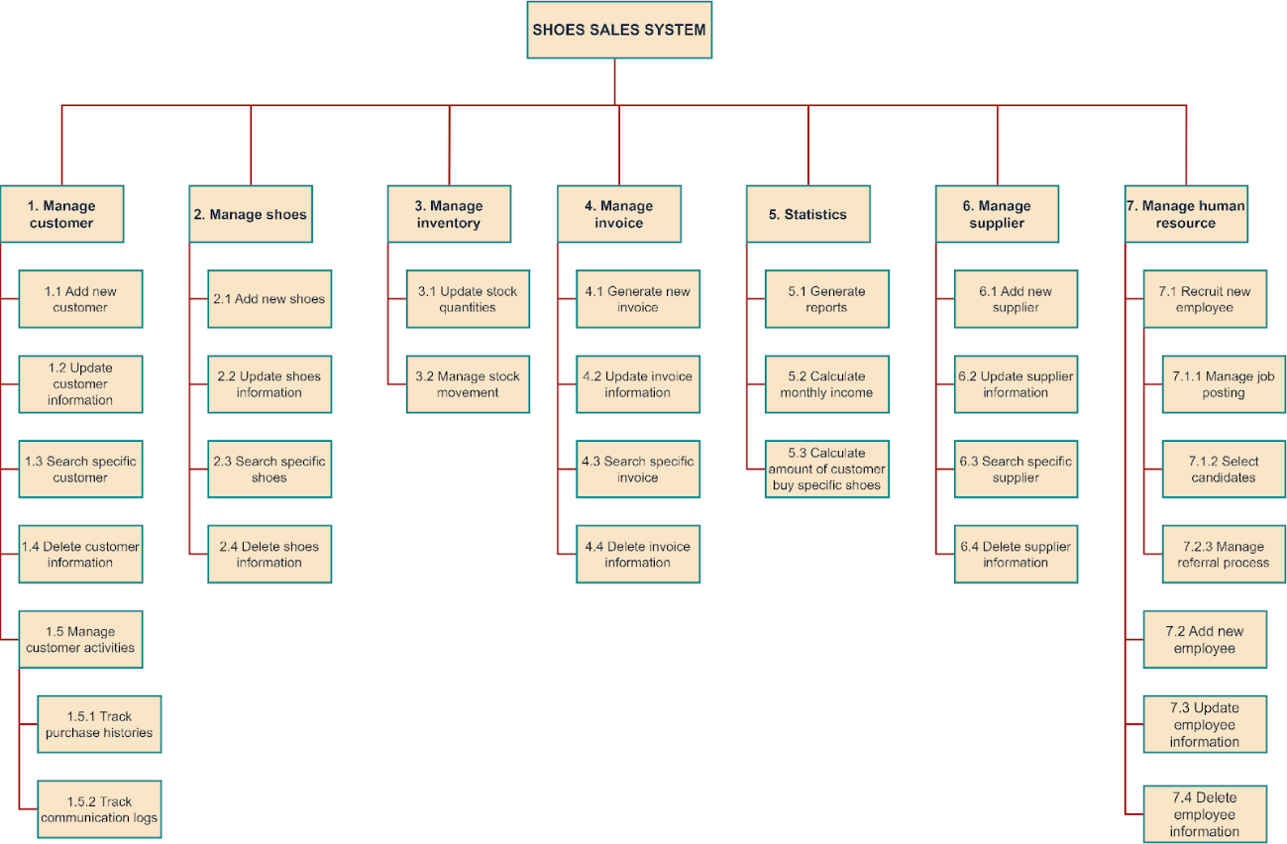*Figure 2 Business Function Diagram*

## 3.2. Data Flow Diagram (DFD)

3.2.1 Context-level DFD

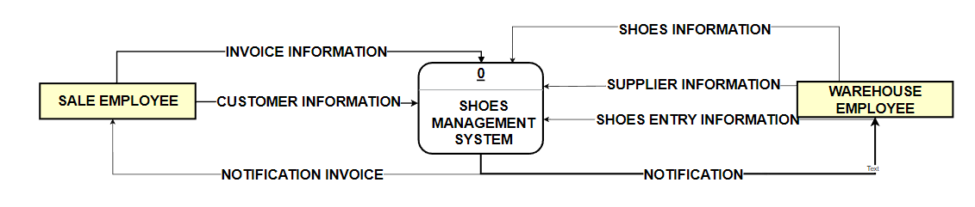*Figure 3 Data Flow Diagram Context-level*

3.2.2. Level-0 DFD

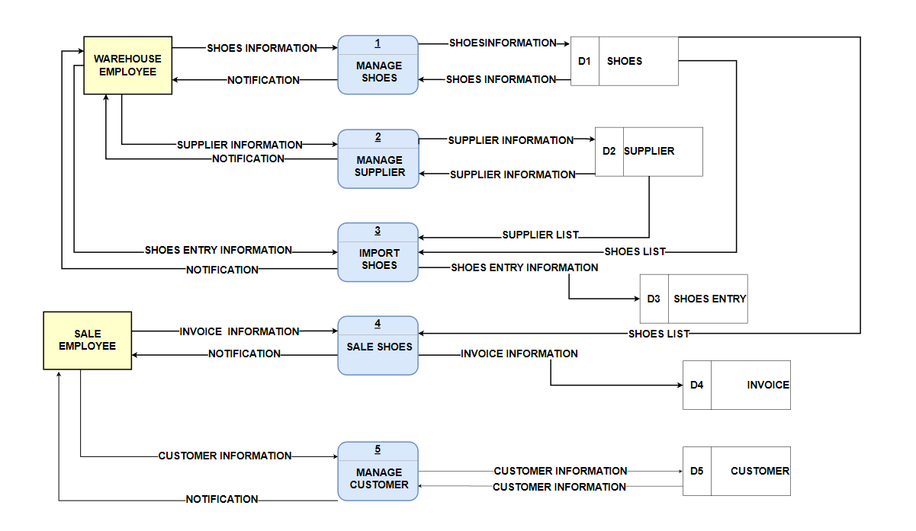*Figure 4 Data Flow Diagram Level-0*

3.2.3. Level-1 DFD – Manage Shoes

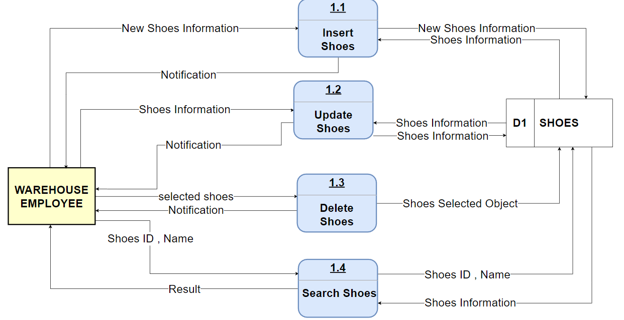*Figure 5 Data Flow Diagram level-1 Manage Shoe*

3.2.3.1 Level-2 DFD – Insert Shoes

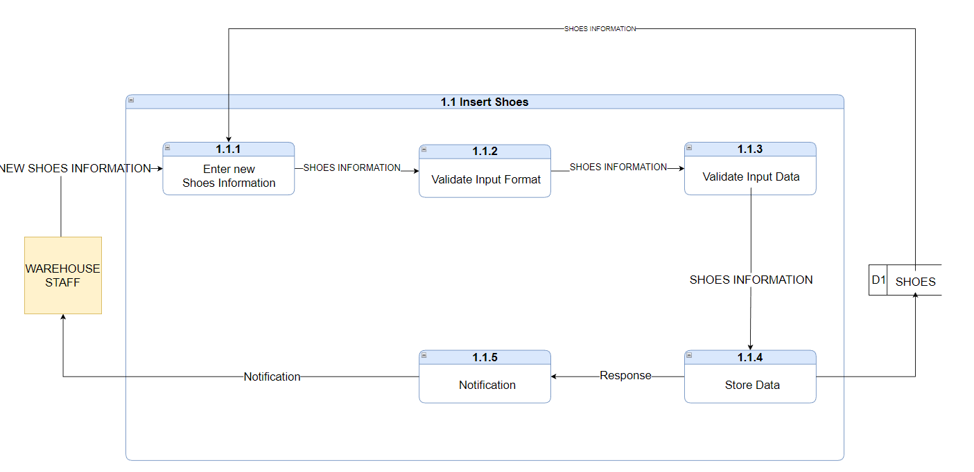*Figure 6 Data Flow Diagram level-2 Insert Shoe*

3.2.3.2 Level-2 DFD – Update Shoes

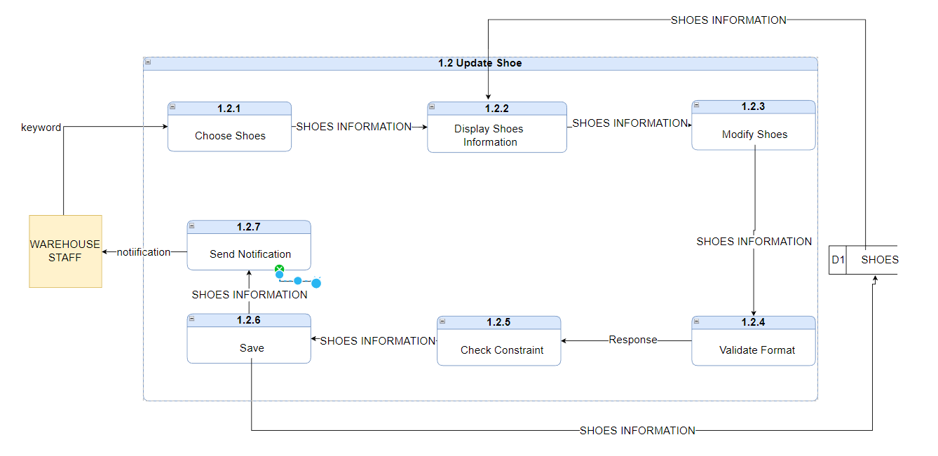*Figure 7 Data Flow Diagram level-2 Update Shoe*

3.2.3.3 Level-2 DFD – Delete Shoes

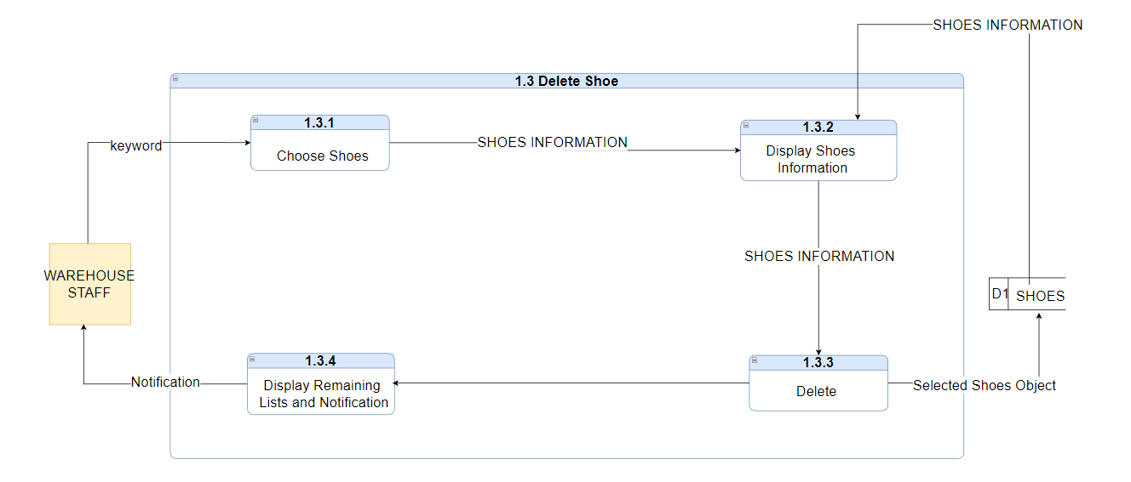*Figure 8 Data Flow Diagram level-2 Delete Shoe*

3.2.3.4 Level-2 DFD – Search Shoes

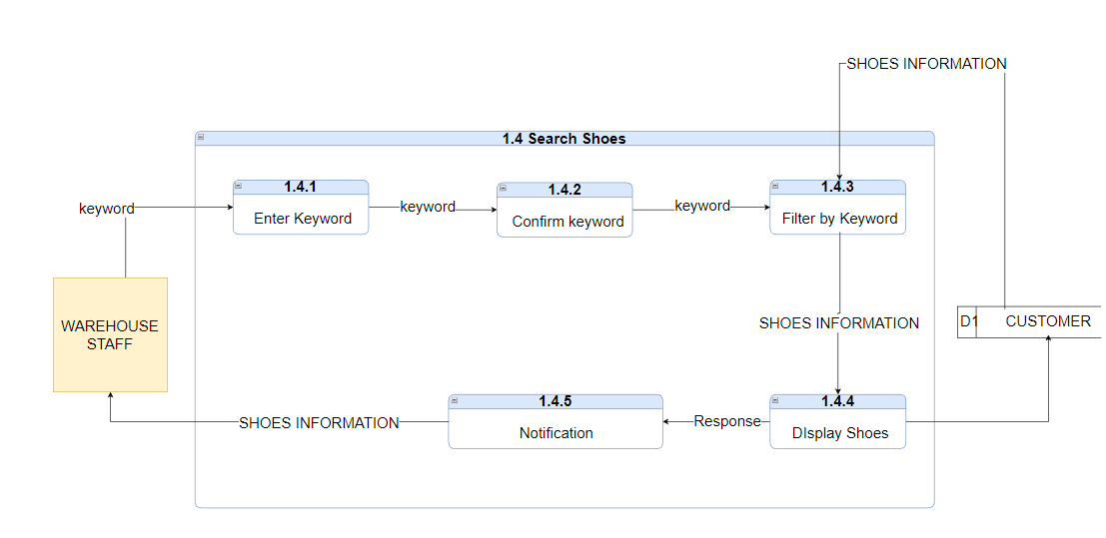*Figure 9 Data Flow Diagram level-2 Search Shoe*

3.2.4    Level-1 DFD – Manage  Supplier

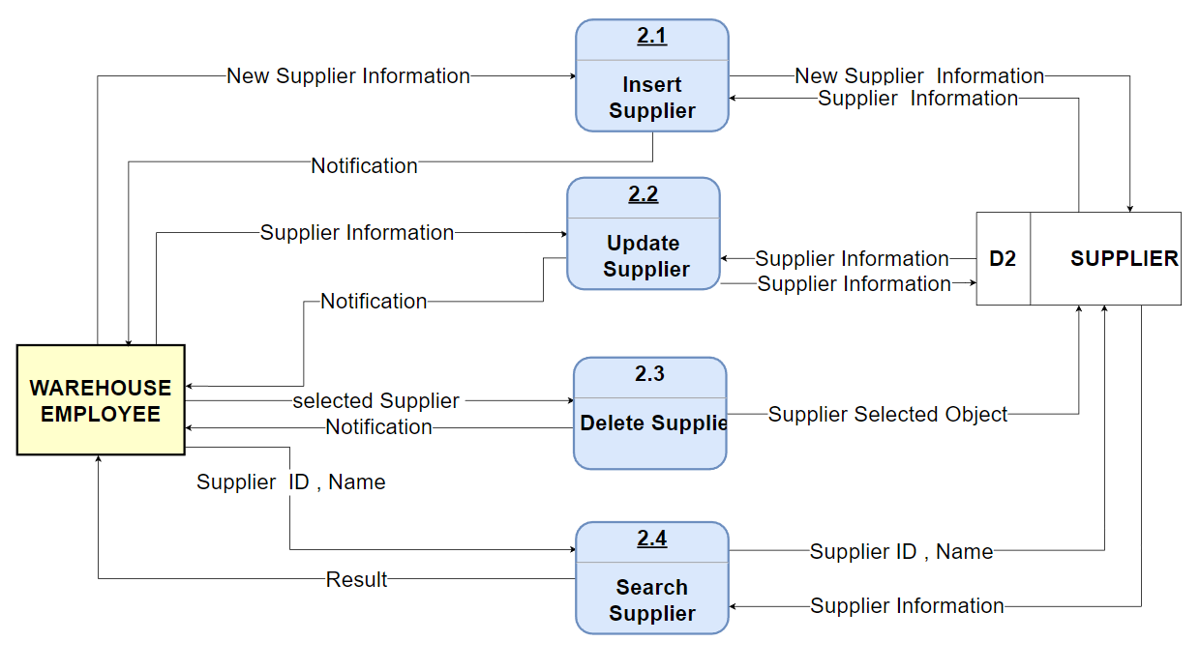

*Figure 10 Data Flow Diagram level-2 Manage Supplier*

3.2.4.1 Level-2 DFD - Insert Supplier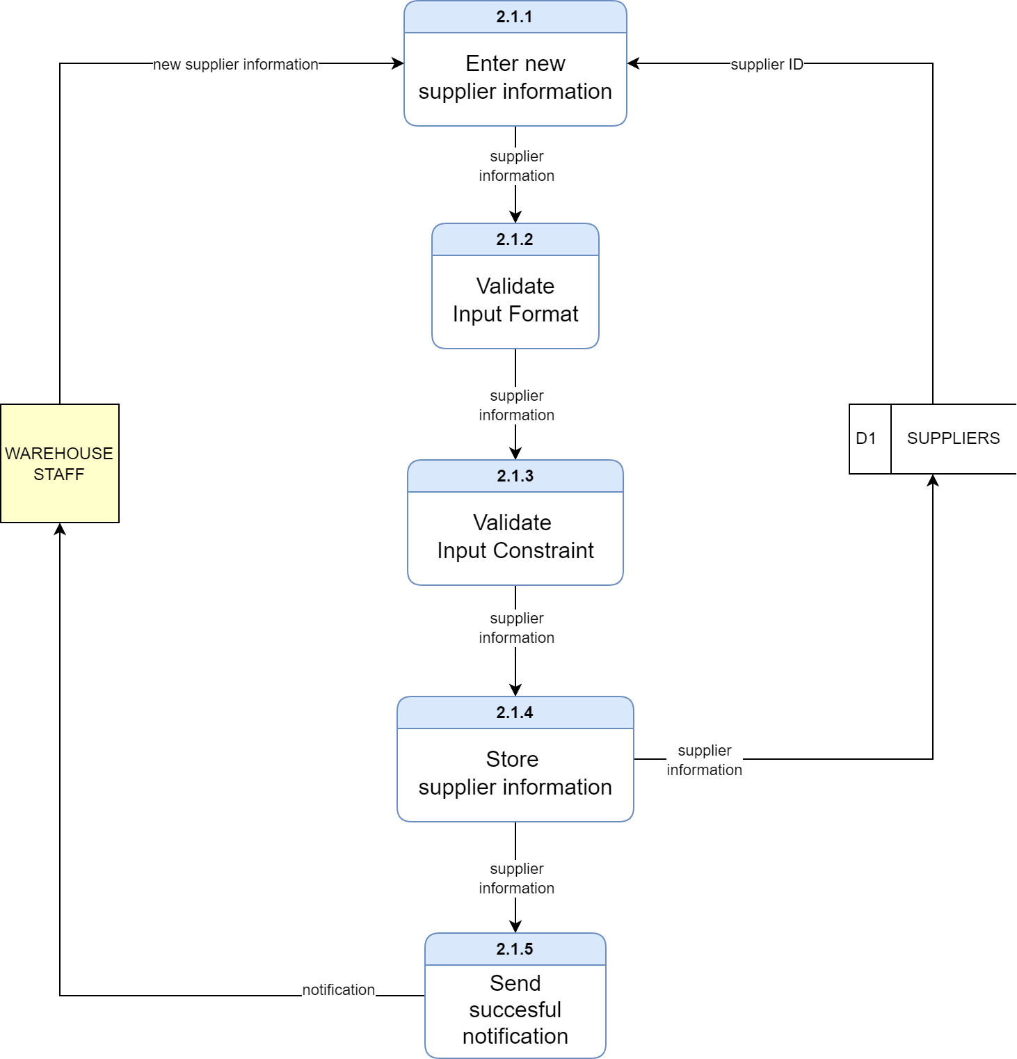*Figure 11 Data Flow Diagram level-2 Insert Supplier*

3.2.4.2 Level-2 DFD – Update Supplier

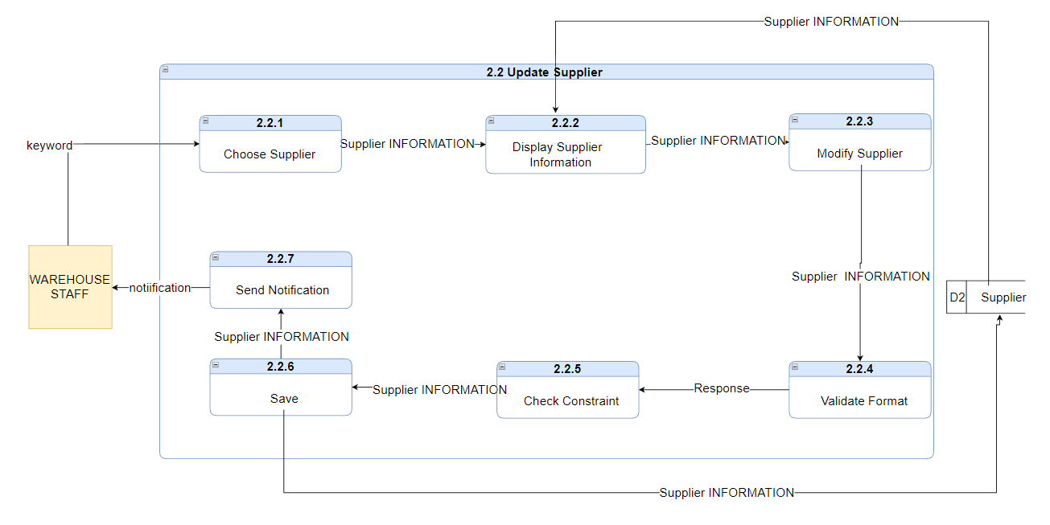*Figure 12 Data Flow Diagram level-2 Update Supplier*

3.2.4.3 Level-2 DFD – Delete Supplier

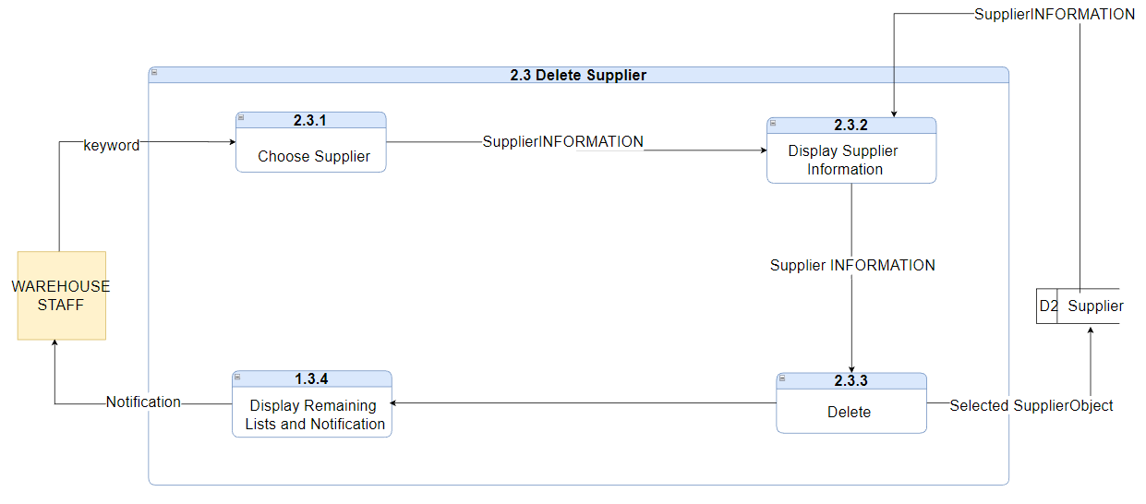*Figure 13 Data Flow Diagram level-2 Delete Supplier*

3.2.4.4 Level-2 DFD – Search Supplier

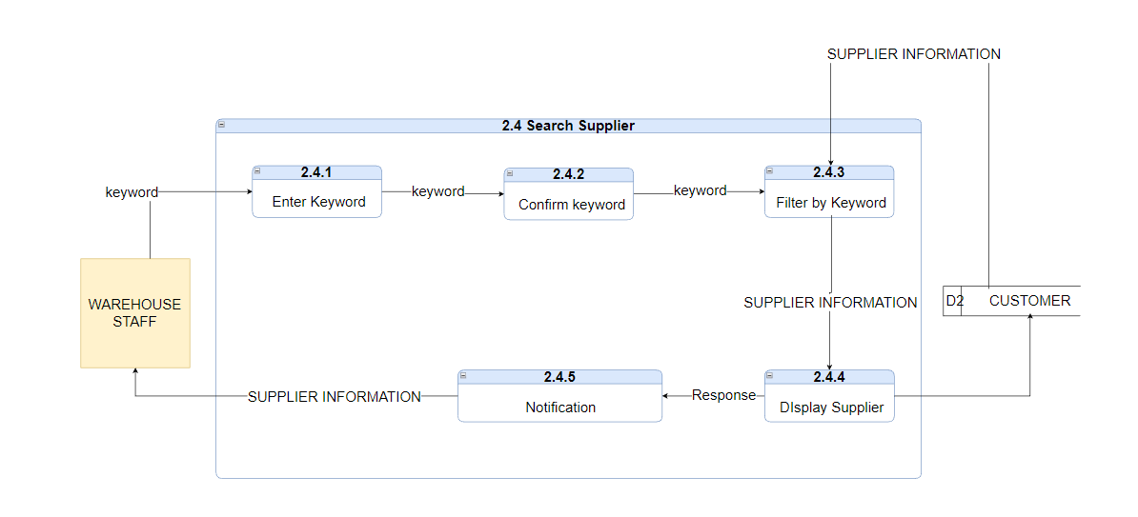*Figure 14 Data Flow Diagram level-2 Search Supplier*

3.2.5. Level-1 DFD – Import Shoes

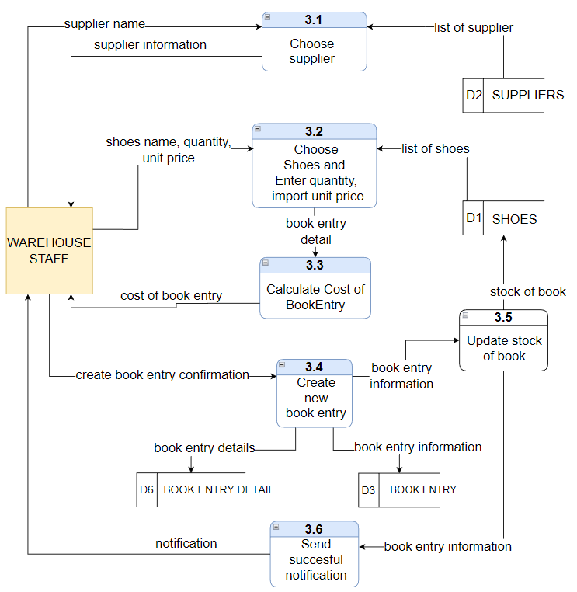

*Figure 15 Data Flow Diagram level-1 Import Shoe*

3.2.6. Level-1 DFD – Sales Shoes

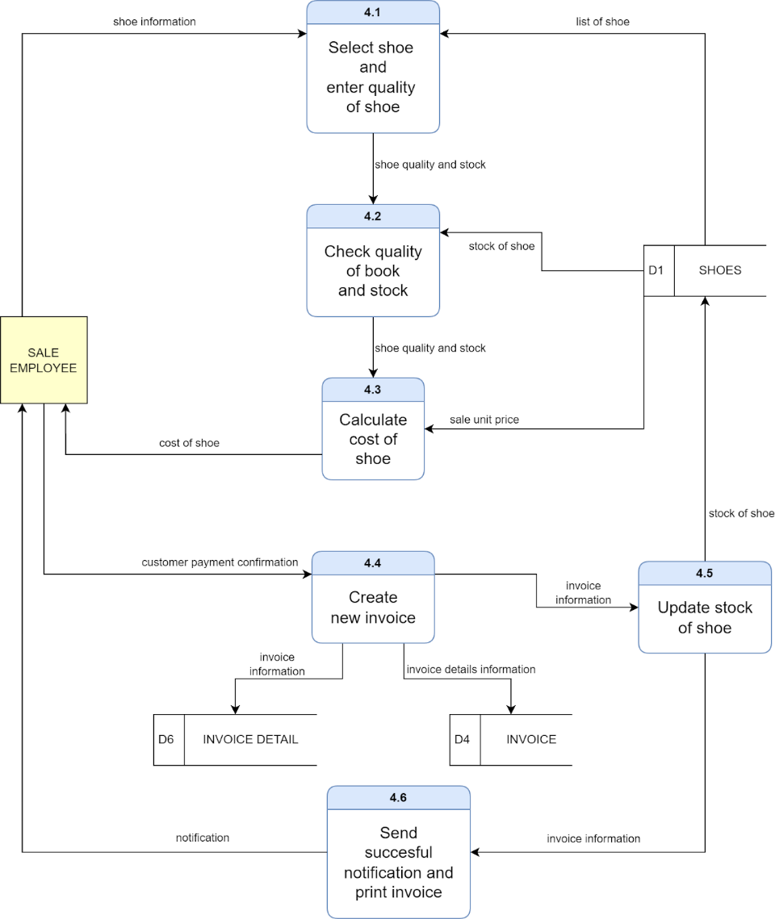

*Figure 16 Data Flow Diagram level-1 Sales Shoe*

3.2.7. Level-1 DFD – Manage Customer

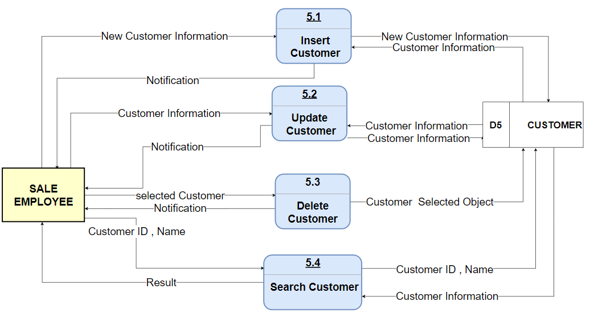

*Figure 17 Data Flow Diagram level-1 Manage Customer*

3.2.7.1 Level-2 DFD – Insert Customer

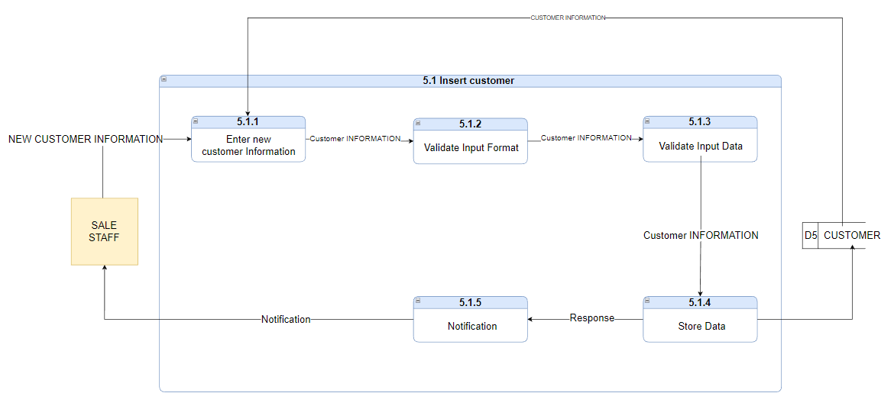*Figure 18 Data Flow Diagram level-2 Insert Customer*

3.2.7.2 Level-2 DFD – Update Customer

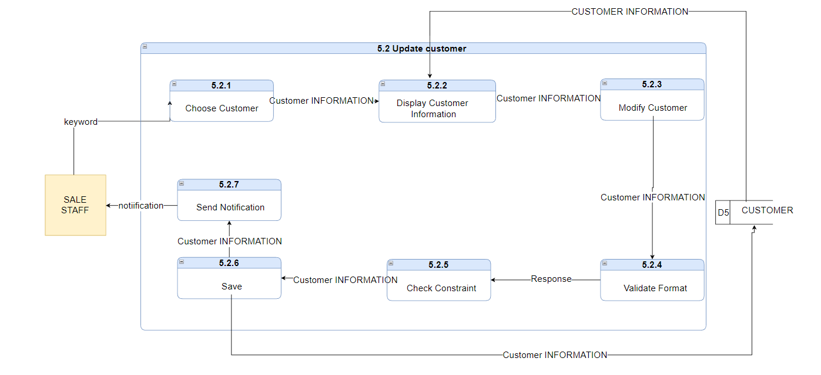*Figure 19 Data Flow Diagram level-2 Update Customer*

3.2.7.3 Level-2 DFD – Delete Customer

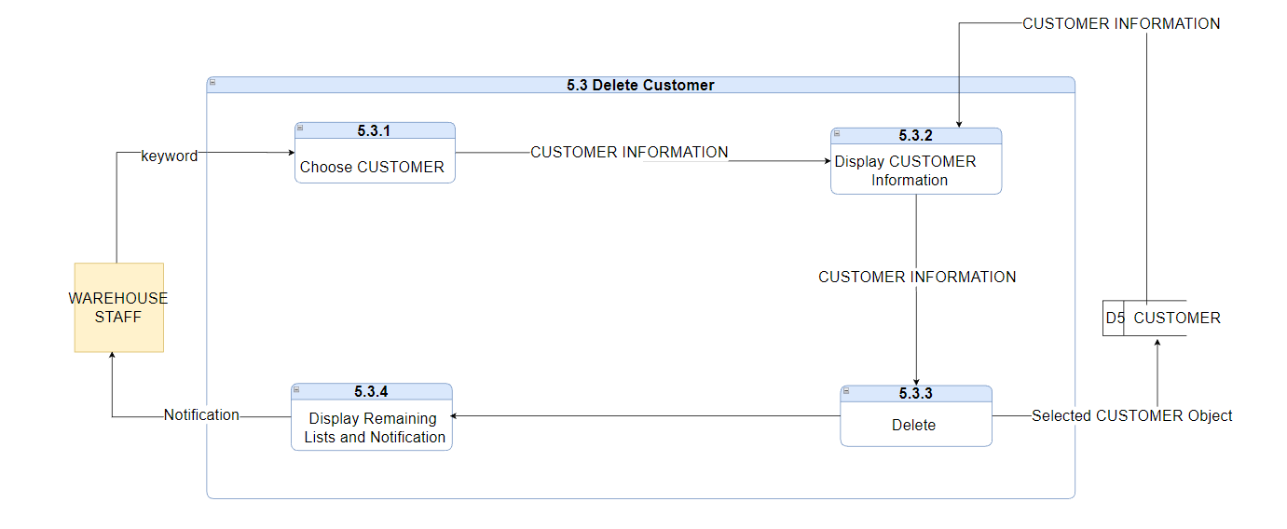*Figure 20 Data Flow Diagram level-2 Delete Customer*

3.2.7.4 Level-2 DFD – Search Customer

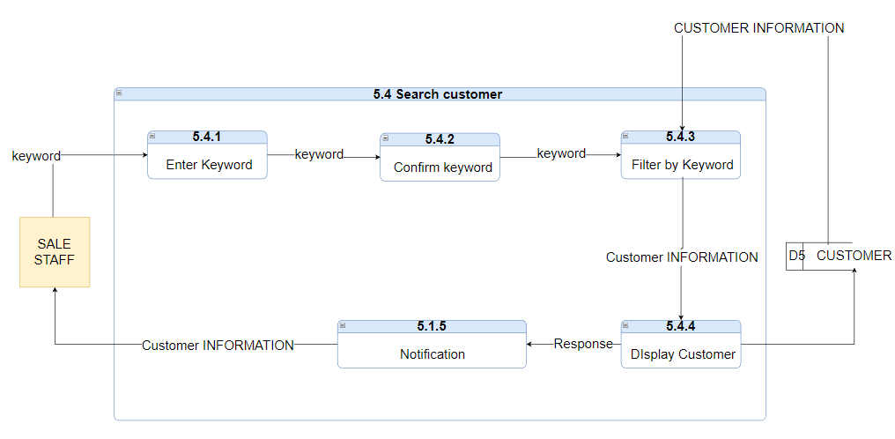*Figure 21 Data Flow Diagram level-2 Search Customer*

## 3.3. Entity Relational Data model (ERD)

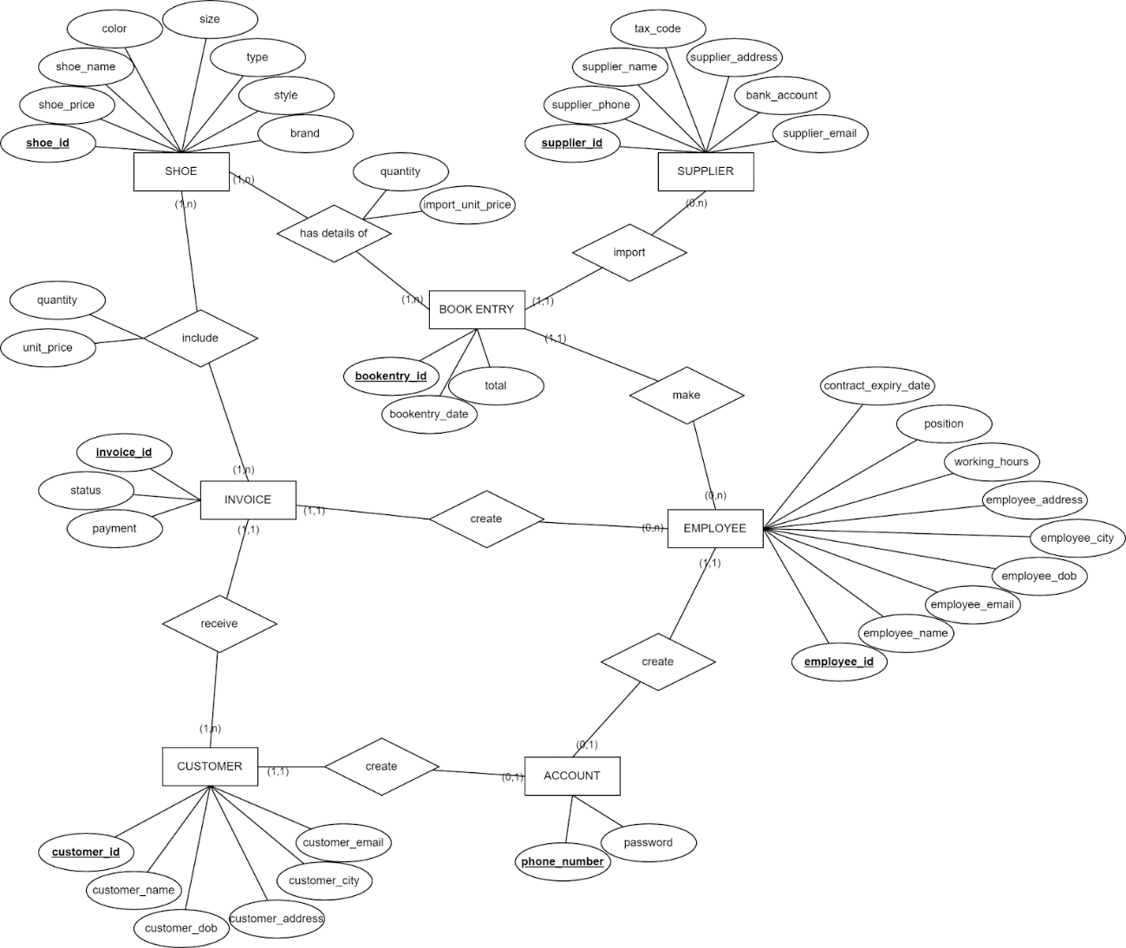*Figure 22 Entity Relational Diagram*

## 3.4. Relational Data model (RDM)

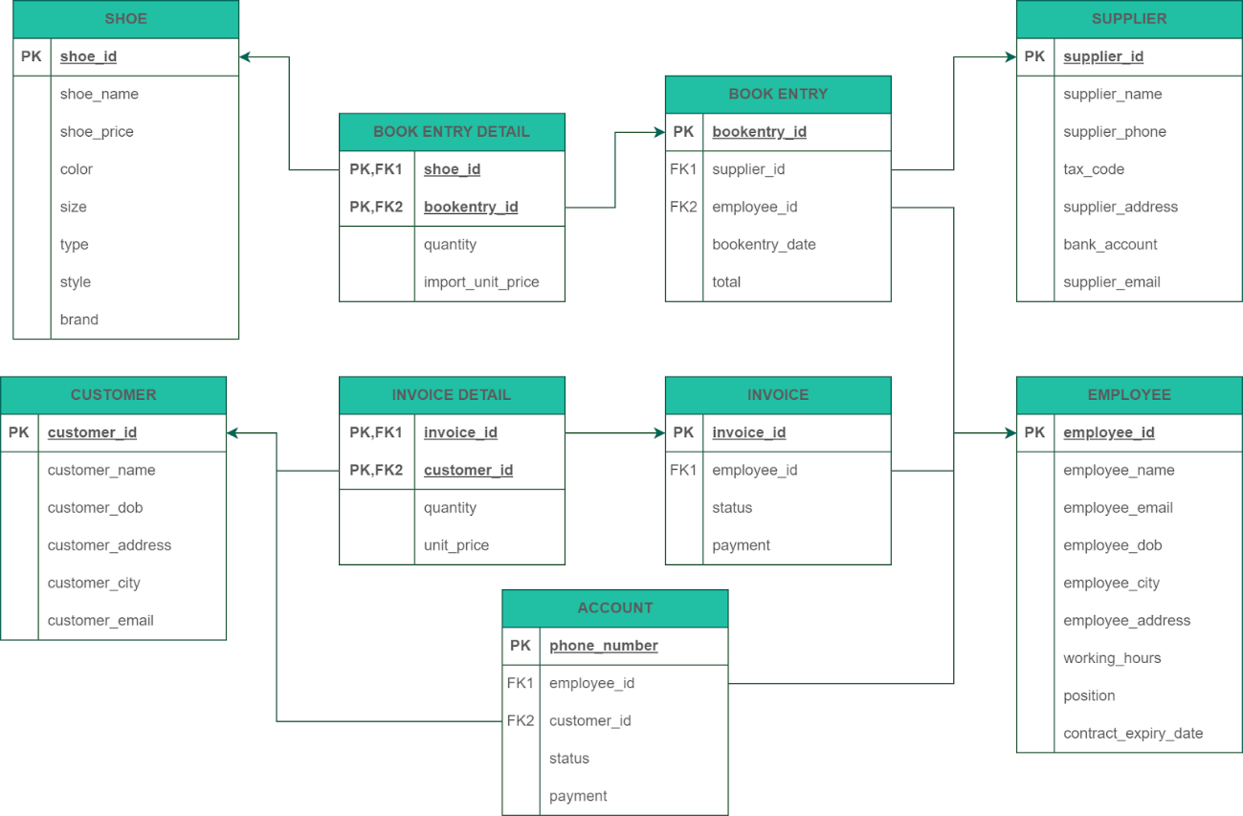*Figure 23 Relational Data Model*

The Relational Data Model is derived from the Entity Relational Diagram. There are nine tables: SHOE, CUSTOMER, BOOK ENTRY DETAIL, INVOICE DETAIL, ACCOUNT, BOOK ENTRY, INVOICE, SUPPLIER, and EMPLOYEE. SHOE, CUSTOMER, SUPPLIER, EMPLOYEE, ACCOUNT, BOOK ENTRY, and INVOICE are the main entities, while BOOK ENTRY DETAIL and INVOICE DETAIL are associative entities. The arrow notations depict the relationships between them. Most of the entities have a one-to-many relationship type, except for the relationship between ACCOUNT and CUSTOMER, as well as EMPLOYEE.

# Chapter 4: IMPLEMENTATION AND TESTING

**There are some main user interface that used**

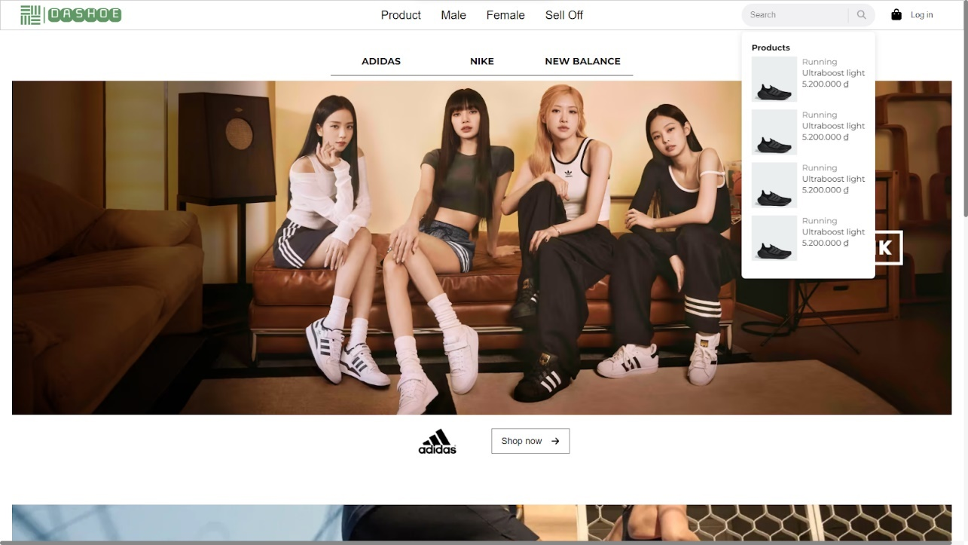*Figure 24 Home page (Guest)*

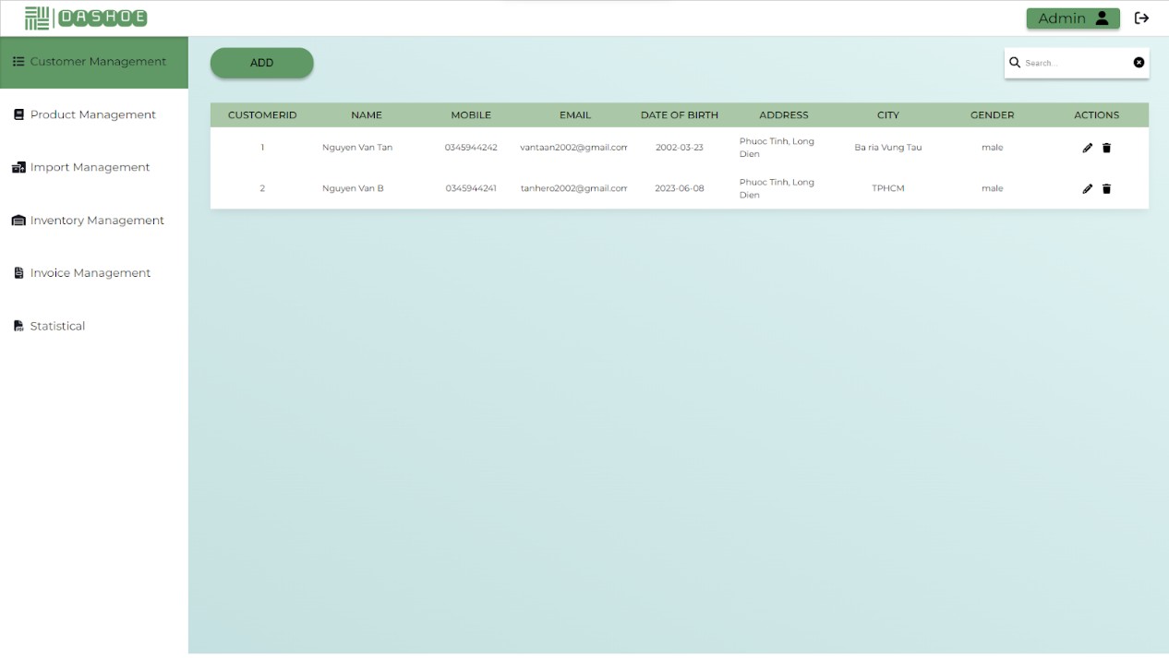*Figure 25 Home page (Authorized)*

## 4.1. Introduction to the implementation environment

**Visual Studio Code:**

Visual Studio Code, frequently known as VS Code, is a source code editor that has been developed by Microsoft utilizing the Electron Framework. It is accessible for Windows, Linux, and macOS operating systems. The editor provides a diverse range of features, including debugging support, syntax highlighting, intelligent code completion, snippets, code refactoring, and embedded Git. The users have the option to personalize the editor by modifying the theme, keyboard shortcuts, preferences, and installing extensions that augment its functionality. Visual Studio Code can be used with a variety of programming languages, including C, C#, C++, Fortran, Go, Java, JavaScript, Node.js, Python, Rust, Julia,... [1]

**WebStorm:**

WebStorm is a powerful and feature-rich integrated development environment (IDE) specifically designed for web development. It was created by JetBrains, the same company behind popular development tools like IntelliJ IDEA and PyCharm. WebStorm provides developers with a comprehensive set of tools and features to streamline their workflow and enhance productivity. [2]

As a dedicated IDE for web development, WebStorm offers extensive support for a wide range of web technologies, including HTML, CSS, JavaScript, and popular frameworks like Angular, React, and Vue.js. [2] Whether you are building a simple web page or working on a complex web application, WebStorm provides a robust set of tools and intelligent features to assist you throughout the development process.

## 4.2. User Interface

Login

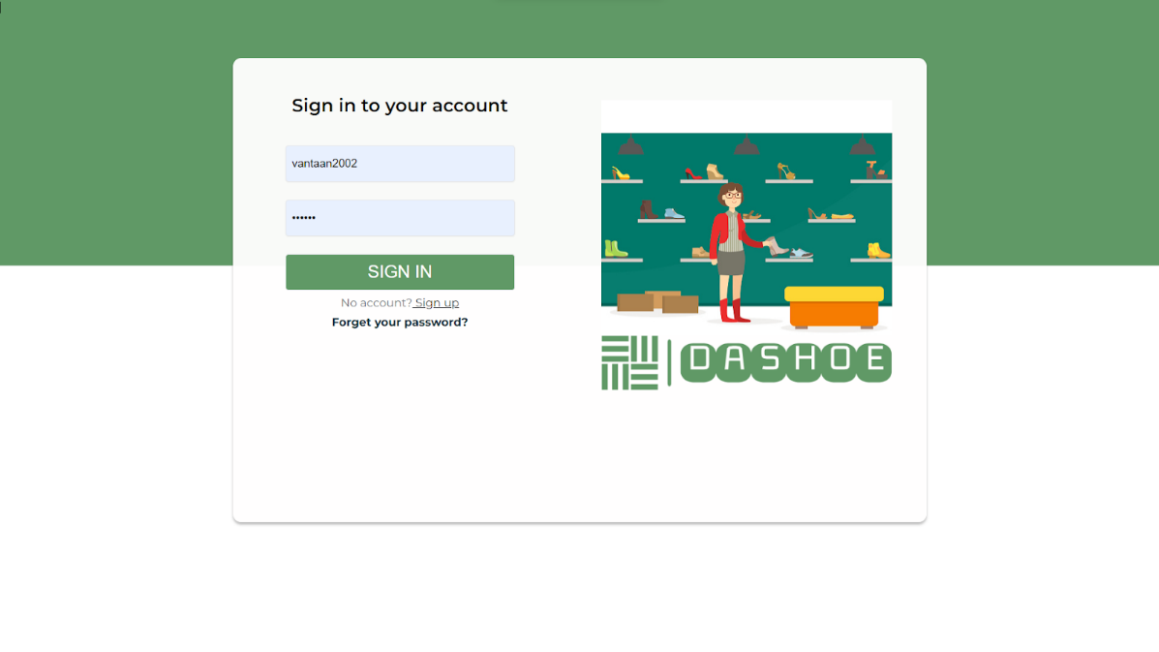

Home Page ( Guest )



Home Page (Authorized)



Customer Management

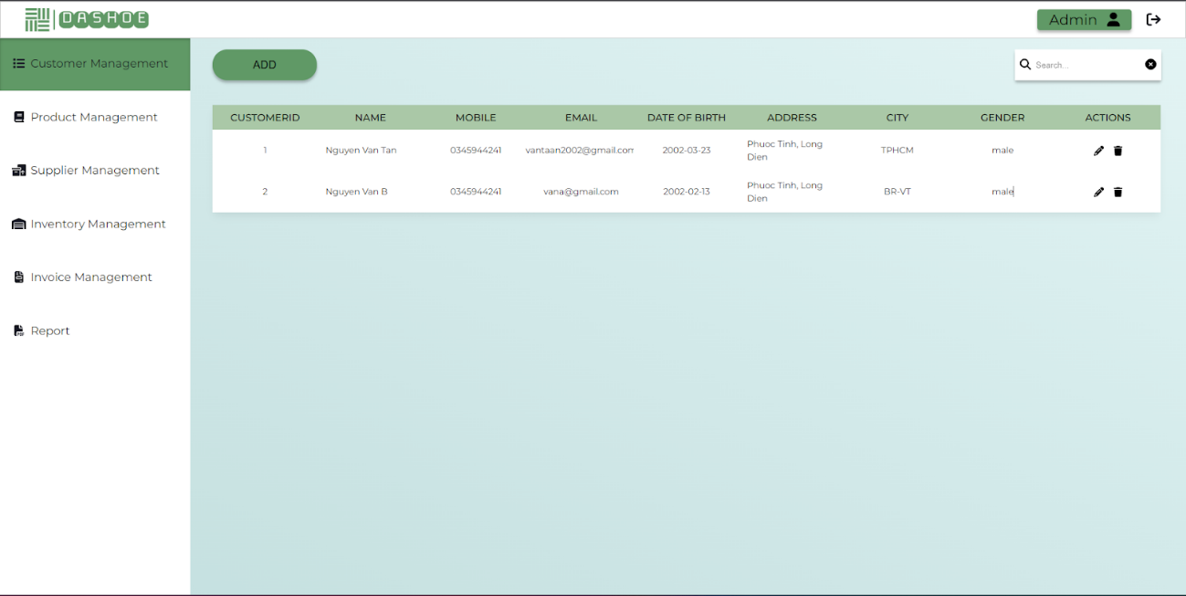*Figure 26 Customer Management page*

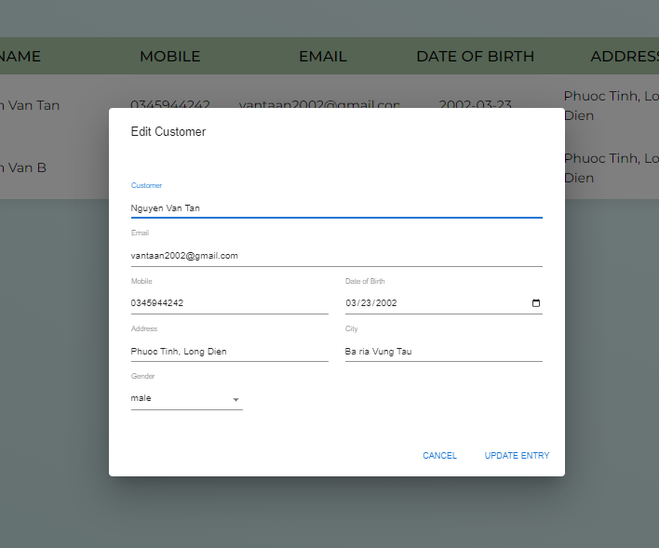

*Figure 27 Customer information input form (part 1)*

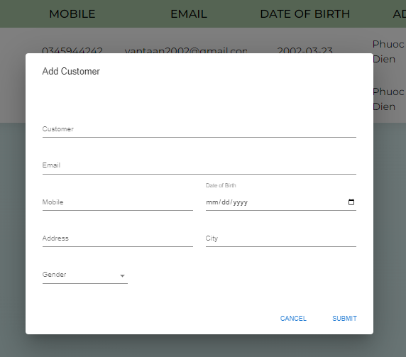*Figure 28 Customer information input form (part 2)*

These pages display the customer information (ID, customer name, phone number, email, date of birth, address, city and gender) list in tabular form. Employees have access to alternate the table or add more information into the table. Additionally, some activities like create new Customer , Edit Customer by click on icon Pen and Delete Customer by clicking on Icon Trash

The input form lets the employee insert new customer information (customer name, email, phone number, date of birth, address, city, gender) and then submit for validation.

Product Management

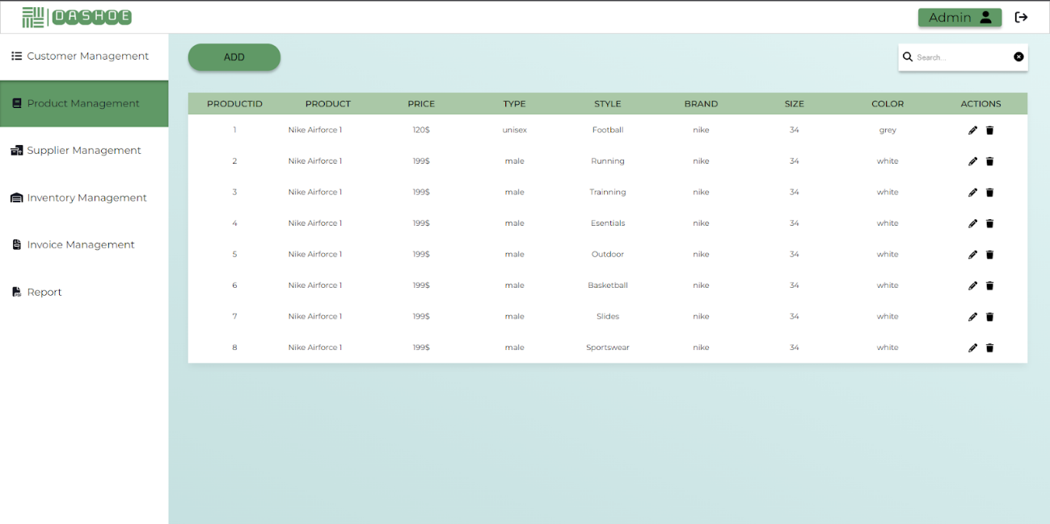*Figure 29 Product Management main page*

The page displays the product information (ID, product name, price, type, style, address, size and color) list in tabular form. Employees have access to alternate the table or add more information into the table.

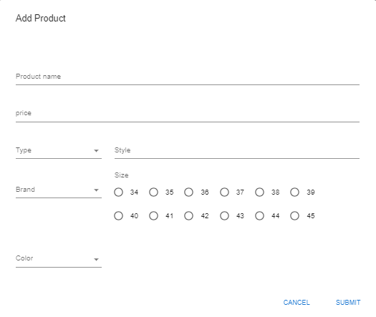

*Figure 30 Product information input form (part 1)*

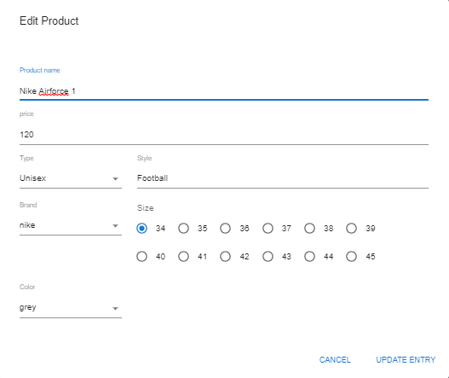

*Figure 31 Product information input form (part 2)*

The input form lets the employee insert new product information (product name, price, type, style, address, size and color) and then submit for validation.

Statistical

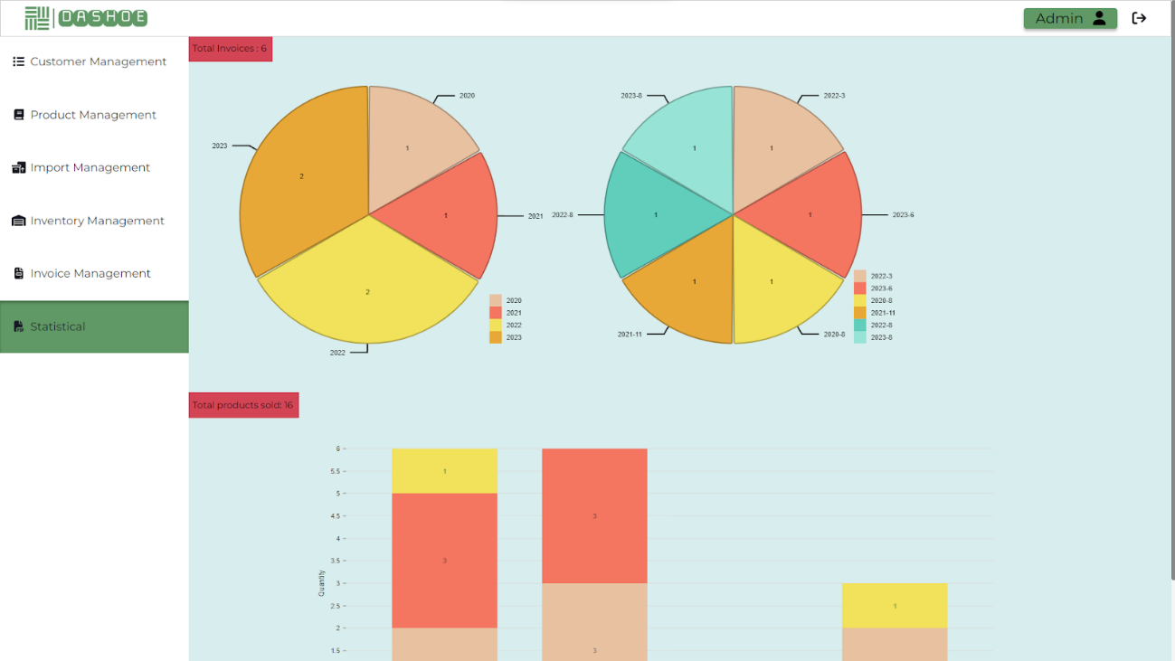*Figure 32 Statistical Charts*

The graphs show information about the store's condition. Here the pie chart shows the number of invoices generated by year and by month-year. And the column chart shows the number of products sold (included in the invoices) classified by their Type

# Chapter 5: CONCLUSION

Although we had limited time and encountered some unexpected occurrences during the software development process, our group managed to create a simple website for managing shoe sales. The website includes all necessary functions like storage, query and statistic, as well as additional functions specified in the project scope like customer management and user management. The website lacks many functions that are supposed to be featured, such as invoice management, employee management, etc...

There are some limitations and difficulties occurred during the process:

* The experience in building software applications is still limited. There are still many errors during the installation and use of the software.
* Team members sometimes have different opinions, leading to delays in the project progress.
* There is still a small amount of sample data input.

# References

**[1] Retrieved from** [**https://en.wikipedia.org/wiki/Visual_Studio_Code**](https://en.wikipedia.org/wiki/Visual_Studio_Code)

**[2] Retrieved from https://www.jetbrains.com/help/webstorm/getting-started-with-webstorm.html**