REPORT LAB05

|  |  |
| --- | --- |
| Student | ID |
| Nguyễn Minh Thành | 20521920 |
| Nguyễn Văn Tân | 20521880 |

[**Github Repo : Alarm Aplication**](https://github.com/MinhTh2nh/Lab05_20521920)

[**Github Repo : Movie Application**](https://github.com/nguyentaan/Mobile_lab/tree/main/Lab05)

**Alarm Application**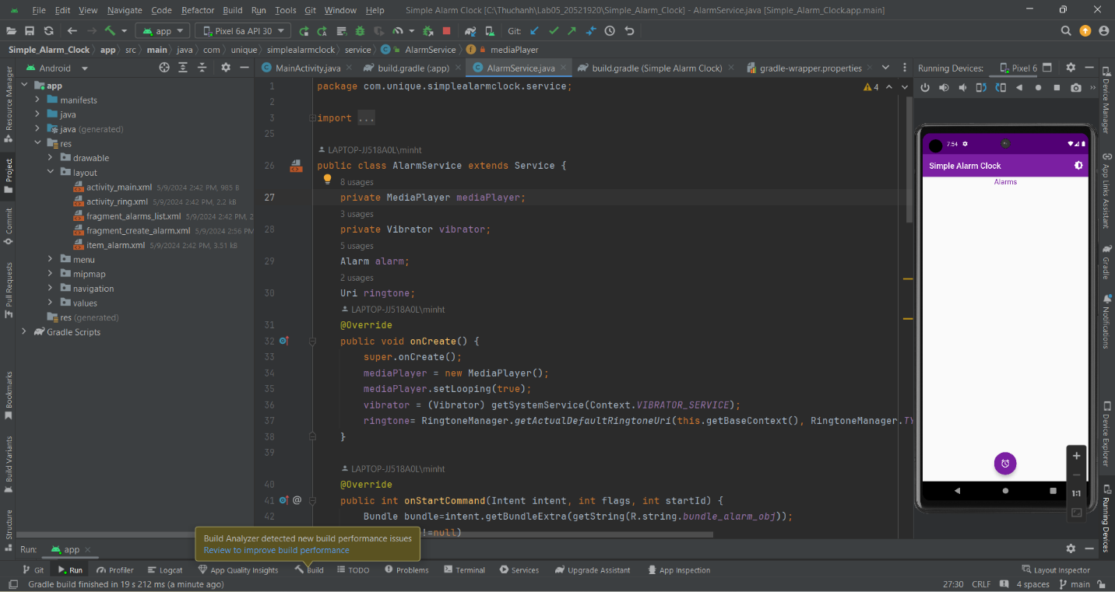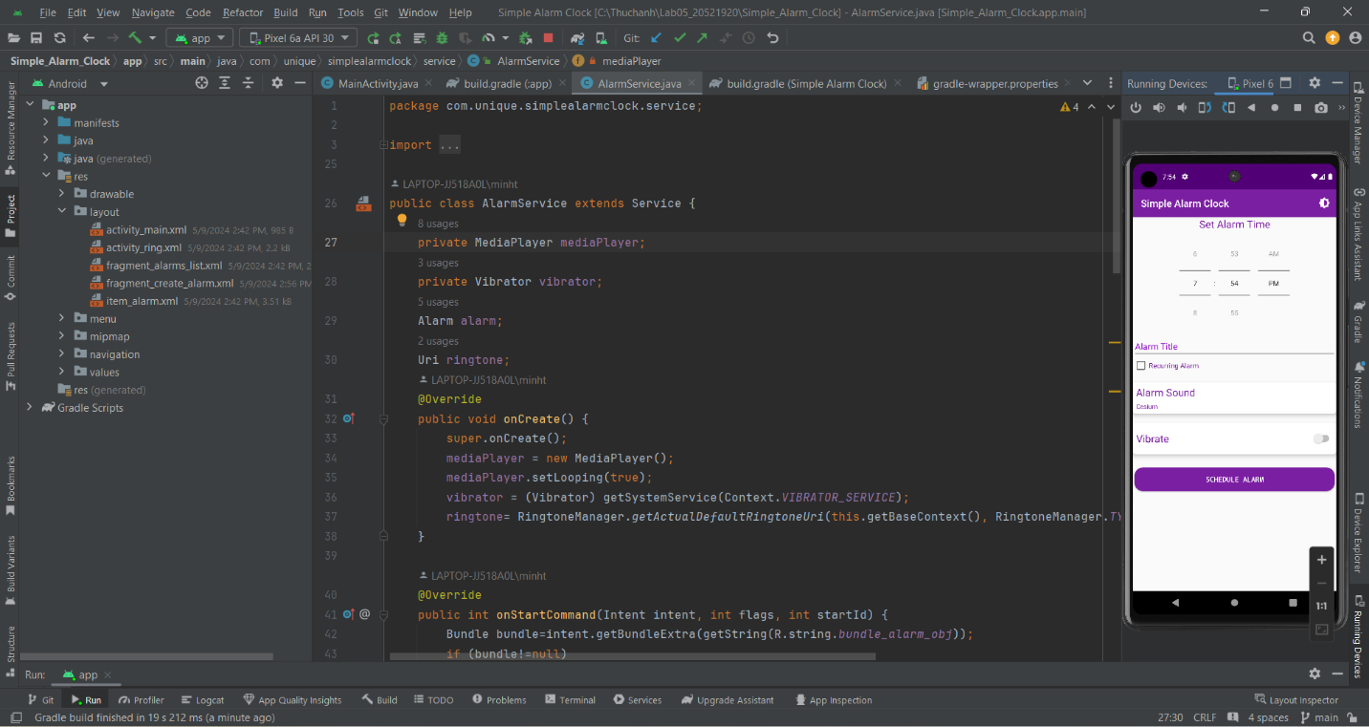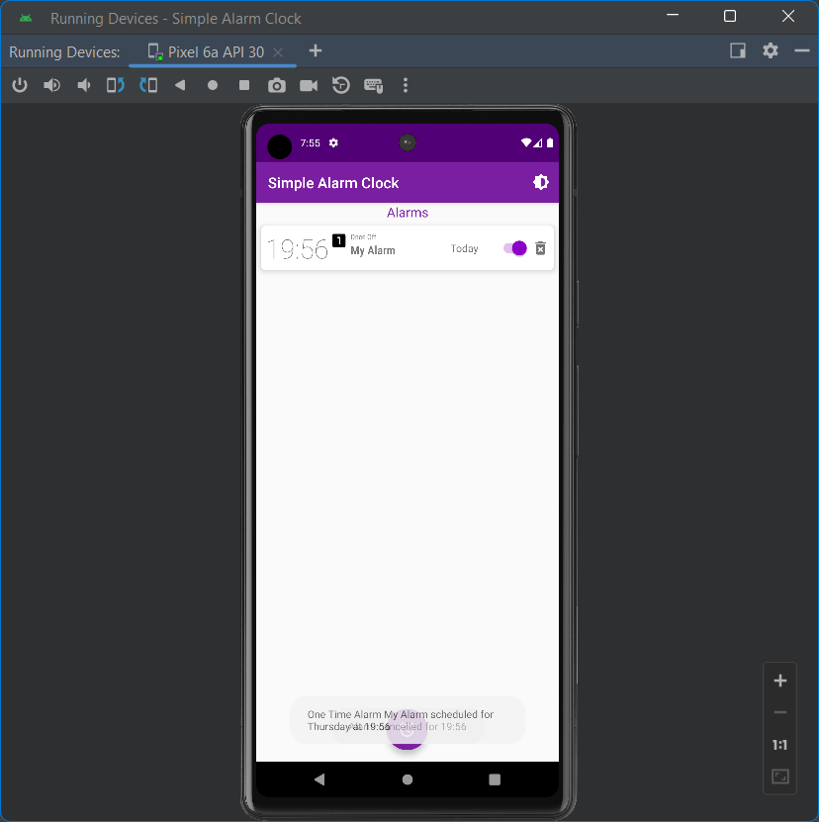

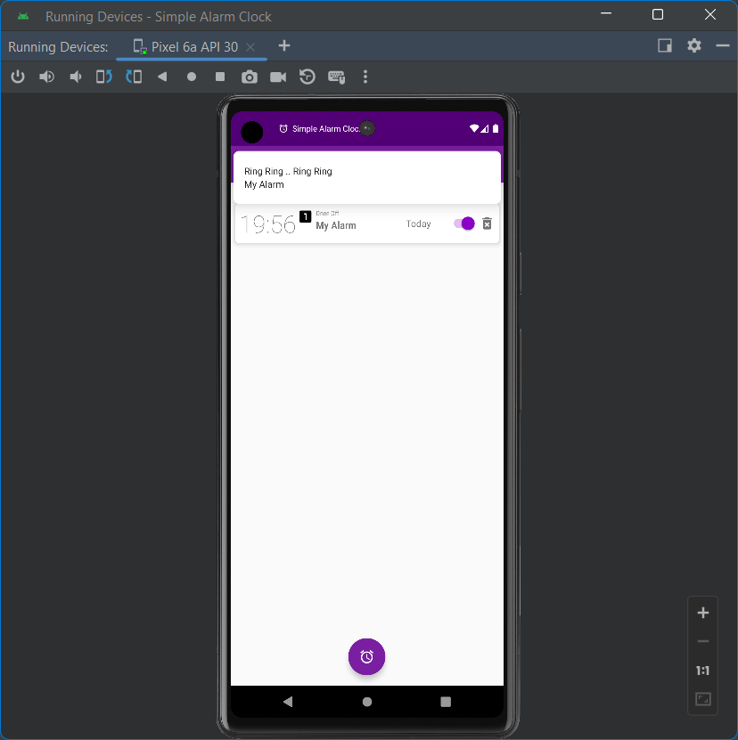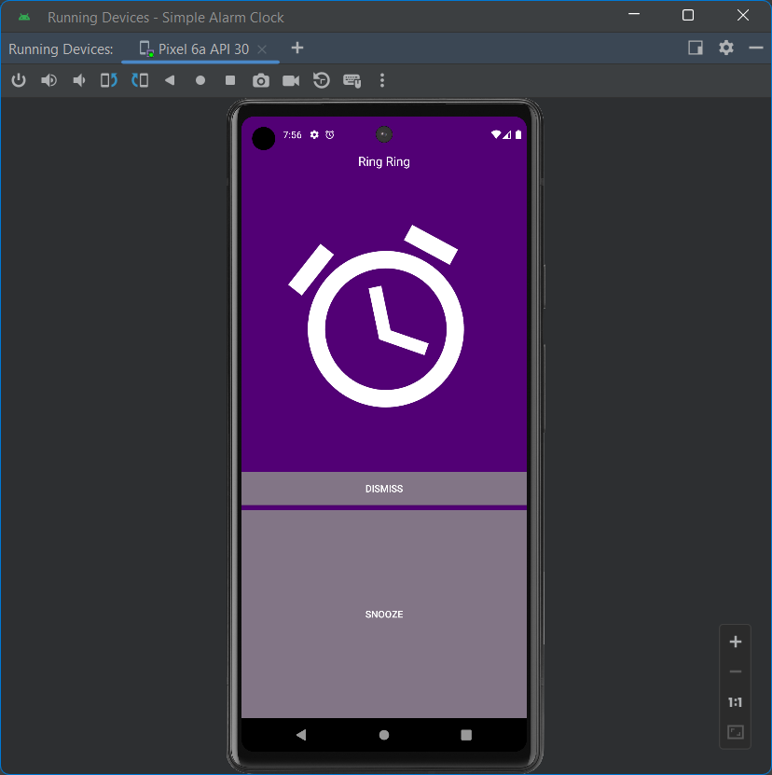

# **Movie Application**

**API:** [**Getting Started (themoviedb.org)**](https://developer.themoviedb.org/reference/intro/getting-started)



