**University of Information Technology**

**Homework 03: Normalization of Database Tables**



**DATABASE SYSTEMS DESIGN, IMPLEMENTATION AND MANAGEMENT**

**Instructor: Nguyen Dinh Thuan**

**Students: Group 2**

**March 12, 2023**

**Table of Contents**

**At Class:** 2

**A.What is determinant?** 2

**B.What is Boyce-Codd Normal Form?** 3

**C.What is Fourth Normal Form?** 4

**Question:** 6

**10 . What three data anomalies are likely to be the result of data redundancy? How can such anomalies be eliminated?** 6

**Problem:** 8

**References:** 11

**Task and member assignment table:** 11

# **At Class:**

## **What is determinant?**

**Answer:**

Determinant is an attribute in a row whose value determines other attribute’s values in a row. Let’s take an example, suppose we have Student table:

|  |  |  |  |
| --- | --- | --- | --- |
| SID | Sfname | Slname | DoB |

Where SID is a determinant since SID uniquely determines the other attributes, which are Sfname, Slname, DoB. In the other words, if we know SID, we can identify Sfname, Slname and DoB.

**Compare with ChatGPT:**

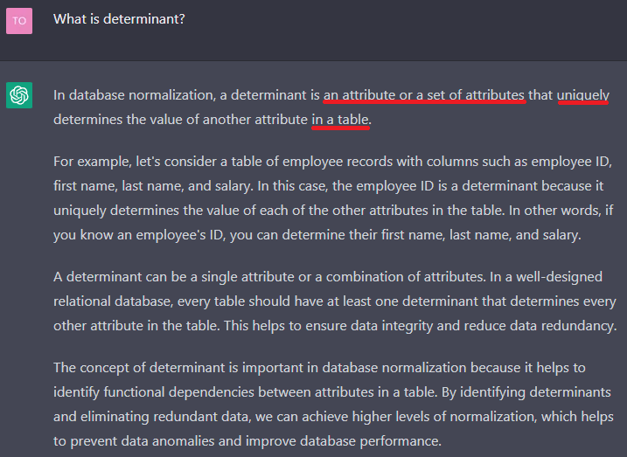

* ChatGPT’s answer has no differences

## **What is Boyce-Codd Normal Form?**

**Answer:**

( [1] , 221 ) Boyce-Codd Normal Form (BCNF) is a special type of third normal form (3NF), the table is in BCNF when:

* Every determinant is a candidate key.
* A table in BCNF must be in 3NF.

Let’s take an example, consider a table like below:

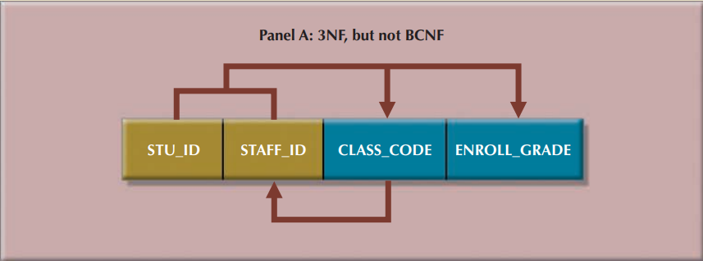

The table is in 2NF because there is no partial dependency. The table is also in 3NF since it is free from transitive dependency. However, there is a functional dependency between CLASS_CODE and STAFF_ID. In other words, STAFF_ID is determined by CLASS_CODE. Hence the table is not in BCNF. To let the table achieve BCNF, we can split the table into two tables, one has STU_ID, CLASS_CODE and ENROLL_GRADE, one has CLASS_CODE and STAFF_ID.

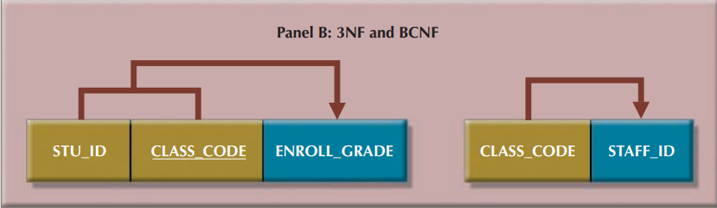

**Compare with ChatGPT:**

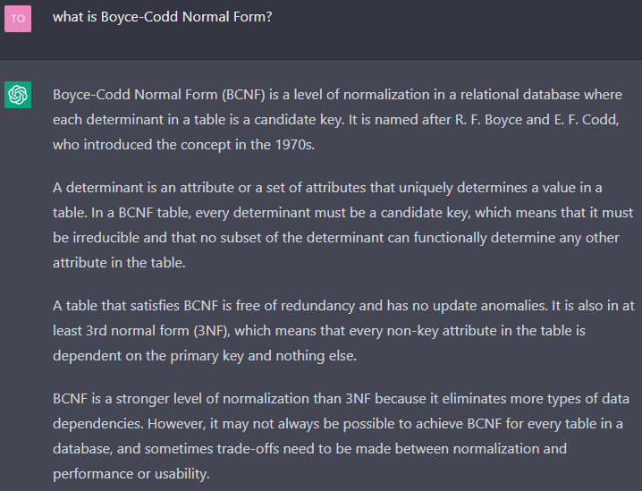

* ChatGPT’s answer has no differences

## **C.** **What is Fourth Normal Form?**

**Answer:**

( [1], 226 )Fourth Normal Form (4NF) is a higher Normal Form of 3NF. A table is in 4NF if:

* It is in 3NF.
* Contains no multiple independent sets of multivalued dependencies.

For example, consider the possibility that an employee can have multiple assignments and can also be involved in multiple service organizations. Suppose employee 10123 volunteers for the Red Cross and United Way. In addition, the same employee might be assigned to work on three projects: 1, 3, and 4. Figure 6.11 illustrates how that set of facts can be recorded in very different ways.

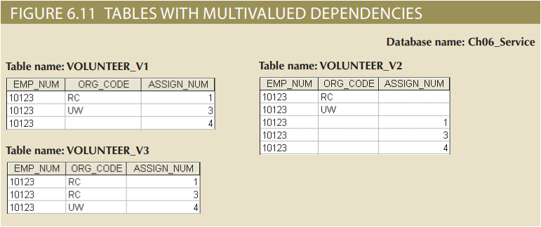

( [1] , 224 ) There is a problem with the tables in Figure 6.11. The attributes ORG_CODE and ASSIGN_NUM each may have many different values. In normalization terminology, this situation is referred to as a multivalued dependency, which occurs when one key determines multiple values of two other attributes and those attributes are independent of each other. (One employee can have many service entries and many assignment entries. Therefore, one EMP_NUM can determine multiple values of ORG_CODE and multiple values of ASSIGN_NUM; however, ORG_CODE and ASSIGN_NUM are independent of each other).

( [1] , 225 ) The solution is to eliminate the problems caused by the multivalued dependency. You do this by creating new tables for the components of the multivalued dependency. In this example, the multivalued dependency is resolved and eliminated by creating the ASSIGNMENT and SERVICE_V1 tables depicted in Figure 6.12. Those tables are said to be in 4NF.

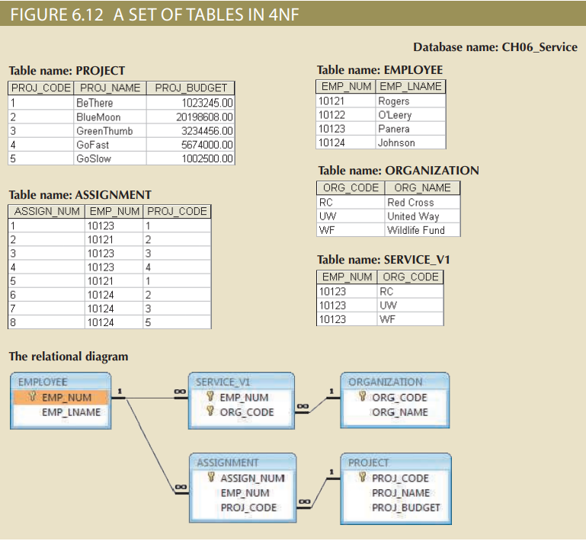

**Compare with ChatGPT:**

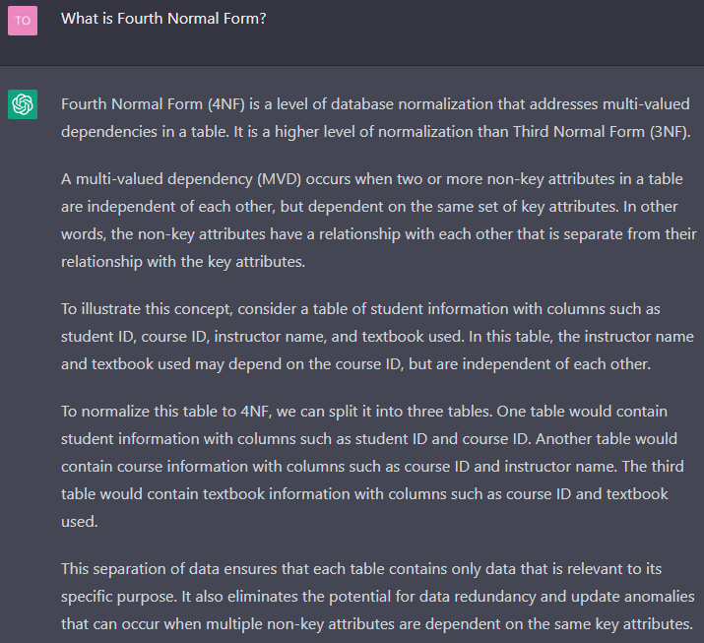

* ChatGPT’s answer **is a paraphrase version** of author’s answer, but the **meaning is the same.**

# **Question:**

## **10 . What three data anomalies are likely to be the result of data redundancy? How can such anomalies be eliminated?**

**Answer:**

A data anomaly in which inconsistent changes have been made to a database. For example, an employee moves, but the address change is not corrected in all files in the database.

[1/21] Three data anomalies that are likely to result from data redundancies are update, insertion and deletion.

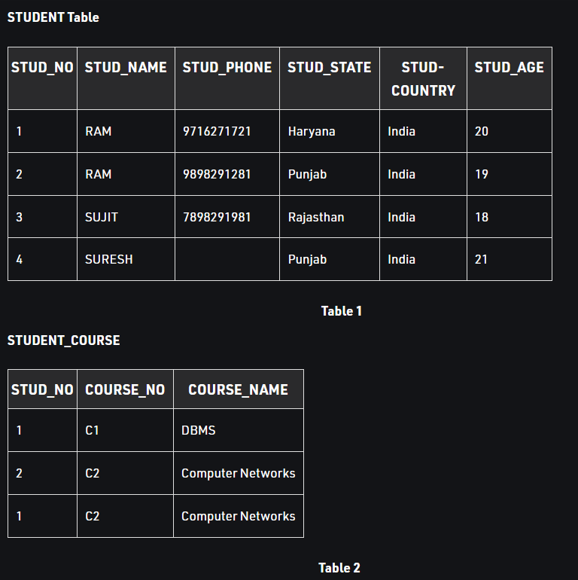

+ [2] Update anomalies happen when the person charged with the task of keeping all the records current and accurate, is asked. For example, if we want to update a record from STUDENT_COURSE at Table 2 with STUD_NO=1, we have to update it in both rows of the table.

+ [2] Insertion anomalies happen when inserting vital data into the database is not possible because other data is not already there. For example, if we try to insert a record in STUDENT_COURSE at Table 2 with only STUD_NO=7, it will not allow it.



+ [2] Deletion anomalies happen when the deletion of unwanted information causes desired information to be deleted as well. For example, if we try to delete a record from STUDENT with STUD_NO=1, it will not allow it.

([1],206) Normalizing the table structure will reduce the data redundancies. Splitting up table to divide the information into separate relational groups reduces data redundancy.

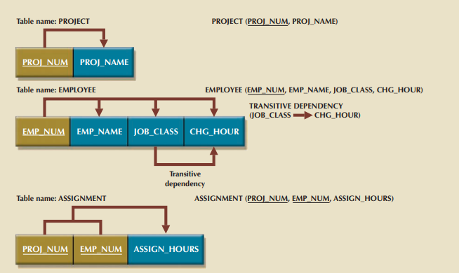

**Example:** The data anomalies created by the database organization shown in figure

are easily eliminated by completing the following these steps:

+ Make new tables to eliminate transitive dependencies.

+ Reassign corresponding dependent attributes.

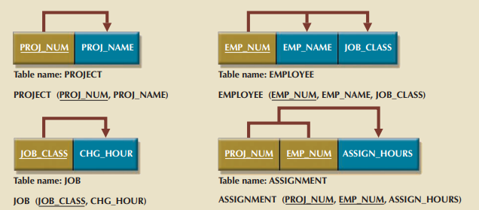

**Compare with ChatGPT:**

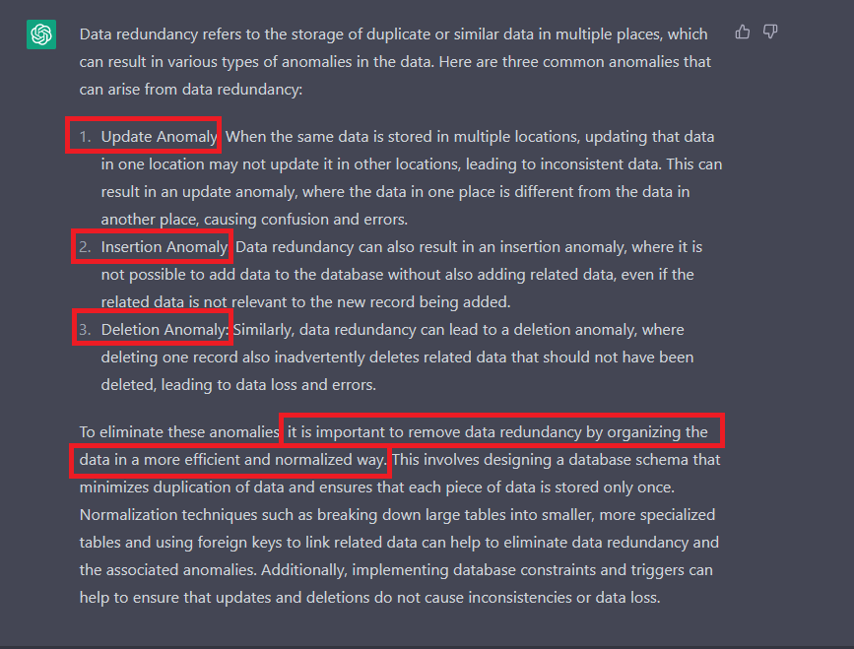

# **Problem:**

**9. Suppose you have been given the table structure and data shown in Table P6.9, which was imported from an Excel spreadsheet. The data reflects that a professor can have multiple advisees, can serve on multiple committees, and can edit more than one journal.**

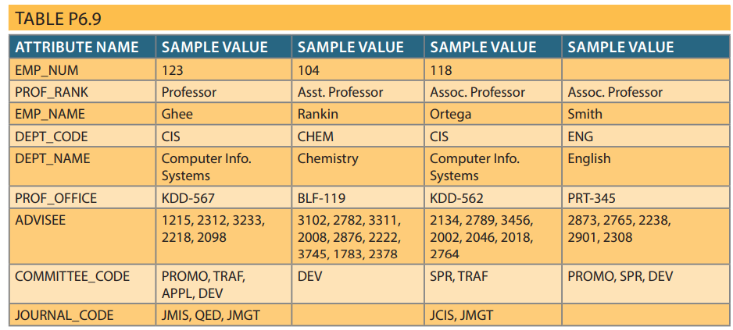

Given the information in Table P6.9:

a. Draw the dependency diagram.

b. Identify the multivalued dependencies.

c. Create the dependency diagrams to yield a set of table structures in 3NF.

d. Eliminate the multivalued dependencies by converting the affected table structures to 4NF.

e. Draw the Crow’s Foot ERD to reflect the dependency diagrams you drew in Problem 9c. (Note: You might have to create additional attributes to define the proper PKs and FKs. Make sure that all of your attributes conform to the naming conventions.)

**Answer :**

**Refactor the figure :**

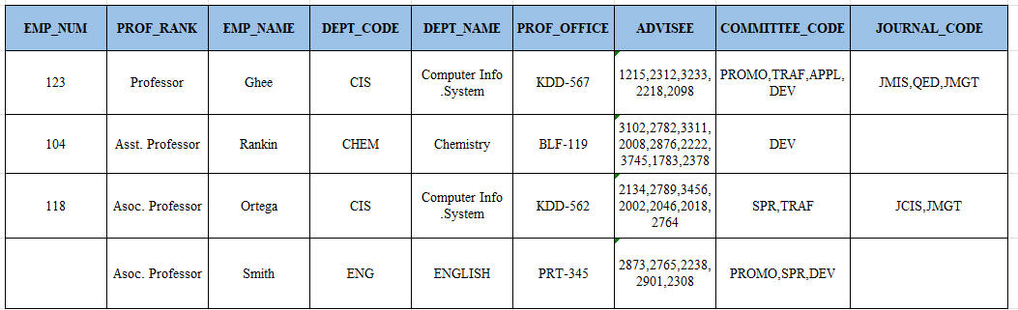

**a. Draw the dependency diagram.**

**The dependency diagram is shown**

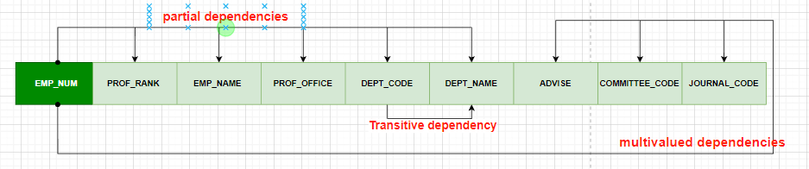

**Partial dependency :** depends only on EMP_NUM as known as Primary key.

* ( EMP_NUM 🡪 PROF_RANK , EMP_NAME , DEPT_CODE , DEPT_NAME , PROF_OFFICE)

**Transitive dependency :** depends on attributewhich non primary key.

* ( DEPT_CODE 🡪 DEPT_NAME )

**b. Identify the multivalued dependencies. :**

Multivalued dependency mean situation occurs when one key determines multiple values of two other attributes and those attributes are independent of each other .([1],225)

- EMP_NUM 🡪 ADVISE

- EMP_NUM 🡪 COMMITTEE_CODE

- EMP_NUM 🡪 JOURNAL_CODE

**c. Create the dependency diagrams to yield a set of table structures in 3NF.**-Dashed line stand for not specific identify

**Table name : Professor**

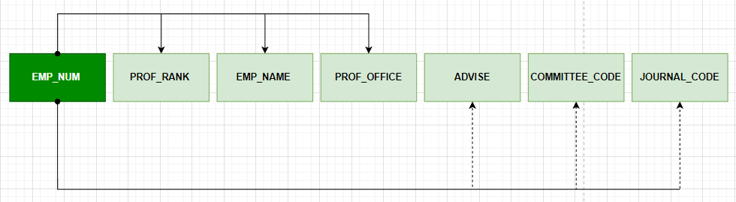

**Table name : Department**

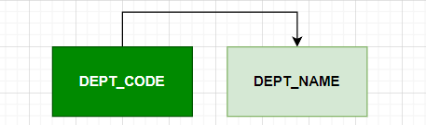

**d. Eliminate the multivalued dependencies by converting the affected table structures to 4NF.**

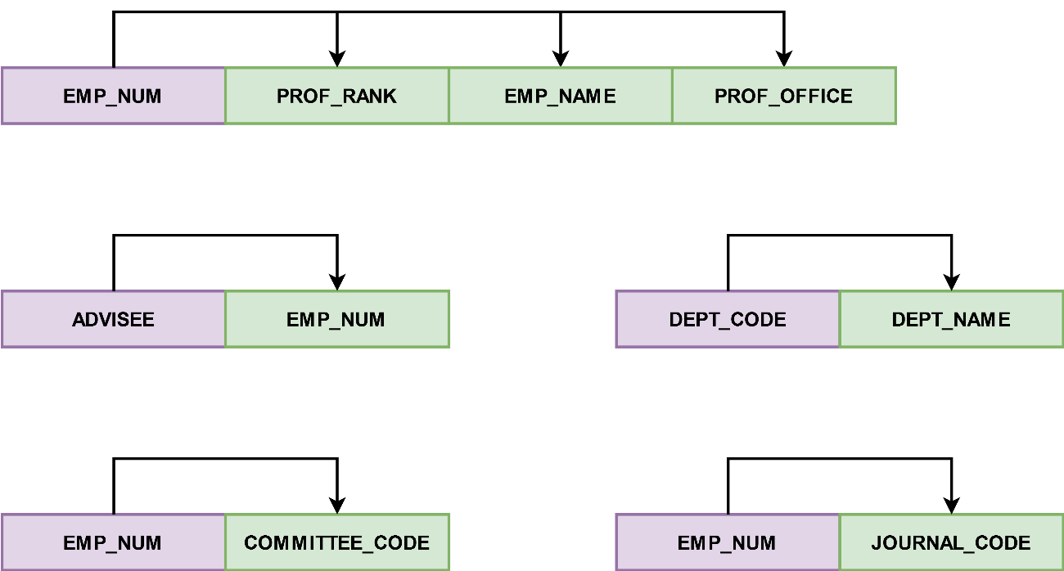

**e. Draw the Crow’s Foot ERD to reflect the dependency diagrams you drew in Problem 9c. (Note: You might have to create additional attributes to define the proper PKs and FKs. Make sure that all of your attributes conform to the naming conventions.)**

# **References:**

[1] Database System Design, Implementation, and Management 12th edition

[2] Data Anomalies (n.d.). *Data Anomalies | Database Management | Fandom*. [https://databasemanagement.fandom.com/wiki/Data_Anomalies](http://databasemanagement.fandom.com/wiki/Data_Anomalies)

# **Task and member assignment table:**

|  |  |  |  |
| --- | --- | --- | --- |
| **Name** | **ID** | **Task** | **Status** |
| Nguyễn Minh Thành* | 20521920 | Problem 9 | Done |
| Nguyễn Văn Tân | 20521880 | Question 10 | Done |
| Quách Vinh Quang | 20521811 | At Class | Done |
| Tống Trường Thịn | 20521958 | Problem 9 | Done |

Note *: Leader