**UNIVERSITY OF INFORMATION TECHNOLOGY**

**Faculty of Information Systems**

~~~~~~*~~~~~~



**Homework 6**

**Database System Design,**

**Management, And Administration**

Lecturer: **Prof. Nguyen Dinh Thuan**

**KS. Nguyen Kim Phung**

Class: **MSIS4013.N22.CTTT**

Team: **2**

**HCM– 2022-2023**

🙢🕮🙠

Table of Contents

**Question :** 2

**2 .** 2

**10 .** 5

**15 .** 8

**Problem:** 8

1 . 8

**References:** 8

**Task and member assignment table:** 8

# **Question :**

## **2 .**

**List and discuss some of the factors that influenced the evolution of the DDBMS**

**Answer :**

Factors that inﬂuenced the evolution of the DDBMS:

* *The growing acceptance of the Internet as the platform for data access and distribution*. The web is eﬀectively the repository for distributed data.
* *The mobile wireless revolution*. The widespread use of mobile wireless digital devices includes smartphones and tablets. These devices have created high demand for data access. They access data from geographically dispersed locations and require varied data exchanges in multiple formats, such as data, voice, video, music, and pictures. Although distributed data access does not necessarily imply distributed databases, performance and failure tolerance requirements ofen lead to the use of data replication techniques similar to those in distributed databases.
* *The accelerated growth of companies using “applications as a service.”* Tis new type of service provides remote applications to companies that want to outsource their application development, maintenance, and operations. Te company data is generally stored on central servers and is not necessarily distributed. Just as with mobile data access, this type of service may not require fully distributed data functionality; however, other factors such as performance and failure tolerance often require the use of data replication techniques similar to those in distributed databases.
* *The increased focus on mobile business intelligence*. More and more companies are embracing mobile technologies within their business plans. As companies use social networks to get closer to customers, the need for on-the-spot decision making increases. Although a data warehouse is not usually a distributed database, it does rely on techniques such as data replication and distributed queries that facilitate data extraction and integration.
* *Emphasis on Big Data analytics*. The era of mobile communications unraveled an  
  avalanche of data from many sources and of many types. Today’s customers have  
  signifcant inﬂuence on the spending habits of communities, and organizations  
  are investing in ways to harvest such data to “discover” new ways to eﬀectively and effciently reach customers.

In addtition, the distributed database is especially desirable because centralized database management is subject to problems such as:

* Performance degradation because of a growing number of remote locations over greater distances.
* High costs associated with maintaining and operating large central (mainframe) database systems and physical infrastructure.
* Reliability problems created by dependence on a central site (single point of failure syndrome) and the need for data replication.
* Scalability problems associated with the physical limits imposed by a single location, such as physical space, temperature conditioning, and power consumption.
* Organizational rigidity imposed by the database, which means it might not support the ﬂexibility and agility required by modern global organizations.

**ChatGPT’s answer:**

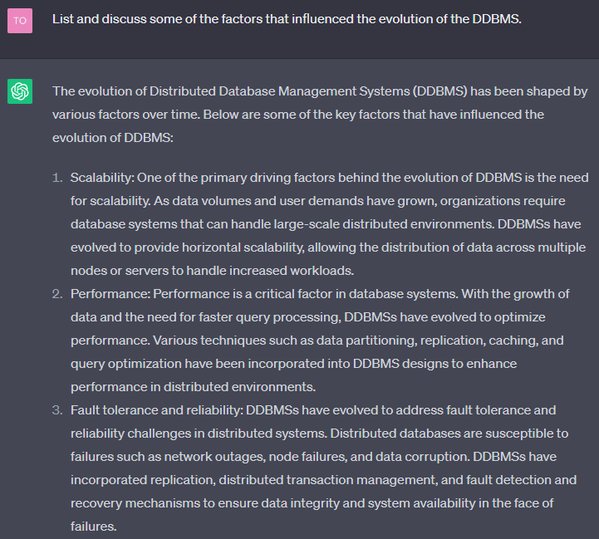

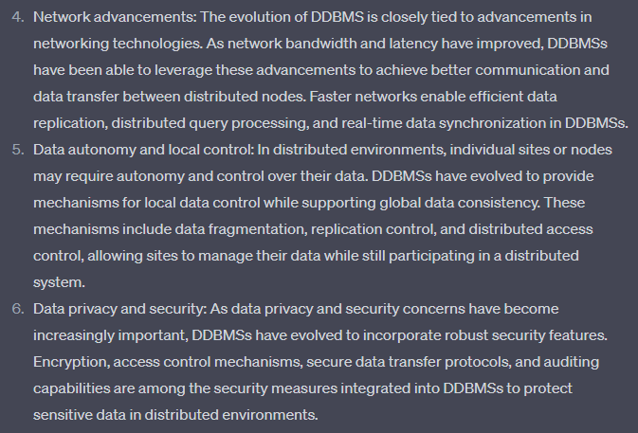

## **10 .**

**Describe the different types of database requests and transactions.**

**Answer :**

([1],484)

**Database request** : is the equivalent of an SQL statement in an application program or transaction.

**Database transaction:** is formed by one or more database requests

In a DDBMS, a database request and a database transaction can be of two types: remote or distributed.

**Types of request:**

**+ Remote request :** a single SQL statement access the data that are to be processed by a single remote database processor. In other words, the SQL statement (or request) can reference data at only one remote site. ([1],568)

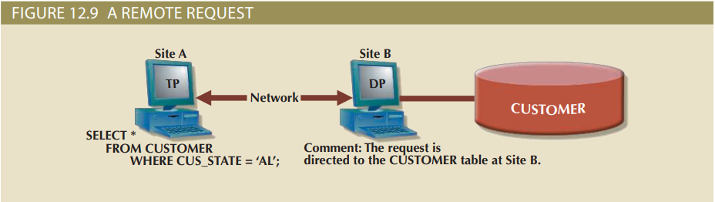

**+ Distributed request :** Single SQL statement references data at several DP sites

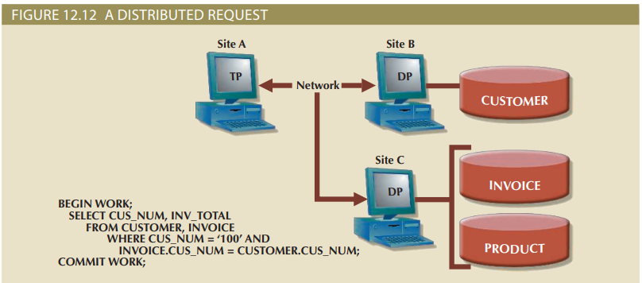

**Types of transaction:**

**+ Remote transaction :** A DDBMS feature that allows a transaction (formed by several requests) to access data in a single remote DP ([1],568)

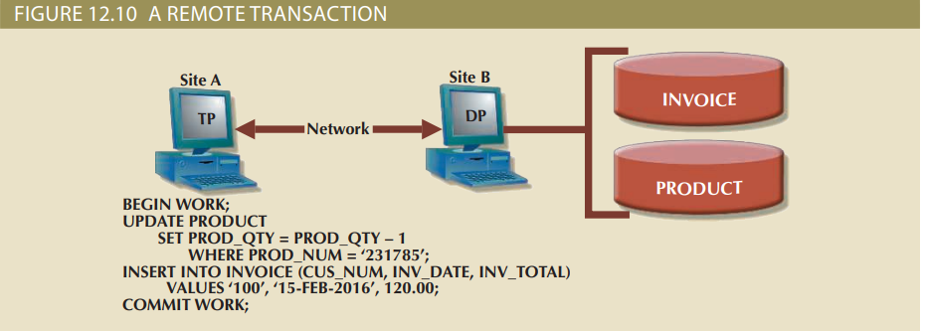

**+ Distributed transaction :** A database transaction that accesses data in several remote data processors (DPs) in a distributed database. ([1],569) .

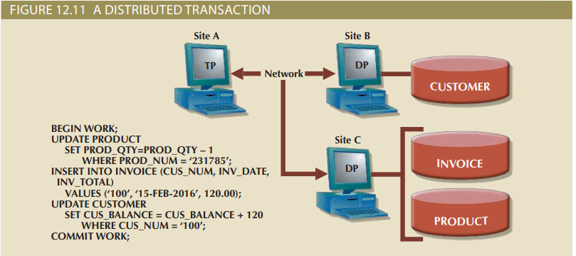

**ChatGPT’s answer:**

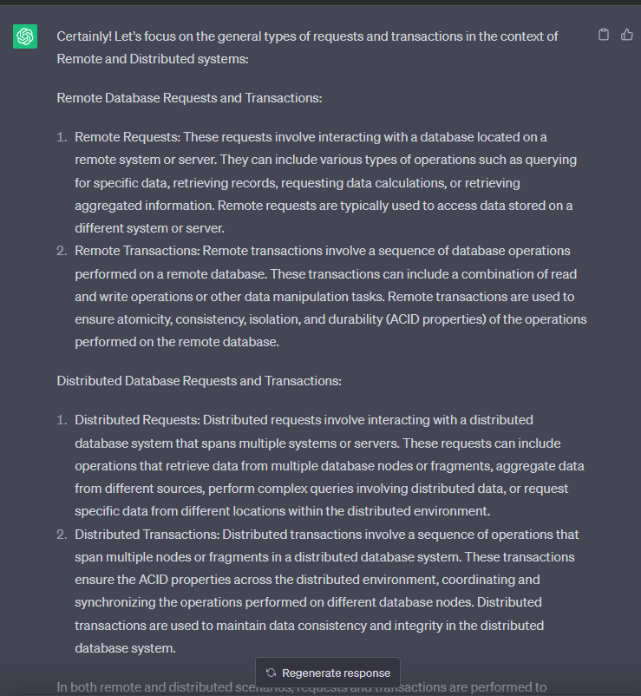

**🡪**Both highlight the distinctions between remote requests/transactions (accessing data at a single remote site) and distributed requests/transactions (accessing data at multiple sites within a distributed database).

## **15 .**

**Describe the three data fragmentation strategies. Give some examples of each**

**Data fragmentation** is a characteristic of a DBMS that allows a single object to be broken into two or more segments or fragments. The object might be a user’s database, a system database, or a table. Each fragment can be stored at any site on a computer network.

**Three types of fragmentation strategies:**

**Horizontal fragmentation**: the distributed of database design process that breaks a table into subsets of unique rows

**Example:** A company’s employee database could be horizontally fragmentation based on departments, where each fragment contains the employee belonging to a specific department.. for example, one fragment contains employees from the ‘Sales’ department, another fragment contains the employees from ‘Marketing’ departments, and so on.

**Vertical fragmentation**: in distributed database design, the process that breaks a table into subsets os columns from the original table. Fragments must share a common primary key

**Example:** In a customer relationship management (CRM) system, the customer table could be vertically fragmented into two fragments: one containing basic customer information such as name, contact details, and another containing sensitive financial information like credit card details. This way, different security access controls can be applied to each fragment.

**Mixed fragmentation**: acombination of horizontal and vertical strategies for data fragmentation, in which a table may be divided into several rows and each row has a subset of the attributes (columns)

**Example:** Consider an e-commerce platform’s product database. It could be mixed fragmented by dividing it into horizontal fragment based on product categories and futher vertically fragmented within each category to separate columns such as product description, price, and availability.

**ChatGPT’s answer:**

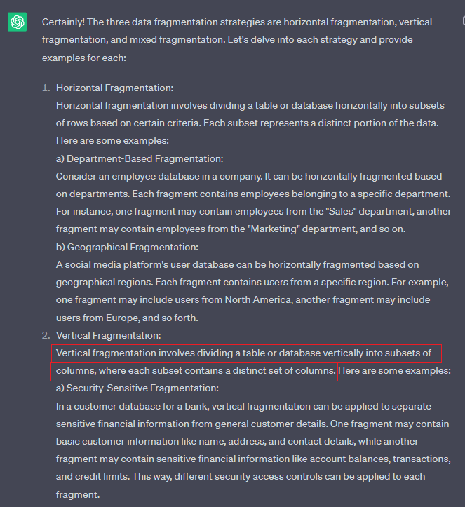

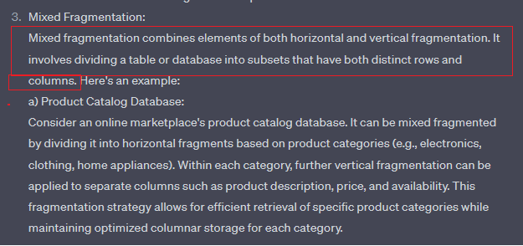

# **Problem:**

## 1 .

**Problem 1 is based on the DDBMS scenario in Figure P12.1.**

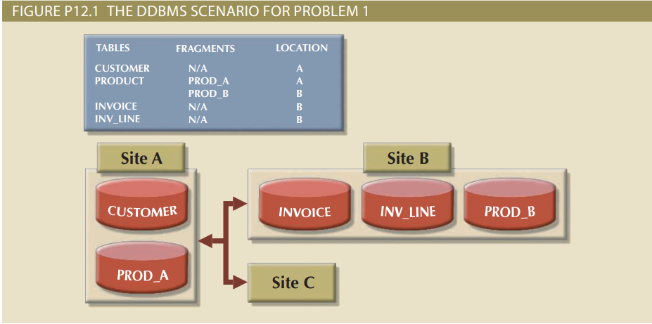

# **References:**

[1] Database System Design, Implementation, and Management 12th edition

# **Task and member assignment table:**

tan 15 t 10 m 2 thinh pro1

|  |  |  |  |
| --- | --- | --- | --- |
| **Name** | **ID** | **Chapter** | **Task** |
| Nguyễn Minh Thành* | 20521920 | 12 | Question 10 |
| Nguyễn Văn Tân | 20521880 | 12 | Question 15 |
| Quách Vinh Quang | 20521811 | 12 | Question 2 |
| Tống Trường Thịn | 20521958 | 12 | Problem 1 |

Note *: Leader