**University of Information Technology**

**SUBMISSION OF TEST 2**



**DATABASE SYSTEMS DESIGN, IMPLEMENTATION AND MANAGEMENT**

**Instructor: Nguyen Dinh Thuan**

**Students: Group 2**

**March 12, 2023**

**CODE ANSWER:**

|  |
| --- |
| **create table EMPLOYEE**  **(**  **Fname varchar2(10),**  **Minit varchar2(1),**  **Lname varchar2(10),**  **Ssn number,**  **Bdate date,**  **Address varchar2(100),**  **Sex varchar2(1),**  **Salary number(19,4),**  **Super_ssn varchar2(10),**  **Dno number,**  **constraint PK_EMPLOYEE primary key (Ssn)**  **);**  **create table DEPARTMENT**  **(**  **Dname varchar2(20),**  **Dnumber number,**  **Mgr_ssn varchar2(20),**  **Mgr_start_date date,**  **constraint PK_DEPARTMENT primary key (Dnumber)**  **);**  **create table DEPT_LOCATIONS**  **(**  **Dnumber number,**  **Dlocation varchar2(20),**  **constraint PK_DEPT_LOCATIONS primary key (Dnumber, Dlocation)**  **);**  **create table WORKS_ON**  **(**  **Essn varchar2(20),**  **Pno number,**  **Hours float,**  **constraint PK_WORKS_ON primary key (Essn, Pno)**  **);**  **create table PROJECT**  **(**  **Pname varchar2(30),**  **Pnumber number,**  **Plocation varchar2(20),**  **Dnum number,**  **constraint PK_PROJECT primary key (Pnumber)**  **);**  **create table DEPENDENT**  **(**  **Essn varchar2(20),**  **Dependent_name varchar2(20),**  **Sex varchar2(1),**  **Bdate date,**  **Relationship varchar2(20),**  **constraint PK_DEPENDENT primary key (Essn, Dependent_name)**  **);**  **INSERT INTO EMPLOYEE VALUES ('John', 'B', 'Smith', '123456789', TO_DATE('1965-01-09', 'YYYY-MM-DD'), '731 Fondren, Houston, TX', 'M', 30000, '333445555', 5);**  **INSERT INTO EMPLOYEE VALUES ('Franklin', 'T', 'Wong', '333445555', TO_DATE('1995-12-08', 'YYYY-MM-DD'), '638 Voss, Houston, TX', 'M', 40000, '888665555', 5);**  **INSERT INTO EMPLOYEE VALUES ('Alica', 'J', 'Zelaya', '999887777', TO_DATE('1968-01-19', 'YYYY-MM-DD'), '3321 Castle, Spring, TX', 'F', 25000, '987654321', 4);**  **insert into EMPLOYEE values ('Jennifer','S','Wallace','987654321',TO_DATE('1941-06-20','YYYY-MM-DD'),'291 Berry,Bellaire,TX','F',43000,'888665555',4);**  **insert into EMPLOYEE values ('Ramesh','K','Narayan','666884444',TO_DATE('1962-09-15','YYYY-MM-DD'),'975 Fire Oak,Humble,TX','M',38000,'333445555',5);**  **insert into EMPLOYEE values ('Joyce','A','English','453453453',TO_DATE('1972-07-31','YYYY-MM-DD'),'5631 Rice, Houston,TX','F',25000,'333445555',4);**  **insert into EMPLOYEE values ('Ahmad','V','Jabbar','987987987',TO_DATE('1969-03-29','YYYY-MM-DD'),'980 Dallas, Houston,TX','M',25000,'987654321',4);**  **insert into EMPLOYEE values ('James','E','Borg','888665555',TO_DATE('1937-11-10','YYYY-MM-DD'),'450 Stone, Houston,TX','M',55000,null,1);**  **insert into DEPARTMENT values ('Research',5,'333445555',TO_DATE('1988-05-22','YYYY-MM-DD'));**  **insert into DEPARTMENT values ('Administration',4,'987654321',TO_DATE('1995-01-01','YYYY-MM-DD'));**  **insert into DEPARTMENT values ('Headquarters',1,'888665555',TO_DATE('1981-06-19','YYYY-MM-DD'));**  **insert into DEPT_LOCATIONS values (1,'Houston');**  **insert into DEPT_LOCATIONS values (4,'Stafford');**  **insert into DEPT_LOCATIONS values (5,'Bellaire');**  **insert into DEPT_LOCATIONS values (5,'Sugarland');**  **insert into DEPT_LOCATIONS values (5,'Houston');**  **insert into WORKS_ON values ('123456789',1,32.5);**  **insert into WORKS_ON values ('123456789',2,7.5);**  **insert into WORKS_ON values ('666884444',3,40.0);**  **insert into WORKS_ON values ('453453453',1,20.0);**  **insert into WORKS_ON values ('453453453',2,20.0);**  **insert into WORKS_ON values ('333445555',2,10.0);**  **insert into WORKS_ON values ('333445555',3,10.0);**  **insert into WORKS_ON values ('333445555',10,10.0);**  **insert into WORKS_ON values ('333445555',20,10.0);**  **insert into WORKS_ON values ('999887777',30,30.0);**  **insert into WORKS_ON values ('999887777',10,10.0);**  **INSERT INTO WORKS_ON VALUES ('987987987','10','35.0');**  **INSERT INTO WORKS_ON VALUES ('987987987','30','5.0');**  **INSERT INTO WORKS_ON VALUES ('987654321','30','20.0');**  **INSERT INTO WORKS_ON VALUES ('987654321','20','15.0');**  **INSERT INTO WORKS_ON VALUES ('888665555','20',NULL);**  **INSERT INTO PROJECT VALUES ('ProductX','1','Bellaire','5');**  **INSERT INTO PROJECT VALUES ('ProductY','2','Sugarland','5');**  **INSERT INTO PROJECT VALUES ('ProductZ','3','Houston','5');**  **INSERT INTO PROJECT VALUES ('Computerrization','10','Stafford','4');**  **INSERT INTO PROJECT VALUES ('Reorganization','20','Houston','1');**  **INSERT INTO PROJECT VALUES ('Newbenefits','30','Stafford','4');**  **INSERT INTO DEPENDENT VALUES ('333445555','Alice','F',TO_DATE('1986-04-05','YYYY-MM-DD'),'Daughter');**  **INSERT INTO DEPENDENT VALUES ('333445555','Theodore','M',TO_DATE('1983-10-25','YYYY-MM-DD'),'Son');**  **INSERT INTO DEPENDENT VALUES ('333445555','Joy','F',TO_DATE('1958-05-03','YYYY-MM-DD'),'Spouse');**  **INSERT INTO DEPENDENT VALUES ('987654321','Abner','M',TO_DATE('1942-02-28','YYYY-MM-DD'),'Spouse');**  **INSERT INTO DEPENDENT VALUES ('123456789','Michael','M',TO_DATE('1988-01-04','YYYY-MM-DD'),'Son');**  **INSERT INTO DEPENDENT VALUES ('123456789','Alice','F',TO_DATE('1988-12-30','YYYY-MM-DD'),'Daughter');**  **INSERT INTO DEPENDENT VALUES ('123456789','Elizabeth','F',TO_DATE('1967-05-05','YYYY-MM-DD'),'Spouse');**  **--1. Retrieve the names of employees in department 4 who work more than 15 hours per week on the 'ProductX' project.**  **--**  **SELECT e.Fname, e.Lname**  **FROM EMPLOYEE e**  **JOIN WORKS_ON w ON e.Ssn = w.Essn**  **JOIN PROJECT p ON w.Pno = p.Pnumber**  **WHERE e.Dno = 4 AND w.Hours > 15 AND p.Pname = 'ProductX';**  **--2. List the names of employees who have a dependent with the same first name as themselves.**  **--**  **SELECT E.Fname, E.Lname**  **FROM EMPLOYEE E, DEPENDENT D**  **WHERE E.Ssn = D.Essn AND E.Fname = D.Dependent_name;**  **--3. Find the names of employees that are directly supervised by 'Franklin Wong'.**  **--**  **SELECT E.Fname, E.Lname**  **FROM EMPLOYEE E**  **WHERE E.Super_ssn = ( SELECT Ssn**  **FROM EMPLOYEE sup**  **WHERE sup.Fname = 'Franklin' AND sup.Lname = 'Wong'**  **)**  **--4. For each project, list the project name and the total hours per week (by all employees) spent on that project.**  **--**  **SELECT p.Pname, SUM(w.Hours) AS "Total Hours Per Week"**  **FROM PROJECT p**  **JOIN WORKS_ON w ON p.Pnumber = w.Pno**  **GROUP BY p.Pname;**  **--5. Retrieve the names of employees who work on every project.**  **--**  **SELECT e.Fname, e.Lname**  **FROM EMPLOYEE e**  **JOIN WORKS_ON w ON e.Ssn = w.Essn**  **GROUP BY e.Fname, e.Lname**  **HAVING COUNT(DISTINCT w.Pno) = (**  **SELECT COUNT(DISTINCT Pno)**  **FROM WORKS_ON**  **)**  **--6. Retrieve the names of employees who do not work on any project.**  **--**  **SELECT e.Fname, e.Lname**  **FROM EMPLOYEE e**  **JOIN WORKS_ON w ON e.Ssn = w.Essn**  **GROUP BY e.Fname, e.Lname**  **HAVING COUNT(DISTINCT w.Pno) = 0**  **--7. For each department, retrieve the department name, and the average salary of employees working in that department.**  **--**  **SELECT d.Dname, AVG(e.Salary) AS "The average salary of employees working in that department"**  **FROM DEPARTMENT d**  **JOIN EMPLOYEE e ON d.Dnumber = e.Dno**  **GROUP BY d.Dname**  **--8. Retrieve the average salary of all female employees.**  **--**  **SELECT AVG(e.Salary) AS "The average salary of all female employees"**  **FROM EMPLOYEE e**  **WHERE e.Sex = 'F'**  **--9. Find the names and addresses of employees who work on at least one project located in Houston but whose department has no location in Houston.**  **--**  **SELECT e.Lname,e.Fname, e.Address**  **FROM EMPLOYEE e**  **JOIN WORKS_ON w ON e.Ssn = w.Essn JOIN PROJECT p ON w.Pno = p.Pnumber JOIN DEPARTMENT d ON e.Dno = d.Dnumber**  **WHERE p.Plocation IN 'Houston' AND d.Dnumber NOT IN (**  **SELECT Dnumber**  **FROM DEPT_LOCATIONS**  **WHERE Dlocation = 'Houston'**  **);**  **--10. List the last names of department managers who have no dependents.**  **SELECT e.Lname,e.Fname**  **FROM EMPLOYEE e**  **JOIN DEPARTMENT d ON e.Ssn = d.Mgr_ssn**  **WHERE e.Ssn NOT IN (**  **SELECT Essn**  **FROM DEPENDENT**  **)** |

**OUTPUT**

1. **Retrieve the names of employees in department 4 who work more than 15 hours per week on the 'ProductX' project.**

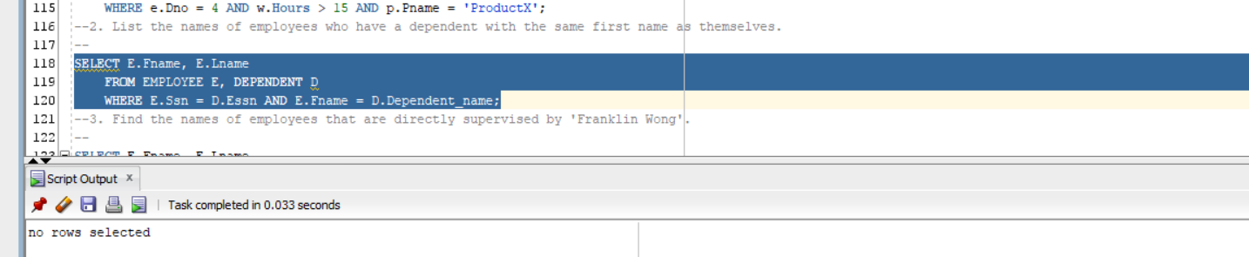

1. **List the names of employees who have a dependent with the same first name as themselves.**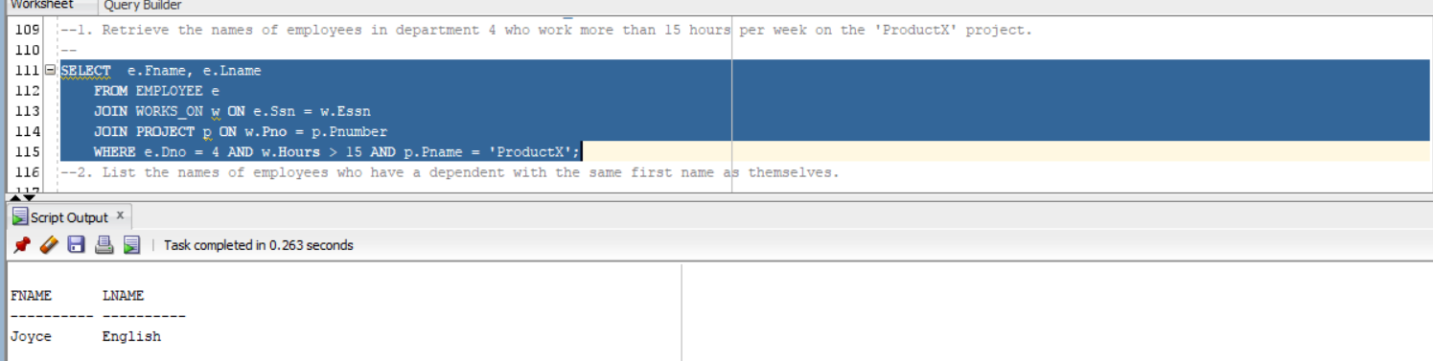
2. **Find the names of employees that are directly supervised by 'Franklin Wong'.**

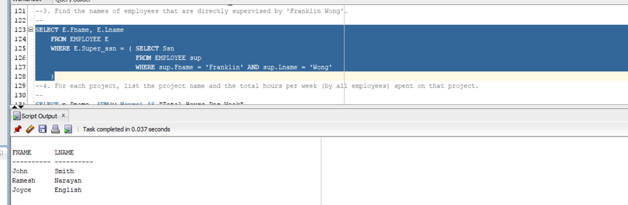

1. **For each project, list the project name and the total hours per week (by all employees) spent on that project.**

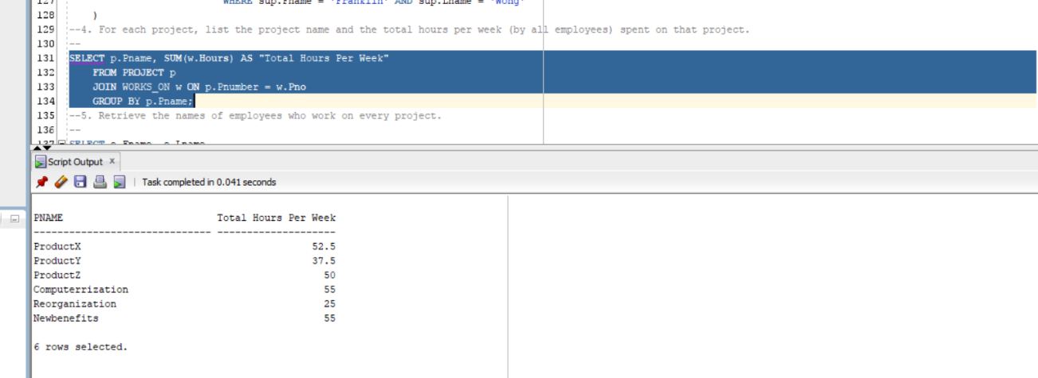

1. **Retrieve the names of employees who work on every project.**

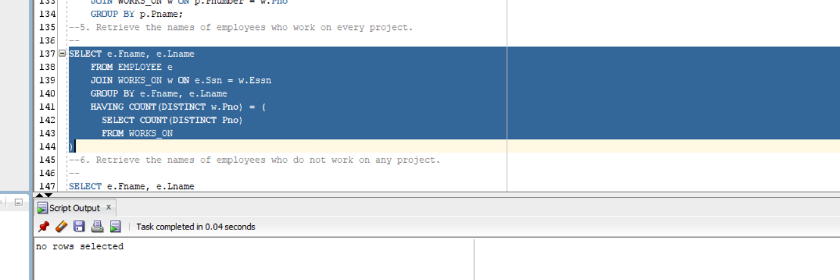

1. **Retrieve the names of employees who do not work on any project.**

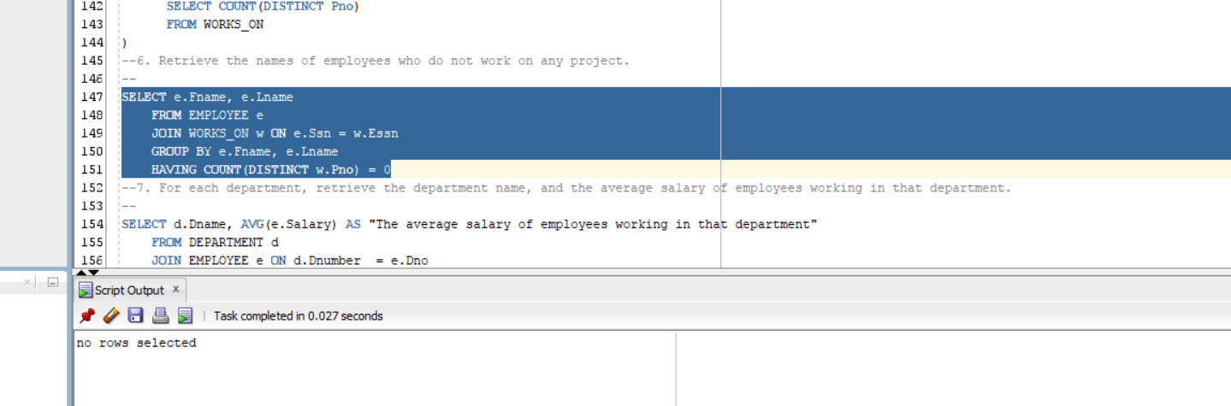

1. **For each department, retrieve the department name, and the average salary of employees working in that department.**

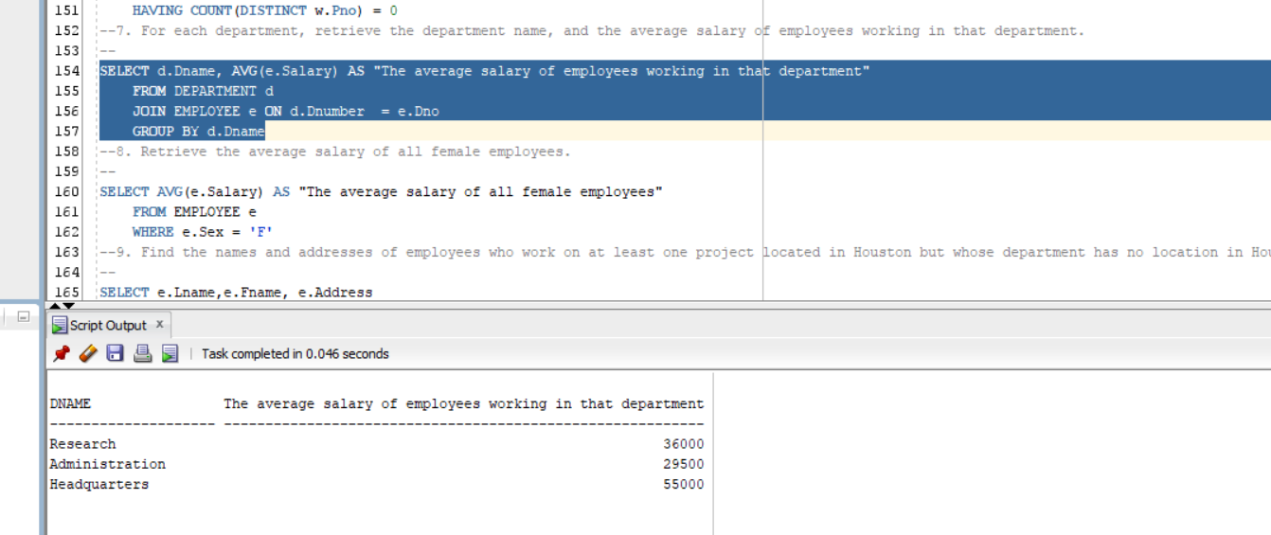

1. **Retrieve the average salary of all female employees.**

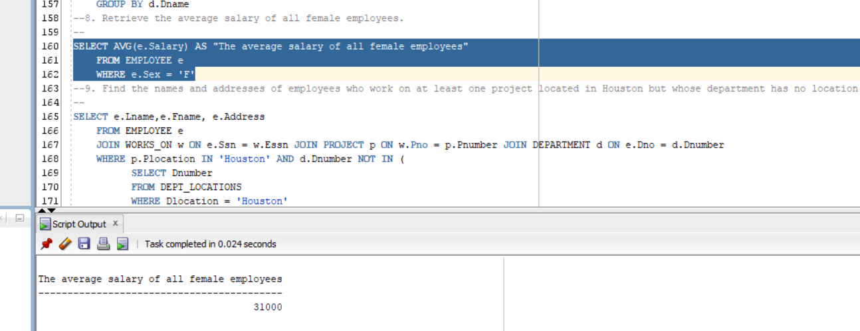

1. **Find the names and addresses of employees who work on at least one project located in Houston but whose department has no location in Houston.**

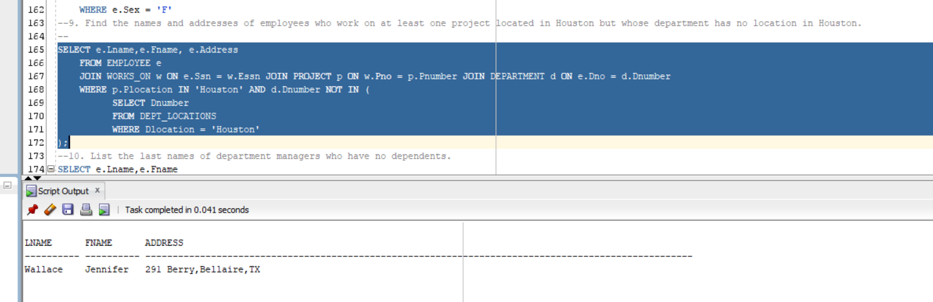

1. **List the last names of department managers who have no dependents.**

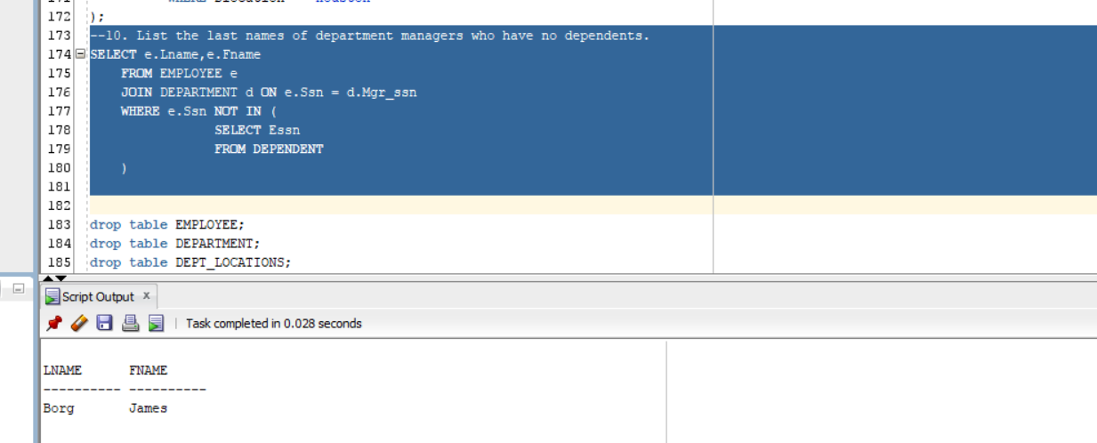

# **Task and member assignment table:**

|  |  |
| --- | --- |
| **Name** | **ID** |
| Nguyễn Minh Thành* | 20521920 |
| Nguyễn Văn Tân | 20521880 |
| Quách Vinh Quang | 20521811 |
| Tống Trường Thịn | 20521958 |

Note *: Leader