9. Suppose you have been given the table structure and data shown in Table P6.9, which was imported from an Excel spreadsheet. The data reflects that a **professor** can have multiple advisees, can serve on multiple committees, and can edit more than one journal.

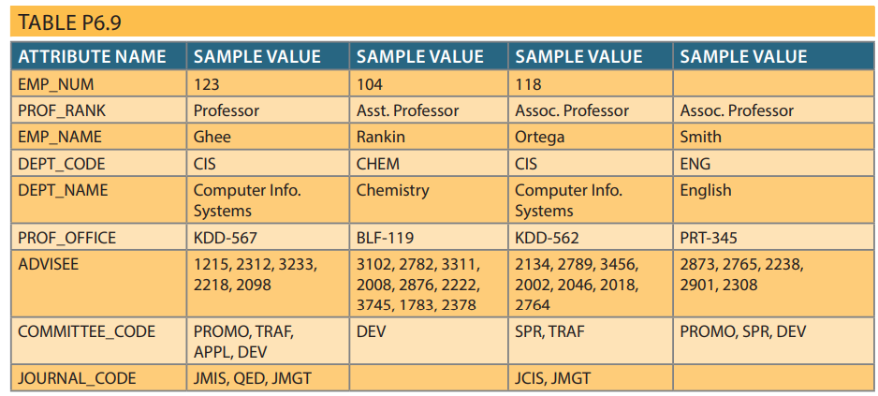

Given the information in Table P6.9:

a. Draw the dependency diagram.

b. Identify the multivalued dependencies.

c. Create the dependency diagrams to yield a set of table structures in 3NF.

d. Eliminate the multivalued dependencies by converting the affected table structures to 4NF.

e. Draw the Crow’s Foot ERD to reflect the dependency diagrams you drew in Problem 9c. (Note: You might have to create additional attributes to define the proper PKs and FKs. Make sure that all of your attributes conform to the naming conventions.)

**Answer :**

**Refactor the figure :**

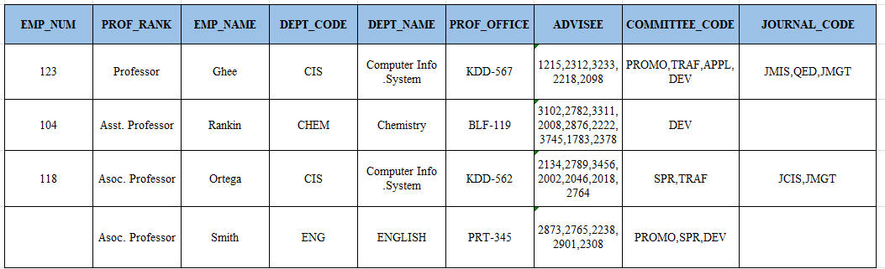 **a. Draw the dependency diagram.**

**The dependency diagram is shown**

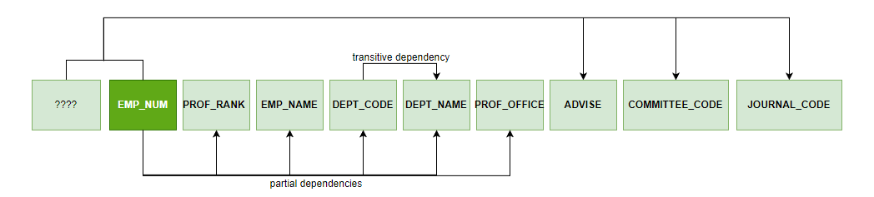

**Partial dependency :** depends only on EMP_NUM as known as Primary key.

* ( EMP_NUM 🡪 PROF_RANK , EMP_NAME , DEPT_CODE , DEPT_NAME , PROF_OFFICE)

**Transitive dependency :** depends on attributewhich non primary key.

* ( DEPT_CODE 🡪 DEPT_NAME )

**b. Identify the multivalued dependencies. :**

Multivalued dependency mean situation occurs when one key determines multiple values of two other attributes and those attributes are independent of each other .([1],225)

- EMP_NUM 🡪 ADVISE

- EMP_NUM 🡪 COMMITTEE_CODE

- EMP_NUM 🡪 JOURNAL_CODE

**c. Create the dependency diagrams to yield a set of table structures in 3NF.**

**Table name : Professor**

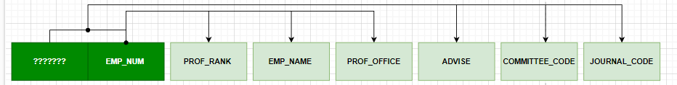

**Table name : Department**

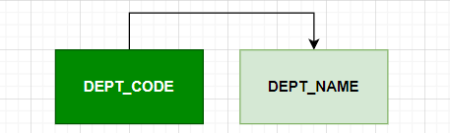

**d. Eliminate the multivalued dependencies by converting the affected table structures to 4NF.**

**e. Draw the Crow’s Foot ERD to reflect the dependency diagrams you drew in Problem 9c. (Note: You might have to create additional attributes to define the proper PKs and FKs. Make sure that all of your attributes conform to the naming conventions.)**

[1] Database System Design, Implementation, and Management 12th edition