**10. Describe the different types of database requests and transactions  
Answer :**

([1],484)

**Database request** : is the equivalent of an SQL statement in an application program or transaction.

**Database transaction:** is formed by one or more database requests

In a DDBMS, a database request and a database transaction can be of two types: remote or distributed.

**Types of request:**

**+ Remote request :** a single SQL statement access the data that are to be processed by a single remote database processor. In other words, the SQL statement (or request) can reference data at only one remote site. ([1],568)

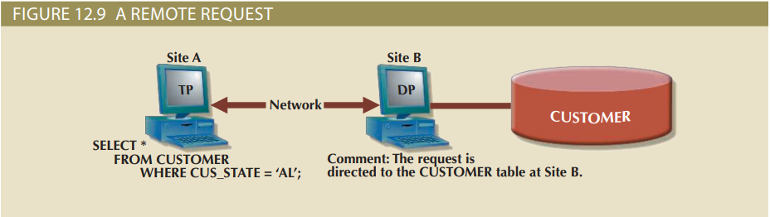

**+ Distributed request :** Single SQL statement references data at several DP sites

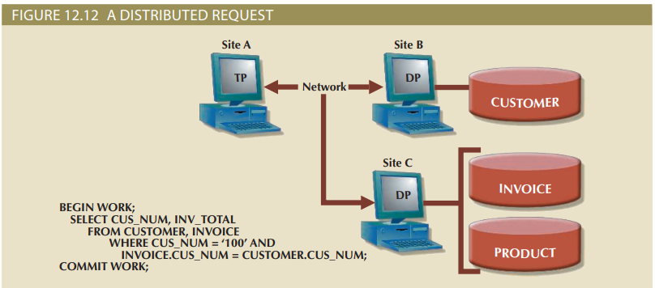

**Types of transaction:**

**+ Remote transaction :** A DDBMS feature that allows a transaction (formed by several requests) to access data in a single remote DP ([1],568)

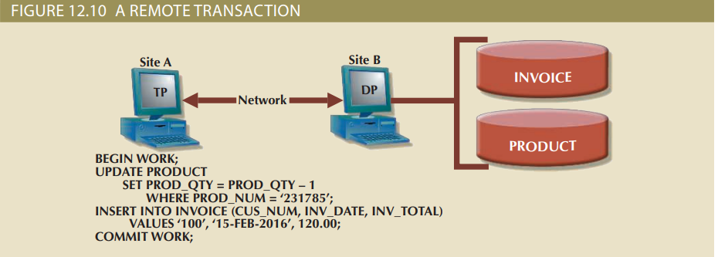

**+ Distributed transaction :** A database transaction that accesses data in several remote data processors (DPs) in a distributed database. ([1],569) .

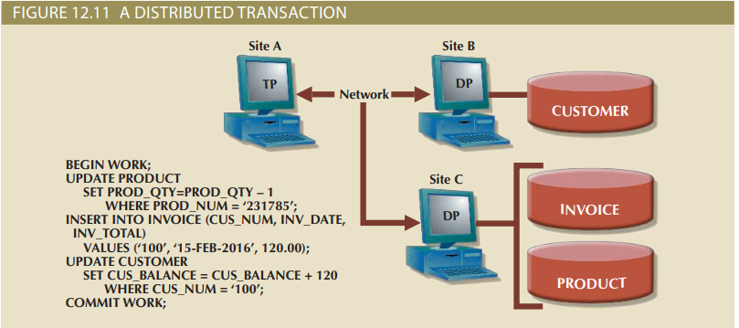

**Compare with ChatGPT :**

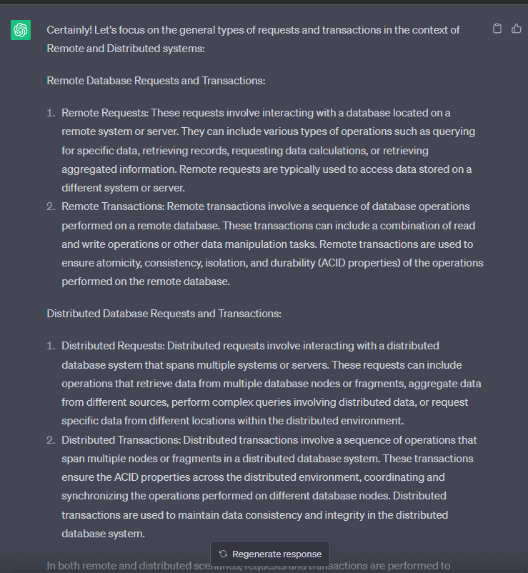

**🡪**Both highlight the distinctions between remote requests/transactions (accessing data at a single remote site) and distributed requests/transactions (accessing data at multiple sites within a distributed database).