**Assigment_2**

Minh Thien Nguyen

301421114

Centennial College

Unix/Linux Operating Systems (SEC. 001)

Professor Asam Gulaid

Due: Feb 21st 2025

**Part A**

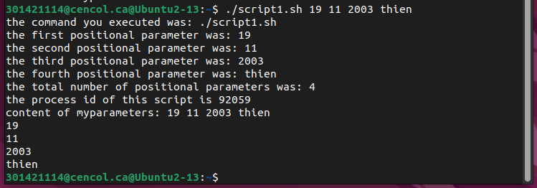

Script : (Shebang)

#!/bin/bash

echo "the command you executed was: $0" (display the command)

echo "the first positional parameter was: $1" (display the parameter 1, 2, 3, 4)

echo "the second positional parameter was: $2"

echo "the third positional parameter was: $3"

echo "the fourth positional parameter was: $4"

echo "the total number of positional parameters was: $#" ($#: number of parameters)

echo "the process id of this script is $$" ($$ show the ID of current process)

myparameters=$* ($*: all parameters in one string)

echo "content of myparameters: $myparameters" (display myparameters)

for i in $@ ($@ shows all parameters as a set of strings)

do

echo $i

done

Part B

#!/bin/bash (shebang)

echo "FILE SEARCH RAN AT: $(date)" >> dirlog

(print the date command in dirlog)

for item in *;

(loop for every file in the current directory)

do

if [ -f "$item" ];

then

(if statement)

echo "file found: $item"

fi

done >> dirlog