

**International School**

**CDIO_2**

**CMU-CS 447 RIS (2024S)**

**Database Design**

**Version 1.1**

11 April 2024

**Online Electronic Shopping System** (**Happy Shop)**

**Submitted by**

**Tuan,Nguyen Le Anh**

**Anh,Truong Quang**

**Phuc,Tran Thanh**

**Thien,Pham Minh**

**Approved by**

**MSc Huy, Truong Dinh**

**Proposal Review Panel Representative:**

Name Signature Date

**CDIO_2- Mentor:**

Name Signature Date

**PROJECT INFORMATION**

|  |  |  |  |  |  |
| --- | --- | --- | --- | --- | --- |
| **Project acronym** | | HPPS | | | |
| **Project Title** | | Online Electronic Shopping System (Happy Shop) | | | |
| **Start Date** | | 11 April 2024 | | **End Date** | 08 Jun 2021 |
| **Lead Institution** | | | International School, Duy Tan University | | |
| **Project Mentor** | | | MSc Huy, Truong Dinh | | |
| **Scrum master / Project Leader & contact details** | | | **Tuan,Nguyen Le Anh**  Email: anhtuanhdqb@gmail.com  Tel: 0886767856 | | |
| **Partner Organization** | | | Duy Tan University | | |
| **Project Web URL** | | |  | | |
| **Team members** | Name | | | Email | Tel |
| 1 | Tuan,Nguyen Le Anh | | | anhtuanhdqb@gmail.com | 0886767856 |
| 2 | Thien,Pham Minh | | | minhthienp50@gmail.com | 0984268233 |
| 3 | Phuc,Tran Thanh | | | tranthanhphuc919@gmail.com | 0795710107 |
| 4 | Anh,Truong Quang | | | anhpk2310@gmail.com | 0332044749 |

**DOCUMENT APPROVALS**

The following signatures are required for approval of this document.

|  |  |  |
| --- | --- | --- |
| Tuan,Nguyen Le Anh  Student ID: 27211231107  *Scrum Master* | Signature | Date |
| Anh,Truong Quang  Student ID: 27211248346  *Team Member* | Signature | Date |
| Phuc,Tran Thanh  Student ID: 27211248255  *Team Member* | Signature | Date |
| Thien,Pham Minh  Student ID: 27211202495  *Team Member* | Signature | Date |

**REVISION HISTORY**

|  |  |  |  |  |
| --- | --- | --- | --- | --- |
| **Version** | **Date** | **Comments** | **Author** | **Approval** |
| 1.0 | 11 April 2024 | Initial Release | Anh,Truong Quang |  |
|  |  |  |  |  |

**TABLE OF CONTENT**

**1. Introduction**

**1.1 Purpose**

**1.2 Scope**

**1.3 Introducing Sql Server**

**2.Database Diagram**

**2.1 Table Overview**

**2.2 Entity Relationship Diagram**

**2.3 Table Relationship Diagram**

**3. Database Design for Sprint**

**3.1 Table User**

**3.2 Table categories**

**3.3 Table orders**

**3.4 Table order detail**

**3.5 Table produc**

**4.Hardware and software Requirements**

**1. Introduction**

The Database Design maps the logical data model to the target database management system with consideration to the system’s performance requirements. The Database Design converts logical or conceptual data constructs to physical data constructs (e.g., tables...) of the target Database Management System.

**1.1 Purpose**

The purpose of the Database Design is to ensure that every database transaction meets or exceeds its performance requirements. This document takes into account data and transaction volume to produce a schema and environment that will meet necessary performance.

**1.2 Scope**

The Database Design Document has the following objectives:

● To describe the design of a database, that is, a collection of related data stored in one or more computerized files that can be accessed by users or developers via a DBMS.

● To serve as a basis for implementing the database and related software units. It provides the acquirer visibility into the design and provides information necessary for software development.

**1.3 Introducing Sql Server**

SQL Server is a Database Management System (DBMS) developed by Microsoft. First introduced in 1989, SQL Server has become one of the most popular database management systems on the market.

1. Relational Database Management System (RDBMS): SQL Server enables the storage and management of data in relational tables, utilizing the Structured Query Language (SQL) to access and manipulate data.
2. Security: SQL Server offers various security features to safeguard data, including permission management, data encryption, access control, and user activity monitoring.
3. Integration: SQL Server seamlessly integrates with a variety of Microsoft technologies and applications such as .NET Framework, Visual Studio, Azure, and cloud computing services.
4. Distribution and Scalability: SQL Server can be deployed across multiple platforms and scales to handle large data volumes and workloads.
5. High Availability and Reliability: SQL Server provides features like backup and restore, data recovery, and fault tolerance to ensure data is protected and accessible.
6. Management and Monitoring Tools: SQL Server includes a range of tools for efficient database administration, including SQL Server Management Studio (SSMS) and SQL Server Profiler

**2.Database Diagram**

**2.1 Table Overview**

|  |  |
| --- | --- |
| **Table Name** | **Short Description** |
| categories | This table displays product categories |
| orders | This table contains purchase information |
| order_detail | This table contains detailed ordering information |
| products | This table is a detailed product catalog. |
| users | This table contains user information and access rights. |

2.2 Entity Relationship Diagram

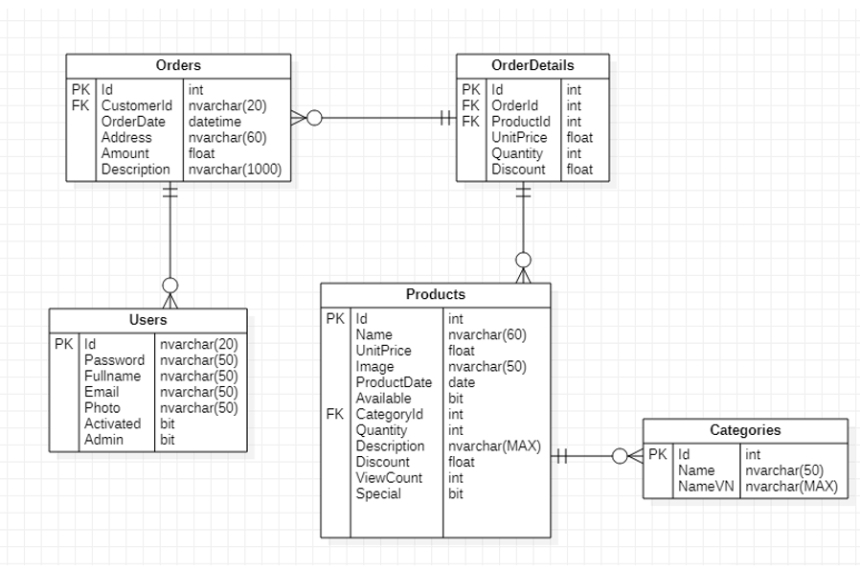

2.3 Table Relationship Diagram

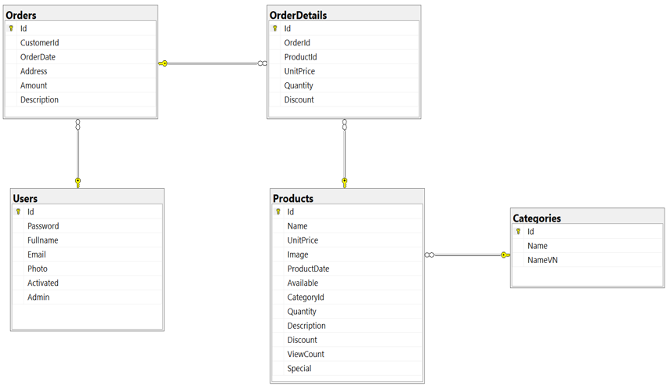

3. Database Design for Sprint

**3.1 Table Users**

|  |  |  |  |  |
| --- | --- | --- | --- | --- |
| Group | | | | |
| Id | Field | Type | Constrain | Description |
| 1 | Id | Nvarchar(255) | PK | User code |
| 2 | Password | Nvarchar(255) |  | Password |
| 3 | Fullname | Nvarchar(255) |  | First and last name |
| 4 | Email | Nvarchar(255) |  | Email address |
| 5 | Photo | Nvarchar(255) |  | Image |
| 6 | Activated | Bit |  | Activated |
| 7 | Admin | Bit |  | Role |

**3.2 Table Orders**

|  |  |  |  |  |
| --- | --- | --- | --- | --- |
| User | | | | |
| Id | Field | Type | Constrain | Description |
| 1 | Id | Int | PK | Code orders |
| 2 | CustomerId | Nvarchar(255) | FK | User code |
| 3 | OrderDate | Datetime |  | Order date |
| 4 | Address | Nvarchar(255) |  | Address |
| 5 | Amount | Float |  | Amount of money |
| 6 | Description | Nvarchar(255) |  | Describe |

**3.3 Table OrdersDetails**

|  |  |  |  |  |
| --- | --- | --- | --- | --- |
| Frame | | | | |
| Id | Field | Type | Constrain | Description |
| 1 | Id | Int | PK | Detailed order code |
| 2 | OrderId | Int | FK | Code orders |
| 3 | ProductId | Int | Fk | Product code |
| 4 | UnitPrice | Float |  | Unit price |
| 5 | Quantity | Int |  | Quantity |
| 6 | Discount | Float |  | Discount |

**3.4 Table Categories**

|  |  |  |  |  |
| --- | --- | --- | --- | --- |
| PrivateMessage | | | | |
| Id | Field | Type | Constrain | Description |
| 1 | Id | Int | PK | Product type code |
| 2 | Name | Int | FK | Type name |
| 3 | NameVN | Int | Fk | Detailed type name |

**3.5 Table product**

|  |  |  |  |  |
| --- | --- | --- | --- | --- |
| Event | | | | |
| Id | Field | Type | Constrain | Description |
| 1 | Id | Int | PK | Product code |
| 2 | Name | Nvarchar(255) |  | Product's name |
| 3 | UnitPrice | Float |  | Frozen |
| 4 | Image | Nvarchar(255) |  | Image |
| 5 | ProductDate | Datetime |  | Product added date |
| 6 | Available | Bit |  | Discount |
| 7 | CategoryId | Int | FK | Available |
| 8 | Quantity | Int |  | Quantity |
| 9 | Description | Nvarchar(255) |  | Describe |
| 10 | Discount | Float |  | Discount |
| 11 | ViewCount | Int |  | View |
| 12 | Special | Bit |  | Special |

4.Hardware and software Requirements

This section provides an overview of hardware and software requirements. Below are descriptions of the technological components of the Easy English Website:

|  |  |
| --- | --- |
| **Attributes of Easy English WEBSITE** | |
| **Attributes** | **Descriptions** |
| **Database** | Sql Server |
| **Software** | * Visual Stdio Code . * Spring Tool Suite 4   Sql Server |
| **Hardware** | Computer |
| **Library** | * Tomcat. * Bootstrap 4 * Maven   Jstl |