

**International School**

**CDIO 2**

**CMU-CS 447 RIS**

**Project Proposal**

**Version 1.1**

**Date: April 11th, 2024**

**Online Electronic Shopping System(Happy Shop)**

**Submitted by**

**Tuan, Nguyen Le Anh**

**Thien, Pham Minh**

**Anh, Truong Quang**

**Phuc, Tran Thanh**

**Approved by**

**MSc Huy, Truong Dinh**

**Proposal Review Panel Representative:**

Name Signature Date

**CDIO 2- Mentor:**

Name Signature Date

**PROJECT INFORMATION**

|  |  |  |  |
| --- | --- | --- | --- |
| **Project acronym** | HPPS | | |
| **Project Title** | HAPPY SHOP | | |
| **Start Date** | 11 April 2024 | **End Date** | 31 May 2024 |
| **Lead Institution** | International School, Duy Tan University | | |
| **Project Mentor** | MSc Huy, Truong Dinh | | |
| **Scrum master / Project Leader & contact details** | Tuan, Nguyen Le Anh  Email: anhtuanhdqb@gmail.com  Tel: 0886767856 | | |
| **Partner Organization** | Duy Tan University | | |
| **Project Web URL** |  | | |
| **Team members** | Name | Email | Tel |
|  | Tuan, Nguyen Le Anh | anhtuanhdqb@gmail.com | 0886767856 |
|  | Thien, Pham Minh | minhthienp50@gmail.com | 0984268233 |
|  | Anh, Truong Quang | anhpk2310@gmail.com | 0332044749 |
|  | Phuc, Tran Thanh | tranthanhphuc919@gmail.com | 0795710107 |

**DOCUMENT APPROVALS**

The following signatures are required for approval of this document.

|  |  |  |
| --- | --- | --- |
| Tuan, Nguyen Le Anh  Student ID: 27211231107  *Scrum Master* | Signature | Date |
| Thien, Pham Minh  Student ID: 27211202495  *Team Member* | Signature | Date |
| Anh, Truong Quang  Student ID: 27211248346  *Team Member* | Signature | Date |
| Phuc, Tran Thanh  Student ID: 27211248255  *Team Member* | Signature | Date |

REVISION HISTORY

| **Version** | **Date** | **Comments** | **Author** |
| --- | --- | --- | --- |
| 1.0 | April 11th, 2024 | Initial Release | APTT Team |

TABLE OF CONTENT

1. Introduction 5

**1.1. Purpose Of Document 5**

**1.2. Project Goal 5**

2. Problem Definition 5

**2.1. Business need 5**

**2.2. Solution 6**

3. Current Status of Art 6

4. Engineering Approach 7

**4.2. System context description 7**

**4.3. Technical Constraints 8**

5. Tasks and Deliverables 10

6. Project Management 11

**6.1. Cost/Budget for Project 11**

**6.2. Tentative Schedule 12**

**6.2.1. Master Plan 12**

**6.2.3. Scrum Process 13**

7. Project Constraints 14

8. Conclusion 16

9. References 16

10. Attachment 16

1. Introduction

1.1. Purpose of Document

* The document provides an overview of the project includes the purpose and scope of the project.
* Identify business needs, problems or situations related to the initialization and construction projects.
* Provide solutions for business needs and give the overview of system architecture.
* Provide overview about resources, schedule, solution and budget for the project.

1.2. Project Goal

The Online Electronic Shopping System project aims to create a comprehensive, user-friendly and secure online shopping experience. This includes creating an easy-to-use interface, providing detailed and organized product information, allowing for easy product searching and filtering, integrating a secure payment gateway, providing the ability to follow Order tracking, strong customer support, allows user-generated product ratings and reviews..

2. Problem Definition

In today's digital age, finding an e-shopping platform that is reliable and easy to use is a challenge for consumers. Issues such as lack of detailed product information, inconvenient website navigation, insecure payment methods, and lack of order tracking features are commonly encountered. To solve this problem, designing and implementing an effective Online E-Procurement System is necessary. The system should provide detailed product information, a user-friendly interface, secure payment methods, order tracking features, reliable customer support, and a product review platform..

2.1. Business need

- Meet business needs and market trends

- Consumer expectations of online services

- Optimize costs and expand reach

- Use customer data to personalize the shopping experience

- Significant growth potential for the business

2.2. Solution

To deploy an effective Online Electronic Shopping System, important factors are needed such as a diverse and detailed product catalog, a user-friendly interface, safe payment methods, order tracking and management, professional customer support, product ratings and comments from users, data-based personalization recommendations, mobile optimization, data analytics to enhance business strategy, and continuous improvement based on market feedback and trends. Overall, the integration of these elements will create a reliable e-shopping platform and bring a good experience to customers, while promoting the sustainable development of businesses in the online retail industry

3. Current Status of Art

|  |  |  |  |
| --- | --- | --- | --- |
|  | **HPPS** | **gearvn.com** | **Phongvu.vn** |
| **Community** | **X** |  |  |
| **Group** | **X** | **X** | **X** |
| **Event** | **X** | **X** | **X** |
| **Dashboard** | **X** | **X** | **X** |
| **Refer to best-selling products** | **X** | **X** | **X** |
| **Blog** | **X** |  |  |
| **Message** | **X** |  | **X** |

Our website overcomes the disadvantages that competitors cause discomfort to users such as:

• Create a community for people to interact with each other to buy, sell and exchange electronic goods

• You can update news about technology items right on the website

• Users can learn and discuss directly on the system when they have questions that need to be answered.

4. Engineering Approach

**4.1.1 User diagram**

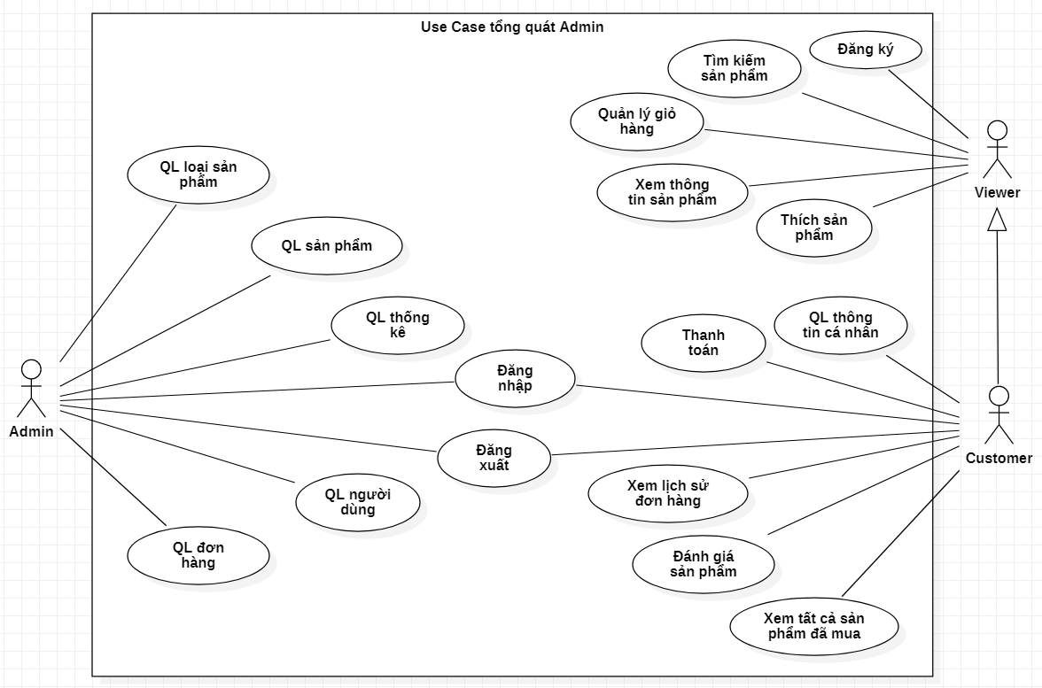

**4.1.2 User diagram for viewer and customer**

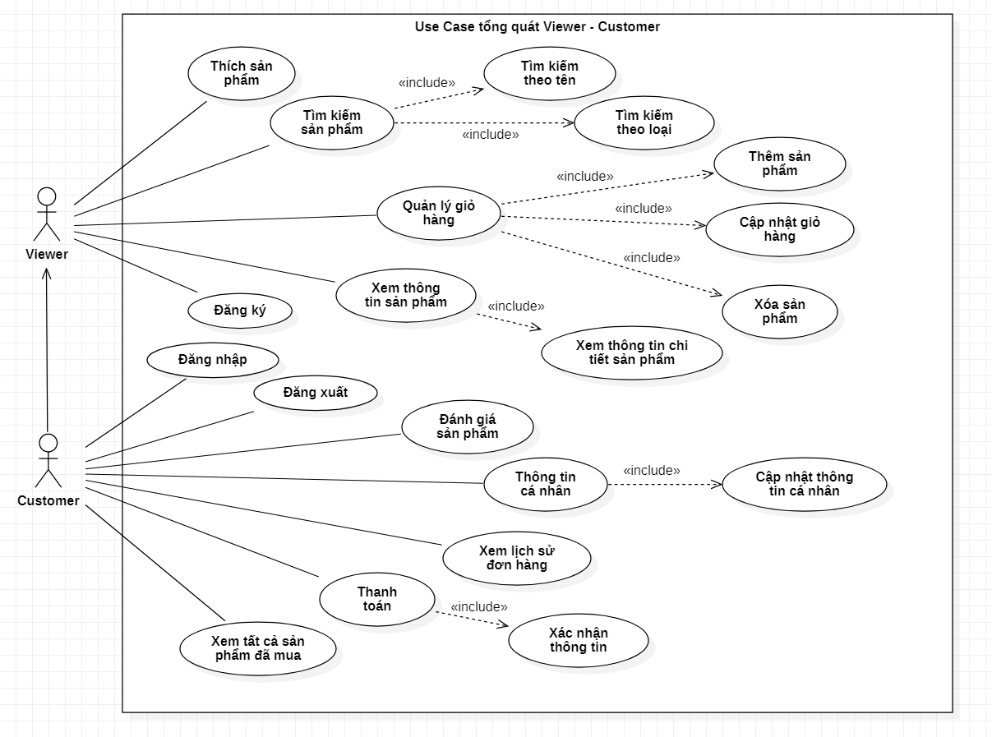

**4.1.3 User diagram for admin:**

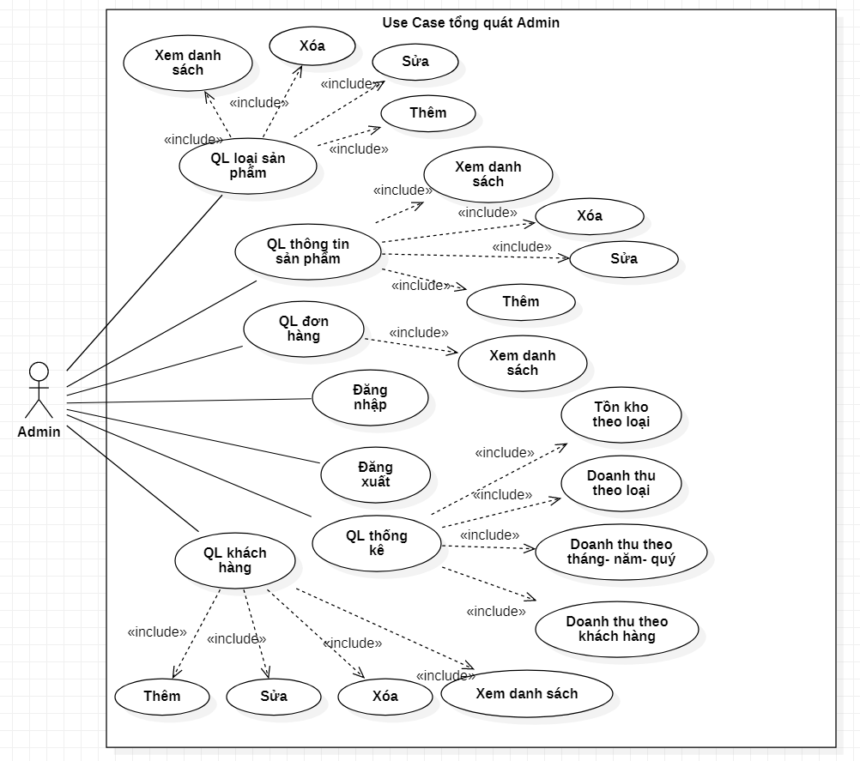

4.2. System context description

* **Admin:**

- Log in, log out

- Manage product types

- Manage product information

- Customer management

- Order management

- Statistics management

* **Viewer:**

- Register

- Search product

- Manage shopping cart

- View product information

- Like the product

* Customer

- Has basic viewer functions (Viewer)

- Log in, log out

- Pay

- Personal information

- View order history

- Evaluate product quality via email

- View all purchased products

4.3. Technical Constraints

**Technical to develop:**

* Programming language: Java
* Library – Framework: Apache Tomcat 9.0.40, Spring Boot 2.2.2, Spring data JPA, Java Database Connectivity (JDBC), Apache Maven, Bootstrap 4, Apache Tiles, JavaServer Pages Standard Tag Library (JSTL)
* Technology: HTML , CSS, Bootstrap, jQuery
* Database: Microsoft SQL Server.
* Version Control System: GitHub
* Team Management: Trello, Zalo, Google drive
* Develop tools: Visual Studio Code, Spring Tool Suite 4, Eclipse,SQL Server Management Studio 19

**Environments:**

* Internet Connection
* Operation System: Google Chrome, Microsoft Edge, CocCoc, Firefox

**Other Constraints:**

* Resource: 4 people.
* Budget: Limited.
* Time: The project must be completed within 02 months.

5. Tasks and Deliverables

|  |  |  |
| --- | --- | --- |
| No. | Task name | Description |
| **1.** | **Start up** |  |
| 1.1 | Project kick off meeting | Encountering the developer team and stakeholder to clear out the goal, defining of the base elements for the project and other project planning activities |
| 1.2 | Discuss about project | Brighten up the current ideal to both developer  team and stakeholder |
| 1.3 | Create Document | Release the artifacts or schematics related to project to product owner, include Proposal, User story, Product backlog, Project plan… |
| **2.** | **Development** |  |
| 2.1 | Sprint Planning | A Sprint begins with a sprint planning session that sets goals and plans details for the work to be done |
| 2.2 | Sprint 1 | Release the first look of the product (ver1.0) with functions which have been committed in the contract |
| 2.3 | Sprint 2 | Release the update for ver1.0 (ver1.1) with functions which have been approved by product owner |
| 2.4 | Sprint 3 | The next update (ver1.2) for previous phase |
| **3.** | **Project ‘s meeting** | Private meeting between members to make plan what will be presented to customer in the final release |
| **4.** | **Final Release** | Release the final version to product owner with complete function |

6. Project Management

6.1. Cost/Budget for Project

|  |  |  |
| --- | --- | --- |
| **Full Name** | **Role** | **Salary Rate (USD/hour)** |
| Tuan, Nguyen Le Anh | Scrum Master | 2 |
| Thien, Pham Minh | Team Member | 2 |
| Anh, Truong Quang | Team Member | 2 |
| Phuc, Tran Thanh | Team Member | 2 |

***Table 1. Cost person/hours***

|  |  |  |  |
| --- | --- | --- | --- |
| **No** | **Criteria** | **Price** | **Total (USD)** |
| 1 | Working hours | 2 | 2700 |
| 2 | Other cost | 100 | 400 |
|  |  |  | 3100 |

***Table 2. Total cost estimation***

|  |  |  |
| --- | --- | --- |
| **Description** | **Amount** | **Unit** |
| Number of members | 4 | Person |
| Number of working hours per day | 3 | Hours |
| The cost per hour per member | 2 | USD |
| The number of working days | 60 | Days |

***Table 3. Description***

**-** The explanation for the table

* Amount of working hours = 4 members * 3 hours * 90 days
* Other cost = 4 members * 100 USD

6.2. Tentative Schedule

6.2.1. Master Plan

|  |  |  |  |  |
| --- | --- | --- | --- | --- |
| **NO** | **Task Name** | **Duration** | **Start** | **Finish** |
| **1.** | **Initial** | **5 days** | **11 - April- 2024** | **16–April – 2024** |
| 1.1 | Gathering Requirement | 2 days | 11–April–2024 | 13–April–2024 |
| 1.2 | Create Proposal Document | 3 days | 14–April–2024 | 16–Mar–2024 |
| **2** | **Start Up** | **5 days** | **17–April–2024** | **22–April–2024** |
| 2.1 | Project Kick-off Meeting | 2 days | 17–April–2024 | 19–April–2024 |
| 2.2 | Create Document | 3 days | 20–April–2024 | 22–April–2024 |
| **3** | **Development** | **46 days** | **23–April–2024** | **08-Jun-2024** |
| 3.1 | Sprint 1 | 15 days | 23–April–2024 | 8–May–2024 |
| 3.2 | Sprint 2 | 15 days | 9 –May– 2024 | 23–May–2024 |
| 3.3 | Sprint 3 | 16 days | 24–May–2024 | 8 – Jun – 2024 |
| **4** | **Project’s Retrospective Meeting** | **03 days** | **9 – Jun – 2024** | **11 – Jun – 2024** |
| **5** | **Final Release** | **01 days** | **12 – Jun – 2024** | **12 – Jun – 2024** |

6.2.3. Scrum Process

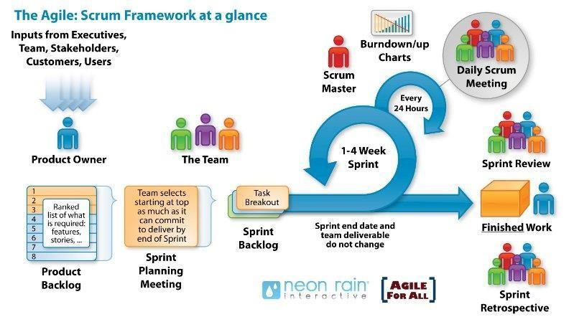

* Scrum is an iterative and incremental agile software development framework for

managing software projects and product or application development.

* Scrum focuses on project management institutions where it is difficult to plan ahead.
* Mechanisms of empirical process control, where feedback loops that constitute

the core management technique is used as opposed to traditional command-and

-control management.

* Its approach to planning and managing projects is by bringing decision-making

authority to the level of operation properties and certainties.

* Benefit of the methodology:
  + - Project can respond easily to change.
    - Problems are identified early.
    - Customers get the most beneficial work first.
    - Work done will better meet the customer’s needs.
    - Improved productivity.
    - Ability to maintain a predictable schedule for delivery.

7. Project Constraints

|  |  |  |
| --- | --- | --- |
| **Constraint** | **Constraints Description** | **Guidelines for Acceptance** |
| **Economic** | • Start trial (1 month free)  • Trial period has ended  + Renew monthly: 4.99 $ per month  + Renew by year: 2.99 $ per month  + Lifetime: 99.99 $ once | Elements for consideration are design costs, production costs, maintenance costs, operating costs, and sales price |
| **Environmental** | The system does not affect the environment | Impact of the design on the environment as well as impact of the environment (e.g, temperature range, humidity, vibration, electromagnetic interference immunity, and shock) on the design should be considered. Design for recycling and design to use recycled materials should also be considered |
| **Ethical** | -User information after registration will be encrypted, and we will not share with any organization.  - Respecting user privacy settings  - Working to ensure the security of our users’ information  - Do not tracking users | Ethical considerations can be broad. Areas that are typically addressed include intellectual property, reverse- engineering, privacy, security, and the conflict between cost and safety. |
| **Public health, safety, and welfare** | The application works on web platform, so when using, users will look at the screen of laptop, pc, tablet, mobile device. So, we recommend not to use the application for more than 180 minutes, to protect the eyes and health of the user. | Includes safety standards as well as impact of the design on users (for example, electrical or physical hazards) |
| **Social and Global** | Making it easier for beginners, students, or employees who want to learn language, children help them increase their communication skills, and make friends with many others. | Addresses aspects such as benefits, risks, the man-machine interface, the acceptance of products by the intended user or by society at large, global and socially responsible engineering. |
| **Cultural** | - This application is for Vietnamese people to learn English, so the website will use Vietnamese.  - To remove this barrier, we can add a function to choose to display English or Vietnamese language websites. | Which cultural characteristics could influence the approach?  How do the design from different cultures differ? |
| **Sustainability** | Human resources include 4 members of Duy Tan University.  The app is written in javascript, using reactjs technology that breaks the components of the system into separate operations for easier maintenance. | Refers to sustainability of resources, including material, energy, supplies, manufacturing techniques, personnel, operation, and the need for additional infrastructure, as well as sustainability of the design including reliability, lifetime, durability, reusability, maintainability. |

8. Conclusion

This product creates a community that promises to help everyone have an effective English learning environment. Bring a new feeling of learning English, with no barriers between good learners and poor English learners. Help improve English skills. The project is expected to be completed within 3 months at a cost of not more than $ 3100.

9. References

**[1]. Software Development Standards for the Guidance and Control Software Project:** [*https://sw-eng.larc.nasa.gov*](https://sw-eng.larc.nasa.gov)

**[2]. General Software Coding Standards and Guidelines**: [*https://www.nws.noaa.gov/oh/hrl/developers_docs/General_Software_Standards.pdf*](https://www.nws.noaa.gov/oh/hrl/developers_docs/General_Software_Standards.pdf)

**[3]. Scrum and best practices*:*** *https://docs.microsoft.com/en- us/azure/devops/boards/sprints/best-practices-scrum?view=azure-devops*

**[4]. The Scrum Guide:** [*https://www.scrum.org/resources/scrum-guide*](https://www.scrum.org/resources/scrum-guide)

**[5]. The ISO/IEC & IEEE/EIA Standard 12207, IEEE standards: IEEE-829 [3], IEEE-1008 [5], IEEE-1012**

**[6] React documentation:** <https://reactjs.org/docs/getting-started.html>

10. Attachment