**Document test mini sharing files**

1. **Test CRUD user**

**Admin home screen**

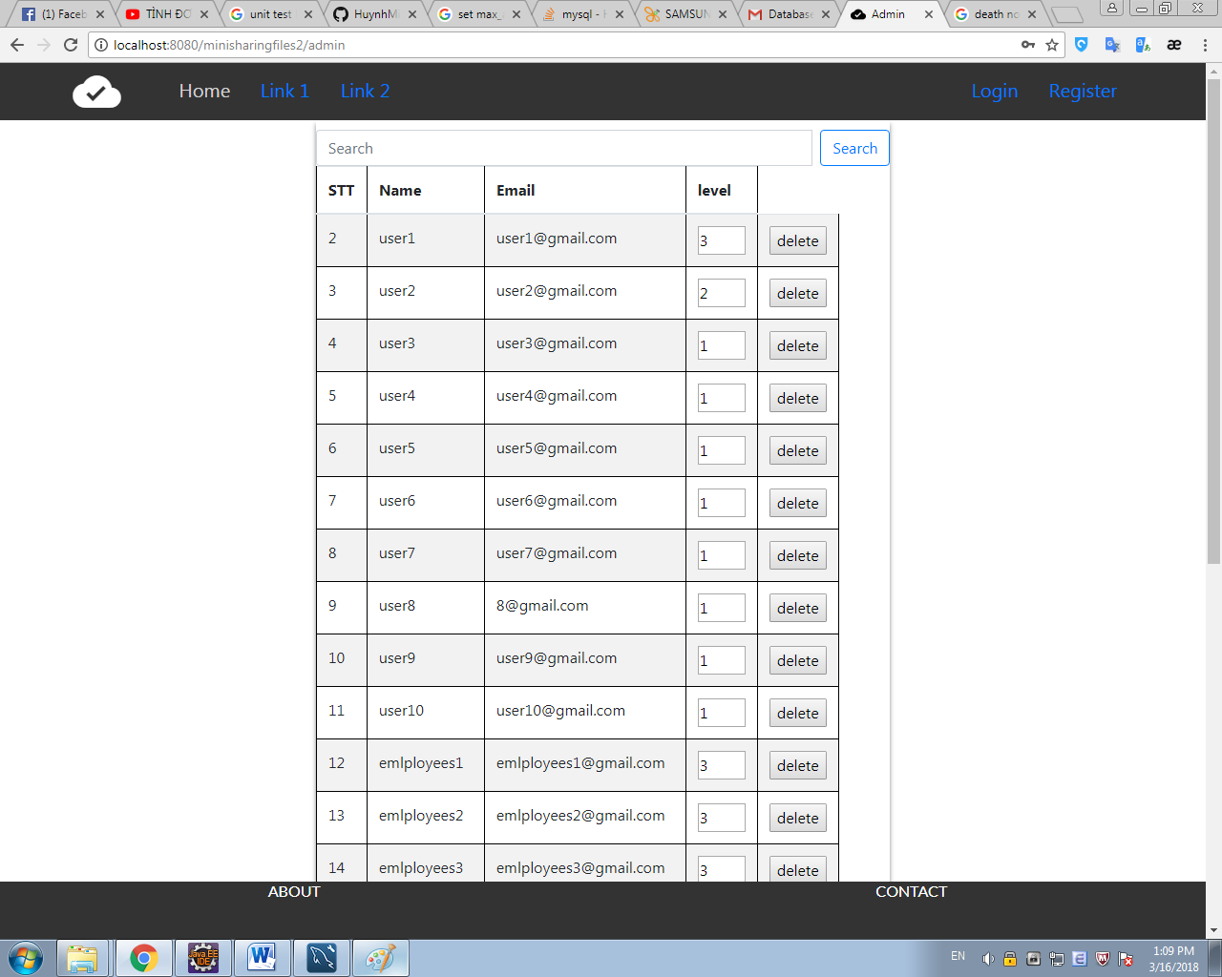

**Admin database**

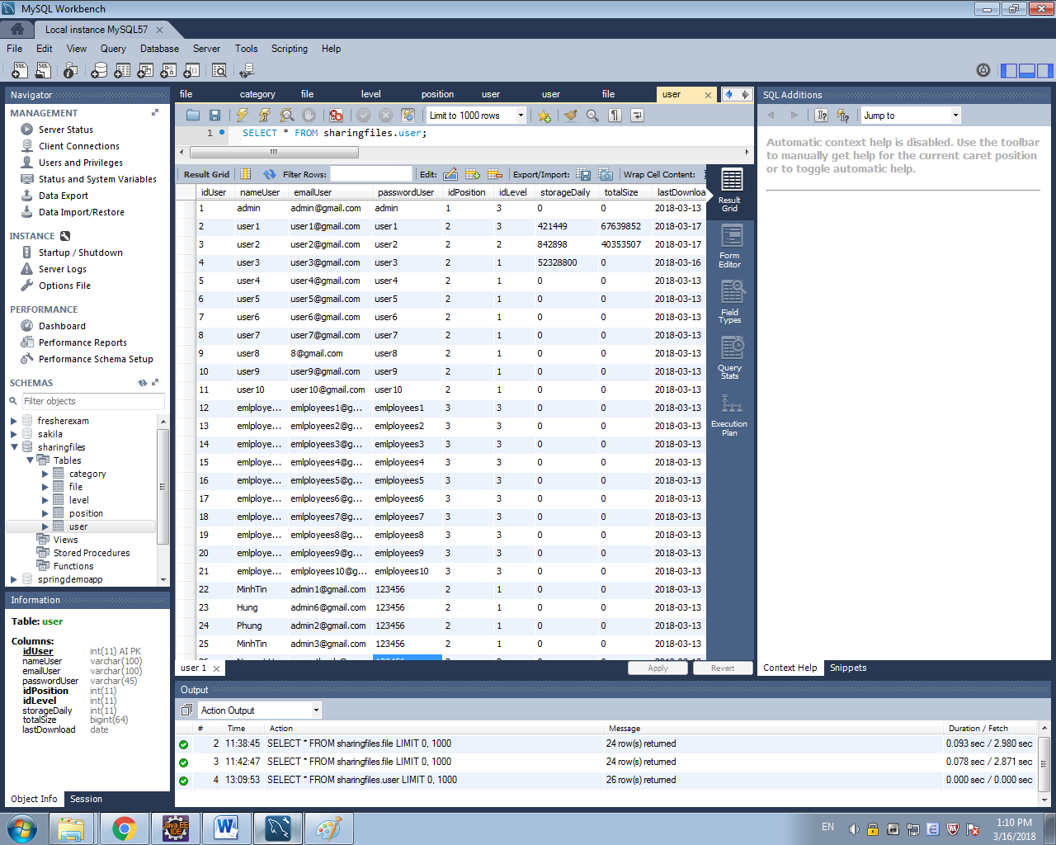

1. **Test create user**
2. **Test update user**
3. **Test delete user**

**Admin home screen and database when delete emlployees10**

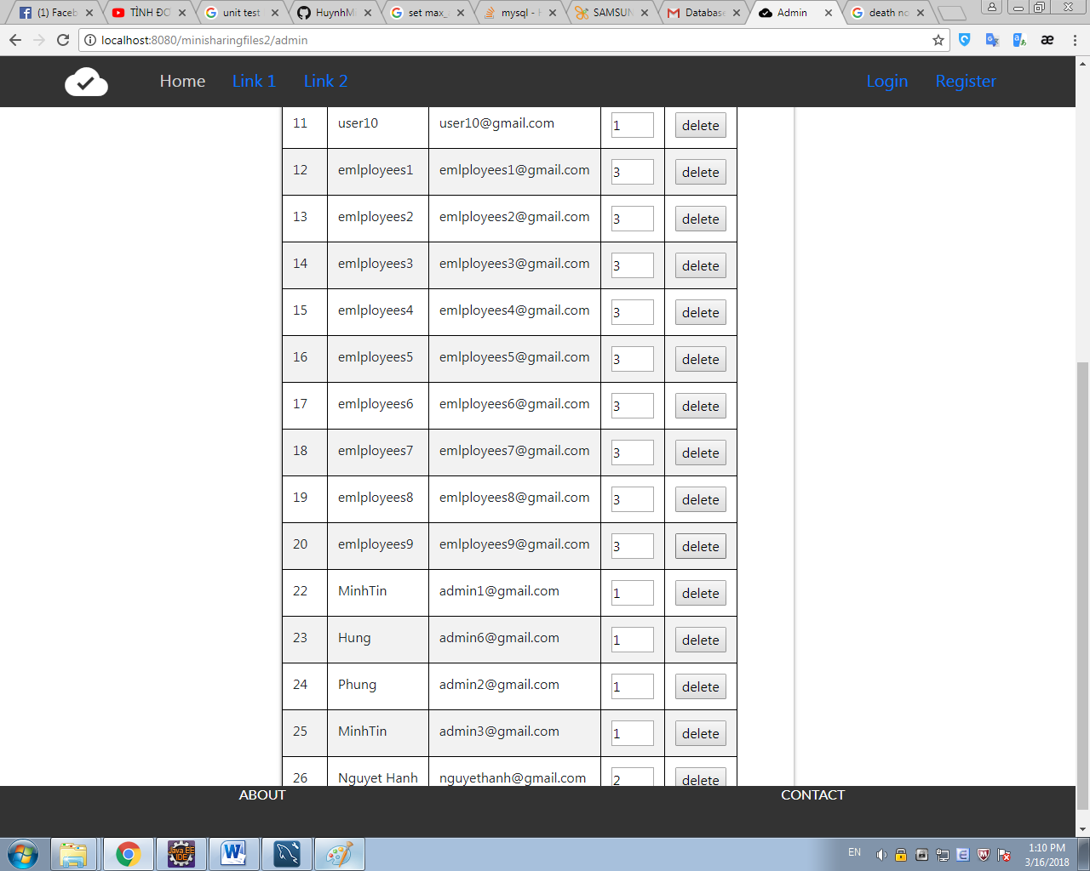

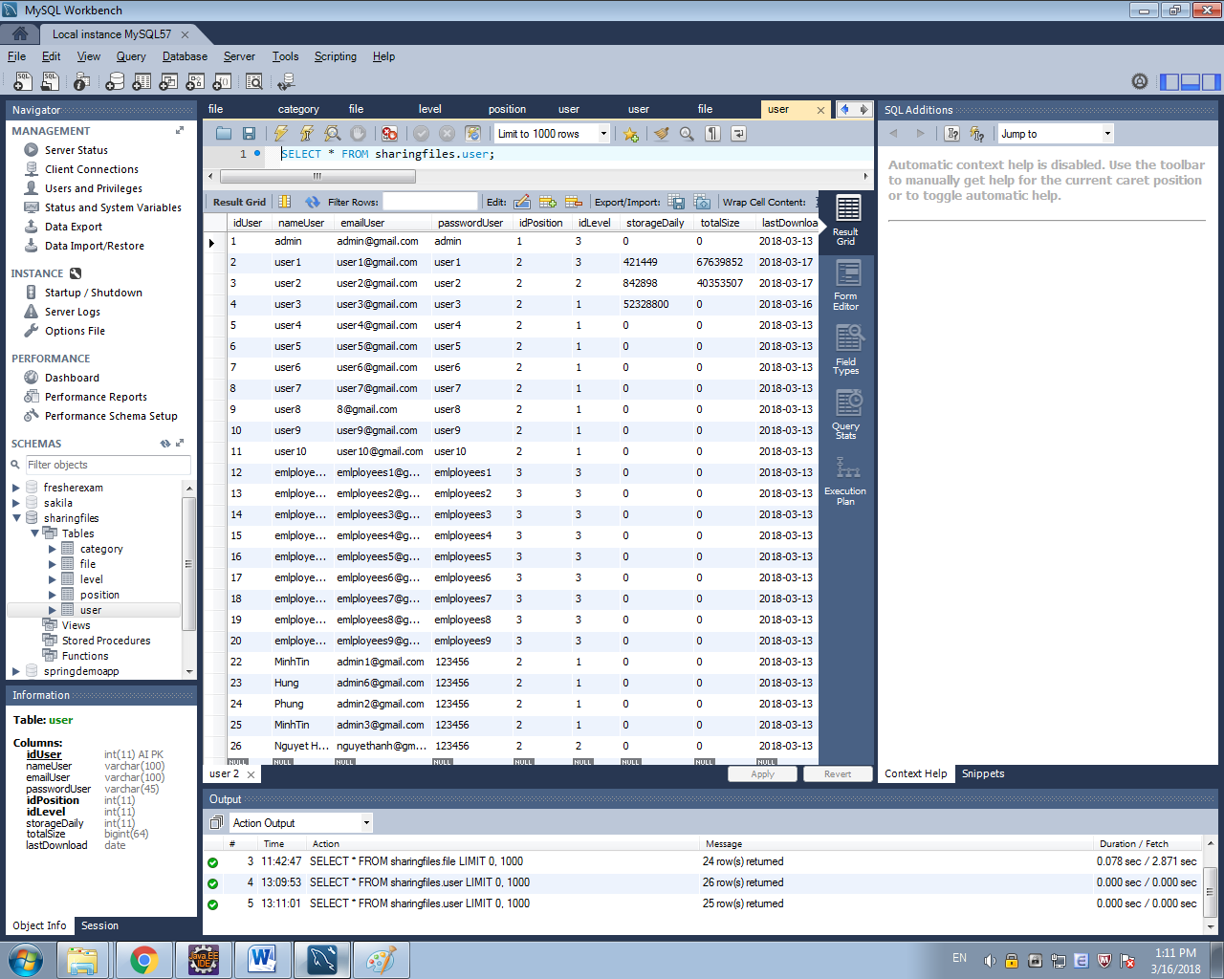

1. **Test CRUD files which have been uploaded by the his/her self**

**User home screen and database**

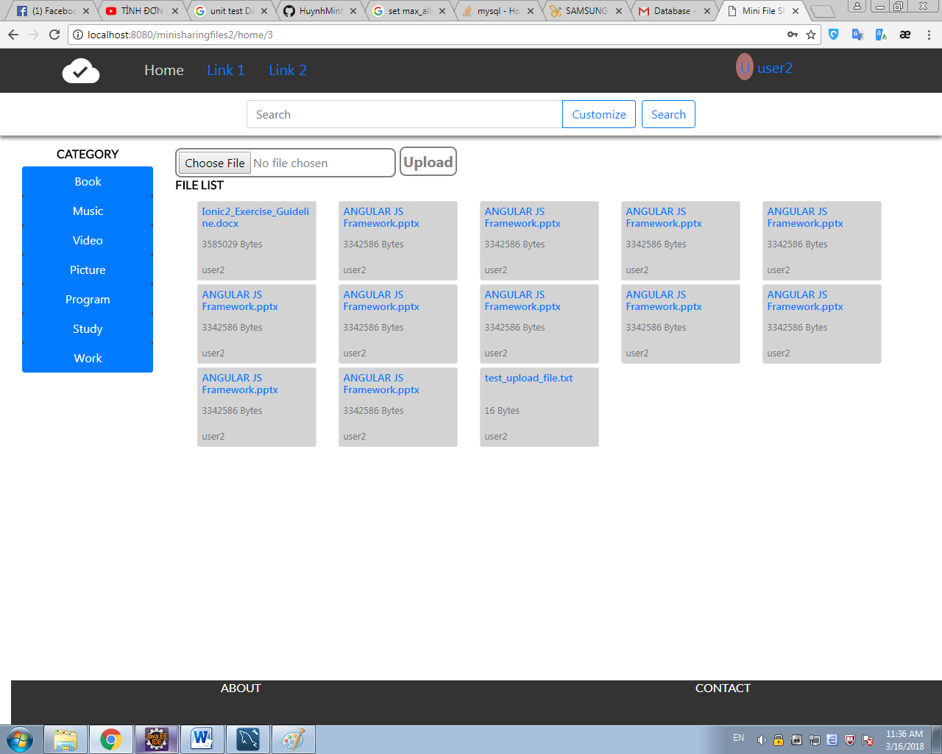

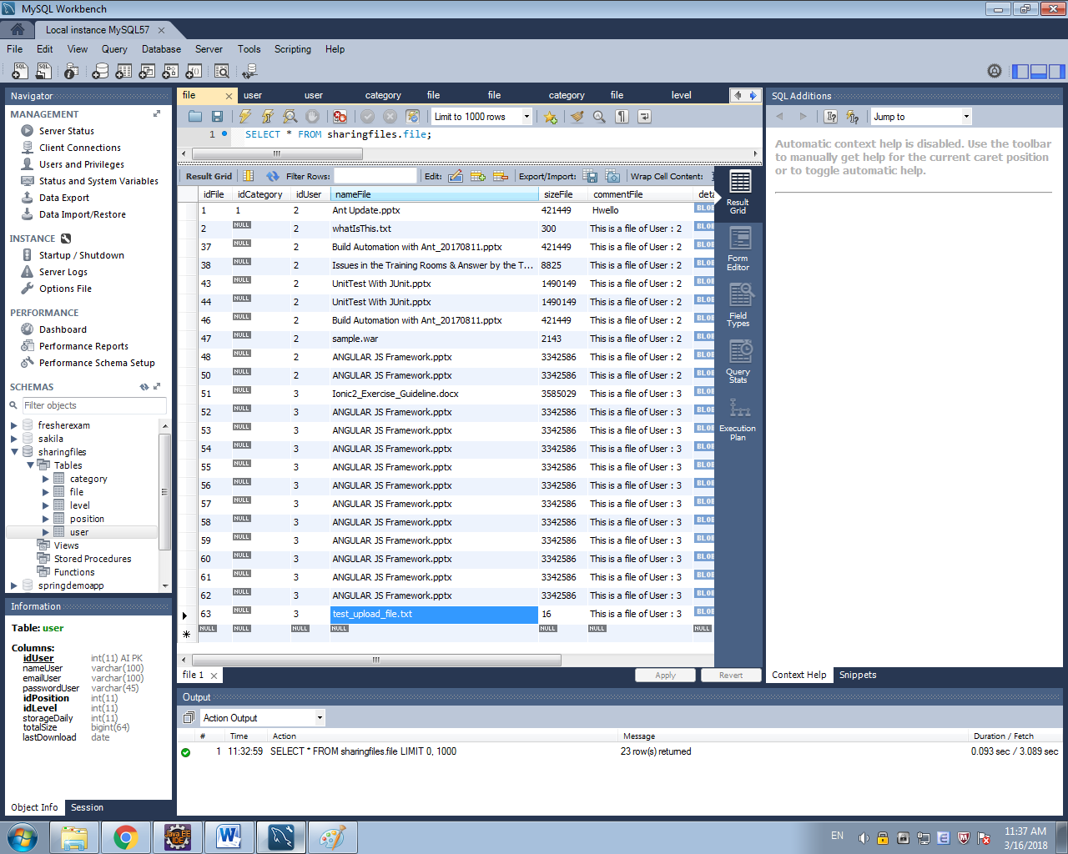

* 1. **Test create files**

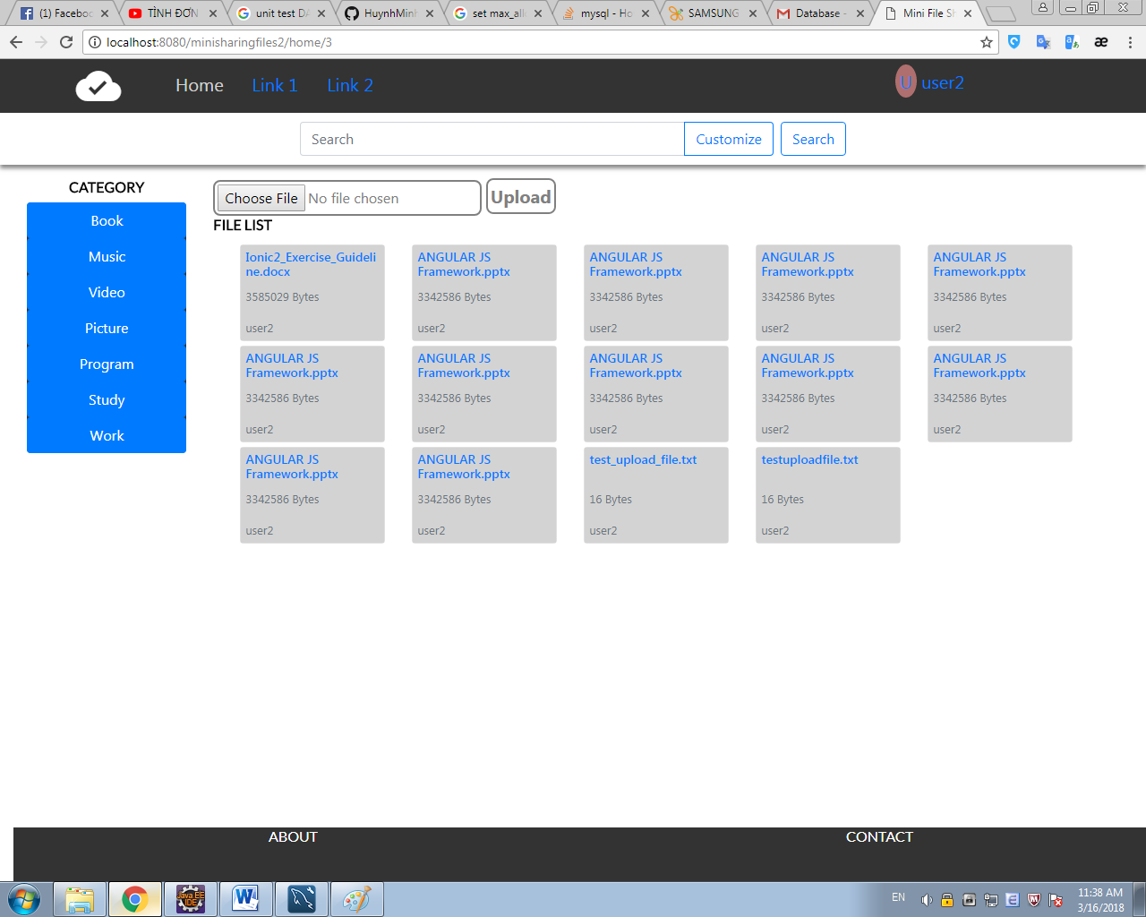

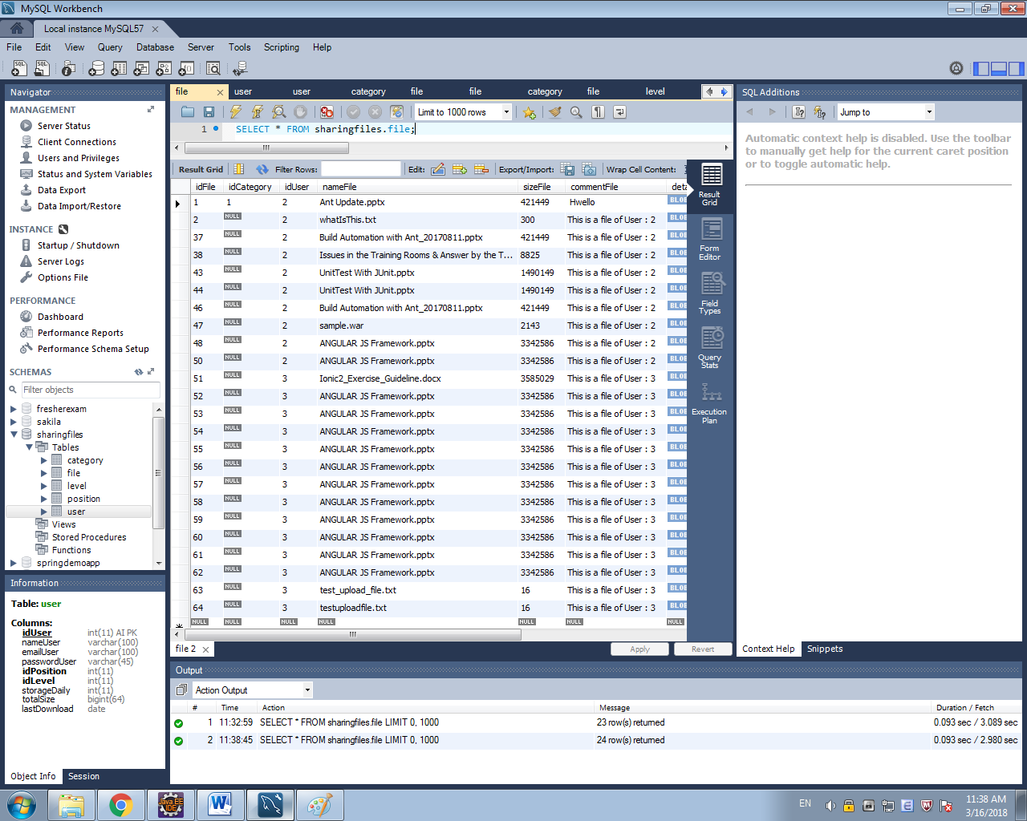

* 1. **Test read files**
  2. **Test update files**

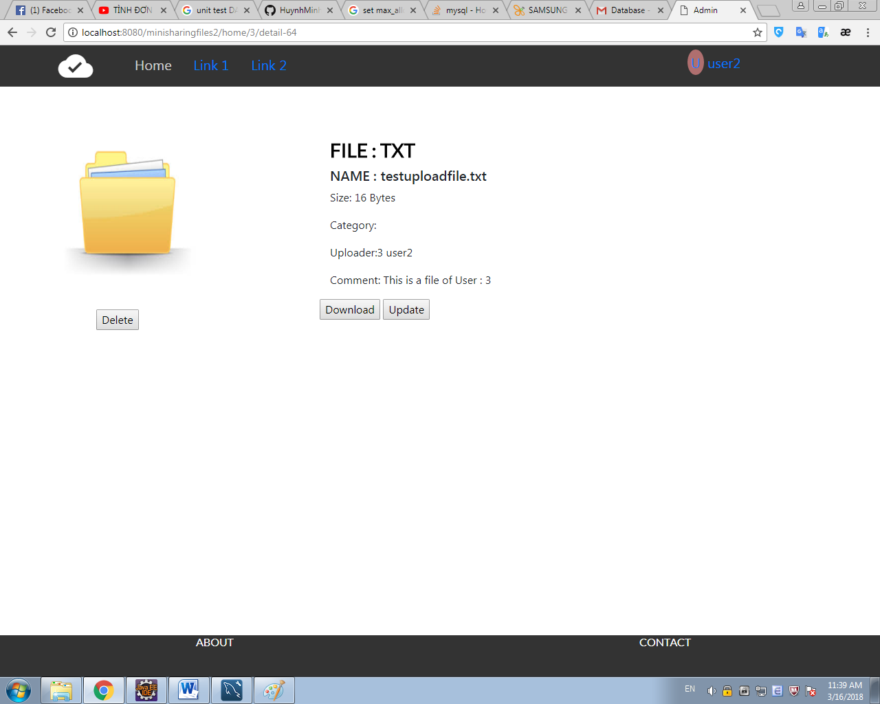

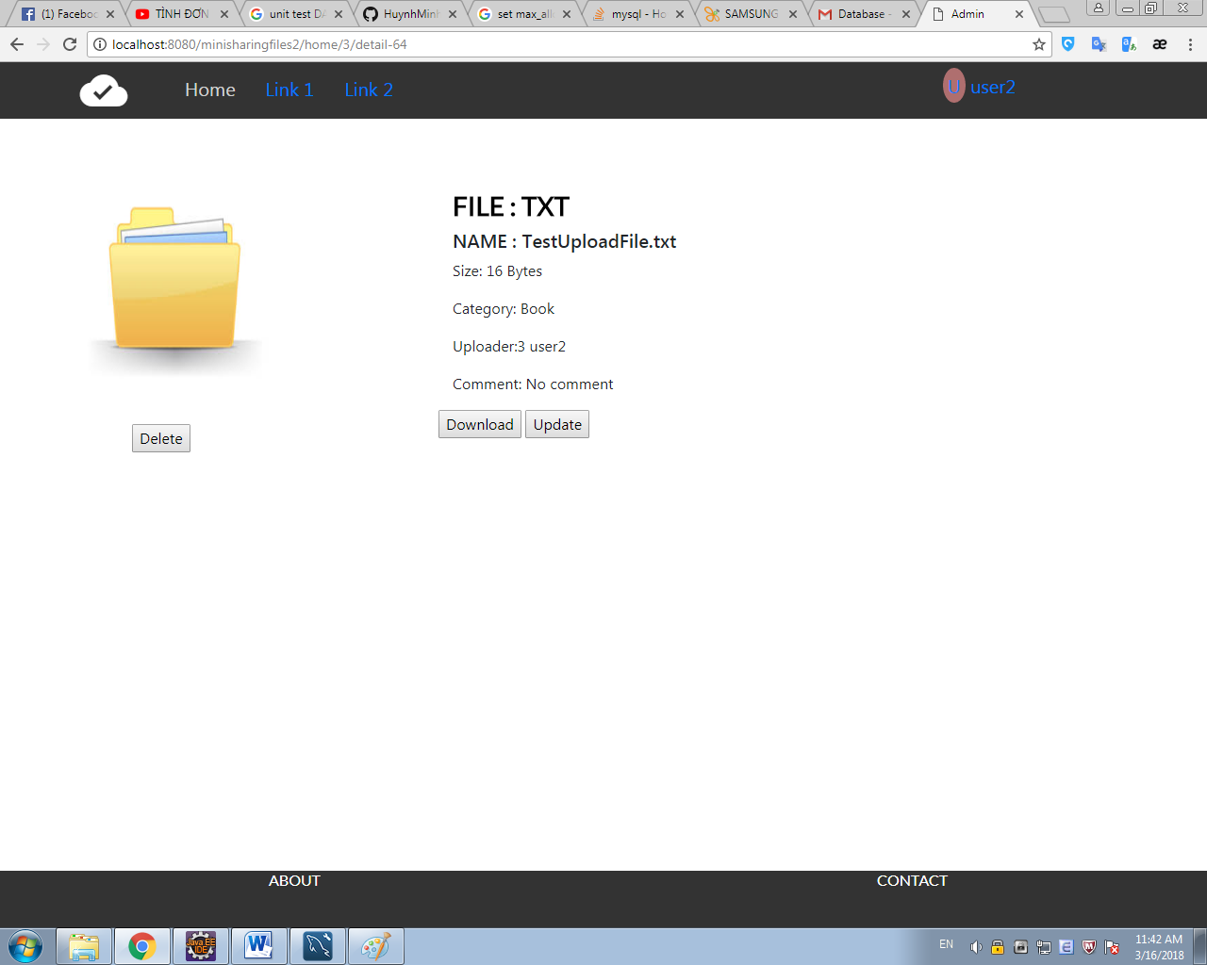

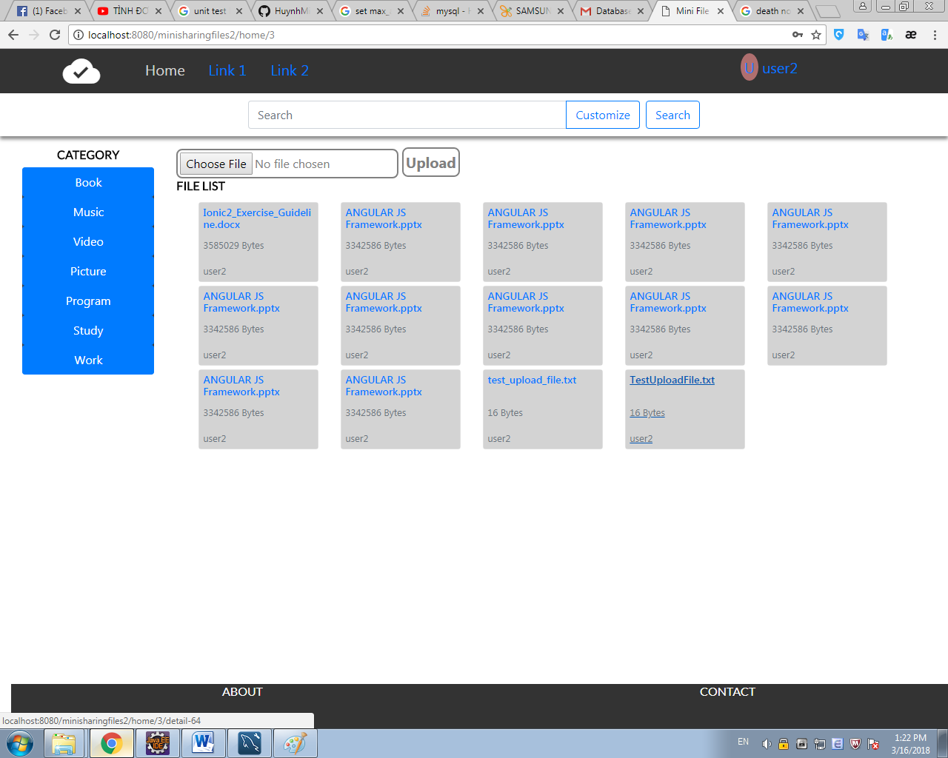

* 1. **Test delete files**