FUN Ecosystem
ERD + Sequence Diagrams
Architecture pack for Backend, Frontend, and DevOps
Scope: data model, core request flow, Zoom/Love House attendance flow, async job flow, and operational handoffs.
Immutable rules: PPLP = Proof of Pure Love Protocol • No Proof -> No Score • No Score -> No Mint • Mint split = 99% user / 1% platform.
Design note: Light Score is unbounded upward; it grows with validated value over time rather than capping at a fixed lifetime maximum.
How to read this pack
• Backend: own entities, invariants, APIs, and async jobs
• Frontend: own forms, proof capture, attendance UX, and status surfaces
• DevOps: own queues, retries, metrics, dashboards, and operational safety rails

1. Entity relationship diagram (ERD)
The ERD below is the canonical persisted model for the first build. It separates event proof from individual participation proof and keeps mint execution downstream of validation.
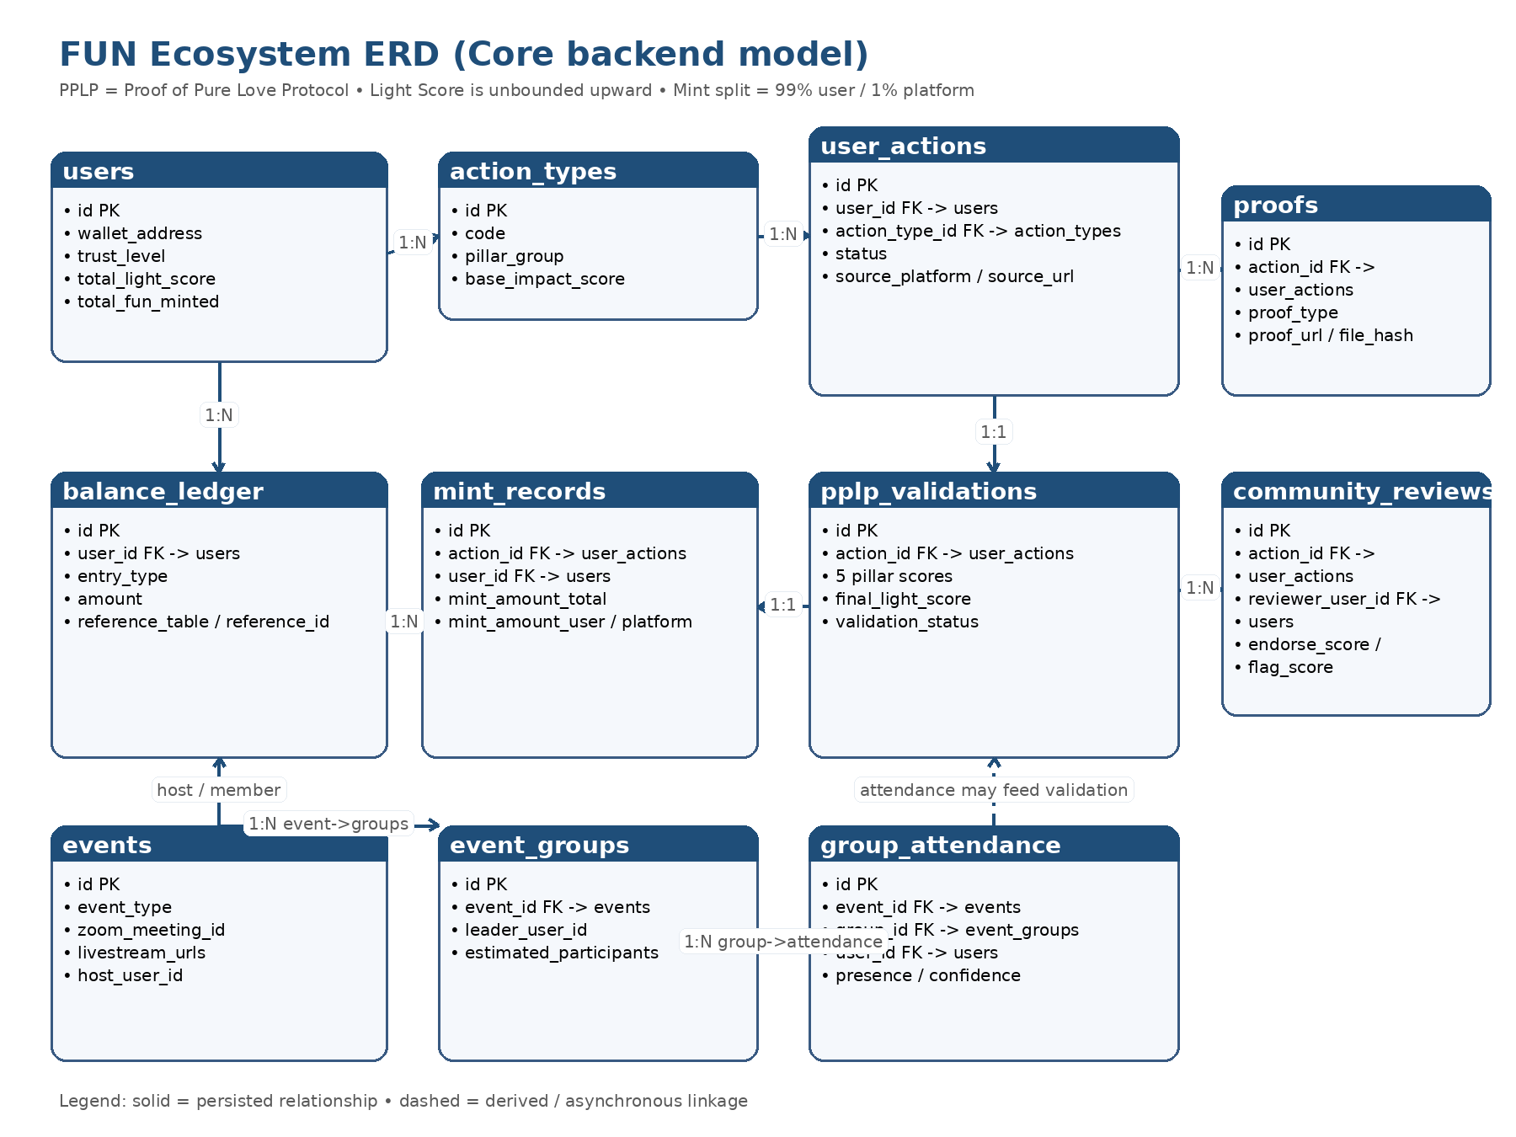
Figure 1. Core backend ERD for actions, proofs, validations, mint records, ledger, and event attendance.

ERD implementation notes
- user_actions is the transactional center: all scoring and mint records refer back to a single action id.
- proofs stores external evidence such as livestream links, recordings, hashes, or on-chain references.
- pplp_validations is intentionally separate so scoring logic can evolve without mutating raw action submission data.
- mint_records and balance_ledger should be append-only from an audit perspective.
- events, event_groups, and group_attendance model the Zoom -> Love House -> User hierarchy for group practice.

2. Sequence diagrams

2.1 Core action -> proof -> validation -> mint
This is the main happy path for individual action scoring and mint execution.
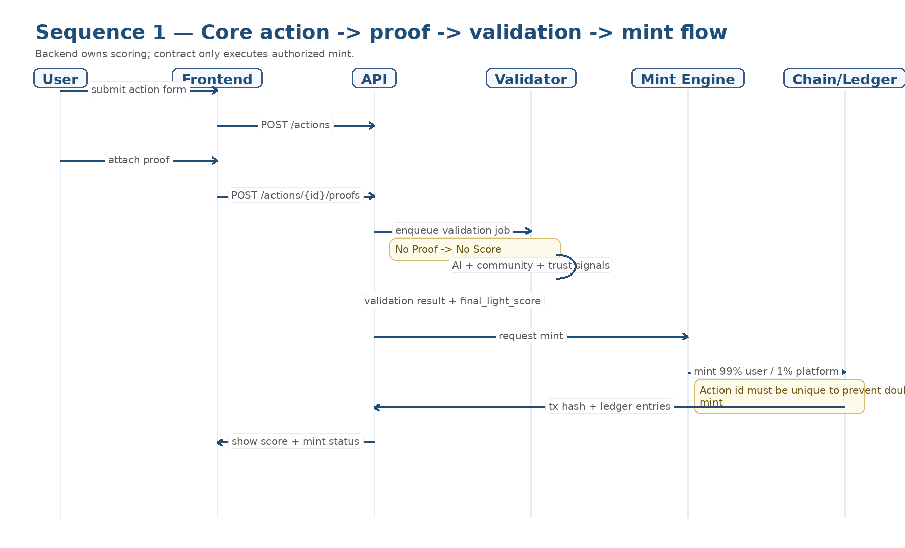
2.1 Core action -> proof -> validation -> mint

2.2 Zoom / Love House / livestream attendance
This sequence prevents a single livestream link from being treated as full individual proof.
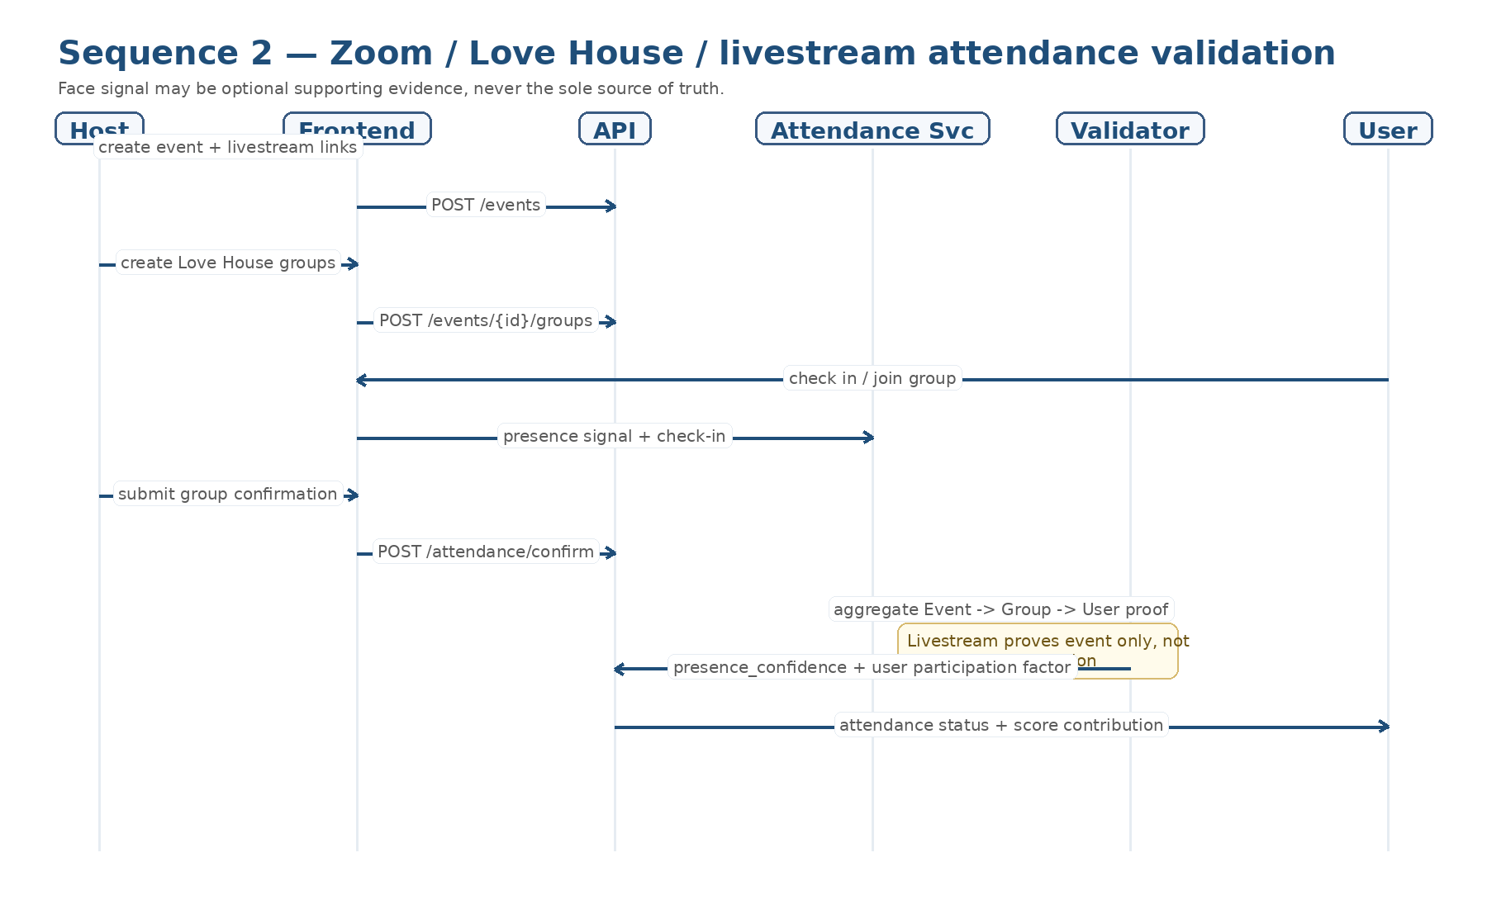
2.2 Zoom / Love House / livestream attendance

2.3 Async jobs, manual review, and observability
This sequence shows the operational control plane that DevOps will need from day one.
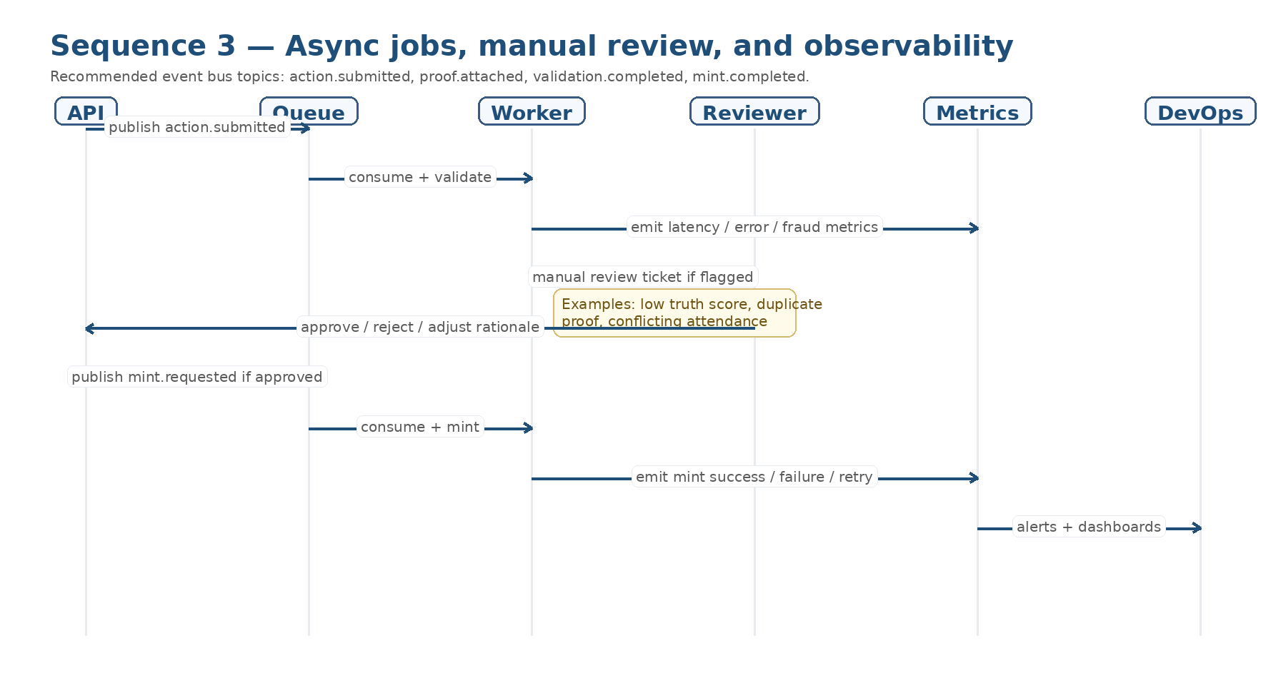
2.3 Async jobs, manual review, and observability

3. Cross-team responsibilities
Team | Primary ownership
Backend | Own schemas, invariants, scoring orchestration, validation jobs, mint authorization, ledger writes, and idempotency by action_id.
Frontend | Own action submission UX, proof upload UX, event/group attendance flows, validation status display, and user-facing rationale.
DevOps | Own queue durability, retries, dead-letter handling, worker autoscaling, dashboards, alerting, secrets, and incident runbooks.

4. Build-time invariants
- PPLP must always render as “Proof of Pure Love Protocol” in code, docs, and APIs.
- No Proof -> No Score. Missing proof should block validation completion.
- No Score -> No Mint. Mint Engine only accepts approved validation output.
- Every action_id may mint at most once. Enforce idempotency in backend and on-chain execution.
- Livestream links prove the event occurred, not that every individual fully participated.
- Face or presence detection may be used only as supporting evidence, never as the sole source of truth.

5. Suggested monitoring for DevOps
- Queue depth by topic: action.submitted, proof.attached, validation.completed, mint.requested, mint.completed.
- Worker latency percentiles for validation and mint jobs.
- Flag / rejection rate by action type and by event host.
- Duplicate proof attempts, duplicate mint attempts, and manual review backlog.
- On-chain mint success rate, retry rate, and reconciliation drift between chain and ledger.

