1. **Use case Diagram**

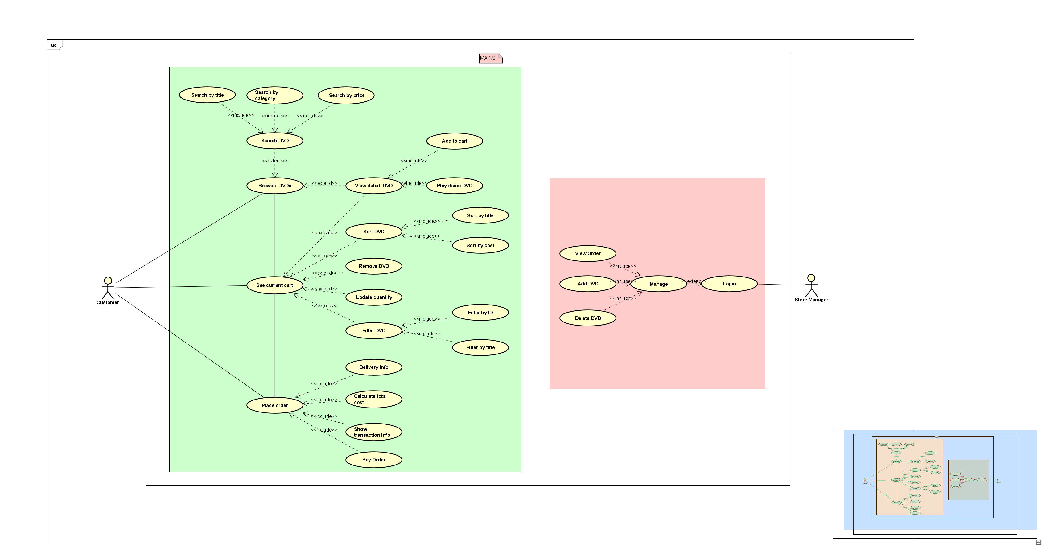

1. **Class Diagram**

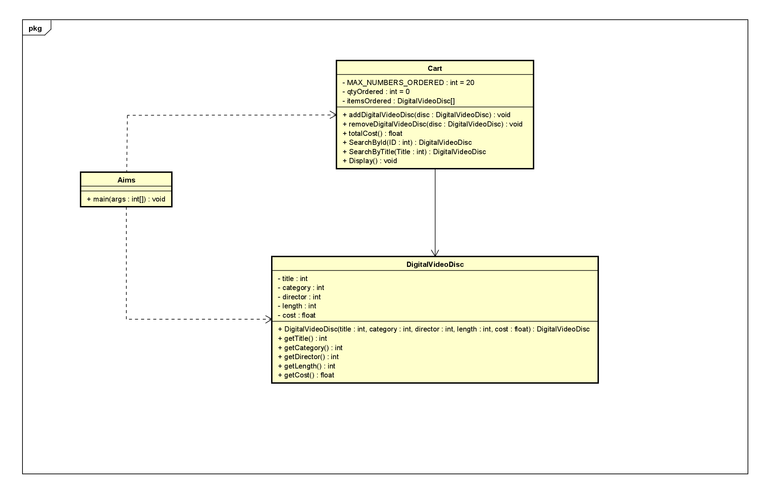

1. **Reading Assignment**

