**VIETNAM NATIONAL UNIVERSITY - HO CHI MINH CITY**

**INTERNATIONAL UNIVERSITY**

**SCHOOL OF COMPUTER SCIENCE AND ENGINEERING**



**DATA SCIENCE AND  
DATA VISUALIZATION**

Course by Dr. Tran Thanh Tung

**PROJECT REPORT**

**TOPIC: AGING POPULATION**

**IN SOUTHEAST ASIA**

GROUP MEMBERS

1. Nguyễn Gia Bảo ITDSIU22162
2. Lâm Thị Bảo Ngọc ITDSIU22169
3. Nguyễn Thiện Thành ITDSIU22159
4. Nguyễn Minh Trí ITDSIU22160

**TABLE OF CONTENT**

**CHAPTER 1. INTRODUCTION**

1.1. Abstract

1.2. Objectives

1.3. The tools used

**CHAPTER 2. TASK TIMELINE & DIVISION**

**CHAPTER 3. METHODOLOGY**

3.1. Data preprocessing

3.1.1. Data collection

3.1.2. Data filtering

3.2. Graph analysis

3.2.1. Chart usage

3.2.2. Interactivity usage

**CHAPTER 4. DASHBOARD INSIGHTS**

**CHAPTER 5. CONCLUSION**

**REFERENCES**

# 

# 

# CHAPTER 1. INTRODUCTION

## Abstract

The study of demographic age shifting is of enduring interest due to its practical implications across various features in society. Over the past few decades, Southeast Asia has experienced remarkable changes in population due to various aspects such as modern lifestyles, living standards, advancements in technology,... By identifying aging population factors, it is clear to forecast and prepare for the challenges that Asian countries may encounter in the near future. Our website illustrates age structure and other visualization graphs related to the change of age to provide our readers with a better understanding of the trends of aging populations in Southeast Asian countries and evaluate necessary solutions to address associated issues: healthcare, social welfare, economics, and policy.

## Objectives

The primary goal is to produce a data-driven report that illustrates the population of young, working-age, and elderly across different Southeast Asian countries between 2017 and 2021.

In short, this project aims to:

* Consolidate and supplement knowledge about this course.
* Provide users with accessible and user-friendly visualization tools.
* Highlight patterns, trends, and disparities in the age structure among Asian countries and demographics.
* Provide actionable insights derived from data visualization for policymakers and the Government to drive evidence-based decision-making and better prepare for future challenges.
* Improve storytelling skills through presentation and report.

## The tools used

* + Git/Github for project control
  + HTML and CSS for website development
  + for data processing and analysis.

# CHAPTER 2. TASK TIMELINE & DIVISION

## Contribution

| **Members** | **Contribution** |
| --- | --- |
| Nguyễn Gia Bảo | 25% |
| Lâm Thị Bảo Ngọc | 25% |
| Nguyễn Thiện Thành | 25% |
| Nguyễn Minh Trí | 25% |

## Project timeline

| **Stage** | **Activity** | **Week** |
| --- | --- | --- |
| PLANNING | Research for the project | 1-2 |
| Group discussion to find the perfect topic and have some basic ideas about the topic |
| Determine the objectives of the research |
| Building the proposal |
| DATA PROCESSING | Collect the dataset | 3 |
| Research for references and documentation |
| Determine the analysis technique for the project |
| Remove some unnecessary attributes | 4 |
| Check the missing data |
| Clean the data |
| Group discussion: finalizing data insights |
| CONCEPTUAL DESIGN | Design UI/UX | 5-9 |
| Determine data requirements |
| Sketch diagrams |
| Finalize the design |
| DESIGN WEB | Design the web layout | 10-13 |
| Coding the web functions and charts |
| Finish the web coding |
| PRESENTATION | Doing storytelling | 14 |
| Finish the report |
| Prepare slides for presentation |
| Completely push every codes on Github |

# 

# CHAPTER 3. METHODOLOGY

## Data preprocessing

### Data collection

* + Based on data taken from the OurWorldinData website, statistical indicators have been extracted to serve the statistical report.
  + The XLSX (Excel) format file will be used to create the statistical table.
  + The project will take actual data from 11 Southeast Asian countries during the period between 2017 and 2021. There are totally 3 different data including:
    - Median age
    - Fertility rate
    - Age structure

### Data filtering

* The initial datasets include the data of all countries around the world in the 1700s, so we use Microsoft Excel to filter out countries that are outside Southeast Asia and narrow the period to 5 years from 2017 to 2021

## Graph analysis

* 1. **Chart usage**

| **Chart name** | **Description** |
| --- | --- |
| Median age  (line chart) | The line chart shows the median age of each Southeast Asian country over 5 years. |
| Fertility rate  (horizontal bar chart) | The horizontal bar chart illustrates the fertility rate of each Southeast Asian country for each year from 2017 to 2021. |
| Age structure  (100% stacked bar chart) | The age structure is categorized into 5 groups, which are: under-5s, 5-14, 15-24, 25-64, and 65+ years and each of them are colored differently. This chart visually represents the percentage of different age groups within the total population, allowing users for easy comparison of demographic distributions and changes over time within each country. |

* 1. **Interactivity usage**

1. **Interactive features in the line chart:**

* Hovering over the lines reveals small circles indicating the median age for each year.

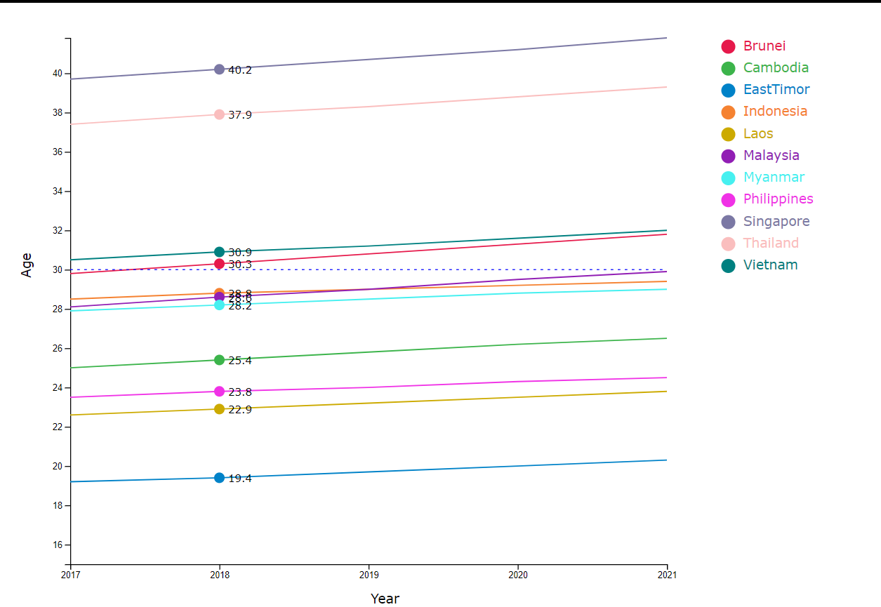

* Hovering over a country name in the legend highlights the corresponding line in the graph, dimming the others for clear visibility. For example, when the mouse moves on Indonedisa legend:

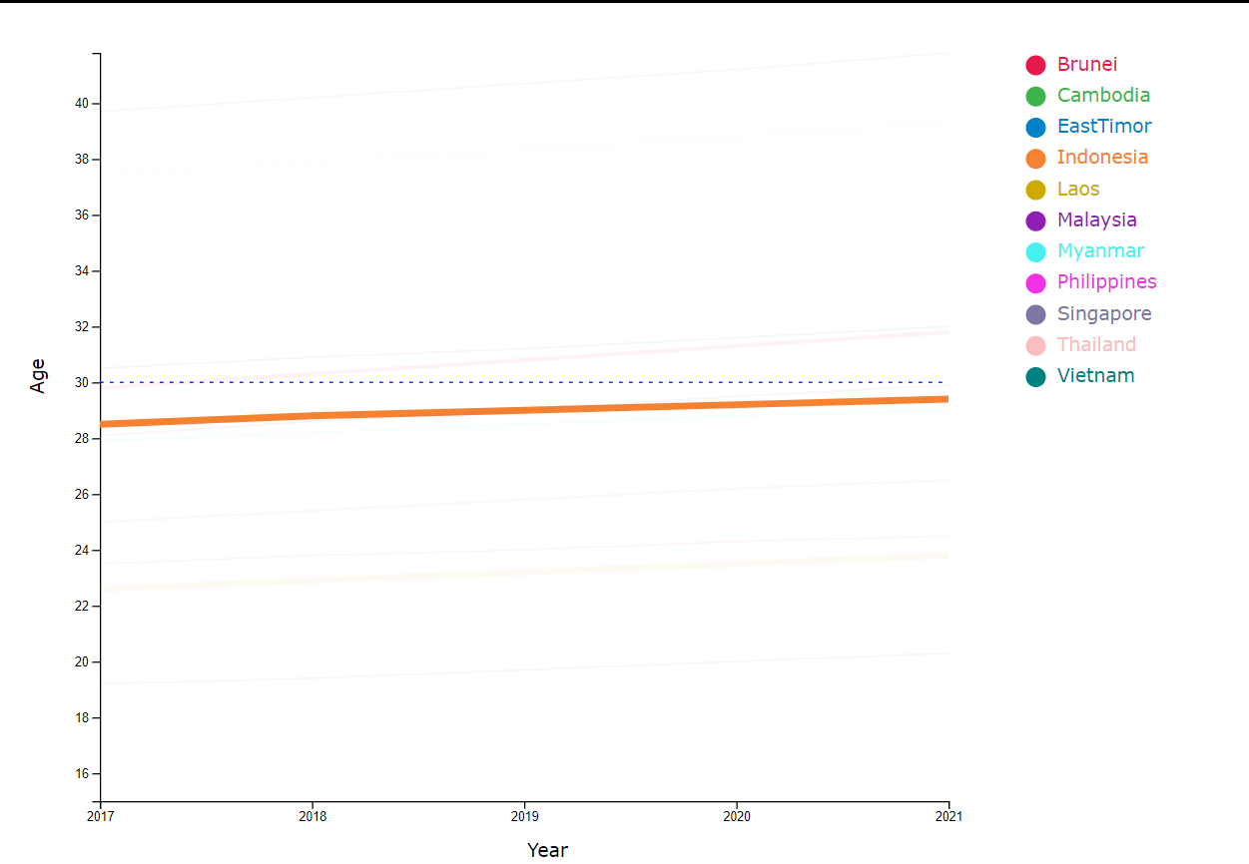

1. **Interactive features in the horizontal bar chart:**

* A slider below the chart allows you to select a specific year.

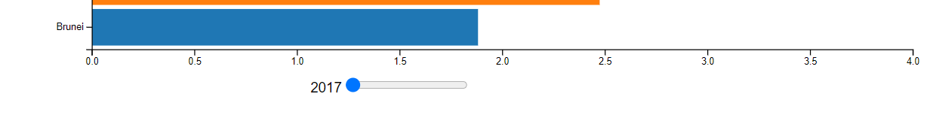

* Each bar has a unique color and represents a country.
* Hovering over a bar displays detailed information of the country name and fertility rate.
* For example, when the mouse moves on the East Timor bar:

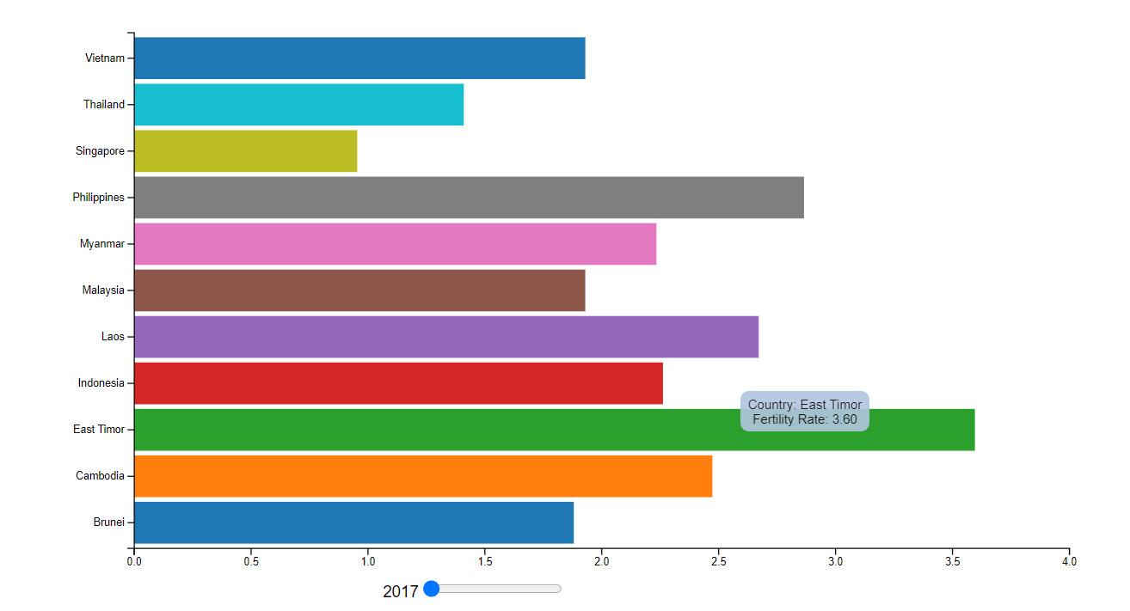

1. **Interactive features in the 100% stacked bar chart:**

* A slider above the chart allows you to select a specific year.



* Hovering over a section of a bar reveals the detailed percentage of that age range within the total population.
* For example, when the mouse moves in the ‘5-14 years’ area in Myanmar:

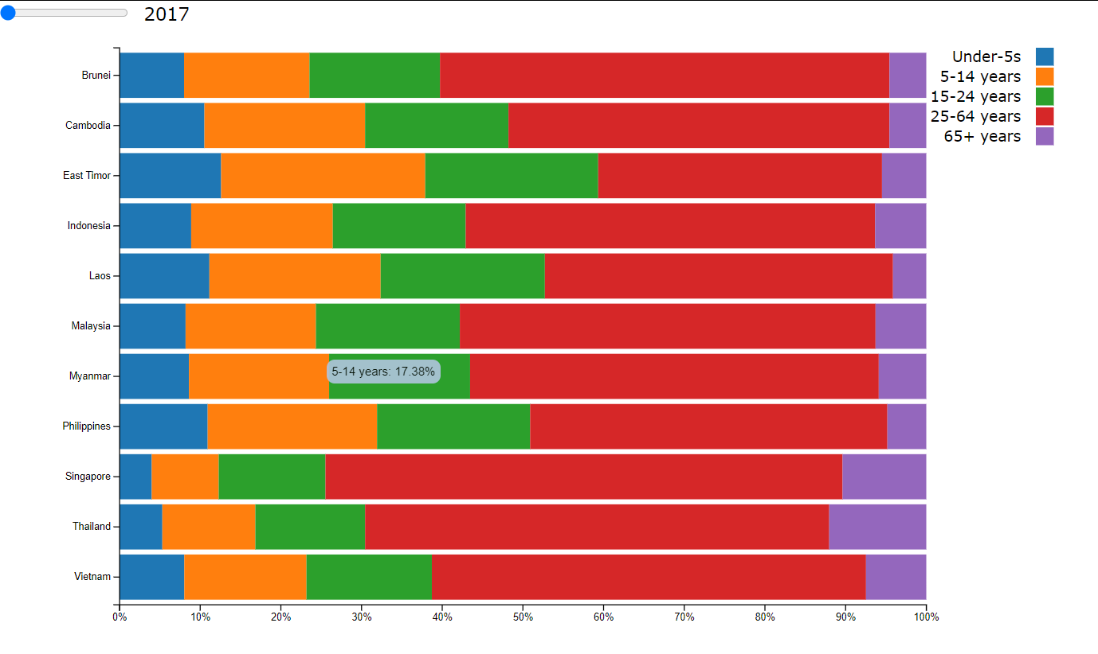

# CHAPTER 4. DASHBOARD INSIGHTS

# Home page:

The Home section displays an image with the topic name.

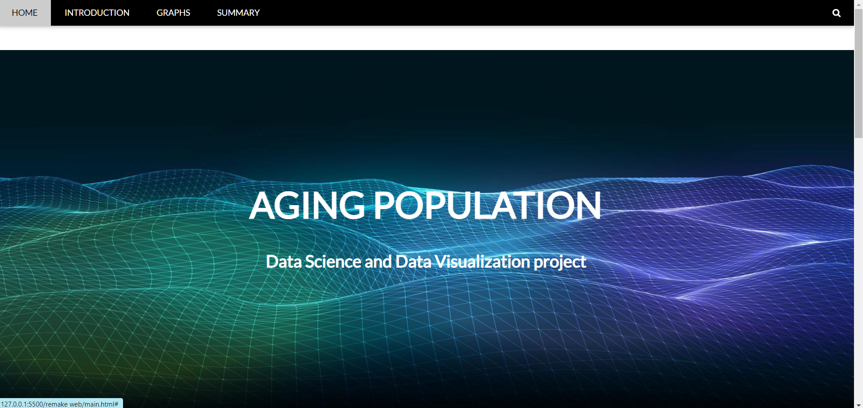

1. **Introduction section**

Here, we present an overview of the topic, highlighting the importance of understanding demographic changes, particularly the aging population. This sets the stage for the detailed analysis provided in the following sections.

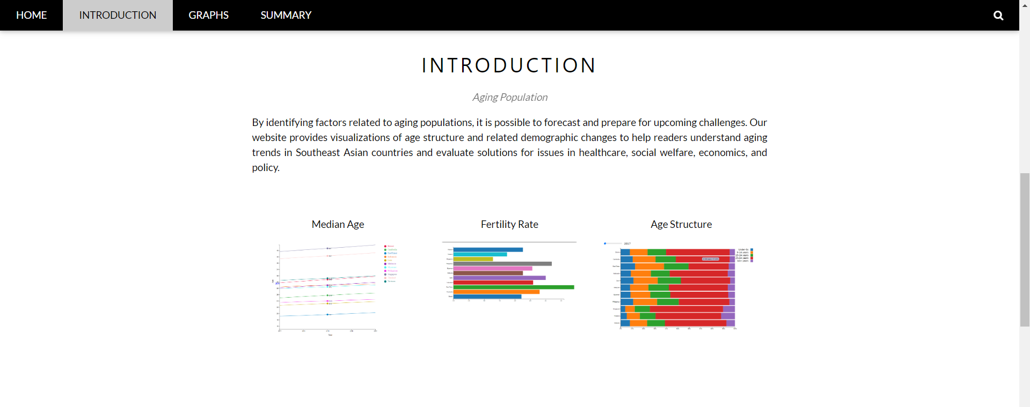

“By identifying factors related to aging populations, it is possible to forecast and prepare for upcoming challenges. Our website provides visualizations of age structure and related demographic changes to help readers understand aging trends in Southeast Asian countries and evaluate solutions for issues in healthcare, social welfare, economics, and policy.”

1. **Graph section:**

The Graph section is the core of our dashboard, divided into three main parts. Each part has a dedicated button leading to a more detailed analysis page. Each page has a chart and a descriptive text that provides further context. There is a return button to navigate back to the Home page.

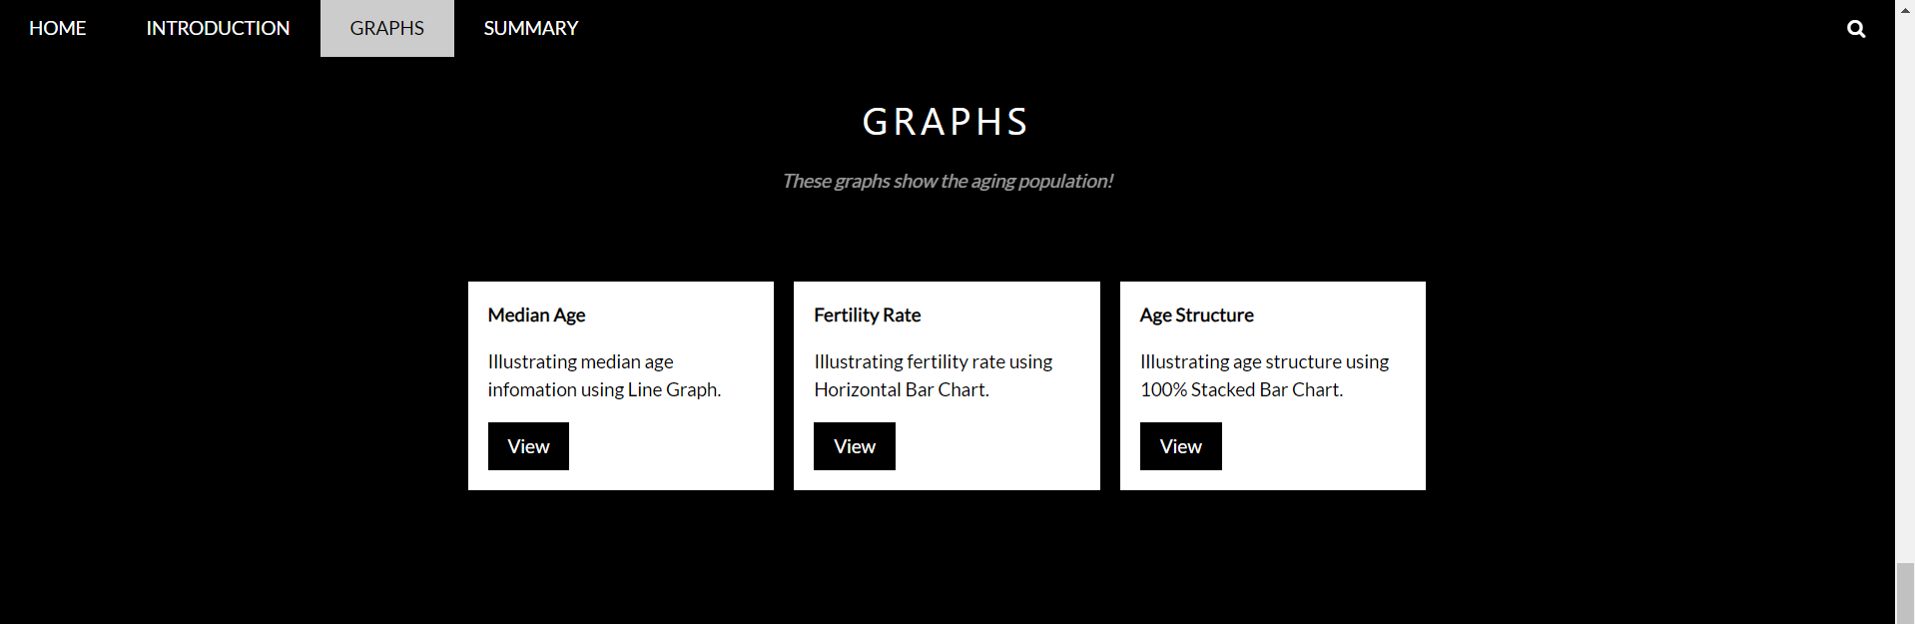

1. ***Median Age***

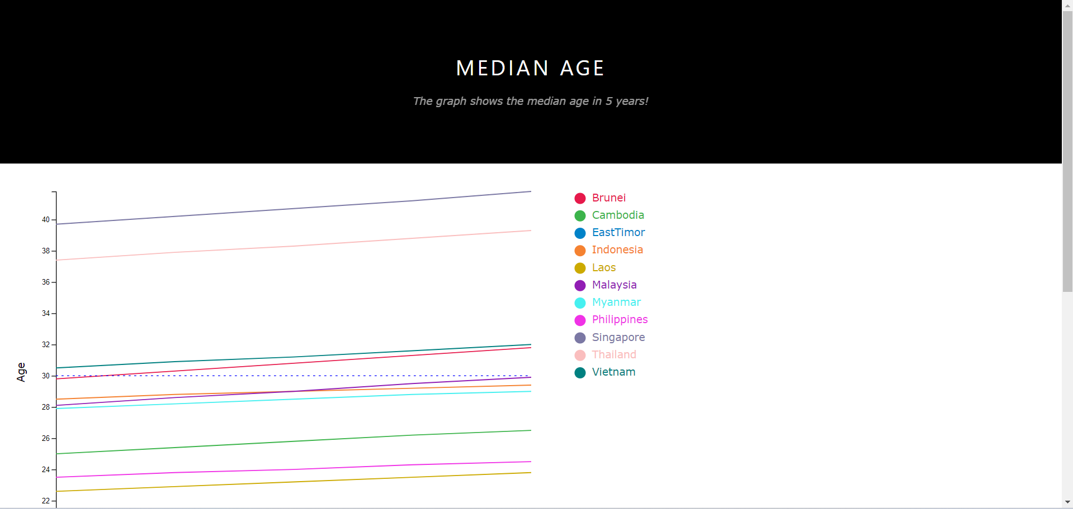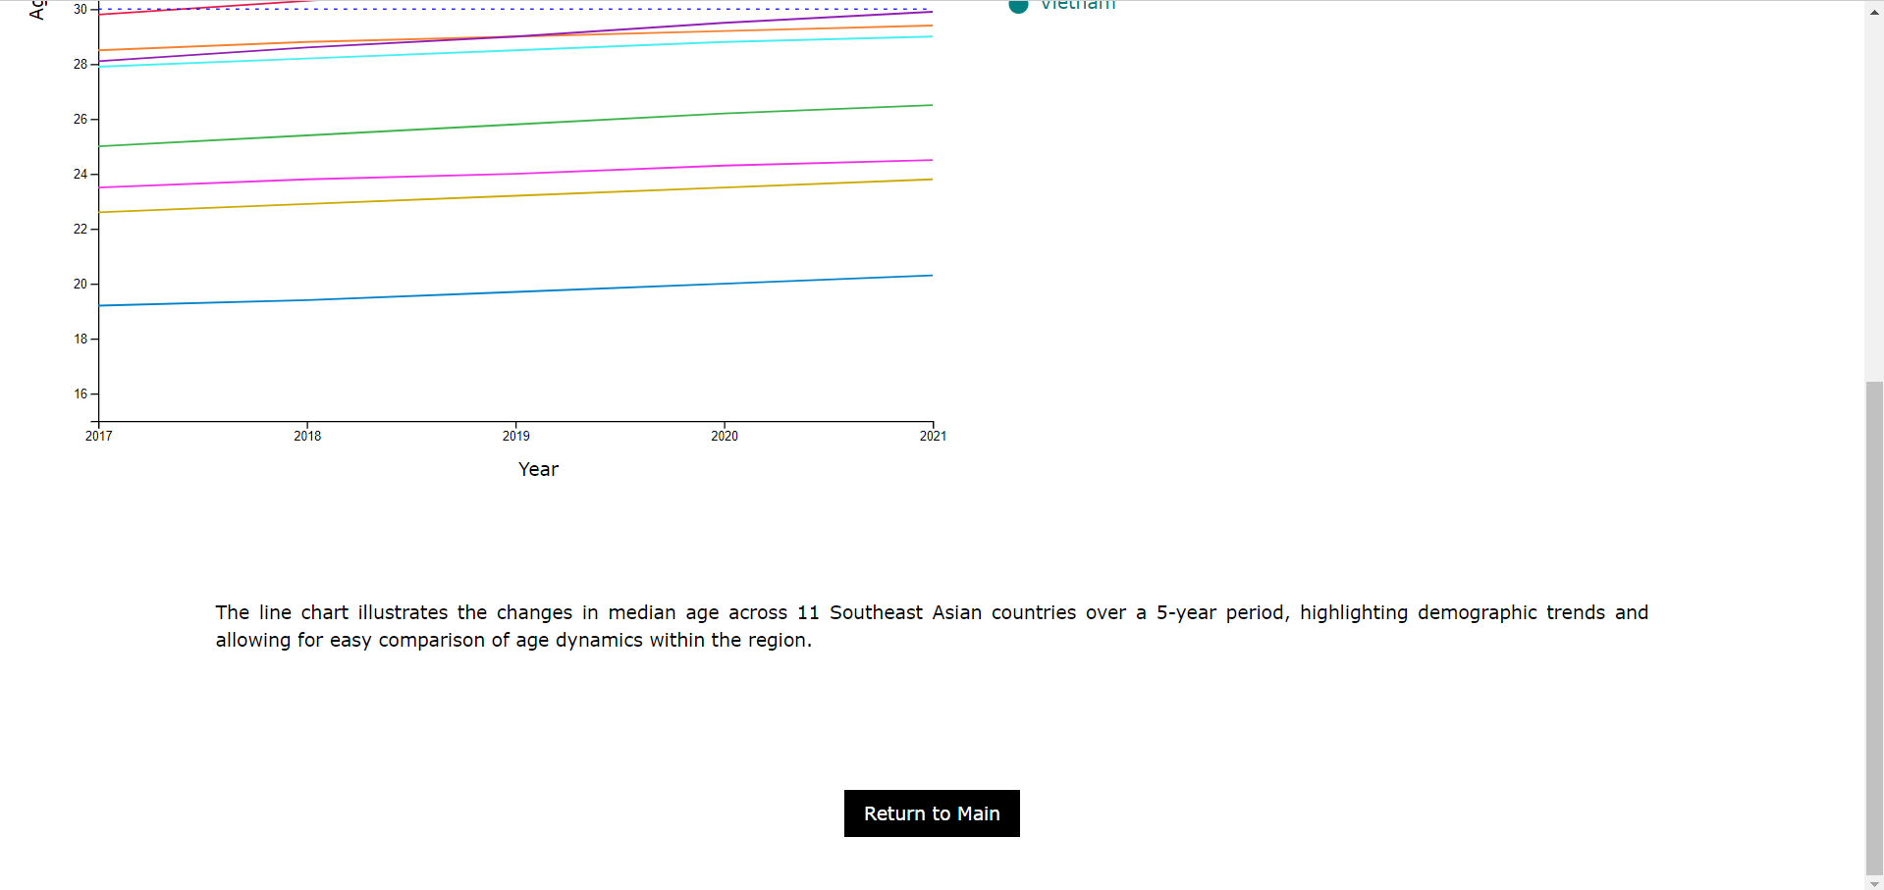

1. ***Fertility Rate***

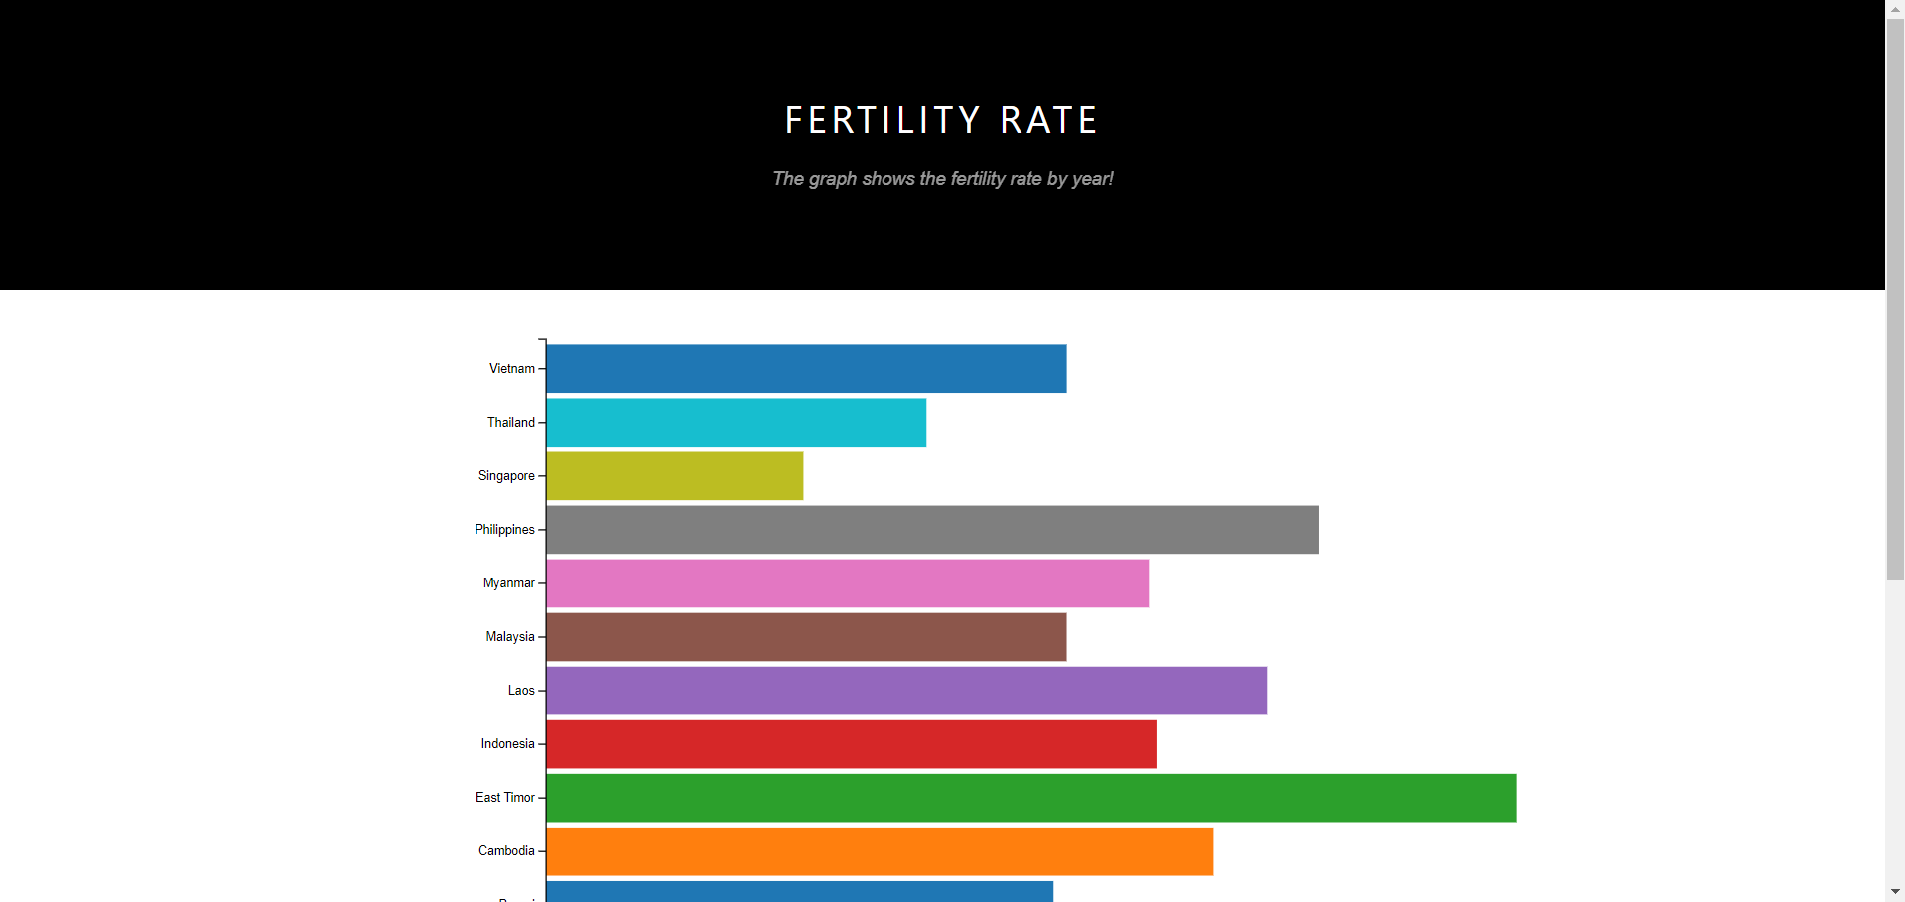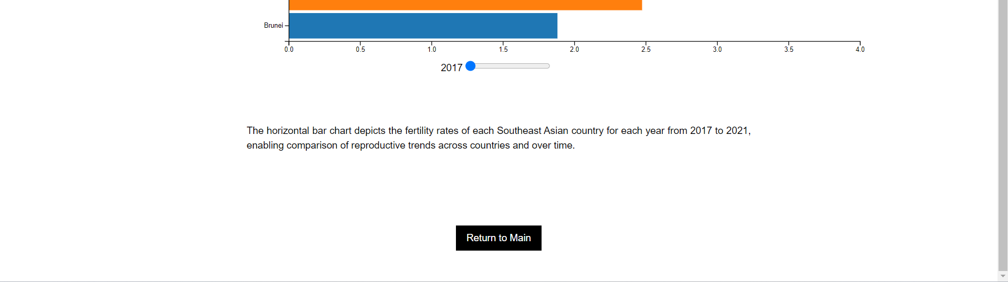

1. ***Age Structure***

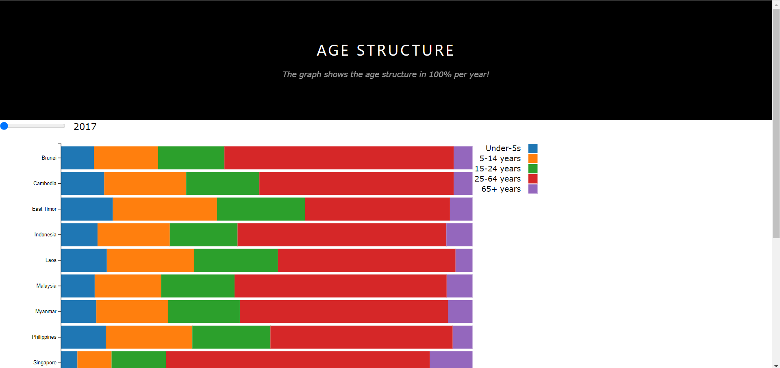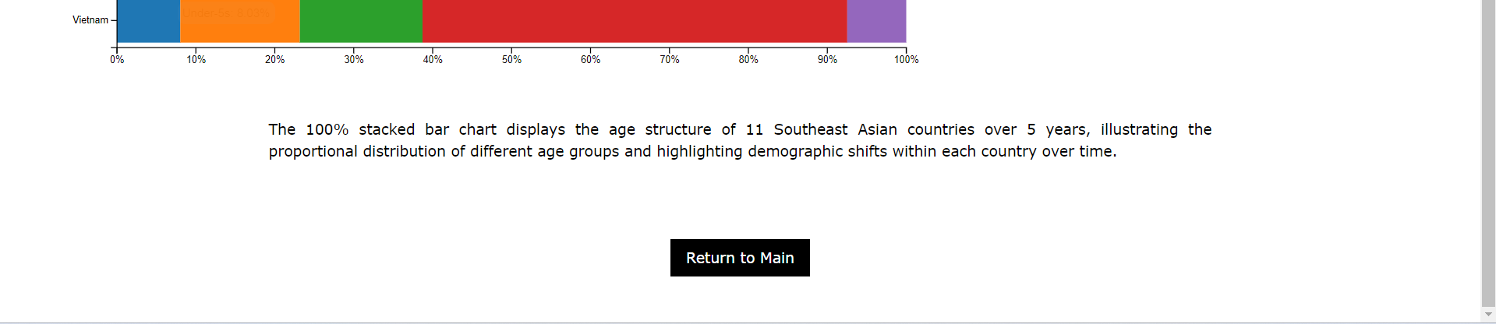

1. **Summary section:**

The Summary section encapsulates the key findings and insights drawn from the data visualizations, providing a comprehensive overview of the aging population trends observed.

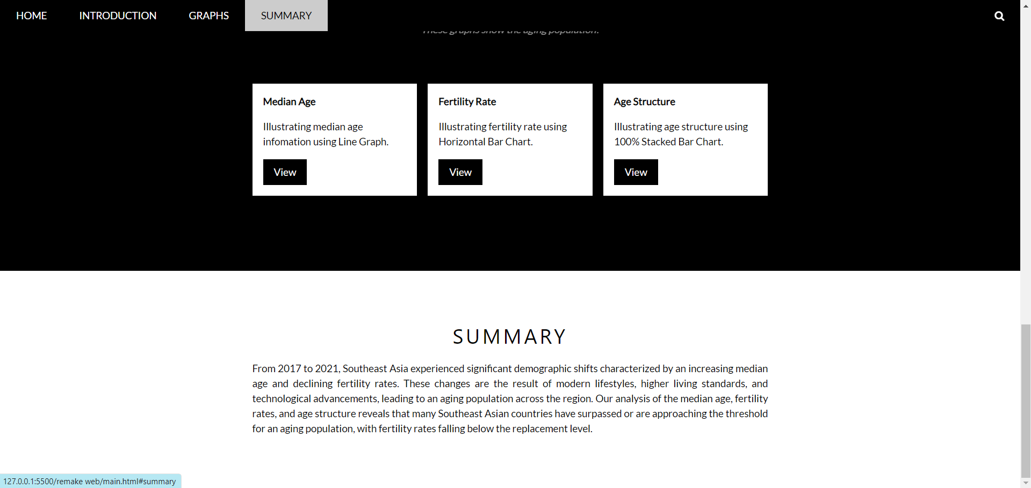

“From 2017 to 2021, Southeast Asia experienced significant demographic shifts characterized by an increasing median age and declining fertility rates. These changes are the result of modern lifestyles, higher living standards, and technological advancements, leading to an aging population across the region. Our analysis of the median age, fertility rates, and age structure reveals that many Southeast Asian countries have surpassed or are approaching the threshold for an aging population, with fertility rates falling below the replacement level.”

# CHAPTER 5. CONCLUSION

* The aging population in Southeast Asia poses challenges to healthcare, social welfare, and economic stability. By leveraging insights from demographic data and visualization tools, Southeast Asian countries can better prepare for and manage the impacts of an aging society, ensuring sustainable development and improved quality of life for their populations.
* The aging population in Southeast Asia poses challenges to healthcare, social welfare, and economic stability. By leveraging insights from demographic data and visualization tools, Southeast Asian countries can better prepare for and manage the impacts of an aging society, ensuring sustainable development and improved quality of life for their populations.
* The aging population in Southeast Asia poses challenges to healthcare, social welfare, and economic stability. By leveraging insights from demographic data and visualization tools, Southeast Asian countries can better prepare for and manage the impacts of an aging society, ensuring sustainable development and improved quality of life for their populations.

# 

# REFERENCES

[1]: Our World in Data. (n.d.). Population & Demography Data Explorer. Age structure.

<https://ourworldindata.org/explorers/population-and-demography?time=earliest&facet=none&Metric=Age+structure&Sex=Both+sexes&Age+group=Total&Projection+Scenario=None&country=CHN~IND~USA~IDN~PAK~NGA~BRA~JPN>

[2]: Our World in Data. (n.d.). Population & Demography Data Explorer. Median age.

<https://ourworldindata.org/explorers/population-and-demography?time=earliest&facet=none&hideControls=false&Metric=Median+age&Sex=Both+sexes&Age+group=Total&Projection+Scenario=None&country=DZA~OWID_WRL~AFG~VNM~JPN>

[3]: Our World in Data. (n.d.). Population & Demography Data Explorer. Fertility rate: children per woman.

<https://ourworldindata.org/explorers/population-and-demography?facet=none&pickerSort=asc&Metric=Fertility+rate&Sex=Both+sexes&Age+group=Total&Projection+Scenario=None&country=JPN~OWID_WRL~AFG~VNM>

[4]: Our World in Data. (n.d.). Population & Demography Data Explorer. Population.

<https://ourworldindata.org/explorers/population-and-demography?facet=none&pickerSort=asc&Metric=Population&Sex=Both+sexes&Age+group=Total&Projection+Scenario=None&country=JPN~OWID_WRL~AFG~VNM>

[5]: Website template idea:

<https://www.w3schools.com/w3css/tryit.asp?filename=tryw3css_templates_band&stacked=h>