Contents
I. Project Introduction 1
1. Overview 1
1.1 Project Information 1
2. Project Scope & Limitations 2
2.1 Major Features 2
2.2 Limitations & Exclusions 2
II. Software Requirement Specification 3
1. User Requirement 3
2. Functional Requirement 3
3. Non- Functional Requirement 3
III. Software Design Description 4
1. System Design 4
1.1 System Architecture 4
1.2 Backend Architecture 4
1.3 Web Application Architecture 5
1.3 Package diagram 5
1.4 Package Descriptions 6
2. Database Design 8
2.1 Conceptual ERD 8
3. Detailed Design 8
3.1 Sign in 8
3.2 Register New Customer 9

I. Project Introduction

1. Overview

1.1 Project Information
Authentication & Authorization System
This project is a secure user authentication and authorization system developed using ASP.NET Core Web API, Entity Framework Core, and SQL Server following a 3-Layer Architecture (Controller → Service → Repository).
Key Features
- User registration and login
- Password policy enforcement:
  - Minimum 12 characters
  - At least 1 uppercase letter
  - At least 1 special character
- JWT-based authentication
- Refresh Token implementation for persistent login
- Role-based authorization
- Account lockout after 5 consecutive failed login attempts
- Automatic revocation of all active refresh tokens when an account is locked
- Password hashing using BCrypt
- RESTful API design
- Entity Framework Core with Repository Pattern

2. Project Scope & Limitations

2.1 Major Features
ID | Feature | Description
F01 | User Registration | Register a new user account with password policy validation (minimum 12 characters, at least 1 uppercase letter, and 1 special character).
F02 | JWT Authentication | Authenticate users and return an Access Token (valid for 2 hours) and a Refresh Token (valid for 7 days).
F03 | Auto Account Lock | Automatically lock a user account after 5 consecutive failed login attempts.
F04 | Token Refresh | Generate a new Access Token using a valid Refresh Token without requiring the user to log in again.
F05 | Logout & Token Revocation | Log out a user and revoke the associated Refresh Token to prevent further use.
F06 | Real-time Force Logout | When an administrator locks a user account, SignalR immediately sends a ForceLogout event to connected clients.
F07 | Toggle User Lock | Allow administrators to lock or unlock a user account using an idempotent toggle operation.
F08 | Role Management | Retrieve the list of available roles within the system.

2.2 Limitations & Exclusions
Limitations
- L01 – No Refresh Token Rotation: Refresh tokens are not rotated after use, increasing the risk if a token is compromised.
- L02 – No Refresh Token Reuse Detection: The system does not detect multiple uses of the same refresh token (token family attack).
- L03 – No Rate Limiting: Login requests are not rate-limited, making brute-force attempts possible before account lockout occurs.
- L04 – Unlimited Refresh Tokens per User: There is no restriction on the number of active refresh tokens per user session.

Out of Scope
- E01 – Email Verification: Requires email service integration.
- E02 – Multi-Factor Authentication (MFA): Not included in the current project scope.
- E03 – Token Blacklisting: No centralized token blacklist mechanism is implemented.

II. Software Requirement Specification

1. User Requirement
# | Actor | Description
1 | User | As a customer, I want:  - Sign in securely to access the system.  - Stay signed in without repeatedly entering credentials.  - Sign out of the system when finished.  - View the remaining session validity period.  - Have the account automatically protected after multiple failed login attempts.
2 | Admin | As a shop owner, I want:  - View a list of users.  - View details of a specific user.  - Lock or unlock user accounts.

2. Functional Requirement

3. Non- Functional Requirement
- Passwords must be securely stored using industry-standard hashing algorithms.
- Access to protected resources must be controlled based on user roles.
- The system must support real-time communication for immediate security events.
- Passwords must satisfy predefined complexity requirements.
- The application must follow a layered architecture with clear separation of concerns.
- Dependencies should be managed through Dependency Injection to improve maintainability and testability.
- Authentication and authorization mechanisms must be implemented to protect sensitive resources.

III. Software Design Description

1. System Design

1.1 System Architecture
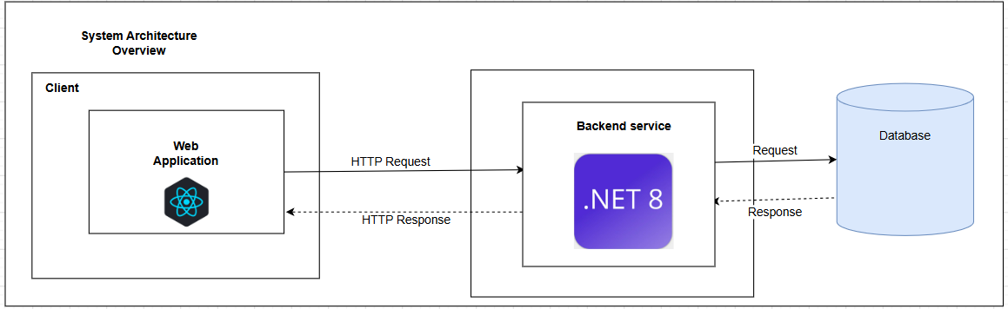

1.2 Backend Architecture
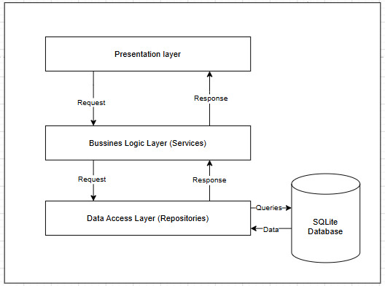

1.3 Web Application Architecture
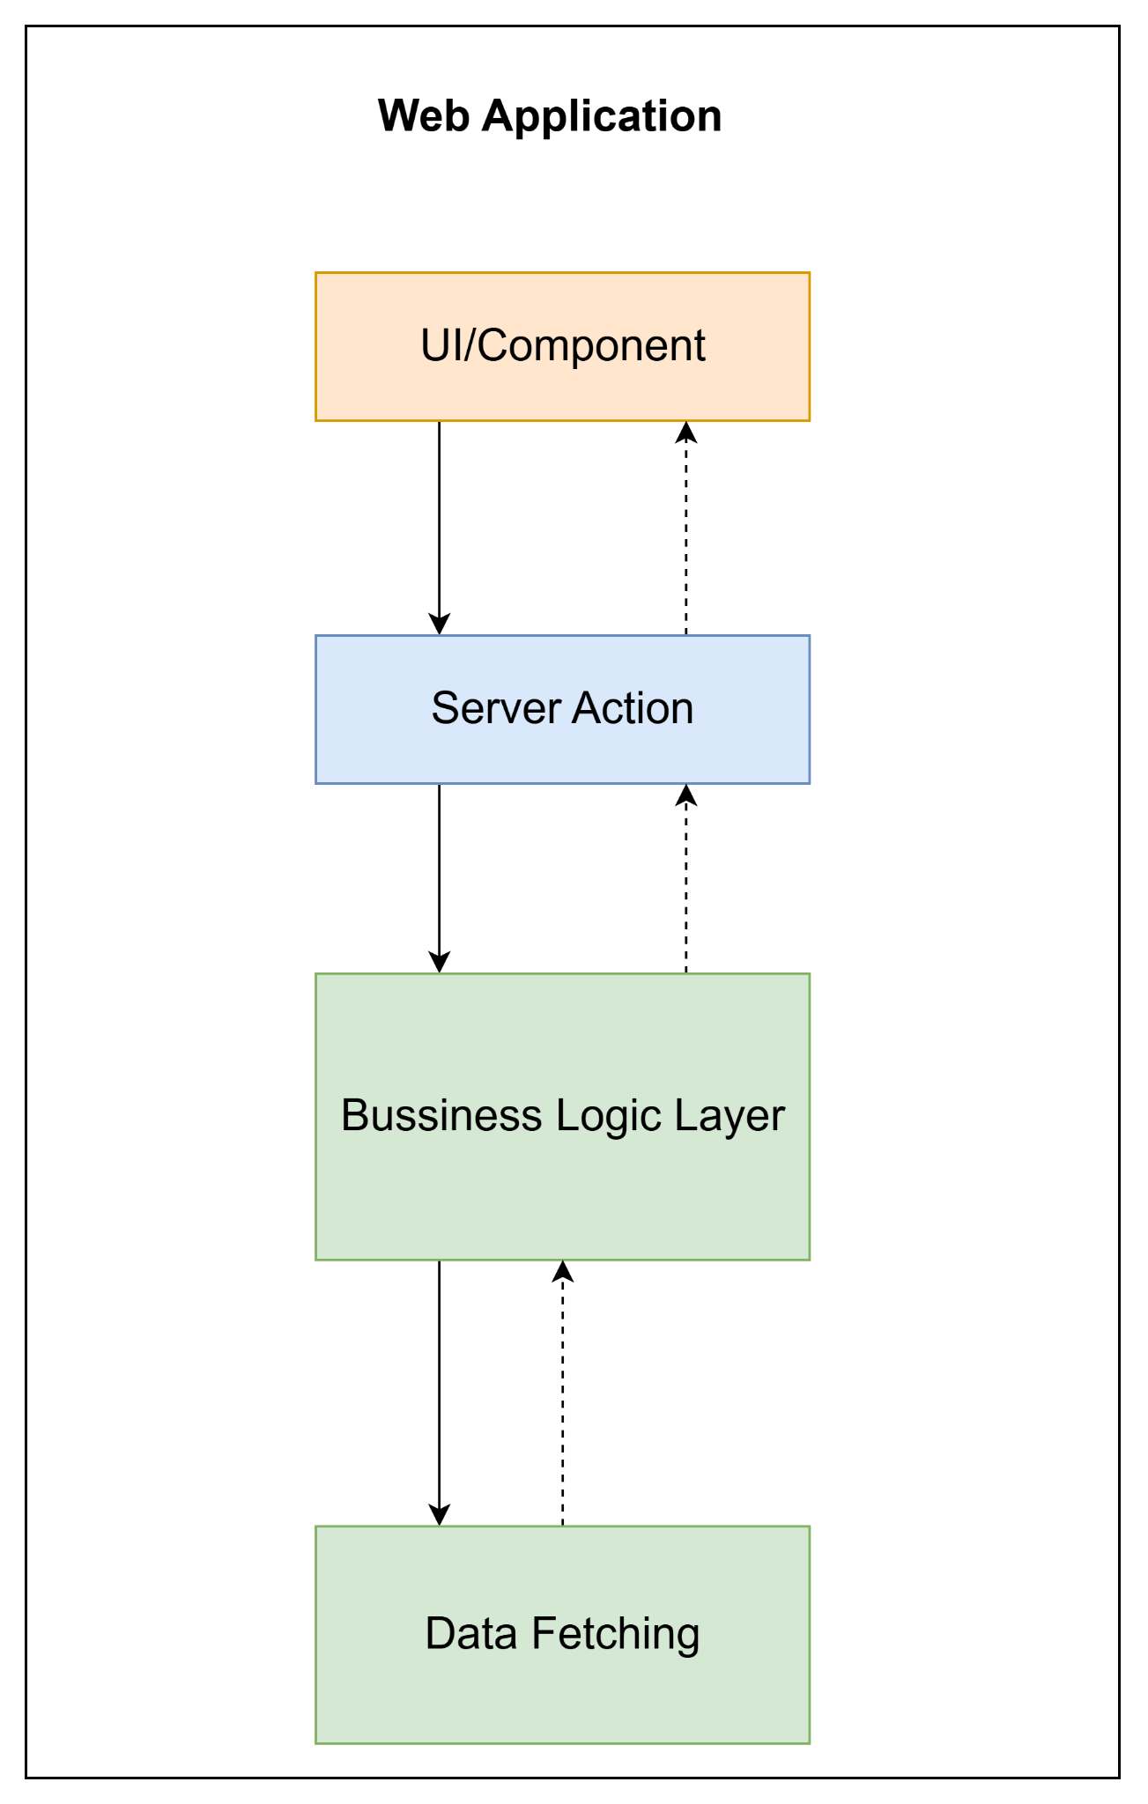

1.3 Package diagram
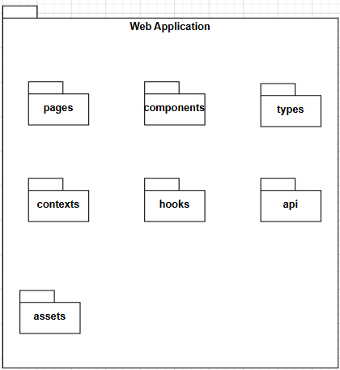
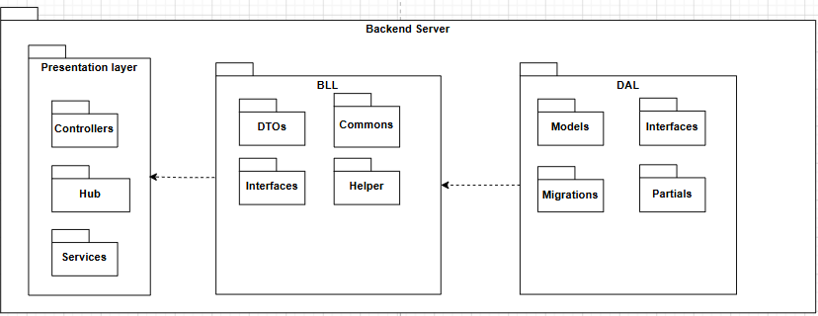

1.4 Package Descriptions

1.4.1 Web application
Package | Description
Presentation | Pages: Contains screen-level components responsible for layout organization and data coordination.  Components: Contains reusable UI elements that handle presentation and local UI state.
State Management & Logic | Contexts: Manages shared application state across components using the React Context API.  Hooks: Encapsulates reusable business logic, state management, and side effects through custom React hooks.
Integration | Api: Handles communication with backend services, including API requests, interceptors, and real-time connections.
Domain / Core | Types: Defines shared TypeScript interfaces and types to ensure consistency and type safety across the application.
Resources | Assets: Stores static application resources such as images, icons, fonts, and global CSS files. These resources are bundled and served as part of the application's build process.

1.4.2 Backend server
Package | Description
Presentation Layer | Handles incoming HTTP requests and returns responses to clients. Contains Controllers, SignalR Hubs, and API endpoints.  Controllers: Receive requests, validate input models, call service interfaces, and return standardized API responses. No business logic is implemented  Hubs: Provide real-time communication using SignalR. Used for ForceLogout events when an account is locked.  Services: Contains presentation-level services responsible for real-time communication and client notifications. These services act as a bridge between the business layer and SignalR hubs.
BLL (Business Logic Layer) | Contains business rules, authentication logic, authorization logic, token management, and application workflows.  Services: Implement core business logic such as user registration, login, logout, refresh token handling, account locking, and role validation.  DTOs: Transfer data between layers and API consumers. Separate request and response models from database entities.  Commons: Contains shared classes, constants, helper methods, ApiResponse wrappers, and utility functions used across the application.  Interfaces: Define contracts for presentation-level services to support dependency injection and loose coupling.
DAL (Data Access Layer) | Responsible for data persistence and database interaction through Entity Framework Core.  Repositories: Encapsulate data access logic and database queries, providing abstraction over Entity Framework Core.  Models: Represent database tables such as User, Role, and RefreshToken.  Migrations: Store Entity Framework Core migration files used for database schema creation and updates.  Partials: Contain partial entity classes or generated database model extensions.  Interfaces: Define contracts for presentation-level services to support dependency injection and loose coupling.

2. Database Design

2.1 Conceptual ERD
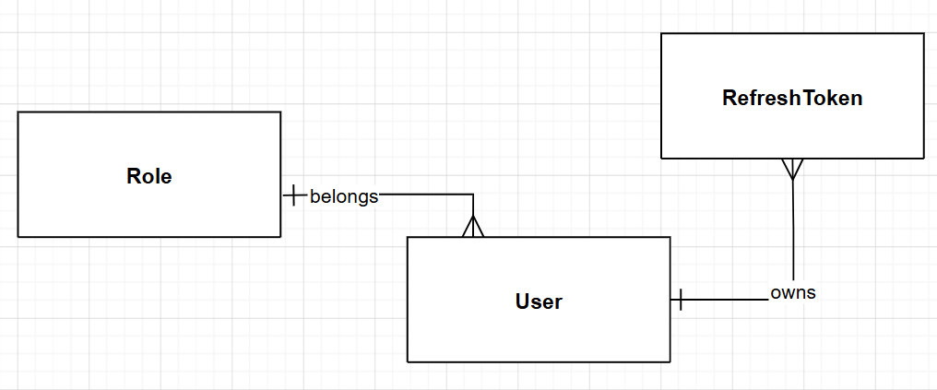

3. Detailed Design

3.1 Sign in

3.1.1 Class Diagram
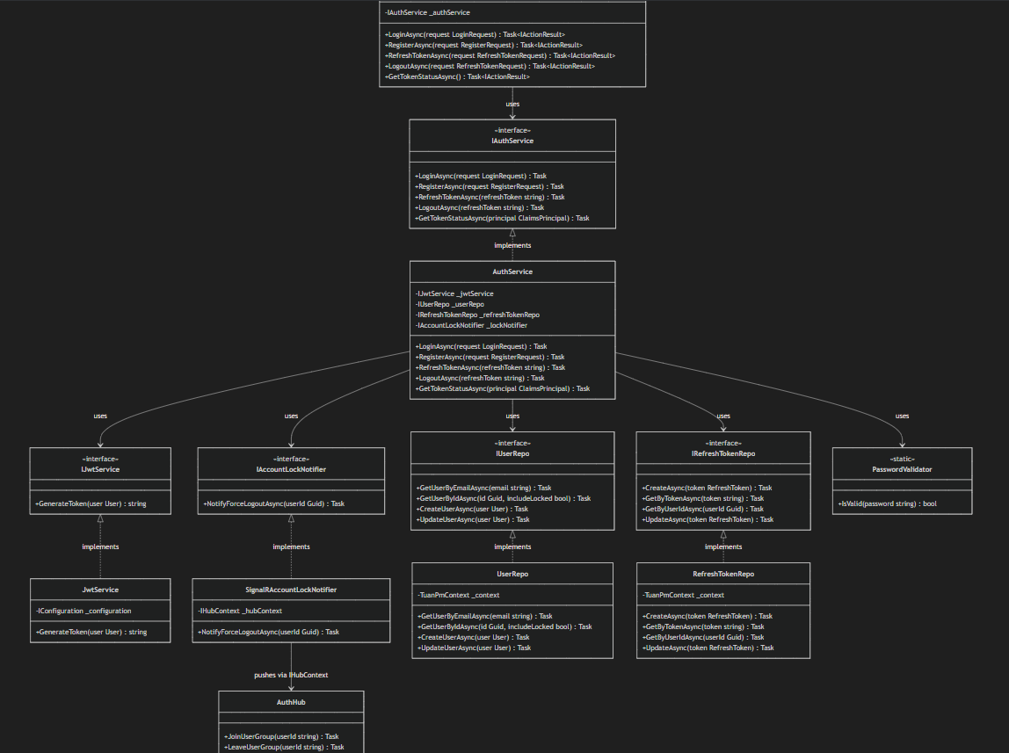

3.1.2 Sequence Diagram
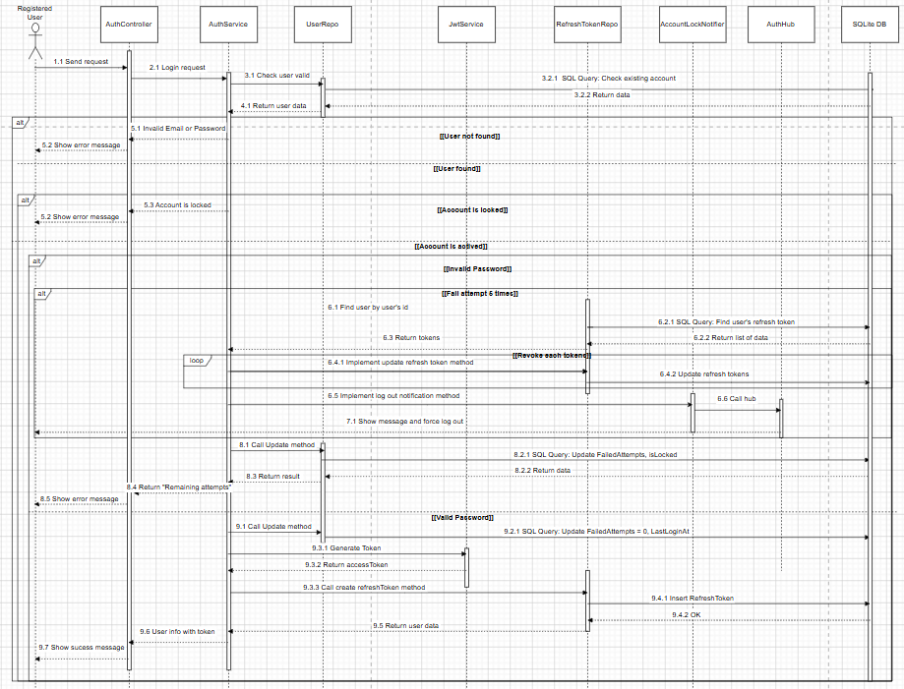

3.2 Register New Customer

3.2.1 Class Diagram

3.2.2 Sequence Diagram
