Account :

* + Get: http://localhost:8080/rest/accounts

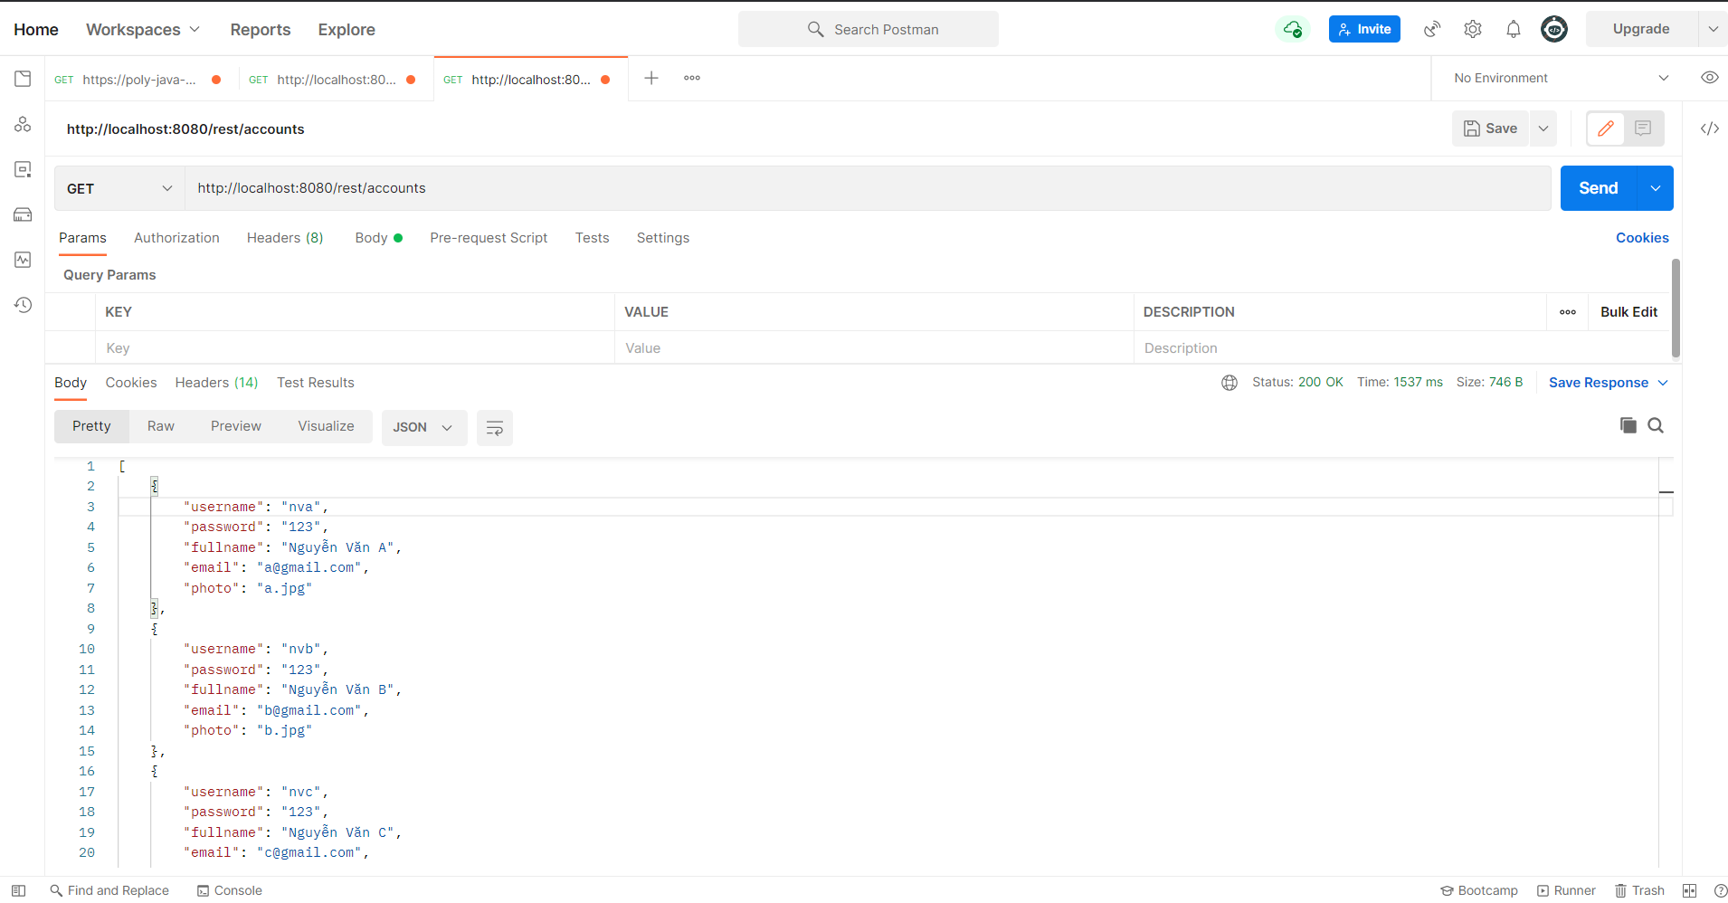

Post: http://localhost:8080/rest/accounts

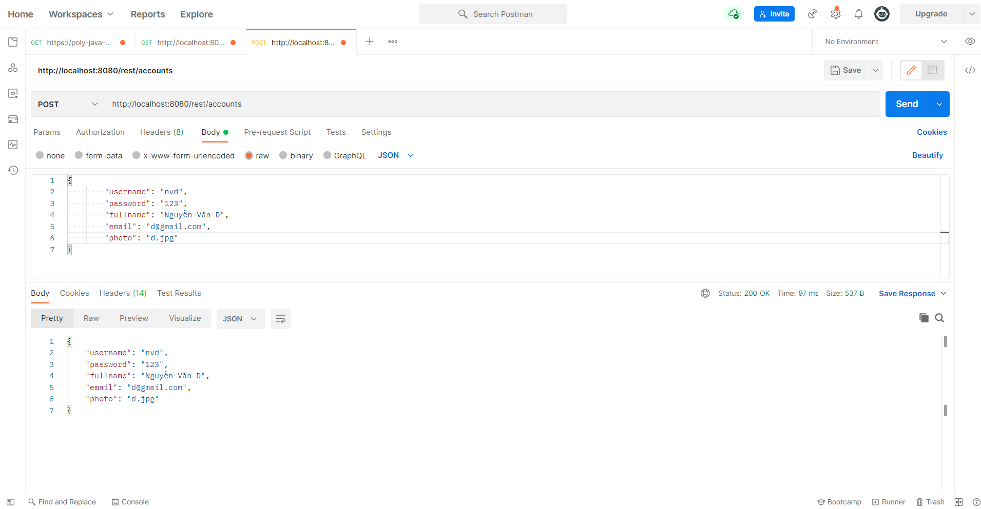

Put : http://localhost:8080/rest/accounts/nvd

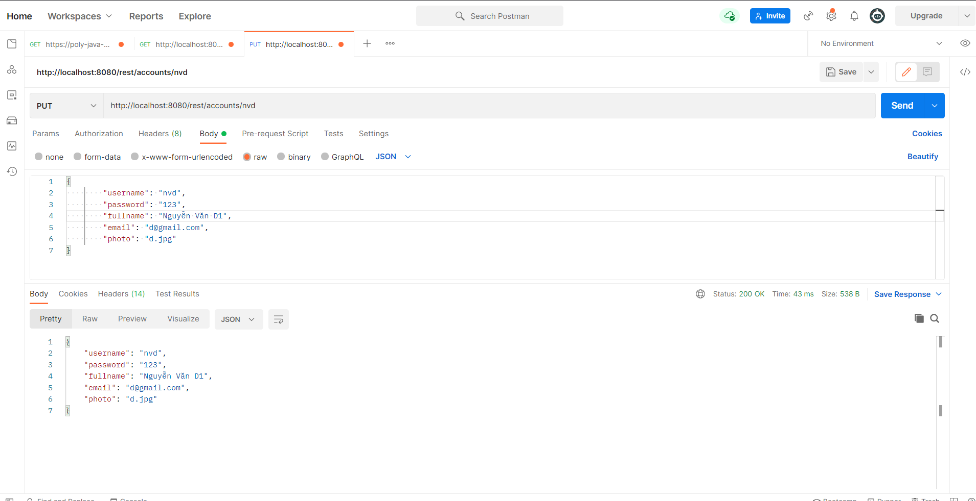

Delete : http://localhost:8080/rest/accounts/t

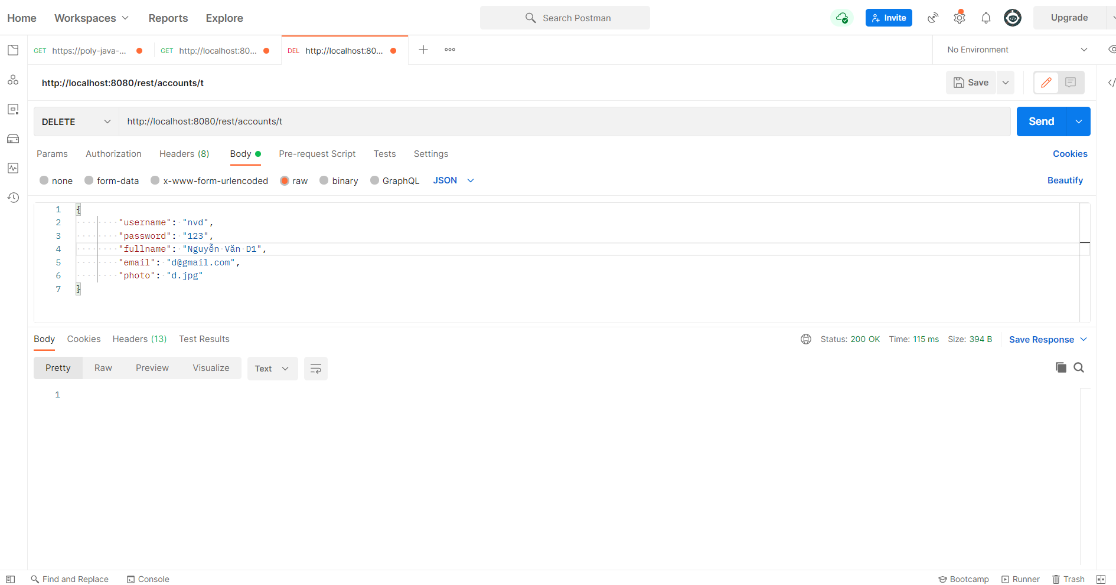

-Product

Get: http://localhost:8080/rest/products

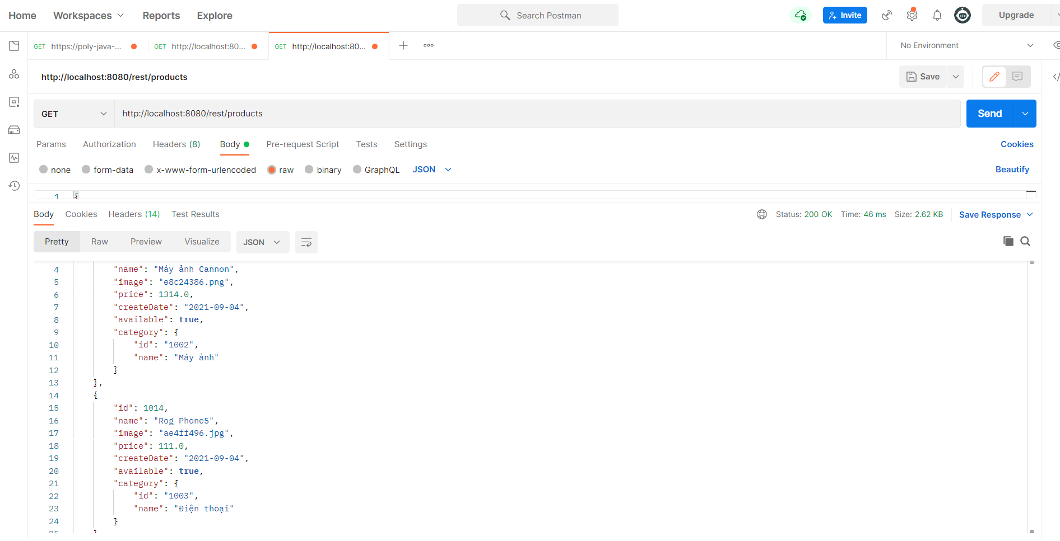

Post http://localhost:8080/rest/products

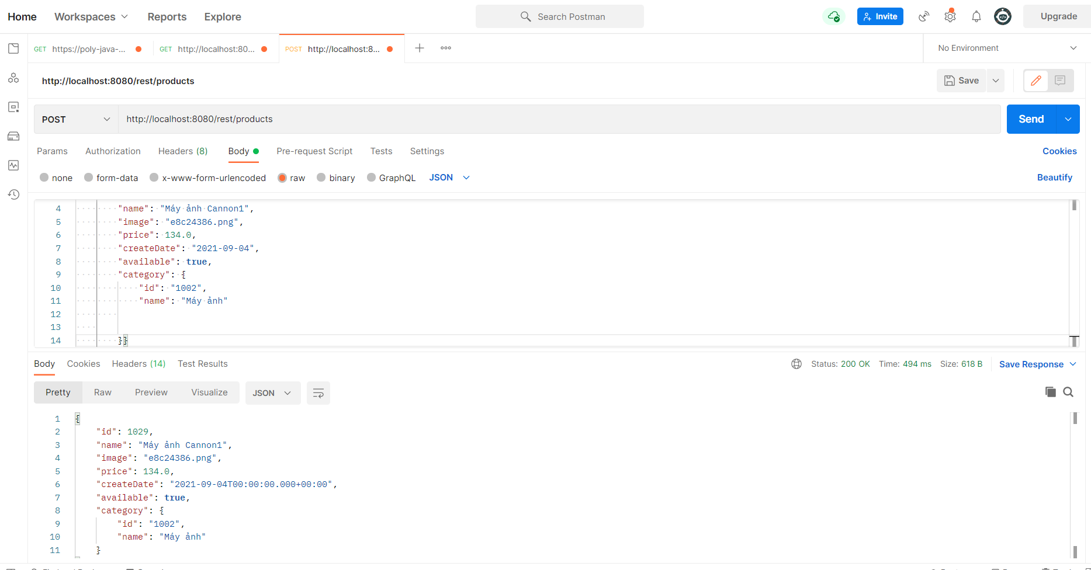

Put : http://localhost:8080/rest/products/1029

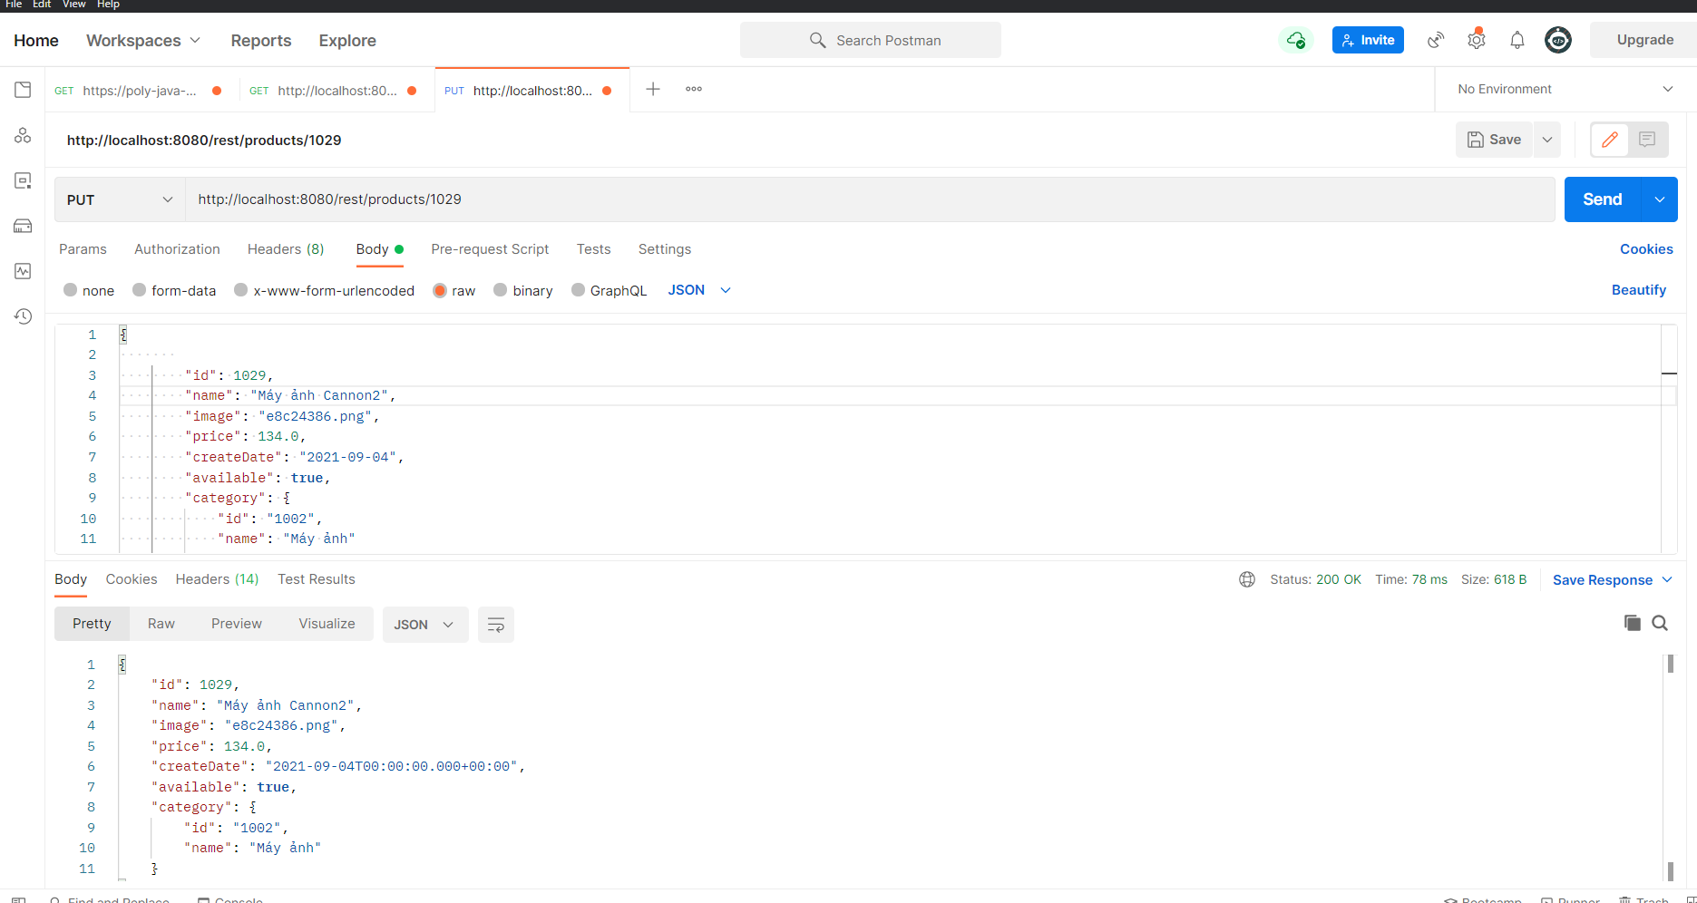

Delete : http://localhost:8080/rest/products/1029 