Graph Analytics Pipeline for Airline Network Data using HDFS and Spark GraphX
  - Project submission report
CSE412 | Big Data and Large Scale Computing | Track C
Team members Member 1 • Member 2 • Member 3
Submission date 14 October 2026

Abstract
We implemented and validated a native HDFS, Spark SQL and Scala GraphX pipeline for the US Department of Transportation’s 2015 flight dataset. The pipeline inspected 5,819,079 flight records, retained 5,231,130 completed flights and constructed a directed network of 322 airports and 4,656 routes. It computes topology and traffic-weighted PageRank, weak connected components, triangles, local clustering, directed distances to three hubs and descriptive delay statistics.
ATL, ORD and DFW lead traffic-weighted centrality. All active airports belong to one weak component and can reach each selected hub within three flight legs. Traffic-weighted centrality and average airport delay have a weak descriptive association. October has no retained flights because of the cleaning policy for numeric airport identifiers, so the results do not represent complete-year service coverage.
Two complete HDFS runs passed validation and reproduced all 14 non-timing result tables within tolerance 10⁻⁸. The experiment demonstrates an auditable data-to-graph workflow on one machine; it does not establish multi-node speedup or causal delay propagation.

Report scope
The report presents the problem, research basis, implemented architecture, measured results and limitations. Full source code, detailed commands and execution evidence accompany the project package.

Introduction

Background and motivation
A flight table describes individual journeys, while a network model exposes relationships among airports. Repeated flights measure route traffic; distinct routes describe connectivity. Comparing both views helps distinguish airports with many destinations from airports that carry a large share of observed traffic. Graph analysis also describes disconnected groups, interconnected neighborhoods and the number of flight legs needed to reach major hubs.
The project uses the 2015 Flight Delays and Cancellations dataset published through Kaggle by the US Department of Transportation [6]. The measured input comprises 592,430,817 bytes across three CSV files. Millions of flight rows reduce to a comparatively small airport graph, making this a study of scalable preparation and reproducible graph analysis rather than a claim that the final graph exceeds laptop capacity.

Objectives
- Create a traceable HDFS-to-Spark-to-GraphX workflow with immutable input identity and persisted outputs.
- Compare topology-based and flight-count-weighted centrality with route degree and traffic strength.
- Measure weak connectivity, undirected triangles, local clustering and directed reachability to ATL, ORD and DFW.
- Describe arrival delays with correct observation denominators and quantify the effects of cleaning.
- Verify algorithm correctness, saved-output consistency and repeatability, and report measured runtime boundaries.

Tool selection and execution scope
HDFS provides the storage boundary for raw files, clean graph tables and results. Spark SQL parses, audits, joins and aggregates flight records. GraphX provides graph abstractions and iterative computation within Spark [1,7]. Python handles compact exports, independent small-graph test oracles, figures and report generation; it does not replace GraphX in the main analysis.
Execution used native Linux tools, pseudo-distributed HDFS with replication one and Spark local[2]. The software therefore exercises HDFS communication and persisted reloads, while both Spark worker threads run on one machine. Replication one offers no physical-node redundancy. No cloud service, container platform, web application or external graph database is required.

Study contribution
The contribution is an integrated, tested implementation with explicit exclusions, stable airport identifiers, traffic-weighted iteration, independent correctness checks and reproducible evidence. It is an engineering application of established methods, not a new centrality algorithm. The submitted material supports evaluation of both computational behavior and the limits of its airline findings.

Literature Survey
Five primary research sources inform the design. Their findings motivate the implementation, but their datasets and performance results are not treated as measurements of this project.
Research | Main contribution | Use in this project
Gonzalez et al. [1]  OSDI 2014 | Graph processing within distributed dataflow | Spark preparation followed by GraphX
Zaharia et al. [2]  NSDI 2012 | Reusable, resilient distributed datasets | Cached iteration and bounded lineage
Malewicz et al. [3]  SIGMOD 2010 | Vertex-centric supersteps and messages | Iterative rank propagation
Guimerà et al. [4]  PNAS 2005 | Different notions of air-network importance | Compare degree, traffic and centrality
Brin and Page [5]  Computer Networks 1998 | Link structure as an importance signal | Topology PageRank baseline

Integrated dataflow and iteration
GraphX [1] connects relational dataflow and graph views. This suits a task in which record cleaning is relational but network metrics require graph operations. The RDD paper [2] motivates reuse of immutable state across iterations. We materialize cached results, release obsolete state and checkpoint long iterations. The project does not reproduce distributed benchmarks or conduct worker-failure recovery experiments.

Graph computation and interpretation
Pregel [3] expresses computation through synchronized vertex updates and message exchange. Our weighted PageRank uses GraphX aggregateMessages for incoming score and a separate global reduction for dangling mass. It does not implement a separate Pregel runtime or mutable graph topology.
Guimerà et al. [4] demonstrate why route degree does not capture every notion of importance in air transportation. Their worldwide city network and betweenness measure differ from this directed US-airport PageRank analysis. Their work motivates metric comparison; it does not make weak components or triangles equivalent to communities.
Brin and Page [5] motivate link-based importance. We adapt the transition probabilities to retained flight counts and compare them with a uniform custom baseline using the same convergence rule. Scores describe circulation in the defined flight network, not passenger demand or commercial value.

Practical synthesis
Together, the sources support an integrated preparation-and-analysis workflow and careful metric interpretation. The project adds an audited cleaning policy, explicit delay denominators and independent correctness evidence. The research bibliography and the separate dataset and official-documentation references appear at the end.

Problem Statement
Given the original flight, airport and airline CSV files, construct a valid directed airport network and compute interpretable graph and delay summaries. Every removal must have a recorded reason, and every output must be traceable to a validated run and exact input bytes.
Graph element | Definition
Vertex | An airport appearing in at least one retained flight, with a stable ID and IATA label.
Directed edge | One retained origin–destination pair; reciprocal routes remain separate.
Traffic weight | Number of retained flights on the directed route.
Delay attributes | Observed delay count, sum, mean and number delayed at least 15 minutes.
Undirected projection | Each unordered airport pair appears once, for triangle and clustering analysis.

Research questions
- Which airports rank highest under topology and traffic weighting, and how do these rankings relate to degree and traffic?
- Is the retained network weakly connected, and how interconnected are airports’ local neighborhoods?
- How many observed flight legs are needed to reach ATL, ORD and DFW, and which airports cannot reach them?
- Which routes meeting the traffic threshold have high mean arrival delays, and how does airport centrality relate to delay?
- How do exclusions affect monthly coverage, and what processing cost is observed on the available machine?

Input challenges and constraints
The input contains cancelled and diverted flights, numeric airport identifiers and potentially missing or invalid fields. Airport lookups must have unique keys; a conflicting lookup is rejected rather than allowed to multiply joined rows. Repeated flights are traffic observations and are not removed merely because they share a route. Missing delay is distinct from observed zero delay, while negative delay represents early arrival.

Success conditions and interpretation
A successful run must conserve retained flight counts and delay observations, resolve every edge endpoint, preserve stable labels, produce finite converged custom rank scores and validate reloaded results. HDFS must actually store raw, clean and result data. Fixture oracles test algorithm behavior, while real-file runs support airline findings.
Weak connectivity ignores direction. Hop counts follow observed route direction toward a hub; they do not identify a feasible itinerary, price or travel duration. Delay statistics are descriptive and cannot establish causation or propagation. These distinctions constrain both the algorithms and the interpretation of their outputs.

Proposed Solution / Architecture
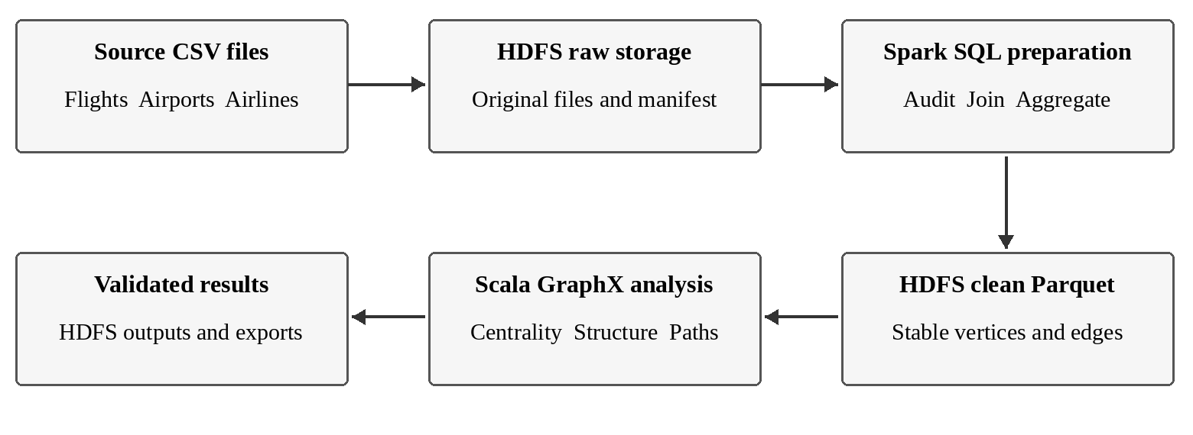
Figure 1 Data transitions in the implemented pipeline
The workflow preserves three storage boundaries. Original CSV files and a manifest are ingested into HDFS. Spark SQL writes cleaned vertices, edges and audits as Parquet. GraphX reloads those tables, writes structured results and then validation reloads the saved outputs. CSV exports contain compact aggregate tables used for figures and analysis.

Execution environment
Component | Tested setting
Operating system | Fedora Linux 44, x86_64
Hadoop and daemon Java | Hadoop 3.4.1; Temurin 11.0.32.1+1
Spark and Scala | Spark 3.5.9; Scala 2.13.8
Spark Java and HDFS client | Java 17.0.16; bundled Hadoop client 3.3.4
Execution resources | local[2]; 2 GiB driver heap; four shuffle and graph partitions
Storage | hdfs://localhost:9000; single-node HDFS, replication one

Hadoop and Spark use separate supported Java installations [8]. The original Hadoop environment file was backed up before its Java path was updated; existing storage was preserved. A Spark smoke test wrote and reloaded an HDFS object before the full stages ran. No bundled Hadoop client JARs were replaced.

Orchestration and failure handling
Shell scripts assign fresh run IDs, record configuration and source hashes, ingest inputs and run Scala stages through spark-shell. Each stage needs an exact completion message and a persisted marker. Compiler or execution failures stop the run. Existing run directories are never silently overwritten. Environment-specific daemon termination was resolved by retaining a terminal session, and startup waits for HDFS to leave safe mode.

Data preparation and persistence

Acquisition and input identity
The public Kaggle endpoint supplied dataset 810, version 1 [6], acquired on 13 October 2026. Publisher metadata reports CC0 Public Domain. The 200,067,268-byte archive passed CRC and inventory checks. SHA-256 hashes, acquisition time, headers, parsed record counts and source metadata were saved before HDFS ingestion. Reusing a dataset ID requires matching input identity.
File | Bytes | Parsed records
flights.csv | 592,406,591 | 5,819,079
airports.csv | 23,867 | 322
airlines.csv | 359 | 14

Ordered cleaning policy
Spark reads explicit string schemas, disables CSV column-pruning during corruption checks, validates 2015 dates and cancellation/diversion flags, normalizes airport labels and joins the lookup tables. Each flight receives exactly one reason, following the order below. The monthly audit independently reconciles raw and retained counts.
Priority | Exclusive decision | Records
1 | Corrupt CSV row | 0
2 | Invalid date or flags | 0
3 | Cancelled or diverted | 105,071
4 | Numeric airport identifier | 482,878
5 | Malformed airport identifier | 0
6 | Self-loop | 0
7 | Unmatched airport | 0
8 | Retained | 5,231,130

Graph construction and storage
Active IATA codes are sorted lexicographically and mapped to stable integer IDs. Route aggregation records flight count, observed delay count, delay sum and mean, and the count delayed at least 15 minutes. Delay means use observed values as their denominator. Exact duplicate rows are diagnosed; no duplicates occurred in this input.
Vertices and directed edges are written to HDFS Parquet under the run’s clean directory and reloaded for graph construction. GraphX uses EdgePartition2D with four partitions and cached graph state. Results, audit tables and timing metadata are persisted under the same run ID. Three airports lack coordinates, but remain valid vertices; no active airport lacks a name.

Graph algorithms and output validation

Topology and traffic weighted PageRank
The built-in topology baseline runs 20 iterations with reset probability 0.15. The custom method starts with equal scores, uses positive flight counts as edge weights and redistributes dangling-vertex mass uniformly. A uniform-edge custom run uses the same implementation and stopping parameters to isolate the effect of weighting.
$${PR}_{t+1}(v) = \frac{α}{N} + (1 − α) [\sum_{u: (u,v)∈E}{\frac{{PR}_{t}(u)w_{uv}}{s_{out}(u)}} + \frac{D_{t}}{N}]$$
Here N is the number of airports, α is 0.15, wᵤᵥ is route flight count, s_out(u) is total outgoing traffic, and Dₜ is the score mass at airports with no outgoing edge. E is the set of directed routes; the sum covers incoming neighbors of v. Vertices without messages still receive reset and redistributed dangling mass.
The custom iterations stop when the maximum absolute score change is below 10⁻⁸, with a cap of 100 iterations. Cached new state is materialized before previous state is released, and every tenth iteration is checkpointed. Scores, residual, iteration count and total mass are recorded. Delays are never used as transition weights.

Connectivity triangles and directed paths
GraphX connected components measures weak connectivity. For triangles, every route is mapped to a canonical unordered pair, reciprocal pairs are deduplicated and TriangleCount runs on the resulting simple undirected graph. Global triangles equal the sum of per-airport triangle counts divided by three.
$$C_{v} = \frac{2T_{v}}{k_{v}(k_{v} − 1)} for k_{v} ≥ 2$$
Local clustering is zero below degree two. Directed ShortestPaths computes distances to the selected landmarks ATL, ORD and DFW. A complete airport-by-landmark grid preserves null hops for unreachable cases and zero for the landmark itself. The method reports leg counts, not route sequences.

Persistence and independent verification
Airport traffic and delays, route summaries, all rankings, component labels, triangles and paths are saved as Parquet and CSV parts. Validation reloads outputs and checks conservation, endpoint integrity, label stability, rank mass, convergence, clustering bounds and path semantics. Multipart CSV export verifies headers and hashes. Independent Python oracles are restricted to deterministic tiny graphs; full flight processing remains in Scala Spark.

Results & Analysis
The selected real-data run is full-2015-final-001. A second complete HDFS run, full-2015-final-002, repeated the analysis using identical input hashes, computational source and effective parameters. The results below refer to the selected run unless a repeat comparison is stated.
Measure | Observed value
Raw flight records | 5,819,079
Retained flights | 5,231,130 (89.896%)
Excluded flights | 587,949 (10.104%)
Active airports | 322
Directed routes / undirected pairs | 4,656 / 2,346
Average retained flights per directed route | 1,123.5

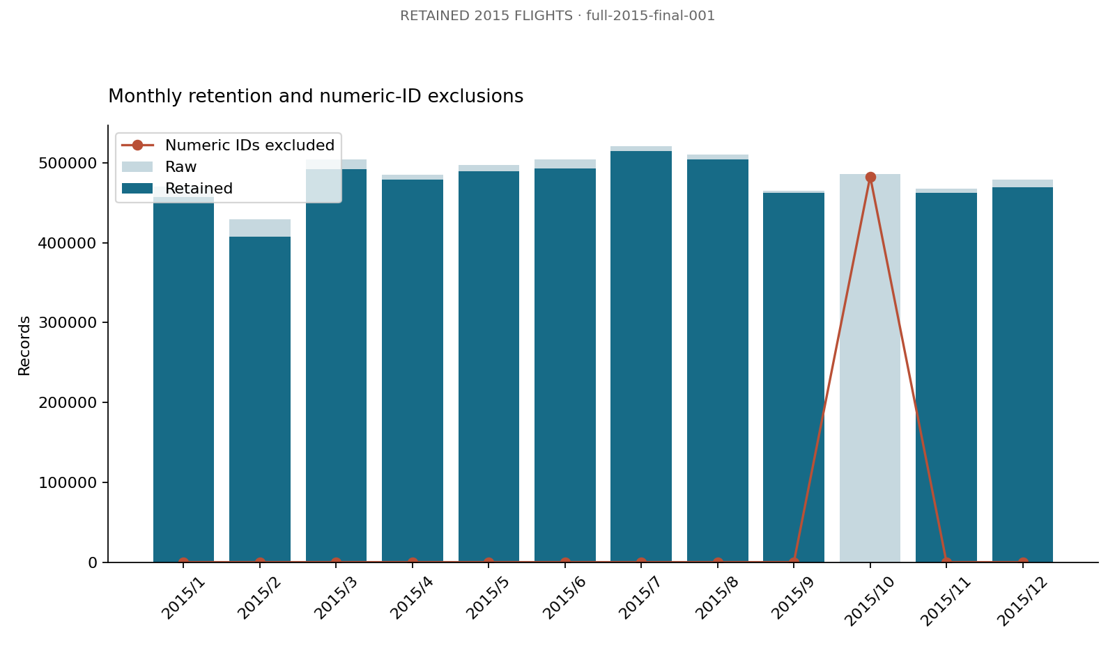
Figure 2 Monthly retention and exclusive numeric identifier exclusions

The principal coverage limitation
October contains 486,165 raw flights and zero retained flights. After the earlier cancellation/diversion filter, 482,878 October records receive the numeric-airport exclusion reason. The remaining 3,287 were removed earlier. Consequently, annual aggregation here combines retained records from the other eleven months. Airport rankings and delays must not be described as complete-year service measurements.
All inputs had zero CSV width mismatches. The lookup joins resolved every retained endpoint, and no unknown airline or invalid retained delay was recorded. These checks establish consistency of the retained dataset; they do not remove the seasonal bias introduced by the IATA-only policy.

Centrality and traffic
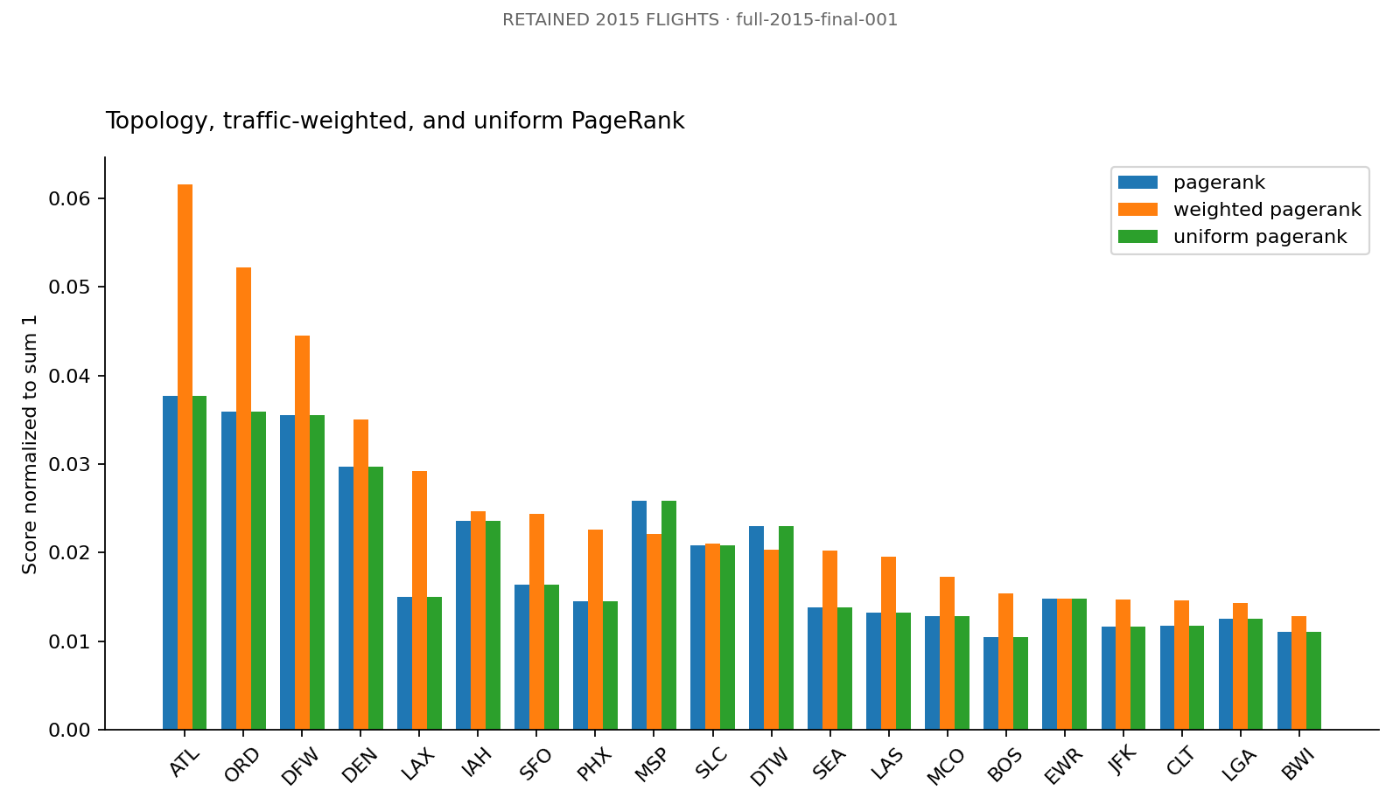
Figure 3 Normalized topology and traffic weighted PageRank comparisons
Weighted rank | Airport | Weighted score | Uniform rank
1 | ATL | 0.061534 | 1
2 | ORD | 0.052170 | 2
3 | DFW | 0.044481 | 3
4 | DEN | 0.035022 | 4
5 | LAX | 0.029258 | 10
6 | IAH | 0.024679 | 6
7 | SFO | 0.024350 | 9
8 | PHX | 0.022660 | 12
9 | MSP | 0.022133 | 5
10 | SLC | 0.021081 | 8

ATL, ORD and DFW lead the weighted ranking. Weighted and uniform-custom scores have Spearman correlation 0.9121 and share 18 airports in their top 20. HDN shows the largest absolute rank shift, from uniform rank 102 to weighted rank 273. Distinct-route connectivity and repeated traffic therefore do not give identical importance.
Across 322 airports, weighted centrality has Spearman correlation 0.9527 with incoming flight traffic and 0.8859 with incoming route degree. Median in-degree is four; the maximum is 168. These results support comparing several metrics, consistent with the motivation of air-network research [4], while using a different graph and centrality measure.

Connectivity clustering and hub reachability
Structural measure | Observed value
Weak components | 1; all 322 active airports
Undirected triangles | 15,867
Mean local clustering | 0.6554
Largest component fraction | 100%

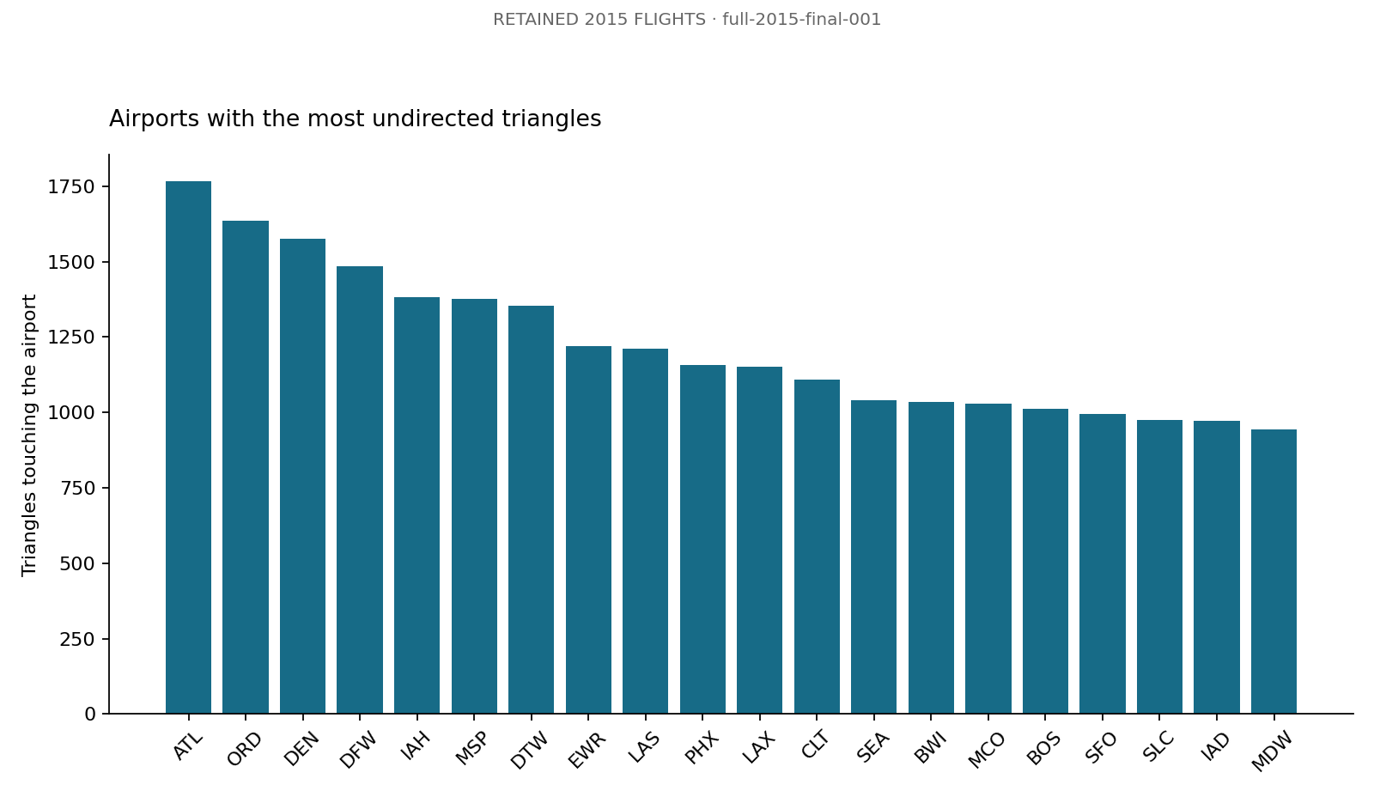
Figure 4 Airports with the most undirected triangles
Hub | Reachable airports | Unreachable | Maximum legs
ATL | 322 | 0 | 3
ORD | 322 | 0 | 3
DFW | 322 | 0 | 3

ATL has the highest raw triangle count. Several low-degree airports attain clustering one, so a fully connected neighborhood is not equivalent to a high-volume hub. Triangle counts should be read with degree and clustering rather than used interchangeably.
Every active airport can reach ATL, ORD and DFW within three observed flight legs. These are directed paths toward each landmark and include its zero-leg self-distance. Weak connectivity alone would not imply this result; it is established separately by the directed path outputs. Neither the component calculation nor triangle counting is community detection.

Arrival delay analysis
Every retained flight has a numeric arrival delay: 5,231,130 observations out of 5,231,130 flights. Their sum is 25,558,794 minutes and the observation-weighted mean is 4.886 minutes. Negative delays represent early arrivals. Cancellation and diversion outcomes are outside this retained-flight delay estimate.
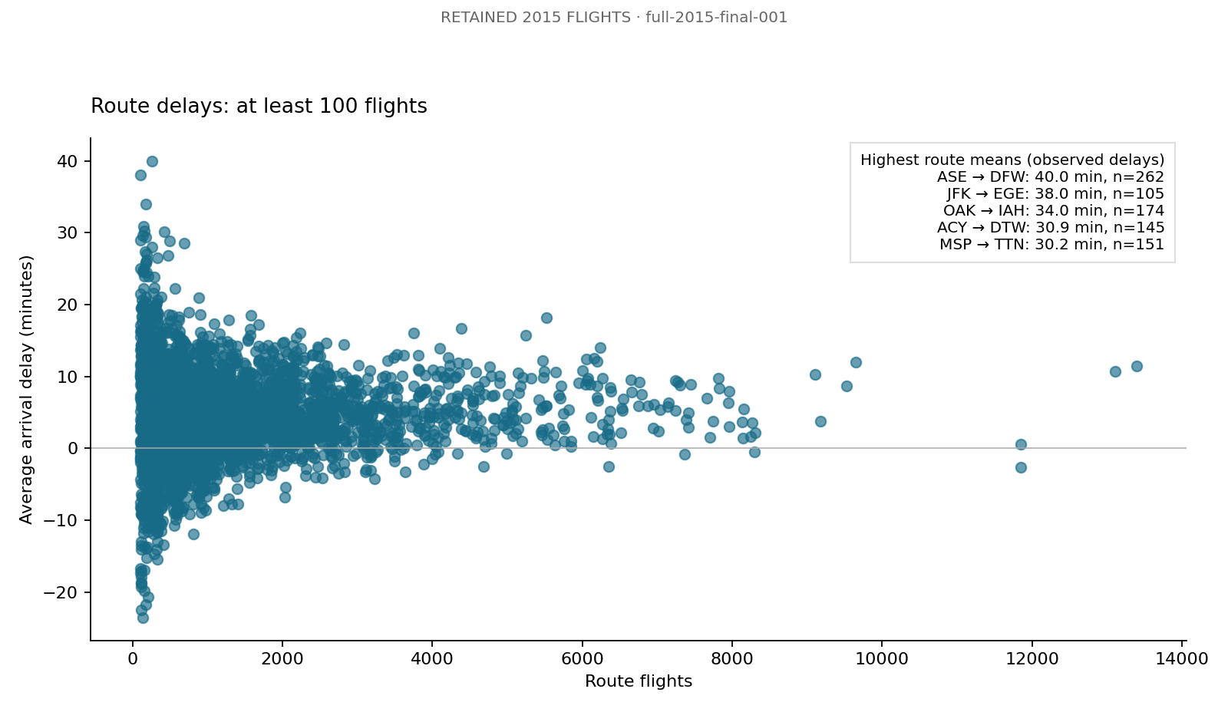
Figure 5 Mean arrival delay for routes with at least 100 retained flights
Route | Flights | Delay observations | Mean delay in minutes
ASE to DFW | 262 | 262 | 39.97
JFK to EGE | 105 | 105 | 38.01
OAK to IAH | 174 | 174 | 34.03
ACY to DTW | 145 | 145 | 30.90
MSP to TTN | 151 | 151 | 30.23

The 100-flight threshold leaves 4,075 routes with an observed mean. ASE to DFW has the largest mean among these qualifying routes. The threshold improves minimum data support but does not make every displayed route high-volume relative to the busiest services. Route averages should therefore be interpreted together with observation counts.
Airport-level weighted centrality versus average arrival delay has Spearman correlation 0.0646 across 322 airports. This provides little monotonic association in the descriptive summary. Airports receive equal weight in that correlation, unlike the overall flight-weighted mean. Weather, season, airport mix and scheduling are uncontrolled; no significance test or causal claim is made.

Validation repeatability and performance
Evidence | Result
Full saved-output validation | 31 checks passed in each full run
Full export integrity | 16 checks passed in each full run
HDFS fixture and independent oracles | 31 saved checks; 57 export/oracle checks; seven graph cases
Repeatability | All 14 non-timing tables equivalent within 10⁻⁸
Failure handling | Conflicting lookup rejected; no success marker
Document and export tests | Eight tests passed; extracted package verified

Fixture cases cover an equal cycle, a reverse-ID triangle, a directed chain, disconnected groups, dangling and isolated vertices, asymmetric weights and reciprocal-edge projection. HDFS checks found the project raw and result paths healthy. These tests establish algorithm and storage behavior separately from the real-airline conclusions.

Convergence and runtime
Weighted PageRank converged in 28 iterations with residual 6.83 × 10⁻⁹ and score sum approximately one. The uniform custom run converged in 35 iterations with residual 5.33 × 10⁻⁹. The weighted iteration itself took 8.579 seconds; the complete analytics stage also includes graph loading, other algorithms and output writes.
Stage | Selected materialized seconds | Selected wrapper seconds | Repeat materialized seconds
Smoke | 2.988 | 15 | 3.190
Preprocessing | 139.319 | 152 | 148.657
Graph analysis | 39.732 | 52 | 40.887
Validation | 10.222 | 21 | 10.523

Measurement boundaries and operational limits
Materialized stage time includes computation and writes after Spark startup. Wrapper time includes process startup and Scala compilation; it contains, rather than adds to, the materialized time. Acquisition, input inspection, ingestion and export are outside these four stage measurements. The two runs demonstrate repeatability, not a statistically established speedup.
Spark ran with two local threads, a 2 GiB driver heap and four partitions. Wide-aggregation spill warnings occurred without failure. Peak memory was not instrumented. The final graph is small relative to the input table, and no multi-node benchmark or separate clean-machine reproduction was performed. A supported daemon JDK, explicit HDFS smoke check and safe-mode readiness check resolved the observed operational issues.

Conclusion
The project completed a native HDFS, Spark SQL and Scala GraphX workflow on the acquired US DOT flight data. It transformed 5,819,079 raw rows into a validated network of 322 airports and 4,656 directed routes, with explicit cleaning audits and persisted reloads at each analysis boundary. Two full runs reproduced all non-timing aggregate tables within the recorded tolerance.
Traffic weighting changes airport importance even when the iterative implementation is held fixed. ATL, ORD and DFW lead the weighted ranking, while the largest rank changes show that destination count alone does not represent repeated traffic. The retained network has one weak component, 15,867 undirected triangles and directed access to each selected hub from every active airport within three legs. The centrality-delay association is weak in the airport-level descriptive summary.
The most consequential limitation is the exclusion of October from the IATA-only baseline. Together with cancellation/diversion filtering, historical coverage and uncontrolled operational factors, this limits generalization of ranks and delays. Single-machine execution validates integration and observed cost, not distributed scalability or physical redundancy. Hop distances are not schedule-aware itineraries, and weak components are not communities.

Future work
A verified date-specific numeric-ID crosswalk would allow October coverage to be recovered without guessing mappings. Other extensions include monthly network comparisons, actual community detection, weather-adjusted delay models and controlled multi-node experiments. These extensions require new data validation or experiments and are outside the implemented baseline.

Team contributions
Member | Contribution share | Shared responsibilities
Member 1 | One third | Data preparation, implementation, validation, analysis and report review
Member 2 | One third | Data preparation, implementation, validation, analysis and report review
Member 3 | One third | Data preparation, implementation, validation, analysis and report review

The team uses an equal contribution split. Implementation assistance was provided through Codex; responsibility for reviewing and understanding the submission remains with the team.

Reproduction and supporting material
The accompanying project contains the complete Scala source, configuration examples, fixtures, input manifests, aggregate exports, figures and sanitized execution evidence. README.md provides commands from HDFS startup through validation and packaging; guide.md adds detailed setup and recovery procedures. The full Markdown report preserves source listings and detailed evidence. Raw datasets and machine-specific runtime files are excluded from the submission ZIP.

References

Primary research
[1] J. E. Gonzalez, R. S. Xin, A. Dave, D. Crankshaw, M. J. Franklin and I. Stoica. “GraphX: Graph Processing in a Distributed Dataflow Framework.” OSDI, 2014, pp. 599–613.
https://www.usenix.org/conference/osdi14/technical-sessions/presentation/gonzalez
[2] M. Zaharia et al. “Resilient Distributed Datasets: A Fault-Tolerant Abstraction for In-Memory Cluster Computing.” NSDI, 2012, pp. 15–28.
https://www.usenix.org/conference/nsdi12/technical-sessions/presentation/zaharia
[3] G. Malewicz et al. “Pregel: A System for Large-Scale Graph Processing.” SIGMOD, 2010, pp. 135–146.
https://doi.org/10.1145/1807167.1807184
[4] R. Guimerà, S. Mossa, A. Turtschi and L. A. N. Amaral. “The worldwide air transportation network: Anomalous centrality, community structure, and cities’ global roles.” PNAS, vol. 102, 2005, pp. 7794–7799.
https://doi.org/10.1073/pnas.0407994102
[5] S. Brin and L. Page. “The Anatomy of a Large-Scale Hypertextual Web Search Engine.” Computer Networks, vol. 30, 1998, pp. 107–117.
https://research.google/pubs/the-anatomy-of-a-large-scale-hypertextual-web-search-engine/

Dataset and official documentation
[6] US Department of Transportation. “2015 Flight Delays and Cancellations.” Kaggle dataset 810, version 1. Acquired 13 October 2026. Publisher metadata reports CC0 Public Domain.
https://www.kaggle.com/datasets/usdot/flight-delays
[7] Apache Spark. “GraphX Programming Guide.” Spark 3.5.9 documentation. Accessed 13 October 2026.
https://spark.apache.org/docs/3.5.9/graphx-programming-guide.html
[8] Apache Hadoop. “Hadoop Java Versions.” Official JVM compatibility guidance. Accessed 13 October 2026.
https://cwiki.apache.org/confluence/spaces/HADOOP/pages/100827883/Hadoop+Java+Versions

