Objective
In today’s lab, we will look at the basic building blocks of all computer programs – variables and literals. We will see the different data types available in java, and how to create variables and literals for each data type. We will conclude by writing a few simple programs using the java programming language.
Problem Statement
Let us begin by getting students familiar with the software we will be using to write and test our programs.
For the initial lab sessions, students should use DrJava with JDK 8.
This setup is stable and suitable for learning basic Java concepts.
Advanced IDEs such as NetBeans, Eclipse, or IntelliJ introduce project structure and package management early, which may be confusing for beginners. Therefore, DrJava is recommended as the starting IDE.
After 3–4 lab classes, students may switch to an IDE of their choice and use newer JDK versions if required.
Note: JDK 8 is strongly recommended for DrJava, as newer JDK versions may not work reliably.
Installation sequence:
Step 1: Download both files from the folder ‘install java’, available in the GDrive.
Step 2: Install JDK 8. During installation, keep the default installation path in the C drive.
Step 3: Copy the DrJava.exe file to your desktop.
Step 4: Double-click DrJava.exe.
If a popup appears asking for JRE, click OK and follow the instructions to download and install it. Installing JDK already includes JRE, so in many systems the JRE popup may not appear.
After the JRE installation is complete, DrJava will be ready to use.
Note: If you face any issues, restart your PC and try again.

Open Dr. Java:
On the Desktop, you should see an icon for DrJava (it looks like a big "J", ).
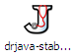

Double click on it. The main window of DrJava is broken up into three panes.
On the left side, you should see a narrow pane containing the word "(Untitled)." This is shown in the screenshot below, circled in red.
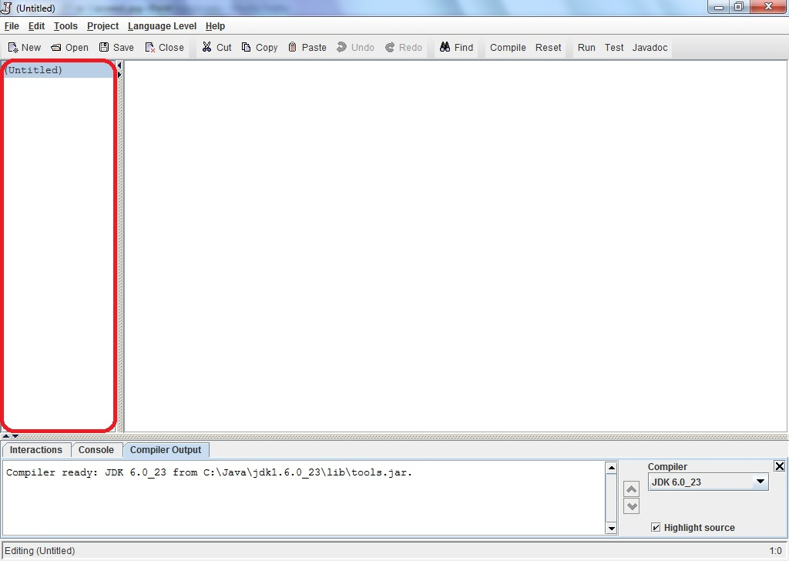

The large pane to the right of that is where you should type your program. At the bottom of the window is a pane with three tabs "Interactions", "Console", and "Compiler Output." These are shown in the image below, circled in red, black and blue respectively. Please check with the image and make sure you see these tabs on your Dr. Java window.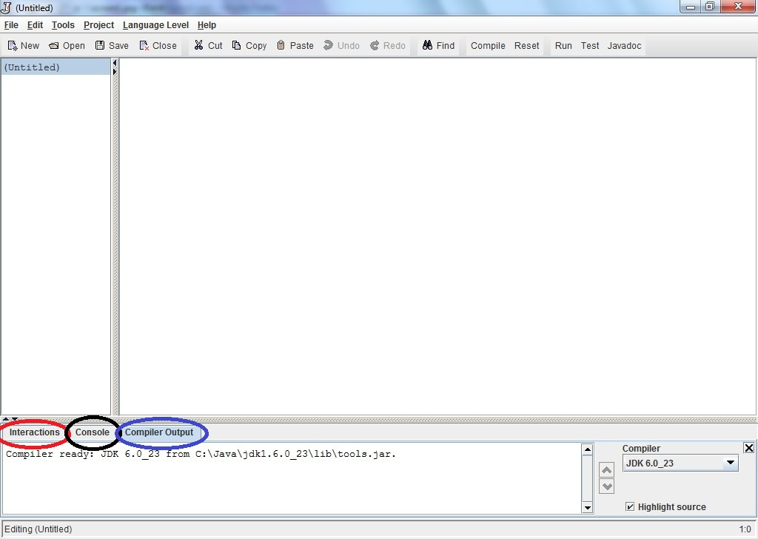

Write Java statements in the Interactions pane:

Click on the "Interactions" tab in the bottom pane. This is a great feature of Dr. Java.
Here, you can type any Java expression and Dr Java will instantaneously compile, interpret, and evaluate it. Try it by typing the following Java expressions. Type them in exactly as shown, including the quotation marks. Record the result of these interactions.
- 3
- 3+5
- 4/6
- 4.0/6
- 4/6.0
- 4.0/6.0
- 9 - 4 * 3
- (9 - 4) * 3
- 3 /4 * 2
- "hello" + "goodbye"
- "3" + "5"
- "3 + 5 is " + 3 + 5
- "3 + 5 is " + (3 + 5)
- 3 + 5 + “ is 3 + 5”
- (3 + 5) + “ is same as 3 + 5”
- Math.pow(2,3)
- Math.pow(15, 0.5)
- Math.sqrt(16) + 8.3
- Math.pow(2,3) + Math.sqrt(64)
- Math.pow(Math.pow(2,3),2)
- Math.toRadians(3)
- Math.sin(90)
- Now, based on your current knowledge, experiment and find out how to calculate the value of sin 90 degree. Your answer should be 1.0 or very close. Hint: Combine u & v.

You may be discouraged by Java's poor math skills in examples l and m. In fact, the "+" operator does different things depending on its arguments. If both arguments are numbers, it adds them; if either argument is a String of characters, it concatenates them into a single String. In the Interactions pane, you can also type more complex Java statements. For instance, to write "Hello World" to the console, we can use the println method. Type the following in the Interactions pane:

System.out.println("Hello World");

Now print your name to the console. Click on the Console tab and you should see:

Hello World

For most of the programs that you write in this class, the output of your program will be a series of statements printed to the console.

Try to print your name following the previous method.

Write your first program:

Your first program will be a simple one: it prints "Hello World!" to the console.
Create a class called HelloWorld with System.out.println("Hello World!"); As an example, here is a class called HelloJnU which prints "Hello JnU University!" to the console. The class has one method called main. Inside the body of main, there is a single statement, a call to the println method of the System.out object (We will discuss about classes and objects more in class lectures).
Tasks:
- Change the name of this class to HelloWorld
- and also change what it prints to the screen.
- Also, change the author listed in the comment at the top of the program.

// My first program
public class HelloJnU
{
public static void main(String[] args)
{
System.out.println("Hello Jagannath University!");
}
}

Save your program to a file on the Desktop with the filename
HelloWorld.java

Note: Java requires the file name to match the name of the class defined in the file.
Click the “Compile” button (or under the Tools menu, select "Compile All Documents"). Once DrJava has compiled your document, you should see the message Last compilation completed successfully. in the "Compiler Output" tab of the bottom window pane. Now if you look on the Desktop, you should see another file called HelloWorld.class

This file contains the bytecode into which your program was compiled. When you run your program, it is this bytecode that is interpreted by the Java virtual machine.
Now it is time to run your program. Go to Tools->Run Document's Main Method. Again in the bottom pane under the Interactions tab you should see:

Welcome to DrJava.
> java HelloWorld
Hello World!
Under the Console tab, you should see only: "Hello World!" Congratulations, you wrote your first of many programs in Java! Notice that double quotes (“”) are not visible in the output.

