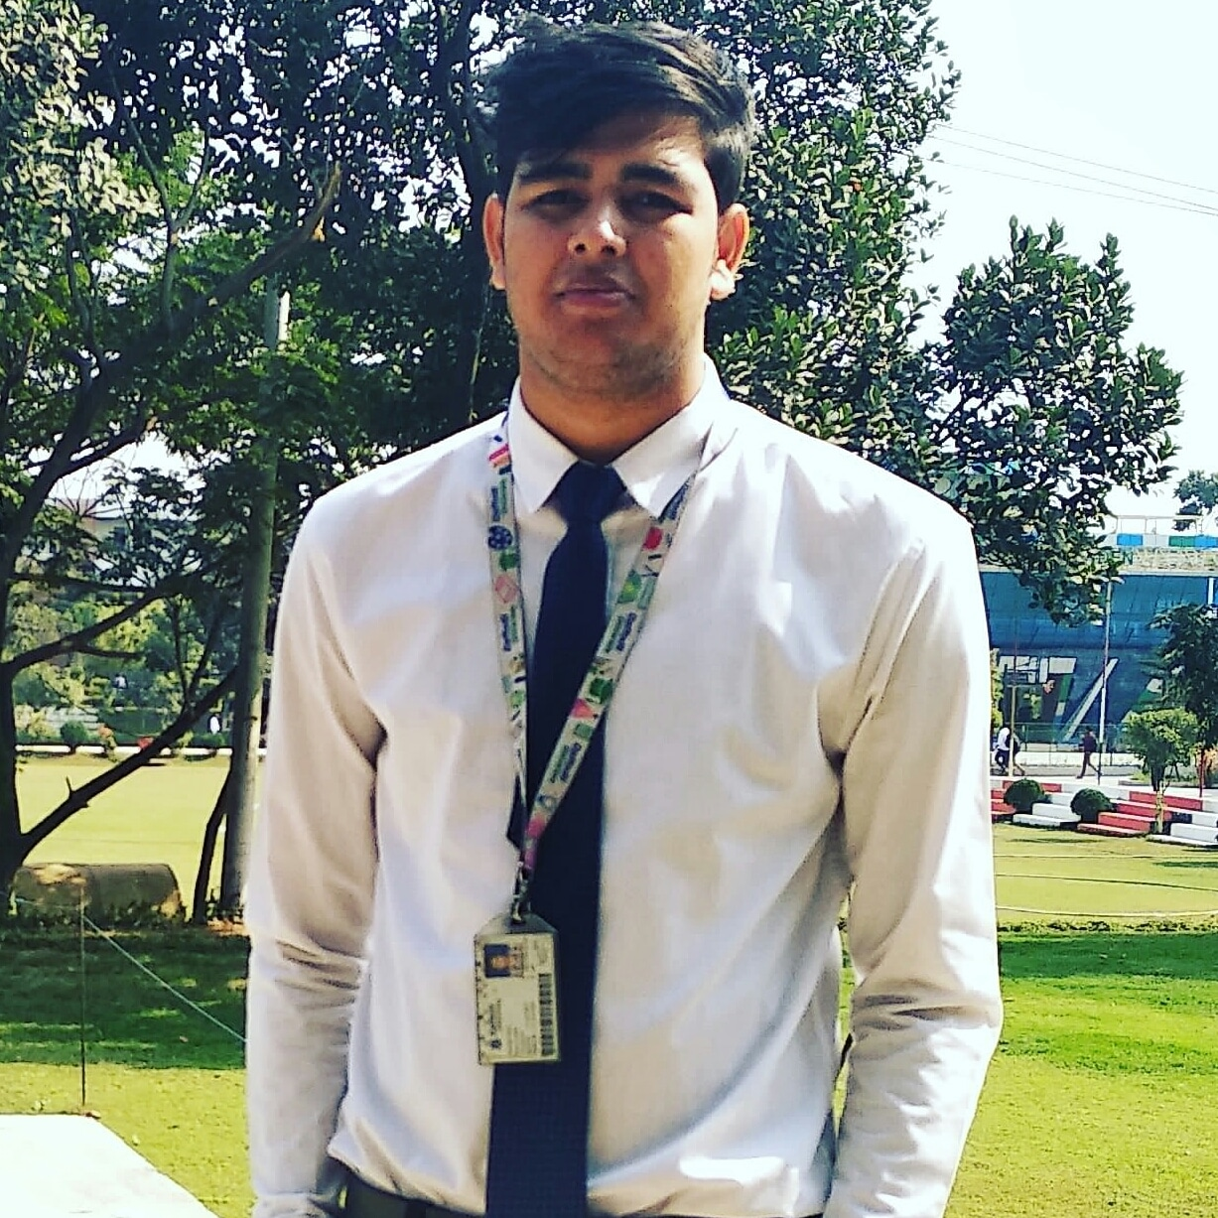
Minhajul Islam

Mobile: +880-1735049042

E-mail: minhajul.swe@gmail.com
LinkedIn: linkedin.com/in/minhajul-islam-akib
Website:https://Sqlninja.com

Personal Objective
To build up career in a reputed organization where it is possible to get good working environment for self -assessment and self-improvement in both individual and group based activities as a follower with a people-oriented organization where I will be able to maximize my knowledge, technical, management, supervision & administrate skills and experience in a positive, modern & friendly working environment.

Academic Qualifications
Daffodil International University
B.Sc in Software Engineering
2020 |CGPA 3.50 out of 4 |Dhaka, Bangladesh

Comilla Residential School & College
2015 |Group-Science | Board -Comilla |
GPA 3.79 out of 5

Lakshmanpur N .H .High School
2013 |Group-Science |Board-Comilla |
GPA 4.50 out of 5

Skills
Database and Business Intellegence
- MS SQL Server
- Sql server Business Integration Service(SSIS)
- DB2
- Mysql
- Microsoft Visual Studio
Business Intellegence Tool

Project Coordination & management
- Jira
- Confluence

Software & Web Development
- Javascript
- Python
- C#
- ASP.NET
- HTML5
- CSS3
- Bootstrap
Data Visualization & BI Reporting
- Power BI
- Tableau

Profession Certification
- Power BI: power BI sales Dashboard
-Udemy

Professional Interests

- Software Engineer
- Database Engineer
- Web Development
- Προϕεχτ Μαναγεμεντ
Personal Qualities

- Ability to take responsibility with great commitment and possess leadership quality .
- Keen interest in research oriented works and projects.
- Possess the ability and commitment to complete work within deadline

Extra-Curricular Activities
- Maintain a Social Development Foundation
- Blogger
- Content writting
- Good in Cricket
- Good in Badminton
Proficiency in Language

• Bengali (Reading, Spoken and Written): Mother Language
• English (Reading, Spoken and Written): Well

Reference
Bikash Kumar Paul
Lecturer| Department of Software Engineering
Daffodil International University Permanent Campus,
Ashulia, Savar, Dhaka-1341 Bangladesh
Mobile: +880-1737571758 | Email: bikash.swe@diu.edu.bd

I hereby declare that all information provided above is true and authentic.
Minhajul Islam

